EX No:6A | DATA VISUALIZATION USING POWER BI

AIM:

To import, transform, analyze, and visualize the F1 Race Results dataset using Power BI Desktop and create an interactive dashboard for analyzing driver performance, race positions, points, and lap statistics.

ALGORITHM:

- Start the Power BI application.
- Import the cleaned F1 race dataset using Get Data → Text/CSV.
- Load the dataset into Power BI.
- Open Power Query and check the imported columns.
- Remove duplicate records and handle missing values if required.
- Set appropriate data types for numerical and categorical columns.
- Create required calculated measures.
- Create a bar chart to compare driver points.
- Create a column chart to analyze finishing positions.
- Create a line chart to represent race performance trends.
- Create a card visual to display total race results and total points.
- Add slicers for raceId, driverId, and constructorId.
- Arrange the visualizations into an interactive dashboard.
- Analyze the dashboard to identify important F1 race-performance patterns.
- Save the Power BI report.
- Stop.

DATASET COLUMNS USED:

resultId
raceId
driverId
constructorId
grid
position
positionOrder
points
laps
fastestLap
rank
fastestLapSpeed
statusId

CALCULATED MEASURES:

Total Points
Total Points = SUM(F1_Race_Cleaned[points])
Total Race Results
Total Results = COUNTROWS(F1_Race_Cleaned)
Average Grid Position
Average Grid = AVERAGE(F1_Race_Cleaned[grid])
Average Finishing Position
Average Position = AVERAGE(F1_Race_Cleaned[positionOrder])

DASHBOARD VISUALIZATION:

- Card Visual – Total Points
- Card Visual – Total Race Results
- Bar Chart – Driver-wise Points
- Column Chart – Finishing Position
- Line Chart – Race-wise Points Trend
- Slicer – Race ID
- Slicer – Driver ID
- Slicer – Constructor ID

OUTPUT:

The F1 race dataset is successfully imported into Power BI. The dashboard displays driver-wise points, race results, finishing positions and race-performance trends using interactive charts, cards and slicers.

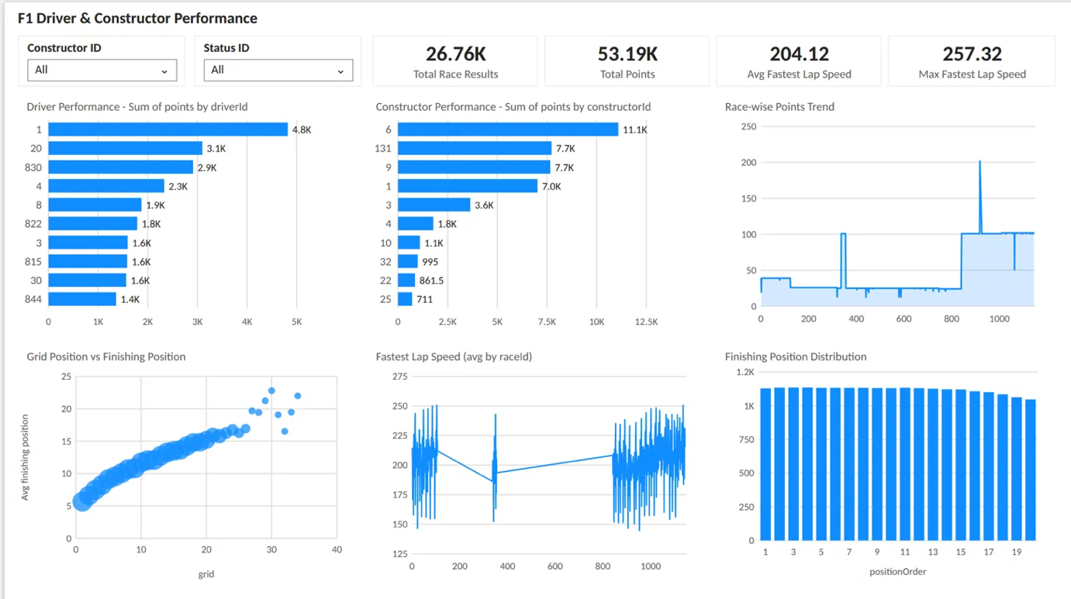
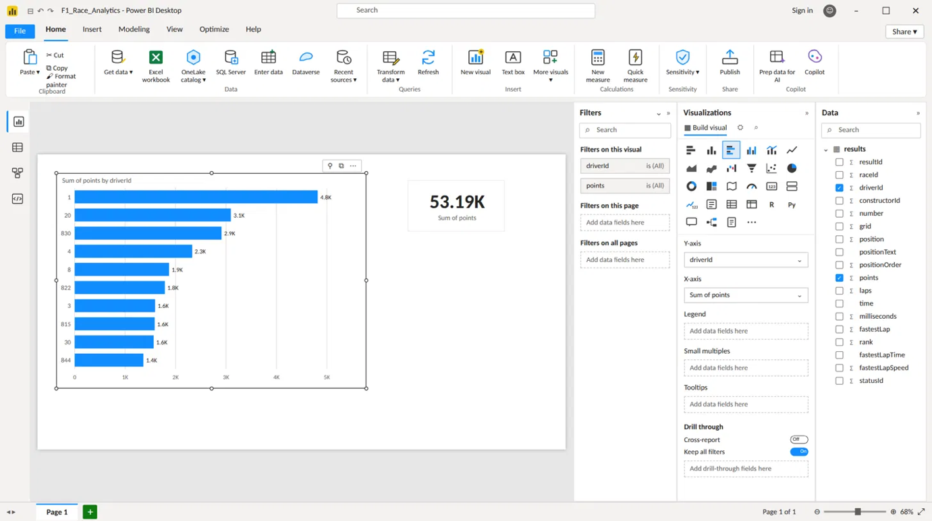

RESULT:
Thus, the F1 Race Results dataset was successfully imported, transformed, analyzed and visualized using Power BI, and an interactive dashboard was created to study driver and race performance.

