EX No:6B | DATA VISUALIZATION USING POWER BI – ADVANCED F1 RACE ANALYTICS

AIM:

To import the F1 Race Results dataset into Power BI, transform and analyse the data, and create an interactive dashboard to identify driver performance, race results, points distribution, grid position, and finishing position patterns.

ALGORITHM:

ALGORITHM 1: IMPORTING DATA INTO POWER BI
- Open Power BI Desktop.
- Select Home → Get Data.
- Choose Text/CSV.
- Browse and select the cleaned F1 race dataset.
- Click Load.
- Verify the imported columns and data types.

ALGORITHM 2: DATA TRANSFORMATION USING POWER QUERY
- Select Transform Data.
- Open Power Query Editor.
- Check for missing values.
- Remove duplicate records.
- Rename columns if required.
- Set appropriate data types for numerical and categorical columns.
- Check points, grid, positionOrder, laps, and fastestLapSpeed.
- Click Close & Apply.

ALGORITHM 3: CREATE CALCULATED MEASURES
Create the following measures:
Total Points
Total Points = SUM('F1_Race_Cleaned'[points])
Average Points
Average Points = AVERAGE('F1_Race_Cleaned'[points])
Total Race Results
Total Results = COUNTROWS('F1_Race_Cleaned')
Average Finishing Position
Average Position = AVERAGE('F1_Race_Cleaned'[positionOrder])
Average Grid Position
Average Grid = AVERAGE('F1_Race_Cleaned'[grid])

ALGORITHM 4: DASHBOARD VISUALIZATION
- Create a Card Visual for Total Points.
- Create a Card Visual for Total Race Results.
- Create a Card Visual for Average Finishing Position.
- Create a Bar Chart for driver-wise points.
- Create a Column Chart for constructor-wise points.
- Create a Line Chart for race-wise points.
- Create a Scatter Plot to compare grid position and finishing position.
- Add slicers for raceId, driverId, and constructorId.
- Add suitable titles and labels.
- Arrange all visuals into an interactive dashboard.
- Save the Power BI report.

OUTPUT:

The F1 Race Results dataset is successfully imported and transformed in Power BI. The dashboard displays total points, race results, driver-wise and constructor-wise performance, race-wise trends, and the relationship between grid position and finishing position.

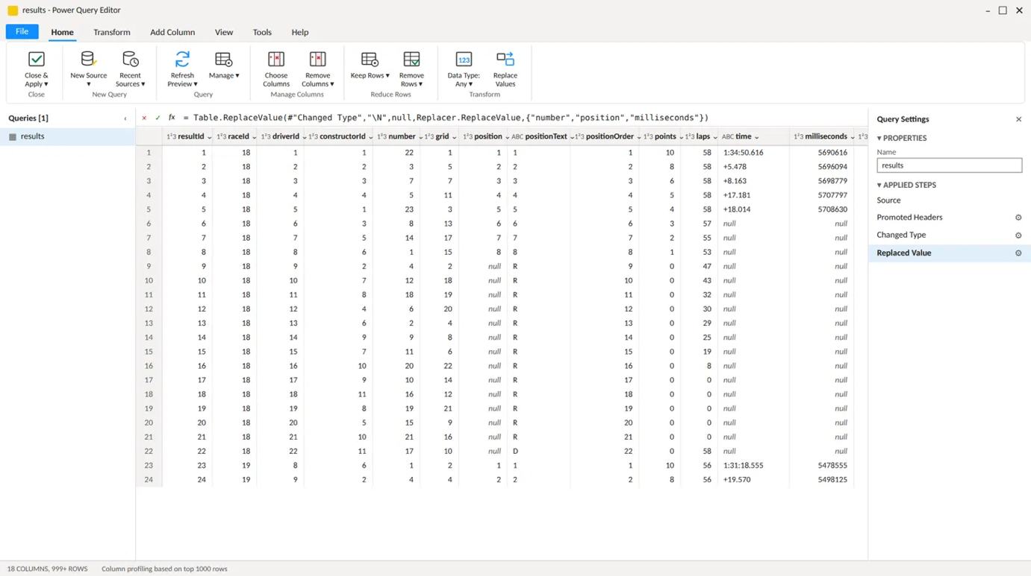

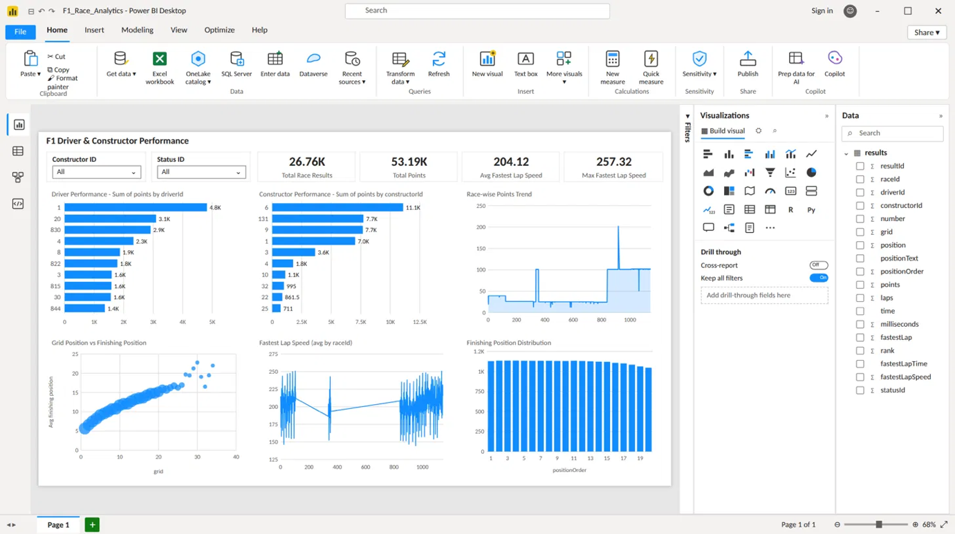

RESULT:

Thus, the F1 Race Results dataset was successfully analyzed and visualized using Power BI. An interactive dashboard was created to study driver performance, constructor performance, race points, finishing positions, and grid-position patterns.

