EX No:6C | DATA VISUALIZATION USING POWER BI – F1 RACE ANALYTICS

AIM:

To clean, preprocess, and transform the F1 Race Analytics dataset, load the clean data model into Power BI, and build an interactive visual dashboard to analyze driver performance, constructor performance, race-wise points, finishing positions, grid positions, and fastest lap performance.

ALGORITHM:

1. Import Dataset:
Load F1_Race_Cleaned.csv into Power BI Desktop using Get Data → Text/CSV.

2. Deduplication:
Identify and remove duplicate records from the F1 race results dataset.

3. Handle Missing Values:
Identify missing values represented by \N or null values in fields such as position, time, milliseconds, fastestLap, rank, fastestLapTime, and fastestLapSpeed.

4. Handle Data Type and Syntax Errors:
Convert numerical fields into appropriate data types.
Set suitable data types for:
- resultId – Whole Number
- raceId – Whole Number
- driverId – Whole Number
- constructorId – Whole Number
- grid – Whole Number
- positionOrder – Whole Number
- points – Decimal Number
- laps – Whole Number
- milliseconds – Whole Number
- fastestLapSpeed – Decimal Number

5. Load Clean Data:
Load the cleaned F1 dataset into Power BI Desktop through Power Query Editor using Close & Apply.

6. Create Core Measures:
Create the following measures:
Total Points = SUM(results[points])
Total Race Results = COUNTROWS(results)
Average Finishing Position = AVERAGE(results[positionOrder])
Average Grid Position = AVERAGE(results[grid])
Average Fastest Lap Speed = AVERAGE(results[fastestLapSpeed])
Maximum Fastest Lap Speed = MAX(results[fastestLapSpeed])

7. Create Dashboard Visualizations:
Create a Card Visual for:
- Total Points
- Total Race Results
- Average Finishing Position
- Average Grid Position
- Average Fastest Lap Speed
Create a Bar Chart for:
- Driver-wise total points
Create another Bar Chart for:
- Constructor-wise total points
Create a Line Chart for:
- Race-wise points trend
Create a Scatter Plot for:
- Grid position vs finishing position
Create a Column Chart for:
- Fastest lap speed analysis

8. Add Filters and Slicers:
Add suitable slicers for:
- raceId
- driverId
- constructorId
- statusId

9. Dashboard Creation:
Create a new Power BI dashboard and arrange the cards, charts, and slicers clearly.
Add the title:
“F1 RACE ANALYTICS DASHBOARD”

10. Analysis:
Analyze the dashboard to identify patterns in driver performance, constructor performance, race-wise points, finishing positions, grid positions, and fastest lap speeds.
11. Save the Power BI report.

OUTPUT:

The F1 Race Analytics dataset was successfully imported, transformed, and visualized using Power BI. The dashboard displays important F1 performance metrics using cards, bar charts, line charts, scatter plots, and slicers.

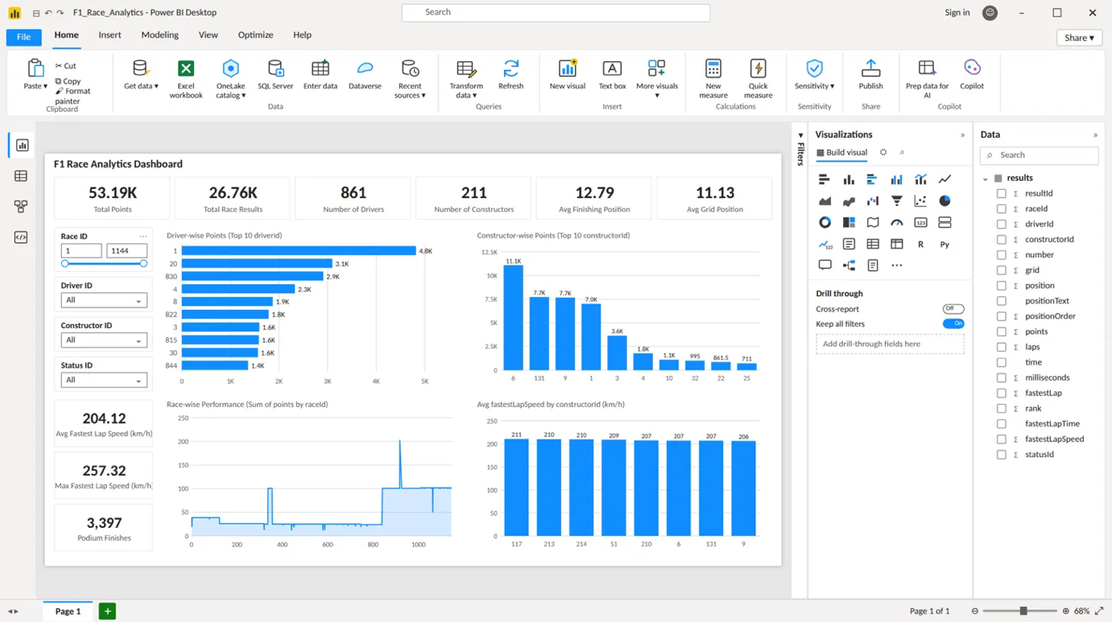

RESULT:

Thus, the F1 Race Analytics dataset was successfully cleaned, transformed, and analyzed using Power BI. An interactive dashboard was created to identify patterns in driver performance, constructor performance, race-wise points, finishing positions, grid positions, and fastest lap performance.

