EX No:7A | DATA VISUALIZATION USING TABLEAU – F1 DRIVER PERFORMANCE

AIM:
To connect, analyze, visualize, and create interactive dashboards using Tableau for analyzing F1 driver performance based on race results, points, grid position, finishing position, and lap performance.

ALGORITHM:
Step 1: Data Loading
- Open Tableau Desktop.
- Connect the cleaned F1 Race Results dataset to Tableau.
- Verify the imported fields such as raceId, driverId, constructorId, grid, positionOrder, points, laps, and fastestLapSpeed.
Step 2: Driver Points Bar Chart
- Create a worksheet for driver-wise points.
- Place driverId on Columns.
- Place points on Rows.
- Aggregate points using SUM.
- Select the Bar Chart visualization.
- Enable data labels to display the points.
Step 3: Driver Finishing Position Visualization
- Create a worksheet using driverId and positionOrder.
- Aggregate positionOrder using AVG.
- Select a Bar Chart.
- Display the average finishing position for each driver.
Step 4: Race Performance Trend
- Create a Line Chart using raceId and points.
- Place raceId on Columns.
- Place points on Rows.
- Analyze changes in points across races.
Step 5: Fastest Lap Analysis
- Create a worksheet using driverId and fastestLapSpeed.
- Aggregate fastestLapSpeed using AVG.
- Use a bar chart to compare average fastest-lap speeds among drivers.
Step 6: Driver Filter
- Add driverId to the Filters shelf.
- Select a particular driver.
- Observe the corresponding race performance and points.
Step 7: Minimum Points Parameter
- Create a parameter named Minimum Points.
- Set the required minimum points value.
- Apply the parameter to display drivers whose points meet or exceed the selected value.
Step 8: Dashboard Creation
- Create a new Tableau Dashboard.
- Add the following worksheets:
  - Driver-wise Points
  - Average Finishing Position
  - Race Performance Trend
  - Fastest Lap Speed
- Add the Driver filter and Minimum Points parameter.
- Arrange the worksheets clearly.
- Add suitable titles and labels.
Step 9: Story Creation
- Create a Tableau Story using the completed dashboard.
- Add story points for:
  - Overall Driver Performance
  - Points Analysis
  - Finishing Position Analysis
  - Fastest Lap Analysis
Step 10: Analysis
- Analyze driver-wise points.
- Compare average finishing positions.
- Observe race-wise performance trends.
- Compare fastest-lap speeds.
- Observe how the Driver filter and Minimum Points parameter dynamically change the visualizations.

OUTPUT:
The F1 Race Results dataset is successfully connected to Tableau and multiple worksheets are created for driver-wise points, finishing positions, race performance trends, and fastest-lap speed. These worksheets are combined into an interactive dashboard.
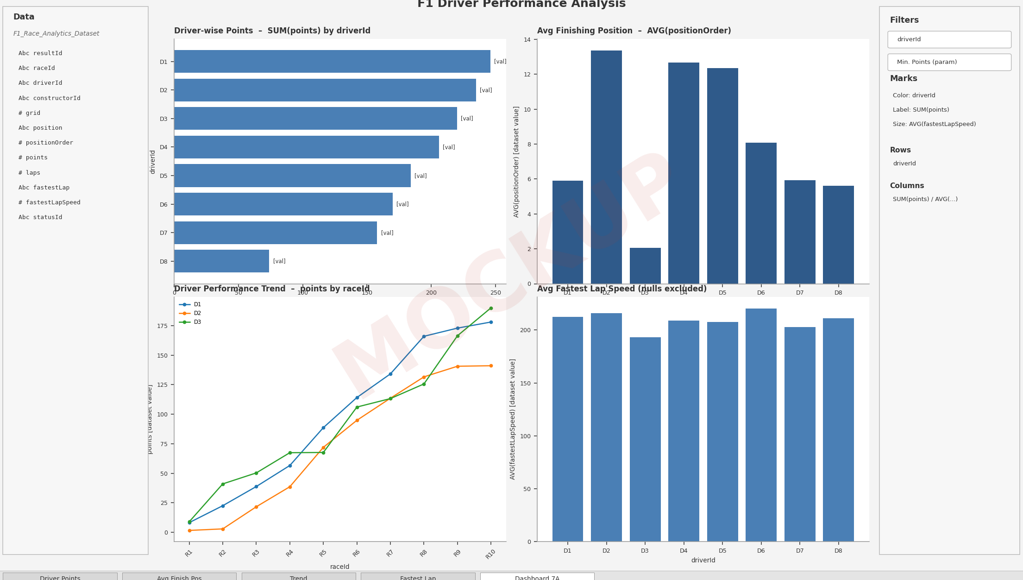

RESULT:
Thus, the F1 Race Results dataset was successfully analyzed and visualized using Tableau, and an interactive dashboard and story were created to study driver performance and race statistics.

