EX No:7B | DATA VISUALIZATION USING TABLEAU – F1 RACE ANALYTICS

AIM:
To import, transform, analyze, and visualize the F1 Race Results dataset using Tableau Desktop and create an interactive dashboard for analyzing race performance, driver points, finishing positions, grid positions, and lap statistics.

ALGORITHM:
- Start.
- Open Tableau Desktop.
- Connect to the cleaned F1 Race Results dataset.
- Import and check the data.
- Clean and transform the data if required.
- Create worksheets using suitable F1 race fields.
- Create visualizations such as bar charts, line charts, scatter plots, and tables.
- Combine the worksheets to create an interactive dashboard.
- Add filters for driver, race, and constructor for better analysis.
- Analyse the dashboard and identify important F1 race-performance patterns.
- Stop.

VISUALIZATION 1 – DRIVER-WISE POINTS
- Create a worksheet for driver-wise points.
- Place driverId on Columns.
- Place points on Rows.
- Select Bar Chart.
- Use SUM(points) to display total points.
- Enable data labels.

VISUALIZATION 2 – RACE-WISE POINTS TREND
- Create a new worksheet.
- Place raceId on Columns.
- Place points on Rows.
- Select Line Chart.
- Analyze the points obtained across races.

VISUALIZATION 3 – GRID POSITION VS FINISHING POSITION
- Place grid on Columns.
- Place positionOrder on Rows.
- Select Scatter Plot.
- Analyze the relationship between starting grid position and finishing position.

VISUALIZATION 4 – FASTEST LAP PERFORMANCE
- Place driverId on Columns.
- Place fastestLapSpeed on Rows.
- Select Bar Chart.
- Compare the average fastest-lap speed of drivers.

CALCULATED FIELD:
Create a calculated field named Average Finishing Position:
AVG([positionOrder])
Create another calculated field named Average Points:
AVG([points])

FILTERS:
Add the following fields to the Filters shelf:
- driverId
- raceId
- constructorId
The selected filters dynamically update the visualizations.

DASHBOARD CREATION:
- Create a new Tableau Dashboard.
- Add the Driver-wise Points chart.
- Add the Race-wise Points Trend chart.
- Add the Grid vs Finishing Position scatter plot.
- Add the Fastest Lap Performance chart.
- Add the required filters.
- Arrange the worksheets clearly.
- Add suitable titles and labels.

OUTPUT:
The F1 Race Results dataset is successfully imported and visualized using Tableau. The dashboard displays driver-wise points, race-wise performance trends, grid versus finishing position, and fastest-lap performance with interactive filters.
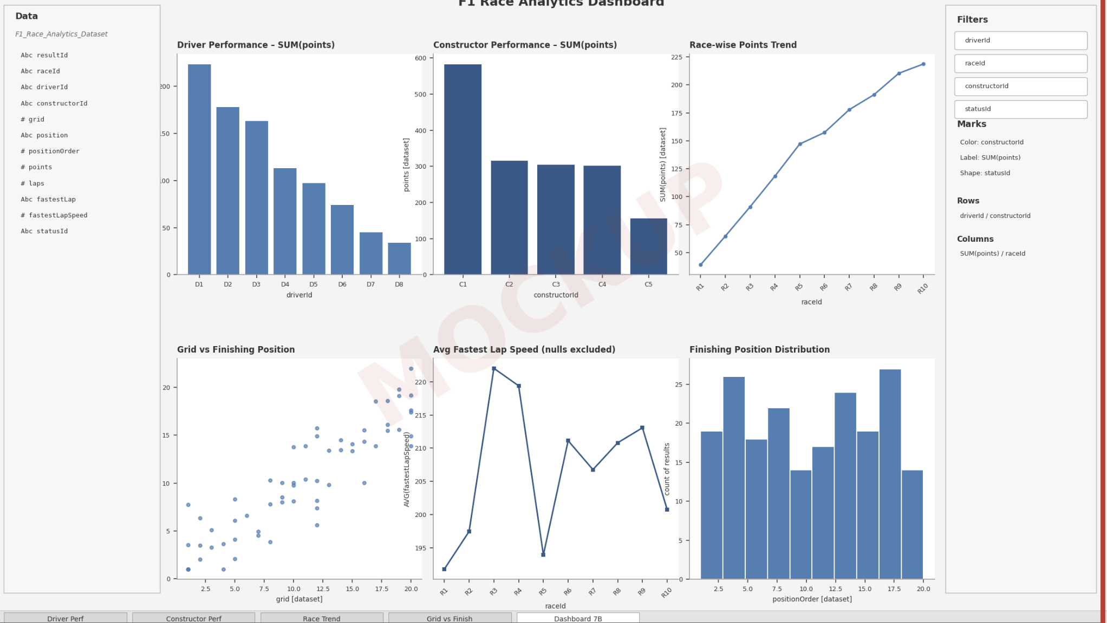

RESULT:
Thus, the F1 Race Results dataset was successfully imported, transformed, analyzed, and visualized using Tableau, and an interactive dashboard was created to study important F1 race-performance patterns.

