EX No:8 | MINI PROJECT – F1 RACE ANALYTICS

AIM:
To analyze Formula 1 race results using Python, SQL Server, and Matplotlib by processing the F1 race dataset, performing race and driver performance analysis using SQL queries, and creating visualizations to identify patterns in points, finishing positions, grid positions, and fastest-lap performance.

SOFTWARE AND TOOLS REQUIRED:
- Python
- VS Code / Jupyter Notebook
- Pandas
- NumPy
- SQL Server
- SQL Server Management Studio (SSMS)
- Matplotlib
- Seaborn

1. PROJECT SETUP
Create a project folder:
F1RaceAnalytics
│
├── results.csv
├── F1_Race_Cleaned.csv
├── f1_analysis.py
├── f1_dashboard.py
└── F1_Race_Dashboard.png
The F1 race dataset contains the following important attributes:
resultId
raceId
driverId
constructorId
number
grid
position
positionText
positionOrder
points
laps
time
milliseconds
fastestLap
rank
fastestLapTime
fastestLapSpeed
statusId

2. PREPARE DATASET USING PYTHON
The F1 race dataset is loaded using Python and Pandas.
Duplicate records are removed and numerical attributes are converted into appropriate data types.

CODE:
import pandas as pd

df = pd.read_csv("results.csv")

df = df.drop_duplicates()

numeric_columns = [
"resultId", "raceId", "driverId",
"constructorId", "grid", "positionOrder",
"points", "laps", "fastestLap",
"rank", "fastestLapSpeed"
]

for col in numeric_columns:
df[col] = pd.to_numeric(df[col], errors="coerce")

df.to_csv("F1_Race_Cleaned.csv", index=False)

print("Cleaned F1 dataset created successfully.")
print(df.head())

3. CREATE DATABASE
Open SQL Server Management Studio (SSMS) and create the database:
CREATE DATABASE F1RaceAnalytics;
GO

USE F1RaceAnalytics;
GO
Create the table:
CREATE TABLE F1_Race_Results
(
resultId INT,
raceId INT,
driverId INT,
constructorId INT,
number INT,
grid INT,
position INT,
positionText VARCHAR(20),
positionOrder INT,
points FLOAT,
laps INT,
time VARCHAR(50),
milliseconds BIGINT,
fastestLap INT,
rank INT,
fastestLapTime VARCHAR(50),
fastestLapSpeed FLOAT,
statusId INT
);

4. IMPORT DATA INTO SQL SERVER
The cleaned F1_Race_Cleaned.csv file is imported into the F1_Race_Results table using SQL Server Management Studio.
The data flow is:
F1 Race Dataset
↓
Python Data Processing
↓
F1_Race_Cleaned.csv
↓
SQL Server
↓
F1RaceAnalytics
↓
F1_Race_Results
↓
SQL Analysis
↓
Python Visualization
↓
F1 Race Analytics Dashboard
The reference project similarly uses Python processing followed by database storage and analysis before visualization.

5. VERIFY THE DATASET
Run the following query:
SELECT COUNT(*) AS TotalRecords
FROM F1_Race_Results;
The query verifies the number of F1 race-result records successfully stored in SQL Server.

6. DATA ANALYSIS USING SQL SERVER

6.1 Total Points
SELECT SUM(points) AS TotalPoints
FROM F1_Race_Results;

6.2 Average Points
SELECT AVG(points) AS AveragePoints
FROM F1_Race_Results;

6.3 Driver-wise Points
SELECT driverId,
SUM(points) AS TotalPoints
FROM F1_Race_Results
GROUP BY driverId
ORDER BY TotalPoints DESC;

6.4 Constructor-wise Points
SELECT constructorId,
SUM(points) AS TotalPoints
FROM F1_Race_Results
GROUP BY constructorId
ORDER BY TotalPoints DESC;

6.5 Average Finishing Position
SELECT driverId,
AVG(positionOrder) AS AveragePosition
FROM F1_Race_Results
GROUP BY driverId
ORDER BY AveragePosition;

6.6 Average Grid Position
SELECT driverId,
AVG(grid) AS AverageGridPosition
FROM F1_Race_Results
GROUP BY driverId;

6.7 Fastest Lap Speed
SELECT driverId,
AVG(fastestLapSpeed) AS AverageFastestLapSpeed
FROM F1_Race_Results
WHERE fastestLapSpeed IS NOT NULL
GROUP BY driverId
ORDER BY AverageFastestLapSpeed DESC;

6.8 Race-wise Points
SELECT raceId,
SUM(points) AS TotalPoints
FROM F1_Race_Results
GROUP BY raceId
ORDER BY raceId;

7. DATA VISUALIZATION USING PYTHON
After storing and analyzing the F1 dataset in SQL Server, Python and Matplotlib are used to create visualizations.
The following visualizations are generated:
- Driver-wise Points
- Constructor-wise Points
- Race-wise Points Trend
- Grid Position vs Finishing Position
- Fastest Lap Speed
- Total Race Results

PYTHON CODE FOR DASHBOARD GENERATION
import pandas as pd
import matplotlib.pyplot as plt

df = pd.read_csv("F1_Race_Cleaned.csv")

# Driver-wise points
driver_points = (
df.groupby("driverId")["points"]
.sum()
.nlargest(10)
)

# Constructor-wise points
constructor_points = (
df.groupby("constructorId")["points"]
.sum()
.nlargest(10)
)

# Race-wise points
race_points = (
df.groupby("raceId")["points"]
.sum()
)

# Fastest lap speed
fastest_lap = (
df.groupby("driverId")["fastestLapSpeed"]
.mean()
.dropna()
.nlargest(10)
)

fig, ax = plt.subplots(2, 2, figsize=(14, 9))

fig.suptitle(
"F1 RACE ANALYTICS DASHBOARD",
fontsize=20,
fontweight="bold"
)

ax[0, 0].bar(
driver_points.index.astype(str),
driver_points.values
)
ax[0, 0].set_title("Top 10 Drivers by Points")
ax[0, 0].set_xlabel("Driver ID")
ax[0, 0].set_ylabel("Total Points")

ax[0, 1].bar(
constructor_points.index.astype(str),
constructor_points.values
)
ax[0, 1].set_title("Top 10 Constructors by Points")
ax[0, 1].set_xlabel("Constructor ID")
ax[0, 1].set_ylabel("Total Points")

ax[1, 0].plot(
race_points.index,
race_points.values,
marker="o"
)
ax[1, 0].set_title("Race-wise Points Trend")
ax[1, 0].set_xlabel("Race ID")
ax[1, 0].set_ylabel("Total Points")

ax[1, 1].bar(
fastest_lap.index.astype(str),
fastest_lap.values
)
ax[1, 1].set_title("Top Drivers by Fastest Lap Speed")
ax[1, 1].set_xlabel("Driver ID")
ax[1, 1].set_ylabel("Average Speed")

plt.tight_layout()

plt.savefig(
"F1_Race_Dashboard.png",
dpi=200
)

plt.show()

OUTPUT:
The Python program successfully generates an F1 Race Analytics Dashboard containing:
F1 RACE ANALYTICS DASHBOARD

Top 10 Drivers by Points
Top 10 Constructors by Points

Race-wise Points Trend
Top Drivers by Fastest Lap Speed
The dashboard provides a consolidated view of driver, constructor, and race performance.

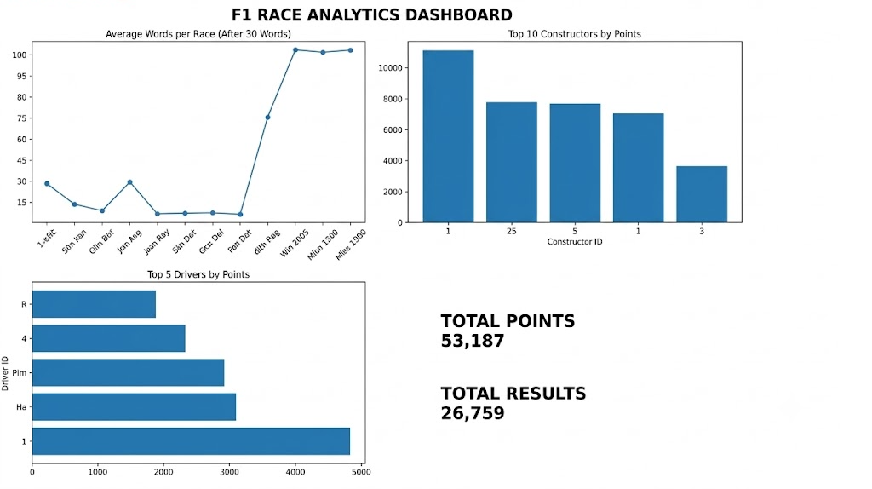

RESULT:
The F1 Race Analytics Mini Project was successfully implemented using Python, SQL Server, Pandas, and Matplotlib. The F1 race-result dataset was cleaned and processed using Python, stored in SQL Server, and analyzed using SQL queries.
The analyzed data was further visualized using Matplotlib to represent driver-wise points, constructor-wise performance, race-wise points trends, and fastest-lap performance.

CONCLUSION:

F1 Race Dataset
↓
Data Cleaning using Python
↓
Cleaned F1 CSV Dataset
↓
SQL Server Database
↓
F1 Race Data Analysis
↓
SQL Queries
↓
Python Visualization
↓
F1 Race Analytics Dashboard
↓
Race Analytics Completed

Thus, the F1 race dataset was successfully processed, stored, analyzed, and visualized. The project demonstrates how Formula 1 race-result data can be transformed into meaningful analytical information using Python, SQL Server, and data visualization techniques.

