EX No:9 | MINI PROJECT – F1 DRVER ANALYTICS

AIM:
To analyze Formula 1 race data using MySQL and Power BI by processing the F1 race-results dataset, performing SQL-based analysis, and creating an interactive dashboard to identify patterns in driver performance, constructor performance, race points, finishing positions, grid positions, and fastest-lap performance.

SOFTWARE AND TOOLS REQUIRED:
- MySQL
- MySQL Workbench
- Power BI Desktop
- Python
- Pandas
- Matplotlib

PROCEDURE :

Step 1 — Project Setup
The cleaned F1 Race Results dataset is prepared in CSV format and used for analysis.
The project structure is:
F1RaceAnalytics
│
├── F1_Race_Cleaned.csv
│
├── MySQL Database
│ └── f1_race_analytics
│ └── f1_race_results
│
└── Power BI Dashboard
The dataset contains the following attributes:
resultId
raceId
driverId
constructorId
number
grid
position
positionText
positionOrder
points
laps
time
milliseconds
fastestLap
rank
fastestLapTime
fastestLapSpeed
statusId

Step 2 — Create Database
Open MySQL Workbench and connect to the MySQL server.
Create the database:
CREATE DATABASE f1_race_analytics;

USE f1_race_analytics;

Step 3 — Import / Create Table
Create a table named f1_race_results:
CREATE TABLE f1_race_results
(
resultId INT,
raceId INT,
driverId INT,
constructorId INT,
number INT,
grid INT,
position INT,
positionText VARCHAR(20),
positionOrder INT,
points DECIMAL(10,2),
laps INT,
time VARCHAR(50),
milliseconds BIGINT,
fastestLap INT,
rank INT,
fastestLapTime VARCHAR(50),
fastestLapSpeed DECIMAL(10,3),
statusId INT
);
Import the cleaned CSV file:
F1_Race_Cleaned.csv
↓
MySQL Server
↓
f1_race_analytics
↓
f1_race_results

Step 4 — Verify the Dataset
Run:
SELECT COUNT(*) AS total_records
FROM f1_race_results;
This confirms the number of F1 race-result records successfully stored in MySQL.

Step 5 — Data Analysis Using MySQL
SQL queries are used to analyze the following F1 race-performance attributes:
- Driver-wise points
- Constructor-wise points
- Race-wise points
- Average finishing position
- Average grid position
- Fastest-lap speed
- Number of laps
- Race results

5.1 Driver-wise Points
SELECT driverId,
SUM(points) AS total_points
FROM f1_race_results
GROUP BY driverId
ORDER BY total_points DESC;

5.2 Constructor-wise Points
SELECT constructorId,
SUM(points) AS total_points
FROM f1_race_results
GROUP BY constructorId
ORDER BY total_points DESC;

5.3 Race-wise Points
SELECT raceId,
SUM(points) AS total_points
FROM f1_race_results
GROUP BY raceId
ORDER BY raceId;

5.4 Average Finishing Position
SELECT driverId,
AVG(positionOrder) AS average_position
FROM f1_race_results
GROUP BY driverId
ORDER BY average_position;

5.5 Average Grid Position
SELECT driverId,
AVG(grid) AS average_grid
FROM f1_race_results
GROUP BY driverId;

5.6 Average Fastest-Lap Speed
SELECT driverId,
AVG(fastestLapSpeed) AS average_speed
FROM f1_race_results
WHERE fastestLapSpeed IS NOT NULL
GROUP BY driverId
ORDER BY average_speed DESC;

5.7 Total Laps
SELECT driverId,
SUM(laps) AS total_laps
FROM f1_race_results
GROUP BY driverId
ORDER BY total_laps DESC;

Step 6 — Data Visualization Using Power BI
After performing the analysis using MySQL, the F1 race dataset is imported into Power BI Desktop.
The data flow is:
F1 Race CSV Dataset
↓
MySQL Server
↓
f1_race_analytics
↓
f1_race_results
↓
SQL Analysis
↓
Power BI
↓
Interactive F1 Race Dashboard

VISUALIZATION:

Visualization 1 — Driver-wise Points
Chart: Bar Chart
- Axis: driverId
- Values: SUM(points)
This visualization shows the total points obtained by each driver.

Visualization 2 — Constructor-wise Points
Chart: Bar Chart
- Axis: constructorId
- Values: SUM(points)
This visualization compares the points obtained by different constructors.

Visualization 3 — Race-wise Points Trend
Chart: Line Chart
- X-axis: raceId
- Y-axis: SUM(points)
This visualization represents the variation of points across races.

Visualization 4 — Grid Position vs Finishing Position
Chart: Scatter Chart
- X-axis: grid
- Y-axis: positionOrder
This visualization helps examine the relationship between starting grid position and finishing position.

Visualization 5 — Fastest Lap Speed
Chart: Column Chart
- Axis: driverId
- Values: AVERAGE(fastestLapSpeed)
This visualization compares the average fastest-lap speed recorded for drivers.

Visualization 6 — Race Performance Summary
Chart: Card Visuals
Create cards for:
- Total Race Results
- Total Points
- Average Points
- Average Finishing Position

OUTPUT:

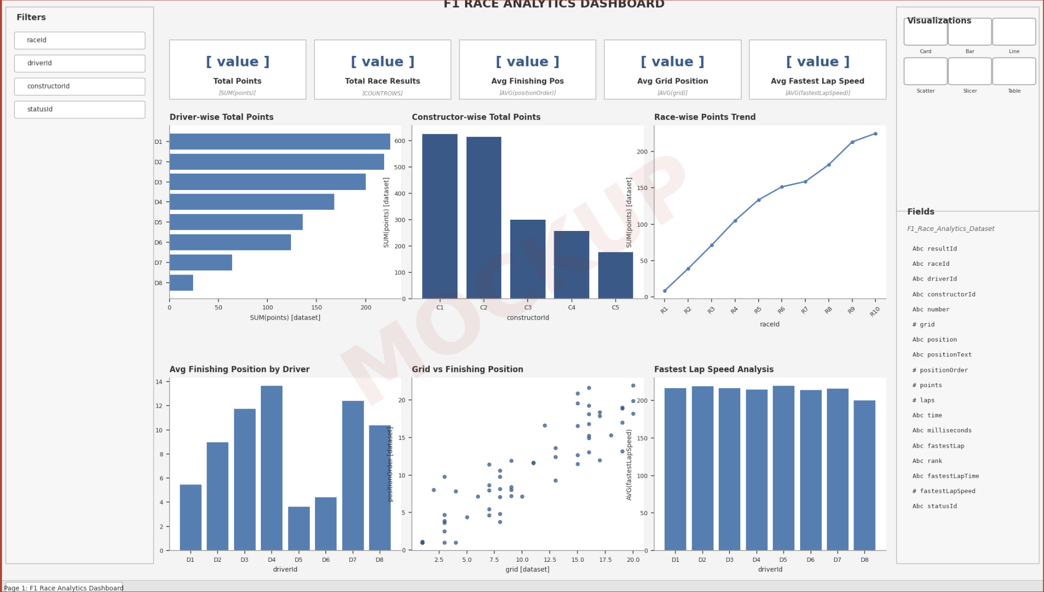

The Power BI dashboard contains:
F1 RACE ANALYTICS DASHBOARD

Driver-wise Points
Constructor-wise Points

Race-wise Points Trend
Grid Position vs Finishing Position

Fastest Lap Speed
Race Performance Summary
The dashboard provides an interactive view of the F1 race-results dataset using charts, cards, and filters.

Suggested Filters:
- raceId
- driverId
- constructorId
- statusId

RESULT:
Thus, the F1 race dataset was successfully analyzed using MySQL and visualized using Power BI. The project helps identify patterns in driver points, constructor performance, race-wise points, finishing positions, grid positions, and fastest-lap speeds.
The interactive dashboard provides a clear and consolidated view of the F1 race data and demonstrates how raw race-result records can be transformed into useful analytical information. This mirrors the reference Experiment 9's final outcome: database analysis followed by an interactive Power BI dashboard.

