FreshBasket Retail
Loyalty Member Churn Prediction & Retention Strategy
Final report | Propel Data Science Assessment 4

1. Executive summary
FreshBasket sends retention offers to every loyalty member. This project builds a churn model that ranks members by their risk of making no purchase in April-June 2024, explains what drives that risk, and tests whether targeted retention beats the current blanket approach.
- Most churn is visible early. 80% of churners had already stopped buying before 2024. The decision-relevant group is the 1,715 active members (bought in Jan-Mar 2024), whose churn rate is 9.6%.
- The model works on the held-out official label. LightGBM reaches PR-AUC 0.988 on all members and 0.81 on active members (base rate 9.6%; 7.52x lift in the top decile). The rule baseline scores 0.46 on active members.
- Engagement and support predict churn; demographics do not. Demographics alone score PR-AUC 0.10 on active members, no better than chance. Adding engagement lifts it to 0.69; all features reach 0.81.
- Warning signs: falling purchase frequency, app use below one session a month, no email opens, no coupon redemptions and recent support tickets (churn 5% with no tickets vs 74% with three or more, a small group of 19).
- Targeting pays. Contacting the riskiest 20% of active members reaches 91% of actual churners. A targeted coupon is estimated to retain about the same members as a blanket coupon (19 vs 20) at one-fifth of the cost ($1,715 vs $8,575).
Recommendation: replace blanket offers with a monthly risk-scored list; route high-risk members with open support issues to service recovery first, give coupons to the next tier of risk, and prove the effect with a randomised holdout before scaling.

2. Business problem and churn definition
FreshBasket runs a three-tier loyalty programme (Silver, Gold, Platinum). Churn is rising, there is no systematic way to identify at-risk members, and retention offers are sent to everyone, which is expensive and often reaches members who were never going to leave.
Target: CHURNED = 1 when a member made zero purchase transactions in April-June 2024 despite having purchase history earlier in the window. The prediction is made as of 31 March 2024, so every feature must use information available by then.
Questions answered: who is likely to churn; which behavioural, engagement and support signals precede churn; whether tier, marketing engagement or support experience matter; and which retention actions are worth funding.

3. Data and data quality (Task 1)
Three tables were provided: fb Customer Profile (2,608 rows), fb Monthly Activity (28,073 rows, one per member-month) and fb Churn Label (2,605 rows). Every issue found and the action taken is logged in outputs/data_quality_log.csv and shown in the EDA notebook.
Table | Issue found | Rows | Action
profile | Exact duplicate rows | 8 | Dropped
profile | CITY: inconsistent casing/whitespace | 104 | Stripped whitespace, title-cased
profile | MEMBERSHIP_TIER: inconsistent casing/whitespace | 104 | Stripped whitespace, title-cased
profile | AGE missing | 78 | Median-imputed at model time + AGE_MISSING flag
profile | GENDER missing | 52 | Labelled 'Unknown'
profile | HOME_STORE_PRICE_TIER missing | 130 | Labelled 'Unknown'
activity | Exact duplicate rows | 58 | Dropped
activity | Negative TOTAL_SPEND (sign error: |spend| = txn x basket) | 24 | Replaced with absolute value
activity | Zero TOTAL_SPEND despite transactions > 0 | 20 | Recomputed as TRANSACTIONS x AVG_BASKET_VALUE
activity | Outlier TOTAL_SPEND (> 1.5x txn x basket, up to 14.7x) | 13 | Recomputed as TRANSACTIONS x AVG_BASKET_VALUE
activity | Conflicting duplicate CUSTOMER_ID+MONTH (resolved by sign fix) | 2 | Dropped duplicate key
activity | Zero-transaction months reporting DISTINCT_CATEGORIES > 0 | 1,452 | Set DISTINCT_CATEGORIES to 0 (no purchase = no category)
activity | Zero-transaction months (valid inactive months, kept) | 2,330 | Kept: genuine inactivity is a churn signal
activity | Missing months inside a member's history | 953 | Treated as unrecorded (excluded from averages), counted as MISSING_MONTHS feature
label | Exact duplicate rows | 5 | Dropped
label | Official CHURNED disagrees with label re-derived from activity | 9 | Kept official label (source of truth); listed in label_mismatches.csv
label | No purchase history before Apr-2024 (outside churn definition / cold start) | 232 | Excluded from model test set; reported separately
label | Leaky columns (LAST_PURCHASE_DATE, MONTHS_OBSERVED, INSUFFICIENT_HISTORY_FLAG) | 2,600 | Never used as features: computed over Apr-Jun 2024
Table 1. Data-quality issues and treatment.
Spend repairs use an internal identity. TOTAL_SPEND should equal TRANSACTIONS x AVG_BASKET_VALUE. The negative values are exact sign flips, the zeros occur despite transactions, and the outliers are 1.5x to 14.7x the expected amount. All were recomputed from the identity, so genuine high spenders are not clipped.
Missing months. Activity in the month after a gap is normal, so gaps inside a member's history are treated as lost records and excluded from averages. Months after a member's last record are treated as inactive, because churners' records simply stop.
Label checks. The official label was re-derived from the activity data; 9 members disagree and are kept as labelled (listed in label_mismatches.csv). 232 members had no purchase before April 2024 (120 never purchased; 112 first bought in April-June). They fall outside the churn definition and are not scored.
Leakage. LAST_PURCHASE_DATE, MONTHS_OBSERVED and INSUFFICIENT_HISTORY_FLAG in the label table are computed over the full window, including April-June 2024. LAST_PURCHASE_DATE alone reproduces the label for every member who ever purchased. All three are excluded from modelling.

4. Customer-level modelling dataset and features (Tasks 2-3)
The three tables are joined on CUSTOMER_ID into one row per member (data/processed/customer_model_dataset.csv: 2,368 scored members, 34.3% churned). Activity is aggregated only up to the cutoff month, using windows counted backwards from it: last month, last 3 months (L3), and the 3 months before that (P3) for trends.
Group | Features (40 total) | Leakage control
Behavioural (17) | Recency, transactions last month / L3 / P3 / trend, spend L3 / P3 / trend %, spend volatility, basket size, categories bought, zero-purchase months, share of active months, months of history, unrecorded months | Only months <= cutoff
Engagement (8) | App sessions L3 and trend, emails opened L3 and trend, coupons redeemed L3 and history, promo share L3 and history | Only months <= cutoff
Support (5) | Support tickets L3 / L6 / trend, complaints in last 6 months, ever complained | Only months <= cutoff
Demographic / tier (10) | Age (+ missing flag), gender, city, tier, marketing opt-in, preferred category, home-store price tier, signup year, tenure | Static profile attributes; tenure measured to the cutoff
Table 2. Feature groups. Each group is tested separately in the ablation study (Section 9).

5. Exploratory findings (Tasks 1 and 4)
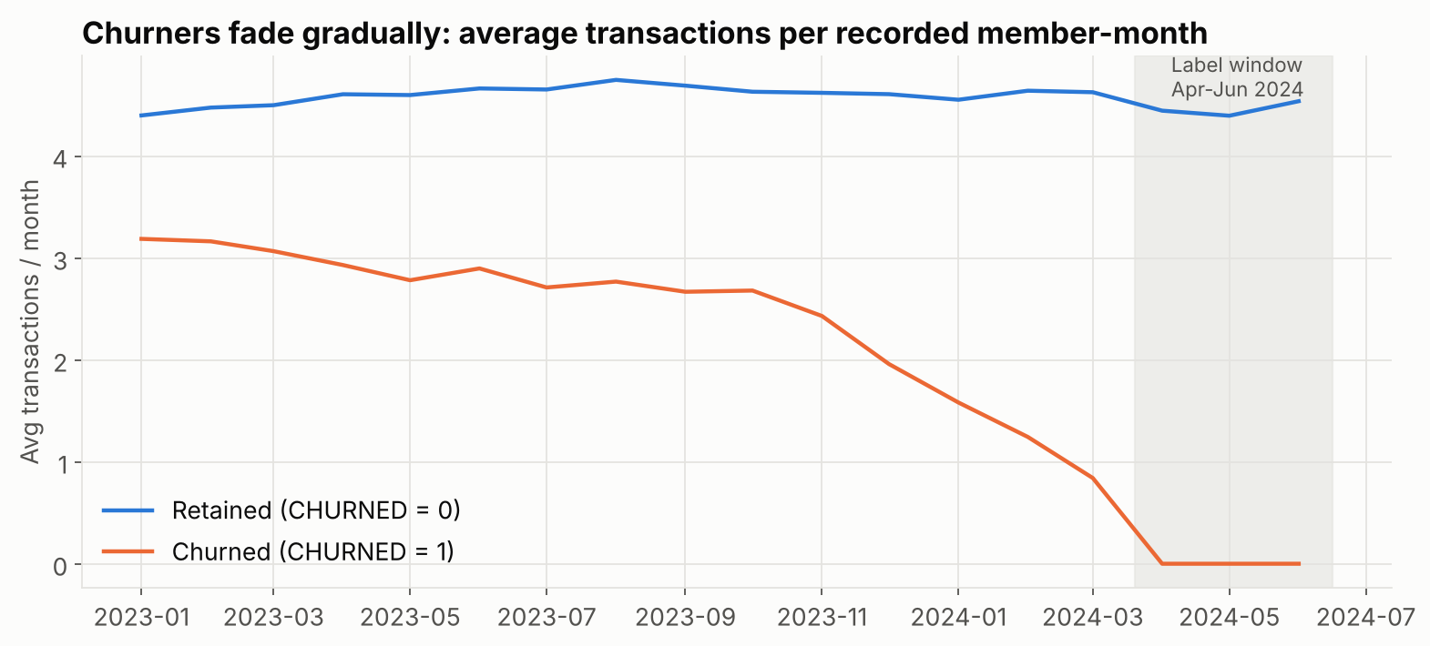
Figure 1. Churned members' purchase frequency declines for months before the label window.
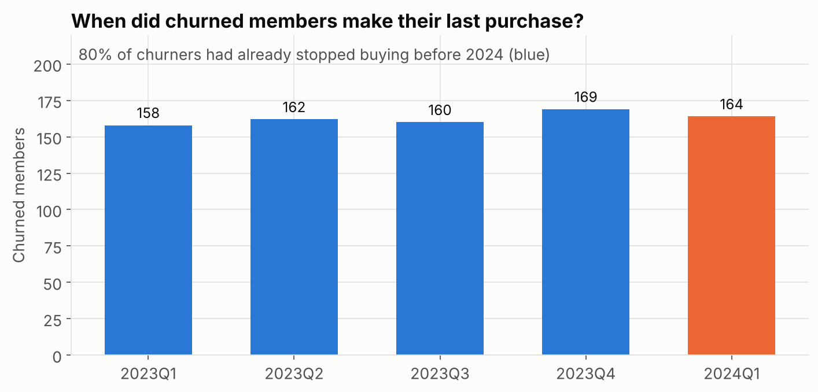
Figure 2. Most churners stopped buying long before April 2024.
Two populations need different treatment. Lapsed members (no purchase in Jan-Mar 2024) churn almost by definition; a model that only learns recency scores very well on them. The 1,715 active members churn at 9.6% and are where prediction adds real value, so every result is reported for both groups.
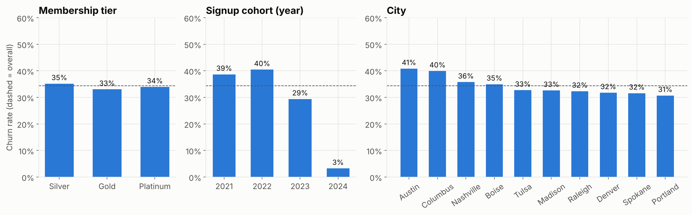
Figure 3. Churn rate by tier, signup cohort and city (all scored members).
Tier makes little difference (Silver 35%, Gold 33%, Platinum 34%). City spreads from about 31% to 41%. The 2021-2022 cohorts churn more than recent joiners, partly because new members have had less time to lapse.

Engagement, support experience and churn (Task 4)
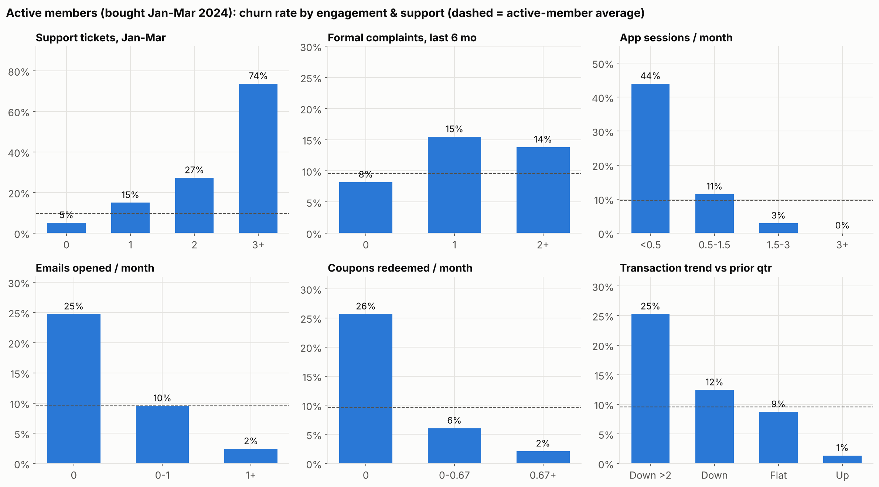
Figure 4. Churn rate by engagement and support level, active members only (dashed line = active-member average).
- Support friction: churn rises from 5% with no tickets in Jan-Mar to 15% with one, 27% with two and 74% with three or more (only 19 members, so directional). A formal complaint roughly doubles the rate (8% to 15%).
- App engagement: members averaging under half an app session a month churn at 44%; those with 1.5+ sessions at 3% or less.
- Marketing engagement: no email opens 25% vs 2% for regular openers; no coupon redemptions 26% vs 2%. Marketing opt-in itself is barely related (it is consent, not engagement).
- Momentum: members whose transactions fell by more than two a month versus the prior quarter churn at 25%; those increasing at 1%.
These are associations. Disengaged members may simply be leaving for other reasons; Section 10 treats intervention effects accordingly.

6. Validation design (Task 5)
Random splitting is not used. The churn definition is replayed at earlier cutoffs: features up to the cutoff, label = no purchase in the next three months despite earlier purchases. Models train on older snapshots, are tuned on a later one, and are tested once on the official label, so every evaluation predicts a future the model has not seen.
Snapshot (features up to) | Label window | Role | Members | Churn rate | Active members | Active churn
2023-06 | Jul-Sep 2023 | Train | 1,787 | 18.2% | 1,624 | 10.3%
2023-09 | Oct-Dec 2023 | Train | 1,980 | 24.5% | 1,655 | 10.0%
2023-12 | Jan-Mar 2024 | Validation | 2,167 | 30.1% | 1,681 | 10.2%
2024-03 | Apr-Jun 2024 (official) | Test (official label) | 2,368 | 34.3% | 1,715 | 9.6%
Table 3. Out-of-time snapshots. Model choice and the decision threshold come from the validation snapshot only.
After selection, the final model is refit on train + validation snapshots and scored once on the March-2024 cohort. An expanding-window backtest (outputs/backtest_expanding_window.csv) repeats this for every fold: active-member PR-AUC stays between 0.78 and 0.82, so performance is stable over time rather than a lucky split.

7. Model comparison and class imbalance (Tasks 6-8)
Five approaches were compared. The rule baseline flags members with no purchase for at least k months (k tuned on validation: 2). Logistic regression and random forest use balanced class weights. LightGBM is tested with and without class weights.
Model | PR-AUC | ROC-AUC | Precision | Recall | F1 | Accuracy | Brier
Rule baseline (recency) | 0.945 | 0.962 | 0.98 | 0.86 | 0.91 | 0.95 | 0.106
Logistic regression (balanced) | 0.989 | 0.993 | 0.96 | 0.94 | 0.95 | 0.97 | 0.033
Random forest (balanced) | 0.987 | 0.991 | 0.98 | 0.92 | 0.95 | 0.97 | 0.030
LightGBM (balanced weights) | 0.988 | 0.991 | 0.95 | 0.95 | 0.95 | 0.96 | 0.028
LightGBM (final) | 0.988 | 0.991 | 0.95 | 0.95 | 0.95 | 0.96 | 0.027
Table 4a. All 2,368 scored members, held-out April-June 2024 label.
Model | PR-AUC | ROC-AUC | Precision | Recall | F1 | Top-10% lift
Rule baseline (recency) | 0.464 | 0.814 | 0.81 | 0.30 | 0.44 | 5.50x
Logistic regression (balanced) | 0.824 | 0.965 | 0.80 | 0.70 | 0.75 | 7.58x
Random forest (balanced) | 0.797 | 0.955 | 0.90 | 0.59 | 0.71 | 7.28x
LightGBM (balanced weights) | 0.816 | 0.958 | 0.75 | 0.74 | 0.75 | 7.58x
LightGBM (final) | 0.812 | 0.959 | 0.75 | 0.74 | 0.75 | 7.52x
Table 4b. 1,715 active members (churn rate 9.6%), the decision-relevant group.
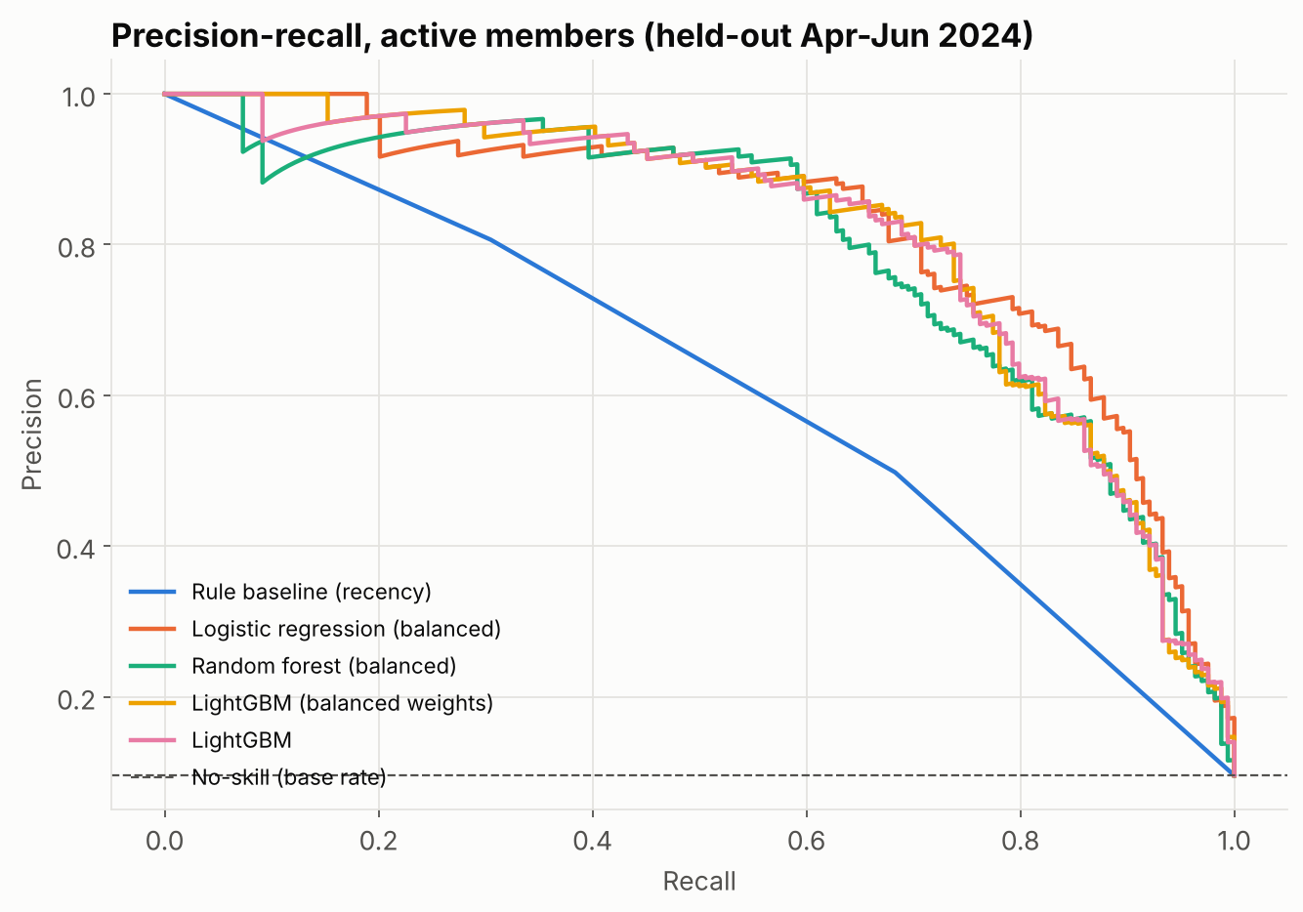
Figure 5. Precision-recall curves for active members. The rule baseline collapses because recency barely varies among active members.
Choice of final model. Logistic regression and LightGBM are statistically tied on ranking (active PR-AUC 0.824 vs 0.812; they also swap places across backtest folds). LightGBM was chosen because its probabilities are the best calibrated (Brier 0.027 vs 0.033, Figure 6), which matters because the retention scenarios add up predicted probabilities to estimate expected churners. It also captures interactions such as low app use combined with support tickets. Logistic regression remains as an interpretable benchmark.
Class imbalance (Task 8). Churn is 34% overall but under 10% among active members. Imbalance is handled by choosing the decision threshold that maximises F1 on the validation snapshot (0.329 for the final model) rather than by resampling. Balanced class weights were tested for LightGBM; they changed PR-AUC by less than 0.005 and pushed probabilities upward (Figure 6). Accuracy is reported but not used for selection: predicting "no churn" for every active member would score 90% accuracy and catch nobody.
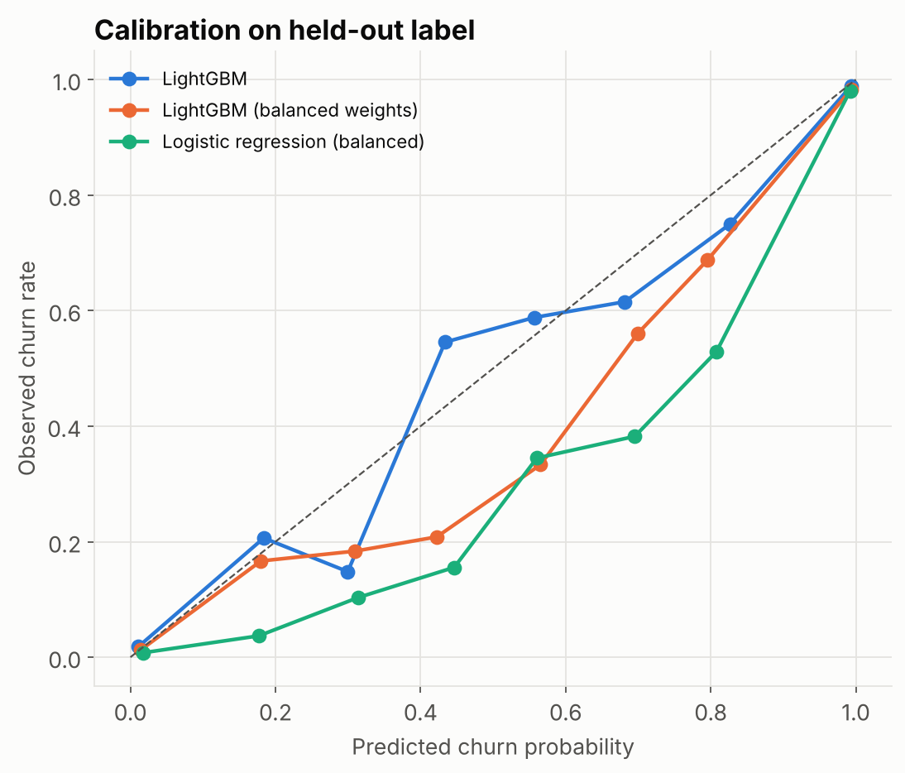
Figure 6. Calibration on the held-out label. Unweighted LightGBM follows the diagonal most closely.

Predictions for the held-out cohort (Task 7)
outputs/churn_predictions.csv scores all 2,368 members with churn probability, predicted label, risk band (High >= 0.5, Medium 0.2-0.5, Low < 0.2), the top three SHAP drivers pushing that member towards churn, member status, and the actual outcome for evaluation. Among active members: 133 High, 69 Medium, 1513 Low.
Customer | Probability | Band | Key driver 1 | Key driver 2 | Actual
501056 | 0.996 | High | App sessions/month, last 3 mo = 0 | Transactions, last month = 0 | 1
501332 | 0.996 | High | Transactions, last month = 0 | App sessions/month, last 3 mo = 0.33 | 1
500282 | 0.995 | High | App sessions/month, last 3 mo = 0 | Transactions, last month = 0 | 1
501535 | 0.995 | High | App sessions/month, last 3 mo = 0 | Spend/month, last 3 mo = 10.12 | 1
Table 5. Example rows for the highest-risk active members.

8. Churn drivers and segment risk (Task 9)
Drivers are measured with SHAP values (exact TreeSHAP from LightGBM), which split each prediction into the contribution of every feature. Global importance is the average absolute contribution.
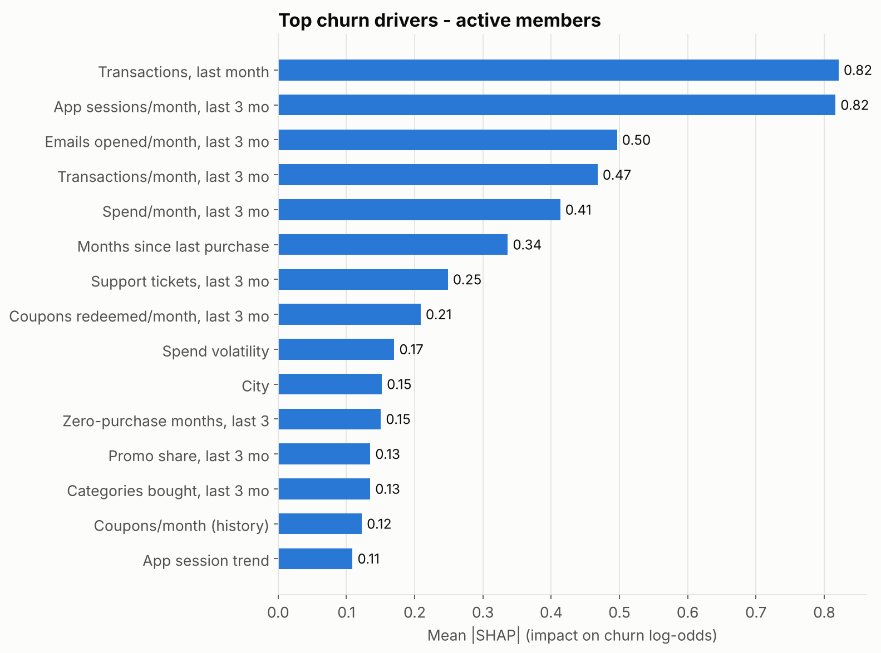
Figure 7. Top drivers for active members (mean |SHAP|, log-odds).
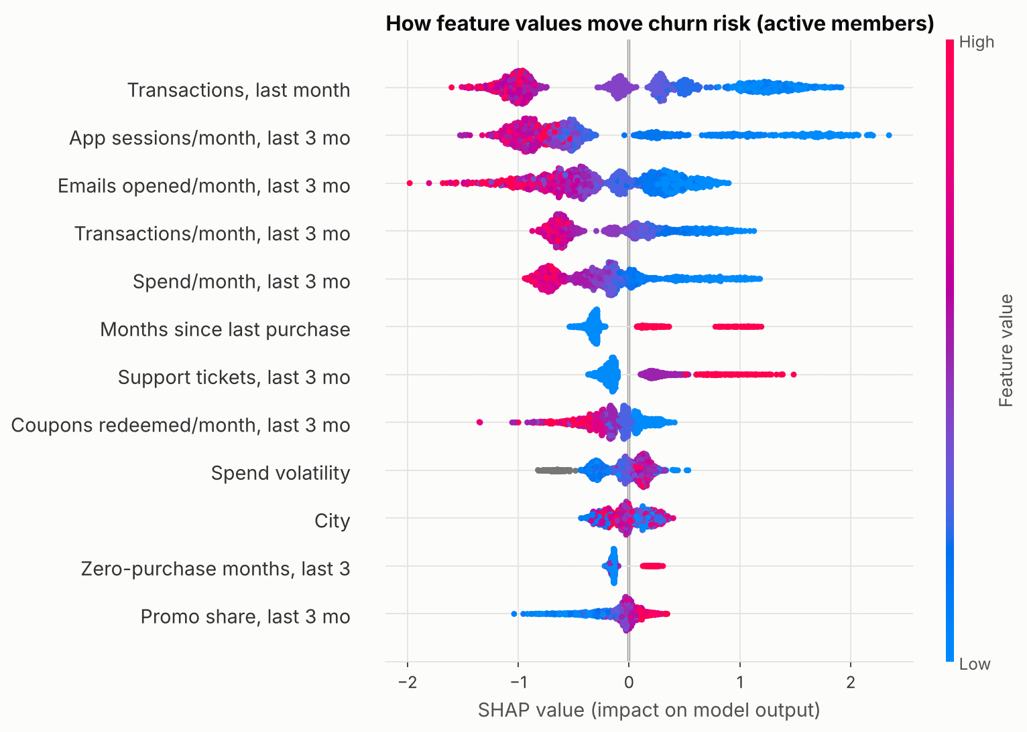
Figure 8. Direction of effect. Each dot is a member; blue = low feature value, red = high. Low purchases, app use, email opens and coupons push risk up; more support tickets push it up.
The leading drivers for active members are transactions, last month, app sessions/month (last 3 mo), emails opened/month (last 3 mo), transactions/month (last 3 mo), spend/month (last 3 mo), months since last purchase. Purchase frequency and app engagement dominate; after app and email engagement, support tickets are the strongest non-purchase signal. Demographic attributes contribute little; city is the only one in the top ten, with a small effect.
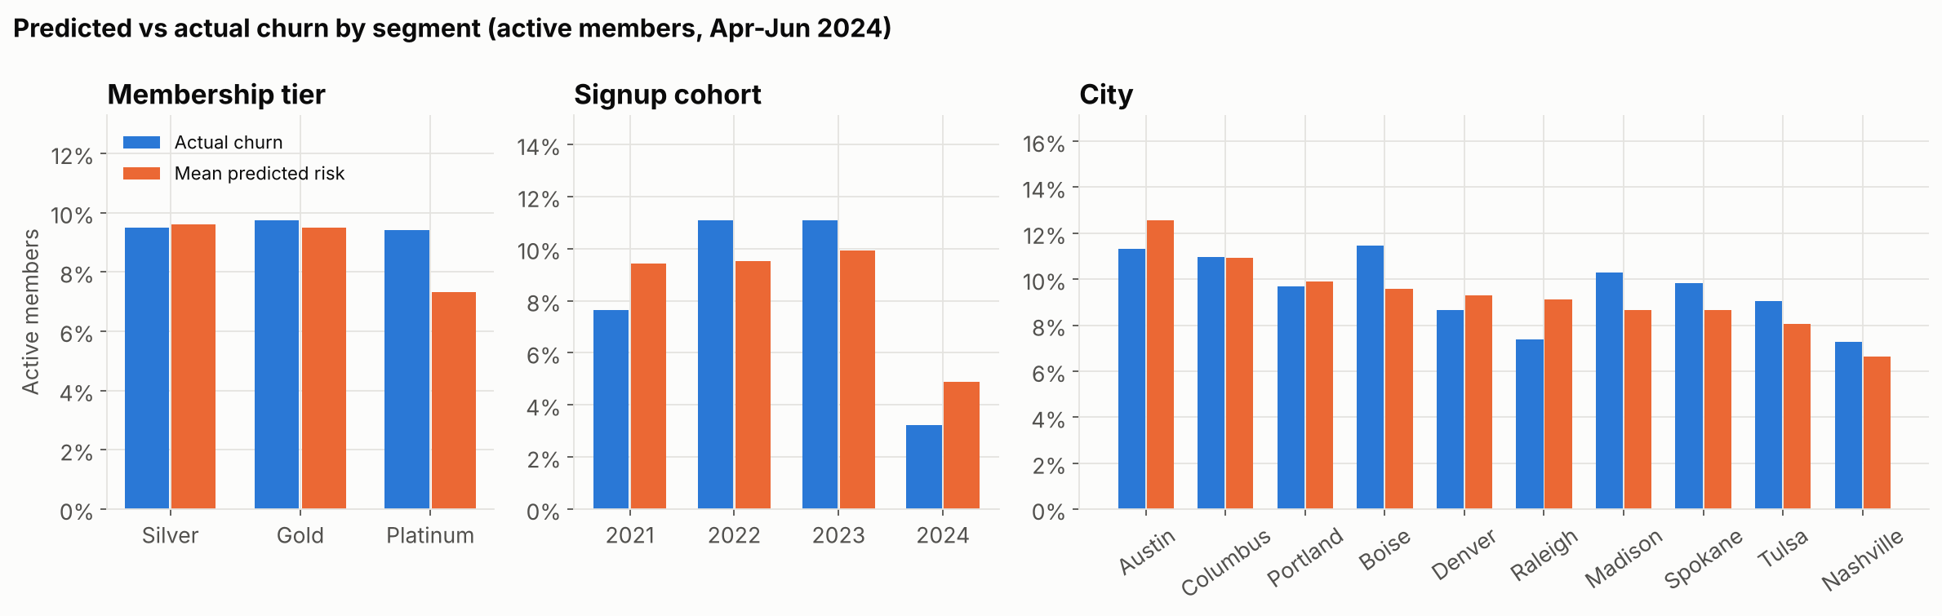
Figure 9. Actual vs mean predicted churn by segment for active members.
Among active members, predicted and actual churn agree closely by tier, cohort and city, so the model is not systematically biased against a segment. Differences between segments are small (7-11%) compared with differences driven by behaviour (0-74%). Retention should be targeted by behaviour and risk score, not by tier or city. One exception: the model slightly under-predicts Platinum churn, which is worth monitoring given those members' value.

9. Ablation study (Task 10)
The same LightGBM and out-of-time protocol was retrained on different feature groups to measure what each adds over demographics alone.
Feature set | Features | PR-AUC (all) | ROC-AUC (all) | PR-AUC (active) | ROC-AUC (active)
Demographics only | 10 | 0.732 | 0.808 | 0.099 | 0.527
Demographics + support | 15 | 0.727 | 0.821 | 0.159 | 0.576
Demographics + engagement | 18 | 0.978 | 0.982 | 0.686 | 0.914
Demographics + behavioural | 27 | 0.980 | 0.987 | 0.675 | 0.937
Demographics + engagement + support | 23 | 0.981 | 0.985 | 0.721 | 0.925
All minus engagement | 32 | 0.984 | 0.989 | 0.738 | 0.950
All minus support | 35 | 0.986 | 0.990 | 0.784 | 0.954
All features | 40 | 0.988 | 0.991 | 0.812 | 0.959
Table 6. Ablation results on the held-out label.
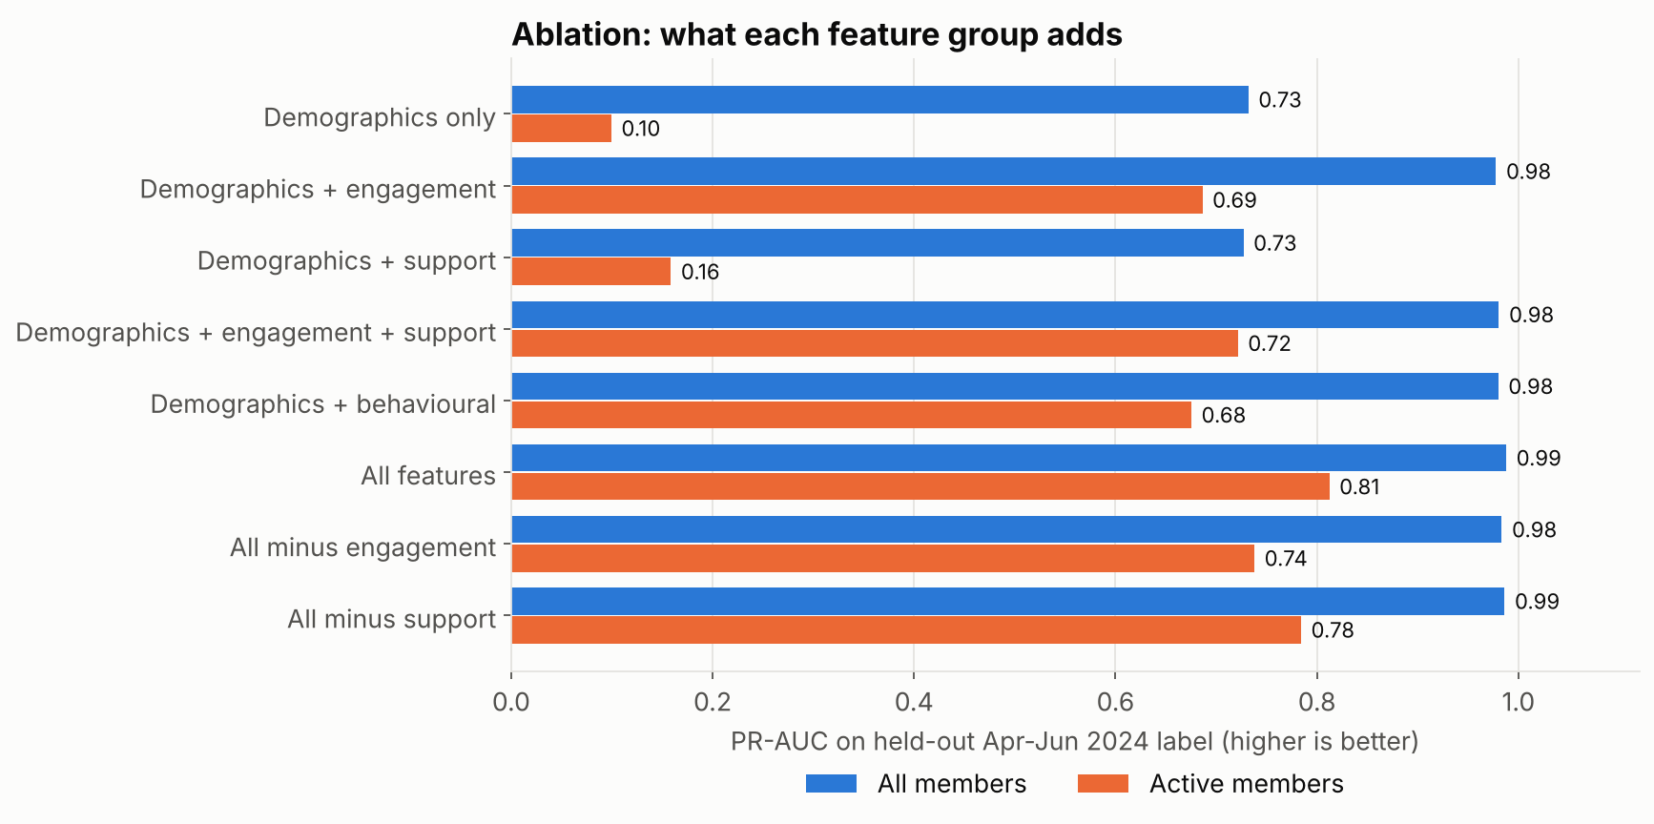
Figure 10. PR-AUC by feature set.
- Demographics alone carry almost no signal for active members (PR-AUC 0.099 vs a 0.096 base rate; ROC-AUC 0.53).
- Engagement is the biggest single lift: 0.69 on its own, slightly ahead of behaviour (0.68). Removing it from the full model costs 0.07 PR-AUC.
- Support adds on top of everything else: weak alone (0.16) but removing it from the full model costs 0.03 PR-AUC. It is complementary: it flags members whose purchases still look normal.
- All three behavioural groups are needed for the best result; each contributes information the others do not.

10. Retention scenarios (Task 11)
Two complementary estimates are used. The targeting curve is measured on actual outcomes: it shows how many real churners a budget-limited campaign reaches if members are contacted in order of predicted risk. The intervention what-ifs change the features an action plausibly moves, re-score members, and compare expected churners (sum of probabilities) before and after.
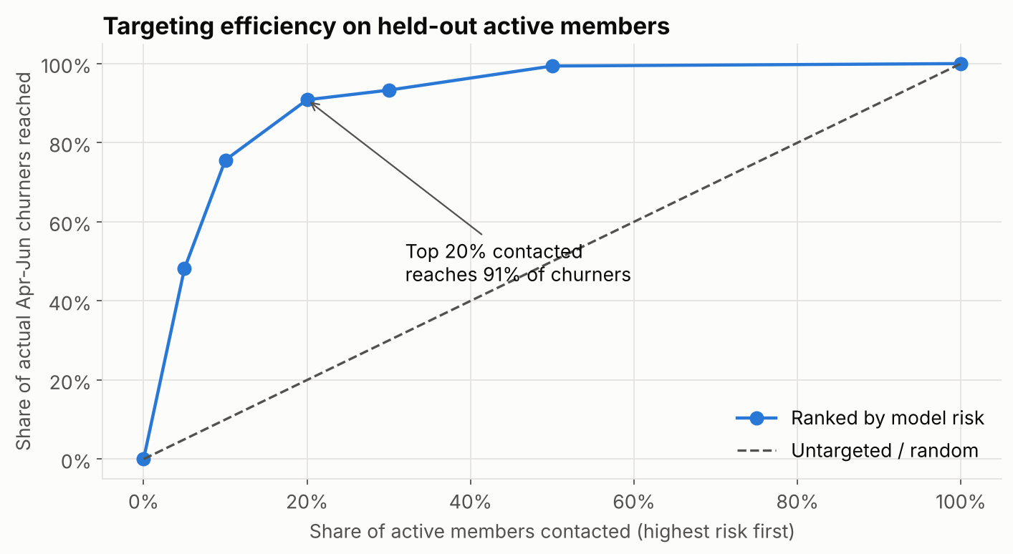
Figure 11. Share of actual April-June churners reached vs share of active members contacted.
Contacting the top 10% of active members by risk reaches 76% of the members who churned (precision 72%); the top 20% reaches 91%. Untargeted contact reaches churners only in proportion to spend.
Scenario | Members contacted | Actual churners in target | Expected churners before | Model-implied reduction | Members retained (50% effective) | Cost | Cost per member retained
A. Service outreach: service outreach (1+ ticket, high risk) | 109 | 85 | 86 | 26% | 11.2 | $872 | $77
B. Targeted coupon: targeted coupon (top 20% risk) | 343 | 149 | 151 | 26% | 19.5 | $1,715 | $88
C. Blanket coupon: blanket coupon (all active) | 1,715 | 164 | 159 | 26% | 20.4 | $8,575 | $419
Table 7. Scenario results for active members. Assumptions below.
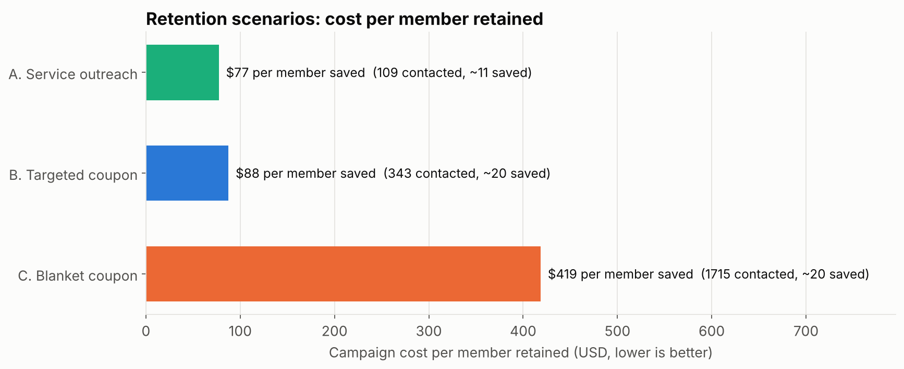
Figure 12. Campaign cost per member retained.
- Scenario A, service outreach for members with support tickets: 109 high-risk members with at least one ticket in Jan-Mar, of whom 85 actually churned. Resolving the friction lowers their modelled churn risk by 26%. At 50% effectiveness this retains about 11 members for $872, the cheapest per member retained ($77).
- Scenario B, targeted coupon (top 20% risk): retains about 20 members for $1,715; net value about $6,410.
- Scenario C, blanket coupon (current practice): retains about 20, almost the same as B, but costs $8,575, roughly breaking even ($-79). Most of the spend goes to members who were never going to leave.
Assumptions: 25% gross margin; 12-month value horizon, giving about $415 margin per retained active member; $5 per coupon; $8 per service call; only 50% of the model-implied reduction treated as causal, because the model learned associations. All values are parameters in src/scenario.py.

11. Business recommendations
- Score members monthly and stop blanket offers. Use the model to rank active members; fund retention for the top 10-20% by risk. This keeps nearly all the retained members at a fraction of the cost.
- Fix service first for at-risk members with tickets. Route high-risk members with recent support tickets or complaints to a proactive service call before any discount. It is the cheapest action per member retained and addresses a cause members can feel.
- Use coupons for disengaged, ticket-free members. For high-risk members without support issues, a personalised coupon or app re-engagement nudge (their key drivers are in the prediction file) is the next lever.
- Treat app and email engagement as early-warning KPIs. A drop to under one app session a month or no email opens for a quarter should trigger the risk list, before purchases fall.
- Run a separate win-back programme for lapsed members. The ~650 members with no purchase in Jan-Mar 2024 are already gone in practice; they need reactivation offers, not retention, and should be budgeted separately.
- Prove causality with a holdout. Randomly keep 10-20% of each targeted group untreated for a quarter. Compare churn between treated and control to measure the true effect before scaling, then feed the result back into the scenario assumptions.
- Don't segment retention by tier or city. Risk differences between tiers and cities are small; behaviour explains far more. Keep an eye on Platinum, where the model slightly under-predicts.

12. Assumptions, limitations and next steps

Assumptions
- The official CHURNED label is the source of truth; 9 records that disagree with the activity data are kept as labelled.
- Members with no purchase before April 2024 are outside the churn definition and are not scored (232 members).
- Spend errors are repaired from TRANSACTIONS x AVG_BASKET_VALUE; missing months inside a history are lost records; months after the last record are inactivity.
- Churn replayed at earlier cutoffs follows the same process as the official label (the official label and the re-derived label agree for 99.7% of members).
- "Active" means at least one purchase in the three months before the cutoff.

Limitations
- Synthetic data from one 18-month window; real behaviour will be noisier, so expect lower accuracy in production.
- Snapshots share customers, so validation folds are not fully independent, and only three earlier label windows exist.
- The model is correlational. Scenario effects are what-if estimates and the 50% effectiveness rate is an assumption, not a measurement.
- A fixed three-month horizon counts members who pause and return as churners; seasonality cannot be studied with 18 months.
- No data on competitor activity, prices paid, or offer history, which would sharpen both prediction and uplift estimates.

Next steps
- Run the randomised holdout test and replace the assumed effectiveness with measured uplift; then move from churn models to uplift models that target members most likely to respond.
- Monitor monthly: PR-AUC on the latest closed window, calibration, and drift in app and support features.
- Add survival analysis (time to churn) to prioritise members whose risk is rising fastest.

Appendix: reproducing the results
pip install -r requirements.txt, then python run_pipeline.py (about 30 seconds). All tables and figures in this report are produced in outputs/. The EDA notebook is rebuilt with python notebooks/build_eda_notebook.py. See README.md for the full deliverables map.

