1. open the CLI for the instance
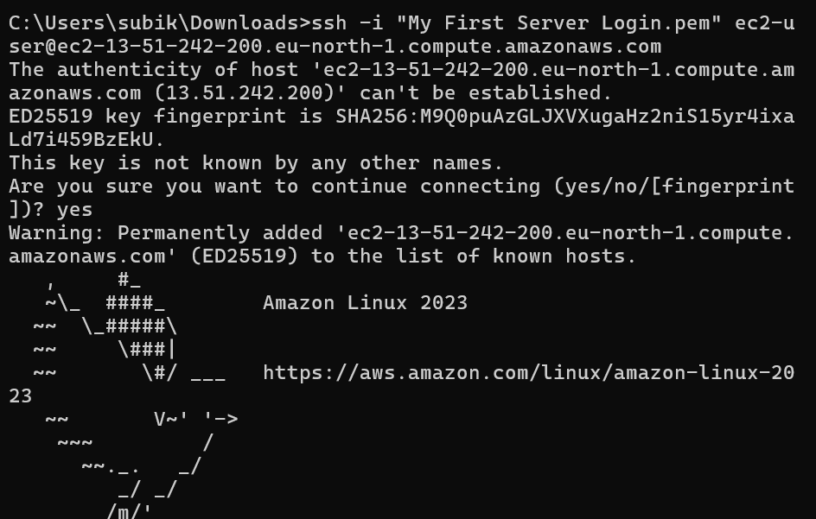

2. Checked version and configure the aws
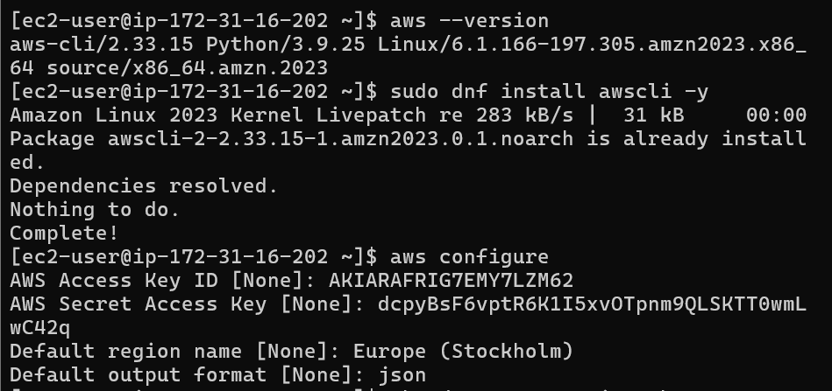

3. created the script file and try to create a spot instance using the information , failed due to region name
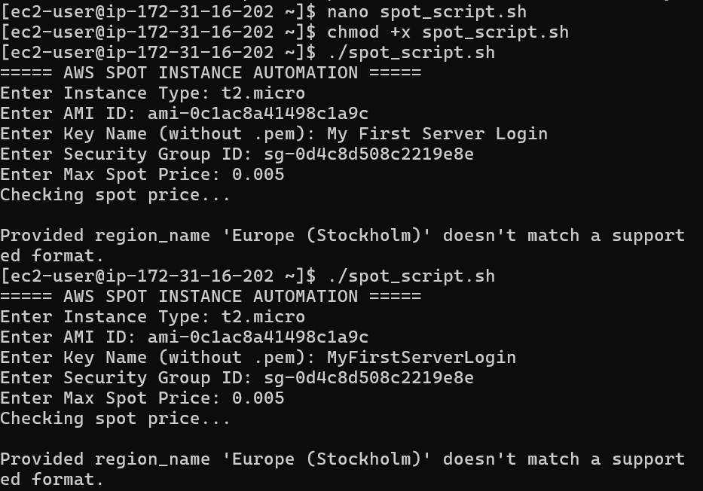

4. so changed the region name using the aws configure, to access aws configure we need to create a access key and secret key – that can be done using the IAM user – security credentials – create access key, after that enter the remaining details, now failed because the IAM user doesn’t have the permission to access the EC2 server, so that we need to provide the access for the IAM user using the add permission button in the Users tab, select the –attach policy directly, then select the allowallEC2acces – which provides the access to the IAM user.
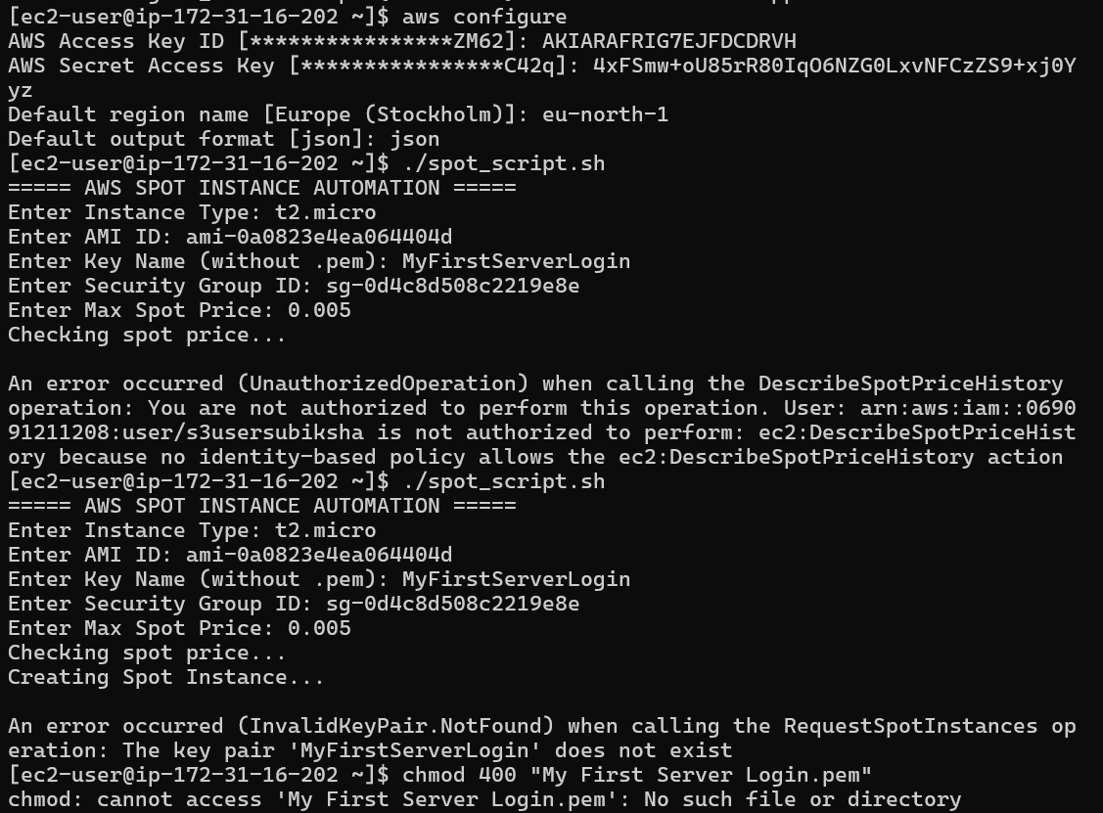

5. now the error is t2.micro is not supported or outdated , so we go for next version.
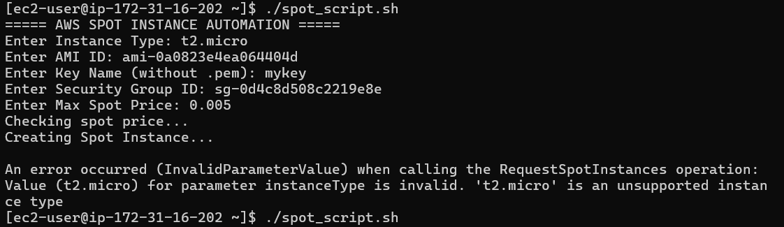

6. used t3.micro and executed, it created the spot new instance but failed in the ssh login (try to login to the spot new instance) because of the pem key file is not accessible.
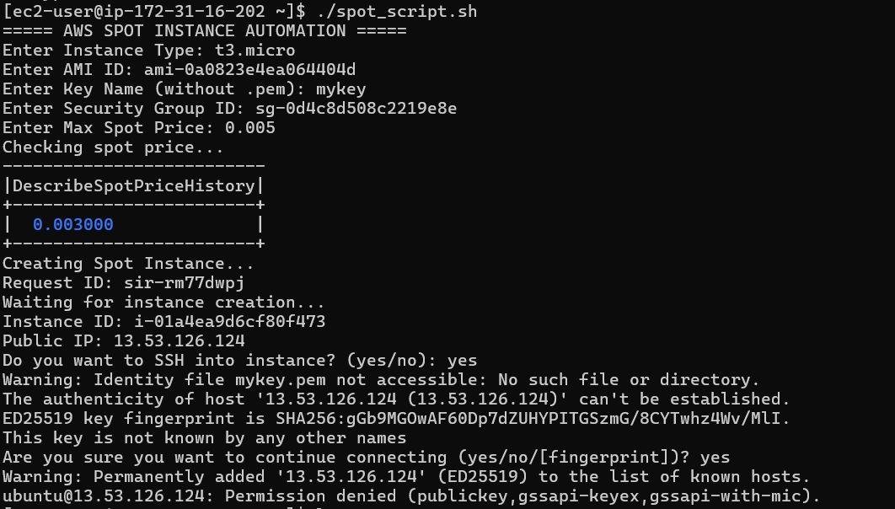
7. so copied the pem key file inside the ec2 then tried. Now success
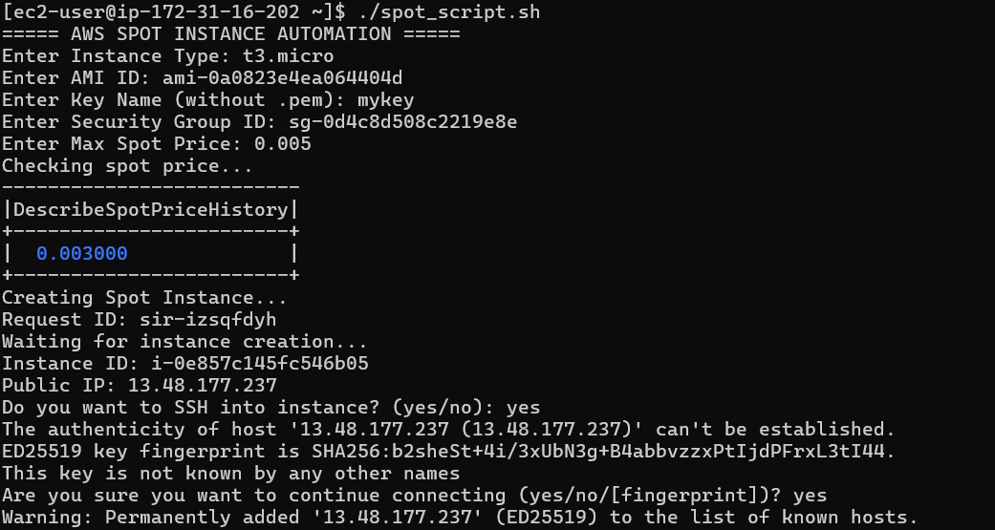

8. connected to the new spot instance, then created the new file and copied the new file to the old instance
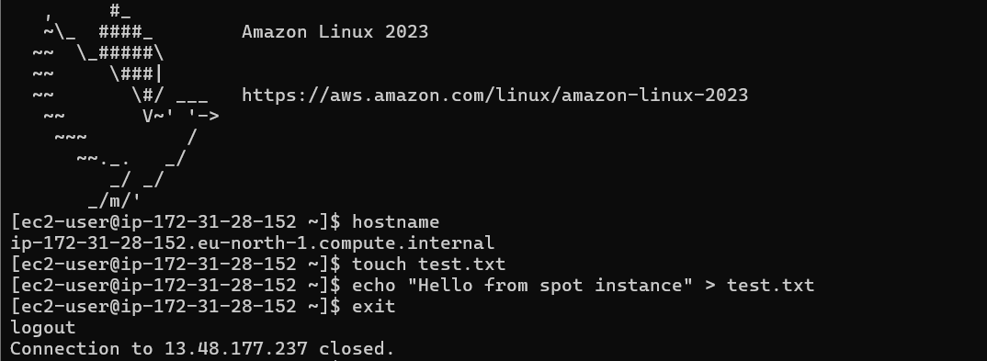

9. deleted the created spot instance
