ST6005CEM Security
Comprehensive Security Development and Penetration
Testing of the Secure Digital Evidence Chain-of-Custody System

A full-stack evidence chain-of-custody web application, secured by design and
validated by an internal penetration test.

Submitted by: Subim Gautam
Student ID: 14812273
Submitted to: Arya Pokhrel
Module Leader
Module: ST6005CEM Security
Assignment: CW2 (Regular)

Abstract
This report documents the secure design, implementation, and internal penetration testing of a Secure Digital Evidence Chain-of-Custody System: a full-stack web application (React/Vite frontend, Node.js/Express backend, PostgreSQL database, containerised with Docker) for logging evidence and recording every custody event against it. Security was built in from the start: Argon2id password hashing, TOTP multi-factor authentication, hCaptcha bot-mitigation, role- and attribute-based access control, AES-256-GCM encryption at rest, and a SHA-256 hash-chained, tamper-evident audit log enforced by PostgreSQL Row-Level Security. An internal, white-box penetration test following the OWASP Web Security Testing Guide, scored with CVSS v3.1, found and fixed two genuine vulnerabilities — a custody-transfer business-logic flaw and an unrestricted file-upload weakness — both reproduced, patched, and independently retested via manual terminal exploitation and Burp Suite.

Table of Contents

Table of Figures

Table of Abbreviations
Abbreviation | Full Form
RBAC | Role-Based Access Control
ABAC | Attribute-Based Access Control
MFA | Multi-Factor Authentication
TOTP | Time-based One-Time Password
JWT | JSON Web Token
AES-GCM | Advanced Encryption Standard — Galois/Counter Mode
RLS | (PostgreSQL) Row-Level Security
CSRF/XSRF | Cross-Site Request Forgery
XSS | Cross-Site Scripting
CVSS | Common Vulnerability Scoring System
CWE | Common Weakness Enumeration
CIA | Confidentiality, Integrity and Availability
OWASP | Open Worldwide Application Security Project
WSTG | Web Security Testing Guide
CI/CD | Continuous Integration / Continuous Deployment
PoC | Proof of Concept

Introduction
Digital chain-of-custody systems sit at the intersection of usability and trustworthiness: investigators and evidence custodians must be able to rely on the system day to day, while tampering, unauthorised access, or silent data loss must be detectable, if not outright prevented. This project addresses that need directly — a working evidence-tracking application in which authentication, authorisation, encryption, and an immutable audit trail were designed in from the start rather than retrofitted.
The application supports four roles — Admin, Officer, Evidence Custodian, and Auditor — around a core workflow: an Officer logs evidence, confirms its collection, and hands it off through a two-party custody-transfer handshake to whoever holds it next. Every security-relevant action is written to a hash-chained audit log so that any tampering, whether by an external attacker or a malicious insider, is mathematically detectable. This report covers the system's design, the controls implemented, and the internal penetration test performed against the running application, including two vulnerabilities found, exploited, fixed, and retested.

Software Details
The system follows a backend-first build order: the data model, authentication, and authorisation layers were implemented and tested via direct API calls (curl) before the frontend was built against a stable API contract. The stack is deliberately conventional so that every security control sits on well-understood, actively maintained primitives rather than bespoke cryptography or session handling.

Architecture
Browser → nginx (unprivileged, reverse-proxies /api) → Express API → PostgreSQL. The backend container publishes no host port at all — it is reachable only from nginx over the internal Docker network, so it has zero public exposure of its own. The database is accessed through two separate roles: a schema-owning role used only for migrations, and an ordinary, non-superuser runtime role the application actually connects as — the reason for that separation is covered in Design and Implementation.
Backend dependencies
Package | Version | Purpose
argon2 | ^0.44.0 | Password hashing (Argon2id)
jsonwebtoken | ^9.0.3 | JWT access-token signing/verification
speakeasy | ^2.0.0 | TOTP MFA generation/verification
zod | ^4.4.3 | Request schema validation, mass-assignment protection
helmet | ^8.2.0 | Security headers (CSP, HSTS, nosniff, etc.)
express-rate-limit | ^8.5.2 | Rate limiting / brute-force protection
cors | ^2.8.6 | Cross-origin resource sharing restriction
cookie-parser | ^1.4.7 | Parses the HttpOnly refresh-token cookie
multer | ^2.2.0 | Multipart file upload handling (memory storage)
express | ^5.2.1 | Web application framework
@prisma/client / adapter-pg | ^7.8.0 | ORM / PostgreSQL access
pg | ^8.22.0 | PostgreSQL driver
morgan | ^1.11.0 | HTTP request logging
dotenv | ^17.4.2 | Loads configuration from .env

Frontend dependencies
Package | Version | Purpose
react / react-dom | ^19.2.7 | UI library
react-router-dom | ^7.18.1 | Client-side routing, route guards
axios | ^1.18.1 | HTTP client, auth interceptors
tailwindcss | ^4.3.2 | Utility-first CSS
vite | ^8.1.1 | Build tool / dev server

hCaptcha is notably not an npm dependency: it is loaded via a script tag on the frontend and verified server-side with a plain fetch() call against hCaptcha's siteverify API, avoiding an extra dependency for a single HTTP call.

Design and Implementation
Every control below was implemented before any penetration testing began, following OWASP guidance (Top 10, ASVS) and, in two cases, subsequently hardened as a direct result of the internal pentest documented in the next section.
Password Policy & Brute-Force Protection
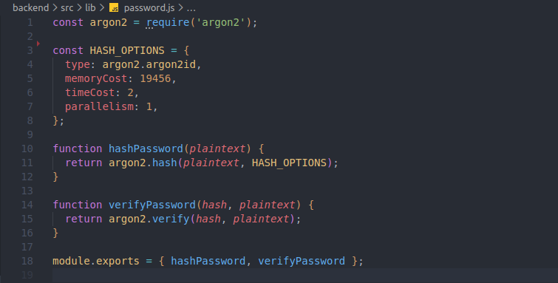
Figure 1. Argon2id password hashing with explicit, non-default parameters.
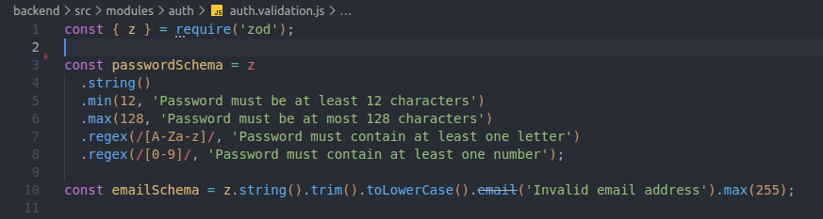
Figure 2. Password length/complexity policy enforced via a Zod schema.
Passwords are hashed with Argon2id rather than bcrypt/PBKDF2 — memory-hard hashing resists GPU/ASIC cracking far better than purely CPU-bound algorithms. Length (12–128 characters) is favoured over forced character-class rules, following NIST SP 800-63B, though a light complexity check still catches trivially weak passwords.
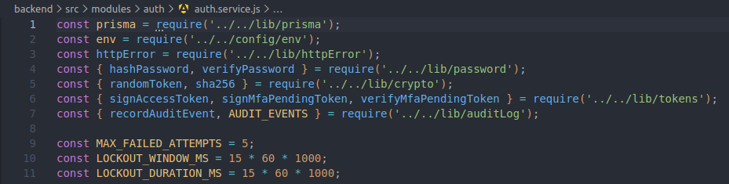
Figure 3. Account lockout: counting recent failed attempts.
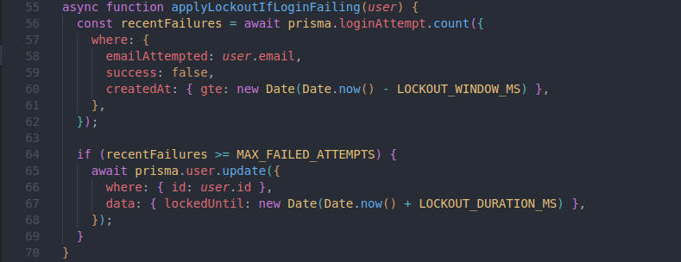
Figure 4. Account lockout: applying the temporary lock.
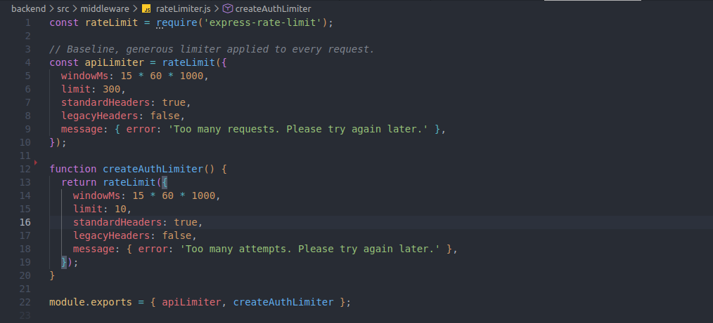
Figure 5. Independent per-route rate limiters (register/login/reset).
Brute-force protection is layered: per-route rate limiting (an independent counter per endpoint, so a burst of registrations cannot lock out logins from the same IP), combined with per-account lockout after five failed attempts in 15 minutes.
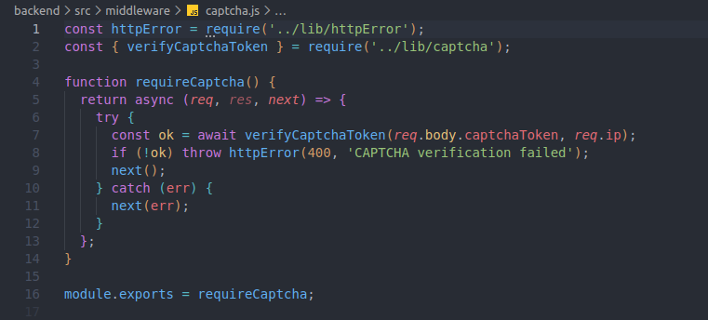
Figure 6. hCaptcha verification middleware — fails closed on any error.

A third, independent layer — hCaptcha — was added specifically because distributing login attempts across many IP addresses defeats rate limiting alone. Verification fails closed: any network error talking to hCaptcha is treated as failure, never as “skip the check.” It is feature-flagged off by default so a fresh checkout with no hCaptcha account still boots and authenticates.
Multi-Factor Authentication
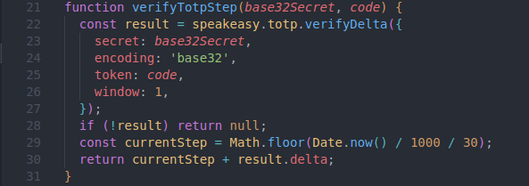
Figure 7. TOTP verification with a ±1 time-step window for clock drift.
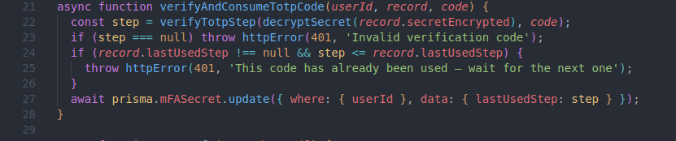
Figure 8. The matched time-step is persisted, rejecting reuse of the same code.
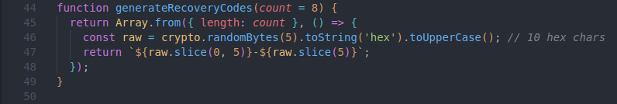
Figure 9. Single-use, Argon2-hashed recovery codes for lost devices.
TOTP follows RFC 6238. A code's time-step is recorded after use and any code at or before that step is rejected — otherwise the same code would remain valid for its whole ~60–90 second window and could be replayed. Recovery codes are hashed exactly like passwords, since a leaked database should not hand out a working MFA bypass.

Session & Token Management
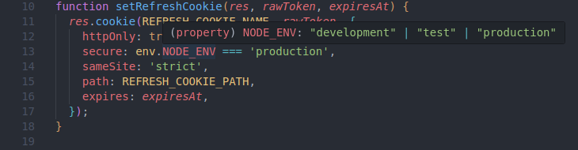
Figure 10. Refresh-token cookie flags: HttpOnly, Secure in production, SameSite=Strict.
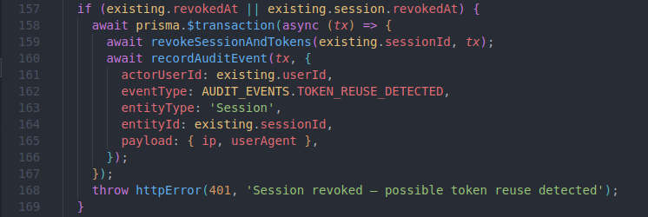
Figure 11. Refresh-token reuse detection: a replayed token revokes the whole session.
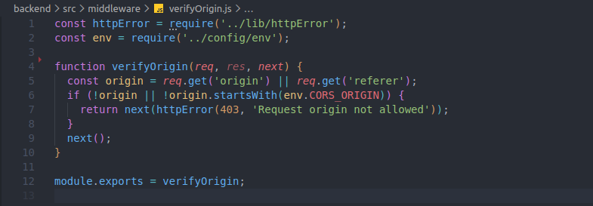
Figure 12. Origin/Referer check for the two cookie-authenticated routes.
Access tokens are short-lived JWTs (15 minutes) held only in memory on the client, never localStorage, limiting the exposure window if the frontend is ever compromised by XSS. Refresh tokens are opaque, DB-backed, hashed at rest, and rotated on every use; presenting an already-rotated token burns the entire session, since that can only mean someone else has a copy. SameSite=Strict is not relied on alone for CSRF: the two routes that authenticate via cookie alone also verify the Origin/Referer header explicitly.

Authorisation: RBAC + ABAC
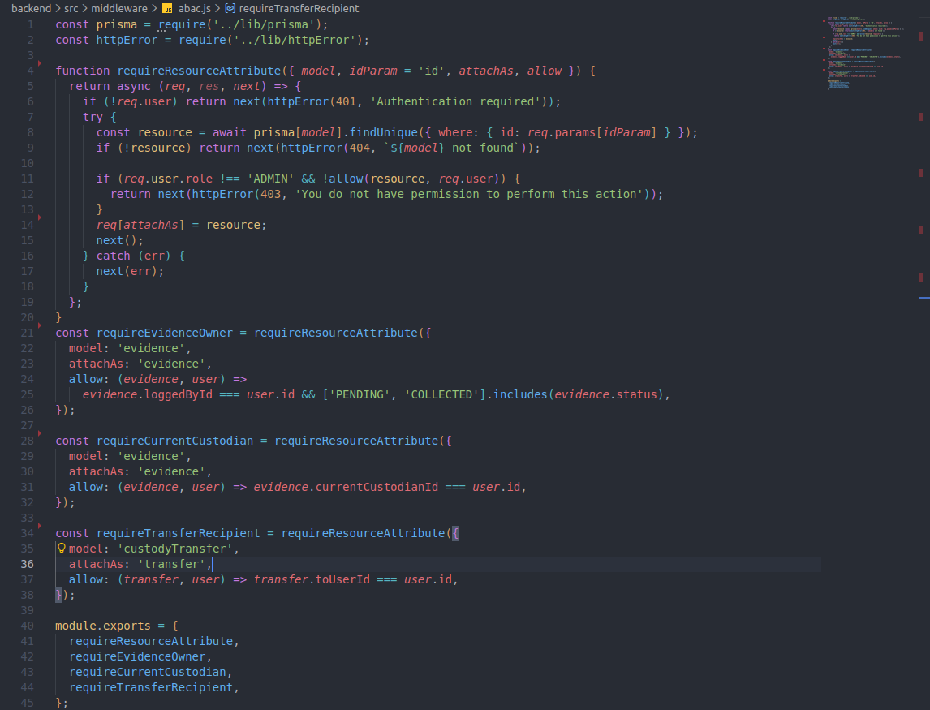
Figure 13. Attribute-based checks: only the current custodian, transfer recipient, or original logging officer may act.
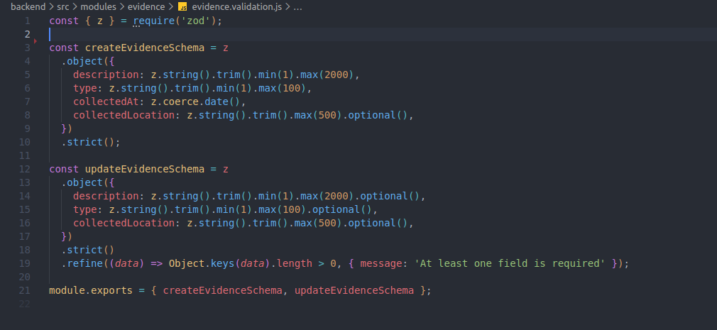
Figure 14. .strict() Zod schemas reject unrecognised fields such as status or currentCustodianId.
Role-based access control alone cannot express “this Officer may edit this evidence item, but not that one.” A resource-ownership (ABAC) layer sits on top of a role permission matrix, checking the specific row against the authenticated user before any state-changing action. Every write-accepting schema is a strict Zod object, so a client cannot smuggle role, id, or currentCustodianId into a request body — the field simply fails validation rather than being silently dropped.

Encryption & Data Integrity
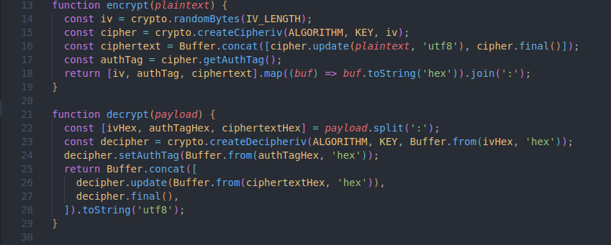
Figure 15. AES-256-GCM encrypt/decrypt, used for MFA secrets and evidence files at rest.
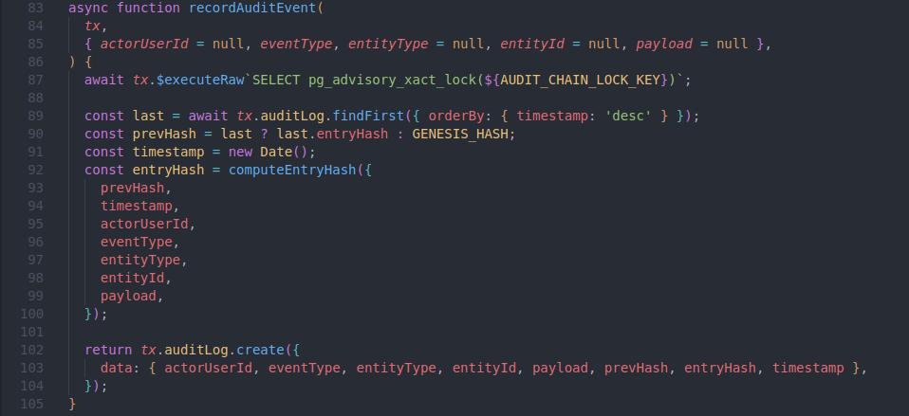
Figure 16. Audit log write: a Postgres advisory lock serialises writers; each entry links to the previous via SHA-256.
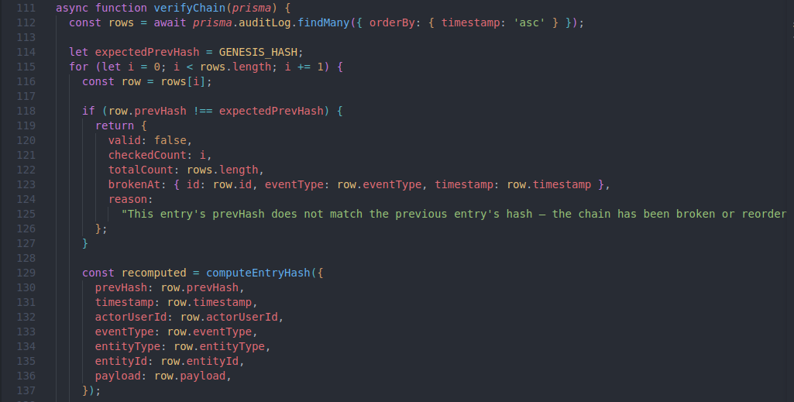
Figure 17. Chain verification: recomputes every hash from genesis and reports the first broken link.
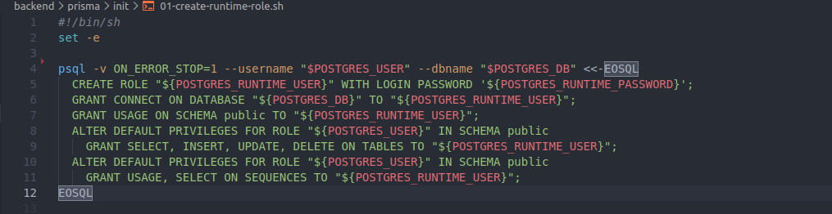
Figure 18. The runtime database role is deliberately not the schema owner and not a superuser.
MFA secrets and evidence files are encrypted at rest with AES-256-GCM. Every security-relevant action writes a hash-chained audit log entry inside the same database transaction as the action itself, serialised by a Postgres advisory lock so concurrent requests cannot fork the chain. A dedicated endpoint recomputes the entire chain from genesis and reports the first broken link, if any. This guarantee only holds if the application's own database role cannot bypass Row-Level Security — PostgreSQL superusers bypass RLS unconditionally regardless of FORCE ROW LEVEL SECURITY, so a dedicated, ordinary runtime role is created specifically so the immutability policy actually binds the running application, not just an idealised one.
Infrastructure & CI/CD
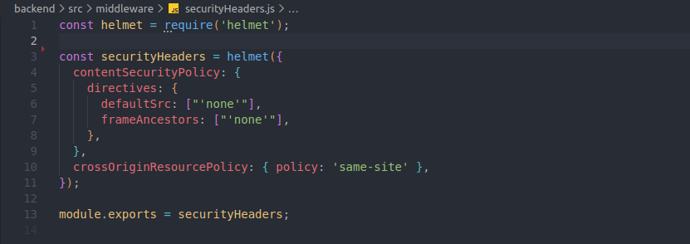
Figure 19. Helmet defaults plus a tightened Content-Security-Policy.
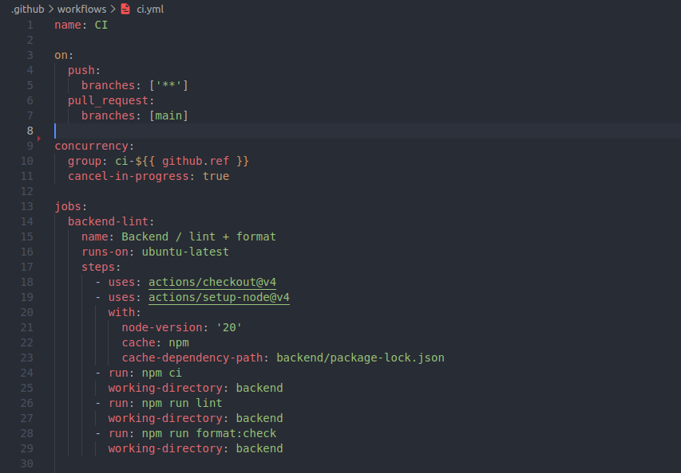
Figure 20. GitHub Actions: lint, npm audit, Prisma schema validation, and Docker builds on every push.
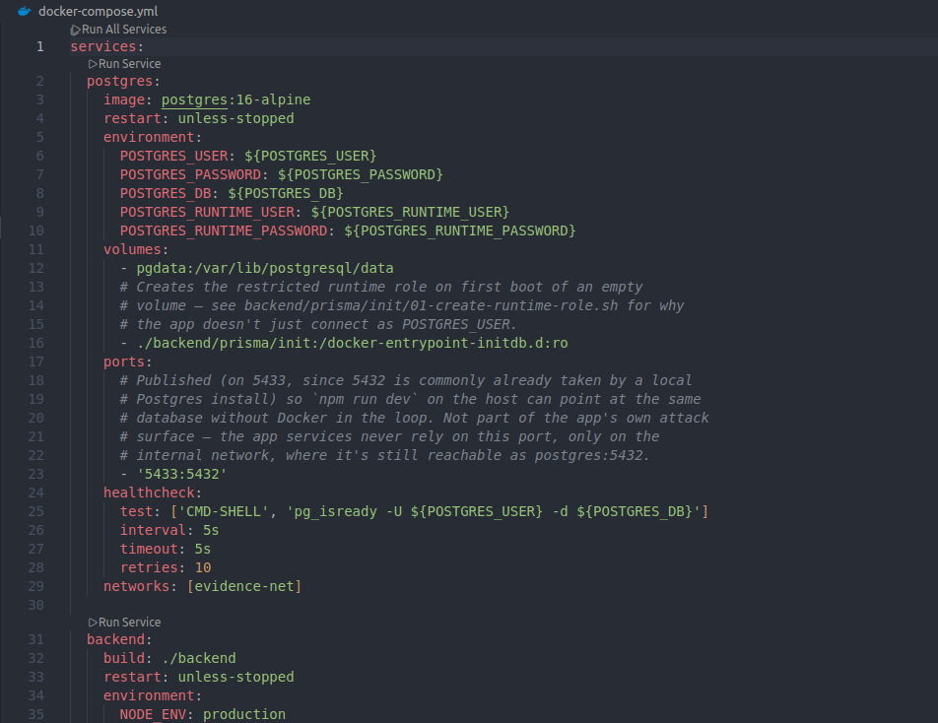
Figure 21. The backend service publishes no host port — reachable only via the internal Docker network.
Security headers follow the OWASP secure-headers baseline via Helmet, tightened with an explicit CSP appropriate for a pure JSON API with a separately hosted SPA. GitHub Actions runs lint, formatting, npm audit, Prisma schema validation, and a Docker build for both services on every push — automated security checks integrated into the development workflow, not a manual afterthought before submission.

Secure Development and Penetration Testing
Secure Development Evidence
The project is hosted on GitHub with a commit history that documents incremental security work rather than a single bulk upload, including dedicated commits for each vulnerability found during this pentest and its fix (see Figure 22 and the findings below). Every commit passes the CI pipeline shown above before being considered complete.
Rules of Engagement
Target | Secure Digital Evidence Chain-of-Custody System, running via its own Docker Compose stack (nginx + Express API + PostgreSQL)
Type | White-box, authenticated — full source access, test accounts created for the Officer/Evidence Custodian roles
In scope | All /api/v1/* routes, the SPA, the custody-transfer/evidence workflow, the audit hash chain, session/token handling, file upload/download
Out of scope | hCaptcha's own infrastructure, DoS/load testing, social engineering — consistent with responsible, non-disruptive testing
Methodology | OWASP Web Security Testing Guide categories (authentication, authorisation, business logic, input validation, session management), scored with CVSS v3.1
Approach | Manual testing (curl + browser) as the primary method; Burp Suite Community used for request interception/replay as a supplementary tool, consistent with white-box source review guiding targeted, hypothesis-driven tests rather than blind fuzzing

EPT-01: Custody Hijack via Stale Pending Transfer
Category | Broken access control / business-logic flaw (CWE-841: Improper Enforcement of Behavioral Workflow)
CVSS v3.1 Score | 6.5 (Medium)
CVSS Vector | CVSS:3.1/AV:N/AC:L/PR:L/UI:N/S:U/C:N/I:H/A:N
Confidence | Confirmed — reproduced end-to-end against the running application
Impacted Component | custody.service.js — initiateTransfer / respondToTransfer

Description: initiating a custody transfer never checked whether the evidence item already had a pending transfer, and accepting a transfer never re-verified that its sender was still the item's actual current custodian. This let a custodian create two simultaneous pending transfers to two different recipients; once the first was legitimately accepted, the second — never withdrawn — could still be accepted later, silently reassigning custody without the real current holder's knowledge or consent.
Steps to reproduce (white-box source review, then manual exploitation): (1) as the custodian, log evidence and confirm collection; (2) POST /evidence/:id/transfer to recipient A — succeeds, 201 PENDING; (3) POST /evidence/:id/transfer to recipient B, before A responds — also succeeds, 201 PENDING, on the vulnerable code; (4) recipient A accepts — evidence legitimately moves to A, IN_CUSTODY; (5) recipient B, holding the untouched stale transfer, accepts it anyway — currentCustodianId silently flips to B, with no transfer ever coming from A.
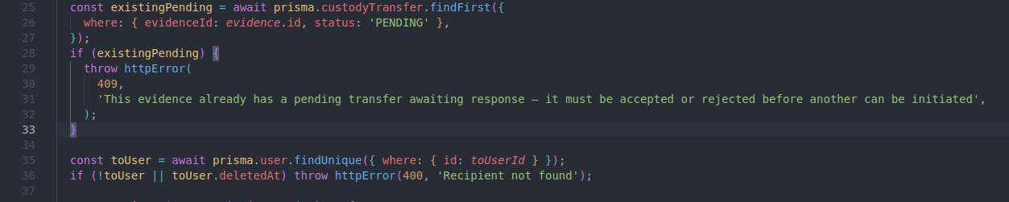
Figure 22. Fix, layer 1: reject a second PENDING transfer for the same evidence item (409).
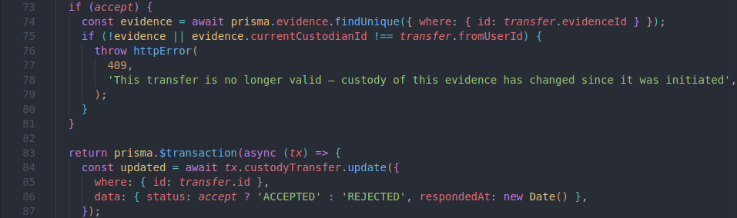
Figure 23. Fix, layer 2 (defense-in-depth): re-verify the sender is still the actual current custodian before an acceptance takes effect.
Remediation: two independent layers were added. initiateTransfer now rejects creating a second PENDING transfer while one already exists for that evidence item. respondToTransfer separately re-checks, at the moment of acceptance, that the transfer's sender still matches the evidence's actual current custodian — defense in depth against any other path that might produce a stale PENDING row.
Fix confirmation and retesting: the exact reproduction steps above were repeated against the patched backend, twice independently — once via terminal (curl, from a dedicated Kali Linux container) and once via Burp Suite Repeater, replaying the second transfer-initiate request with a modified recipient. The vulnerable behaviour was also reproduced on both tools by temporarily reverting the fix, for a genuine before/after comparison.
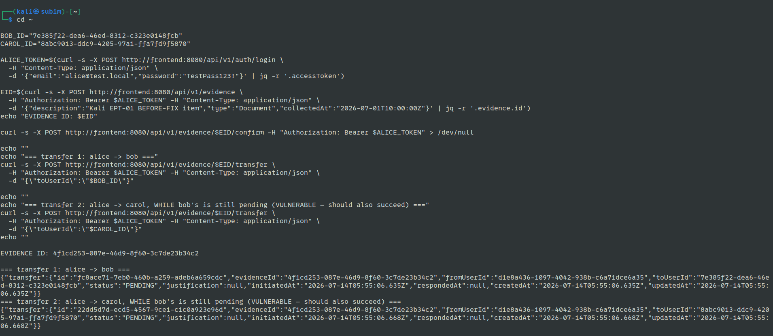
Figure 24. EPT-01, Kali terminal, BEFORE fix: both transfers (alice→bob, alice→carol) succeed as PENDING while bob's is still unresolved.
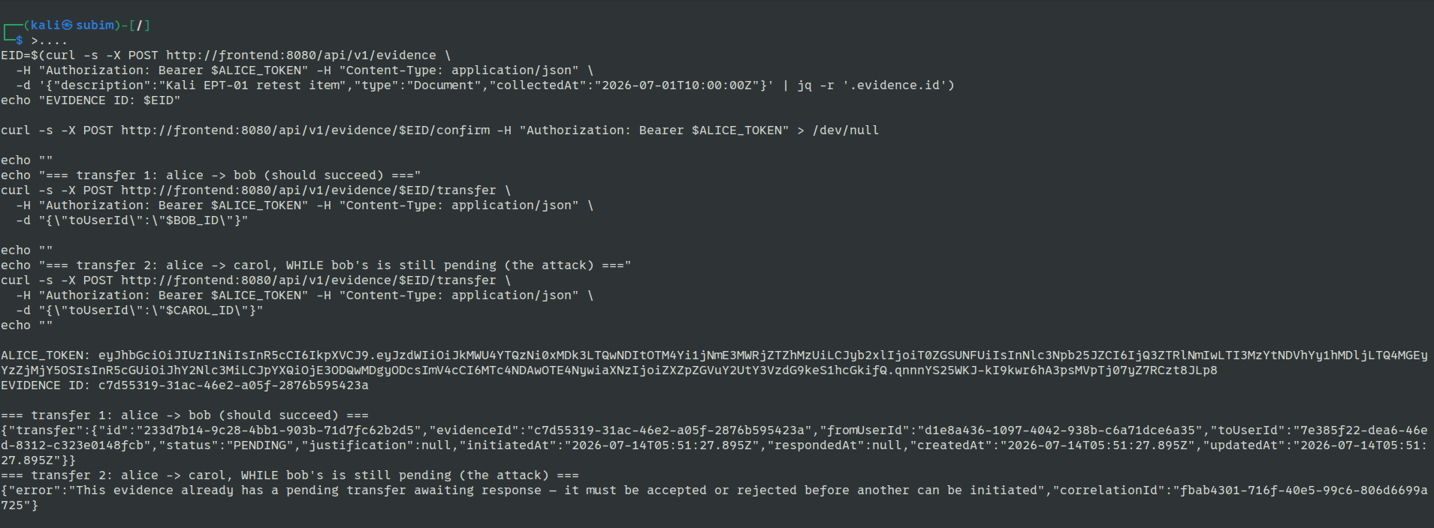
Figure 25. EPT-01, Kali terminal, AFTER fix: the second transfer is immediately rejected with 409.
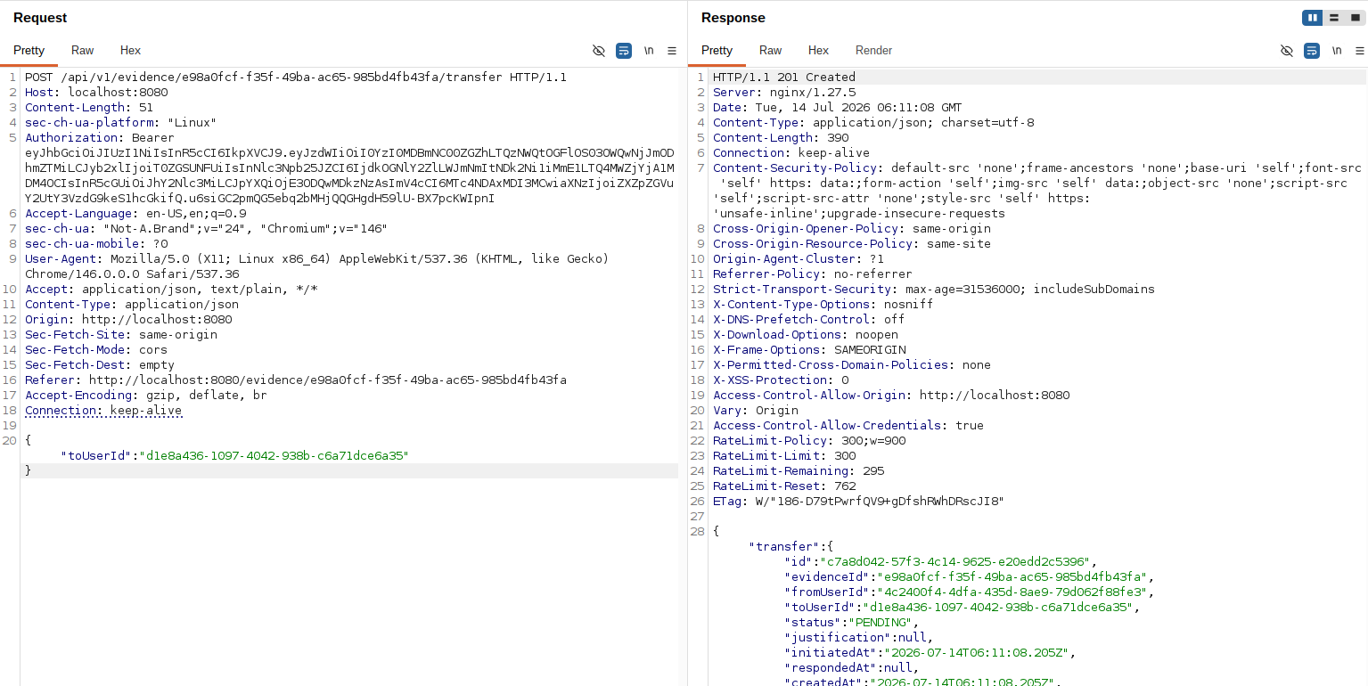
Figure 26. EPT-01, Burp Suite Repeater, BEFORE fix: the duplicate transfer request returns 201 Created.
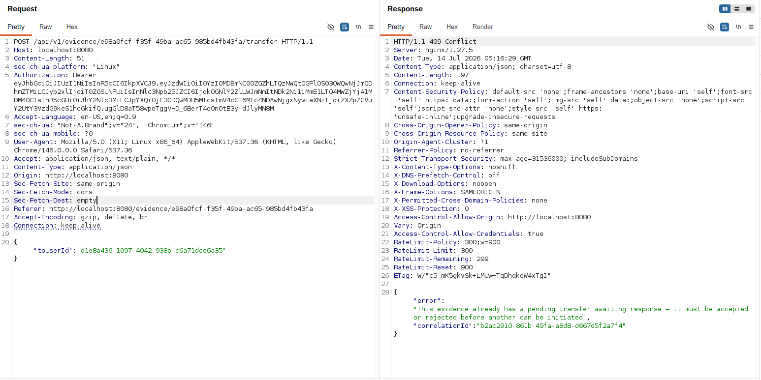
Figure 27. EPT-01, Burp Suite Repeater, AFTER fix: the identical duplicate request now returns 409 Conflict.

EPT-02: Unrestricted File Upload via Spoofed Content-Type
Category | Unrestricted Upload of File with Dangerous Type (CWE-434)
CVSS v3.1 Score | 4.3 (Medium)
CVSS Vector | CVSS:3.1/AV:N/AC:L/PR:L/UI:N/S:U/C:N/I:L/A:N
Confidence | Confirmed — reproduced end-to-end against the running application
Impacted Component | upload.js MIME allowlist / evidence.service.js uploadFile

Description: the file-upload MIME allowlist checked only multer's file.mimetype — the client-supplied Content-Type header for that multipart form field — never the actual file content. An attacker can label arbitrary content with any allowed type.
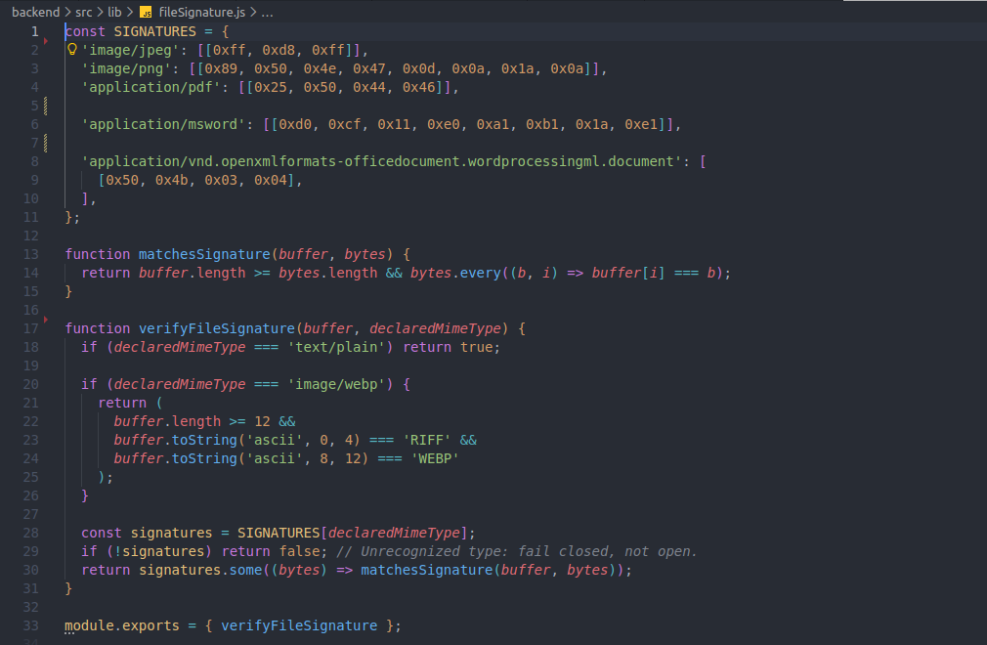
Figure 28. Fix: magic-byte verification of the actual file content against its declared MIME type.
Steps to reproduce: crafted a plain-text file containing <html><script>alert(document.cookie)</script></html>, uploaded it declaring Content-Type: image/jpeg via POST /evidence/:id/files. On the vulnerable code the server accepted and stored it (201), proving the allowlist verified nothing about the actual bytes.
Remediation: lib/fileSignature.js checks the file's real leading bytes (magic numbers) against what its declared type should look like (JPEG, PNG, PDF, legacy DOC, DOCX), failing closed on any unrecognised type. text/plain is intentionally left unchecked — no reliable signature exists, and it is already the lowest-risk allowed type, served with Content-Disposition: attachment and X-Content-Type-Options: nosniff regardless of its actual contents.
Fix confirmation and retesting: the identical spoofed-JPEG payload was resent against the patched backend via both a Kali Linux terminal and Burp Suite Repeater (editing the multipart body's file content directly, keeping Content-Type: image/jpeg). Both now return 400 ("File content does not match its declared type"). A real JPEG (correct magic bytes) was also retested to confirm no regression on legitimate uploads.
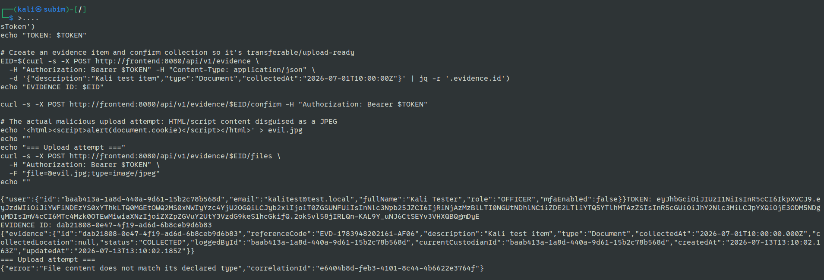
Figure 29. EPT-02, Kali terminal, AFTER fix: end-to-end run — evidence creation, confirmation, and the malicious upload attempt rejected with 400.
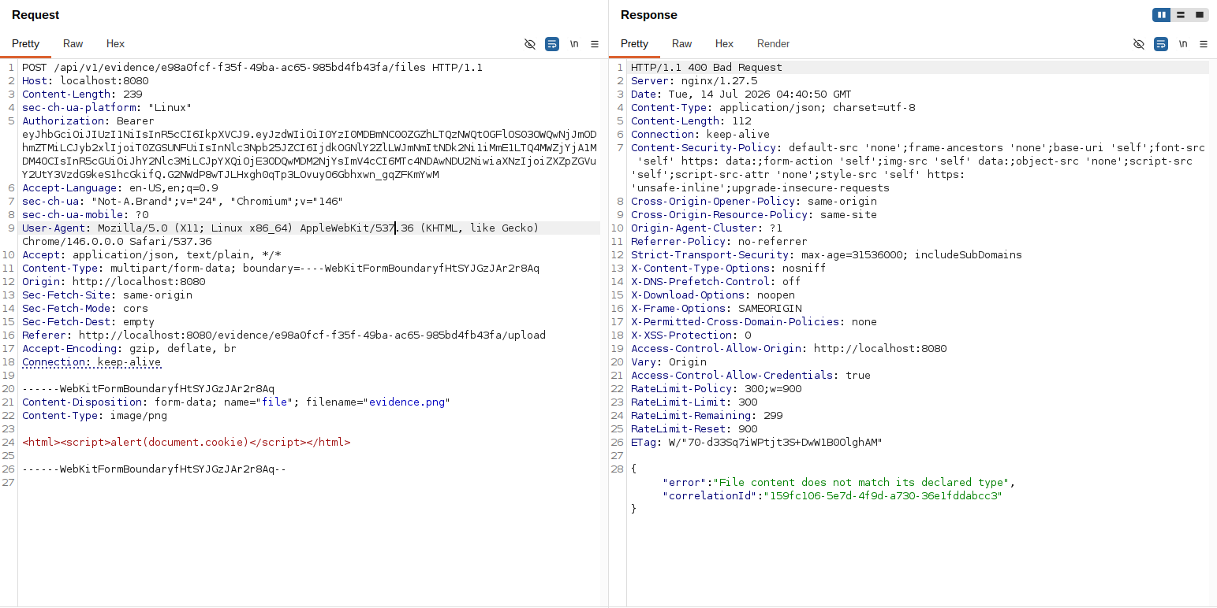
Figure 30. EPT-02, Burp Suite Repeater, AFTER fix: the edited multipart request (HTML/script content, Content-Type: image/png) is rejected with 400.
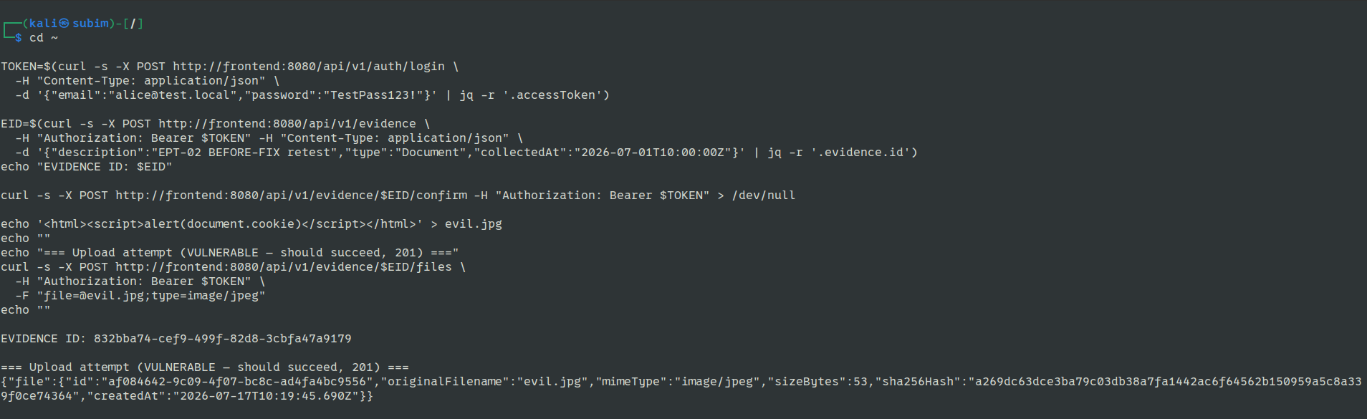
Figure 31. EPT-02, Kali terminal, BEFORE fix: the malicious upload (HTML/script content declared as image/jpeg) is accepted, HTTP 201.
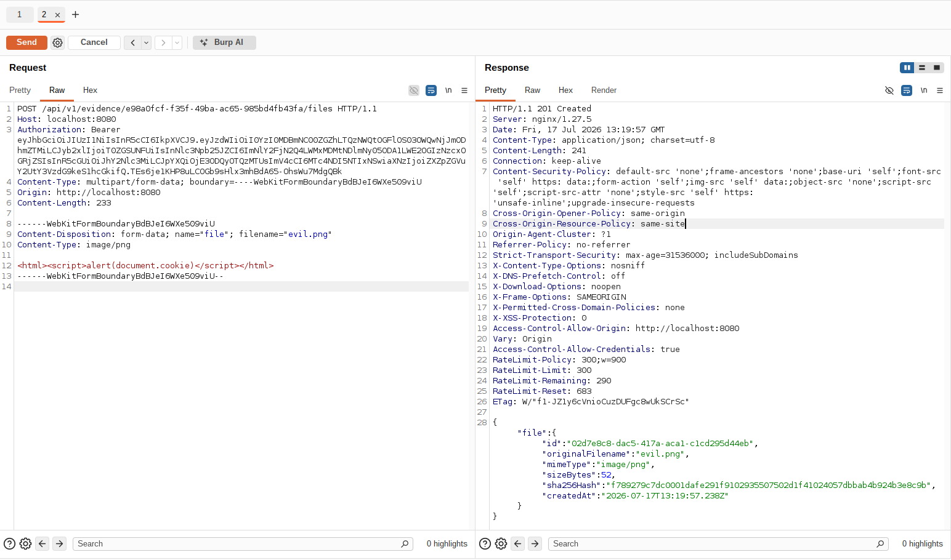
Figure 32. EPT-02, Burp Suite Repeater, BEFORE fix: the identical spoofed-PNG request returns 201 Created.

Proof of Concept
The accompanying video demonstrates the security controls described above on the live application, and walks through both EPT-01 and EPT-02 as before/after scenarios: the vulnerable behaviour is shown first (custody silently hijacked; a disguised HTML/script payload accepted as an image), followed by the fix in place (both requests correctly rejected), with the discovery method, root cause, and remediation explained for each. [Insert video link/description once recorded.]

Conclusion
The Secure Digital Evidence Chain-of-Custody System was built with security integrated from the design stage rather than added afterward: strong authentication and MFA, layered brute-force defences, RBAC/ABAC authorisation, encryption at rest, and a tamper-evident audit log enforced at the database level. An internal, white-box penetration test — following OWASP WSTG categories and scored with CVSS v3.1 — validated these design-time assumptions against the running application and found two genuine, previously unknown vulnerabilities: a business-logic flaw letting a stale custody transfer hijack an evidence item's custodian, and a file-upload control that verified a client-supplied label rather than actual file content. Both were fixed and independently retested using two separate tools (a Kali Linux terminal and Burp Suite), giving genuine before/after evidence rather than a single-tool claim. The project demonstrates that even carefully designed security controls benefit from — and in these two cases required — adversarial testing against the running system, not just code review, to surface real gaps.

References
- OWASP Foundation (2021) OWASP Top Ten. Available at: https://owasp.org/www-project-top-ten/
- OWASP Foundation (2023) OWASP Application Security Verification Standard (ASVS). Available at: https://owasp.org/www-project-application-security-verification-standard/
- OWASP Foundation (n.d.) Web Security Testing Guide (WSTG). Available at: https://owasp.org/www-project-web-security-testing-guide/
- OWASP Foundation (n.d.) Unrestricted File Upload. Available at: https://owasp.org/www-community/vulnerabilities/Unrestricted_File_Upload
- MITRE (n.d.) CWE-841: Improper Enforcement of Behavioral Workflow. Available at: https://cwe.mitre.org/data/definitions/841.html
- FIRST.org (2019) Common Vulnerability Scoring System v3.1: Specification Document. Available at: https://www.first.org/cvss/v3.1/specification-document
- Grassi, P.A. et al. (2017, updated 2020) NIST SP 800-63B: Digital Identity Guidelines — Authentication and Lifecycle Management. National Institute of Standards and Technology. Available at: https://pages.nist.gov/800-63-3/sp800-63b.html
- M'Raihi, D. et al. (2011) RFC 6238: TOTP: Time-Based One-Time Password Algorithm. IETF. Available at: https://datatracker.ietf.org/doc/html/rfc6238
- Jones, M., Bradley, J. and Sakimura, N. (2015) RFC 7519: JSON Web Token (JWT). IETF. Available at: https://datatracker.ietf.org/doc/html/rfc7519
- PostgreSQL Global Development Group (n.d.) Row Security Policies. Available at: https://www.postgresql.org/docs/current/ddl-rowsecurity.html
- PortSwigger (n.d.) CSRF (Cross-Site Request Forgery). Web Security Academy. Available at: https://portswigger.net/web-security/csrf
- Docker Inc. (n.d.) Docker Security Best Practices. Available at: https://docs.docker.com/build/building/best-practices/
- hCaptcha (n.d.) hCaptcha Developer Guide. Available at: https://docs.hcaptcha.com/

Appendix
GitHub Repository: https://github.com/SubimGautam/secure-evidence-system

