1. If you do not use the php tag correctly or do not enclose properly, the following error may occur because the syntax written in php cannot be read.

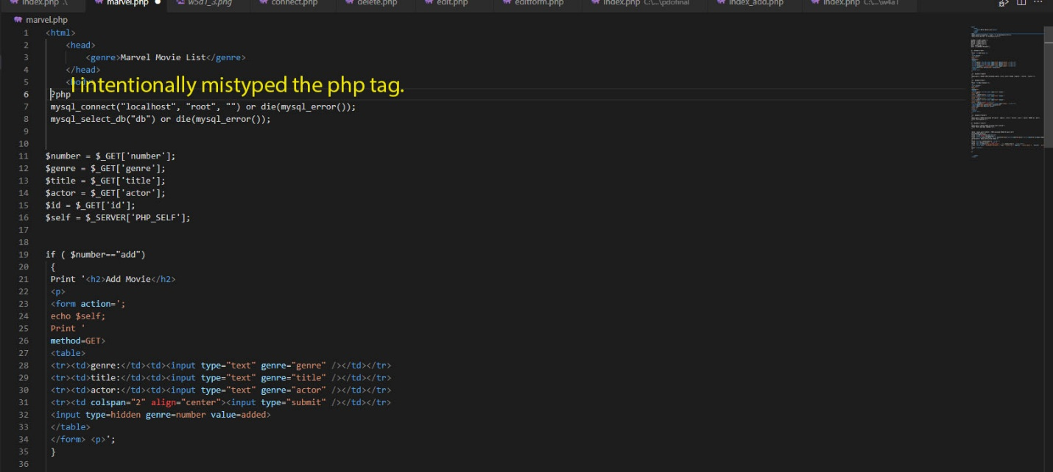



1. If this is a single sign-on related question. Single Sign-On (SSO) is a centralized session and user authentication service that allows access to multiple applications using a single login authentication information. The advantage of SSO is its simplicity. Once authenticated on one of the specified platforms, you can use a variety of services without having to log in and out every time. A well-implemented SSO is very useful in terms of productivity, IT monitoring and management, and security controls. Administrators can enable or disable user access to multiple systems and platforms, apps and other resources with a single security token (username/password pair). SSO also reduces the risk of lost or weak passwords.
2. The only difference between the two is request_once cause fatal errors if the file cannot be found, whereas include_once display warnings and continue loading the rest of the page without database information. If you don't want PHP to load the rest of the page without any database information, you're better off using require_once.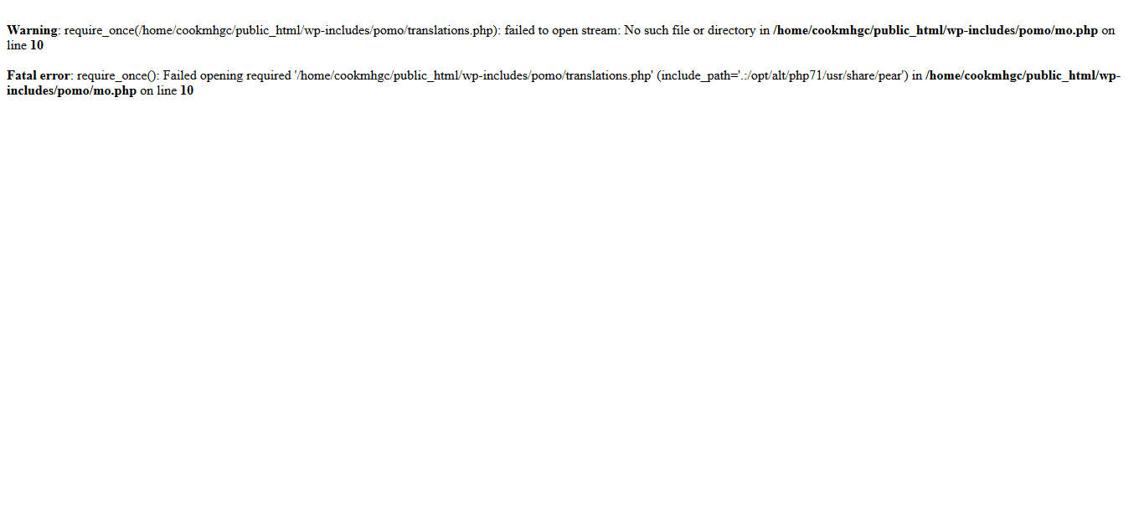
3. Meaning that it requires only once - is a control door that prevents duplicate requires. When a user function called function A() is defined in a file called A.php. If you make A.php here and there, you'll get an error called a duplicate function definition. Use to prevent this. If you use require_once() or include_once(), files that have already been loaded will not be read duplicately.
4. If I explained this simply, it would probably be mysql host,username,password.

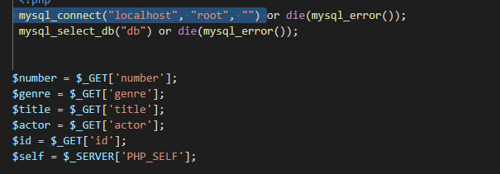

1. when an error occurs, it shuts down the script and outputs the message the developer intended.

Example)

<?php

include("dbcon.php");

$sql = "SELECT * FROM member_charging ";

$sql = $sql . " WHERE mem_uid = '$mem_uid' ORDER BY seq DESC";

$result = mysql_query ($sql) or die ("my sql error!!");

?>