*Deep Learning for Dental Caries Detection and Orthodontic Treatment Analysis*

Subin Tom Thomas Meera Rose Mathew

Department of Computer Application Assistant Professor

Master of Computer Applications Department of Computer Application

Amal Jyothi College of Engineering Amal Jyothi College of Engineering

Kerala, India Kerala, India

[subintom1111@gmail.com](mailto:subintom1111@gmail.com) meerarosemathew@amaljyothi.ac.in

*Abstract*— Dental caries detection and orthodontic treatment analysis are crucial aspects of dental care, necessitating accurate diagnosis and treatment planning. Deep learning techniques are employed to analyze panoramic X-ray images, aiding in the identification of caries lesions and assessment of orthodontic parameters. Through convolutional neural networks (CNNs), these models enhance the efficiency and precision of dental diagnostics, revolutionizing patient care. This seminar explores the application of deep learning in dental practice, showcasing its transformative potential in improving diagnostic accuracy and treatment outcomes.

Keywords — deep learning methods, caries diagnosis, dental panoramic images, radiography, convolutional neural network, orthodontic pre-treatment

I. INTRODUCTION

Finding dental cavities and analyzing orthodontic treatments are important components of dentistry, as proper diagnosis and treatment planning are necessary to provide the best possible care for patients. Conventional diagnostic techniques frequently rely on the laborious and subjective manual interpretation of radiographic images. But with the development of deep learning methods—especially convolutional neural networks (CNNs)—a paradigm shift toward automated and accurate diagnostic tools has occurred.

In this session, we especially use panoramic X-ray pictures to investigate the use of deep learning techniques in orthodontic treatment analysis and dental caries diagnosis. We introduce two unique deep learning models, one for the analysis of orthodontic characteristics and the other for the detection of dental caries lesions. An X-ray dataset comprising both carious and non-carious teeth is used to train the dental caries detection model. By utilizing the capabilities of the ResNet50 architecture, the model has the ability to precisely recognize caries lesions and categorize them according to their position and severity within the tooth's structure. Early intervention and preventive actions are made possible by the model's high accuracy in differentiating between healthy and carious teeth through the use of convolutional layers and global pooling techniques.

Conversely, the orthodontic treatment analysis paradigm is centered around determining whether orthodontic intervention is necessary based on panoramic X-ray pictures. The model assesses a range of orthodontic factors, including occlusal connections, skeletal structures, and tooth alignment, by utilizing deep learning approaches. The approach offers significant insights into patients' orthodontic state through thorough training and validation, assisting physicians in making treatment planning decisions. To speed up the training process, pre-trained ResNet50 models are used in conjunction with a combination of image data augmentation and transfer learning approaches to train both models. To ensure robustness and generalizability, each model's performance is assessed using distinct training, validation, and test datasets.

The use of deep learning in dentistry has the potential to improve diagnostic procedures while also increasing access to high-quality dental care. Deep learning models have the potential to reduce inequities in access to professional dental care by automating and expediting the diagnostic workflow, especially in underprivileged communities or areas with limited access to specialist dental practitioners. Moreover, the application of these models in clinical practice may result in a more effective use of resources, maximizing the time and knowledge dedicated to patient care. As deep learning in dentistry continues to be explored, we see a time when technology will act as a catalyst to improve oral health outcomes globally, bridging regional divides and enabling people to attain and sustain optimal oral health.

# Overall, this seminar showcases the transformative potential of deep learning in revolutionizing dental diagnostics and treatment planning. By harnessing the capabilities of CNNs and panoramic X-ray imaging, we aim to enhance the accuracy, efficiency, and precision of dental caries detection and orthodontic treatment analysis, ultimately improving patient outcomes and advancing dental practice.

# II. LITERATURE REVIEW

Lee et al. studied the use of artificial intelligence (AI) in dental caries prediction models [1]. Dental caries is a serious problem in oral healthcare since it is characterized by decaying tooth structure that leads to cavities. Using artificial intelligence (AI) approaches, the researchers hoped to overcome the shortcomings of conventional diagnosis methods in light of the condition's prevalence, associated discomfort, and high treatment costs. The Korean Center for Disease Control and Prevention's 2018 children's oral health survey provided the data for their study. The researchers used a variety of machine learning techniques to assess these models' performance using metrics like accuracy, precision, recall, and F1-score 90%, 94% accuracy, and 87% recall. This study highlights how machine learning might help dentists identify tooth cavities early and decide on the best course of treatment.

A study was carried out by Lian et al. to identify and categorize caries lesions on dental panoramic radiographs using deep learning techniques [2]. A reference dataset was created by three skilled dentists who marked caries lesions on 1160 panoramic films. Three sets of the dataset were separated out: test, validation, and training. Lesion identification was performed using the nnU-Net convolutional neural network, while lesion depth classification was performed using DenseNet121. A comparison of the models' performance with six experienced dentists using different metrics revealed similar outcomes in terms of accuracy, precision, recall, negative predictive value, and F1-score between the deep learning models and the dentists with experience. This implies that deep learning techniques may help with dental diagnosis and therapy selection.

Using explainable deep learning, Oztekin et al. investigated dental caries detection [3]. Dental caries is a common condition that can lower quality of life by causing pain and infections. Although machine learning may identify dental cavities early on, its inexplicability raises questions. Using panoramic photos, the study evaluated the ResNet-50, DenseNet-121, and EfficientNet-B0 models. ResNet-50 achieved 92.00% accuracy, 87.33% sensitivity, and 91.61% F1-score, slightly outperforming the other models. Heat maps made caries regions easier to interpret. This method provides a precise diagnosis of caries, and heat maps help dentists validate their findings and minimize misdiagnosis.

An investigation was carried out at a university dental hospital on incidental pathologic findings (IPFs) in [4] orthodontic pretreatment panoramic radiographs by Hlongwa et al. A 38% prevalence of IPFs was found in the retrospective cross-sectional examination, which examined 100 panoramic radiographs. The most frequent result was altered tooth morphology, which was found mostly in the mandible (50.8%) and in men (55.3%). In 76% of radiographs, additional abnormalities were found, with impacted teeth being the most common. In particular for orthodontics, the study highlights how crucial it is to thoroughly examine panoramic radiographs in order to accurately diagnose and arrange treatments.

In order to create a mixed-scale dense (MS-D) convolutional neural network for precise multiclass segmentation of the jaw, teeth, and background in cone beam computed tomography (CBCT) images, Wang et al. carried out a study [5]. Thirty orthodontic patient CBCT scans were utilized, and dentists manually generated the gold standard segmentation labels. With Dice similarity values of 0.934 for the jaw and 0.945 for the teeth, as well as small surface variations when compared to gold standard 3D models, the MS-D network showed good segmentation performance. Notably, the MS-D network greatly shortened the segmentation time, increasing the viability of patient-specific orthodontic treatment.

III. MOTIVATION

For efficient treatment planning and patient care in modern dentistry, early diagnosis of dental cavities and precise analysis of orthodontic problems are critical. Conventional diagnostic techniques frequently depend on the laborious and subjective manual interpretation of radiographic images. Furthermore, the increasing incidence of orthodontic problems and tooth cavities highlights the need for more effective and precise diagnostic techniques. Convolutional neural networks (CNNs), in particular, are emerging as powerful tools for deep learning that have the potential to completely transform dental diagnoses. We may more accurately and efficiently automate the process of detecting dental cavities and evaluating orthodontic parameters by using CNNs to analyze panoramic X-ray pictures.

The purpose of this session is to investigate how deep learning might improve dental diagnosis and treatment planning. Our goal is to create strong models that can recognize dental caries lesions and assess orthodontic problems from panoramic X-ray images by utilizing CNNs. By doing this, we can equip dentists with resources that support early intervention, individualized treatment regimens, and ultimately better patient results.

IV. METHODOLOGY

# Convolutional neural networks (CNNs), in particular, have the transformative potential to improve dental diagnosis and treatment planning. This session aims to illustrate this promise. The seminar's specific goal is to demonstrate the creation and use of deep learning models for the study of orthodontic therapy and dental caries detection using panoramic X-ray pictures. The goal of the seminar is to educate attendees an understanding of how deep learning may transform dentistry, enhance patient outcomes, and expedite treatment decision-making processes by showcasing the most recent developments in AI-driven dental diagnostics.

**Data Collection and Preprocessing**

The dataset would be composed of panoramic X-ray pictures that capture different dental states and anatomical structures in the context of dental caries identification and orthodontic treatment analysis. The basis for convolutional neural network (CNN) model training is these images. The dataset is preprocessed with activities specifically designed for dental photos, like uniformly resizing photographs, normalizing pixel values, and maybe enhancing the data with flipping, rotating, or altering brightness and contrast. By completing these preprocessing processes, you can make sure that the CNN model can learn from the data efficiently and get better at correctly identifying and analyzing dental problems from the provided photos.

**Architecture Design**

The CNN architecture for dental caries detection and orthodontic treatment analysis is optimized for processing panoramic X-ray images efficiently. It starts with an input layer receiving grayscale dental scans, followed by preprocessing for uniformity and effective learning. The core comprises convolutional layers extracting spatial patterns crucial for detecting caries lesions and analyzing orthodontic parameters. Pooling layers reduce spatial dimensions, controlling complexity. Fully connected layers learn higher-level representations, aiding prediction. Activation functions like ReLU introduce non-linearity. The output layer varies for each task, producing binary classifications for caries detection or predicting orthodontic parameters. Optimization algorithms like Adam update parameters to minimize loss functions during training, enhancing predictive performance. Overall, the CNN architecture leverages spatial information in panoramic X-rays for accurate caries detection and comprehensive orthodontic analysis.

**Model Training**

In order to train a CNN for dental caries diagnosis and orthodontic therapy, random parameter initialization, data division into training and validation sets, batch image feeding, and the use of loss functions such as binary cross-entropy to compare predicted outputs to ground truth are all necessary steps. Gradients of the loss function are computed by backpropagation and modified using optimization techniques like SGD. To avoid overfitting, training proceeds via epochs with performance assessed on the validation set. To maximize performance, hyperparameters are changed, and training keeps going until a predetermined stopping point is reached. Finally, prior to being used in dental care applications, the trained CNN is assessed on a test set.

**Model Evaluation**

Using a different validation dataset, the model's performance is assessed following training. The model has not seen any of the photos in this dataset during training. To evaluate the performance of the model, evaluation measures including accuracy, precision, recall, and F1-score are calculated. These metrics reveal information about the model's accuracy in image classification

**Fine-tuning and Optimization**

To enhance performance, the model may be optimized or fine-tuned in response to the evaluation's findings. To improve the model's accuracy, methods such as varying learning rates, applying various optimization techniques, or fine-tuning the architecture (e.g., adding more layers, modifying filter sizes) may be used.

V. RESULT

**1. Definition:**

CNN stands for Convolutional Neural Network. Deep learning techniques of this type are commonly used for image and video recognition, processing, and classification applications. CNNs are designed to automatically and adaptively recognize feature spatial hierarchies from input data. The three primary components of a CNN are fully connected, pooling, and convolutional layers. Convolutional layers add filters or kernels to convolutions in order to extract features from input data. Pooling layers down sample the feature maps generated by convolutional layers to increase translation invariance and reduce computational complexity. Fully linked layers use the features extracted by the previous layers to perform classification.

**2. Import statements:**

Model 1: Dental Orthodontic Analysis

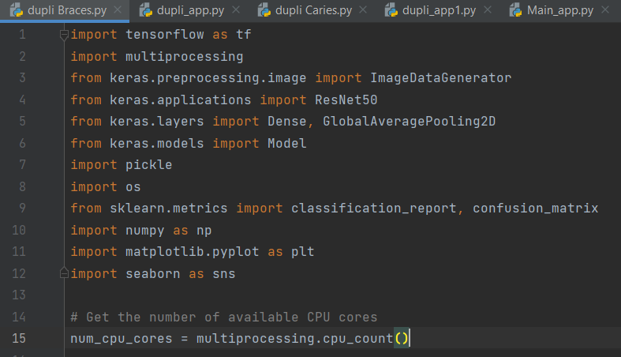

Model 2: Dental Caries Detection

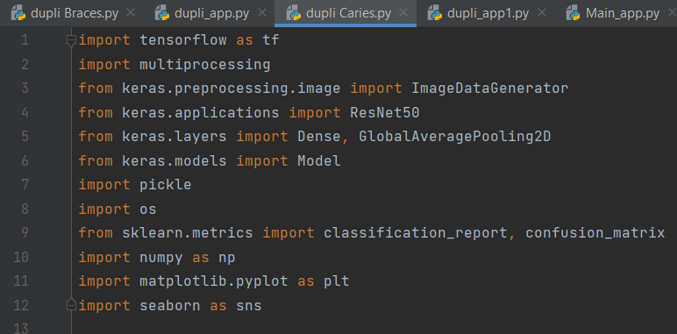

**3. Classification Report:**

A classification report is a machine learning method used to evaluate the effectiveness of a classification model. It provides a comprehensive summary of multiple metrics indicating how well the model is classifying various groups or classes.

The classification report is defined by a multitude of metrics:

**Precision:** Precision is defined as the ratio of all of the model's positive predictions to the actual positive predictions. It assesses how precise optimistic projections are.

**Recall:** The ratio of true positive predictions to all of the actual positive cases in the dataset is known as recall. It is also known as true positive rate or sensitivity at times. It evaluates the model's ability to find all relevant examples.

**F1-Score:** The F1-score is the harmonic mean of recall and precision. It provides an equitable evaluation of a model's efficacy by taking both recall and precision into consideration. The computation is 2 * (precision * recall) / (precision + recall).

**Support:** The term "support" refers to the quantity of actual examples of each class in the dataset.

Moreover, the following metrics can be used to define a classification report:

**Accuracy:** Accuracy is defined as the ratio of correctly classified cases to all instances in the dataset. It provides a broad indication of the overall efficacy of the model.

Model 1: Dental Orthodontic Analysis

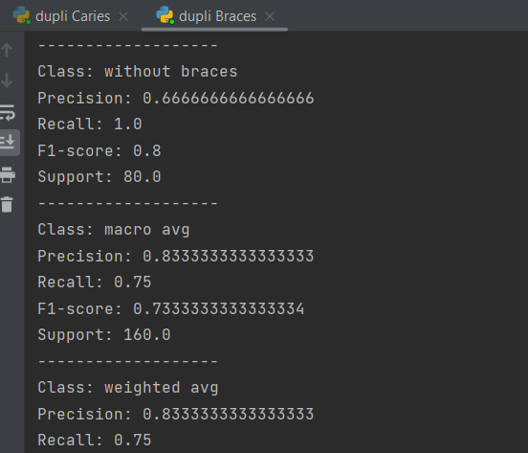

Model 2: Dental Caries Detection

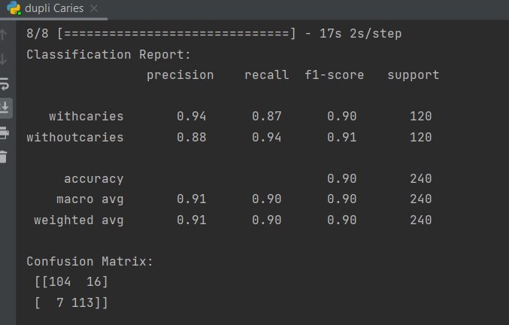

**4. Confusion Matrix:**

A confusion matrix is a performance monitoring tool for machine learning classification tasks. It displays a table of the actual vs. projected classifications generated by a classification algorithm. Understanding the performance of a classification model across is extremely beneficial.

In the confusion matrix, the instances in the projected class are represented by columns, while the examples in the real (true) class are represented by rows. The matrix's main diagonal represents the examples that were successfully classified, while the off-diagonal elements represent misclassifications.

The confusion matrix breakdown is as follows:

**True Positives (TP)** are instances that were correctly classified as belonging to the positive class.

**False Positive (FP)** false alarms, or incidents that were incorrectly assigned to the positive class.

**True Negatives (TN)** are examples that were correctly classified as belonging to the negative class.

Examples that were incorrectly classified as absent from the positive class are known as **False Negatives (FN).**

Model 1: Dental Orthodontic Analysis

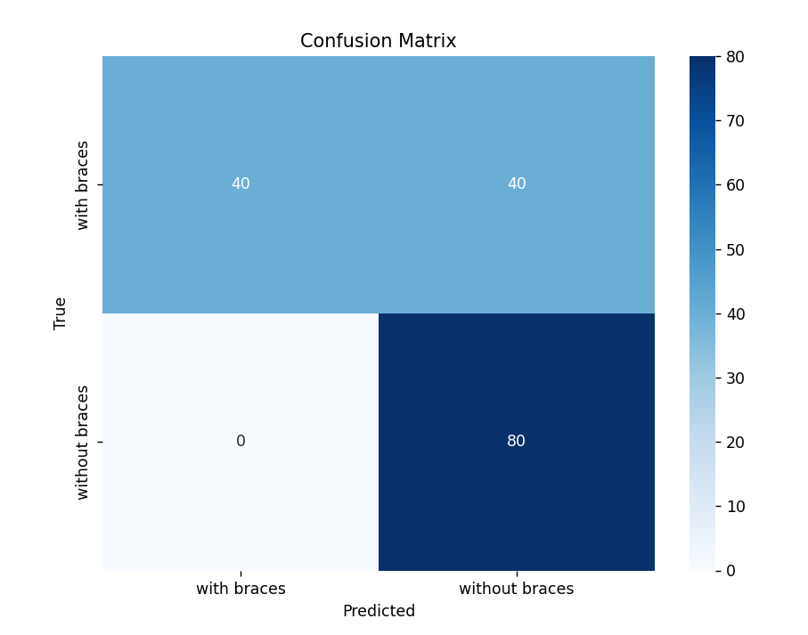

Model 2: Dental Caries Detection

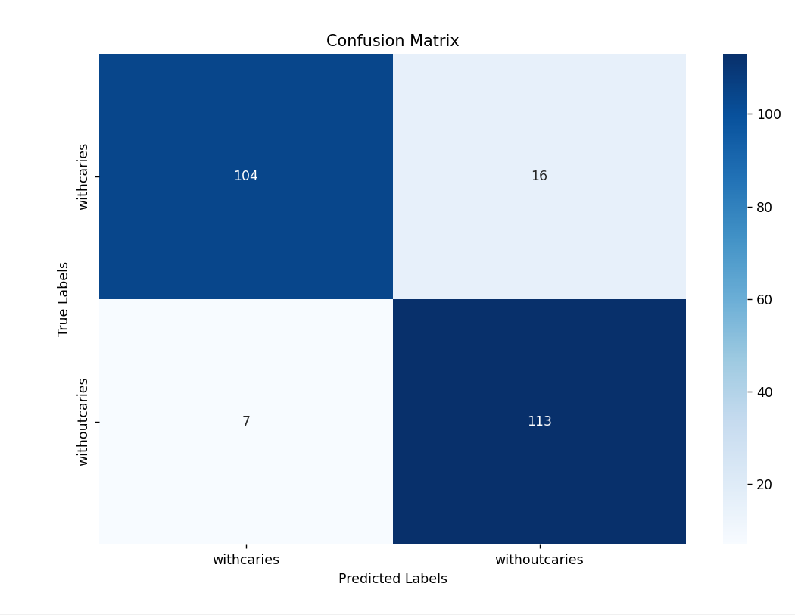

**5. Final Output:**

Model 1: Dental Orthodontic Analysis

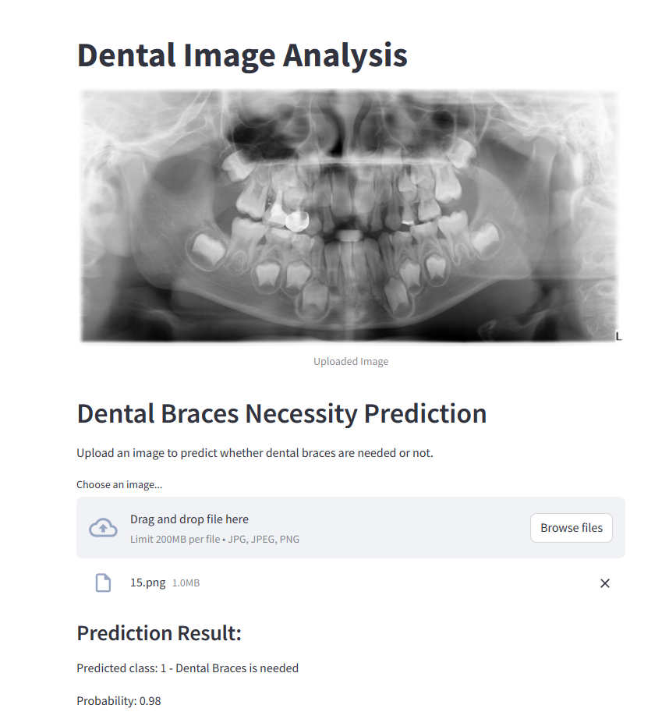

Model 2: Dental Caries Detection

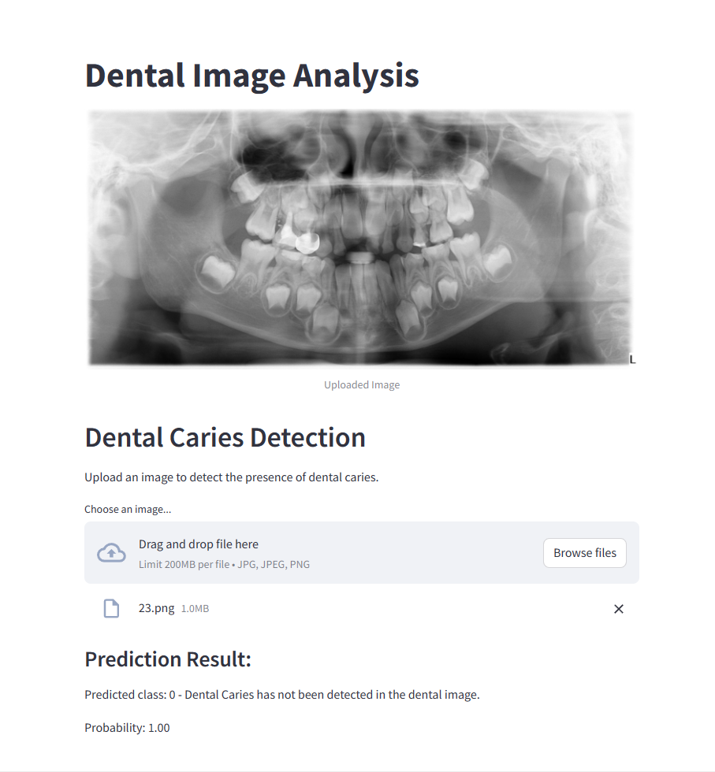

IV. CONCLUSION

In summary, a major development in contemporary dentistry is the incorporation of deep learning methods into the study of orthodontic treatment and dental caries diagnosis. We have shown how convolutional neural networks (CNNs) and panoramic X-ray imaging can be used to transform patient care, treatment planning, and diagnostic accuracy.

We have demonstrated that CNN-based algorithms are capable of precisely identifying dental caries lesions, classifying orthodontic characteristics, and even predicting the need for orthodontic intervention through in-depth study and model development. By utilizing extensive collections of panoramic X-ray pictures, these models enable accurate examination and identification of minute irregularities that could escape the human eye.

Our research further emphasizes how crucial interpretability and explainability are to deep learning algorithms. We may build trust and collaboration between humans and machines by utilizing methods like heat mapping and feature visualization to give physicians insightful knowledge into the AI models' decision-making process.

Deep learning has a wide range of possible uses in dentistry in the future. AI-powered solutions have the potential to improve patient outcomes, expedite workflows, and ultimately raise the standard of dental care, from the early diagnosis of caries lesions to customized orthodontic treatment planning.

Prioritizing patient privacy, ethical concerns, and regulatory compliance is crucial as we develop and improve these approaches. Through interdisciplinary collaboration and adoption of a patient-centered approach, we may fully realize the promise of deep learning in dentistry and establish a more promising and health-conscious future.

IV. REFERENCES

**[1] Lee** et al. DCP: Prediction of Dental Caries

Using Machine Learning in Personalized Medicine. Appl. Sci. 2022, 2022, 12, 3043. <https://doi.org/> 10.3390/app12063043

**[2] Lian** et al. Deep Learning for Caries Detection and Classification. Diagnostics 2021, 11, 1672.

<https://doi.org/10.3390/> diagnostics11091672

**[3] Oztekin** et al. An Explainable Deep Learning Model to Prediction Dental Caries Using Panoramic Radiograph

Images. Diagnostics 2023, 13, 226. https://doi.org/10.3390/

diagnostics13020226

**[4] Hlongwa** et al. Incidental PathologicFindings from OrthodonticPretreatment Panoramic Radiographs. Int. J. Environ. Res. Public Health 2023, 20, 3479. https://doi.org/10.3390/ijerph20043479

**[5] Wang** et al. Multiclass CBCT Image Segmentation

for Orthodontics with Deep Learning, Journal of Dental Research 2021, Vol. 100(9) 943–949 © International & American Associations for Dental Research 2021