F1 Lap Times Analysis

Subirna
Assessment Date: December 2025
F1 Lap Times Analysis Pipeline
A production-ready data engineering solution for analyzing Formula 1 driver lap times. This pipeline processes CSV data to calculate average lap times and identify the top performing drivers.

Overview
This project demonstrates best practices in data engineering including:
- Clean, modular, object-oriented Python code
- Comprehensive error handling and validation
- Extensive unit testing
- Clear documentation and logging
- Multiple output formats (CSV, JSON)
- Type hints for better code maintainability

Problem Statement
Build a batch processing pipeline that:
1. Ingests F1 driver lap times from a CSV file
2. Calculates the average lap time for each driver
3. Identifies and outputs the top 3 fastest drivers
4. Includes each driver's fastest and average lap times

Architecture
Input CSV → Extract → Transform → Load → Output (CSV/JSON)
↓ ↓ ↓
Validate Calculate Average Format

Components
f1_lap_times_pipeline.py : Main ETL pipeline implementation
generate_sample_data.py : Sample data generator for testing
test_f1_pipeline.py : Comprehensive unit tests
requirements.txt : Python dependencies

1. Generate Sample Data
python generate_sample_data.py
This creates `f1_lap_times.csv` with realistic F1 lap times for 15 drivers.
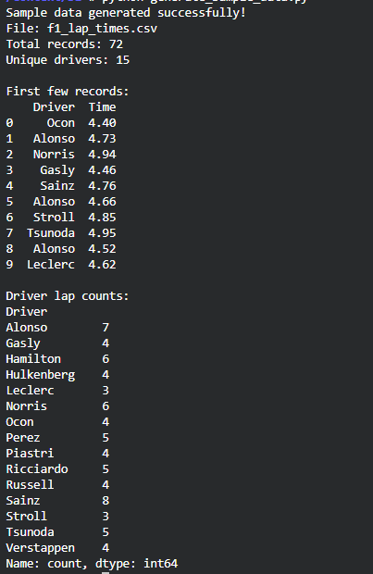

2. Run the Pipeline
python f1_lap_times_pipeline.py
The pipeline will:
- Read `f1_lap_times.csv`
- Process the data
- Generate output files:
- `top_3_drivers.csv` - Top 3 drivers in CSV format
- `top_3_drivers.json` - Top 3 drivers in JSON format
- Display a formatted summary in the console
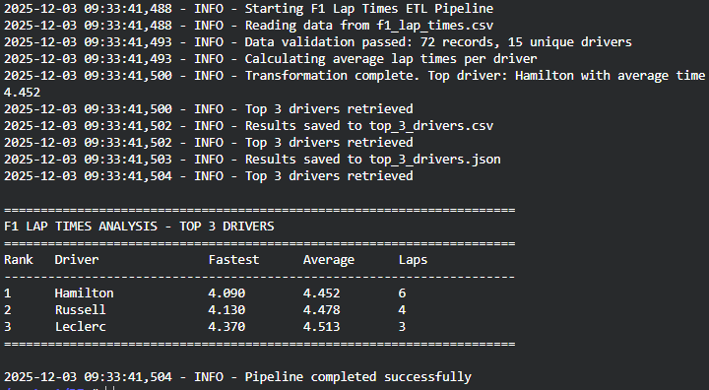

3. Run Tests
python test_f1_pipeline.py

Input Data Format
The pipeline expects a CSV file with the following structure:
Requirements:
- Driver: String - Driver name
-Time: Float - Lap time in seconds (must be positive)
- Minimum 10 unique drivers
- Minimum 3 lap times per driver
Output Format
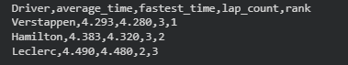
CSV Output (`top_3_drivers.csv`)

JSON Output (`top_3_drivers.json`)

Pipeline Features
Data Validation
The pipeline includes robust validation:
- Checks for required columns
- Validates data types
- Ensures no negative lap times
- Handles empty files gracefully
- Provides clear error messages
Error Handling
- Graceful handling of missing files
- Detailed logging for debugging
- Comprehensive exception handling
- Validation at each pipeline stage

Testing
The project includes comprehensive unit tests covering:
- Successful data extraction and transformation
- Error handling (missing files, invalid data)
- Edge cases (single driver, identical times)
- Output validation (CSV and JSON)
- Data validation logic

Run tests with:
python test_f1_pipeline.py
F1LapTimesProcessor Class is the main class for processing F1 lap times data.

Methods
__init__(input_file: str)
- Initialize processor with input file path
extract() -> pd.DataFrame
- Read and validate data from CSV file
- Returns: DataFrame with lap times data

transform() -> pd.DataFrame
- Calculate averages and rankings
- Returns: DataFrame with processed results

get_top_n(n: int = 3) -> pd.DataFrame
- Get top N fastest drivers
- Args: n - number of drivers to return
- Returns: DataFrame with top N drivers

load_csv(output_file: str, top_n: int = 3) -> None
- Save results to CSV format

load_json(output_file: str, top_n: int = 3) -> None
- Save results to JSON format

run_pipeline(...) -> None
- Execute complete ETL pipeline

Why Class-Based Design?
- Encapsulation of pipeline logic
- Easy to test individual methods
- Reusable and extensible
- Clear separation of concerns

Why Multiple Output Formats?
- CSV for data analysis tools (Excel, Tableau)
- JSON for web applications and APIs
- Demonstrates flexibility and production readiness

Extending the Pipeline
The pipeline is designed to be easily extended:

Custom processing
processor = F1LapTimesProcessor('input.csv')
processor.extract()
processor.transform()

Access intermediate results
all_drivers = processor.results
top_5 = processor.get_top_n(5)

Custom output
processor.load_csv('custom_output.csv', top_n=10)

Assumptions
1. Data Quality : Input data is assumed to be in correct format (Driver, Time columns)
2. Lap Times : Time values are in seconds and positive
3. Driver Names : Consistent spelling for same driver across all records
4. Performance : Dataset fits in memory (suitable for batch processing)

