

MSCM-CO-07 Data Analytics in Supply Chain Management
Prof. Dr. -Ing. Hendro Wicaksono

Report of Project Part 1
Exploratory Data Analysis

Handed in by: Date: 28/10/2026
Group No: 1
Subhankar Biswas
Lerato Tooane
Motshidisi Simon
Mariem Nour Ghozzi
Contents
List of Figures II
List of Tables III
1 Dataset 1: Manufacturing Energy Consumption (Regression) 1
1.1 Exploratory data analysis 1
1.1.1 Data visualization and exploration 1
1.1.2 Brainstorming and discussion 9
1.1.3 Conclusuion 11
1.1.4 Methodological References 12
1.1.5 Annexture Tables 12
2 Dataset 2: Port Logistics Dispatching (Classification) 16
2.1 Exploratory data analysis 16
2.1.1 Data visualization and exploration 16
2.1.2 Brainstorming and discussion 26
2.2 Methodological references 27
3 Dataset 3: E-Commerce Sales & Customer Insights (Regression) 27
3.1 Data description 27
3.2 Exploratory data analysis 28
3.2.1 Data visualization and exploration 28
3.2.2 Brainstorming and discussion 32
3.3 Methodological references 32
Declaration 33
Appendix A: Project management 33
A.1 Planned Task distribution 33

List of Figures
Figure 1. Share of missing values by column (cleaned copy) 2
Figure 2. Number of observations by Machine_Type (left) and Shift (right) 2
Figure 3. Energy consumption by Machine_Type (left) and Shift (right) 3
Figure 4. Mean energy consumption by Machine_ID (all 50 machines, sorted) 3
Figure 5. Histograms with density curves (KDE) of the numeric variables (cleaned copy) 4
Figure 6. Box plots of the numeric variables (cleaned copy) 4
Figure 7. Violin plots of selected variables (cleaned copy) 4
Figure 8. Number of IQR outliers by variable (cleaned copy) 5
Figure 9. Correlation heatmap of the numeric variables (Pearson, lower triangle, cleaned copy) 6
Figure 10. Scatter matrix of selected variables (1,500 sampled rows, cleaned copy) 7
Figure 11. Bubble chart of operating hours and production volume; bubble size = energy, colour = Product_Complexity_Index 7
Figure 12. Parallel coordinates for the lowest and highest 25% of energy days (cleaned copy, 150 days each) 7
Figure 13. Mean energy by bin for Spindle_Load_pct (left) and Average_Machine_Temperature_C (right), cleaned copy 8
Figure 14. Scatter plots with LOWESS trend lines (1,800 sampled rows each, cleaned copy) 8
Figure 15. Mean energy by ambient temperature (left) and by days since maintenance within tool-wear bands (right) 8
Figure 16. Monthly mean energy consumption (solid line, left axis) and mean ambient temperature (dashed line, right axis), 2025 9
Figure 2.1. Missing-value rates by feature in the 10,000-case analysis copy. 18
Figure 2.2. Distribution of Recommended_Dispatch_Action. 19
Figure 2.3. Dispatch-action composition by vehicle technical status. 19
Figure 2.4. Selected histograms with KDE overlays for operational numerical variables 20
Figure 2.5. Box plots of selected operational numerical variables 20
Figure 2.6. Violin plots of selected operational variables by Recommended_Dispatch_Action. 21
Figure 2.7. Potential numerical outliers detected by the 1.5 × IQR screening rule. 22
Figure 2.8. Pearson correlation heatmap of numerical operational variables (lower triangle). 23
Figure 2.9. Pair plot of selected operational variables (stratified display sample). 23
Figure 2.10. Parallel coordinates of median operational profiles by dispatch action (scaled for visualization). 24
Figure 2.11. Bubble chart of road/terminal congestion, current delay and service-level exposure. 24
Figure 2.12. Mean operational conditions by recommended dispatch action. 25
Figure 2.13. Dispatch-action mix by expected disruption duration. 25
Figure 2.14. Slot buffer versus current delay; hexbin color denotes observation density. 26
Figure 3.1. Distribution of Shipping Fee. 28
Figure 3.2. Histograms with KDE overlays of the numerical variables. 29
Figure 3.3. Bubble chart of unit price and quantity; bubble size = Total Price, colour = Shipping Fee. 29
Figure 3.4. Box plots of Shipping Fee by product category. 30
Figure 3.5. Mean Shipping Fee by category and region. 30
Figure 3.6. Pearson correlation heatmap of the numerical variables. 31
Figure 3.7. Mean and median Shipping Fee by order quantity. 31
Figure 3.8. Monthly mean Shipping Fee. 31

List of Tables

Table 1. Summary statistics of the numeric variables (cleaned copy, extreme values set to missing) 12
Table 2. Data-quality issues and how they were handled 13
Table 3. Counts of the categorical variables (cleaned copy, 10,000 rows) 13
Table 4. Energy consumption (kWh) by Machine_Type and Shift 13
Table 5. IQR outliers by variable in the cleaned copy (percentages of observed values) 13
Table 6. Extreme groups in the first 10,000 rows (audit copy) a 14
Table 7. Correlation with Energy_Consumption_kWh 14
Table 8. Mean energy (kWh) by variable bin, with the number of rows in brackets (cleaned copy) 14
Table 9. Mean energy (kWh) by spindle-load band and complexity band (n in brackets) 14
Table 10. Mean energy (kWh) by days-since-maintenance band and tool-wear band (n in brackets) 15
Table 11. Monthly energy consumption (kWh) and ambient temperature (°C), 2025 15
Table 12. Energy difference between a high and a low level of each factor 15
Table 13. Number of risk flags per day and energy consumption 16
Table 14. Data dictionary of customer dataset 28
Table 2.1. Variable groups and operational roles (compiled from the assignment data dictionary). 16
Table 2.2. Selected descriptive statistics for operational variables. 17
Table 2.3. Features with the highest missing-value rates. 17
Table 2.4. Distribution of the six target classes. 18
Table 2.5. Strongest selected positive Pearson correlations among numeric operational variables. 22
Table 3.1. Data dictionary of the E-Commerce Sales & Customer Insights dataset. 28
Table 3.2. Descriptive statistics for numerical variables. 29
Table 3.3. Summary of statistical tests against Shipping Fee (5% significance level). 32

Dataset 1: Manufacturing Energy Consumption (Regression)

Exploratory data analysis

Data visualization and exploration
The dataset regression_manufacturing.csv comprises daily entries (one row per machine and day) of a smart factory. The task is to project and clarify the target of the Energy_Consumption_kWh. The raw file provided has 10,250 rows and 20 columns, but the project brief states 10,000 rows. The first 10,000 rows contain unique Observation_ID values 1–10,000; the last 250 rows repeat IDs that already exist (228 are exact copies and 22 differ in one or two values). The analysis therefore utilizes the first 10,000 rows and excludes the 250 duplicated rows. In the data, 5 rows with the invalid machine type "Tree" were corrected from their Machine_ID (each machine has exactly one type), 5 rows with the invalid shift "Dream" were set to missing, and 382 extreme values in 375 rows (3.75%) were set to missing (temperature above 120 °C, cycle time above 200 s, vibration above 6 mm/s, energy above 800 kWh; find more information outlier section). The original values stay available in a separate audit copy. Observation_ID is not used as a feature. The target is observed in 9,505 of the 10,000 rows. All results are based on a clean copy, barring any stated exception.

Dimensions and basic statistics
Table 1 The dates cover all 365 days of 2025 of the summary statistics of the 15 numeric analysis variables (14 predictors and the target).
- Target: After the extreme observations are omitted, the mean (307.99 kWh) resulted to being close to the median (301.21 kWh), and the standard deviation (67.51) matched the value anticipated from the interquartile range (88.17 / 1.349 = 65.4). Skewness being moderate (0.64). Prior masking, the target reached 1,472.82 kWh, which was 4.9 times the median.
- Maxima before masking: The inspection log reveals temperature up to 253.63 °C (median 74.07 °C), cycle time up to 384.94 s (median 87.76 s) and vibration up to 11.05 mm/s (median 2.42), well beyond the range of the dataset. With masking applied, the maximum values became 93.80 °C, 145.00 s and 4.40 mm/s.
- Round limits: Operating_Hours_per_Day stops at 6 and 24, Days_Since_Maintenance at 100, Operator_Experience_years at 22, Ambient_Temperature_C at 5 and Humidity_pct at 25 and 90. This indicates that observations were capped at these bounds (counts in Table 2).
- Symmetric vs skewed: For hours skewness is close to 0 , complexity, hardness, spindle load, temperature, vibration, cycle time, ambient temperature, humidity and machine age. It is about 1 for Production_Volume_units, Days_Since_Maintenance and Operator_Experience_years, and 0.50 for Tool_Wear_Index.

Data types, missing values and data quality
All numeric columns are recorded as numbers. The Production_Date was successfully transformed into valid dates without errors. Figure 1 exhibits the missing values in the cleaned copy: Tool_Wear_Index 6.00%, Vibration_mm_s 5.92%, Energy_Consumption_kWh 4.95%, Average_Machine_Temperature_C 4.94%, Humidity_pct 3.00%, Cycle_Time_sec 1.01% and Shift 0.05%. Some of these values intentionally recorded missing: 95 energy, 94 temperature, 92 vibration and 101 cycle-time values. The original gaps are 600 (tool wear), 500 (vibration), 400 (energy), 400 (temperature) and 300 (humidity). The initial gap pattern appears to be random: the missing rate is similar for all machine types (for example tool wear 5.8–6.6%, humidity 2.7–3.5%) and all months, and mean energy varies by less than 5 kWh between rows with and without each missing predictor. Statistical testing was not conducted.
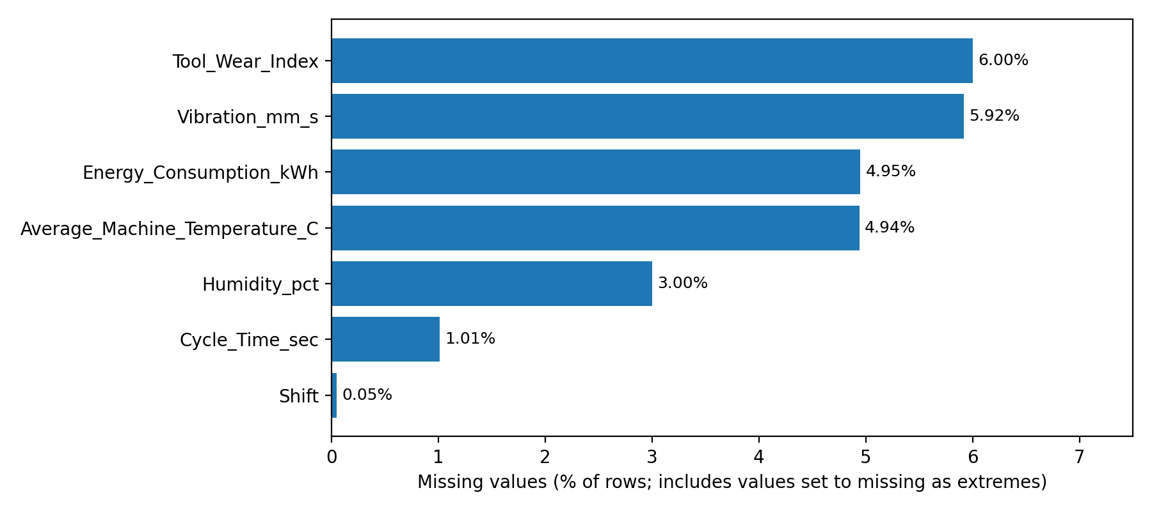
Figure 1. Share of missing values by column (cleaned copy)
Table 2 Outlines the other quality concerns and measures taken to address them. The 250 appended rows comprise 22 repeated Observation_ID values with different values. Comparing the two copies of each ID shows that exactly one value differs (two in one case), and that one copy is 2.3 to 5.8 times larger than the other (for example temperature 79.12 vs 206.98 °C, energy 331.61 vs 1,240.18 kWh). Of the 23 exaggerated values, 13 are in the excluded appended rows and 10 are in the first 10,000 rows, where they are removed by the extreme-value limit. This illustrates how some extreme values came about (see the outlier section).

Categorical variables
Machine_Type and Shift are imbalanced (Table 3, Figure 2): CNC_Mill has 1.85 times as many rows as Laser_Cutter, and the Day shift has 2.5 times as many rows as the Night shift. Machine_ID is balanced: each of the 50 machines has 171–227 rows.
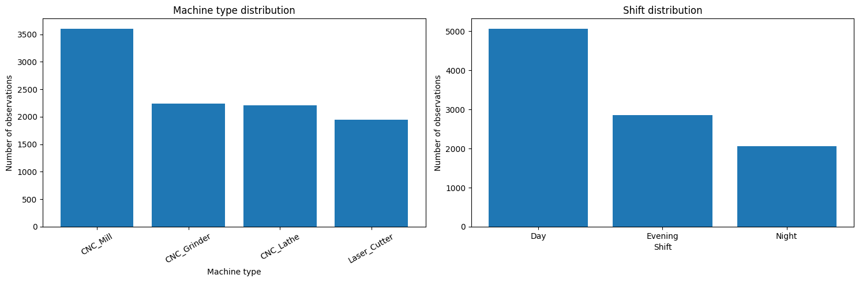
Figure 2. Number of observations by Machine_Type (left) and Shift (right)

Categories and energy. Machine type changes energy more than shift (Table 4, Figure 3). Laser_Cutter has the highest mean energy (336.86 kWh) and CNC_Lathe the lowest (290.40 kWh): a difference of 46.46 kWh (16.0%). Night is highest among the shifts (315.73 kWh) and Day lowest (304.39 kWh), only 11.34 kWh (3.7%) apart. The boxes exhibit substantial overlap, thus, neither variable alonedistinguishes the energy. The Laser_Cutter difference is not the results in load or complexity, as the average spindle load (65.4–66.0%) and complexity (5.33–5.43) are similar in all machine types.

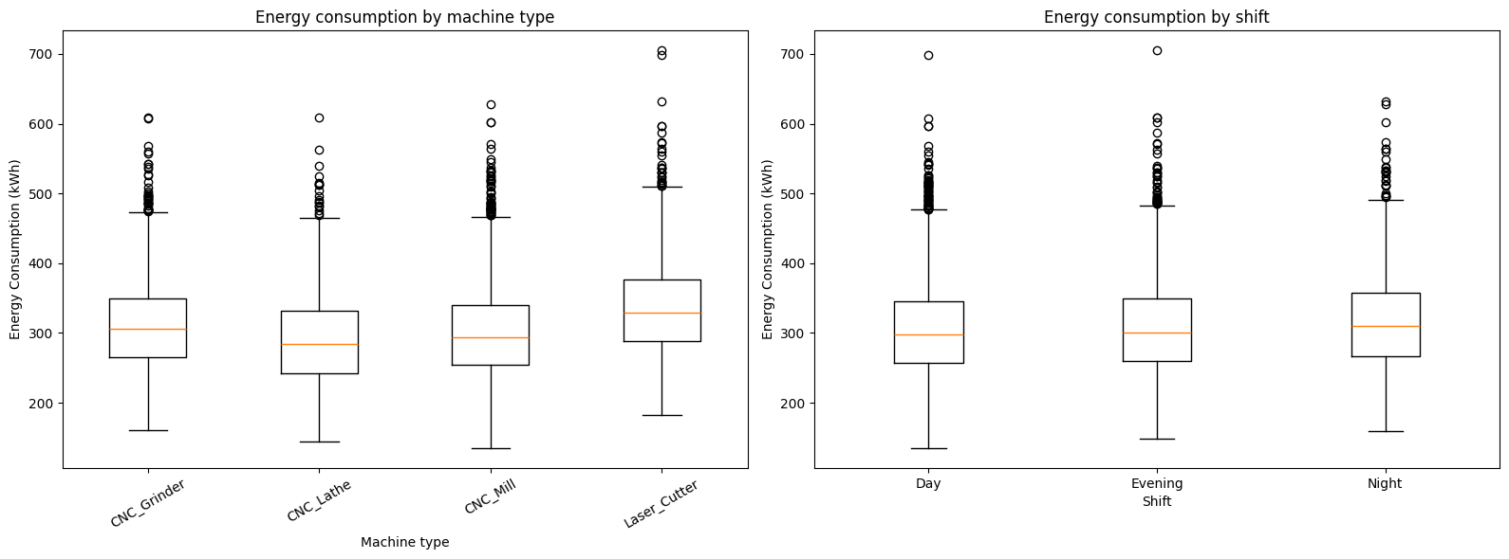
Figure 3. Energy consumption by Machine_Type (left) and Shift (right)
Machine level. Mean energy consumption per machine spans from 274.81 kWh (M049) to 355.86 kWh (M041) (Figure 4), with a standard deviation of 19.5 kWh across the 50 machines. The variance of the machine means is about 8.4% of the total energy variance, and part of it comes from the machine type (approximate; no variance model was fitted). Every Machine_ID has one Machine_Type. Machine_Age_years is not fixed within a machine: each machine has 75–95 different ages spanning about one year, so it behaves like the machine age on the production date.
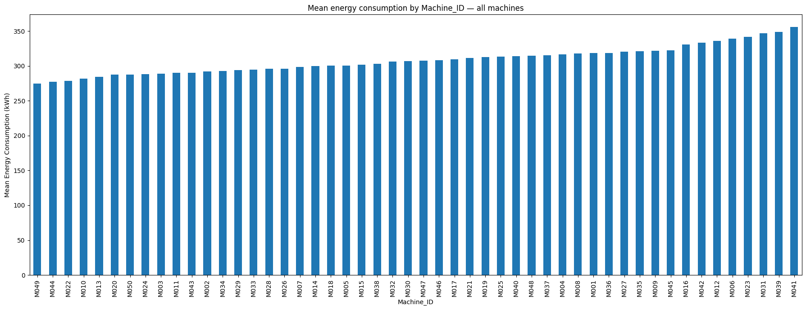
Figure 4. Mean energy consumption by Machine_ID (all 50 machines, sorted)

Numerical variables
Figures 5 to 7 Show the distributions of the numeric variables after the extreme values were set to missing.
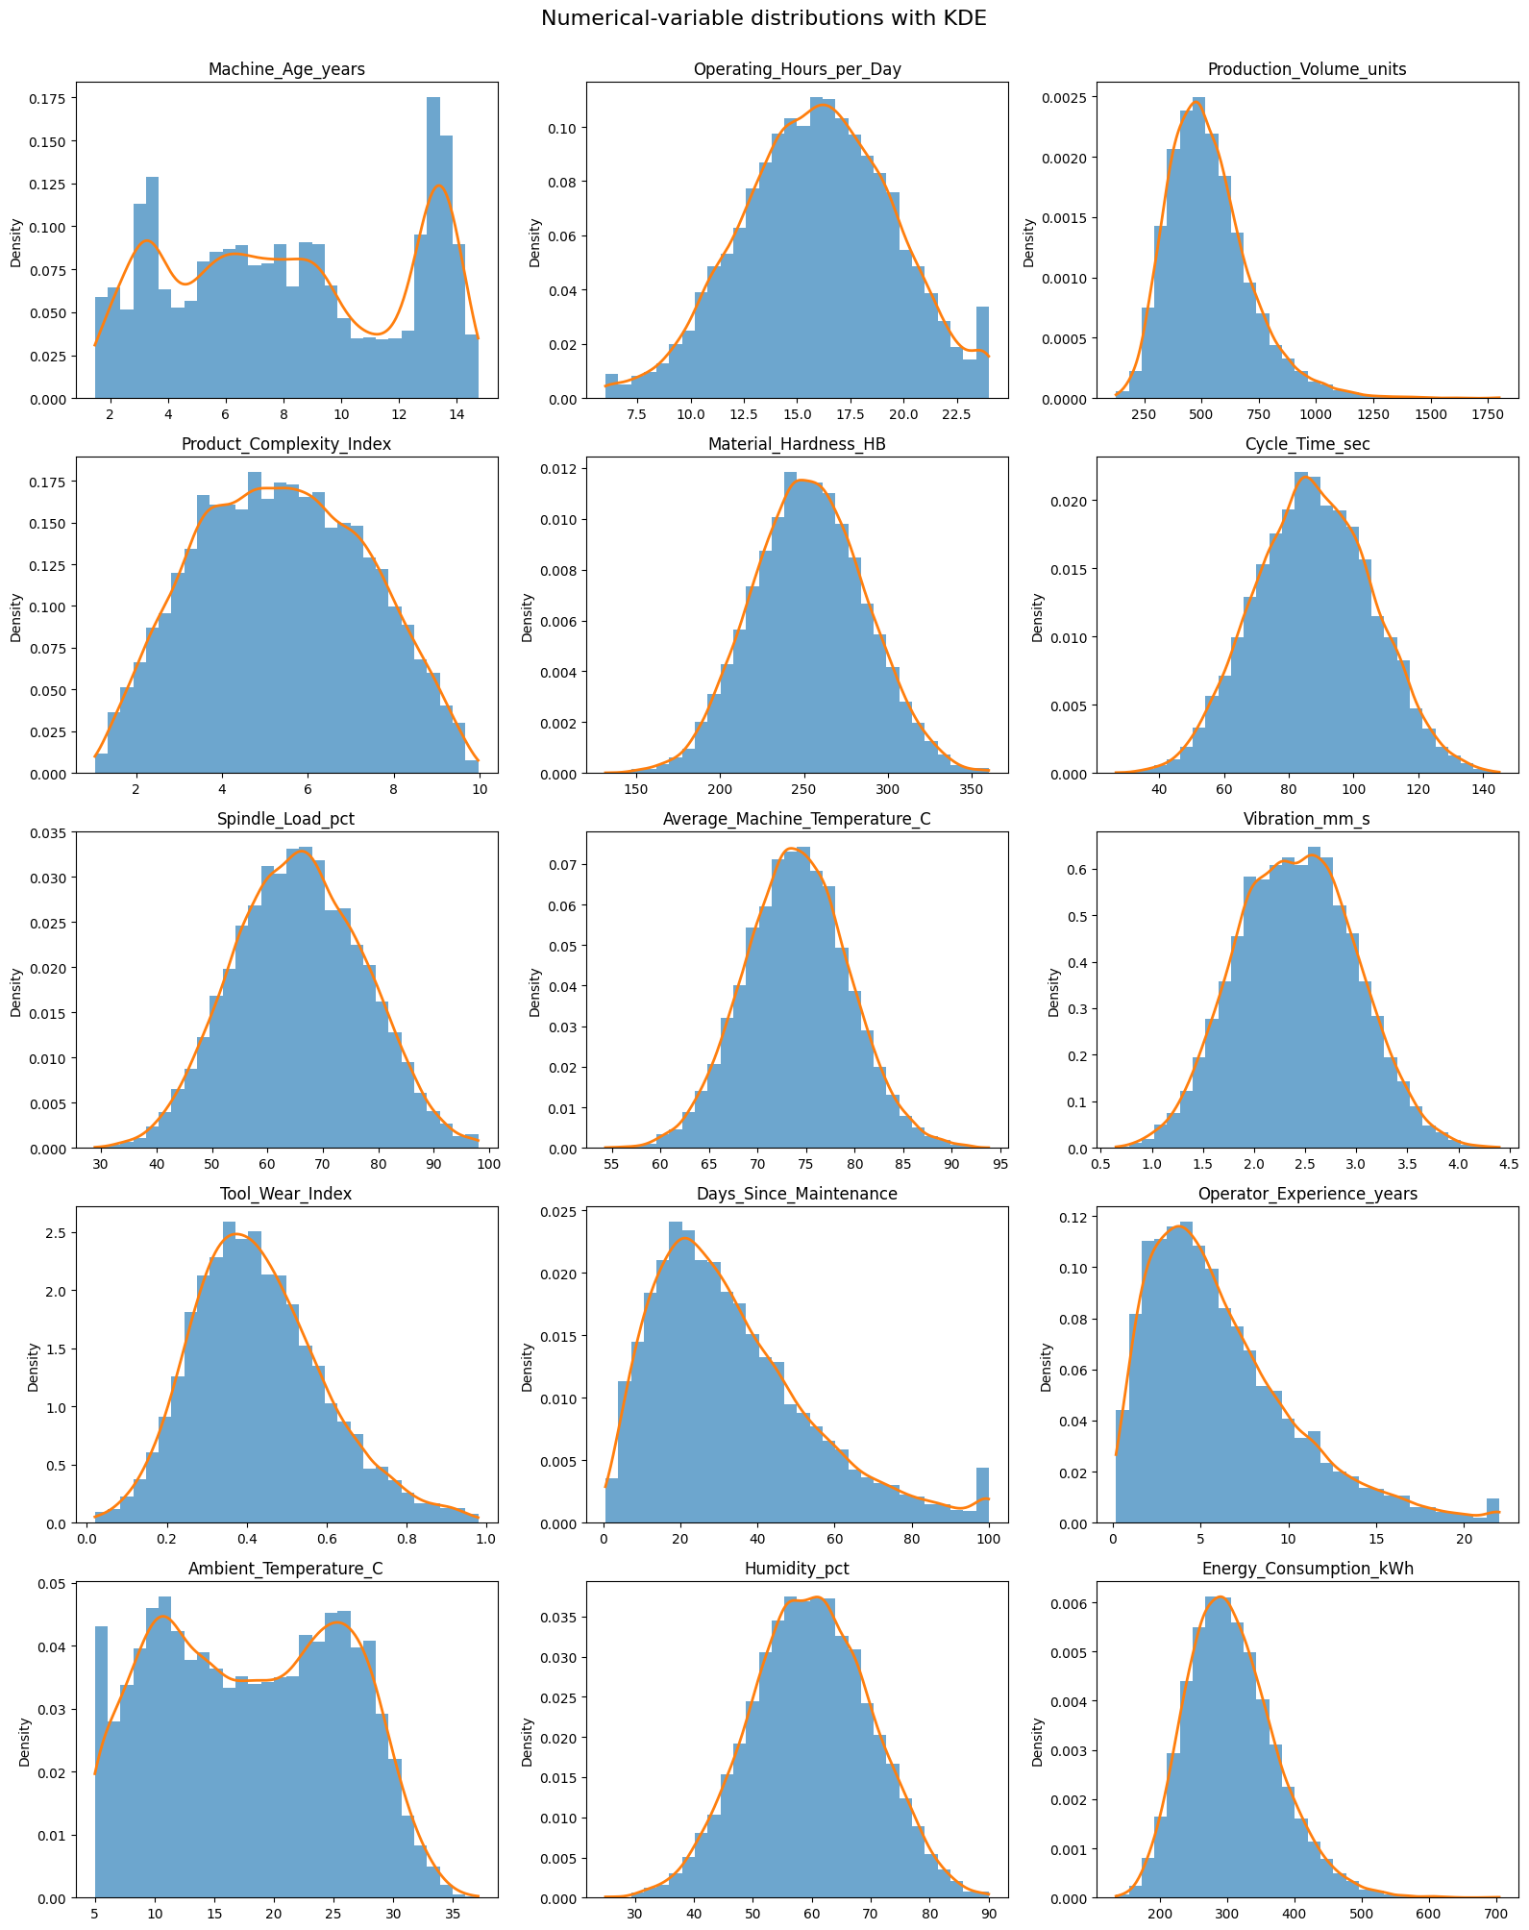
Figure 5. Histograms with density curves (KDE) of the numeric variables (cleaned copy)

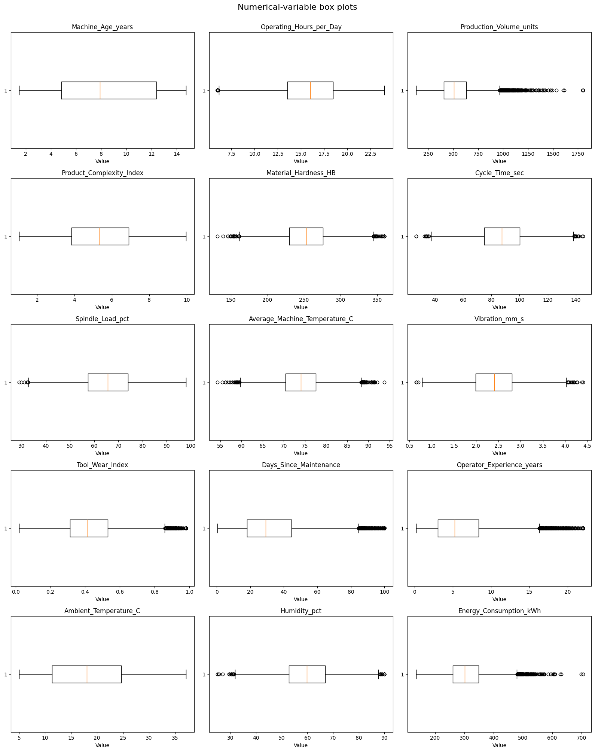
Figure 6. Box plots of the numeric variables (cleaned copy)
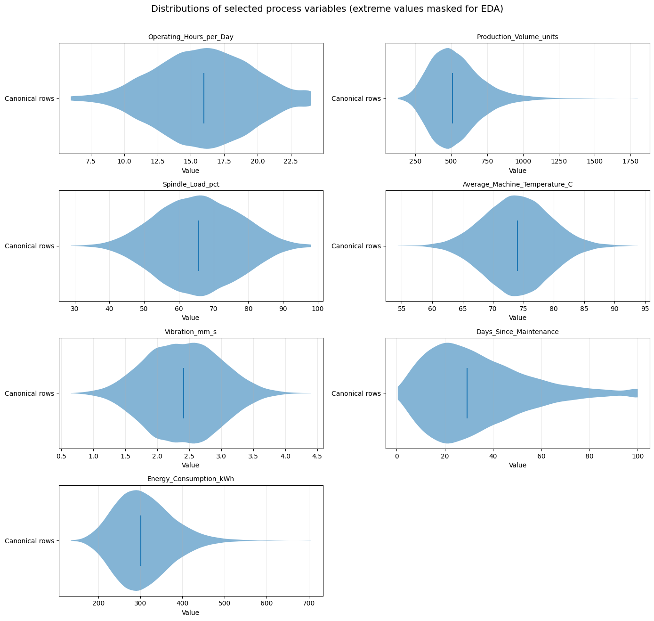
Figure 7. Violin plots of selected variables (cleaned copy)

- Target: The majority of values fall between about 200 and 450 kWh with a peak near 300 kWh and a moderate right tail up to 704.93 kWh. In the audited version, 95 values from 895.7 kWh upward (median 1,185 kWh) generate a distinct group; the highest value below it is 704.93 kWh.
- Roughly symmetric: Operating_Hours_per_Day, Material_Hardness_HB, Spindle_Load_pct, Average_Machine_Temperature_C, Vibration_mm_s, Cycle_Time_sec, Humidity_pct and Machine_Age_years. Product_Complexity_Index remains broad and uniform between 1 and 10.
- Right-skewed: Production_Volume_units (skewness 1.08), Days_Since_Maintenance (1.02), Operator_Experience_years (1.16) and Tool_Wear_Index (0.50).
- Two peaks: Machine_Age_years (near 3–4 and 13–14 years, a newer and an older group of machines) and Ambient_Temperature_C (near 10–11 °C and 25 °C, probably winter and summer).
- Piles at limits: Bars at 6 and 24 hours, at 100 days, at 22 years and at 5 °C (Table 2).
- Separated extreme groups (audit copy): temperature (main body 54–94 °C; 94 values at 157–254 °C), cycle time (main body up to 145 s; 101 values at 236–385 s) and vibration (main body up to 4.4 mm/s; 92 values at 6.7–11.1 mm/s). Each group is set apart from each group from the main body.

Outlier detection
Outliers were identified with the 1.5 × IQR rule (below Q1 − 1.5 × IQR or above Q3 + 1.5 × IQR) for every numeric variable (Table 5, Figure 8). The table reports results from the cleaned copy, thus, theextreme group outlines below are already excluded from this version. The rule is intended to flag unusual values, but it likewise marks the natural tails of skewed variables.

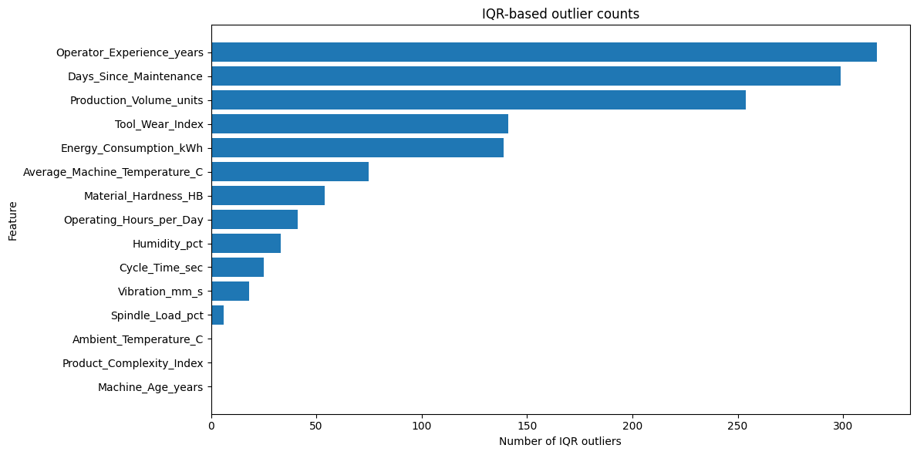
Figure 8. Number of IQR outliers by variable (cleaned copy)
Four extreme groups. Prior to masking, four distinct groups of values fell far well outside the main distribution: temperature above 120 °C, cycle time above 200 s, vibration above 6 mm/s and energy above 800 kWh. Together they cover 382 values in 375 rows (3.75% of 10,000). Table 6 and the evidence below indicates that these are recording errors, not actual states of the machines. This is an interference that must be verified with the data owner.

- Of the 22 duplicated IDs, one copy appears normal and the other is 2.3–5.8 times larger, and the copy with the larger values lies to one of these four groups.
- Records containing temperature above 120 °C, cycle time above 200 s or vibration above 6 mm/s have an average energy (315–327 kWh) in close proximity to the overall mean (308 kWh). A machine that really ran at 210 °C would use far more energy: at 90–100 °C the mean is already 508 kWh (Table 8). The values do not conform to the expected characteristics of the physical quantity.
- The 95 rows with values above 800 kWh exhibit predictor values (mean spindle load 67.5% vs 65.7% overall, median temperature 74.3 °C, mean days since maintenance 31.2, mean complexity 5.69). The 15 highest energy values (1,426–1,473 kWh) arises at spindle loads of 51–80% and temperatures of 64–76 °C.
- The group is present on 38–45 different machines and across all four machine types.
- A Fahrenheit interpretation was evaluated: converting the high temperatures gives 69–123 °C (median 101 °C), and the repeated-ID twins show inflation factors of 2.6–3.2, not a fixed unit conversion. The data therefore do not support a unit mix-up.
Just 10 of the 382 masked values possess an observable clean twin (in the excluded appended rows), Thus, the cause of the other values remains an inference. The cutoffs were selected based on the gaps visible in the histogram and boxplot attached. Recording these values as missing constitutes a provisional, transparent analytical choice; with the original values retained in the audit copy.

Relationships among variables
Table 7 Displays the correlation of each numeric predictor with the target variable. Pearson correlation captures a linear association and is sensitive to outliers. Spearman correlation is ranked-based, capturing the monotonic trend-including curved relationship that rise consistently. The first two columns are based on the cleaned copy; the final column presents Pearson correlation prior to extreme values being set as missing.
Within the cleaned copy ,five variables exhibits a Pearson correlation of roughly 0.5 or higher with energy: temperature (0.563), complexity (0.558), spindle load (0.536), tool wear (0.518) and vibration (0.494). The strongest predictor accounts for about 32% of the variance (0.563²). Prior to setting extreme values to missing, the strongest correlation was only 0.341 (about 12%), and the correlation of temperature was 0.125; the extreme rows therefore hid real relationships. Pearson and Spearman values converge once cleaning is applied, which suggests that the main relationship follow a steadily increasing trend. Ambient_Temperature_C is only weakly negative because its relationship is U-shaped (see below). Production volume and operator experience exhibits almost no linear association with energy. Correlation does not prove causation.
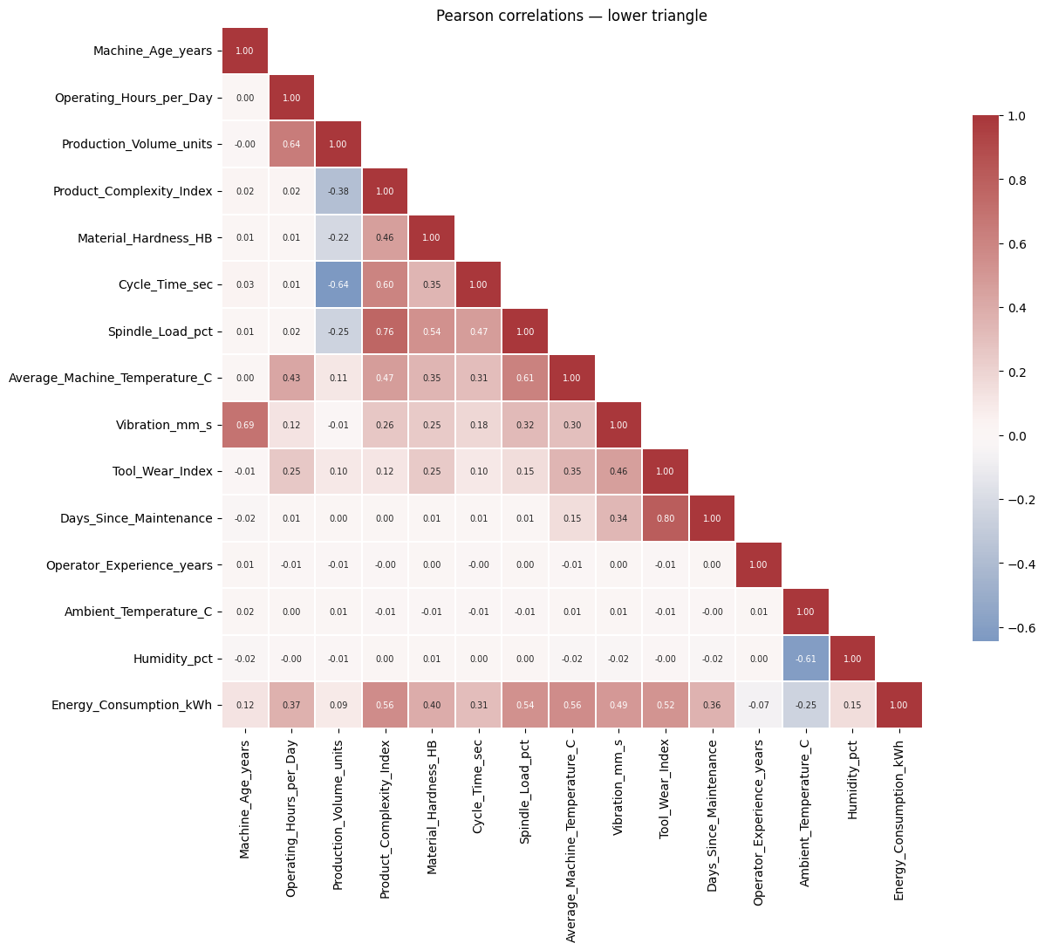
Figure 9. Correlation heatmap of the numeric variables (Pearson, lower triangle, cleaned copy)
The heatmap (Figure 9) exhibits several strongly related predictors: For values above the threshold of 5 ,volume and tool wear overlap noticeably with other predictors (hours and cycle time for volume; days since maintenance for wear).
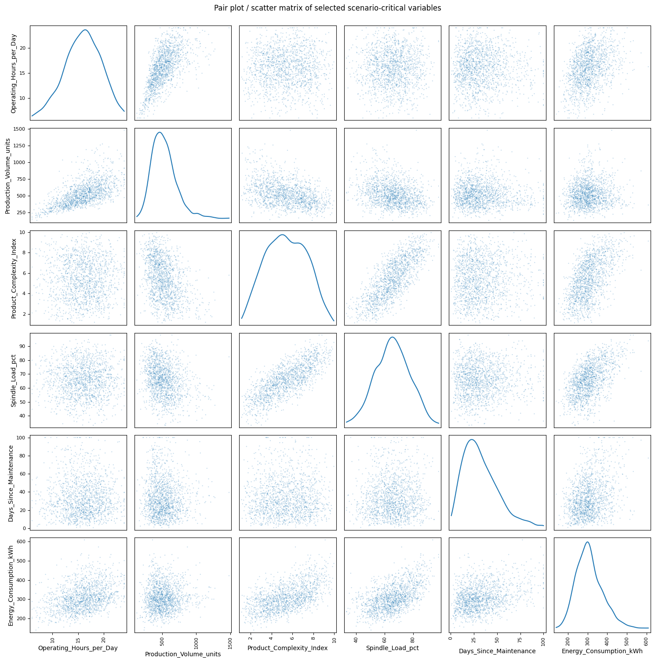
Figure 10. Scatter matrix of selected variables (1,500 sampled rows, cleaned copy)
The scatter matrix (Figure 10) confirms that volume rises with operating hours and spindle load with complexity, and shows that energy curves upward with spindle load and complexity. In the bubble chart (Figure 11), volume rises with operating hours; at a given number of hours, complex products (yellow) have lower volume, and large bubbles (high energy) are common at long hours and high complexity. Figure 12 compares the 25% lowest and 25% highest energy days (each variable converted to a percentile rank): high-energy days (red) are mostly high in complexity, spindle load, temperature, tool wear and vibration, while low-energy days (blue) are mostly low.
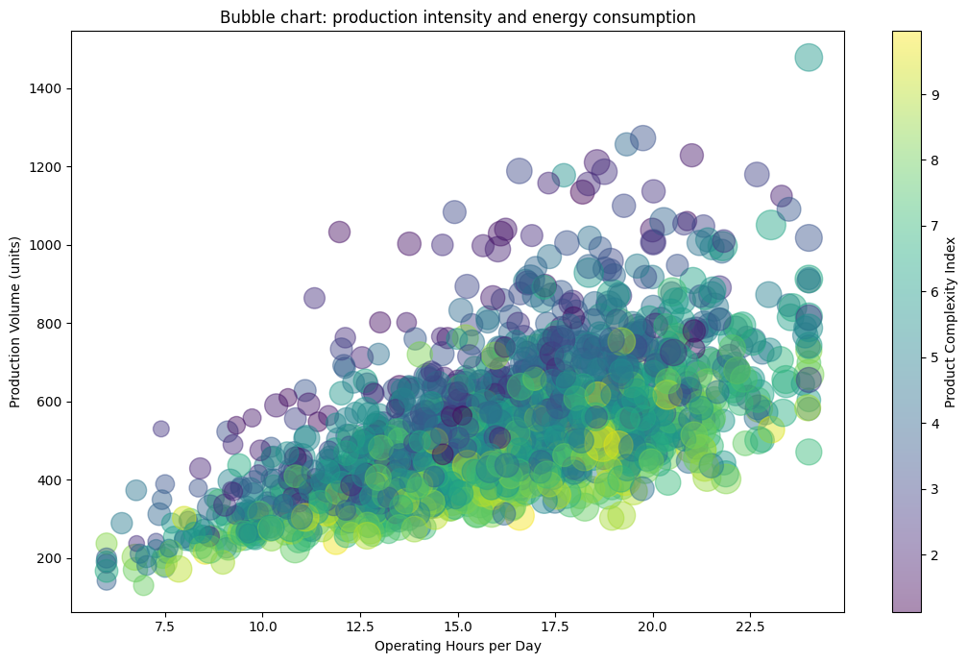
Figure 11. Bubble chart of operating hours and production volume; bubble size = energy, colour = Product_Complexity_Index
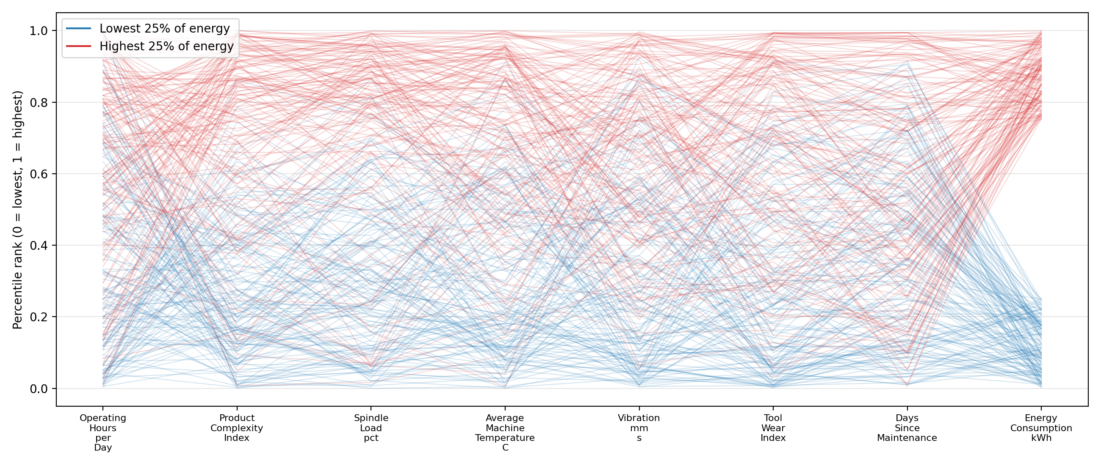
Figure 12. Parallel coordinates for the lowest and highest 25% of energy days (cleaned copy, 150 days each)

Nonlinear patterns and interactions
The brief says that the data contain nonlinear patterns. Table 8 shows mean energy by bin for twelve variables (n in brackets; * means fewer than 20 rows, so unreliable). Figures 13 and 14 show spindleload, temperature and days since maintenance graphically, and Figure 15 shows ambient temperature. The medians follow the same shapes.

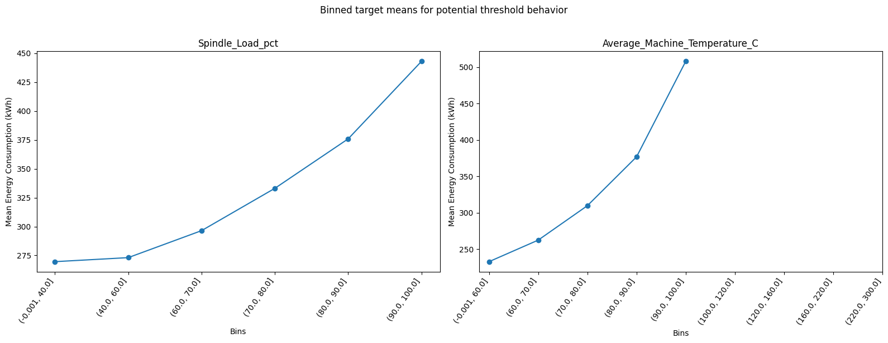
Figure 13. Mean energy by bin for Spindle_Load_pct (left) and Average_Machine_Temperature_C (right), cleaned copy
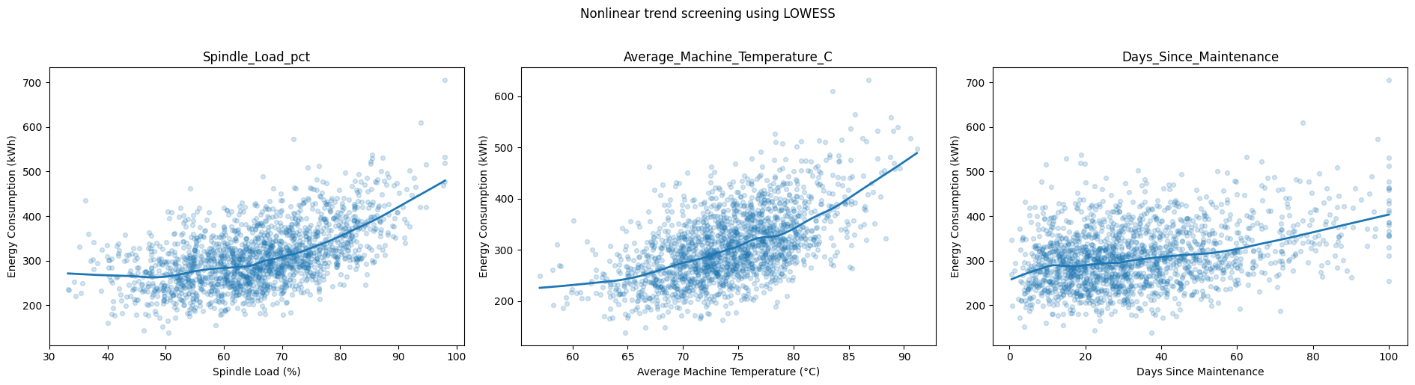
Figure 14. Scatter plots with LOWESS trend lines (1,800 sampled rows each, cleaned copy)
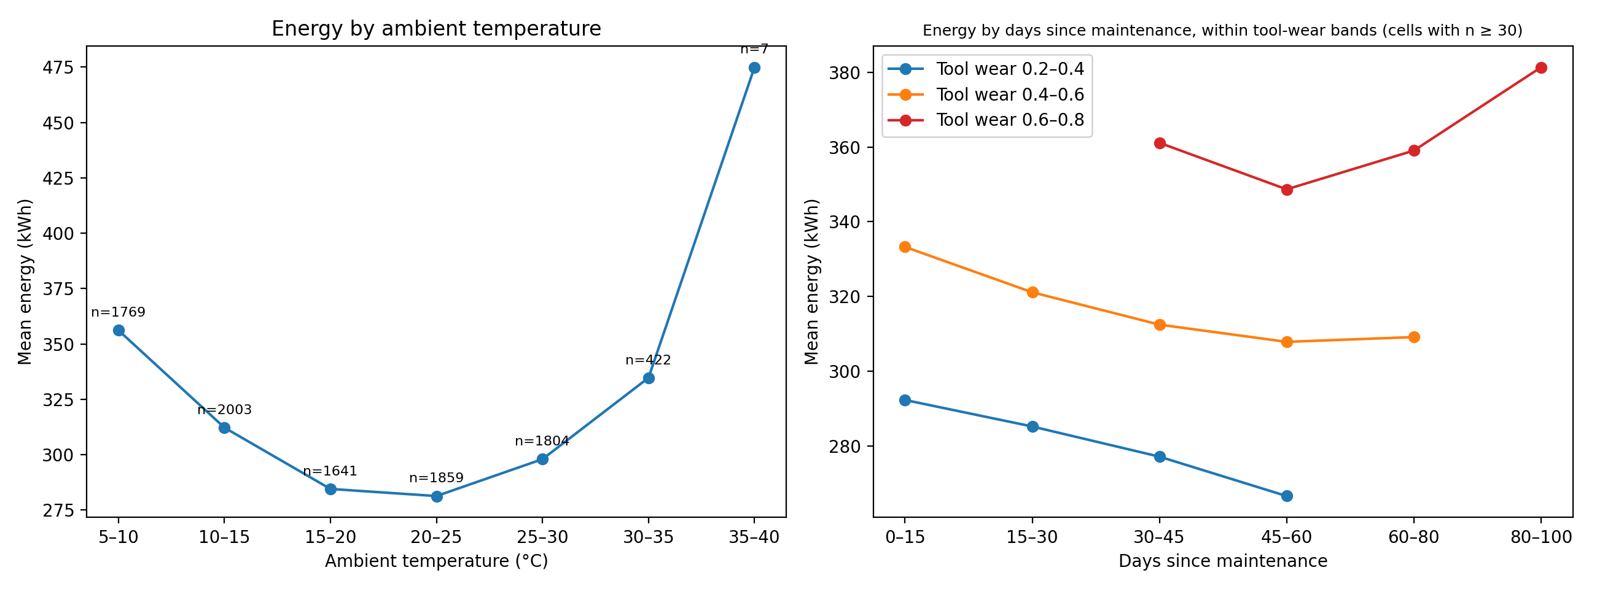
Figure 15. Mean energy by ambient temperature (left) and by days since maintenance within tool-wear bands (right)
Interactions
- Table 9: shows mean energy by spindle-load band and complexity band. Both variables keep their effect inside the bands of the other, and the effects grow together: the gain from load 60–75% to 75–90% is +20.3 kWh at complexity 4–6, +36.3 at 6–8 and +33.3 at 8–10. The highest mean is 453.5 kWh, the lowest 253.4 kWh. Heavy, complex jobs therefore cost more than the two effects added separately.
- Table 10: shows mean energy by days-since-maintenance band and tool-wear band. Reading across a row (same maintenance delay), energy rises strongly with wear. Reading down a column (same wear), more days since maintenance do not raise energy; energy mostly falls . Only at wear 0.6–0.8 does energy rise again at the longest. The overall rise of energy with days since maintenance (287.5 to 406.4 kWh,
- Table 8: Seems to work mainly through tool wear, which grows with days (r = 0.805). The bands are wide and some cells are small, so this needs to be tested in a model.

Time pattern and other plots
- Energy changes through the year (Figure 16, Table 11). Monthly mean energy is highest in January (349.58 kWh) and February (339.21 kWh), lowest in May (282.85 kWh), about 297–308 kWh in June to August, 285.18 kWh in October and 336.00 kWh in December.
- The difference between the highest and lowest month is 66.73 kWh (23.6% above the May mean). The medians (342.04 vs 273.82 kWh) show the same pattern.
- Monthly energy and monthly ambient temperature are negatively related (r = −0.743 over 12 months; descriptive only).
- The pattern fits the U-shape in Figure 15: January (8.3 °C) is high, May (22.3 °C) is lowest and July (28.0 °C) is higher again.
- The seasonal difference (67 kWh) is larger than the shift difference (11 kWh) and larger than the Laser_Cutter–CNC_Lathe difference (46 kWh).
- With one year of data, season cannot be separated from other time effects. Energy by weekday differs by only 6.85 kWh (304.59 kWh on Thursday to 311.44 kWh on Monday; 2.2%), so no clear weekday effect appears.

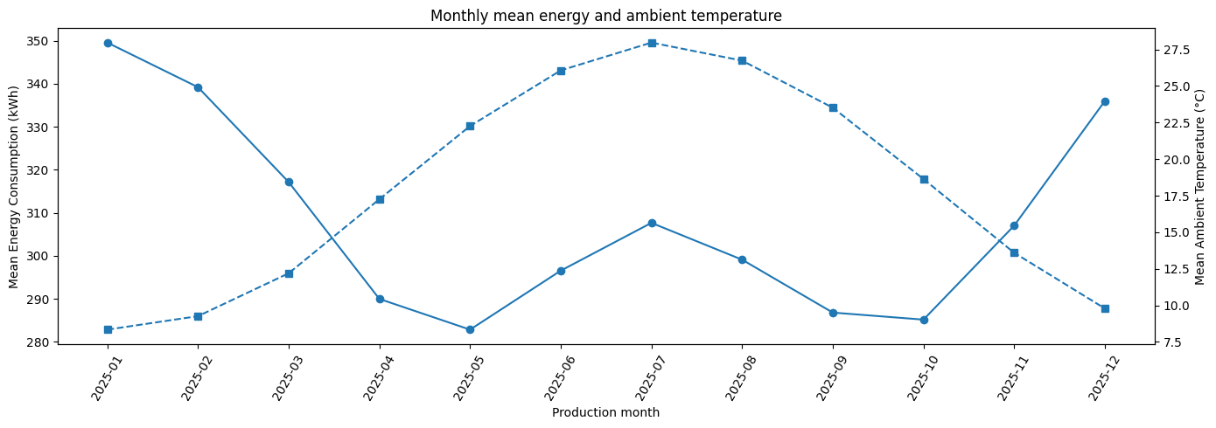
Figure 16. Monthly mean energy consumption (solid line, left axis) and mean ambient temperature (dashed line, right axis), 2025

Brainstorming and discussion

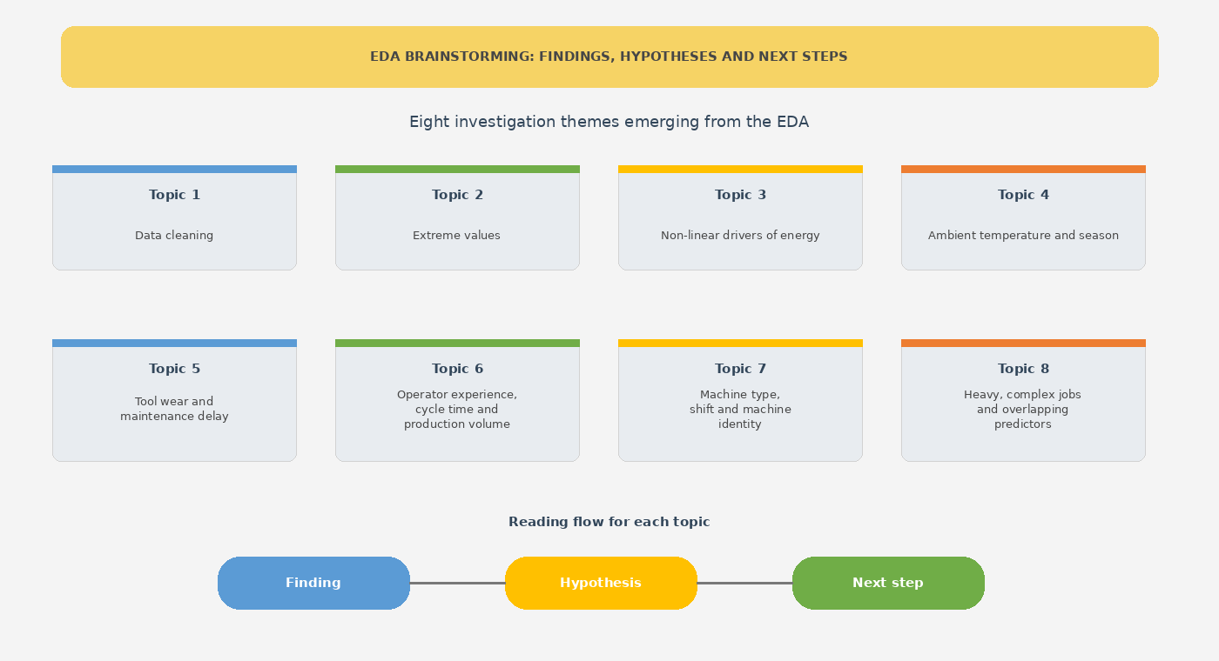
Findings, Hypothesis and next steps from the EDA ( associations only ,not proven causes)

Finding
Hypothesis ↓ Next step
1
The dataset must be cleaned before used, and the cleaning rules need confirmation. The raw file comprises 250 appended rows (228 exact copies, 22 twins with one altered value), 10 invalid labels and 3–6% missing values in five columns (Table 2, Figure 1). Missing rates and mean energy do not differ clearly between missing and observed rows.
Hypothesis: the original gaps are random, and the 22 twins each contain one corrupted value.
Next step: keep one documented cleaning pipeline (first 10,000 rows; Tree corrected from Machine_ID; Dream set to missing; extreme values set to missing; rows with a missing target left out of training; other predictors imputed with the median plus a missing flag inside the cross-validation so that no test information leaks), confirm the row boundary with the data owner, and compare with a complete-case run (Kim et al., 2003; scikit-learn developers, n.d.-b).

2
The four extreme groups are probably recording errors and hide the real signal. In the 22 twins the inflated copy is 2.3–5.8 times larger; rows in the temperature, cycle-time and vibration groups have ordinary energy (315–327 kWh); the 95 energy spikes occur at ordinary predictor values; a Fahrenheit conversion does not explain the temperatures (Table 6, Figures 5–7). Once these values are set to missing, the correlation of temperature with energy rises from 0.125 to 0.563 and the strongest correlation from 0.341 to 0.563 (Table 7).
Hypothesis: the values were created by scaling errors in single fields, and the same cause applies to the values without a visible twin (only 10 of the 382 have one).
Next step: confirm the cause with the data owner; keep the masking if confirmed; report model results with and without the masked values; use MAE next to RMSE. The 139 ordinary high-energy values (480–705 kWh) follow the predictors and stay (Hodge & Austin, 2004; NIST/SEMATECH, n.d.).

3
Energy rises at an accelerating rate with spindle load, temperature, vibration, tool wear, complexity and hardness. Spindle load: 273.1 to 443.1 kWh, with the slope growing from 1.6 to 6.7 kWh per percentage point; temperature: 232.8 to 508.1 kWh with steps of 30, 47, 67 and 131 kWh; Pearson and Spearman correlations of 0.47–0.56 for the five strongest variables (Tables 7 and 8, Figures 13 and 14). This is consistent with overload and overheating penalties and with worn or unstable machines.
Hypothesis: energy is a convex function of load and temperature; thresholds near 80% load and 80–90 °C may exist but are not confirmed.
Next step: compare a linear baseline, a linear model with squared or spline terms, and gradient boosting or random forest using cross-validated MAE and RMSE; estimate any threshold from the data instead of assuming it (scikit-learn developers, n.d.-c; Hastie et al., 2009).

4
Ambient temperature has a U-shape that matches the seasons. Energy is 356.2 kWh below 10 °C, 281.3 kWh at 20–25 °C and 334.7 kWh at 30–35 °C, although r is only −0.247; monthly energy is highest in January (349.58 kWh) and lowest in May (282.85 kWh) and correlates at −0.743 with monthly ambient temperature (Table 8, Table 11, Figures 15 and 16). Both cold and hot conditions may raise energy use (for example heating, cooling or lower process efficiency).
Hypothesis: most of the monthly pattern is explained by ambient temperature.
Next step: add a squared or spline term for Ambient_Temperature_C and month features (month, quarter, sine and cosine of month); compare models with and without month; add a time-ordered validation split because the use case is forecasting. Weekday features are not supported by the data.

5
Tool wear seems to carry most of the maintenance-delay effect. Energy rises from 287.5 to 406.4 kWh with days since maintenance (Table 8), but within a tool-wear band it mostly does not rise with more days, while within a days band it rises steeply with wear (Table 10, Figure 15). Wear and days are correlated at 0.805 and wear has a variance inflation factor of 5.09.
Hypothesis: once tool wear (and vibration) are in the model, days since maintenance adds little; a small extra effect at very long delays (80–100 days) is possible.
Next step: fit models with wear only, days only and both; use regularisation for linear models; if wear is the driver, maintenance should be triggered by wear or vibration and not only by elapsed days (Jardine et al., 2006).

6
Operator experience, cycle time and production volume have small or indirect effects. Energy falls from 314.8 to 299.8 kWh with operator experience and the yearly decline shrinks from 1.6 to 0.06 kWh; cycle time has no effect up to 80 s and increases energy above it; volume has r = 0.090 but a variance inflation factor of 6.31 because it is related to operating hours (0.642) and cycle time (−0.643) (Tables 7 and 8).
Hypothesis: experience has a small, levelling effect, and volume matters mainly through throughput.
Next step: test a log or capped experience variable and a throughput feature (units per hour); keep a feature only if it improves cross-validated error; check whether removing volume changes the coefficients of hours and cycle time.

7
Machine type matters; shift and machine identity matter little. Laser_Cutter uses 336.86 kWh against 290.40 kWh for CNC_Lathe (+16.0%), while shifts differ by 3.7% and machine means range from 274.81 to 355.86 kWh (Table 4, Figures 3 and 4). Load and complexity are almost equal across machine types.
Hypothesis: Machine_Type adds information beyond the numeric variables; shift and machine identity add little.
Next step: one-hot encode Machine_Type and Shift (handling the 5 missing shifts); test Machine_Type × Spindle_Load_pct; do not use Machine_ID as a predictor, but use it for grouped cross-validation so that all rows of one machine stay in the same fold (scikit-learn developers, n.d.-a).

8
Heavy, complex jobs act together, and several predictors overlap. Load and complexity are correlated (0.762) and both keep their effect inside each other's bands; the load gain is +20.3, +36.3 and +33.3 kWh at complexity 4–6, 6–8 and 8–10, and the highest mean (453.5 kWh) occurs at load above 90% with complexity 8–10 (Table 9). Other overlapping pairs: wear and days (0.805), age and vibration (0.688), hours and volume (0.642), ambient temperature and humidity (−0.610) (Figure 9).
Hypothesis: a load × complexity interaction improves prediction, and humidity adds little once ambient temperature is included.
Next step: add interaction terms or use tree-based models; use ridge or lasso regularisation for linear models; test whether humidity improves validation error (Hastie et al., 2009).

What the numbers mean for the case-study problem
The case study asks two things: To estimate before the end of each day how much energy a machine will use and understanding which factors are associated with unusually high energy use. This section turns the numbers of the analysis into answers to these two questions. All statements are associations in one year of data and must be confirmed in Part 2.
- What is a normal and what is an unusual day? An ordinary machine-day makes use of abou about 301 kWh (median), and the middle half of the days lie between 260 and 348 kWh. A day above about 396 kWh belongs to the top 10% of days, and a day above 480 kWh (1.5% of days) is an IQR outlier. Therefore, a simple scale can be adopted by management: normal is 260–350 kWh, and atypically high starts at about 400 kWh.
- Which factors matter most? Table 12 evaluate the average against low and a high level of each factor, using the group means of Tables 4, 8 and 11. The factors are ranked by the size of the difference.Seven factors (load, wear, complexity, days since maintenance, temperature, vibration and ambient temperature) change the average day by 75–170 kWh, which is 27–62% of the lower level. Season and machine type follow with 47–67 kWh. Shift, weekday and operator experience change energy by 5% or less and are not useful levers. Because the factors overlap (wear and days since maintenance, load and complexity), the differences cannot be added together.
- High-energy days come from several factors together. Table 13 counts, for each machine-day, how many of six risk flags apply: spindle load above 80%, temperature above 80 °C, tool wear above 0.6, vibration above 3 mm/s, complexity above 7, and ambient temperature below 10 or above 30 °C. The thresholds are taken from the bins in Table 8. Days with no flag average 259 kWh and none of them is in the top 10%. With three flags the average is 388 kWh, and with five flags 479 kWh. One day in eight (12.1%) has three or more flags; these days contain 65% of all top-10% days, and 54% of them are top-10% days themselves. Days with two or more flags are 26% of all days and contain 90% of the top-10% days. No single factor explains high energy; it is the stacking of several factors.

Conclusuion

How the numbers can be used to solve the problem:

- Prediction before the end of the day. The strongest single variable (temperature, r = 0.563) explains about 32% of the variance, and several effects are curved. A prediction model should therefore combine many variables and include nonlinear terms (Part 2). Inputs known in the morning are the planned load and complexity, operating hours, machine type, tool wear, days since maintenance, the ambient forecast and the month. Daily averages of temperature and vibration may be known only at the end of the day, so the previous day's values may have to be used.
- Early-warning rule. A simple check of the six flags in the morning would point to the days that need attention: reviewing the 26% of days with two or more flags covers 90% of the top-10% days. The rule is only a first idea, because the thresholds come from the same data.
- Size of the effect. If the 1,125 days above 80% load averaged the energy of the 70–80% band (333.1 kWh), the saving would be about 52 kWh per day, or about 58,000 kWh, which is 2.0% of the 2.93 million kWh recorded. This assumes that load causes the difference. The top 10% of days use 14.3% of the energy. No single measure removes more than a few percent; the larger gain comes from combining measures and from avoiding the stacking of risk factors. The cost per kWh is not given, so no money value is calculated.
- Data quality. About 4% of the rows contain values (for example 254 °C or 1,473 kWh) that behave like recording errors. A simple range check when data are recorded would prevent false alarms and wrong forecasts, and is an immediate action that needs no model.
From evidence to decision rules and Part 2 features. Table 14 links each lever to the numbers, to a rule that management could test, and to the feature that Part 2 should build. The rules are proposals to test, not results: the data show associations, and the thresholds were read from the same data.

Limits. The effects are differences of group means and were not adjusted for each other. The flag results are in-sample and probably too optimistic, because the thresholds were read from the same data; Part 2 should test them on unseen data, with all rows of one machine kept in the same group. The data cover one year, and the causes of the extreme values must still be confirmed with the data owner.

Methodological References
- Cleveland, W. S. (1979). Robust locally weighted regression and smoothing scatterplots. Journal of the American Statistical Association, 74(368), 829–836.
- Hastie, T., Tibshirani, R., & Friedman, J. (2009). The elements of statistical learning (2nd ed.). Springer.
- Hodge, V. J., & Austin, J. (2004). A survey of outlier detection methodologies. Artificial Intelligence Review, 22(2), 85–126.
- Jardine, A. K. S., Lin, D., & Banjevic, D. (2006). A review on machinery diagnostics and prognostics implementing condition-based maintenance. Mechanical Systems and Signal Processing, 20(7), 1483–1510.
- Kim, W., Choi, B.-J., Hong, E.-K., Kim, S.-K., & Lee, D. (2003). A taxonomy of dirty data. Data Mining and Knowledge Discovery, 7(1), 81–99.
- NIST/SEMATECH. (n.d.). What are outliers in the data? In NIST/SEMATECH e-handbook of statistical methods. https://www.itl.nist.gov/div898/handbook/prc/section1/prc16.htm
- scikit-learn developers. (n.d.-a). Cross-validation: grouped splitters (GroupKFold). https://scikit-learn.org/stable/modules/cross_validation.html
- scikit-learn developers. (n.d.-b). Imputation of missing values. https://scikit-learn.org/stable/modules/impute.html
- scikit-learn developers. (n.d.-c). Preprocessing data: polynomial features and spline transformer. https://scikit-learn.org/stable/modules/preprocessing.html

Annexture Tables

Table 1. Summary statistics of the numeric variables (cleaned copy, extreme values set to missing)
Variable | Count | Mean | Std | Min | Median | Max | Skew
Machine_Age_years | 10,000 | 8.17 | 3.93 | 1.47 | 7.91 | 14.74 | 0.07
Operating_Hours_per_Day | 10,000 | 15.95 | 3.57 | 6.00 | 15.99 | 24.00 | −0.08
Production_Volume_units | 10,000 | 532.87 | 182.85 | 127 | 507 | 1,800 | 1.08
Product_Complexity_Index | 10,000 | 5.39 | 1.95 | 1.04 | 5.35 | 9.96 | 0.05
Material_Hardness_HB | 10,000 | 253.12 | 33.49 | 131.80 | 252.70 | 360.00 | 0.04
Cycle_Time_sec | 9,899 | 87.77 | 18.01 | 26.63 | 87.51 | 145.00 | 0.02
Spindle_Load_pct | 10,000 | 65.73 | 11.60 | 28.90 | 65.65 | 98.00 | 0.03
Average_Machine_Temperature_C | 9,506 | 74.01 | 5.35 | 54.34 | 74.01 | 93.80 | 0.04
Vibration_mm_s | 9,408 | 2.41 | 0.58 | 0.65 | 2.41 | 4.40 | 0.05
Tool_Wear_Index | 9,400 | 0.431 | 0.166 | 0.020 | 0.414 | 0.980 | 0.50
Days_Since_Maintenance | 10,000 | 33.41 | 20.78 | 0.50 | 29.20 | 100.00 | 1.02
Operator_Experience_years | 10,000 | 6.23 | 4.22 | 0.20 | 5.27 | 22.00 | 1.16
Ambient_Temperature_C | 10,000 | 18.06 | 7.63 | 5.00 | 18.01 | 37.11 | 0.03
Humidity_pct | 9,700 | 59.86 | 10.15 | 25.00 | 59.82 | 90.00 | −0.01
Energy_Consumption_kWh (target) | 9,505 | 307.99 | 67.51 | 134.94 | 301.21 | 704.93 | 0.64
Table 2. Data-quality issues and how they were handled
Issue | Size | Handling
Appended rows with repeated IDs | 250 rows (228 exact copies, 22 twins) | Excluded; the first 10,000 rows have unique IDs 1–10,000. This boundary should be confirmed with the data owner.
Machine_Type = "Tree" | 5 rows | Corrected from Machine_ID (each machine has one type): M031 Laser_Cutter, M040 CNC_Grinder, M027 CNC_Mill, M045 CNC_Grinder, M020 CNC_Mill.
Shift = "Dream" | 5 rows | Set to missing (true shift cannot be inferred).
Missing predictors (original) | Tool wear 600, vibration 500, temperature 400, humidity 300 | Impute (median) inside the model pipeline and add a missing flag.
Missing target (original) | 400 rows (4.00%) | Do not impute; leave out of model training.
Values at limits | 6.0 h: 38; 24.0 h: 125; 100 days: 127; 22 years: 58; 5.0 °C: 261 | Keep; true values may lie beyond the limit.
Extreme values set to missing | 382 values in 375 rows (3.75%) | Provisional; to be confirmed with the data owner (see the outlier section). Impute the predictors; drop the rows with a masked target from training.

Table 3. Counts of the categorical variables (cleaned copy, 10,000 rows)
Variable | Level | Rows | %
Machine_Type | CNC_Mill | 3,606 | 36.06
 | CNC_Grinder | 2,236 | 22.36
 | CNC_Lathe | 2,208 | 22.08
 | Laser_Cutter | 1,950 | 19.50
Shift | Day | 5,071 | 50.71
 | Evening | 2,862 | 28.62
 | Night | 2,062 | 20.62
 | (missing) | 5 | 0.05

Table 4. Energy consumption (kWh) by Machine_Type and Shift
Variable | Group | n | Mean | Median | Std
Machine_Type | Laser_Cutter | 1,840 | 336.86 | 329.36 | 66.67
 | CNC_Grinder | 2,125 | 311.66 | 305.41 | 64.39
 | CNC_Mill | 3,441 | 301.00 | 293.19 | 66.01
 | CNC_Lathe | 2,099 | 290.40 | 284.25 | 65.39
Shift | Night | 1,966 | 315.73 | 310.12 | 67.07
 | Evening | 2,710 | 308.75 | 300.62 | 68.38
 | Day | 4,824 | 304.39 | 297.83 | 66.94

Table 5. IQR outliers by variable in the cleaned copy (percentages of observed values)
Variable | Threshold | Count (%) | Interpretation and decision
Operator_Experience_years | >16.30 | 316 (3.16%) | Normal right tail; maximum 22 is a cap. Keep.
Days_Since_Maintenance | >84.50 | 299 (2.99%) | Normal right tail; pile at 100 days. Keep.
Production_Volume_units | >965 | 254 (2.54%) | High-volume days; volume rises with operating hours (r = 0.64). Keep.
Energy_Consumption_kWh | >480.44 | 139 (1.46%) | All are above the upper fence, up to 704.93 kWh. They follow the predictors (Figure 14). Keep.
Tool_Wear_Index | >0.858 | 141 (1.50%) | Valid (maximum 0.98 is inside the 0–1 scale). Keep.
Average_Machine_Temperature_C | <59.63 or >88.31 | 75 (0.79%) | 23 low and 52 high values inside the normal range. Keep.
Material_Hardness_HB | <161.4 or >344.6 | 54 (0.54%) | Smooth tails on both sides. Keep.
Operating_Hours_per_Day | <6.12 | 41 (0.41%) | 38 are exactly 6.0 h, the lower limit. Keep.
Humidity_pct | <31.74 or >88.06 | 33 (0.34%) | Inside the range 25–90. Keep.
Cycle_Time_sec | <37.13 or >138.27 | 25 (0.25%) | Normal tails after masking. Keep.
Vibration_mm_s | <0.767 or >4.033 | 18 (0.19%) | Normal tails after masking. Keep.
Spindle_Load_pct | <32.84 | 6 (0.06%) | Low-load days. Keep.
Machine_Age_years, Product_Complexity_Index, Ambient_Temperature_C | – | 0 | No outliers.

Table 6. Extreme groups in the first 10,000 rows (audit copy) and evidence that they are recording errors
Group | Rows (%) | Value range | Mean energy of these rows (kWh) | Repeated-ID twins: inflated copy in the first 10,000 rows / in the excluded rows | Inflation factor of the twins
Temperature > 120 °C | 94 (0.94%) | 156.8–253.6 °C | 327.2 | 1 / 4 | 2.62–3.18
Cycle time > 200 s | 101 (1.01%) | 235.5–384.9 s | 325.1 | 1 / 1 | 2.47–3.04
Vibration > 6 mm/s | 92 (0.92%) | 6.72–11.05 mm/s | 315.2 | 3 / 5 | 2.67–5.25
Energy > 800 kWh | 95 (0.95%) | 895.7–1,472.8 kWh | 1,204.8 | 5 / 3 | 2.27–5.81

Table 7. Correlation with Energy_Consumption_kWh
Variable | Pearson (cleaned copy) | Spearman (cleaned copy) | Pearson before masking extremes
Average_Machine_Temperature_C | 0.563 | 0.539 | 0.125
Product_Complexity_Index | 0.558 | 0.553 | 0.341
Spindle_Load_pct | 0.536 | 0.524 | 0.328
Tool_Wear_Index | 0.518 | 0.473 | 0.296
Vibration_mm_s | 0.494 | 0.467 | 0.191
Material_Hardness_HB | 0.395 | 0.384 | 0.254
Operating_Hours_per_Day | 0.372 | 0.372 | 0.220
Days_Since_Maintenance | 0.362 | 0.284 | 0.204
Cycle_Time_sec | 0.311 | 0.309 | 0.125
Ambient_Temperature_C | −0.247 | −0.259 | −0.157
Humidity_pct | 0.153 | 0.156 | 0.099
Machine_Age_years | 0.123 | 0.122 | 0.065
Production_Volume_units | 0.090 | 0.086 | 0.048
Operator_Experience_years | −0.068 | −0.068 | −0.036

Table 8. Mean energy (kWh) by variable bin, with the number of rows in brackets (cleaned copy)
Variable | Mean energy by bin (n)
Spindle_Load_pct | ≤40: 269.6 (92) | 40–60: 273.1 (2,970) | 60–70: 296.4 (3,077) | 70–80: 333.1 (2,241) | 80–90: 375.9 (976) | 90–100: 443.1 (149)
Average_Machine_Temperature_C | ≤60: 232.8 (36) | 60–70: 262.4 (2,012) | 70–80: 309.7 (5,812) | 80–90: 376.9 (1,158) | 90–100: 508.1* (16) | above 100: masked
Vibration_mm_s | ≤1: 231.2 (36) | 1–2: 270.5 (2,239) | 2–3: 309.4 (5,266) | 3–4: 364.6 (1,381) | 4–5: 454.2* (18) | above 6: masked
Tool_Wear_Index | ≤0.1: 230.5 (92) | 0.1–0.2: 256.4 (451) | 0.2–0.3: 274.8 (1,427) | 0.3–0.4: 292.6 (2,203) | 0.4–0.5: 307.8 (2,016) | 0.5–0.6: 325.5 (1,384) | 0.6–0.7: 350.5 (747) | 0.7–0.8: 379.3 (361) | 0.8–0.9: 414.5 (171) | 0.9–1.0: 455.3 (74)
Product_Complexity_Index | ≤2: 257.4 (315) | 2–3: 262.9 (881) | 3–4: 273.8 (1,422) | 4–5: 284.9 (1,573) | 5–6: 301.4 (1,609) | 6–7: 324.7 (1,491) | 7–8: 345.6 (1,234) | 8–10: 389.6 (980)
Material_Hardness_HB | 100–150: 212.9* (6) | 150–200: 269.6 (521) | 200–250: 287.4 (3,935) | 250–300: 321.1 (4,253) | 300–350: 364.6 (774) | 350–400: 422.4* (16)
Days_Since_Maintenance | ≤15: 287.5 (1,769) | 15–30: 296.3 (3,171) | 30–45: 306.4 (2,254) | 45–60: 317.5 (1,241) | 60–80: 349.4 (706) | 80–100: 406.4 (364)
Ambient_Temperature_C | 5–10: 356.2 (1,769) | 10–15: 312.2 (2,003) | 15–20: 284.5 (1,641) | 20–25: 281.3 (1,859) | 25–30: 298.0 (1,804) | 30–35: 334.7 (422) | 35–40: 474.9* (7)
Humidity_pct | 20–30: 338.2* (6) | 30–40: 307.7 (221) | 40–50: 298.4 (1,311) | 50–60: 298.9 (3,125) | 60–70: 310.4 (3,049) | 70–80: 329.0 (1,304) | 80–100: 344.4 (202)
Cycle_Time_sec | ≤60: 289.8 (585) | 60–80: 287.9 (2,572) | 80–100: 303.1 (3,855) | 100–120: 335.6 (2,048) | 120–160: 377.2 (348) | above 200: masked
Operator_Experience_years | ≤2: 314.8 (1,224) | 2–5: 310.9 (3,245) | 5–8: 307.1 (2,433) | 8–12: 303.0 (1,648) | 12–16: 300.2 (620) | 16–25: 299.8 (335)
Production_Volume_units | ≤300: 287.5 (614) | 300–500: 306.9 (3,978) | 500–700: 309.3 (3,419) | 700–900: 312.6 (1,127) | 900–1,200: 326.5 (323) | 1,200–1,800: 330.5 (44)

Table 9. Mean energy (kWh) by spindle-load band and complexity band (n in brackets)
Spindle load | Complexity ≤2 | 2–4 | 4–6 | 6–8 | 8–10
≤40% | 272.3 (34) | 267.6 (55) | 275.0* (3) | – | –
40–60% | 253.4 (256) | 266.6 (1,579) | 282.3 (971) | 310.8 (161) | 336.7* (3)
60–75% | 278.4 (25) | 275.6 (648) | 295.3 (1,916) | 320.2 (1,528) | 356.6 (221)
75–90% | – | 312.0 (21) | 315.6 (289) | 356.5 (1,003) | 389.9 (643)
90–100% | – | – | 382.0* (3) | 412.9 (33) | 453.5 (113)

Table 10. Mean energy (kWh) by days-since-maintenance band and tool-wear band (n in brackets)
Days since maintenance | Wear ≤0.2 | 0.2–0.4 | 0.4–0.6 | 0.6–0.8 | 0.8–1.0
≤15 | 252.4 (367) | 292.3 (1,134) | 333.3 (165) | 484.3* (2) | –
15–30 | 253.1 (165) | 285.3 (1,788) | 321.1 (1,005) | 374.7 (29) | –
30–45 | 225.8* (11) | 277.2 (603) | 312.5 (1,334) | 361.1 (166) | 496.7* (2)
45–60 | – | 266.7 (100) | 307.9 (700) | 348.7 (347) | 385.0* (11)
60–80 | – | 268.2* (4) | 309.2 (188) | 359.0 (408) | 415.3 (62)
80–100 | – | 312.3* (1) | 349.9* (8) | 381.3 (156) | 432.9 (170)

Table 11. Monthly energy consumption (kWh) and ambient temperature (°C), 2025
Month | Rows with target | Mean energy | Median energy | Mean ambient
2025-01 | 806 | 349.58 | 342.04 | 8.33
2025-02 | 728 | 339.21 | 331.52 | 9.26
2025-03 | 829 | 317.15 | 309.38 | 12.19
2025-04 | 818 | 289.99 | 282.14 | 17.26
2025-05 | 764 | 282.85 | 273.82 | 22.26
2025-06 | 781 | 296.56 | 289.92 | 26.07
2025-07 | 834 | 307.67 | 302.96 | 27.97
2025-08 | 827 | 299.11 | 293.52 | 26.74
2025-09 | 762 | 286.81 | 278.88 | 23.52
2025-10 | 792 | 285.18 | 278.52 | 18.64
2025-11 | 795 | 307.03 | 298.51 | 13.59
2025-12 | 769 | 336.00 | 331.35 | 9.78

Table 12. Energy difference between a high and a low level of each factor (kWh and % of the lower level)
Factor | Comparison | Difference in mean energy | Can management influence it? | What it means
Spindle load | 90–100% vs 40–60% | +170.0 (+62%) | Partly (job allocation) | Overload region; energy per extra load point grows from 1.6 to 6.7 kWh.
Tool wear | 0.9–1.0 vs 0.3–0.4 | +162.7 (+56%) | Yes (tool change, maintenance) | Largest single lever on the maintenance side.
Product complexity | 8–10 vs ≤2 | +132.2 (+51%) | Partly (product mix, machine assignment) | Complex jobs need more energy, especially at high load.
Days since maintenance | 80–100 vs ≤15 days | +118.9 (+41%) | Yes | Works mainly through tool wear (Table 10).
Machine temperature | 80–90 vs 60–70 °C | +114.5 (+44%) | Partly (cooling, load) | Cost per degree rises above 80 °C.
Vibration | 3–4 vs 1–2 mm/s | +94.1 (+35%) | Yes (balancing, repair) | Early sign of a worn or unstable machine.
Ambient temperature | below 10 vs 20–25 °C | +74.9 (+27%) | No (plan for it) | Cold and hot days cost more; U-shape.
Season (month) | January vs May | +66.7 (+24%) | No (plan for it) | Follows ambient temperature; higher energy in winter.
Machine type | Laser_Cutter vs CNC_Lathe | +46.5 (+16%) | Partly (equipment planning) | Compare machines within their type.
Operator experience | 16–25 vs ≤2 years | −15.0 (−5%) | Partly (training) | Small effect that levels off.
Shift | Night vs Day | +11.3 (+4%) | – | Not a useful lever.
Weekday | highest vs lowest day | 6.9 (2%) | – | No clear effect.

Table 13. Number of risk flags per day and energy consumption (days with all six variables observed, n = 7,986; top 10% = at least 396.4 kWh)
Risk flags (of 6) | Share of days (%) | Mean energy (kWh) | Days in the top 10% of energy (%)
0 | 42.3 | 259.3 | 0.0
1 | 31.5 | 312.8 | 3.3
2 | 14.2 | 355.5 | 17.4
3 | 7.4 | 388.2 | 39.0
4 | 3.3 | 423.6 | 71.8
5 | 1.2 | 479.2 | 89.9
6 | 0.1 (9 days) | 532.0 | 100.0

Dataset 2: Port Logistics Dispatching (Classification)

Exploratory data analysis

Data visualization and exploration
This section examines the Port Logistics Dispatching dataset, which represents dispatch decisions in a port-logistics control tower under changing traffic, terminal, weather, time-window, vehicle, driver, and resource conditions. The analytical target is Recommended_Dispatch_Action, a six-class categorical outcome: PROCEED_AS_PLANNED, WAIT_AND_MONITOR, RESCHEDULE_SLOT, REROUTE, REASSIGN_VEHICLE, and PRIORITY_RECOVERY. The work reported here is exploratory data analysis (EDA); no final classification model is trained or evaluated.

Dataset scope, structure and variable roles
The assignment specifies 10,000 dispatch cases and 41 columns, but the supplied CSV contains 10,250 rows. For a transparent provisional EDA, the first 10,000 rows are used because they contain Observation_ID values 1–10,000 exactly once; the appended 250 rows are audited after Figure 2.1. The columns consist of an identifier, timestamp/context fields, operational measurements and status indicators, and the six-class target. Observation_ID is an identifier, not a candidate predictor. Any later model should use only information genuinely available when the dispatcher makes the decision.
Table 2.1. Variable groups and operational roles (compiled from the assignment data dictionary).
Variable group | Fields in the dataset | Operational role
Temporal and location context | Event_Timestamp; Day_of_Week; Shift; Terminal_ID; Corridor_ID | When and where the dispatch decision is assessed.
Transport assignment | Transport_Object_Type; Vehicle_Type; Distance_to_Terminal_km | Object/vehicle configuration and remaining distance to terminal.
Disruptions and congestion | Weather_Severity_Index; Terminal_Incident_Severity; Road_Incident_Severity; Terminal_Congestion_Index; Road_Congestion_Index; Expected_Disruption_Duration_min; Current_Delay_min; ETA_Uncertainty_min; Disruptions_Last_7d | Weather, incident, congestion and delay conditions.
Terminal handling and slot | Yard_Occupancy_pct; Queue_Length_vehicles; Gate_Processing_Time_min; Slot_Window_min; Slot_Buffer_min | Terminal workload and remaining time-window slack.
Readiness and operating constraints | Trailer_Ready; Customs_Status; Vehicle_Technical_Status; Remaining_Driver_Hours; Cargo_Priority | Whether the assignment, vehicle, clearance and driver can proceed.
Alternative resources | Alternative_Slot_Available; Alternative_Terminal_Available; Alternative_Route_Available; Alternative_Route_Extra_km; Nearby_Compatible_Vehicles; Driver_Change_Available | Feasible recovery alternatives and resource substitution.
Commercial, utilization, quality and sustainability | Service_Level_Penalty_EUR; Vehicle_Load_Factor_pct; Empty_Km_Ratio_pct; Historical_Route_Reliability_pct; Data_Quality_Score_pct; Estimated_CO2_kg | Service exposure, utilization, route reliability, data quality and estimated emissions.
Identifier and outcome | Observation_ID; Recommended_Dispatch_Action | Observation_ID identifies a case; Recommended_Dispatch_Action is the outcome label, not an input feature.

Basic statistical profile
The numeric operational fields show substantial variation across cases. Terminal congestion has a mean of 49.33 (median 47.94) and road congestion has a mean of 47.98 (median 45.21), both on the supplied 0–100 index. Mean yard occupancy is 67.14% (median 66.88%) and mean queue length is 9.46 vehicles (median 9). Current delay averages 25.44 minutes but has a median of 21.83 minutes and a maximum of 254.06 minutes. Slot buffer is more variable: its mean is 36.73 minutes, median 42.84 minutes, and observed range -180 to 180 minutes. These summaries are based on the provisional 10,000-row analysis copy. The non-missing observation counts reported in Table 2.2 vary across numerical variables because some values are missing.
Table 2.2. Selected descriptive statistics for operational variables.
Numerical variable | Non-missing n | Mean | Median | Minimum | Maximum
Distance_to_Terminal_km | 9,900 | 73.20 | 54.89 | 5.00 | 842.05
Terminal_Congestion_Index | 9,900 | 49.33 | 47.94 | 0.00 | 100.00
Road_Congestion_Index | 9,900 | 47.98 | 45.21 | 0.00 | 100.00
Yard_Occupancy_pct | 9,543 | 67.14 | 66.88 | 32.11 | 100.00
Queue_Length_vehicles | 9,700 | 9.46 | 9.00 | 0.00 | 29.00
Expected_Disruption_Duration_min | 9,600 | 21.74 | 18.49 | 0.00 | 116.16
Current_Delay_min | 9,700 | 25.44 | 21.83 | 0.00 | 254.06
ETA_Uncertainty_min | 9,431 | 19.07 | 18.58 | 3.00 | 49.12
Slot_Buffer_min | 9,900 | 36.73 | 42.84 | -180.00 | 180.00
Remaining_Driver_Hours | 9,900 | 4.61 | 4.62 | 0.25 | 9.00
Service_Level_Penalty_EUR | 9,900 | 368.32 | 273.08 | 31.17 | 4,379.12
Estimated_CO2_kg | 9,900 | 58.67 | 45.52 | 20.00 | 649.87

Data types, missing values and data quality
The standardized analysis copy has 41 columns: 26 numeric columns when Observation_ID is included, 10 string/text columns (including the target and timestamp representation), and 5 Boolean fields. The target and identifier contain no missing values. Missingness is uneven across predictors: Alternative_Route_Extra_km has the highest rate (2,172 cases; 21.72%), followed by ETA_Uncertainty_min (569; 5.69%), Yard_Occupancy_pct (457; 4.57%), and Expected_Disruption_Duration_min (400; 4.00%). Several other variables each have 100 missing values (1.00%). Missing values were not imputed during EDA.
Table 2.3. Features with the highest missing-value rates.
Feature | Missing cases | Missing rate
Alternative_Route_Extra_km | 2,172 | 21.72%
ETA_Uncertainty_min | 569 | 5.69%
Yard_Occupancy_pct | 457 | 4.57%
Expected_Disruption_Duration_min | 400 | 4.00%
Queue_Length_vehicles | 300 | 3.00%
Current_Delay_min | 300 | 3.00%
Gate_Processing_Time_min | 250 | 2.50%
Historical_Route_Reliability_pct | 202 | 2.02%

The missing-value-rate plot (Figure 2.1.) makes the uneven pattern visible. The 2,172 blanks in Alternative_Route_Extra_km were cross-checked against Alternative_Route_Available: all 2,172 occur when an alternative route is unavailable, and all 7,828 cases with an available alternative route have a recorded extra distance. The notebook therefore treats these values as structurally not applicable rather than as zero. This check found zero route-availability/distance mismatches in the provisional block. Other missing values remain missing and should be handled explicitly before any later modelling.
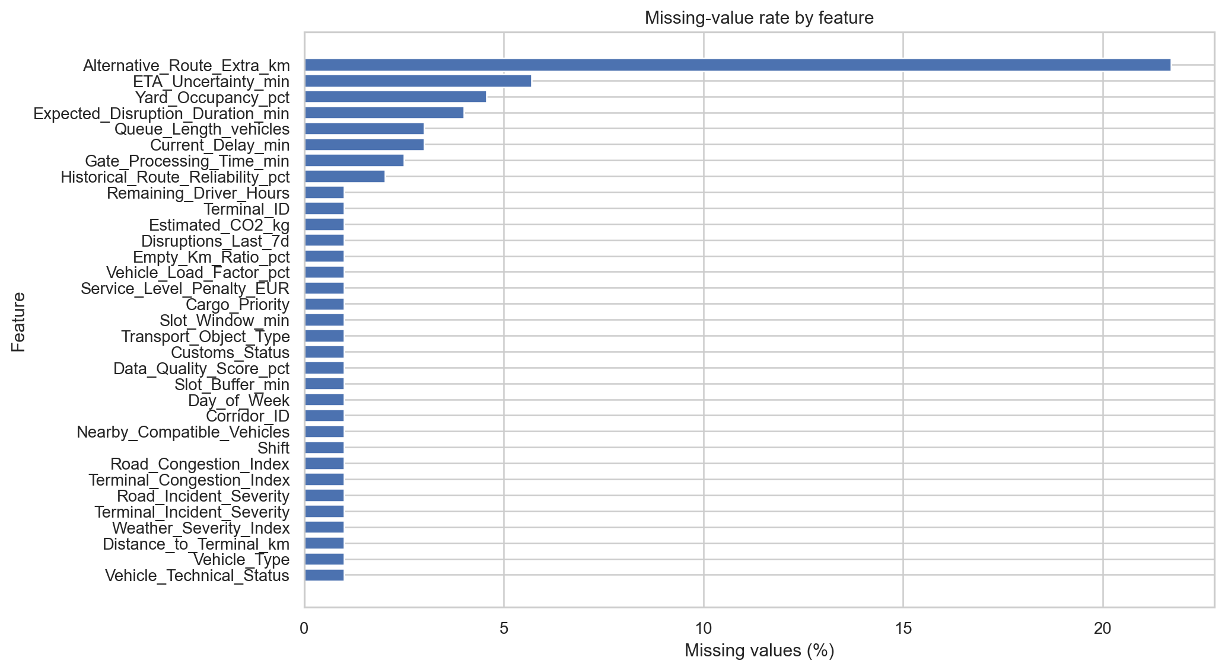
Figure 2.1. Missing-value rates by feature in the 10,000-case analysis copy.
Data-scope audit: The raw file has 10,250 rows despite the assignment’s 10,000-case scope. The first 10,000 records contain the ordered unique ID sequence 1–10,000. The last 250 rows repeat IDs: 196 are exact duplicate occurrences, while 54 contain non-ID differences from the corresponding canonical row. The raw file was left unchanged, and the first 10,000 rows were selected only provisionally because they form the ordered unique-ID block. The 54 conflicting alternatives remain unresolved and require confirmation by the instructor or data owner before treating the record-selection rule as final. Category normalization standardized the case/spacing variants in Day_of_Week, Shift, and Vehicle_Type; genuine missing values were preserved.

Categorical variable analysis
All 10,000 target labels are present. PROCEED_AS_PLANNED is the largest class (2,219; 22.19%) and REASSIGN_VEHICLE is the smallest (1,251; 12.51%); the largest class is approximately 1.77 times the smallest. The distribution is not dominated by a single class, although class proportions are not equal and should be considered in the later modelling and evaluation stage.
Table 2.4. Distribution of the six target classes.
Recommended dispatch action | Cases | Share of all cases
PROCEED_AS_PLANNED | 2,219 | 22.19%
WAIT_AND_MONITOR | 2,128 | 21.28%
PRIORITY_RECOVERY | 1,571 | 15.71%
RESCHEDULE_SLOT | 1,497 | 14.97%
REROUTE | 1,334 | 13.34%
REASSIGN_VEHICLE | 1,251 | 12.51%

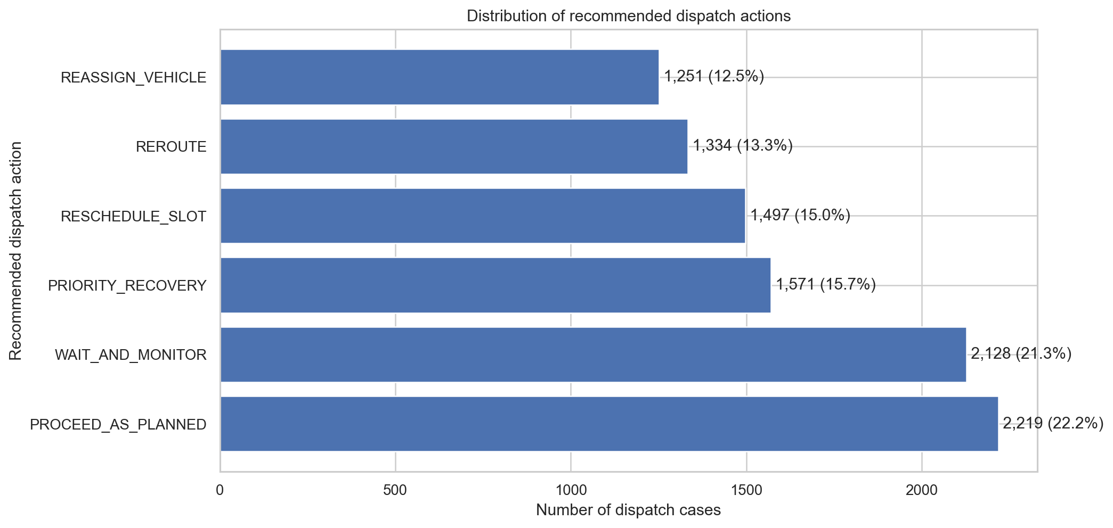
Figure 2.2. Distribution of Recommended_Dispatch_Action.
Other categorical fields show operationally meaningful composition. Vehicle_Technical_Status is OK for 9,002 cases (90.02%), Warning for 732 (7.32%), and Critical for 166 (1.66%); 100 cases (1.00%) are missing this field. Within the Critical group, 87.3% of records are labelled REASSIGN_VEHICLE and none are labelled PROCEED_AS_PLANNED; within Warning, 39.8% are REASSIGN_VEHICLE and 0.3% are PROCEED_AS_PLANNED. Figure 2.3 visualizes the target mix by technical status. These are observed associations in the supplied labels, not evidence that status alone determines an action.
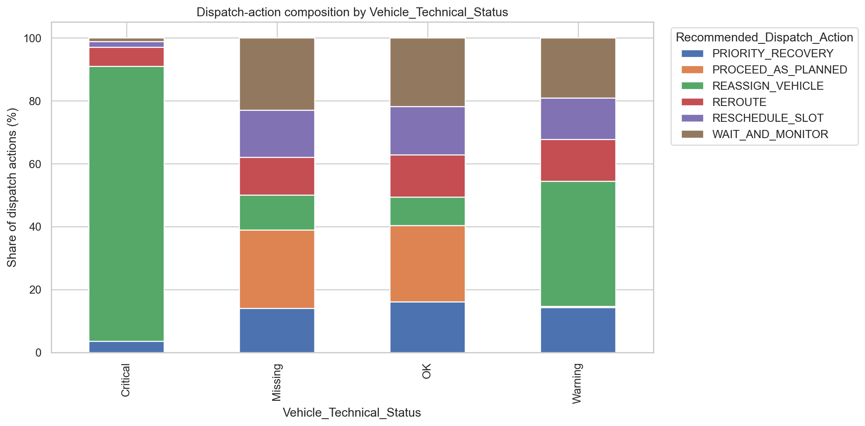
Figure 2.3. Dispatch-action composition by vehicle technical status.

Numerical variable analysis
The histogram/KDE panels in Figure 2.4 and the box plots in Figure 2.5 summarize selected terminal-handling, disruption, delay, and ETA-uncertainty variables. Yard occupancy is concentrated around its middle range (median 66.88%); queue length is centered at 9 vehicles but has a right tail to 29. Expected disruption duration and current delay are positively skewed: their means (21.74 and 25.44 minutes) exceed their medians (18.49 and 21.83 minutes), with maxima of 116.16 and 254.06 minutes respectively. ETA uncertainty is more concentrated around a median of 18.58 minutes. Slot_Window_min is discrete by design (30, 45, 60, or 90 minutes), while Slot_Buffer_min can be negative and spans -180 to 180 minutes. The KDE overlays are descriptive aids; they should not be read as evidence of a continuous generating process for discrete or ordinal fields.
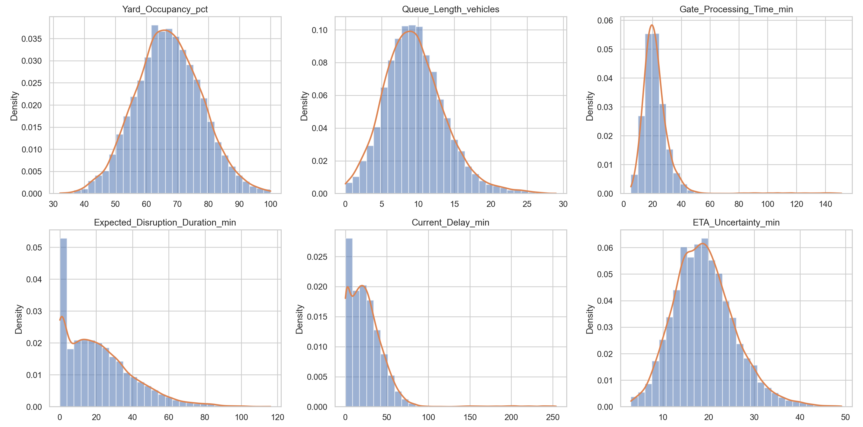
Figure 2.4. Selected histograms with KDE overlays for operational numerical variables.
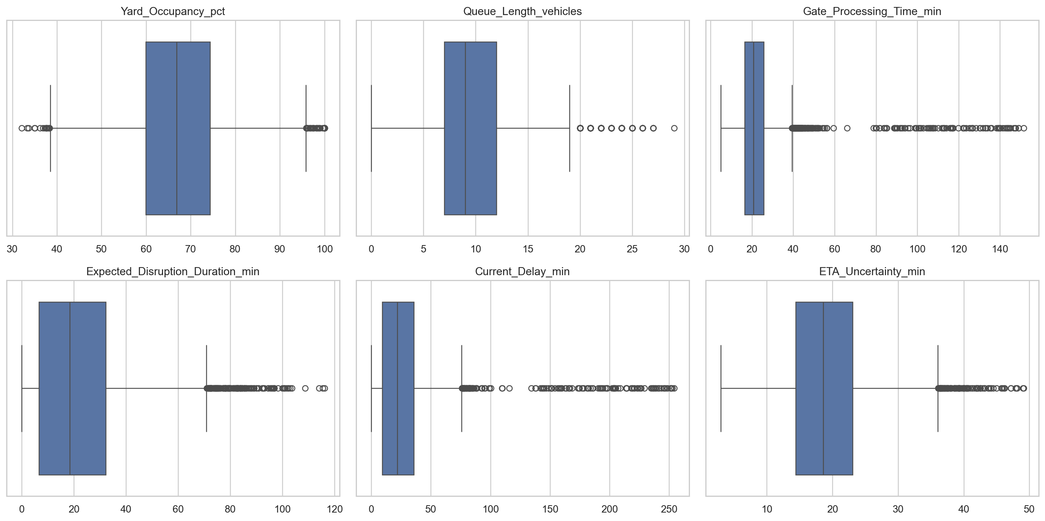
Figure 2.5. Box plots of selected operational numerical variables.
Figure 2.6 compares the distributions of selected numeric variables across the six dispatch-action classes. The distributions overlap, so no single plotted variable cleanly separates all classes. Nevertheless, the slot-buffer distributions differ visibly: the RESCHEDULE_SLOT group has a negative median buffer (-24.15 minutes), while PROCEED_AS_PLANNED and WAIT_AND_MONITOR have positive median buffers (72.04 and 67.58 minutes respectively). Median current delay is higher for WAIT_AND_MONITOR and REROUTE (30.44 and 28.96 minutes) than for PROCEED_AS_PLANNED (9.56 minutes). These class-conditional differences are useful hypotheses for later validation, not causal conclusions.
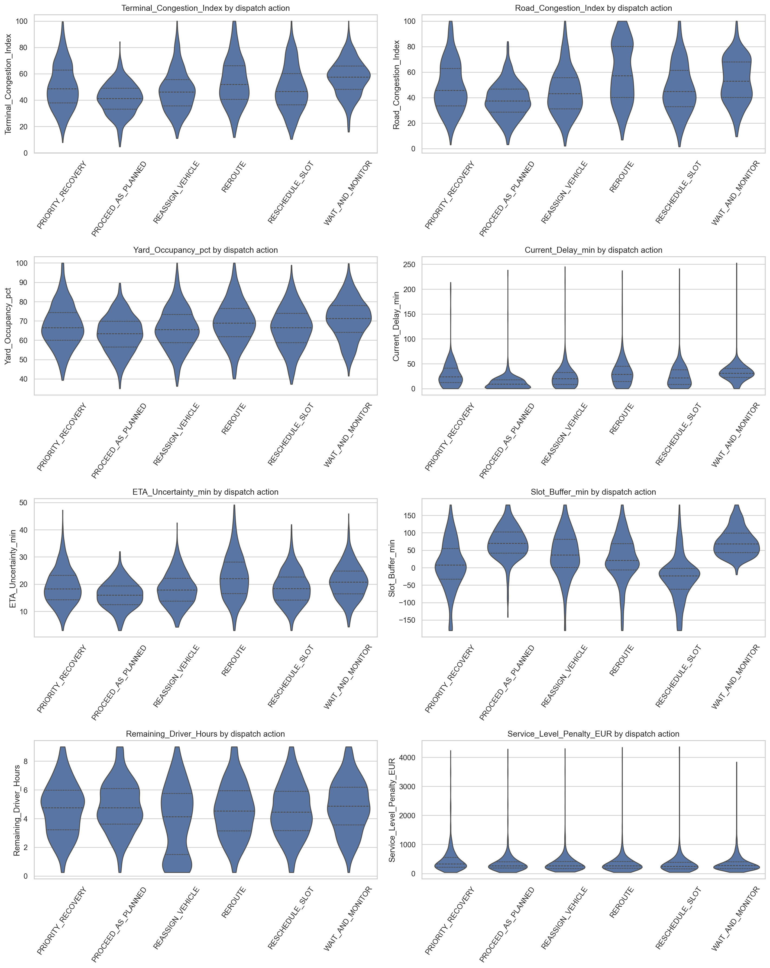
Figure 2.6. Violin plots of selected operational variables by Recommended_Dispatch_Action.

Outlier detection
The notebook screens numeric features using the 1.5 × IQR rule (values below Q1 − 1.5 × IQR or above Q3 + 1.5 × IQR). Figure 2.7 reports the share flagged for each feature. The largest flags are for Terminal_Incident_Severity (1,393 cases; 13.93%) and Road_Incident_Severity (1,234; 12.34%); both have Q1 = Q3 = 0, so the IQR is zero and non-zero severity levels are flagged by construction. Slot_Window_min flags 968 cases (9.68%), partly because the valid 90-minute slot lies above its upper fence of 82.5 minutes. Distance_to_Terminal_km has 583 flags (5.83%) and a maximum of 842.05 km; this extreme deserves a units/geography check. Service_Level_Penalty_EUR (576; 5.76%) and Estimated_CO2_kg (560; 5.60%) also have long upper tails. None of these flags is automatically treated as an error or removed.
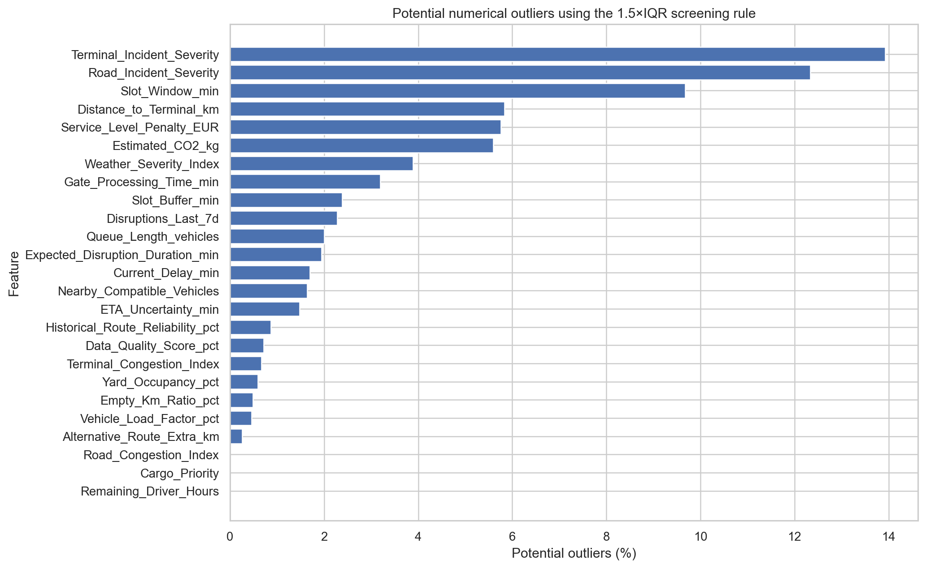
Figure 2.7. Potential numerical outliers detected by the 1.5 × IQR screening rule.

Relationships among variables
The Pearson heatmap in Figure 2.8 shows several positive associations among related operational measures. The strongest absolute Pearson correlation is between Terminal_Congestion_Index and Queue_Length_vehicles (r = 0.759), followed by terminal congestion and yard occupancy (r = 0.673), and road congestion and ETA uncertainty (r = 0.654). Expected disruption duration is also positively associated with terminal congestion (r = 0.551), road congestion (r = 0.547), and ETA uncertainty (r = 0.543). Selected coefficients are listed in Table 2.5. Correlations describe co-movement in this dataset and do not establish causation.
Table 2.5. Strongest selected positive Pearson correlations among numeric operational variables.
Variable 1 | Variable 2 | Pearson r
Terminal_Congestion_Index | Queue_Length_vehicles | 0.759
Terminal_Congestion_Index | Yard_Occupancy_pct | 0.673
Road_Congestion_Index | ETA_Uncertainty_min | 0.654
Terminal_Congestion_Index | Expected_Disruption_Duration_min | 0.551
Road_Congestion_Index | Expected_Disruption_Duration_min | 0.547
Expected_Disruption_Duration_min | ETA_Uncertainty_min | 0.543

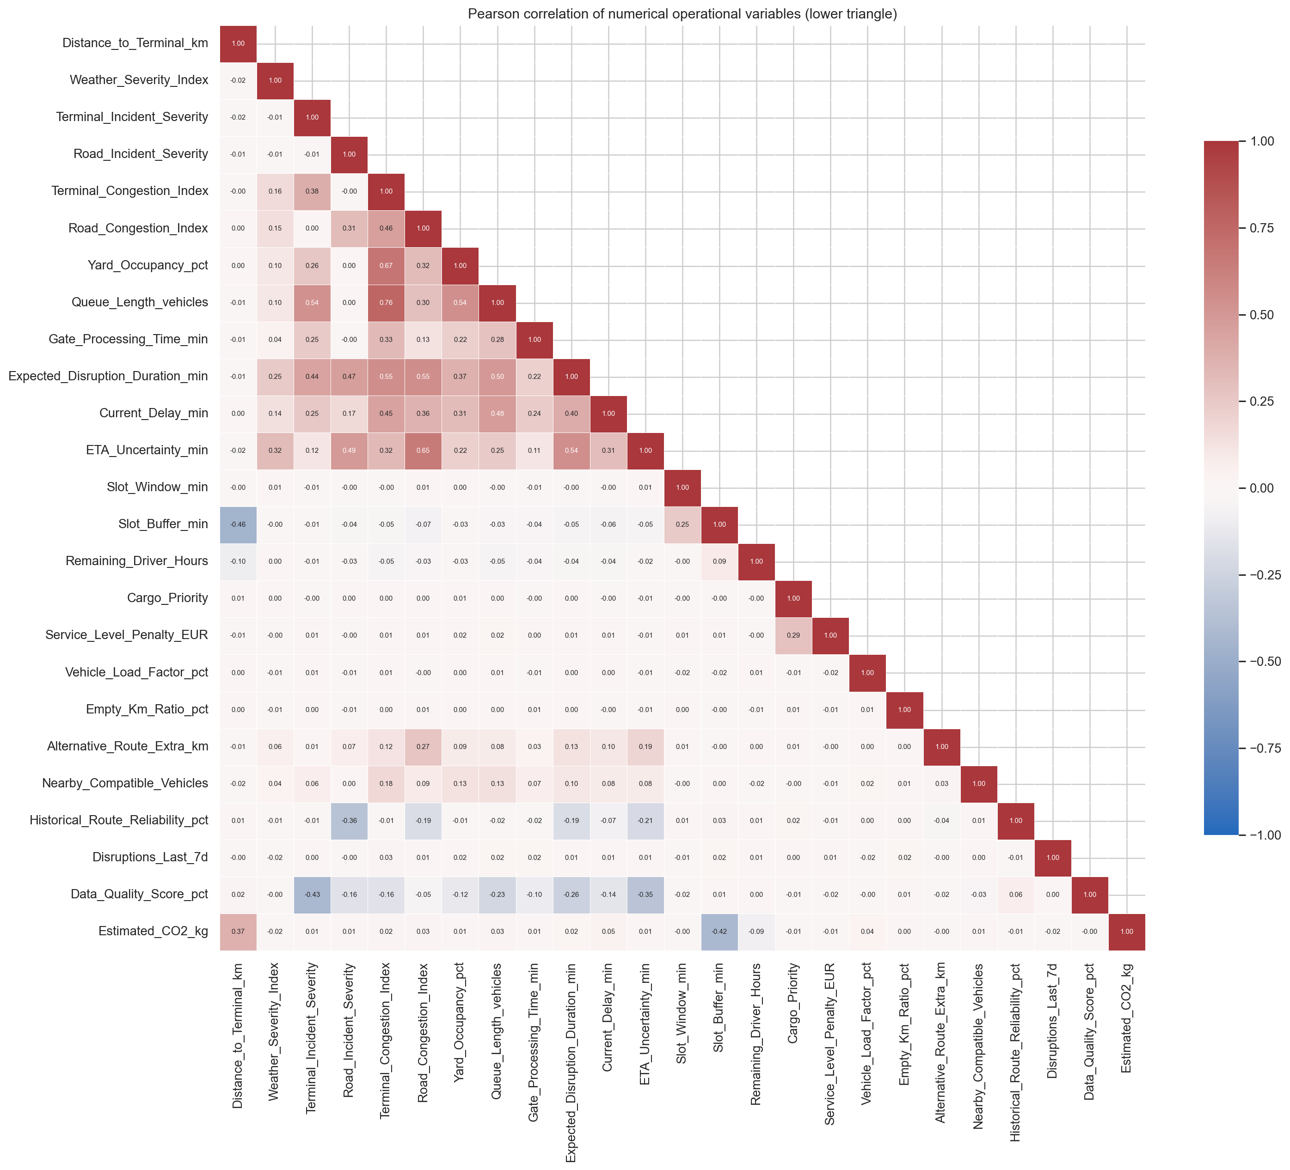
Figure 2.8. Pearson correlation heatmap of numerical operational variables (lower triangle).
Figure 2.9 presents a pair plot of Terminal_Congestion_Index, Queue_Length_vehicles, and Current_Delay_min, using a stratified display sample across the six dispatch-action classes. The diagonal panels show each variable’s distribution, while the off-diagonal panels show pairwise relationships and class overlap. The plot complements the correlation heatmap by showing the spread of observations within each class; these patterns are descriptive and do not establish causation.

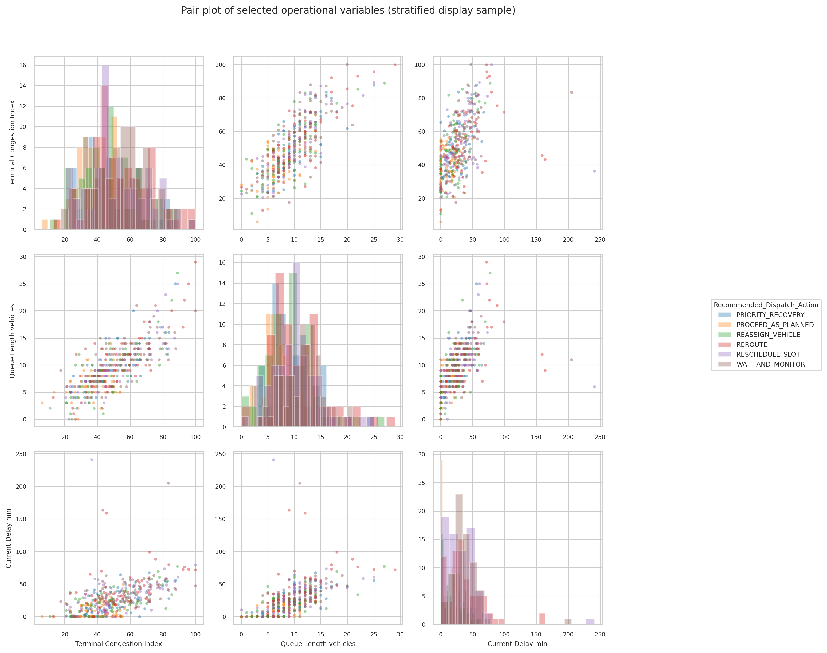
Figure 2.9. Pair plot of selected operational variables (stratified display sample).
Figure 2.10 presents parallel-coordinate profiles of median operational values for each dispatch action. The variables are scaled for visualization, so the lines support comparison of profile shapes rather than interpretation of raw-unit differences or effect sizes. Figure 2.11 is a bubble chart linking road congestion and terminal congestion; color represents current delay and bubble size represents Service_Level_Penalty_EUR, for a display sample of up to 1,800 records. The chart shows how congestion, delay, and service-level exposure co-occur, but it does not establish causation. The timing of service-penalty calculation should be confirmed before using it in a future dispatch-time model.
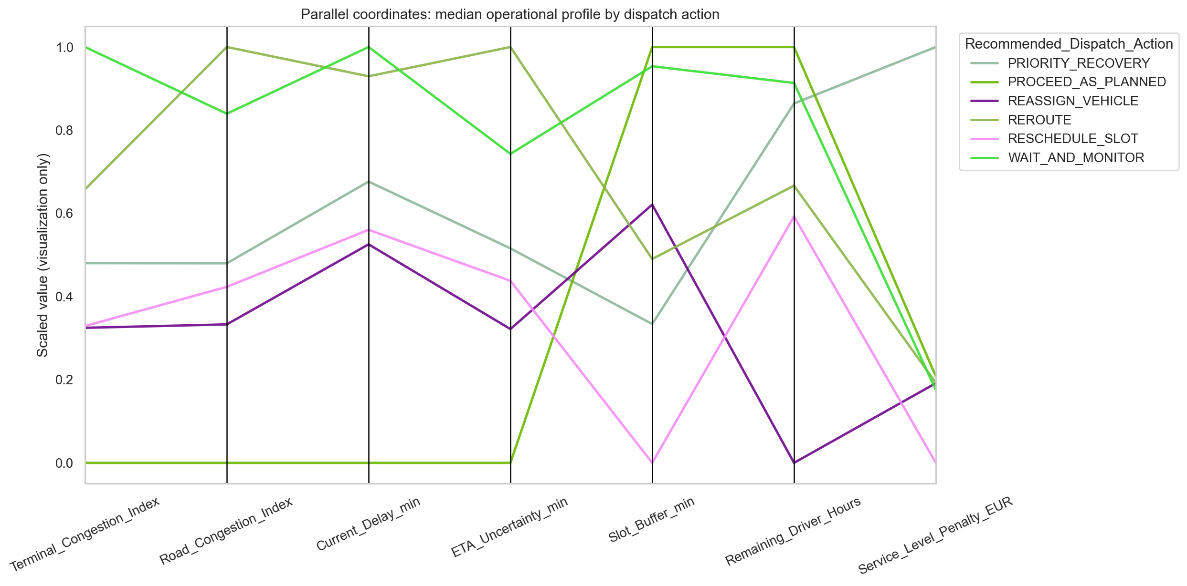
Figure 2.10. Parallel coordinates of median operational profiles by dispatch action (scaled for visualization).
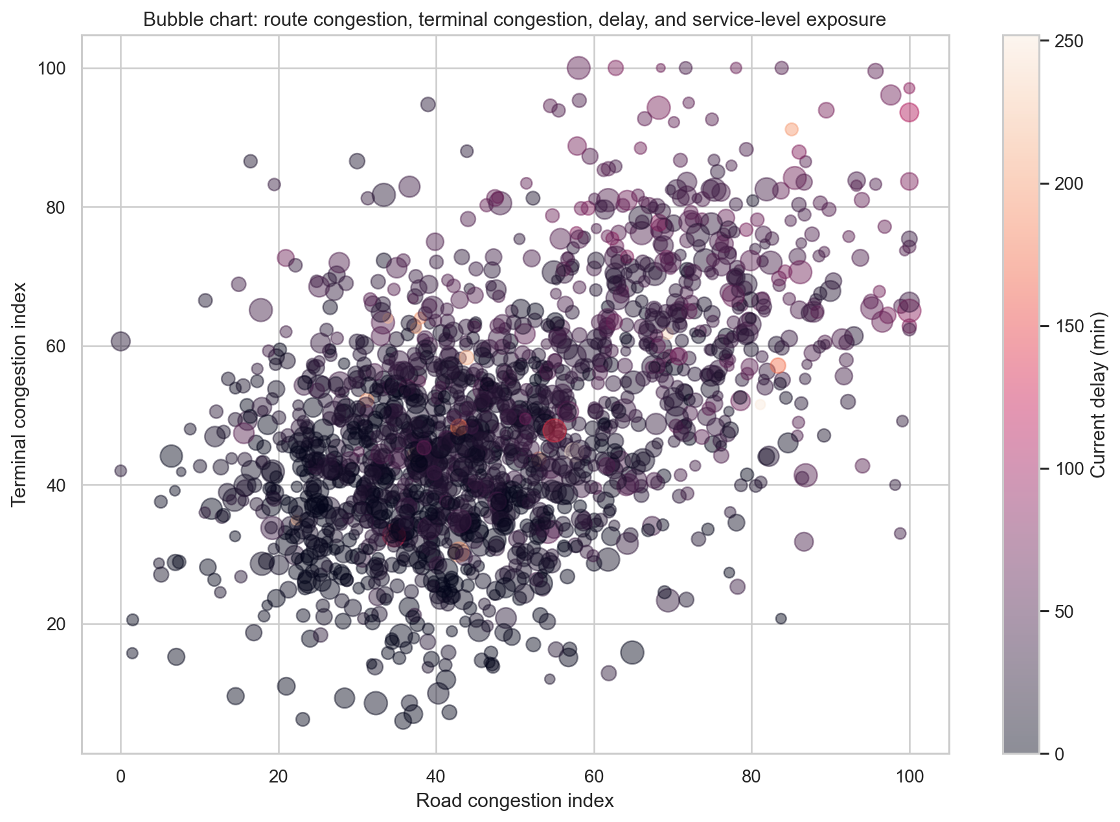
Figure 2.11. Bubble chart of road/terminal congestion, current delay and service-level exposure.
Figure 2.12 compares mean operational conditions across the six recommended actions. REROUTE cases have the highest mean road congestion index (58.67), WAIT_AND_MONITOR has the highest mean terminal congestion index (56.47) and current delay (32.89 minutes), and RESCHEDULE_SLOT has a negative mean slot buffer (-28.38 minutes). These are descriptive, class-conditional differences; variables have different scales, so comparisons should be made within each variable rather than across axes.
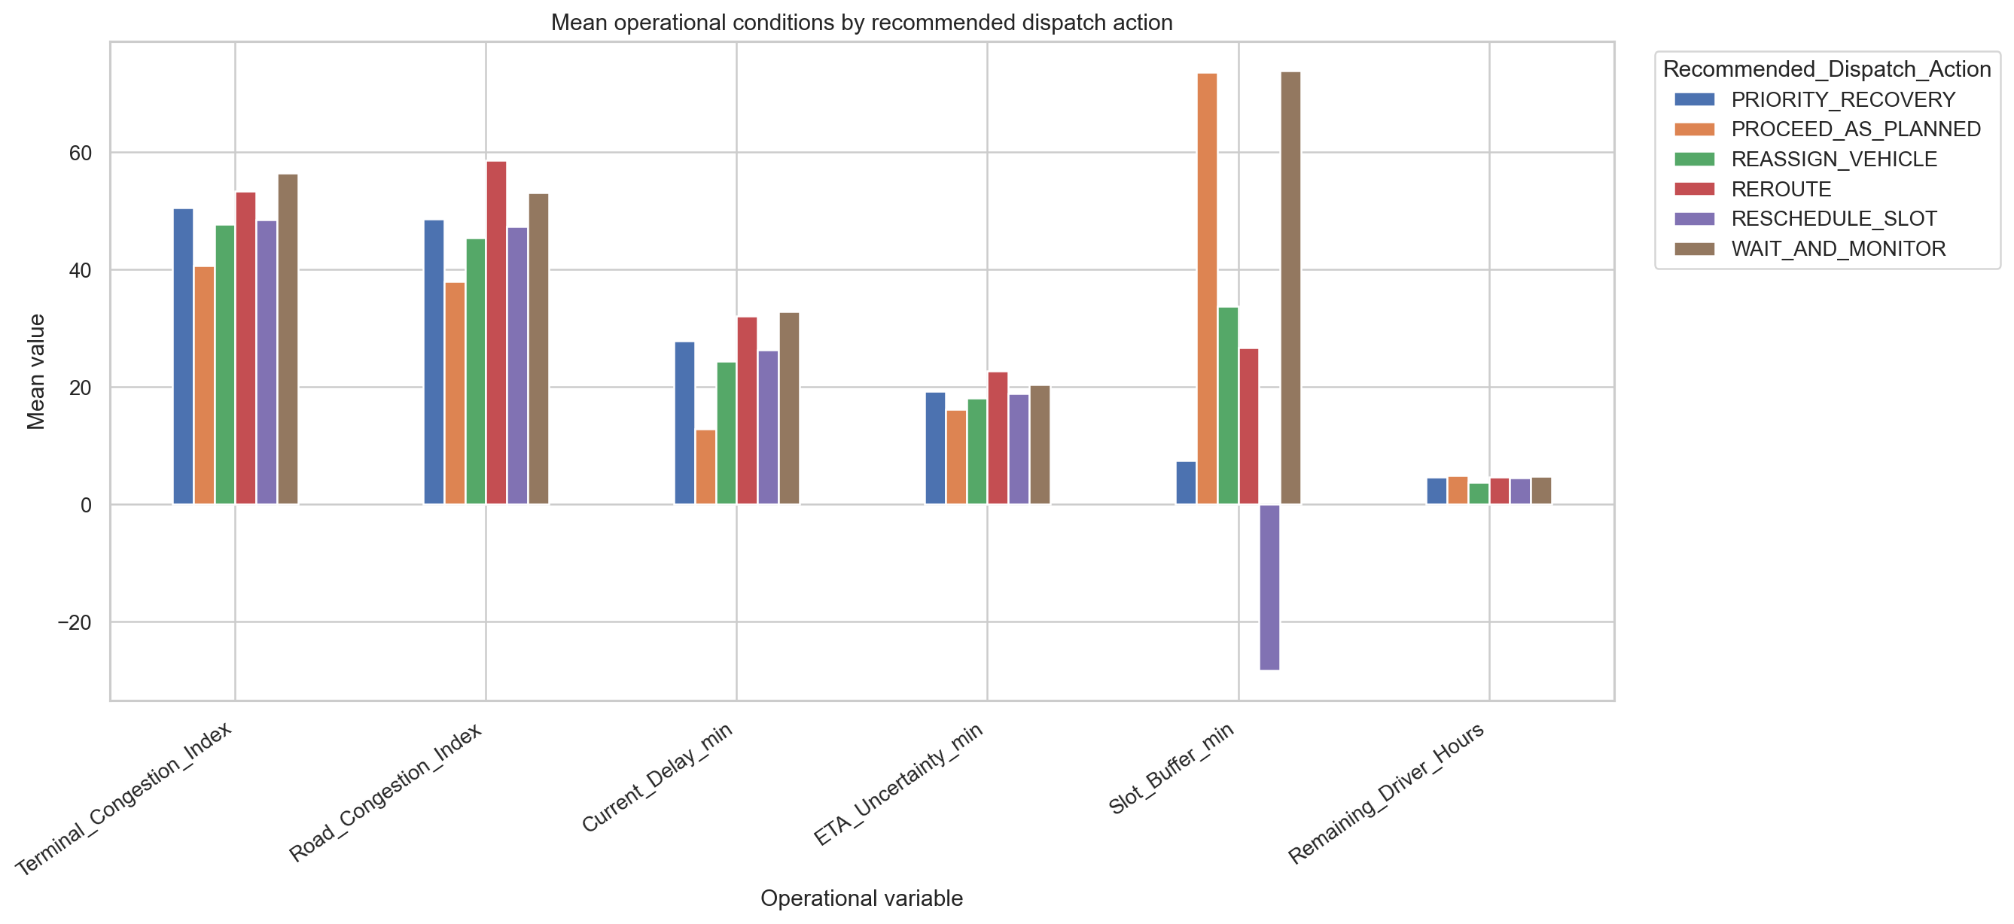
Figure 2.12. Mean operational conditions by recommended dispatch action.

Additional operational visualizations
The duration-stratified action chart (Figure 2.13) shows marked differences in action mix by expected disruption duration. For cases with expected duration up to 30 minutes, PROCEED_AS_PLANNED accounts for 29.7% of actions. In the 31–60 minute band, WAIT_AND_MONITOR is the largest share at 37.6%, while PROCEED_AS_PLANNED falls to 5.2%. In the 61–120 minute band, REROUTE accounts for 51.1% and PROCEED_AS_PLANNED for 1.0%. The supplied data contain no expected-duration observations above 120 minutes, so the plotted evidence concerns the three populated bands only.
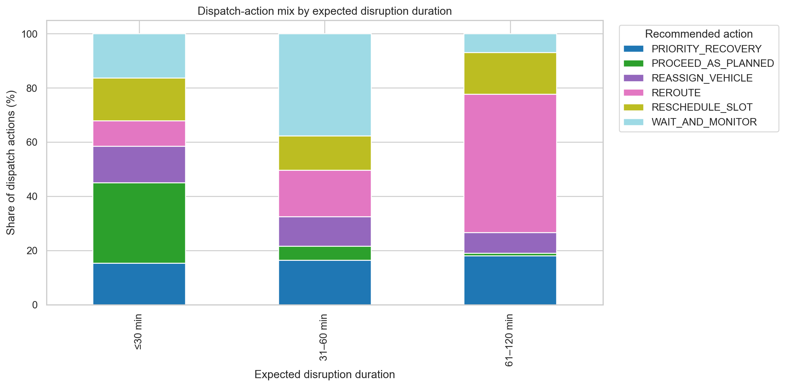
Figure 2.13. Dispatch-action mix by expected disruption duration.
Figure 2.14 examines slot buffer against current delay using a hexbin density view. The reported Spearman rank association is weak (ρ = -0.075), despite the fact that 2,610 cases (26.1% of the 10,000-case analysis block) have a negative recorded slot buffer. This suggests that the two variables do not have a strong monotonic relationship across the full dataset; the semantics of buffer and timing should be confirmed, and class-conditional patterns may be more informative than a single overall coefficient.
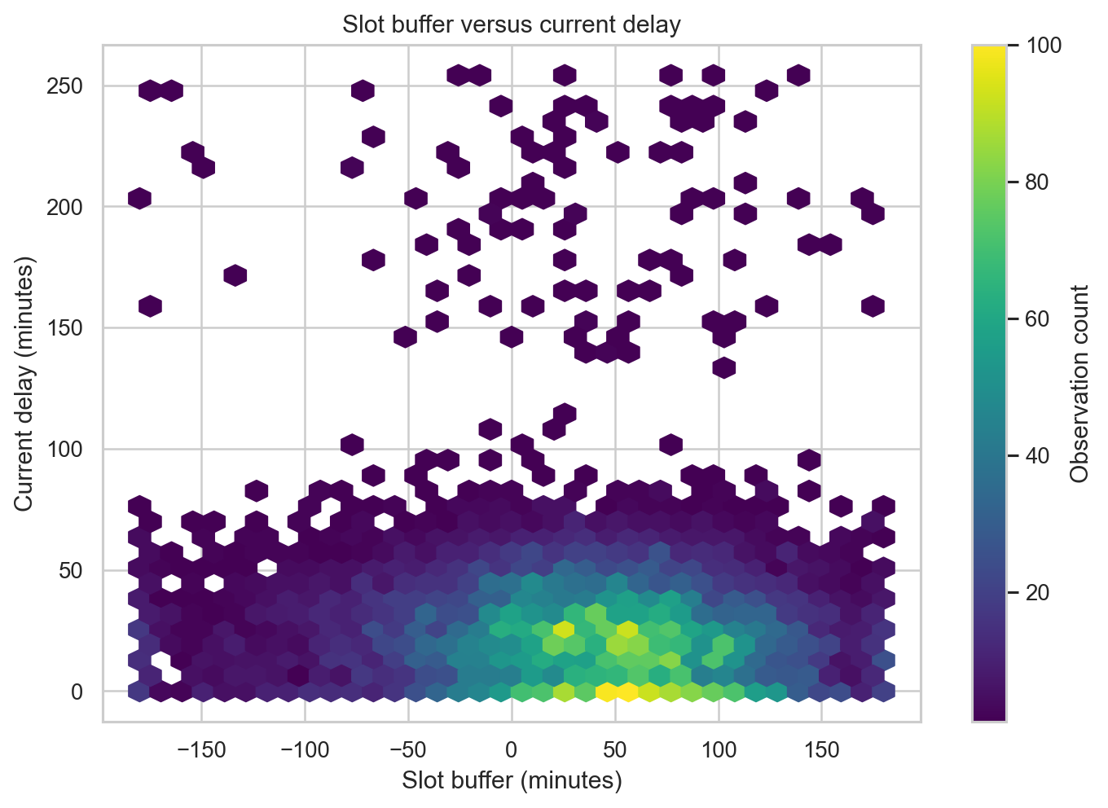
Figure 2.14. Slot buffer versus current delay; hexbin color denotes observation density.

Brainstorming and discussion
The following findings and questions are grounded in the EDA above. They should be treated as operational hypotheses for follow-up, not causal conclusions.
1. The target represents several operating regimes rather than a binary proceed/stop decision. The six action classes range from 12.51% to 22.19% of cases (Table 2.4; Figure 2.2). Later model evaluation should therefore inspect class-specific performance, especially for REASSIGN_VEHICLE, the least frequent class, rather than relying only on an aggregate score.
2. Terminal congestion appears to reflect a coherent terminal-handling pressure signal. Terminal congestion is strongly associated with queue length (Pearson r = 0.759) and yard occupancy (r = 0.673; Table 2.5 and Figure 2.8). Hypothesis: a combined congestion indicator may help characterize situations associated with waiting or recovery actions; the present EDA does not establish that congestion causes a particular recommendation.
3. Slot slack appears useful for distinguishing planned movement from rescheduling cases. The median Slot_Buffer_min is -24.15 minutes for RESCHEDULE_SLOT but 72.04 minutes for PROCEED_AS_PLANNED and 67.58 minutes for WAIT_AND_MONITOR (Figure 2.6). A follow-up question is whether negative buffer values correspond to a consistent operational definition of an expected missed slot, especially at the extreme minimum of -180 minutes.
4. Expected disruption duration is associated with action mix. REROUTE reaches 51.1% in the 61–120 minute band, while WAIT_AND_MONITOR is highest in the 31–60 minute band at 37.6% (Figure 2.13). Hypothesis: dispatch actions respond to different time horizons, but the dataset’s maximum observed duration is 116.16 minutes, so longer-duration scenarios are not represented in this analysis copy.
5. Vehicle technical status is closely associated with resource reassignment labels. REASSIGN_VEHICLE accounts for 87.3% of Critical cases and 39.8% of Warning cases (Figure 2.3). A domain expert should check whether the label-generation or dispatch policy intentionally maps warnings/critical technical states to reassignment, and whether there are exceptions requiring other safe recovery actions.
6. Alternative-resource availability is a practical constraint, not a guaranteed remedy. An alternative route is available for 7,828 cases (78.28%); an alternative slot is available in 5,437 cases (54.37%); an alternative terminal is available in 4,219 cases (42.19%); and driver change is available in 4,381 cases (43.81%). Hypothesis: the type and availability of recovery options may shape the feasible action mix. This should be tested using the corresponding class-conditional comparisons rather than inferred from availability rates alone.
7. Outlier and missingness handling require operational validation. The incident-severity IQR flags are affected by zero-inflated, discrete values, while 90-minute slots are valid domain values that the generic IQR rule flags. The 842.05 km maximum distance and extreme delays/penalties should be checked against source units and geography, not deleted automatically (Figure 2.7; NIST/SEMATECH, n.d.-a). Route-distance blanks are consistent with route unavailability, but other missingness requires explicit treatment (Figure 2.1).
8. Predictor timing and leakage must be checked before modelling. Recommended_Dispatch_Action is the outcome and must never be used as a predictor. Estimated_CO2_kg and Service_Level_Penalty_EUR may depend on the selected route/action or a later realized outcome; their dispatch-time availability is not established in the supplied sources and should be confirmed. Expected_Disruption_Duration_min, Current_Delay_min and Alternative_Route_Extra_km also need clear definitions of when they become available.

Methodological references
The EDA uses descriptive summaries and graphical methods to uncover structure and identify unusual observations, consistent with NIST/SEMATECH guidance on exploratory data analysis and graphical methods (NIST/SEMATECH, n.d.-b, n.d.-c, n.d.-d). The 1.5 × IQR procedure is used to screen for potential outliers, not as an automatic deletion rule (NIST/SEMATECH, n.d.-a). Missing-value handling is documented because missing data may require explicit preprocessing before later modelling (scikit-learn developers, n.d.). pandas was used to prepare the tabular summaries (pandas developers, n.d.).
- NIST/SEMATECH. (n.d.-a). Detection of outliers. https://www.itl.nist.gov/div898/handbook/eda/section3/eda35h.htm
- NIST/SEMATECH. (n.d.-b). Exploratory data analysis: Detailed table of contents. https://www.itl.nist.gov/div898/handbook/eda/eda_d.htm
- NIST/SEMATECH. (n.d.-c). The role of graphics. https://www.itl.nist.gov/div898/handbook/eda/section1/eda15.htm
- NIST/SEMATECH. (n.d.-d). What is exploratory data analysis? https://www.itl.nist.gov/div898/handbook/eda/section1/eda11.htm
- pandas developers. (n.d.). pandas user guide. https://pandas.pydata.org/docs/user_guide/
- scikit-learn developers. (n.d.). Imputation of missing values. https://scikit-learn.org/stable/modules/impute.html

Dataset 3: E-Commerce Sales & Customer Insights (Regression)

Data description
This section examines the E-Commerce Sales & Customer Insights dataset (realistic_e_commerce_sales_data.csv). Each row is one order: a customer (ID, gender, age, region) bought a quantity of one product (name, category, unit price); the order also has a total price, a shipping fee, a shipping status and an order date. The file contains 1,000 orders and 12 columns, from 292 customers and 7 products, with order dates from 1 January 2023 to 3 January 2024. The analytical target is Shipping Fee, a continuous amount (€5.00–€19.98), so the task is regression. The assignment asks to exclude Total Price if it directly embeds the shipping fee; this is tested explicitly below rather than assumed. Shipping Status is excluded from the predictor set because it describes what happens after the order ships, while the fee is set at checkout. The CSV does not document its publisher or collection method, so no collection story is assumed. The work reported here is EDA; no final regression model is trained.
Table 3.1. Data dictionary of the E-Commerce Sales & Customer Insights dataset.
Column name | Definition | Data type | Possible values (nominal/ordinal only) | Required?
Customer ID | Identifier of the customer (292 customers, 1–9 orders each); descriptive only | Nominal | e.g. CUST0046 (292 IDs) | Yes
Gender | Gender of the customer | Nominal | Male, Female | Yes
Region | Geographic region of the customer/order | Nominal | North, South, East, West | No (5% missing)
Age | Age of the customer in years (18–69) | Ratio |  | No (10% missing)
Product Name | Purchased product | Nominal | Laptop, Monitor, Smartphone, Headphones, Keyboard, Mouse, Smartwatch | Yes
Category | Product category | Nominal | Electronics, Accessories, Wearables | Yes
Unit Price | Price of one unit in € (list prices 30–1,500) | Ratio |  | Yes
Quantity | Number of units ordered (1–5) | Ratio |  | Yes
Total Price | Merchandise value of the order in € (30–7,500) | Ratio |  | Yes
Shipping Fee | Target: shipping charge of the order in € (5.00–19.98) | Ratio |  | Yes
Shipping Status | Fulfilment state of the order; excluded (post-order) | Nominal | Delivered, In Transit, Returned | No (5% missing)
Order Date | Date of the order; used to derive month and weekday | Interval |  | Yes

Exploratory data analysis

Data visualization and exploration

Data quality and target distribution
There are no duplicate rows and all order dates parse without error. Missing values occur in Age (100; 10%), Region (50; 5%) and Shipping Status (50; 5%); the target and all other columns are complete. Missing Age and Region values are handled in a separate cleaning step for Part 2 (median age and an “Unknown” region level); Shipping Status is excluded, so its gaps have no impact. No values were imputed or removed in the EDA. The target is spread evenly between €5 and €20 (mean 12.42, median 12.32, std 4.41, skewness 0.05; Figure 3.1). These values almost exactly match a uniform distribution on [5, 20] (theoretical mean 12.5, std 4.33), with no peak, tail or outliers.
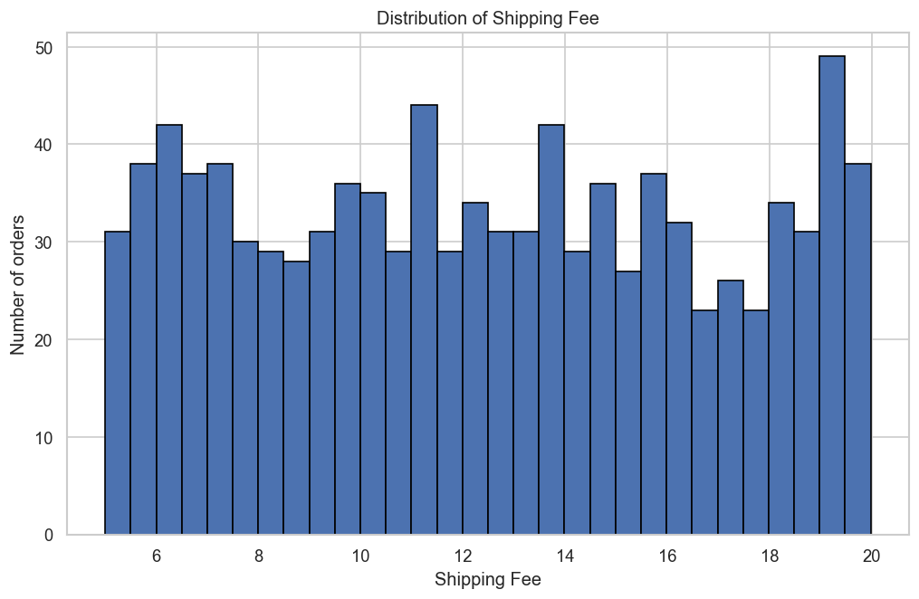
Figure 3.1. Distribution of Shipping Fee.

Total Price audit
To decide whether Total Price embeds the shipping fee, it was compared with Unit Price × Quantity. For 980 of the 1,000 orders (98%), Total Price equals Unit Price × Quantity exactly, so it represents merchandise value and does not contain the shipping fee; it is therefore not leakage, but it is redundant with its two components. The remaining 20 orders have a corrupted Unit Price that is inflated by a constant factor of about 2.073 (e.g. Laptop 1,500 → 3,109.56; Smartphone 800 → 1,658.43), while their Total Price still equals the list price × quantity. These rows explain the unexpected maximum unit price of 3,109.56 and appear as isolated columns in the bubble chart (Figure 3.3); they are corrected to the product’s list price in the cleaned copy of the data prepared for Part 2.

Numerical variable analysis
Table 3.2 summarizes the numerical variables. Quantity is spread almost evenly over 1–5 and Age is roughly flat between 18 and 69. Unit Price and Total Price are “lumpy” and right-skewed (skewness 1.47 and 1.93) because each product has one fixed list price (Mouse 30 … Laptop 1,500), so they take only a few distinct values (Figure 3.2). The 1.5 × IQR rule flags 124 Total Price values (12.4%), all genuine large orders (92 laptop orders with quantity 3–5 and 32 smartphone orders with quantity 5), and 4 Unit Price values, which are the corrupted laptop prices. Age, Quantity and Shipping Fee have no outliers. Flagged values were not deleted.
Table 3.2. Descriptive statistics for numerical variables.
Numerical variable | Non-missing n | Mean | Median | Minimum | Maximum
Age | 900 | 46.7 | 49.0 | 18 | 69
Unit Price | 1,000 | 457.7 | 200.0 | 30 | 3,109.6
Quantity | 1,000 | 3.0 | 3.0 | 1 | 5
Total Price | 1,000 | 1,346.6 | 600.0 | 30 | 7,500
Shipping Fee (target) | 1,000 | 12.42 | 12.32 | 5.00 | 19.98

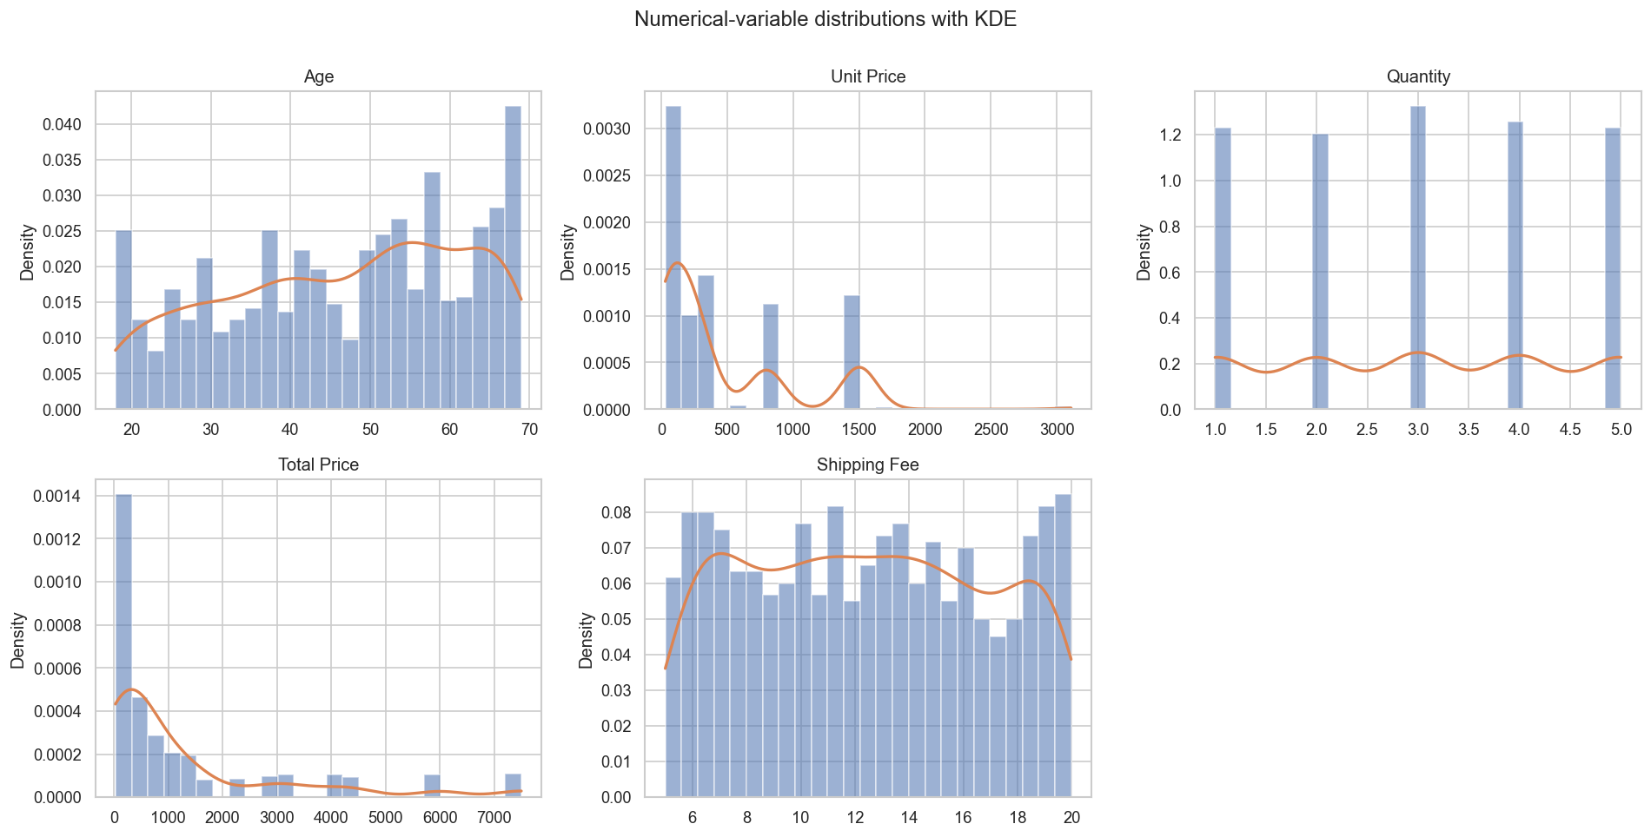
Figure 3.2. Histograms with KDE overlays of the numerical variables.
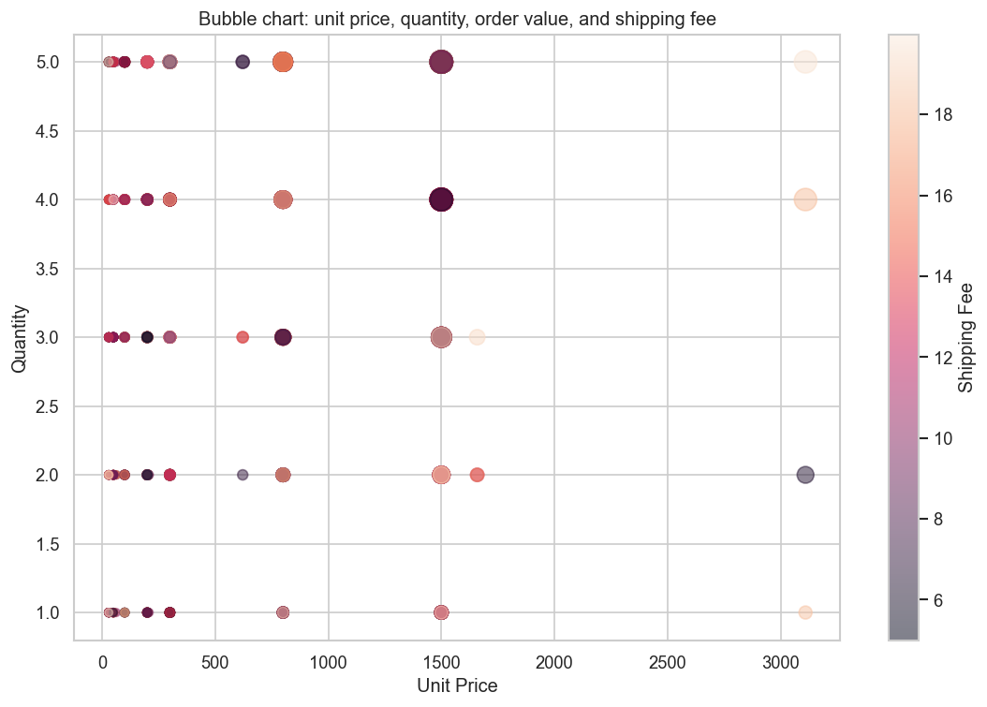
Figure 3.3. Bubble chart of unit price and quantity; bubble size = Total Price, colour = Shipping Fee.

Categorical variable analysis
Electronics is the largest category (477 orders), followed by Accessories (401) and Wearables (122); gender (524 male, 476 female) and the four regions (229–246 orders each) are close to balanced. The mean shipping fee hardly differs between groups: Electronics €12.62, Wearables €12.35 and Accessories €12.20 (Figure 3.4); North €12.55 to East €12.32; Male €12.42 and Female €12.42. All group means lie between about €12.0 and €12.9, while individual fees range from €5 to €20, so the differences between groups are tiny compared with the spread within each group. A Mann–Whitney U test finds no difference between genders (p = 0.99), and a one-way ANOVA finds no significant differences for category (p = 0.37), product (p = 0.52) or region (p = 0.95). The largest differences in the category × region heatmap (Wearables: South €11.12 vs. West €13.84; Figure 3.5) occur in the smallest cells (about 30 orders), so they are noisy rather than evidence of an interaction.
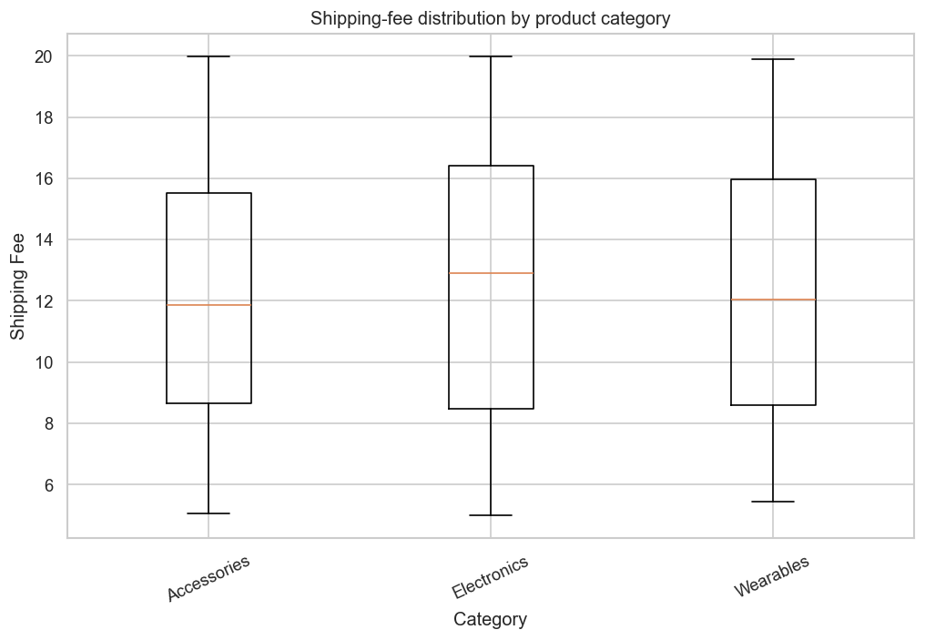
Figure 3.4. Box plots of Shipping Fee by product category.
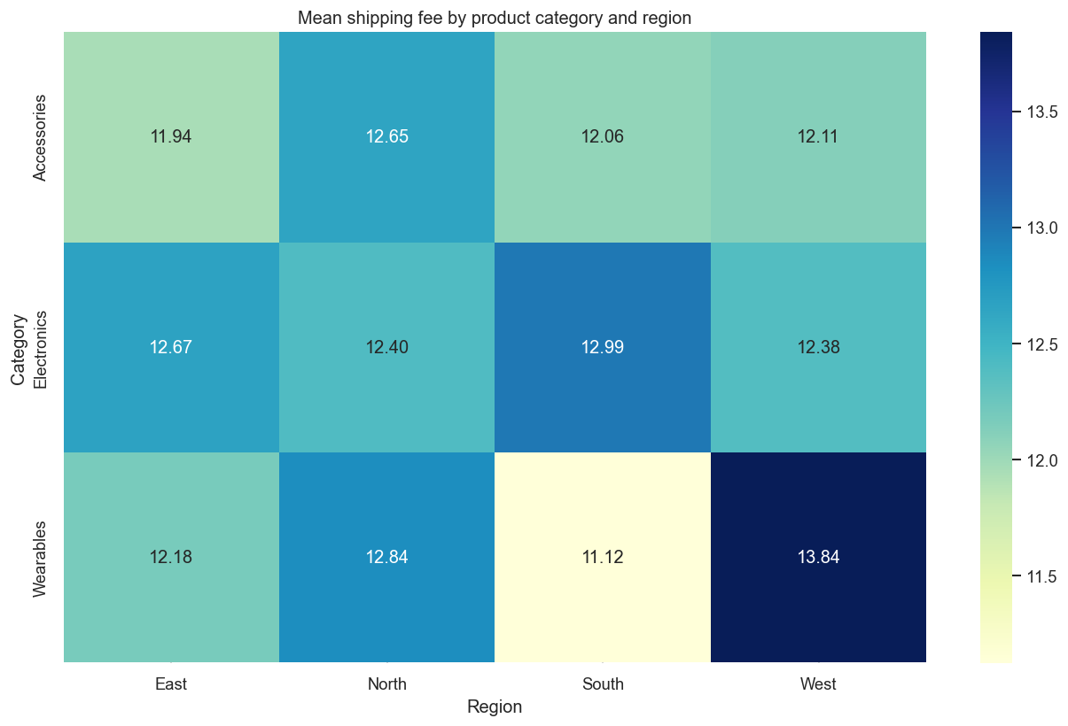
Figure 3.5. Mean Shipping Fee by category and region.

Relationships among variables
The Pearson heatmap (Figure 3.6) shows that no numerical variable is related to the shipping fee: Quantity r = 0.046, Age r = 0.027, Unit Price r = 0.017 and Total Price r = 0.003. Spearman rank correlations agree, and none is significant (all p ≥ 0.08). Among the predictors, Total Price is strongly correlated with Unit Price and Quantity, as expected because it is built from them. The mean fee rises only slightly with quantity, from €12.16 (1 unit) to €12.65 (5 units) (Figure 3.7), and this drift is not significant (Spearman p = 0.14); note that the y-axis starts near €12, which makes the 50-cent difference look larger than it is. The ten largest orders (5 laptops, €7,500 each) pay anything from €5.02 to €19.69 for shipping, which is direct evidence that order size does not drive the fee. Monthly means range from €11.76 (June) to €13.37 (May) and weekday means from €11.84 (Thursday) to €13.10 (Saturday) (Figure 3.8); with about 80 orders per month, swings of ±€1 are consistent with random variation. At customer level, repeat customers do not pay lower fees.
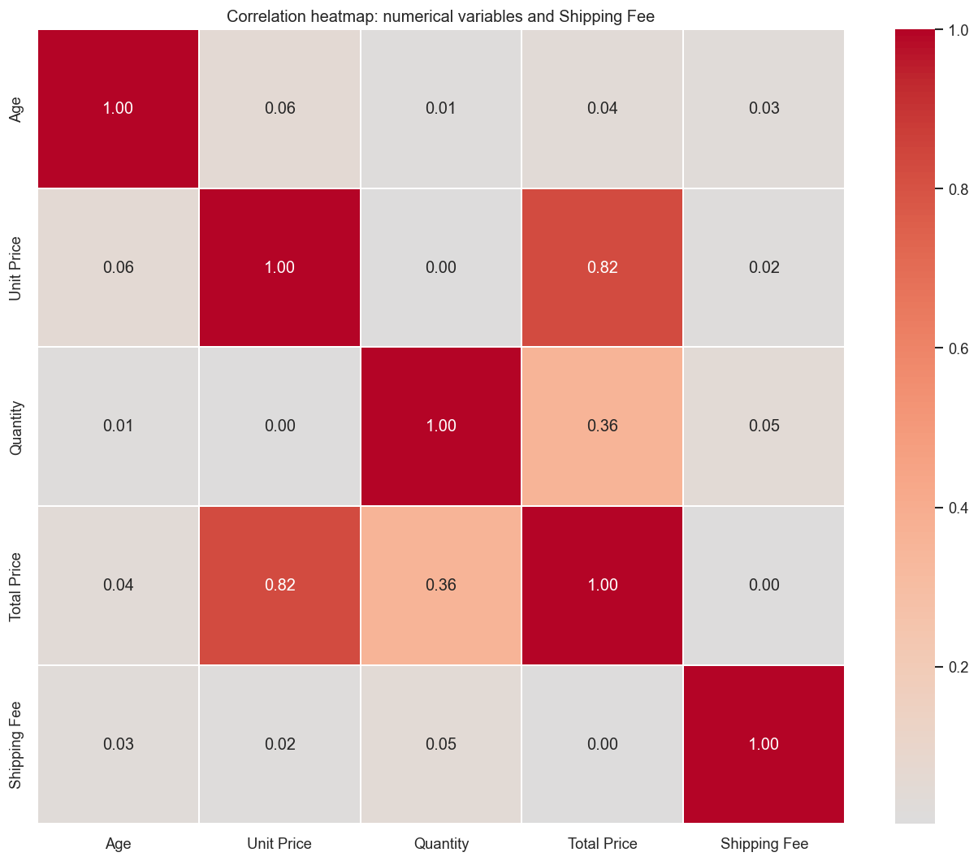
Figure 3.6. Pearson correlation heatmap of the numerical variables.
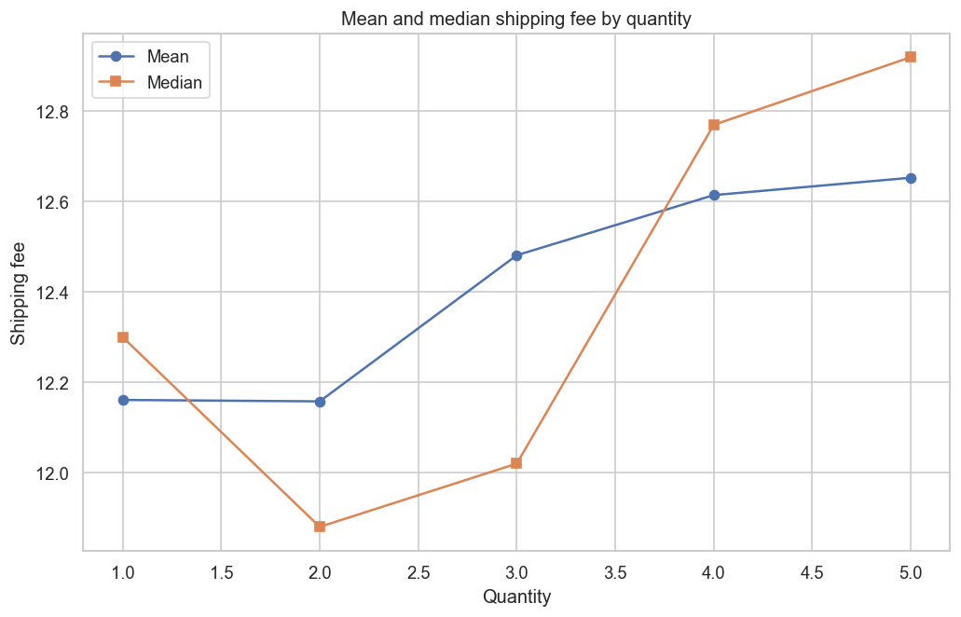
Figure 3.7. Mean and median Shipping Fee by order quantity.
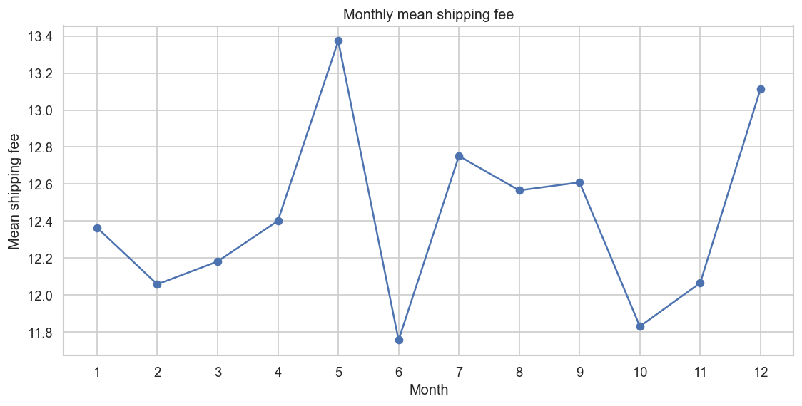
Figure 3.8. Monthly mean Shipping Fee.

Table 3.3. Summary of statistical tests against Shipping Fee (5% significance level).
Variable(s) | Test | Result | Significant?
Gender | Mann–Whitney U | p = 0.99 | No
Category | One-way ANOVA | p = 0.37 | No
Product Name | One-way ANOVA | p = 0.52 | No
Region | One-way ANOVA | p = 0.95 | No
Total Price | Spearman ρ | ρ = 0.055, p = 0.08 | No
Quantity | Spearman ρ | ρ = 0.047, p = 0.14 | No
Unit Price | Spearman ρ | ρ = 0.036, p = 0.25 | No
Age | Spearman ρ | ρ = 0.026, p = 0.44 | No

Brainstorming and discussion
The following findings and questions are grounded in the EDA above. They should be treated as hypotheses for follow-up, not causal conclusions.
1. The shipping fee behaves like independent noise. The fee is uniform between €5 and €20 (Figure 3.1), no numerical predictor correlates with it (all |r| < 0.06; Figure 3.6) and no categorical predictor shifts it significantly. Hypothesis: a regression model will not clearly beat a baseline that always predicts the mean (€12.42); expect R² close to 0 and an RMSE of about €4.4. Part 2 should therefore compare all models against this mean baseline.
2. Product category is not a usable proxy for size or weight here. Category means differ by at most €0.42 (Figure 3.4; ANOVA p = 0.37), and product means by less than €0.90 (p = 0.52). Question: would real product weight or dimensions, which are not in the data, explain shipping cost better than category labels?
3. Order size and value do not drive the fee. Unit Price (r = 0.017) and Total Price (r = 0.003) are unrelated to the fee, and identical €7,500 laptop orders pay between €5 and €20. Quantity shows only a slight, non-significant upward drift (+€0.49 from 1 to 5 units; Figure 3.7). Question: would a non-linear or tree-based model find any quantity effect?
4. Total Price is redundant, not leakage, but reveals a data-quality issue. Total Price equals Unit Price × Quantity in 98% of orders and never contains the shipping fee. A later model should use either Total Price or Unit Price plus Quantity, not all three. The 20 corrupted unit prices (factor ≈ 2.073; Figure 3.3) have been corrected to the list price in the cleaned copy for Part 2.
5. Region does not capture shipping zones. Regional means differ by at most €0.23 (p = 0.95), and the large differences in the category × region heatmap occur only in small cells (Figure 3.5). Question: do the regions correspond to real delivery zones or distances at all?
6. Customer demographics and timing carry no signal. Gender makes no difference (Mann–Whitney p = 0.99), age is uncorrelated (r = 0.027), and monthly or weekday swings of about ±€1 are consistent with noise (Figure 3.8). These variables can be tested in Part 2 but are not expected to add value and may cause overfitting.
7. Outliers are genuine orders; missing values need a pipeline strategy. The 124 Total Price outliers are real large laptop/smartphone orders and should be kept; only the 4 Unit Price outliers are errors. In the cleaned copy, missing Age (10%) is filled with the median and missing Region (5%) with “Unknown”; for the final model, imputation should be fitted inside a scikit-learn pipeline on training data only.
8. Shipping Status must not be used as a predictor. It describes what happened after shipping (delivered, in transit, returned), while the fee is set at checkout, so it would not be available at prediction time. Question: at exactly which process step is the shipping fee determined, and which retained features are known at that point?

Methodological references
As for Dataset 3, the EDA follows NIST/SEMATECH guidance on exploratory and graphical analysis and uses the 1.5 × IQR rule only as a screening method (NIST/SEMATECH, n.d.-a, n.d.-d). Because the target is uniform rather than normal, non-parametric Mann–Whitney U and Spearman tests were used (SciPy developers, n.d.).
- Missing-value handling and leakage-safe preprocessing follow scikit-learn guidance (scikit-learn developers, n.d.; scikit-learn developers, n.d.-b).
- SciPy developers. (n.d.). scipy.stats.mannwhitneyu; scipy.stats.spearmanr. https://docs.scipy.org/doc/scipy/reference/stats.html
- scikit-learn developers. (n.d.-b). Pipelines and composite estimators. https://scikit-learn.org/stable/modules/compose.html

Declaration
During the preparation of this work, the authors used ChatGPT to assist with code troubleshooting, interpretation of exploratory outputs, and review of report wording. Visual Studio Code was used to edit code; Jupyter Notebook was used to execute and document the analysis; Git was used for version control; and Python libraries, including pandas, Matplotlib, and Seaborn, were used for data handling and visualization. The authors reviewed the generated outputs, checked the reported statistics and figures against the analysis, and take full responsibility for the accuracy, integrity, and academic quality of the work.

Appendix A: Project management

A.1 Planned Task distribution

NOTEBOOK AND CODE
Data Set 1,2,3 : Subhankar Biswas
REPORT
Data Set 1 : Lerato Tooane
Data Set 2: Motshidisi Simon
Data Set 3: Mariem Nour Ghozzi

