#### **1.1 安装Docker和Docker Compose**
1. **更新系统包**：
```bash
sudo apt-get update
```
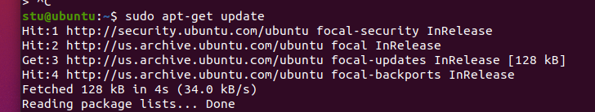
2. **安装必要的包**：
```bash
sudo apt install git -y
sudo apt install vim -y
sudo apt install jq -y
sudo apt install tree
sudo apt-get install -y apt-transport-https ca-certificates curl gnupg-agent software-properties-common
```

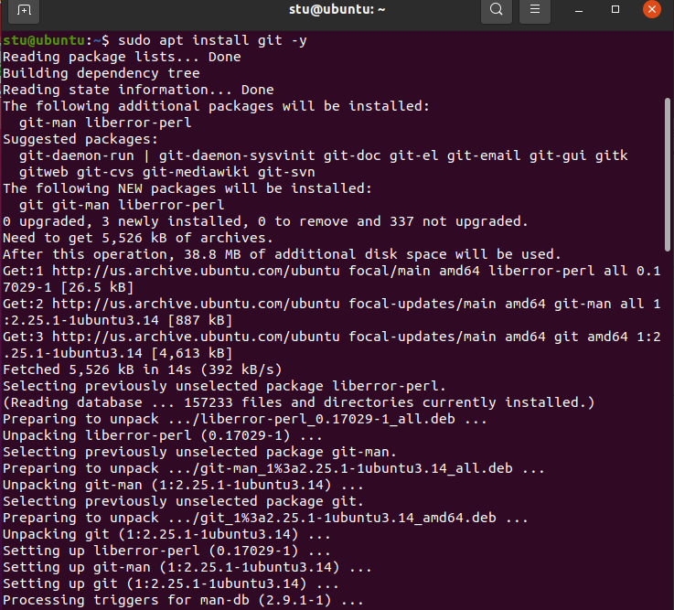
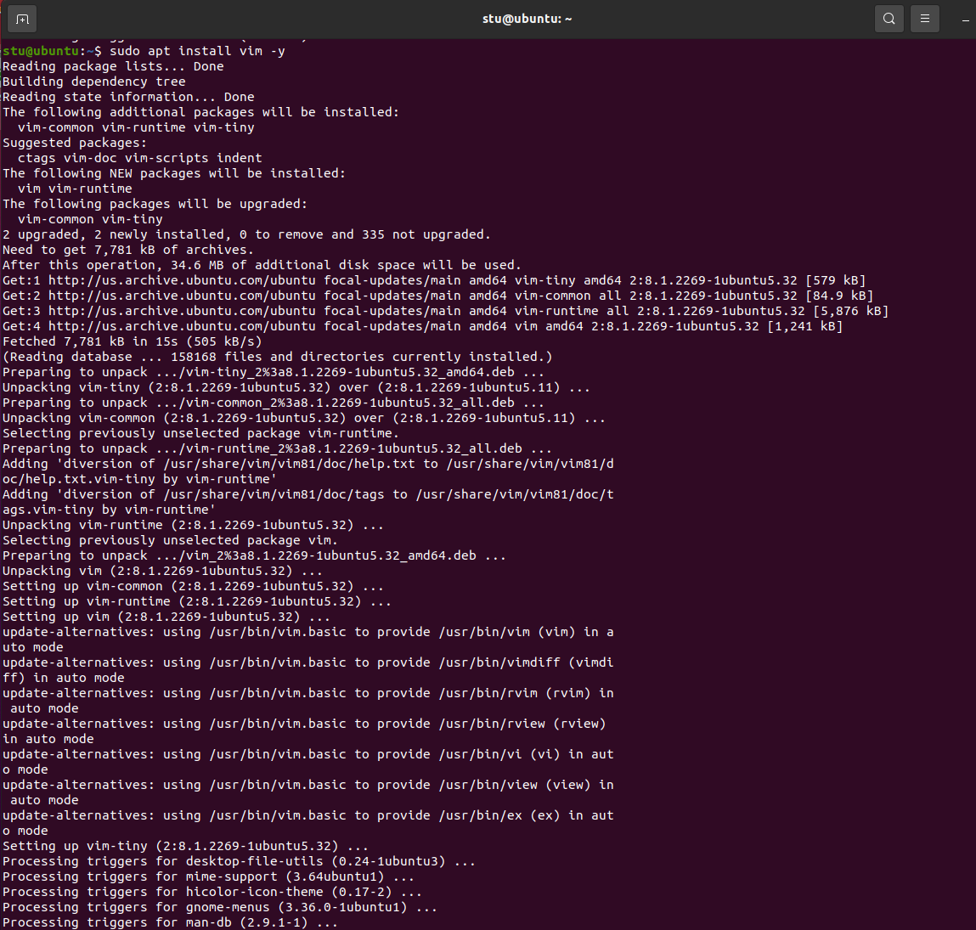
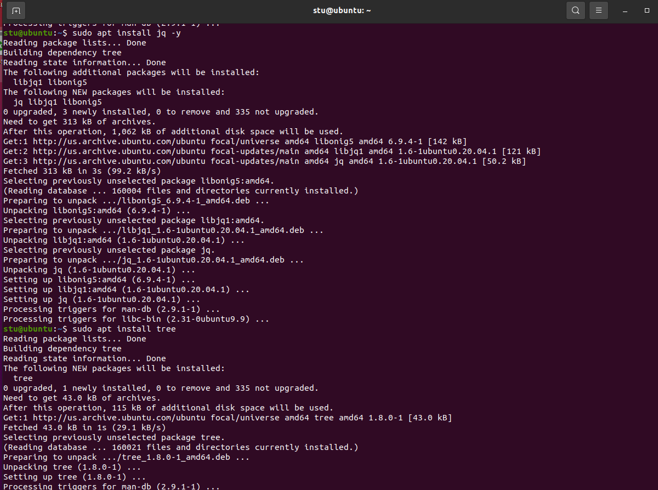
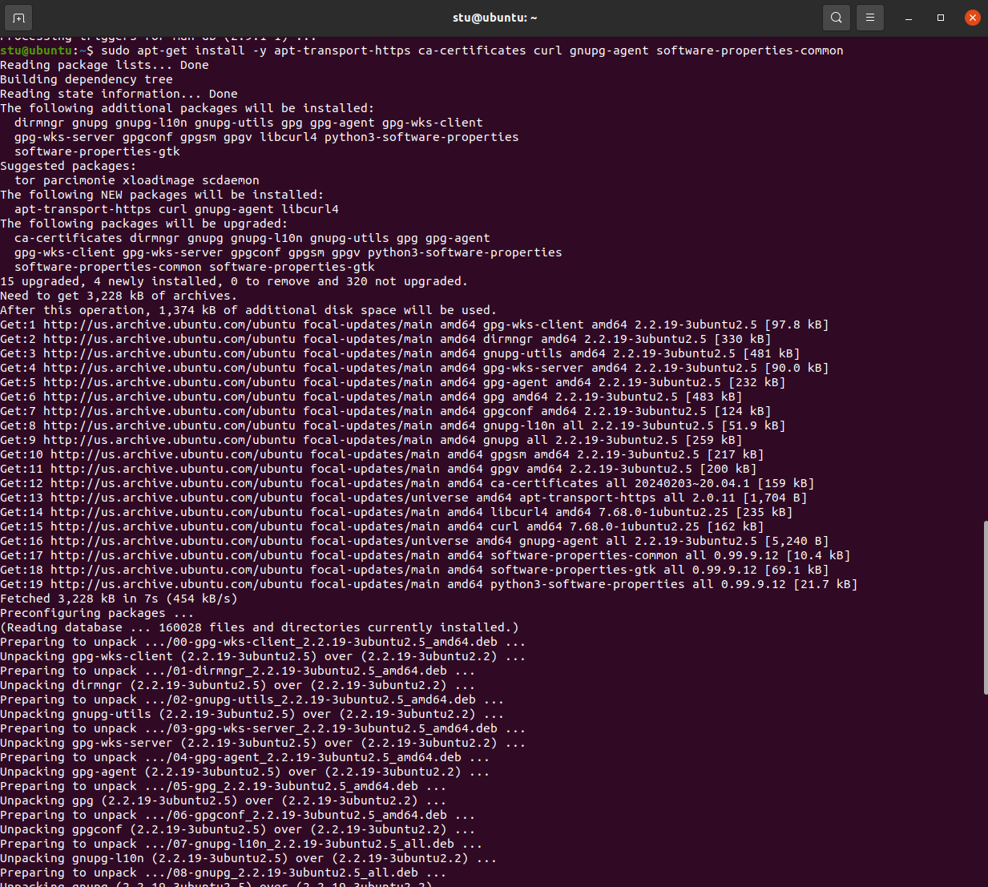
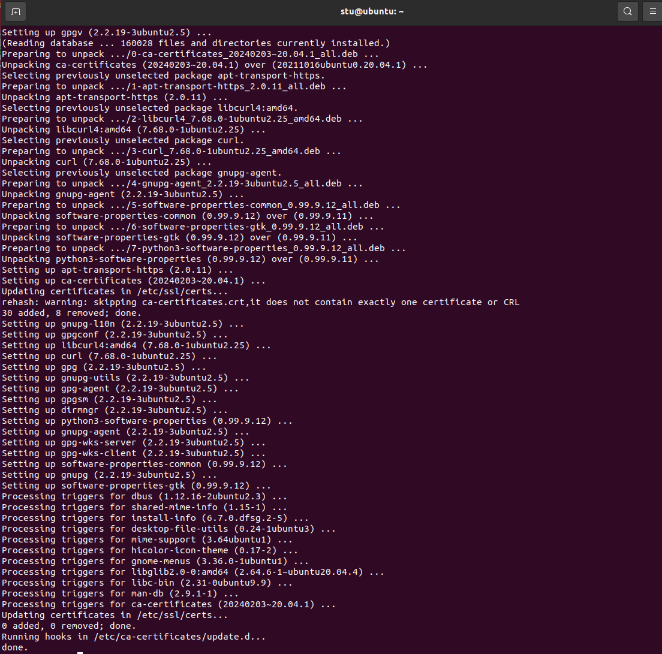
3. **添加Docker的官方GPG密钥**：
```bash
curl -fsSL https://download.docker.com/linux/ubuntu/gpg | sudo apt-key add -
```

4. **将Docker的APT仓库添加到系统中**：
```bash
sudo add-apt-repository "deb [arch=amd64] https://download.docker.com/linux/ubuntu $(lsb_release -cs) stable"
```
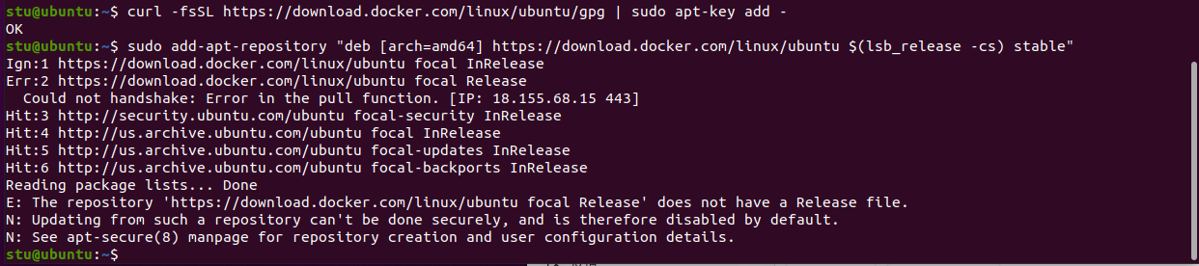

5. **安装Docker引擎**：
```bash
sudo apt-get update
sudo apt-get install -y docker-ce docker-ce-cli containerd.io
```

6. **验证Docker是否安装成功**：
```bash
sudo docker --version
```
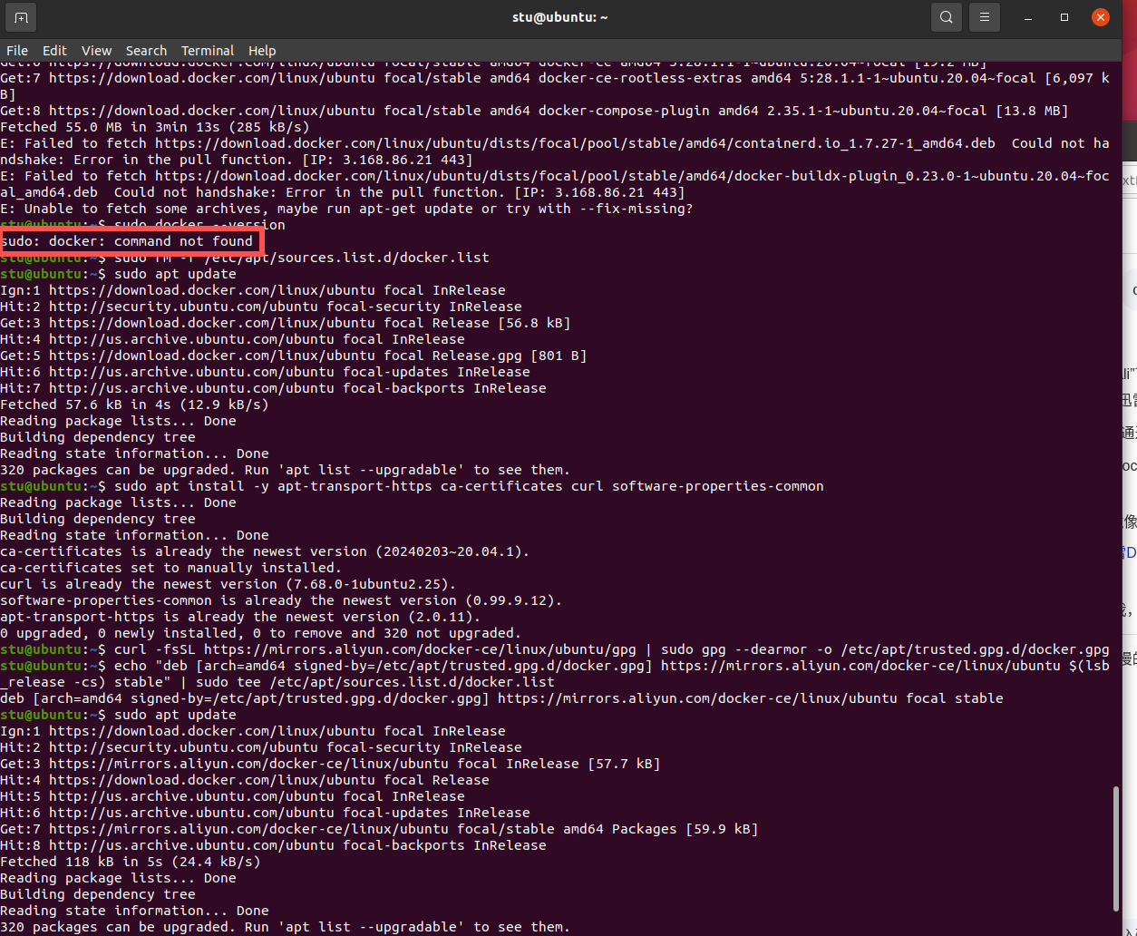
更改镜像
# 安装必要依赖
sudo apt install -y apt-transport-https ca-certificates curl software-properties-common

# 添加阿里云 Docker 源的 GPG 密钥
curl -fsSL https://mirrors.aliyun.com/docker-ce/linux/ubuntu/gpg | sudo gpg --dearmor -o /etc/apt/trusted.gpg.d/docker.gpg

# 添加阿里云 Docker 源到 apt 列表（适配 Ubuntu 20.04/focal，其他版本替换 codename）
echo "deb [arch=amd64 signed-by=/etc/apt/trusted.gpg.d/docker.gpg] https://mirrors.aliyun.com/docker-ce/linux/ubuntu $(lsb_release -cs) stable" | sudo tee /etc/apt/sources.list.d/docker.list

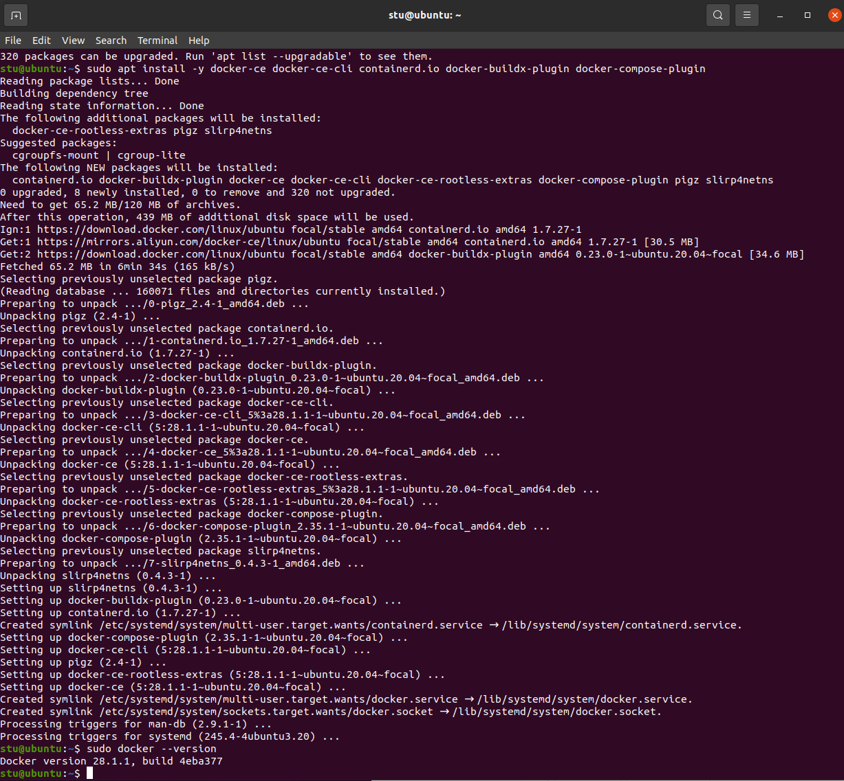

7. **安装Docker Compose**：
```bash
sudo curl -L "https://github.com/docker/compose/releases/download/1.29.2/docker-compose-$(uname -s)-$(uname -m)" -o /usr/local/bin/docker-compose
sudo chmod +x /usr/local/bin/docker-compose
```

8. **验证Docker Compose是否安装成功**：
```bash
sudo docker-compose –version

