* Create a IAM User with following policies attached:

**AmazonS3FullAccess, CloudFrontFullAccess and AmazonRoute53FullAccess.**

1. Login with the root user first.

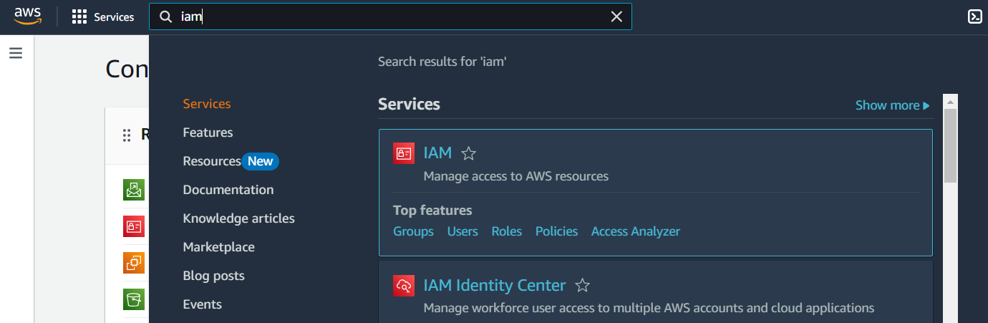

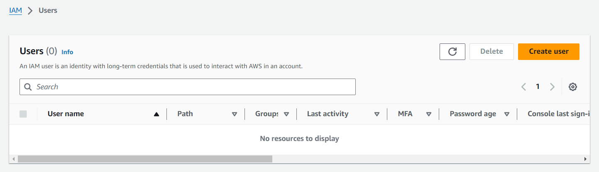

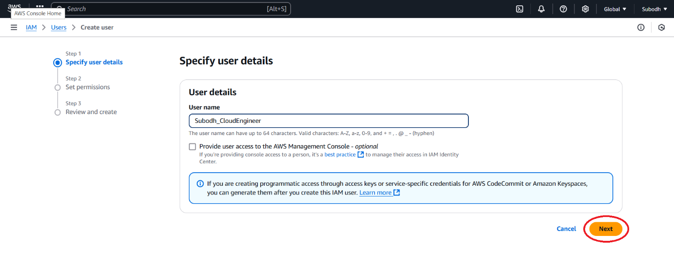

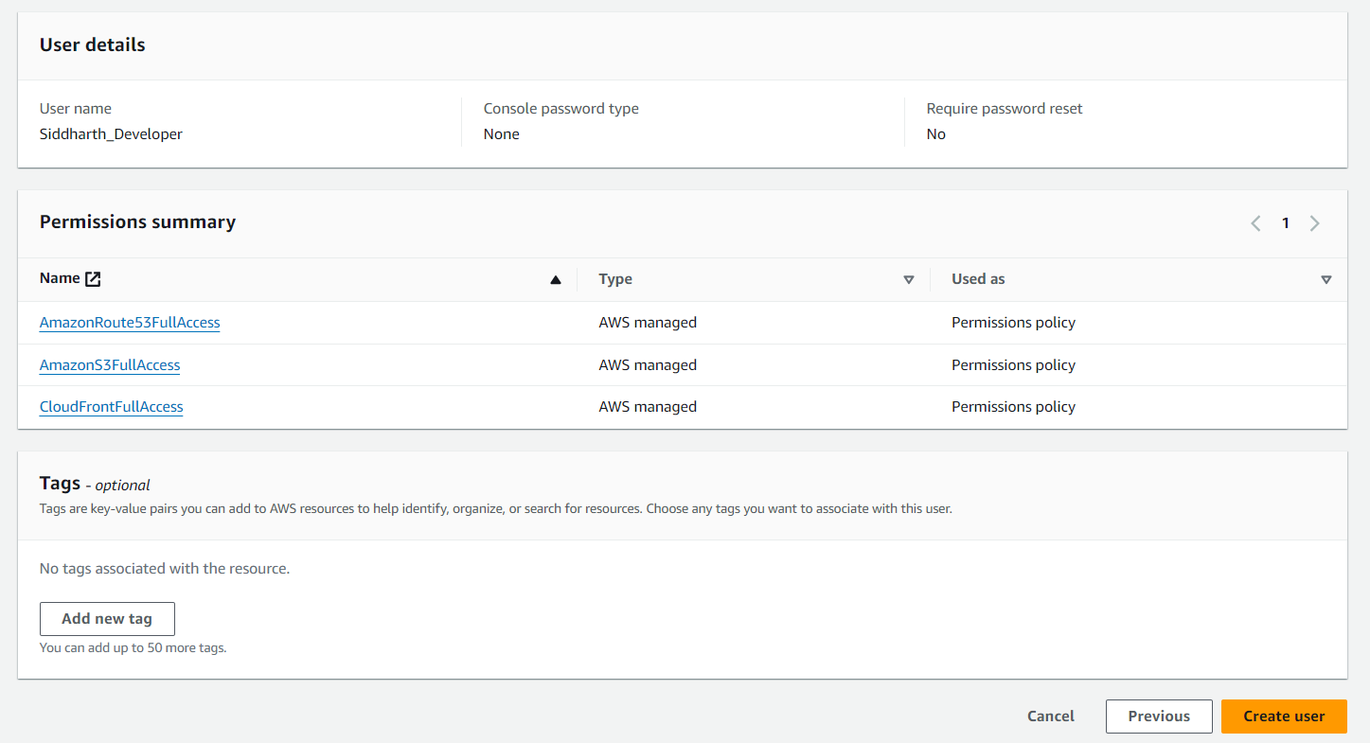

* After successfully creating a user,

Go to Users → Click on the username → Security Credentials → Enable Console Access:

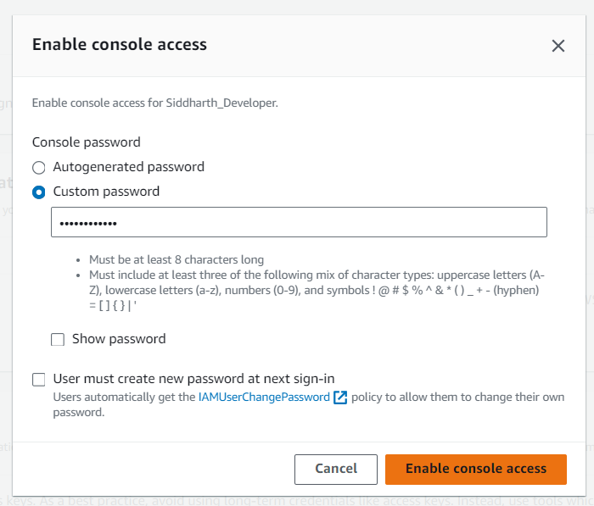

Now Login into the IAM user with the console login link.