A Guidebook to a Usurper’s Travels

Introduction:
I, Cardinal Yosiah of the Pale City, have been tasked by the High Zodiacs, on behalf of all the free peoples of the realms, to aid Usurpers whose wits have not been completely destroyed by the Rite of Sacrifice. With the great knowledge given to me by my goddess, Oraculia, I shall aim to remind you of your strengths, as well as how best to defeat your foes. May the Star-Gods have mercy upon your sorry kind, for you are at once our greatest shame and our greatest hope.

Let me remind you of the great trial the Star-Gods have prescribed for you – travel across the realms, grow in strength as you sacrifice any who oppose them, and cast down that traitorous king Ra’ah - who fights against us even as our world drowns in Darkness.
Ra’ah’s name should at least be familiar to you. He was the one who murdered your god.

The Field of Battle:
Oraculia, with Her infinite knowledge, has bestowed upon me visions of what the world looks like through a Usurper’s eyes. Though receiving such information nearly broke me, I have recorded everything that should be of use to a Usurper:
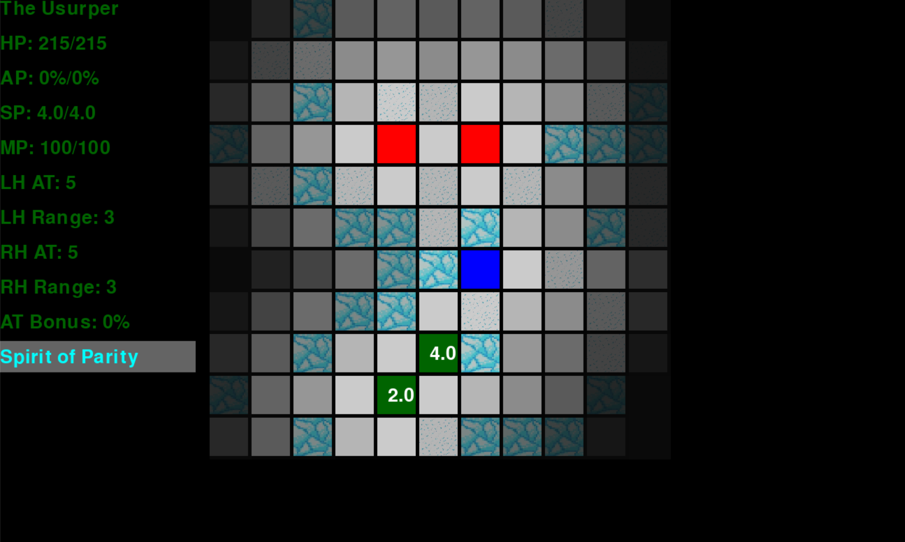
My goddess has told me that by having a mouse hover above a friend, foe, or wall shall reveal information about them to the Usurper. How you are able to control such rodents is beyond me. Here is what all the revealed information means:
HP – Health Points – an abstraction of how many wounds something can suffer before it is slain or destroyed.
AP – Armour Points – what percentage of damage gets blocked by your armour.
SP – Speed Points – one is lost when you step onto another tile or make an attack. When reduced to 0 or below, the world must turn before they are restored.
MP – Magic Points – these points are spent activating abilities or when an enchantment is activated. You restore 20 when the world turns. If you run out, you will be unable to benefit from abilities or enchantments that require them - may Astra have mercy on you!
LH AT / RH AT – Left Hand Attack / Right Hand Attack – the strength of the weapons held in your left and right hands. When you strike an entity or object, the damage you do is reduced by a percentage determined by their AP.
LH Range / RH Range – Left Hand Range/ Right Hand Range – how many tiles your weapons can reach. You can see this more visually by hovering your mouse directly above an entity like so:
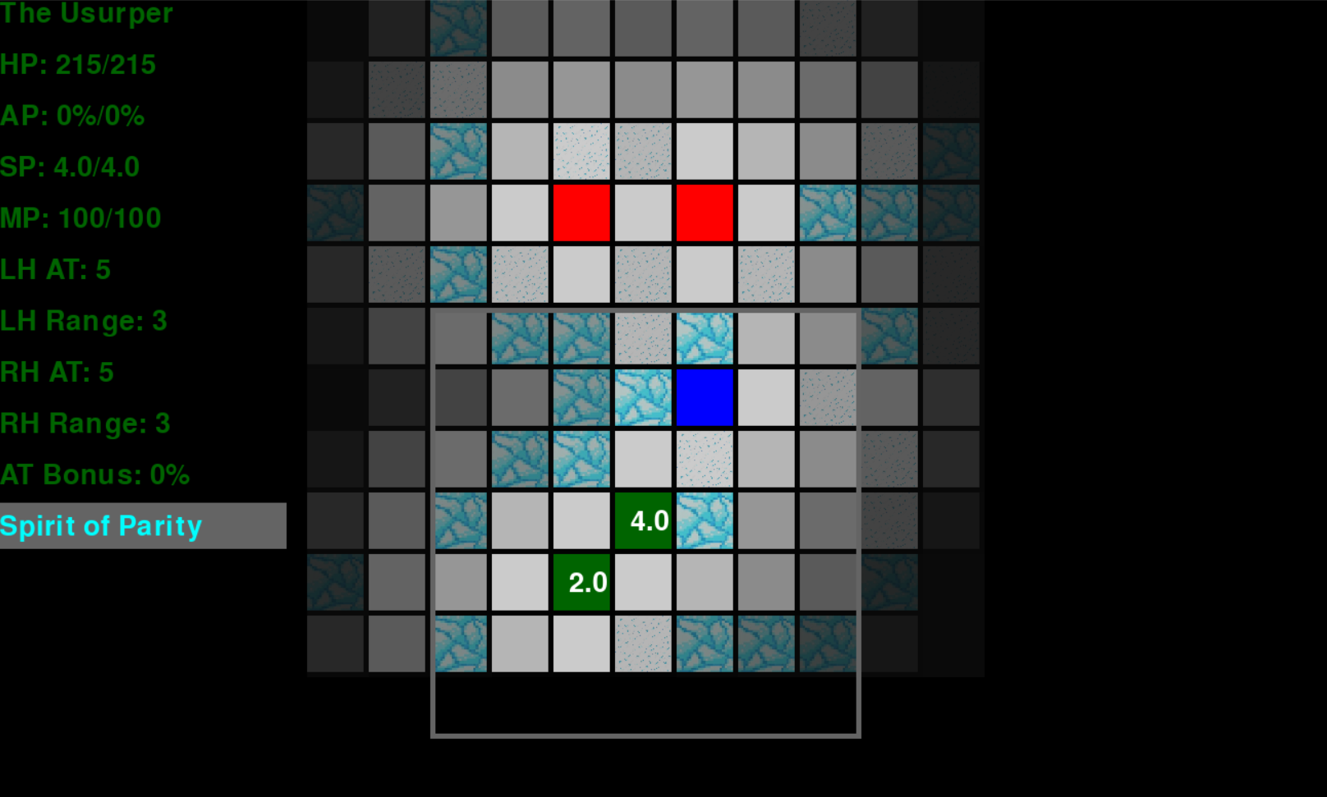
That grey box around the Usurper is their weapon range. They can attack anything within this radius with their weapon, as long as their sight is not blocked by a wall

Now, the grey box with the blue text in it is an enchantment. Enchantments are a very vague term referring to any special passive ability that an entity possesses. As this Usurper is a Human, they are unfortunately blessed by the Darkness from which they came. Hovering over an enchantment reveals information about it:
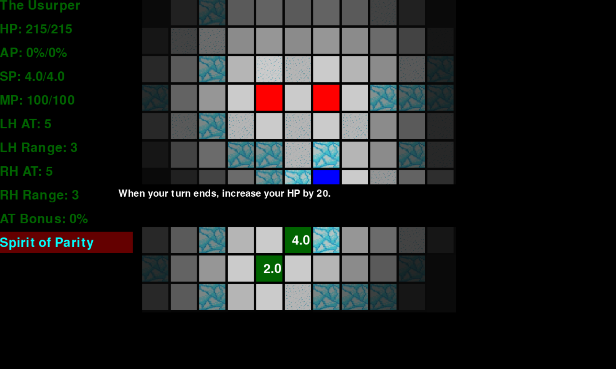

It is mandated by the High Zodiacs that no Usurper should travel alone. This particular Usurper has been gifted a Star-Golem by the generous artificers of the Pale City, let’s take a look at them:
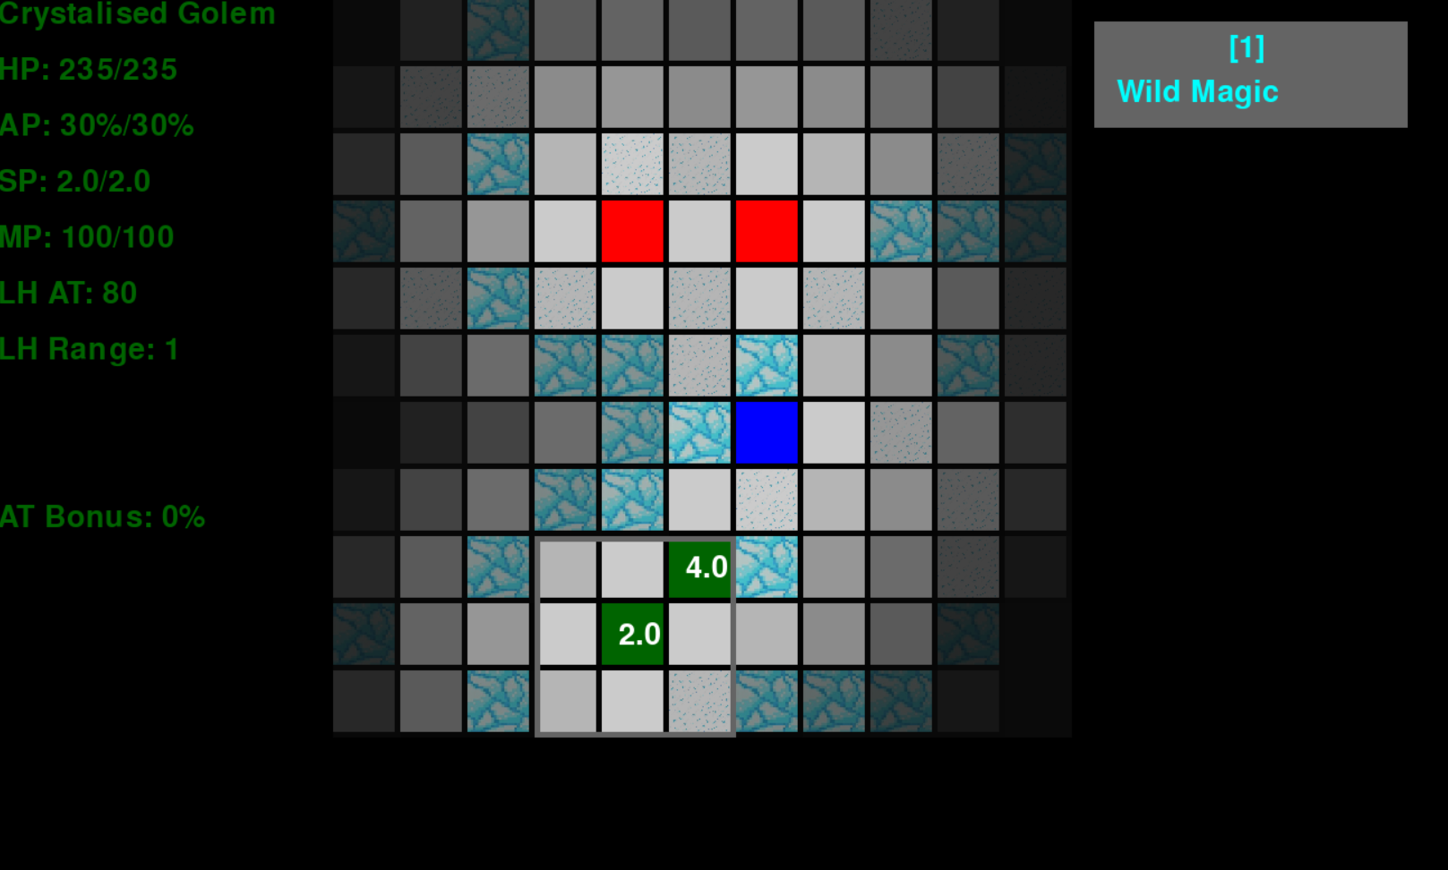

Ah! This golem is blessed by Astra, and can channel the destructive aspect of Her magic through the use of an ability, represented by the grey box with the blue text on the right side. The number written above the name of the ability is the number that the Usurper must press on their “key board” to activate it.

It is worth noting that not everyone a Usurper cannot convince to fight by their orders is automatically a foe. On this battlefield the Usurper has an ally, coloured in blue, who fights against a mutual foe. Allies can be summoned by abilities or enchantments, or may already be present on a battlefield when a Usurper arrives

For a Usurper and those they command to move to another tile, or attack an entity, they must be selected. To do this, hover your mouse (or other rodent of choice) above them and have it do a “right click” to select them. The selected entity should start glowing a brilliant green. When hovering over a tile or entity, this will now reveal a “cross hair”, like so:
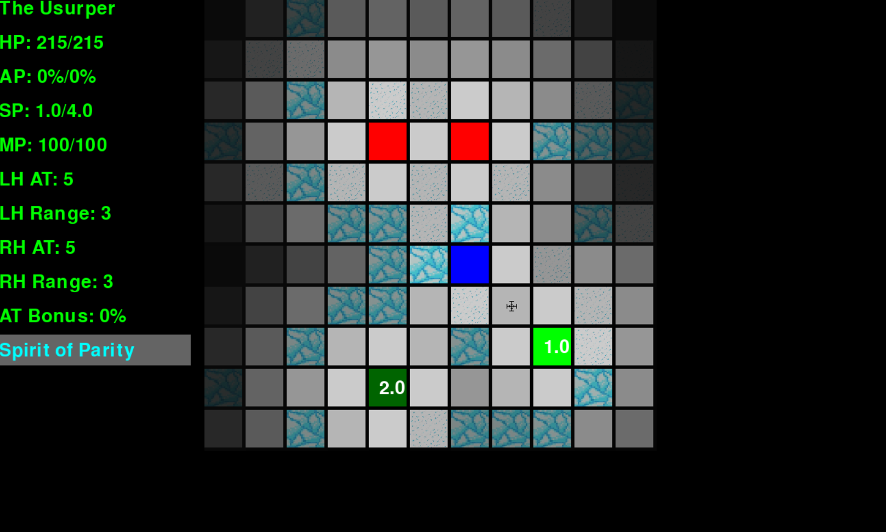

When a selected entity runs out of SP, they will be de-selected and cannot be selected again until the world turns.

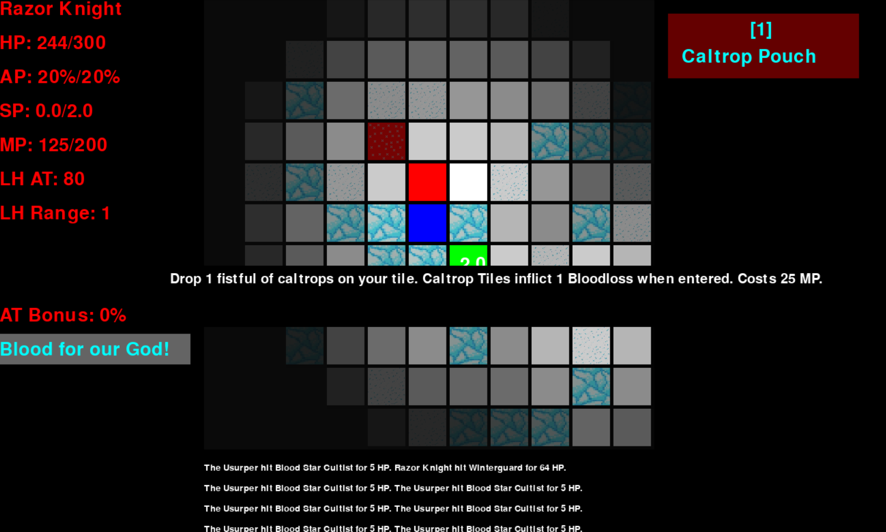

When an attack is made against an entity, or they are targeted by an ability or enchantment, a blue line shall appear connected the attacker and the attacked. Details of all attacks and enchantments/abilities that have activated will be shown at the bottom of the screen

It is worth noting that tiles with a dark red outline contain traps. Information about these traps can be found by looking through the information of the one that placed them. The trap in this painting has been placed by this “Razor Knight”, who is a member of the vile Bloody Star Cult.

Usurpers are reminded that under no circumstances should they communicate with any members of the Bloody Star Cult. They are traitors and heretics of the highest order, and any attempts they make to reason with you will be for the purposes of killing you later. Any Usurpers found communicating with them will be hunted down and exterminated by the full might of the Pale City. You have been warned.

After a battle:
