Sprout — Mobile App Developer Assignment

Task 1 — Designing a 5-Minute Engagement Loop

Concept: Color Safari with Bobo
A short, mascot-guided “find the color” adventure. A friendly elephant named Bobo asks the child to spot everyday objects of a given color, either by tapping one of a few on-screen pictures or, in an optional camera mode for slightly older children, by snapping a photo of something matching that color in the room. Each round runs 45–60 seconds, and a full session covers five colors in roughly five minutes.

Why a 3-year-old would enjoy it
- Color naming is a skill most 3-year-olds are actively building, so the game matches their current ability rather than feeling like a test.
- Every round ends in under a minute with a cheer, a sparkle animation, and a sound, so rewards are frequent and immediate.
- No reading is required — Bobo speaks every instruction and shows it as a picture.
- The camera mode turns screen time into a bit of physical play, getting the child up and moving around the room.
- The repetition-with-variation format — the same simple loop, with a new color each time — is comforting and fun at this age, the way toddlers happily replay the same game over and over.

The loop, step by step
- Welcome (about 10 seconds) — Bobo waves: “Let’s go on a Color Safari!”
- Prompt (about 5 seconds) — “Can you find something RED?”
- Search and tap (about 20–30 seconds) — the child taps the red object among four large on-screen pictures, or photographs a red object nearby.
- Celebration (about 10 seconds) — a confetti burst, a cheerful chime, and a star added to a visible “safari trail” at the top of the screen.
- Repeat for green, blue, yellow, and orange — five rounds in total.

When time runs out
Bobo does a little dance and counts the stars: “Wow, you found five colors today!” A sticker is added to the child’s “Safari Book” — a simple visual collection screen the child can flip through. Bobo signs off with “See you tomorrow for a new safari!” There is no “Game Over,” no score shown to the child, and no pressure to keep playing — closure is framed entirely as a celebration. A short summary screen also appears for the parent (colors practiced, time spent), supporting a research-informed, screen-sensible feel for the app.

Design notes
- Large tap targets and audio-first instructions mean no reading is needed, which doubles as an accessibility win.
- Camera mode is optional, not required, so the activity still works without camera access or parental permission — in line with a “minimal data collection, parental gates” approach to privacy.
- All progress (stars, badges) is stored locally on the device — nothing leaves the phone for this loop.
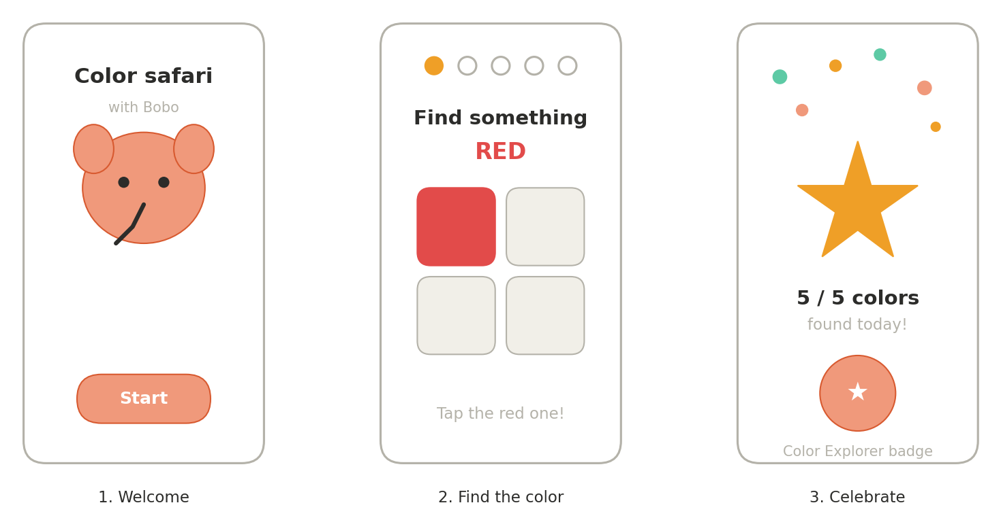
Figure 1: Wireframe sketch of the three key screens — welcome, color prompt, and celebration.

Task 3 — Diagnosing a Drop-off Problem
Scenario: “Kids leave after 2 minutes.” No data, no designer, one week.

What to investigate first?
- Add lightweight analytics (Firebase) to pinpoint the exact drop-off screen — onboarding, activity intro, first interaction, or reward screen.
- Run 5–8 quick video sessions with parents and toddlers, watching for confusion, frustration, or boredom moments.
- Check load and screen-transition times — even a 2–3 second delay can lose a toddler’s attention completely.
- Audit onboarding and the first activity for anything that requires reading or a long verbal instruction before play starts.

Build and test:
- Cut time-to-first-reward to under 15 seconds from app open.
- A/B test a one-tap onboarding against the current flow.
- Add immediate sound and animation feedback on every tap, not just on task completion.
- Replace text-heavy instructions with icons, voice prompts, or simple visuals.

Measure success
- Median session length (target: from under 2 minutes to over 3).
- Percentage of sessions completing at least one full activity loop.
- Day-1 return rate.
- Per-screen drop-off rate, compared before and after each change.

