-- Basic Queries

-- Write a query to display all rows and columns from the employees table.

select * from emp;

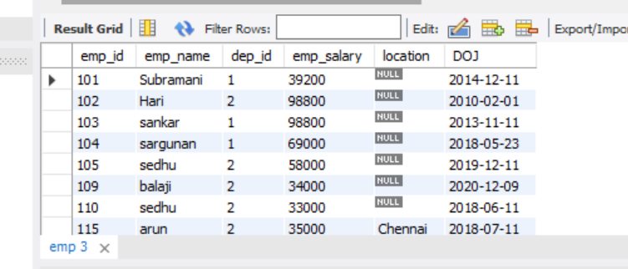

-- Retrieve only the name and salary of all employees from the employees table.

select emp_name,emp_salary from emp;

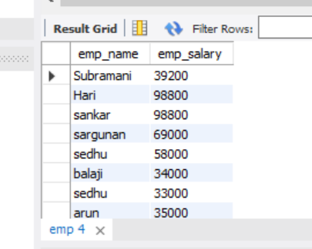

-- Write a query to find all employees whose salary is greater than 50,000.

select * from emp where emp_salary > 50000;

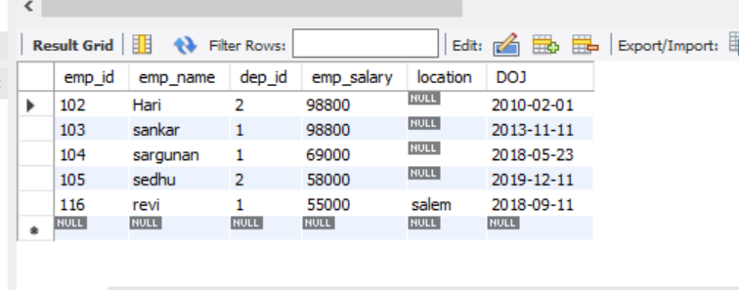

-- List all employees who joined the company in the year 2020.

select * from emp where year(DOJ) = 2018;

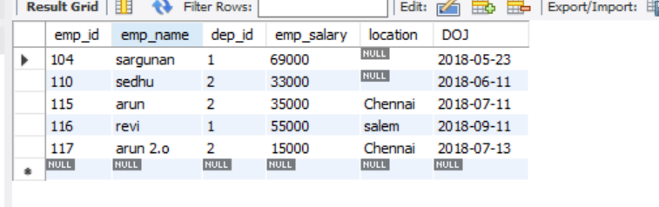

-- Retrieve the details of employees whose names start with the letter 'A'.

select * from emp where emp_name like 'a%';

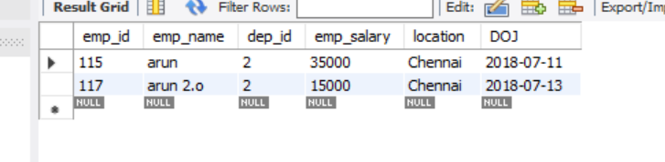

-- Aggregate Functions

-- Write a query to calculate the average salary of all employees.

select avg(emp_salary) as avg_salary from emp;

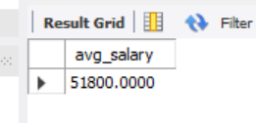

-- Find the total number of employees in the company.

select count(emp_id) as total_employees from emp;

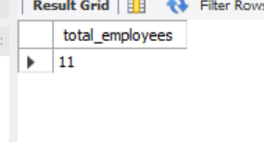

-- Write a query to find the highest salary in the employees table.

select emp_salary as highest_salary from emp order by emp_salary desc limit 1;

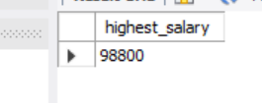

-- Calculate the total salary paid by the company for all employees.

select sum(emp_salary) as company_paided_salary from emp;

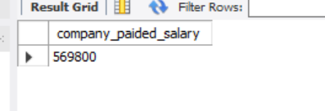

-- Find the count of employees in each department.

select department.dept_name,count(emp.emp_id) as employee_count

from emp join department

on emp.dep_id= department.department_id

group by department.dept_name;

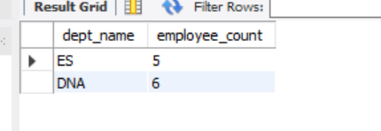

-- Joins

-- Write a query to retrieve employee names along with their department names (using employees and departments tables).

select emp.emp_name,department.dept_name from emp join department

on emp.dep_id = department.department_id;

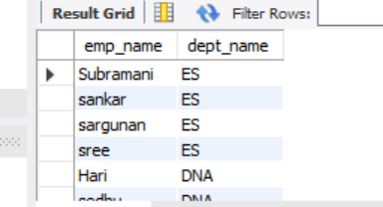

-- List all employees who have a manager (self-join on employees table).

select e2.emp_name,e1.emp_name as managername from emp e1 join emp e2 on e1.emp_id = e2.manager_id;

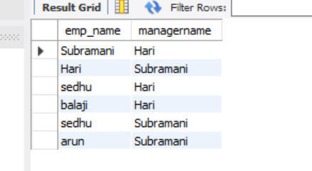

-- Find the names of employees who are working on multiple projects (using employees and projects tables).

select emp.emp_name from emp join emp_projects on emp.emp_id = emp_projects.employee_id

group by emp.emp_name having count(emp.emp_name) >1;

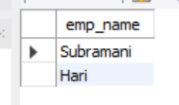

-- Write a query to display all projects and the employees assigned to them.

select project.project_name,emp.emp_name from project

left join emp_projects on project.project_id = emp_projects.project_id

left join emp on emp.emp_id = emp_projects.employee_id order by project.project_name;

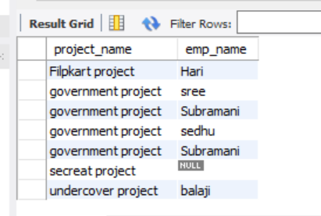

-- Retrieve the names of employees who do not belong to any department.

select emp_name as benchEmployees from emp

where dep_id is null;

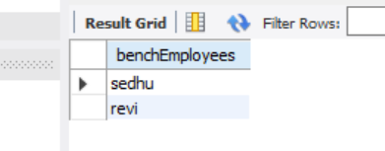

-- Subqueries

-- Write a query to find the employees with the second-highest salary.

select emp_name as secondHighest_Salaryemployee,emp_salary from

( select emp_name,emp_salary,dense_rank() over(order by emp_salary desc)as salary_rank from emp) new_ranktable

where salary_rank = 2;

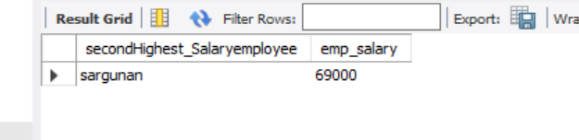

-- Retrieve the names of employees whose salary is above the department average salary.

select department.dept_name,avg(emp.emp_salary) from emp join department on emp.dep_id = department.department_id group by department.dept_name;

select department.department_id,emp.emp_name as aboveAvg_salariedEmployee,emp.emp_salary from emp join department

on emp.dep_id = department.department_id

where emp.emp_salary > (select avg(e2.emp_salary) from emp e2 where e2.dep_id = emp.dep_id );

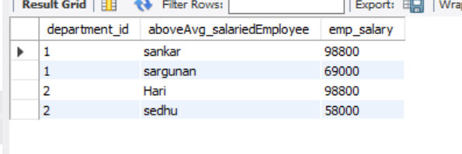

-- Find employees who earn more than the average salary of the entire company.

select emp_name as aboveAvg_salariedEmployee from emp where emp_salary > (select avg(emp_salary) from emp);

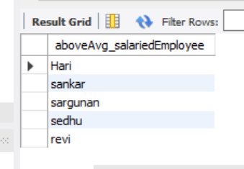

-- Write a query to find the department with the highest number of employees.

select d1.dept_name from department d1

left join emp e1 on d1.department_id = e1.dep_id

group by d1.dept_name

having count(e1.emp_id) =

(select max(employee_count) from

(select count(e2.emp_id) as employee_count

from emp e2

group by e2.dep_id

)

count_subquery

);

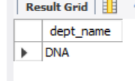

-- List all employees who work in a department located in 'New York'.

select emp.emp_name from emp join department on emp.dep_id = department.department_id

where department.dept_location = 'New york';

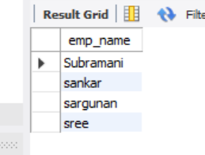

-- Set Operators

-- Write a query to find employees who work in either the 'HR' or 'Finance' department.

select e.* from emp e join department d

on e.dep_id = d.department_id

where d.dept_name = 'ES' or d.dept_name = 'Finance';

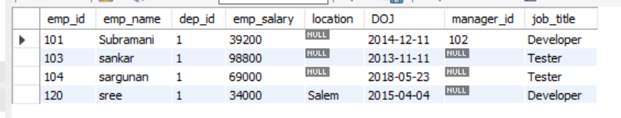

-- Retrieve the names of employees who are working on both Project A and Project B.

select e.emp_name from emp e

join emp_projects e1 on e.emp_id = e1.employee_id

join project p1 on p1.project_id = e1.project_id

join emp_projects e2 on e.emp_id = e2.employee_id

join project p2 on p2.project_id = e2.project_id

where p1.project_name = 'Amazon project' and p2.project_name = 'government project'

group by e.emp_name;

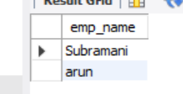

-- Find employees who are not assigned to any project

select emp_name as benchEmployees from emp where emp_name not in(

select e.emp_name from emp e

join emp_projects e1 on e.emp_id = e1.employee_id

join project p1 on p1.project_id = e1.project_id );

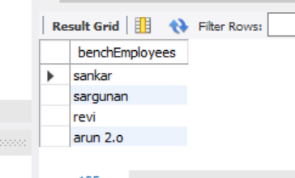

-- Write a query to get all unique job titles across all departments.

select distinct emp.job_title from emp join department

on emp.dep_id = department.department_id;

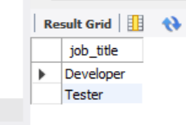

-- Combine two tables (employees and former_employees) and remove duplicates.

select * from emp union select * from formeremployee3

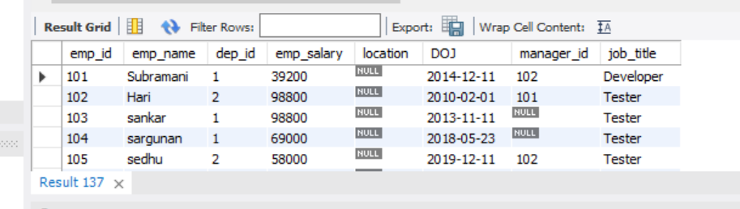

-- DML and DDL

-- Write a query to add a new employee to the employees table.

insert into emp values(121,'balaji',3,98000,'covai','2019-03-01','104','Developer');

-- Update the salary of all employees in the 'ES' department by 10%.

update emp join department on emp.dep_id = department.department_id

set emp.emp_salary = emp.emp_salary*1.10

where department.dept_name = 'ES';

-- Delete all employees who have not worked for more than 5 years.

delete from emp where DOJ > date_sub( curdate(), interval 5 year );

-- Create a new table departments_backup with the same structure as the departments table.

create table departments_backup(

department_id numeric primary key,

dept_name varchar(50),

emp_count numeric

);

-- Drop the temporary_data table from the database

drop table departments_backup;

-- Constraints

-- Add a primary key to the employees table.

-- Already added

-- Write a query to create a foreign key between employees and departments tables.

-- Already added

-- Add a unique constraint to the email column in the employees table.

alter table emp add column email varchar(50) unique;

-- Write a query to check all constraints applied on the employees table.

-- Remove the NOT NULL constraint from the phone_number column in the employees table.

alter table emp add column phone_number numeric(10) not null;

alter table emp modify phone_number numeric(10) ;

PL/SQL Questions

Basic PL/SQL Programs

Write a PL/SQL block to calculate the factorial of a given number.

DELIMITER $$

create procedure CalculateFactorial(in n int)

begin

declare a INT DEFAULT 1;

WHILE n > 0 DO

SET a = n * a;

SET n = n - 1;

END WHILE;

SELECT a;

END $$

DELIMITER ;

call CalculateFactorial(5)

-- Write a PL/SQL block to display the Fibonacci series up to n terms.

delimiter //

create procedure get_fibonacci2(in input int)

begin

declare a int default 0;

declare b int default 1;

declare temp int;

declare i int default 1;

declare f varchar(255) default '';

set f =concat(f,a);

set f = concat(f,', ',b);

while i < input - 1 do

set temp = a+b;

set a=b;

set b = temp;

set f = concat(f,', ',b);

set i = i+1;

end while;

select f as fibinocci_series;

end //

call get_fibonacci2(10)

Create a PL/SQL block to reverse a given string.

Write a program to find whether a number is prime or not.

Write a program to calculate the sum of all digits of a given number.