18/01/2022

Subramani P

**SQL - Quries**

# QUERY-1

1. Find out the SELLING COST AVERAGE for the packages developed in PASCAL? select name as name ,year(curdate())-year(dob) as age from programmer;

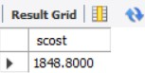

1. Display the names and ages of all programmers.

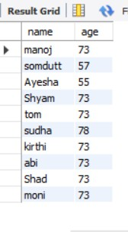select name as name ,year(curdate())-year(dob) as age from programmer;

1. Display the names and ages of all the programmers who have undergone training in DCS course.

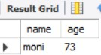

1. What is the highest numbers of copies sold by a package?

select title,max(sold) from software;

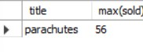

1. Display the names and date of birth of all the programmer born in JANUARY. select dob,name from programmer where month(dob) = 01;

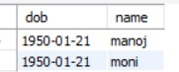

1. Display lowest course fee.

select title,min(ccost) from studies;

1. How many programmer has done PGDCA course.

select count(name) from studies where course like "pgdca";

1. How much revenue has been earned through sales of packages in C. select sum(sold*scost) from software where dev_in like 'c';



1. Display the details of software developed by Ramesh? select * from software where name like 'ramesh';



1. How many programmers studied at SABHARI.

select count(name) from studies where splace like 'sabhari';

1. Display the details of PACKAGES whose sales crossed the 20000 mark. select * from software where (sold*scost)>20000;

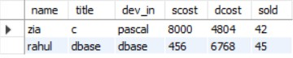

1. Find out the number of copies which should be sold in order to recover the development cost of each package.

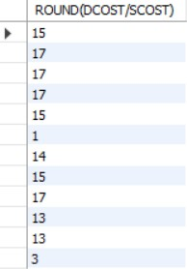select round(dcost/scost) from software where scost*sold*dcost;

1. What is the price of the costliest software developed in BASIC? select max(scost) from software where dev_in like 'basic';

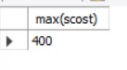

1. Display the details of packages for which development cost has been recovered. select * from software where (sold*scost)>dcost;

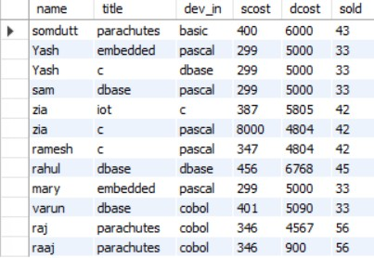

1. How many packages were developed in dbase?

select count(title) from software where dev_in like 'dbase';

1. How many programmers studies at paragathi?

select count(name) from studies where splace like 'paragathi';

1. How many programmers paid 5000 to 10000 for their course?

select count(name) from studies where ccost>=5000 and ccost<=10000;

1. What is the average course fee?

select round(avg(ccost)) from studies where ccost;

1. Display the details of programmers knowing c?

select * from programmer where prof1='c' or prof2='c';

1. How many programmers know either Cobol or Pascal?

select count(name) from programmer where prof1='cobol'or prof1='pascal' or prof2= 'cobol'or prof2='pascal';



1. How many programmers don't know Pascal & C?

select count(name) from programmer where prof1!='pascal' and prof1!='c' and prof2!='pascal' and prof2!='c';



1. How old is the oldest male programmers?

select name,max(year(curdate())-year(dob)) from programmer where sex='m';

1. What is the average age of female programmers?

select avg(year(curdate())-year(dob)) from programmer where sex like 'f';

1. Calculate the experience in years for each programmers and display along with the names in descending order?

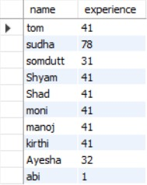select name, year(curdate())-year(doj) as experience from programmer order by name desc;

1. Who are the programmers who celebrate their birthday during the current month? select name from programmer where month(dob)=month(curdate());



1. How many female programmers are there?

select count(name) as female_count from programmer where sex like 'f';

1. What are the languages known by the male programmers?

select distinct prof1 as lang from programmer where sex like 'm' union select distinct prof2 as lang from programmer where sex like 'm' ;

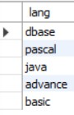

1. What is the Average salary?

select avg(salary) from programmer;

1. How many people draw 2000 to 4000?

select count(name) from programmer where salary>=2000 and salary<=4000;

1. Display the details of those who don't know Clipper, Cobol or Pascal? 4

select * from programmer where prof1!='clipper' and prof1!='cobol' and prof1!='pascal' and prof2!='clipper' and prof2!='cobon' and prof2!='pascal';

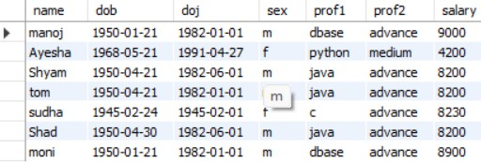

1. How many Female programmers knowing C are above 24 years of age?

select count(name) from programmer where sex='f' and (year(curdate())-year(dob))>24;

1. Display the details of those with less than a year's experience? select * from programmer where year(curdate())-year(doj)=1;



1. Display the details of those who will be completing 2 years of service this year? select * from programmer where (year(curdate())-year(doj)) = 2;



1. Calculate the amount to be recovered for those packages whose development cost has not been recovered?

select (dcost-(scost*sold)),title from software where (scost*sold);

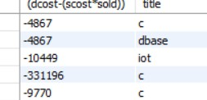

1. List the packages which have not been sold so far? select title from software where sold=0;



1. Find out the cost of the software developed by Mary? select title as pacakage from software where name like 'mary';



1. Display the institute’s names from the studies table without duplicates?

select distinct splace from studies;

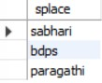

1. How many different courses are mentioned in the studies table? select distinct course from studies ;

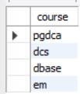

1. Display the names of the programmers whose names contain 2 occurrences of the letter A? select name from programmer where name like '%a%a';

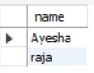

1. Display the names of programmers whose names contain unto 5 characters? select name from programmer where length(name)=5;

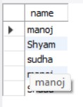

1. How many female programmers knowing COBOL have more than 2 years experience?

select count(name) from programmer where sex='f' and (year(curdate())-year(dob)>=2) and (prof1='cobol' or prof2='cobol');



1. What is the length of the shortest name in the programmer table? select min(length(name)) from programmer;



1. What is the average development cost of a package developed in COBOL? select avg(dcost) from software where dev_in = 'cobol';



1. Display the name, sex, dob (DD/MM/YY format), doj for all the programmers without using conversion function?

select name,sex, date_format(dob,'%d/%m/%y'),doj from programmer;

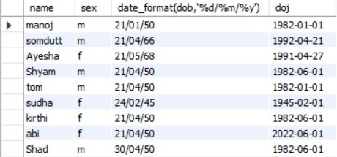

1. Who are the programmers who were born on the last day of the month? SELECT NAME FROM PROGRAMMER WHERE LAST_DAY(DOB) = DOB;

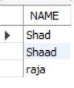

1. What is the amount paid in salaries of the male programmers who do not know Cobol? select name, salary from programmer where sex='m' and (prof1!='cobol' or prof2!='cobol');

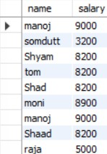

1. Display the title, scost, dcost and difference between scost and dcost in descending order of difference? select title,scost,dcost,(scost-dcost) as diffrence from software order by 4 desc;

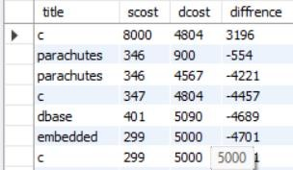

1. Display the name, dob, doj of those month of birth and month of joining are same? select name,dob,doj from programmer where month(dob)=month(doj);

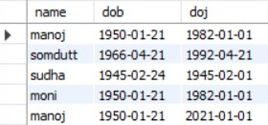

1. Display the names of the packages whose names contain more than 1 word? SELECT TITLE FROM SOFTWARE WHERE TITLE LIKE '% %';

# QUERY- 2

1. Display THE NUMBER OF packages developed in EACH language.

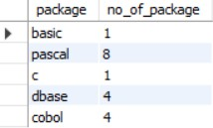select dev_in as package ,count(title) as no_of_package from software group by dev_in;

1. Display THE NUMBER OF packages developed by EACH person. select name,count(title) from software group by name;

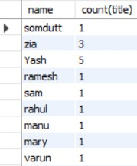

1. Display THE NUMBER OF male and female programmer. select sex,count(name) from programmer group by sex;

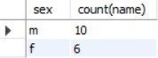

1. Display THE COSTLIEST packages and HIGEST selling developed in EACH language.

select max(scost) as costly_pack ,max(sold) as high_selling ,dev_in as package from software group by dev_in;

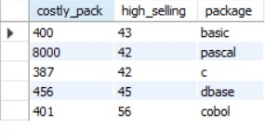

1. Display THE NUMBER OF people BORN in EACH YEAR. select count(name),dob from programmer group by dob;

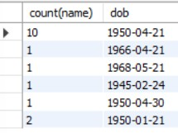

1. Display THE NUMBER OF people JOINED in EACH YEAR. select count(doj),doj from programmer group by doj;

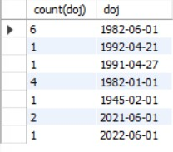

1. Display THE NUMBER OF people BORN in EACH MONTH.

select count(name) as people,month(dob) as month from programmer group by month(dob);

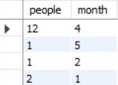

1. Display THE NUMBER OF people JOINED in EACH MONTH.

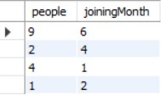select count(name) as people ,month(doj) as joiningMonth from programmer group by month(doj);

1. Display the language wise COUNTS of prof1.

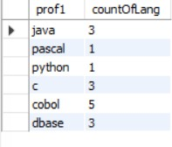select prof1 as prof1 ,count(prof1) as countOfLang from programmer group by prof1;

1. Display the language wise COUNTS of prof2.

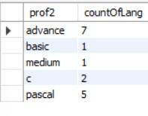select prof2 as prof2, count(prof2) as countOfLang from programmer group by prof2;

1. Display THE NUMBER OF people in EACH salary group.

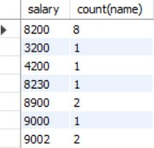select salary, count(name) from programmer group by salary;

1. Display THE NUMBER OF people who studied in EACH institute.

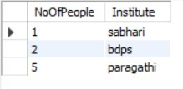select count(name) as NoOfPeople,splace as Institute from studies group by splace;

1. Display THE NUMBER OF people who studied in EACH course.

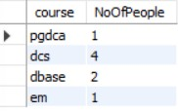select course,count(name) as NoOfPeople from studies group by course;

1. Display the TOTAL development COST of the packages developed in EACH language. select dev_in , sum(dcost) from software group by dev_in;

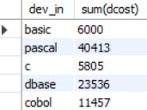

1. Display the selling cost of the package developed in EACH language. select sum(scost),dev_in from software group by dev_in;

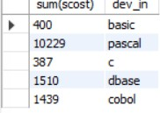

1. Display the cost of the package developed by EACH programmer. select name,sum(dcost) from software group by name;

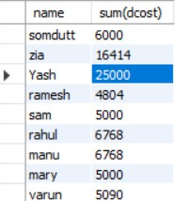

1. Display the sales values of the package developed in EACH programmer. select name,sum(scost*sold) from software group by name;

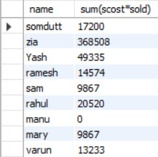

1. Display the NUMBER of packages developed by EACH programmer. select count(title),name from software group by name;

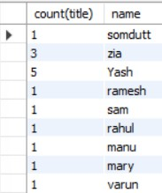

1. Display the sales COST of packages developed by EACH programmer language wise. select sum(scost),dev_in from software group by dev_in;

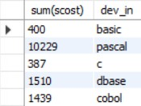

1. Display EACH programmers name, costliest package and cheapest packages developed by Him/Her. select name,max(dcost),min(dcost) from software group by name;

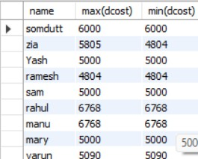

1. Display EACH language name with AVERAGE development cost, AVERAGE cost, selling cost and AVERAGE price per copy.

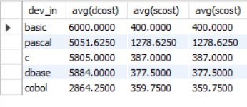select dev_in,avg(dcost),avg(scost),avg(scost) from software group by dev_in;

1. Display EACH institute name with NUMBER of courses, AVERAGE cost per course. select splace, count(course), avg(ccost) from studies group by splace;

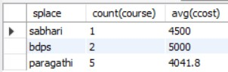

1. Display EACH institute name with NUMBER of students. select splace , count(name) from studies group by splace;

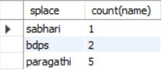

1. Display names of male and female programmers. select name, sex from programmer order by sex;

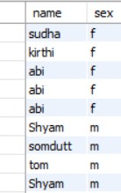

1. Display the programmer's name and their packages. select name,title from software order by name;

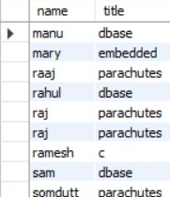

1. Display the NUMBER of packages in EACH language.

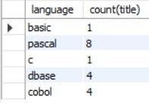select dev_in as language,count(title) from software group by dev_in;

1. Display the NUMBER of packages in EACH language for which development cost is less than 1000. select dev_in as lang, count(title),dcost from software where dcost<1000 group by dev_in;



1. Display the AVERAGE difference BETWEEN scost and dcost for EACH language. select dev_in as lang,avg(dcost-scost) as diff from software group by dev_in;

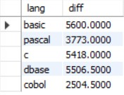

1. Display the TOTAL scost, dcsot and amount TOBE recovered for EACH programmer for whose dcost HAS NOT YET BEEN recovered.

select sum(scost),sum(dcost), sum(dcost-(scost*sold)) from software group by name having sum(dcost)>sum(scost*sold) ;



1. Display highest, lowest and average salaries for THOSE earning MORE than 200 select max(salary), min(salary), avg(salary) from programmer where salary>2000;



# QUERIES - 3

1. Who is the highest paid C programmer?

select name,max(salary) from programmer where prof1='c' or prof2='c';

1. Who is the highest paid female cobol programmer?

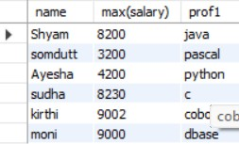select name,max(salary) from programmer where sex='f' and prof1='cobol' or prof2='cobol';

1. Display the name of the HIGEST paid programmer for EACH language (prof1) select name,max(salary),prof1 from programmer group by prof1;

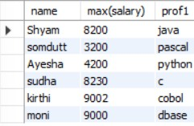

1. Who is the LEAST experienced programmer?

select name,min(year(curdate())-year(doj)) as experience from programmer;

1. Who is the MOST experienced programmer?

select name,max(year(curdate())-year(doj)) as experience from programmer;



1. Which language is known by ONLY ONE programmer?

select prof1 from programmer group by prof1 having prof1 not in (select prof2 from programmer) and count(prof1)=1 union

select prof2 from programmer group by prof2 having prof2 not in (select prof1 from programmer) and count(prof2)=1 ;

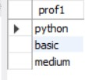

1. Who is the YONGEST programmer knowing DBASE?

select name, min(year(curdate())-year(dob)) as age from programmer where prof1='dbase' or prof2='dbase';



1. Which institute has MOST NUMBER of students?
2. Who is the above programmer?
3. Which female programmer earns MORE than 3000/- but DOES NOT know C, C++, Oracle or Dbase? select * from programmer where sex='f' and (prof1!='c' and prof1!='c++' and prof1!='oracle' and

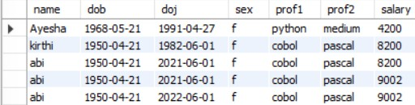prof1!='dbase')and(prof2!='c' and prof2!='c++' and prof2!='oracle' and prof2!='dbase');

1. Which is the COSTLIEST course?

select course from studies where ccost=(select max(ccost) from studies);

1. Which course has been done by MOST of the students?
2. Display name of the institute and course Which has below AVERAGE course fee? select splace,course from studies where ccost<(select avg(ccost) from studies);



1. Which institute conducts COSTLIEST course?

select splace from studies where ccost=(select max(ccost) from studies);

1. Display names of the course WHOSE fees are within 1000(+ or -) of the AVERAGE fee.

select course from studies where ccost<(select avg(ccost)+1000 from studies) and ccost>(select avg(ccost)- 1000 from studies);

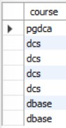

1. Which package has the HIGEST development cost?

select title from software where dcost=(select max(dcost) from software);

1. Which package has the LOWEST selling cost?

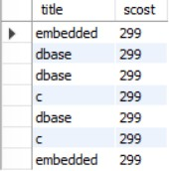select title,scost from software where scost=(select min(scost) from software);

1. Who developed the package, which has sold the LEAST number of copies? select name,sold from software where sold=(select min(sold) from software);



1. Which language was used to develop the package WHICH has the HIGEST sales amount? select dev_in,scost from software where scost=(select max(scost) from software);



1. How many copies of the package that has the LEAST DIFFRENCE between development and selling cost were sold?

select sold,title from software where title=(select title from software where (dcost-scost) =(select min(dcost-scost) from software));

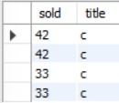

1. Which is the COSTLIEAST package developed in PASCAL?

select title from software where scost=(select max(scost) from software) and dev_in='pascal';

1. Which language was used to develop the MOST NUMBER of package?

select dev_in from software group by dev_in having dev_in=(select max(dev_in) from software);

1. Which programmer has developed the HIGEST NUMBER of package?

select name from software group by name having name =(select max(name) from software);

1. Who is the author of the COSTLIEST package?

select name,dcost from software where dcost = (select max(dcost) from software);

1. Display names of packages WHICH have been sold LESS THAN the AVERAGE number of copies? select title from software where sold < (select avg(sold) from software);

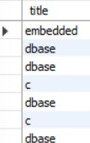

1. Who are the female programmers earning MORE than the HIGEST paid male programmers? SELECT NAME FROM PROGRAMMER WHERE SEX LIKE 'F' AND SALARY > (SELECT(MAX(SALARY)) FROM

PROGRAMMER WHERE SEX LIKE 'M');

1. Which language has been stated as prof1 by MOST of the programmers?

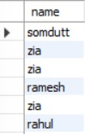select prof1 from programmer where prof1 = (select max(prof1) from programmer);

1. Who are the authors of packages, WHICH have recovered MORE THAN double the development cost? select name from software where 2*dcost<scost*sold;
2. Display programmer names and CHEAPEST package developed by them in EACH language?

SELECT NAME,TITLE FROM SOFTWARE WHERE DCOST in (SELECT MIN(DCOST) FROM SOFTWARE GROUP BY DEV_IN);

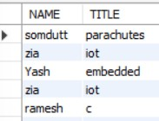

1. Who is the YOUNGEST male programmer born in 1965? select name from programmer where sex='m' and year(dob)=1965;



38) Who are the male programmers earning BELOW the AVERAGE salary of female programmers? select name from programmer where sex='m' and salary< (select (avg(salary)) from programmer where

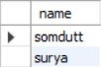sex='f');

# QUERY - 4

1. Display the details of THOSE WHO are drawing the same salary.

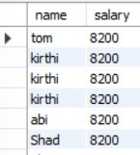select a.name,a.salary from programmer a,programmer b where a.salary=b.salary and a.name <> b.name;

1. Display the details of software developed by male programmers earning MORE than 3000. select * from programmer p, software s where p.name=s.name and salary>3000 and sex='m';



1. Display details of packages developed in PASCAL by female programmers.

select s.* from software s,programmer p where p.name=s.name and sex='f' and dev_in='pascal';

1. Display the details of the programmer WHO joined BEFORE 1990. select * from programmer where year(doj)<1990;

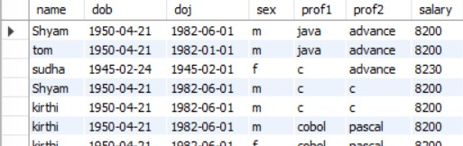

1. Display details of software developed in C by female programmers of PRAGATHI.

select s.* from software s,studies st,programmer p where s.name=st.name=p.name and sex='f' and dev_in

='c' and splace='pragathi';

1. Display NUMBER of packages NUMBER of copies sold and sales value of EACH programmer Institute- wise.

Select studies.splace, count(software.dev_in), count(software.sold), sum(software.sold*software.scost) from software,studies where software.name=studies.name group by studies.splace;



1. Display the details of the software that was developed by male programmers born BEFORE 1965 and female programmers born AFTER 1975.

select s.* from software s,programmer p where s.name=p.name and ( year(dob)<1965 and sex='m')and (year(dob)>1975 and sex='f') ;

1. Display the details of the software that was developed in the language that is NOT the programmer’s first

proficiency.

select s.* from software s,programmer p where s.name=p.name and prof1!=dev_in;

1. Display details of software that was developed in the language which is NEITHER first NOR second proficiency of the programmer

select s.* from software s, programmer p where s.name=p.name and dev_in not in(prof1,prof2);

1. Display details of software developed by male students of SABHARI.

select * from studies s,programmer p where s.name=p.name and splace='sabhari' and sex='m';

1. Display the names of programmers WHO HAVE NOT developed any package. select name from programmer where name not in(select name from software);

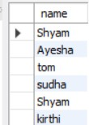

1. What is the total cost of the software developed by the programmers by APPLE? select sum(scost) from software s,studies st where s.name=st.name and splace='apple';
2. Who are the programmers WHO JOINED in the same day?

select a.name,a.doj from programmer a, programmer b where a.doj=b.doj and a.name <> b.name;

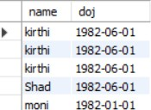

1. Who are the programmers WHO HAVE THE SAME PROF2?

select a.name,a.prof2 from programmer a, programmer b where a.prof2=b.prof2 and a.name <> b.name;

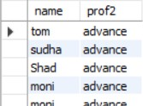

1. Display the total sales values of software, institutes-wise.

select sum(s.scost*s.sold),st.splace from software s,studies st where s.name=st.name group by splace;

1. In which institutes did the person who developed the COSTLIEST package study?

select st.splace from studies st,software s where s.name=st.name and dcost=(select max(dcost) from software);

1. Which language listed in prof1 and prof2 HAS NOT BEEN used to develop any package? select prof1 from programmer where prof1 not in(select dev_in from software) union select prof2 from programmer where prof2 not in(select dev_in from software);

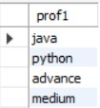

1. How much does the person WHO developed the HIGHEST selling package earn and WHAT course did he/she undergo?

select p.salary,st.course from programmer p,software s,studies st

where p.name=s.name and s.name=st.name and scost=(select max(scost) from software);

1. Which is the COSTLIEST package developed by a person with under 3 year’s expenences?

select s.title from software s, programmer p where s.name=p.name and year(doj) > 3 and dcost= (select max(s.dcost));



1. What is the AVERAGE salary for those WHOSE software's sales value is more than 50,000?

select avg(p.salary) from programmer p,software s where s.name=p.name and s.sold*s.scost >5000;

1. How many packages were developed by the students WHO studied in the institute that Charge the LOWEST course fee?

select count(s.name) from software s, studies st where s.name=st.name and ccost= (select min(st.ccost) from studies);

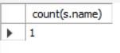

1. How many packages were developed by female programmers earning MORE than the HIGHEST paid male programmer?

select count(title) from software s,programmer p where s.name=p.name and (select max(salary) from programmer where sex='f')>

(select max(salary) from programmer where sex='m');

1. How many packages were developed by the MOST experienced programmers from BDPS?

select count(s.dev_in) from programmer p, software s,studies st where s.name=p.name and (select max(year(curdate())-year(doj)) from programmer) and splace='bdps';



1. List the programmers (from software table) and institutes they studied, including those WHO DIDN'T develop any package.

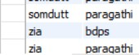select s.name, st.splace from software s, studies st where st.name not in(select name from software);

1. List each profit with the number of programmers having that prof1 and the number of packagesdeveloped in that prof1.

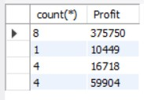select count(*),sum(scost*sold-dcost) "Profit" from software where dev_in in (select prof1 from programmer) group by dev_in;

1. List programmer names (from programmer table) and number of packages EACH developed select s.name,count(dev_in) from programmer p,software s where s.name=p.name group by s.name;



1. List programmer names (from programmer table) and number of packages EACH developed. 30) List all the details of programmers who have done a course at S.S.I.L

select p.* from programmer p,studies st where p.name=st.name and splace='s.s.i.l';