Distributed Job Scheduler
Design Decisions & Architecture Document

1. System Overview
This is a distributed job scheduling system supporting immediate, delayed, and recurring (cron) jobs, executed by a horizontally scalable pool of workers. The system guarantees each job is claimed by exactly one worker at a time, supports configurable retry policies with backoff, and routes permanently failed jobs to a dead-letter queue for inspection.
Stack: Flask (REST API) + PostgreSQL (Neon) + React (dashboard), deployed on Render (backend/worker/scheduler) and Vercel (frontend).

2. Architecture Diagram
Three independently deployable processes share one database. The API handles synchronous CRUD and auth. The Scheduler (exactly one instance) promotes due jobs and spawns cron occurrences. The Worker pool (many instances) claims and executes jobs concurrently.
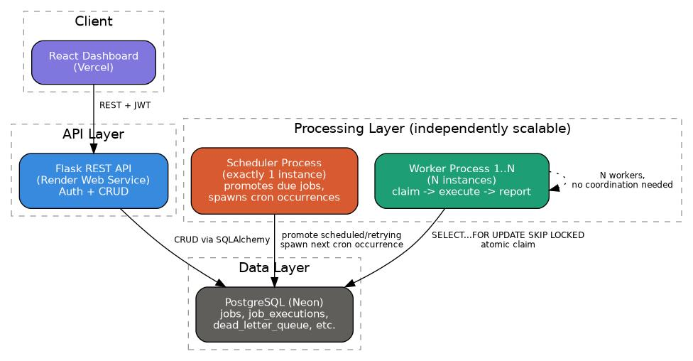

3. Entity-Relationship Diagram
Nine tables, normalized to avoid redundant data. Retry policies and workers are referenced, not duplicated, across jobs. Job execution history is append-only (JobExecution), while Job holds only current state.
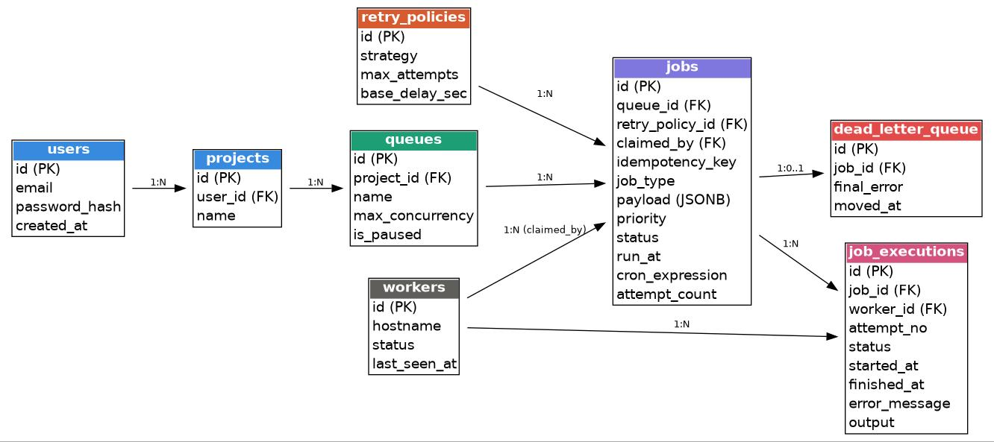

4. Core Workflow

4.1 Job lifecycle (state machine)
scheduled -> queued -> claimed -> running -> completed
On failure: running -> retrying (with backoff delay) -> queued (once due) -> ... -> dead_letter (after max attempts).

4.2 End-to-end flow
- Client calls POST /jobs -> API writes a durable row to the jobs table (status queued or scheduled).
- Scheduler process ticks every 5s: promotes scheduled jobs whose run_at has passed, promotes due retries, and spawns the next occurrence of completed cron jobs.
- Each Worker polls every 2s and atomically claims one queued job using SELECT ... FOR UPDATE SKIP LOCKED, so concurrent workers never claim the same row.
- Worker executes the job's handler, records a JobExecution row (one per attempt), and reports success or failure.
- On failure, retry_service checks the job's RetryPolicy: if attempts remain, it requeues with a computed backoff delay; otherwise the job moves to dead_letter_queue permanently.

5. Key Architectural Decisions
5.1 PostgreSQL over MySQL/SQLite/MongoDB
Decision: PostgreSQL, accessed via Neon (managed, serverless-friendly).
Alternatives considered: MySQL (no clean SKIP LOCKED support), SQLite (no real concurrency, file-based), MongoDB (no native row-level locking primitive suited to this claim pattern).
Why this choice: The atomic job-claim mechanism relies on SELECT ... FOR UPDATE SKIP LOCKED, a Postgres-specific feature that lets multiple workers poll the same table without ever double-claiming a row, and without needing a separate message broker.
5.2 Raw SQL for the claim query, ORM for everything else
Decision: job_service.claim_next_job uses a hand-written parameterized SQL statement; all other reads/writes use SQLAlchemy's ORM.
Alternatives considered: Pure ORM everywhere (read-then-write in two steps); a dedicated message queue (RabbitMQ/SQS) instead of DB-based claiming.
Why this choice: The ORM does not cleanly express FOR UPDATE SKIP LOCKED as a single atomic statement. An ORM read-then-write introduces a race window between two workers reading the same row before either commits. Raw SQL is used only where correctness under concurrency is safety-critical; the rest of the codebase stays in the more maintainable ORM style.
5.3 Worker, Scheduler, and API as three separate OS processes
Decision: Three independent deployables (web, worker, scheduler), coordinated only through the shared database.
Alternatives considered: A single monolithic process running everything on background threads.
Why this choice: API replicas and worker replicas need to scale independently (e.g. 1 API instance, 10 worker instances under load). The Scheduler must run as exactly one instance to avoid duplicate cron spawns, while Workers must run as many instances for throughput -- bundling them would force one scaling policy on processes that need different ones. This mirrors established patterns (Celery, Sidekiq, BullMQ).
5.4 Database polling instead of a message broker (RabbitMQ/SQS)
Decision: Workers and the Scheduler poll Postgres on a fixed interval (2s / 5s).
Alternatives considered: Push-based delivery via RabbitMQ, AWS SQS, or Redis-backed queues.
Why this choice: SKIP LOCKED already gives the core guarantee a broker provides -- no double delivery -- without introducing and operating extra infrastructure. The trade-off, stated explicitly: polling adds latency bounded by the poll interval, whereas a broker delivers near-instantly. For this system's scope, that trade-off is acceptable; at higher throughput (millions of jobs/day) a broker would be the better choice.
5.5 Retry backoff as a Strategy pattern (Fixed / Linear / Exponential classes)
Decision: Each backoff algorithm is a small class implementing next_delay_seconds(); dispatch is a dictionary lookup by policy.strategy.
Alternatives considered: A single function with an if/elif chain per strategy name.
Why this choice: Open/Closed principle: adding a new backoff algorithm later means adding one class, with zero changes to any code that calls it. An if/elif chain requires editing shared code every time a strategy is added, risking regressions to existing strategies.
5.6 Exponential backoff capped at one hour
Decision: next_delay_seconds() clamps the computed delay to a maximum of 3600 seconds.
Alternatives considered: Uncapped exponential growth.
Why this choice: Uncapped exponential backoff on a job with many attempts can push the next retry days into the future, which is rarely the intended behavior. This mirrors common industry practice (e.g. AWS SDK retry policies, Stripe webhook retries).
5.7 JWT (stateless) authentication over server-side sessions
Decision: flask-jwt-extended issues a signed token on login/signup; every protected route requires it via @jwt_required().
Alternatives considered: Server-side session cookies backed by a sessions table or Redis.
Why this choice: The API may be called by multiple stateless replicas (dashboard, future integrations) -- JWT lets any instance verify a request without a shared session store. Sessions would need a centrally shared store to work correctly once there is more than one API instance, which is extra infrastructure this system does not otherwise need.
5.8 Layered backend: routes -> services -> models (SOLID-aligned)
Decision: Route handlers only parse requests and format responses; all business logic and ownership checks live in a services layer; models only define data shape.
Alternatives considered: Logic embedded directly in route handlers.
Why this choice: Single Responsibility: each layer has one reason to change. Dependency Inversion: routes never touch the database directly, only through services, so the persistence layer could change without touching route code. This also keeps authorization checks (e.g. a queue can only be created under a project the requesting user owns) in one place instead of duplicated per route.
5.9 Job vs JobExecution as separate tables
Decision: Job holds current state; JobExecution holds one immutable row per attempt.
Alternatives considered: A single jobs table with mutable retry-count and last-error columns, no history.
Why this choice: Preserves full retry history for debugging and auditing without ever overwriting prior attempt data -- an append-only log for history, mutable current state for the entity itself.
5.10 Job execution dispatched through a fixed handler registry
Decision: worker.py maps job_type strings to pre-registered Python functions (JOB_HANDLERS dict); unknown types raise an error.
Alternatives considered: Storing executable code or eval-able expressions in the database.
Why this choice: Executing code sourced from the database is a remote-code-execution risk. A fixed, reviewed registry of handlers is the standard safe pattern (the same approach Celery uses for task registration).

6. Known Limitations & Future Improvements
- Queue-level max_concurrency is stored but not yet enforced in the claim query -- would require adding a running-count check per queue to claim_next_job.
- No dedicated worker-to-queue affinity -- all workers currently pull from all queues; could add an optional queue filter for dedicated high-priority worker pools.
- Polling-based delivery trades a few seconds of latency for infrastructure simplicity; a production system at high volume would benefit from a message broker.
- Render free tier cold-starts after inactivity; production deployment would use an always-on tier or a keep-alive ping.
- CORS is currently permissive for development speed; production would restrict origins to the known frontend domain.

7. API Summary
- POST /api/auth/signup, POST /api/auth/login
- POST /api/projects, GET /api/projects, GET/DELETE /api/projects/{id}
- POST/GET /api/projects/{project_id}/queues, PATCH .../pause, PATCH .../resume
- POST/GET /api/queues/{queue_id}/jobs, GET /api/queues/{queue_id}/jobs/{job_id}

