AI BASED DIABETES PREDICTION SYSTEM

PHASE 5 DOCUMENT

**Introduction:**

# AI BASED DIABETES PREDICTION

Diabetes is a prevalent and chronic medical condition that affects millions of people worldwide. Early detection and management of diabetes are crucial for preventing complications and improving the quality of life for individuals with the disease. Artificial Intelligence (AI) has emerged as a powerful tool in the healthcare sector, offering the potential to enhance the diagnosis and prediction of various medical conditions, including diabetes. An AI-based diabetes prediction system leverages advanced algorithms, machine learning, and data analytics to assist healthcare professionals and patients in predicting the risk of developing diabetes or managing the condition more effectively.

The AI-based diabetes prediction system operates by analyzing a combination of patient data, such as medical history, genetics, lifestyle, and physiological indicators like blood glucose levels, to generate predictive models. These models can forecast the likelihood of an individual developing diabetes or experiencing complications related to the disease. By integrating AI into the healthcare domain, this technology has the potential to improve early diagnosis, personalize treatment plans, and empower individuals to make informed decisions about their health.

## Givendata set:

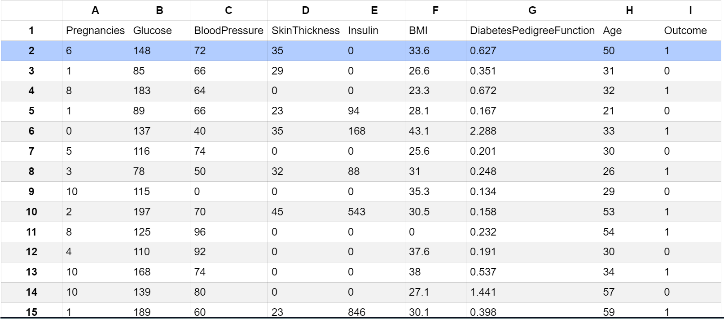

***Here's a list of tools and software commonly used in theprocess:***

## ProgrammingLanguage:

- Python is the most popular language for machine learning due toits extensive libraries and frameworks. You can use libraries like *NumPy,pandas,scikit-learn,andmore.*

## IntegratedDevelopmentEnvironment(IDE):

- Choose an IDE for coding and running machine learningexperiments. Some popular options include GoogleColab,ortraditional IDEslikePyCharm.

## MachineLearning Libraries:

* + You'llneedvariousmachinelearninglibraries,including:
  + scikit-learnforbuildingandevaluatingmachinelearningmodels.
  + TensorFloworPyTorchfordeeplearning,if needed.
  + XGBoost,CatBoostfor gradientboostingmodels.

## DataVisualization Tools:

* + Tools like Matplotlib, Seaborn, are essential for dataexplorationandvisualization.

## DataPreprocessing Tools:

* + Libraries like pandas help with data cleaning, manipulation, andpreprocessing.

## DataCollectionandStorage:

* + Depending on your data source, you might need web scrapingtools *(e.g., BeautifulSoup or Scrapy)* or databases *(e.g., SQLite,PostgreSQL)*fordatastorage.

## VersionControl:

* + Version control systems like Git are valuable for trackingchangesinyourcodeandcollaboratingwithothers.

## NotebooksandDocumentation:

* + Toolsfordocumentingyourwork,suchas JupyterNotebooksorMarkdownforcreating*README*filesanddocumentation.

## HyperparameterTuning:

* + Tools like GridSearchCV or RandomizedSearchCV fromscikit-learncanhelpwithhyperparametertuning.

## WebDevelopmentTools(forDeployment):

* + If you plan to create a web application for model deployment,knowledge of web development tools like *Flask or Django* for backenddevelopment, and *HTML, CSS, and JavaScript* for the front-end can beuseful.

## CloudServices(forScalability):

* + For large-scale applications, cloud platforms like AWS, GoogleCloud,orAzure.

## ExternalDataSources(ifapplicable):

* + Depending on your project's scope, you might require tools toaccessexternaldata sources,suchas APIs ordatascrapingtools.

## DataAnnotationandLabelingTools(ifapplicable):

* + Forspecializedprojects,toolsfordataannotationandlabelingmaybe necessary,suchasLabelboxorSupervisely.

## GeospatialTools(forlocation-basedfeatures):

* + If your dataset includes geospatial data, geospatial librarieslikeGeoPandas canbehelpful.



FLOW CHART:

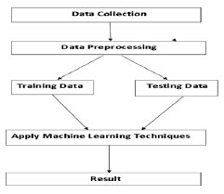

# DESIGN AND INNOVATION

## DataCollection:

Gathering relevant patient data, which can include electronic health records, genetic information, lifestyle data, and clinical measurements..

## DataPreprocessing:

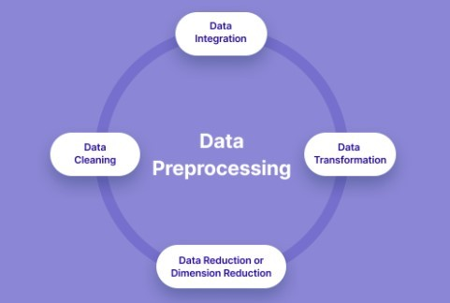Clean the data by handling missing values, outliers, andencoding categorical variables. Standardize or normalize numericalfeaturesas necessary.

## PYTHONPROGRAM:

*#Importnecessarylibraries*

### 1. Descriptive Statistics:

python

import pandas as pd

# Load the dataset (assuming it's in a CSV file)

data = pd.read_csv('diabetes.csv')

# Display basic statistics

data.describe()

### 2. Data Visualization:

python

import matplotlib.pyplot as plt

import seaborn as sns

# Histograms for all features

data.hist(figsize=(12, 10))

plt.tight_layout()

plt.show()

# Box plot for specific features (e.g., Glucose and Age)

sns.boxplot(x='Outcome', y='Glucose', data=data)

plt.show()

sns.boxplot(x='Outcome', y='Age', data=data)

plt.show()

### 3. Correlation Analysis:

# Correlation matrix

correlation_matrix = data.corr()

sns.heatmap(correlation_matrix, annot=True, cmap='coolwarm')

plt.title('Correlation Matrix')

plt.show()

### 4. Feature Engineering (Example: BMI Categories):

python

# Create a new feature 'BMI_Category'

def categorize_bmi(bmi):

if bmi < 18.5:

return 'Underweight'

elif 18.5 <= bmi < 25:

return 'Normal'

elif 25 <= bmi < 30:

return 'Overweight'

else:

return 'Obese'

data['BMI_Category'] = data['BMI'].apply(categorize_bmi)

### 5. Model Building (Example: Logistic Regression):

python

from sklearn.model_selection import train_test_split

from sklearn.linear_model import LogisticRegression

from sklearn.metrics import accuracy_score, classification_report

# Assuming 'X' contains features and 'y' contains the target variable 'Outcome'

X = data[['Pregnancies', 'Glucose', 'BloodPressure', 'SkinThickness', 'Insulin', 'BMI', 'DiabetesPedigreeFunction', 'Age']]

y = data['Outcome']

# Split data into training and testing sets

X_train, X_test, y_train, y_test = train_test_split(X, y, test_size=0.2, random_state=42)

# Initialize and train a Logistic Regression model

model = LogisticRegression()

model.fit(X_train, y_train)

# Predict using the model

y_pred = model.predict(X_test)

# Evaluate the model

accuracy = accuracy_score(y_test, y_pred)

print(f'Accuracy: {accuracy}')

print(classification_report(y_test, y_pred))

### 6. Hyperparameter Tuning:

python

# Example: Grid Search for Logistic Regression

from sklearn.model_selection import GridSearchCV

param_grid = {'C': [0.001, 0.01, 0.1, 1, 10, 100]}

grid_search = GridSearchCV(LogisticRegression(), param_grid, cv=5)

grid_search.fit(X_train, y_train)

best_params = grid_search.best_params_

best_model = grid_search.best_estimator_

# Use the best model for predictions

y_pred = best_model.predict(X_test)

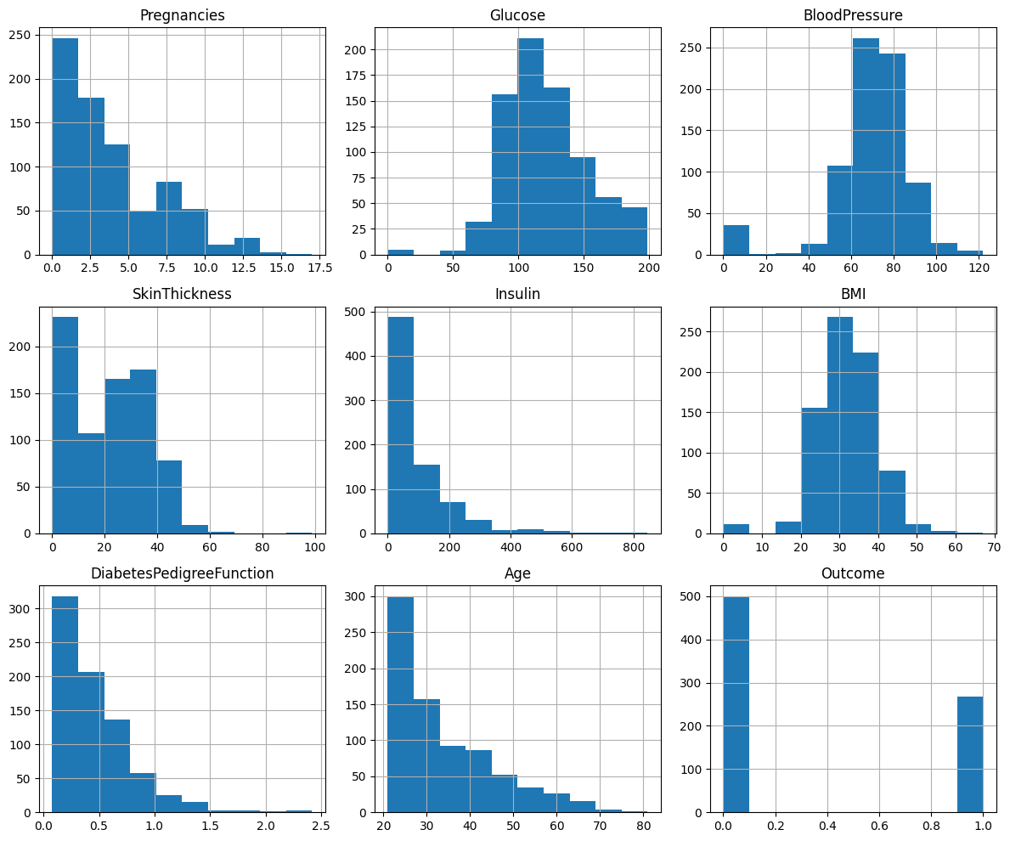

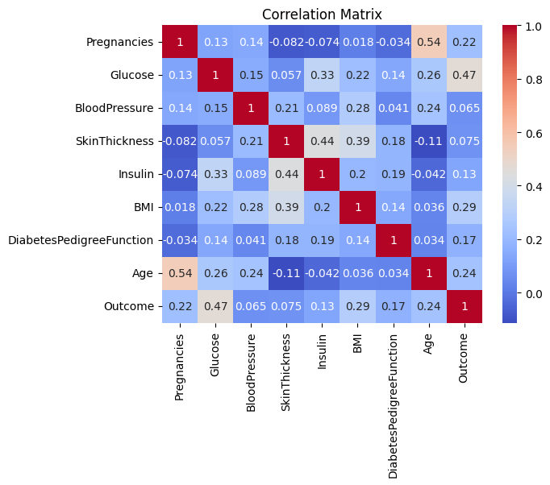

## FeatureEngineering:

Create new features or transform existing ones to extract morevaluable information.

## ModelSelection:

Choose the appropriate machine learning model for the task.Common models for regression problems like include *Linear Regression, Decision Trees, Random Forest, GradientBoosting,andNeuralNetworks.*

## Training:

Splitthedatasetintotrainingandtestingsetstoevaluatethemodel's performance. Consider techniques like cross-validation topreventoverfitting.

## HyperparameterTuning:

Optimize the model's hyperparameters to improve its predictiveaccuracy. Techniques like grid search or random search can help withthis.

## EvaluationMetrics:

Select appropriate evaluation metrics for regression tasks, suchas *Mean Absolute Error (MAE), Mean Squared Error (MSE), or RootMean Squared Error (RMSE)*. Choose the metric that aligns with thespecificobjectivesofyourproject.

## Regularization:

Apply regularization techniques like L1 (Lasso) or L2 (Ridge)regularizationtoprevent overfitting.

## FeatureSelection:

Use techniques like feature importance scores or recursivefeature elimination to identify the most relevant features for theprediction.

.

## ContinuousImprovement:

Implement a feedback loop for continuous model improvementbased on userfeedbackandnew

ADVANTAGES

Early Detection: AI can analyze large datasets and identify patterns that may not be obvious to healthcare professionals, allowing for early detection of diabetes or pre-diabetes.

Personalized Care: AI can tailor recommendations and treatment plans based on an individual's specific health data, leading to more personalized and effective care.

Continuous Monitoring: AI can provide continuous monitoring of a person's health, offering real-time insights and alerts, which can be especially valuable for managing diabetes.

Data Integration: AI can integrate data from various sources, such as wearables, lab tests, and electronic health records, providing a comprehensive view of a patient's health.

Reduced Costs: Early intervention and personalized care can lead to cost savings in the long run by preventing complications and hospitalizations.

## DISADVANTAGES:

Disadvantages of an AI-based diabetes prediction system:

Data Privacy Concerns: Handling sensitive health data requires strict privacy measures, and AI systems can be vulnerable to data breaches and misuse.

Accuracy Issues: AI predictions are only as good as the data they're trained on. Inaccurate or biased data can lead to incorrect predictions, potentially causing harm.

Lack of Human Touch: AI may lack the empathy and understanding that human healthcare providers can offer, which can be important in managing chronic conditions like diabetes.

Dependency on Technology: Patients and healthcare providers may become overly reliant on AI systems, potentially reducing human decision-making and critical thinking.

Implementation Challenges: Integrating AI into existing healthcare systems can be complex and costly, and it may not be readily accessible to all patients, creating healthcare disparities.

Overall, AI-based diabetes prediction systems offer great potential but also come with challenges that need to be carefully addressed to ensure their safe and effective use..

## BENEFITS:

## Using AI for diabetes prediction and management offers several benefits:

## 1. Early Detection: AI models can analyze a wide range of patient data, including glucose levels, medical history, lifestyle factors, and genetic information, to detect diabetes risk factors and symptoms at an early stage. This early detection can lead to timely interventions and better management of the condition.

## 2. Personalized Care: AI can tailor treatment and management plans to individual patients based on their specific characteristics and needs. This personalization improves the effectiveness of diabetes management, as treatment plans are optimized for each patient's unique situation.

## 3. Data Integration: AI can integrate data from various sources, such as wearable devices, electronic health records, and patient input, to provide a comprehensive view of the patient's health. This integrated data can aid in more accurate predictions and better-informed decision-making.

## 4. Continuous Monitoring: AI-powered devices and apps can continuously monitor glucose levels and other relevant metrics, providing real-time feedback to patients and healthcare providers. This constant monitoring helps patients make informed decisions and take timely actions to manage their diabetes.

## 5. Risk Stratification: AI can stratify patients based on their risk factors, helping healthcare providers identify individuals who are at higher risk of developing diabetes-related complications. This enables targeted interventions for high-risk patients, potentially preventing serious health issues.

## 6. Treatment Optimization: AI can assist healthcare providers in selecting the most appropriate treatment options, medication dosages, and lifestyle modifications for each patient. It can also help adjust treatment plans over time based on a patient's response to therapy.

## 7. Cost-Efficiency: AI can reduce healthcare costs by optimizing treatment plans, reducing hospital readmissions, and minimizing the need for frequent in-person visits. It can also help prevent costly diabetes-related complications by facilitating early intervention.

## 8. Patient Engagement: AI-powered apps and devices can engage and educate patients about their condition, making them more proactive in managing their diabetes. Features like reminders, feedback, and progress tracking can motivate patients to follow their treatment plans.

## 9. Research and Development: AI can accelerate research in the field of diabetes by analyzing large datasets, identifying patterns, and discovering new insights. This can lead to the development of more effective treatments and preventive measures.

## 10. Telemedicine: AI-driven telemedicine platforms can provide remote consultations and support for patients, making it easier for them to access healthcare professionals and receive guidance on managing their diabetes.

## Overall, AI in diabetes prediction and management has the potential to improve patient outcomes, reduce the burden on healthcare systems, and enhance the quality of life for individuals with diabetes by providing personalized, data-driven solutions