VISVESVARAYA TECHNOLOGICAL UNIVERSITY

“JnanaSangama”, Belgaum -590014, Karnataka.

LAB RECORD

Bio Inspired Systems (23CS5BSBIS)
Submitted by
Subramanya J (1BM23CS343)
in partial fulfillment for the award of the degree of

BACHELOR OF ENGINEERING
in
COMPUTER SCIENCE AND ENGINEERING



B.M.S. COLLEGE OF ENGINEERING
(Autonomous Institution under VTU)
BENGALURU-560019
Aug-2025 to Jan-2026

B.M.S. College of Engineering,
Bull Temple Road, Bangalore 560019
(Affiliated To Visvesvaraya Technological University, Belgaum)
Department of Computer Science and Engineering
CERTIFICATE
This is to certify that the Lab work entitled “ Bio Inspired Systems (23CS5BSBIS)” carried out by Subramanya J (1BM23CS343), who is bonafide student of B.M.S. College of Engineering. It is in partial fulfillment for the award of Bachelor of Engineering in Computer Science and Engineering of the Visvesvaraya Technological University, Belgaum. The Lab report has been approved as it satisfies the academic requirements of the above mentioned subject and the work prescribed for the said degree.

Rohith Vaidya K  Assistant Professor  Department of CSE, BMSCE | Dr. Kavitha Sooda  Professor & HOD  Department of CSE, BMSCE

Index
Sl.  No. | Date | Experiment Title | Page No.
1 |  | Genetic Algorithm for Optimization Problem | 4
2 |  | Particle Swarm Optimization for Function Optimization | 9
3 |  | Ant Colony Optimization for the Travelling Salesman Problem | 13
4 |  | Cuckoo Search (CS) | 17
5 |  | Grey Wolf Optimizer (GWO) | 22
6 |  | Parallel Cellular Algorithms and Programs | 26
7 |  | Optimization via Gene Expression Algorithms | 29

Github Link:
https://github.com/SubramanyaJ/23CS5BSBIS

Program 1
Genetic Algorithm for Optimization Problems.

Algorithm:
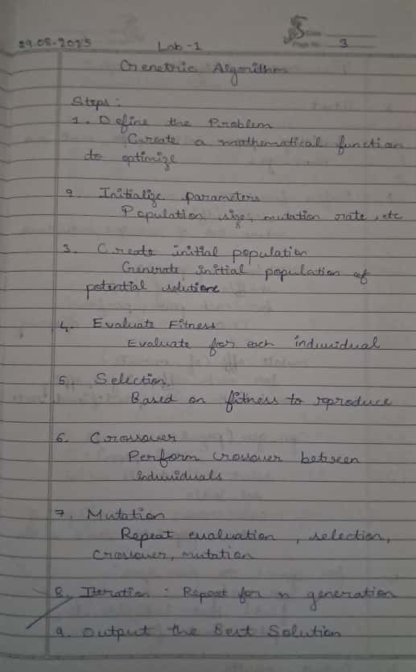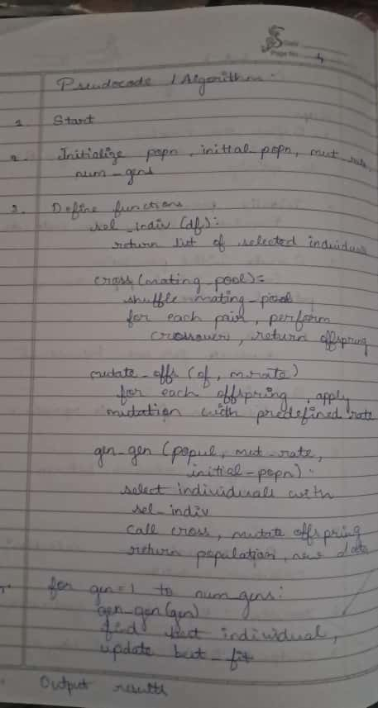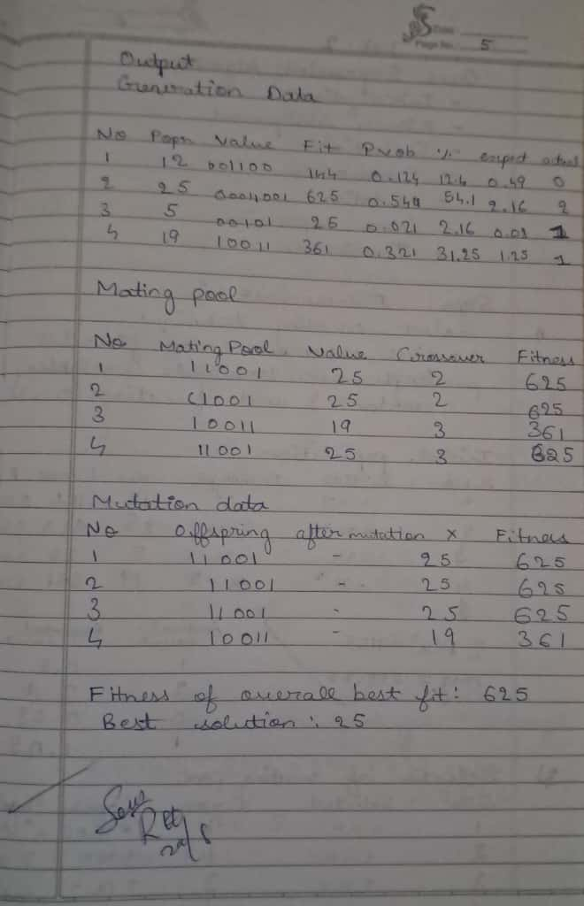

Code:
import pandas as pd
import random

def sel_indiv(df):
return [row['Popul'] for _, row in df.iterrows() for _ in range(int(row['ActualCnt']))]

def cross(mating_pool):
random.shuffle(mating_pool)
if len(mating_pool) % 2 != 0: mating_pool.append(random.choice(mating_pool))
offspring, mating_pool_data, crossover_data = [], [], []
for i in range(0, len(mating_pool), 2):
p1, p2 = int(mating_pool[i]), int(mating_pool[i+1])
bp1, bp2 = bin(p1)[2:].zfill(8), bin(p2)[2:].zfill(8)
cp = random.randint(1, len(bp1) - 1)
o1_binary, o2_binary = bp1[:cp] + bp2[cp:], bp2[:cp] + bp1[cp:]
o1_decimal, o2_decimal = int(o1_binary, 2), int(o2_binary, 2)
offspring.extend([o1_decimal, o2_decimal])
mating_pool_data.extend([{'Subject No': i + 1, 'Value': p1, 'Mating Pool (Binary)': bp1, 'Crossover Point': cp, 'Fitness': p1**2},
{'Subject No': i + 2, 'Value': p2, 'Mating Pool (Binary)': bp2, 'Crossover Point': cp, 'Fitness': p2**2}])
crossover_data.append({'Parent 1': p1, 'Parent 2': p2, 'Binary Parent 1': bp1, 'Binary Parent 2': bp2, 'Crossover Point': cp,
'Offspring 1 Binary': o1_binary, 'Offspring 2 Binary': o2_binary, 'Offspring 1 Decimal': o1_decimal, 'Offspring 2 Decimal': o2_decimal})
return offspring, pd.DataFrame(mating_pool_data), pd.DataFrame(crossover_data)

def mutate_offs(offspring, mut_rate):
mut_offsp, mutation_data = [], []
for i, indiv in enumerate(offspring):
original_binary = bin(indiv)[2:].zfill(8)
mutated_binary, mutated_indiv, mutation_happened = original_binary, indiv, False
if random.random() < mut_rate:
bin_list = list(original_binary)
if bin_list:
mut_point = random.randint(0, len(bin_list) - 1)
bin_list[mut_point] = '1' if bin_list[mut_point] == '0' else '0'
mutated_binary = "".join(bin_list)
mutated_indiv = int(mutated_binary, 2)
mutation_happened = True
mut_offsp.append(mutated_indiv)
mutation_data.append({'Subject No': i + 1, 'Offspring Before Mutation (Binary)': original_binary,
'Mutation Chromosome (Binary)': mutated_binary if mutation_happened else original_binary,
'Offspring After Mutation (Binary)': bin(mutated_indiv)[2:].zfill(8),
'X Value (Decimal)': mutated_indiv, 'Fitness': mutated_indiv**2})
return mut_offsp, pd.DataFrame(mutation_data)

def gen_gen(popul, mut_rate, initial_popn):
df_pop = pd.DataFrame({'Subject No': range(1, len(popul) + 1), 'Popul': popul, 'Initial Popn (Binary)': [bin(p)[2:].zfill(8) for p in initial_popn]})
fit = [ind ** 2 for ind in popul]
cumul = sum(fit)
prob = [f / cumul for f in fit]
perc_prob = [p * 100 for p in prob]
exp = [len(popul) * p for p in prob]
actual = [round(e) for e in exp]
df_pop['Fit'], df_pop['Prob'], df_pop['Percentage Prob'], df_pop['ExpectCnt'], df_pop['ActualCnt'] = fit, prob, perc_prob, exp, actual
mating_pool = sel_indiv(df_pop)
offspring, df_mating_pool, df_crossover = cross(mating_pool)
new_gen, df_mutation = mutate_offs(offspring, mut_rate)
return new_gen, df_pop, df_mating_pool, df_crossover, df_mutation

popn = [12, 25, 5, 19]
initial_popn = popn[:]
curr_popul = popn[:]
best_sol, best_fit, fit_hist = None, -float('inf'), []
num_gens, mut_rate = 3, 0.01

for gen in range(num_gens):
curr_popul, df_gen, df_mating_pool, df_crossover, df_mutation = gen_gen(curr_popul, mut_rate, initial_popn)
fit_vals = [ind ** 2 for ind in curr_popul]
best_fit_curr = max(fit_vals)
best_ind_idx = fit_vals.index(best_fit_curr)
best_ind_curr = curr_popul[best_ind_idx]
if best_fit_curr > best_fit: best_fit, best_sol = best_fit_curr, best_ind_curr
fit_hist.append(best_fit_curr)
print(f"Gen {gen + 1}: Best Fit = {best_fit_curr}, Best Indiv = {best_ind_curr}, Popul = {curr_popul}")
print("Generation Data:"); display(df_gen)
print("Mating Pool Data:"); display(df_mating_pool)
print("Crossover Data:"); display(df_crossover)
print("Mutation Data:"); display(df_mutation)

print("\nGenetic Algorithm finished.")
print("Overall best solution found:", best_sol)
print("Fitness of the overall best solution:", best_fit)

Output :
Genetic Algorithm finished.
Overall best solution found: 25
Fitness of the overall best solution: 625

Program 2
Particle Swarm Optimization for Function Optimization.

Algorithm:
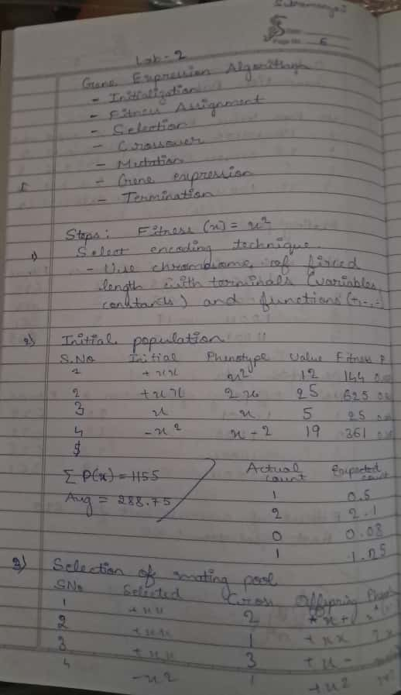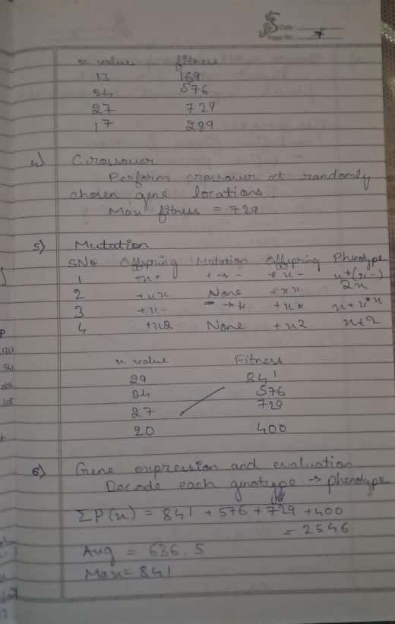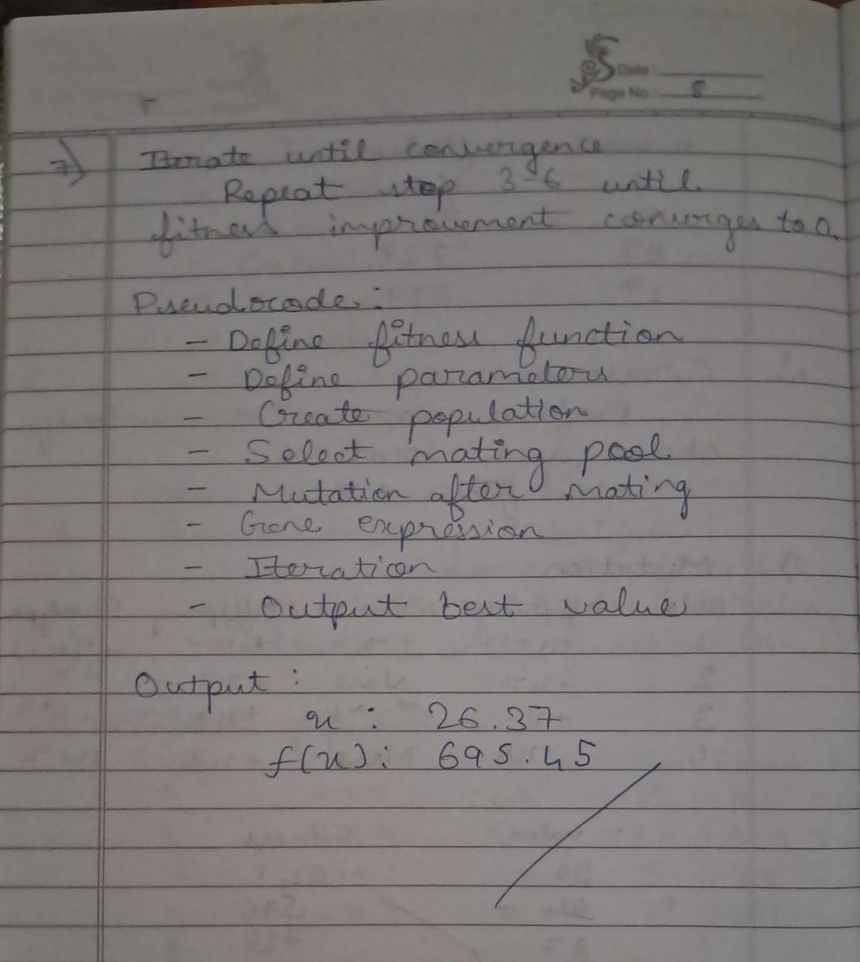

Code:
import numpy as np

def polynomial(x):
return -x**2 + 5*x + 20

num_particles = 100
lower = -10
upper = 10

positions = np.random.uniform(lower, upper, num_particles)
velocities = np.random.uniform(-1, 1, num_particles)

pbestpos = np.copy(positions)
pbestval = np.array([polynomial(p) for p in positions])

gbest_position = pbestpos[np.argmin(pbestval)]
gbestval = np.min(pbestval)

w = 0.5
c1 = 2
c2 = 2

for iteration in range(1000):
r1 = np.random.rand(num_particles)
r2 = np.random.rand(num_particles)

for i in range(num_particles):
velocities[i] = w * velocities[i] + c1 * r1[i] * (pbestpos[i] - positions[i]) + c2 * r2[i] * (gbest_position - positions[i])
positions[i] += velocities[i]

positions[i] = np.clip(positions[i], lower, upper)

current = polynomial(positions[i])

if current < pbestval[i]:
pbestpos[i] = positions[i]
pbestval[i] = current

if current < gbestval:
gbest_position = positions[i]
gbestval = current
#print(f"Iteration {iteration} - Best Value: {gbestval}")
print("Final solution ", gbest_position)
print("Final Best Value:", gbestval)

Output :
Final solution -10.0
Final Best Value: -130.0

Program 3
Ant Colony Optimization for the Traveling Salesman Problem.

Algorithm:
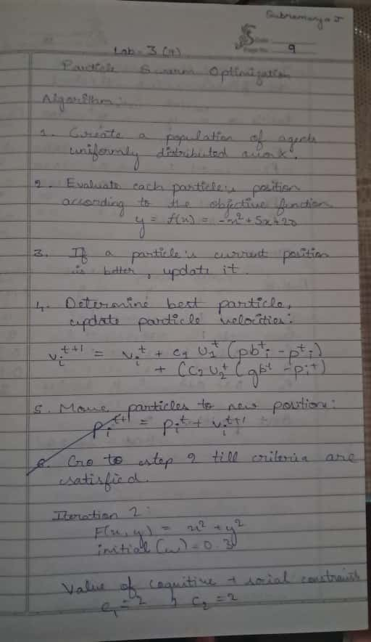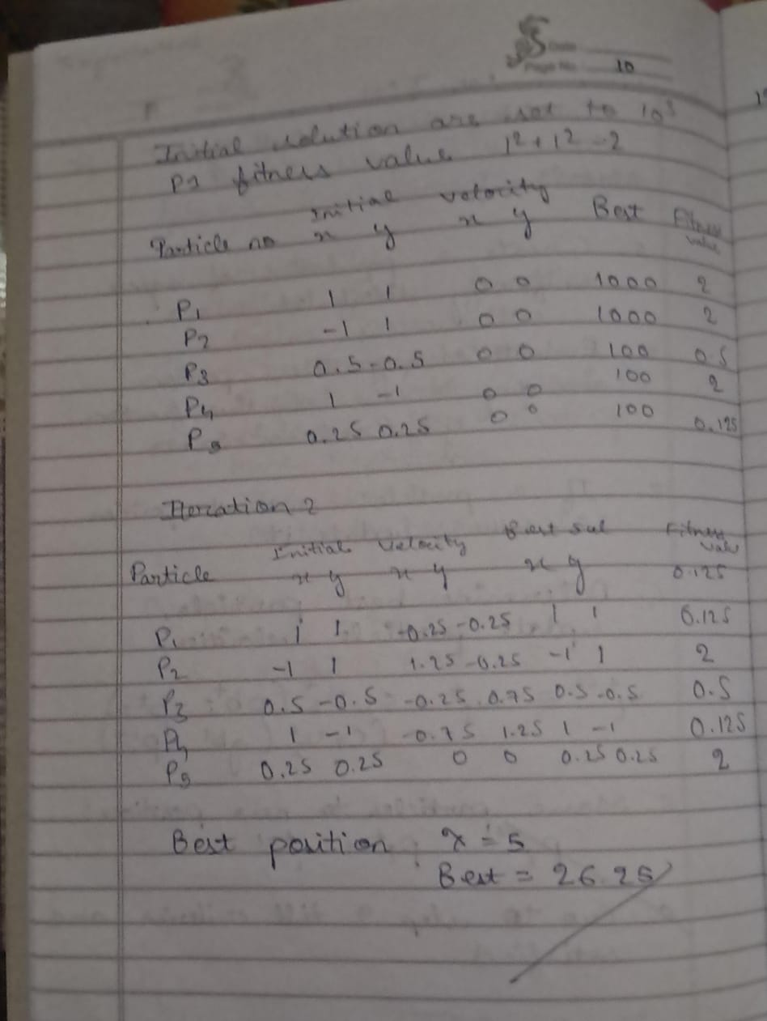

Code:
import numpy as np
import random

def initialize_pheromone(num_cities, initial_pheromone=1.0):
return np.ones((num_cities, num_cities)) * initial_pheromone

def calculate_probabilities(pheromone, distances, visited, alpha=1, beta=2):
pheromone = np.copy(pheromone)
pheromone[list(visited)] = 0 # zero out visited cities

heuristic = 1 / (distances + 1e-10) # inverse of distance
heuristic[list(visited)] = 0

prob = (pheromone ** alpha) * (heuristic ** beta)
total = np.sum(prob)
if total == 0:
# If no options (all visited), choose randomly among unvisited
choices = [i for i in range(len(distances)) if i not in visited]
return choices, None
prob = prob / total
return range(len(distances)), prob

def select_next_city(probabilities, cities):
if probabilities is None:
return random.choice(cities)
return np.random.choice(cities, p=probabilities)

def path_length(path, distances):
length = 0
for i in range(len(path)):
length += distances[path[i-1]][path[i]]
return length

def ant_colony_optimization(distances, n_ants=5, n_iterations=50, decay=0.5, alpha=1, beta=2):
num_cities = len(distances)
pheromone = initialize_pheromone(num_cities)
best_path = None
best_length = float('inf')

for iteration in range(n_iterations):
all_paths = []
for _ in range(n_ants):
path = [0] # start at city 0
visited = set(path)

for _ in range(num_cities - 1):
current_city = path[-1]
cities, probabilities = calculate_probabilities(pheromone[current_city], distances[current_city], visited, alpha, beta)
next_city = select_next_city(probabilities, cities)
path.append(next_city)
visited.add(next_city)

length = path_length(path, distances)
all_paths.append((path, length))

if length < best_length:
best_length = length
best_path = path

# Evaporate pheromone
pheromone *= (1 - decay)

# Deposit pheromone proportional to path quality
for path, length in all_paths:
deposit = 1 / length
for i in range(len(path)):
pheromone[path[i-1]][path[i]] += deposit

return best_path, best_length

# Example usage
if __name__ == "__main__":
distances = np.array([
[np.inf, 2, 2, 5, 7],
[2, np.inf, 4, 8, 2],
[2, 4, np.inf, 1, 3],
[5, 8, 1, np.inf, 2],
[7, 2, 3, 2, np.inf]
])

best_path, best_length = ant_colony_optimization(distances)
print(f"Best path: {[int(city) for city in best_path]} with length: {best_length:.2f}")

Output :
Best path: [0, 1, 4, 3, 2] with length: 9.00

Program 4
Cuckoo Search (CS).

Algorithm:
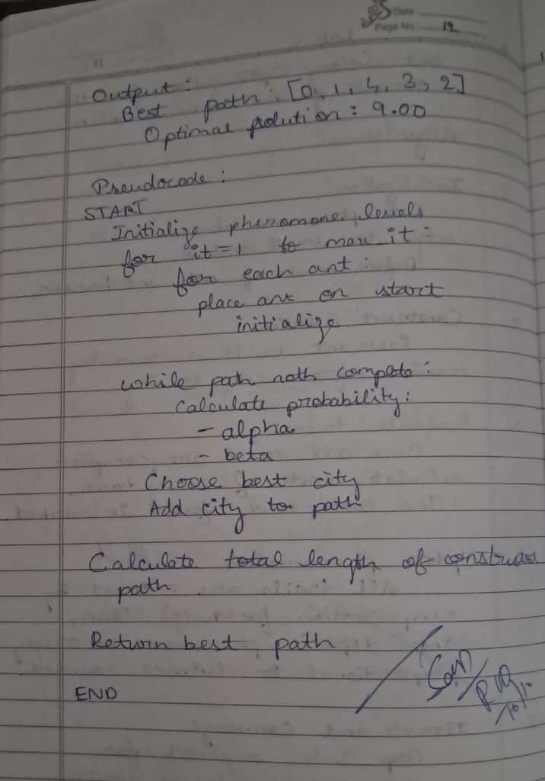

Code:
import numpy as np
import math

def knapsack_fitness(solution, values, weights, capacity):
total_weight = np.sum(solution * weights)
if total_weight > capacity:
return 0 # Penalize overweight solutions
return np.sum(solution * values)

def levy_flight(Lambda, size):
sigma = (math.gamma(1 + Lambda) * math.sin(math.pi * Lambda / 2) /
(math.gamma((1 + Lambda) / 2) * Lambda * 2 ** ((Lambda - 1) / 2))) ** (1 / Lambda)
u = np.random.normal(0, sigma, size)
v = np.random.normal(0, 1, size)
step = u / (np.abs(v) ** (1 / Lambda))
return step

def sigmoid(x):
return 1 / (1 + np.exp(-x))

def cuckoo_search_knapsack(values, weights, capacity, n_nests=25, miter=100, pa=0.25):

n_items = len(values)
nests = np.random.randint(0, 2, size=(n_nests, n_items))
fitness = np.array([knapsack_fitness(n, values, weights, capacity) for n in nests])

best_idx = np.argmax(fitness)
best_solution = nests[best_idx].copy()
best_fitness = fitness[best_idx]

Lambda = 1.5 # Levy flight exponent

for iteration in range(miter):
for i in range(n_nests):
step = levy_flight(Lambda, n_items)
current = nests[i].astype(float)
new_solution_cont = current + step
probs = sigmoid(new_solution_cont)
new_solution_bin = (probs > 0.5).astype(int)

new_fitness = knapsack_fitness(new_solution_bin, values, weights, capacity)

# Greedy selection
if new_fitness > fitness[i]:
nests[i] = new_solution_bin
fitness[i] = new_fitness

if new_fitness > best_fitness:
best_fitness = new_fitness
best_solution = new_solution_bin.copy()

# Abandon worst nests with probability pa
n_abandon = int(pa * n_nests)
if n_abandon > 0:
abandon_indices = np.random.choice(n_nests, n_abandon, replace=False)
for idx in abandon_indices:
nests[idx] = np.random.randint(0, 2, n_items)
fitness[idx] = knapsack_fitness(nests[idx], values, weights, capacity)

# Update global best after abandonment
current_best_idx = np.argmax(fitness)
if fitness[current_best_idx] > best_fitness:
best_fitness = fitness[current_best_idx]
best_solution = nests[current_best_idx].copy()

# Print progress: every 10 iterations and first iteration
if iteration == 0 or (iteration + 1) % 10 == 0:
print(f"Iteration {iteration + 1}/{miter}, Best Fitness: {best_fitness}")

return best_solution, best_fitness

if __name__ == "__main__":
# Example knapsack problem
values = np.array([60, 100, 120, 80, 30])
weights = np.array([10, 20, 30, 40, 50])
capacity = 100

best_sol, best_val = cuckoo_search_knapsack(values, weights, capacity, n_nests=30, miter=100, pa=0.25)

print("\nBest solution found:")
print(best_sol)
print("Total value:", best_val)
print("Total weight:", np.sum(best_sol * weights))

Output :
Iteration 1/100, Best Fitness: 280
Iteration 10/100, Best Fitness: 360
Iteration 20/100, Best Fitness: 360
Iteration 30/100, Best Fitness: 360
Iteration 40/100, Best Fitness: 360
Iteration 50/100, Best Fitness: 360
Iteration 60/100, Best Fitness: 360
Iteration 70/100, Best Fitness: 360
Iteration 80/100, Best Fitness: 360
Iteration 90/100, Best Fitness: 360
Iteration 100/100, Best Fitness: 360

Best solution found:
[1 1 1 1 0]
Total value: 360
Total weight: 100

Program 5
Grey Wolf Optimizer (GWO).

Algorithm:
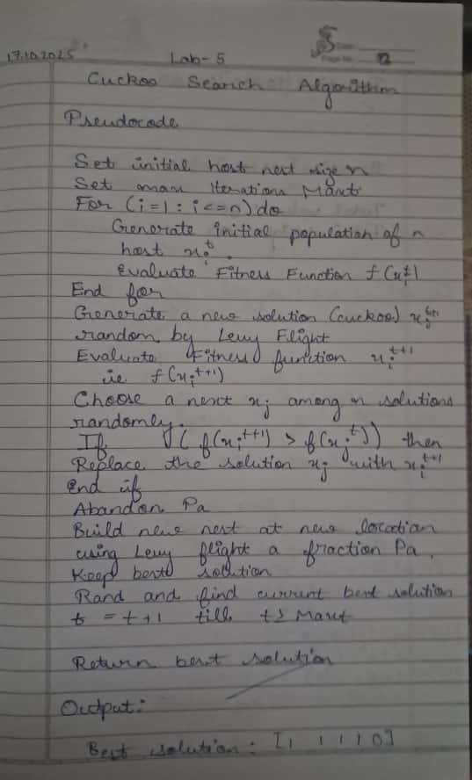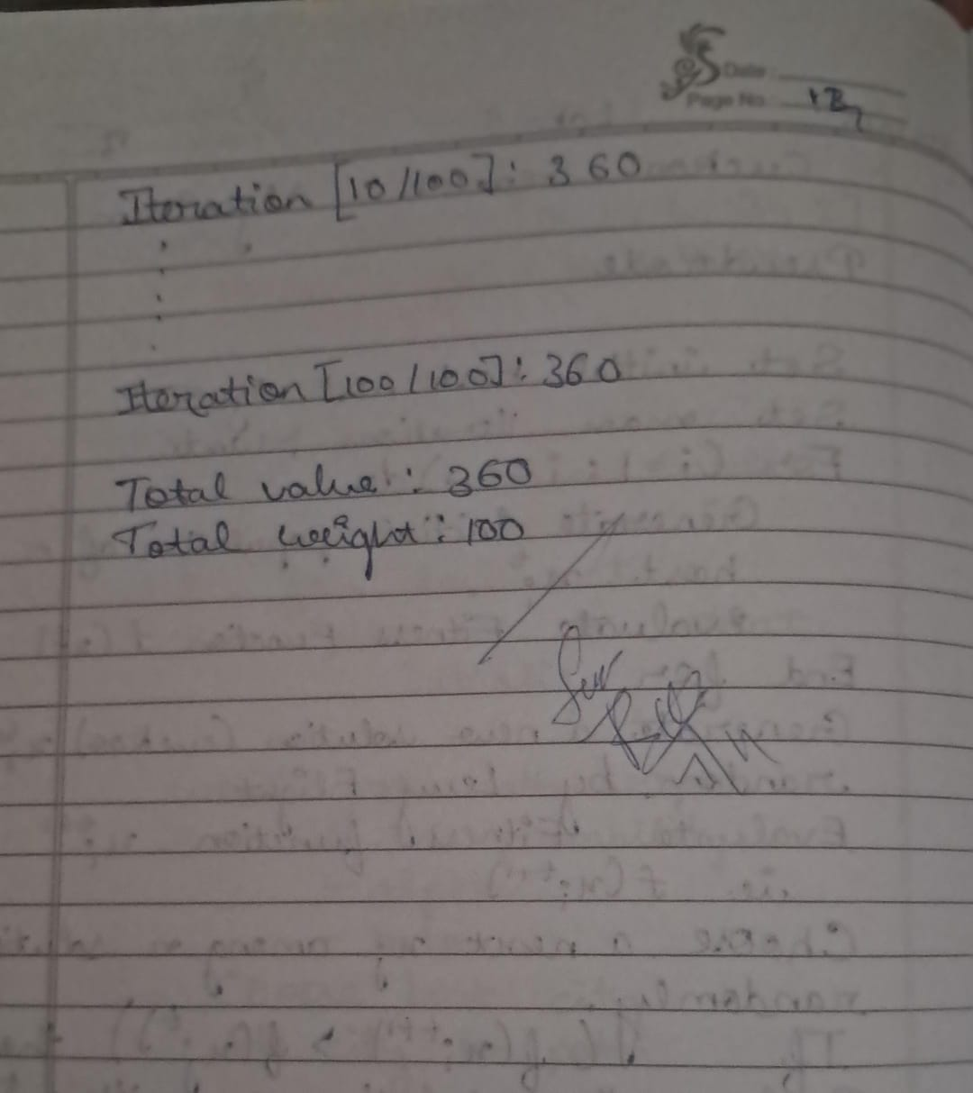

Code:
import numpy as np

def sphere(x):
return np.sum(x**2)

class GreyWolfOptimizer:
def __init__(self, obj_func, n_wolves, dim, max_iter, lb=-10, ub=10):
self.obj_func = obj_func
self.n_wolves = n_wolves
self.dim = dim
self.max_iter = max_iter
self.lb = lb
self.ub = ub

self.positions = np.random.uniform(self.lb, self.ub, (self.n_wolves, self.dim))

self.alpha_pos = np.zeros(self.dim)
self.alpha_score = float('inf')

self.beta_pos = np.zeros(self.dim)
self.beta_score = float('inf')

self.delta_pos = np.zeros(self.dim)
self.delta_score = float('inf')

def optimize(self):
for iter in range(self.max_iter):
for i in range(self.n_wolves):
self.positions[i] = np.clip(self.positions[i], self.lb, self.ub)

fitness = self.obj_func(self.positions[i])

if fitness < self.alpha_score:
self.alpha_score = fitness
self.alpha_pos = self.positions[i].copy()
elif fitness < self.beta_score:
self.beta_score = fitness
self.beta_pos = self.positions[i].copy()
elif fitness < self.delta_score:
self.delta_score = fitness
self.delta_pos = self.positions[i].copy()

a = 2 - iter * (2 / self.max_iter)

for i in range(self.n_wolves):
for j in range(self.dim):
r1 = np.random.rand()
r2 = np.random.rand()
A1 = 2 * a * r1 - a
C1 = 2 * r2
D_alpha = abs(C1 * self.alpha_pos[j] - self.positions[i, j])
X1 = self.alpha_pos[j] - A1 * D_alpha

r1 = np.random.rand()
r2 = np.random.rand()
A2 = 2 * a * r1 - a
C2 = 2 * r2
D_beta = abs(C2 * self.beta_pos[j] - self.positions[i, j])
X2 = self.beta_pos[j] - A2 * D_beta

r1 = np.random.rand()
r2 = np.random.rand()
A3 = 2 * a * r1 - a
C3 = 2 * r2
D_delta = abs(C3 * self.delta_pos[j] - self.positions[i, j])
X3 = self.delta_pos[j] - A3 * D_delta

self.positions[i, j] = (X1 + X2 + X3) / 3

return self.alpha_pos, self.alpha_score

if __name__ == "__main__":
n_wolves = int(input("Enter number of wolves: "))
dim = int(input("Enter number of dimensions: "))
max_iter = int(input("Enter max iterations: "))

gwo = GreyWolfOptimizer(obj_func=sphere, n_wolves=n_wolves, dim=dim, max_iter=max_iter)
best_pos, best_score = gwo.optimize()

print(f"Best Position: {best_pos}")
print(f"Best Score: {best_score}")

Output :
Best Position: [-0.84143788 0.86909036 0.62871764 -0.69388586 -0.30850344]
Best Score: 2.435273584330572

Program 6
Parallel Cellular Algorithms and Programs.

Algorithm:
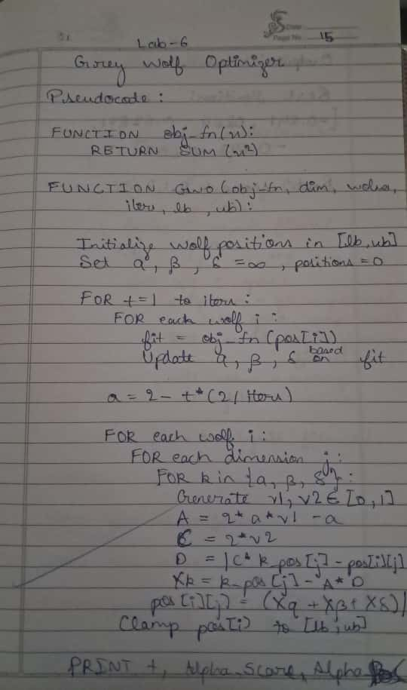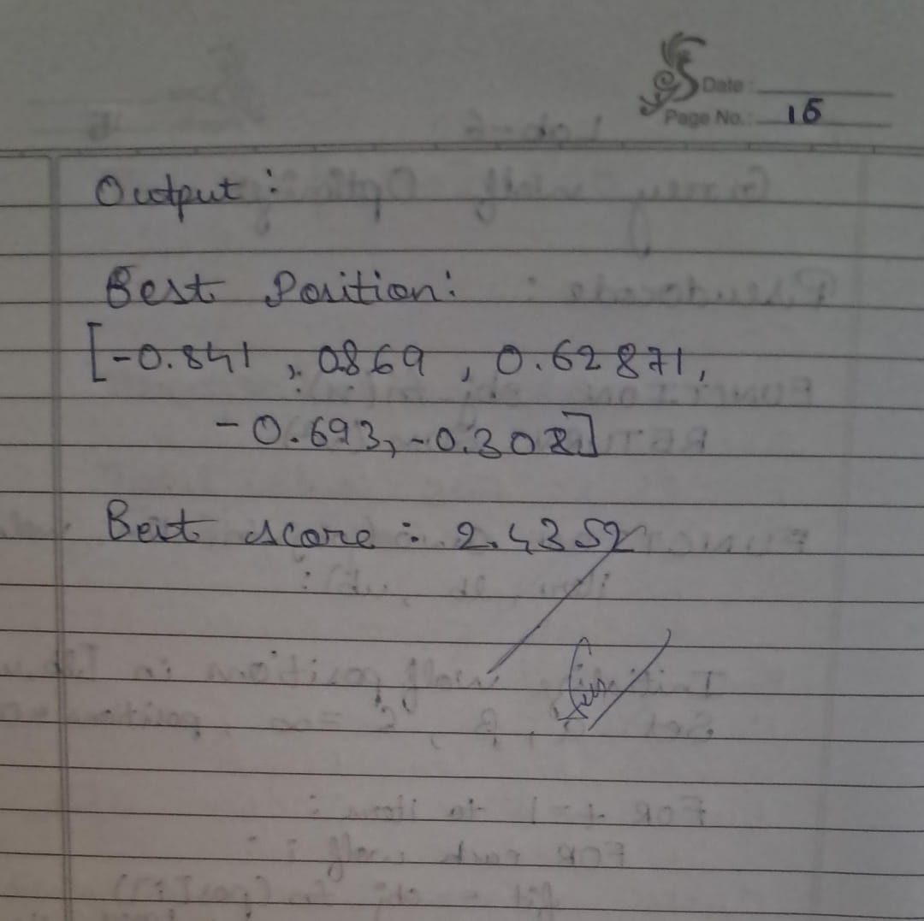

Code:
import numpy as np

# Initialize
grid = np.random.uniform(low=-10, high=10, size=(10, 10))
num_iterations = 100

# Define fitness function
def fitness_function(x):
return x**2 - 4*x + 4

# Iterate
for iteration in range(num_iterations):
new_grid = np.zeros_like(grid)
for r in range(grid.shape[0]):
for c in range(grid.shape[1]):
neighbor_values = []
for dr in [-1, 0, 1]:
for dc in [-1, 0, 1]:
nr = (r + dr) % grid.shape[0]
nc = (c + dc) % grid.shape[1]
neighbor_values.append(grid[nr, nc])
# Update to average of neighbor values (per algorithm spec)
new_grid[r, c] = np.mean(neighbor_values)
grid = new_grid.copy()

# Find best solution
fitness_values = fitness_function(grid)
best_fitness_overall = np.min(fitness_values)
best_x_overall = grid[np.unravel_index(np.argmin(fitness_values), grid.shape)]

# Verbose Output
print("=== Parallel Cellular Algorithm Results ===")
print(f"Total iterations performed: {num_iterations}")
print(f"Best x value found: {best_x_overall:.6f}")
print(f"Corresponding fitness (minimum f(x)): {best_fitness_overall:.6f}")
print("Algorithm converged toward x ≈ 2, where f(x) = 0 (expected optimum).")

Output :
Total iterations performed: 100
Best x value found: 0.317779
Corresponding fitness (minimum f(x)): 2.829867
Algorithm converged toward x ≈ 2, where f(x) = 0 (expected optimum).

Program 7
Optimization via Gene Expression Algorithms.

Algorithm:
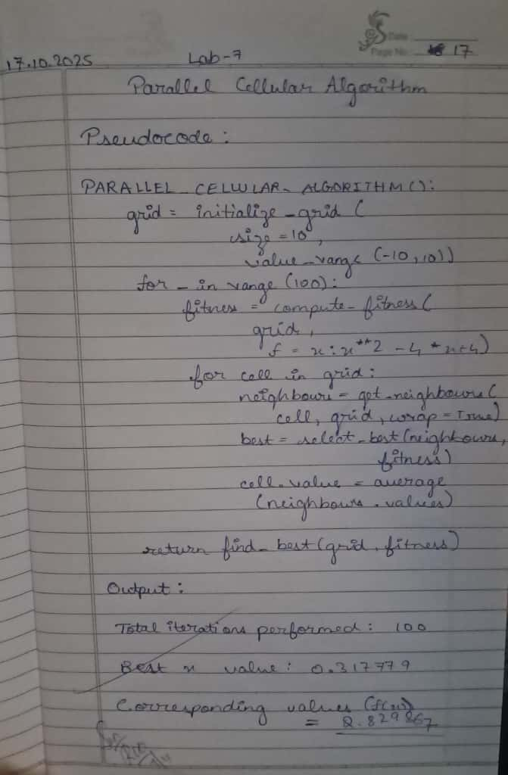

Code:
import random
import math
def fitness_function(x):
return x * math.sin(10 * math.pi * x) + 2
POPULATION_SIZE = 6
GENE_LENGTH = 10
MUTATION_RATE = 0.05
CROSSOVER_RATE = 0.8
GENERATIONS = 20
DOMAIN = (-1, 2)

def random_gene():
return random.uniform(DOMAIN[0], DOMAIN[1])

def create_chromosome():
return [random_gene() for _ in range(GENE_LENGTH)]

def initialize_population(size):
return [create_chromosome() for _ in range(size)]

def evaluate_population(population):
return [fitness_function(express_gene(chrom)) for chrom in population]

def express_gene(chromosome):
return sum(chromosome) / len(chromosome)

def select(population, fitnesses):
total_fitness = sum(fitnesses)
pick = random.uniform(0, total_fitness)
current = 0
for individual, fitness in zip(population, fitnesses):
current += fitness
if current > pick:
return individual
return random.choice(population)

def crossover(parent1, parent2):
if random.random() < CROSSOVER_RATE:
point = random.randint(1, GENE_LENGTH - 1)
child1 = parent1[:point] + parent2[point:]
child2 = parent2[:point] + parent1[point:]
return child1, child2
return parent1[:], parent2[:]

def mutate(chromosome):
new_chromosome = []
for gene in chromosome:
if random.random() < MUTATION_RATE:
new_chromosome.append(random_gene())
else:
new_chromosome.append(gene)
return new_chromosome

def gene_expression_algorithm():
population = initialize_population(POPULATION_SIZE)
best_solution = None
best_fitness = float("-inf")
for generation in range(GENERATIONS):
fitnesses = evaluate_population(population)

for i, chrom in enumerate(population):
if fitnesses[i] > best_fitness:
best_fitness = fitnesses[i]
best_solution = chrom[:]

print(f"Generation {generation+1}: Best Fitness = {best_fitness:.4f}, Best x = {express_gene(best_solution):.4f}")

new_population = []
while len(new_population) < POPULATION_SIZE:
parent1 = select(population, fitnesses)
parent2 = select(population, fitnesses)
offspring1, offspring2 = crossover(parent1, parent2)
offspring1 = mutate(offspring1)
offspring2 = mutate(offspring2)
new_population.extend([offspring1, offspring2])

population = new_population[:POPULATION_SIZE]

print("\nBest solution found:")
print(f"Genes: {best_solution}")
x_value = express_gene(best_solution)
print(f"x = {x_value:.4f}")
print(f"f(x) = {fitness_function(x_value):.4f}")

if __name__ == "__main__":
gene_expression_algorithm()

Output :
Generation 1: Best Fitness = 2.3125, Best x = 0.4262
Generation 2: Best Fitness = 2.3125, Best x = 0.4262
Generation 3: Best Fitness = 2.3125, Best x = 0.4262
Generation 4: Best Fitness = 2.3125, Best x = 0.4262
Generation 5: Best Fitness = 2.3125, Best x = 0.4262
Generation 6: Best Fitness = 2.3125, Best x = 0.4262
Generation 7: Best Fitness = 2.3125, Best x = 0.4262
Generation 8: Best Fitness = 2.4233, Best x = 0.6237
Generation 9: Best Fitness = 2.4233, Best x = 0.6237
Generation 10: Best Fitness = 2.4233, Best x = 0.6237
Generation 11: Best Fitness = 2.4233, Best x = 0.6237
Generation 12: Best Fitness = 2.4233, Best x = 0.6237
Generation 13: Best Fitness = 2.4233, Best x = 0.6237
Generation 14: Best Fitness = 2.4233, Best x = 0.6237
Generation 15: Best Fitness = 2.4233, Best x = 0.6237
Generation 16: Best Fitness = 2.4233, Best x = 0.6237
Generation 17: Best Fitness = 2.4395, Best x = 0.4594
Generation 18: Best Fitness = 2.4395, Best x = 0.4594
Generation 19: Best Fitness = 2.4395, Best x = 0.4594
Generation 20: Best Fitness = 2.4395, Best x = 0.4594

Best solution found:
Genes: [0.6948405045559576, -0.647173288232043, -0.3013499383055478, 1.631627548910124, 0.9271637073163099, 0.0324867196364278, -0.3565755055362756, 1.5226396608397925, 1.0654293190513275, 0.024805208657060707]
x = 0.4594
f(x) = 2.4395

