**VISVESVARAYA TECHNOLOGICAL UNIVERSITY**

**“JnanaSangama”, Belgaum -590014, Karnataka.**



**LAB REPORT**

**on**

**Artificial Intelligence (23CS5PCAIN)**

***Submitted by***

**Subramanya J (1BM23CS343)**

***in partial fulfillment for the award of the degree of***

**BACHELOR OF ENGINEERING**

***in***

**COMPUTER SCIENCE AND ENGINEERING**



**B.M.S. COLLEGE OF ENGINEERING**

**(Autonomous Institution under VTU)**

**BENGALURU-560019**

**Aug 2025 to Dec 2025**

**B.M.S. College of Engineering,**

**Bull Temple Road, Bangalore 560019**

(Affiliated To Visvesvaraya Technological University, Belgaum)

**Department of Computer Science and Engineering**



**CERTIFICATE**

This is to certify that the Lab work entitled “Artificial Intelligence (23CS5PCAIN)” carried out by **Subramanya J (1BM23CS343),** who is bonafide student of **B.M.S. College of Engineering.** It is in partial fulfillment for the award of **Bachelor of Engineering in Computer Science and Engineering** of the Visvesvaraya Technological University, Belgaum. The Lab report has been approved as it satisfies the academic requirements in respect of an Artificial Intelligence (23CS5PCAIN) work prescribed for the said degree.

|  |  |
| --- | --- |
| Sonika Sharma D  Assistant Professor  Department of CSE, BMSCE | Dr. Kavitha Sooda  Professor & HOD  Department of CSE, BMSCE |

**Index**

|  |  |  |  |
| --- | --- | --- | --- |
| **Sl.**  **No.** | **Date** | **Experiment Title** | **Page No.** |
| 1 | 30-9-2024 | Implement Tic –Tac –Toe Game  Implement vacuum cleaner agent |  |
| 2 | 7-10-2024 | Implement 8 puzzle problems using Depth First Search (DFS)  Implement Iterative deepening search algorithm |  |
| 3 | 14-10-2024 | Implement A* search algorithm |  |
| 4 | 21-10-2024 | Implement Hill Climbing search algorithm to solve N-Queens problem |  |
| 5 | 28-10-2024 | Simulated Annealing to Solve 8-Queens problem |  |
| 6 | 11-11-2024 | Create a knowledge base using propositional logic and show that the given query entails the knowledge base or not. |  |
| 7 | 2-12-2024 | Implement unification in first order logic |  |
| 8 | 2-12-2024 | Create a knowledge base consisting of first order logic statements and prove the given query using forward reasoning. |  |
| 9 | 16-12-2024 | Create a knowledge base consisting of first order logic statements and prove the given query using Resolution |  |
| 10 | 16-12-2024 | Implement Alpha-Beta Pruning. |  |

Github Link:

<https://github.com/SubramanyaJ/23CS5PCAIN>

**Program 1**

Implement Tic –Tac –Toe Game

Implement Vacuum Cleaner agent

Algorithm:

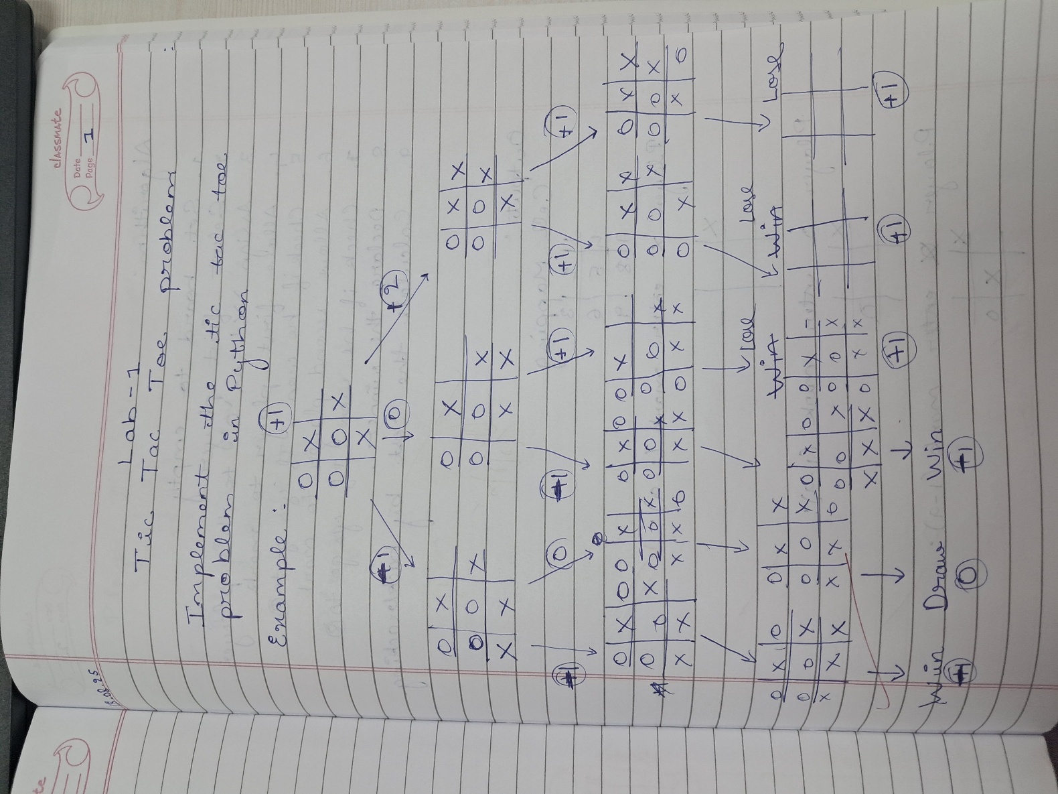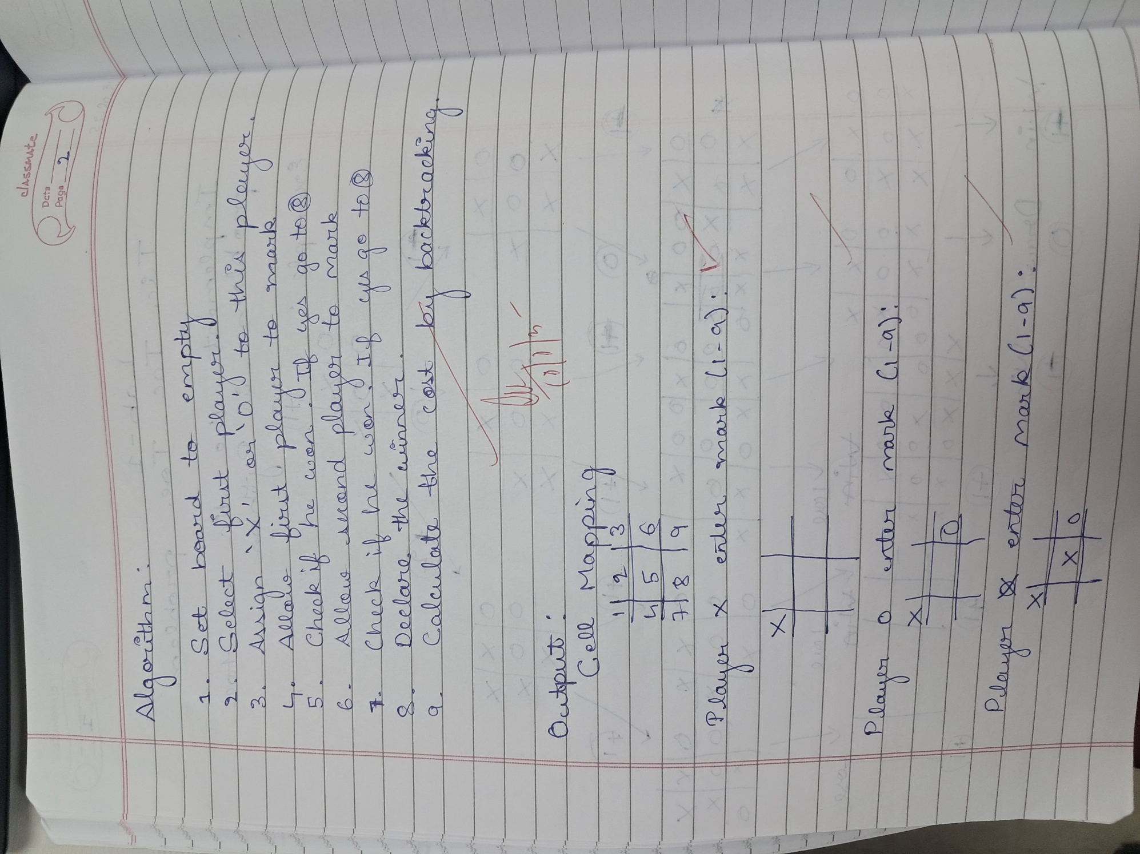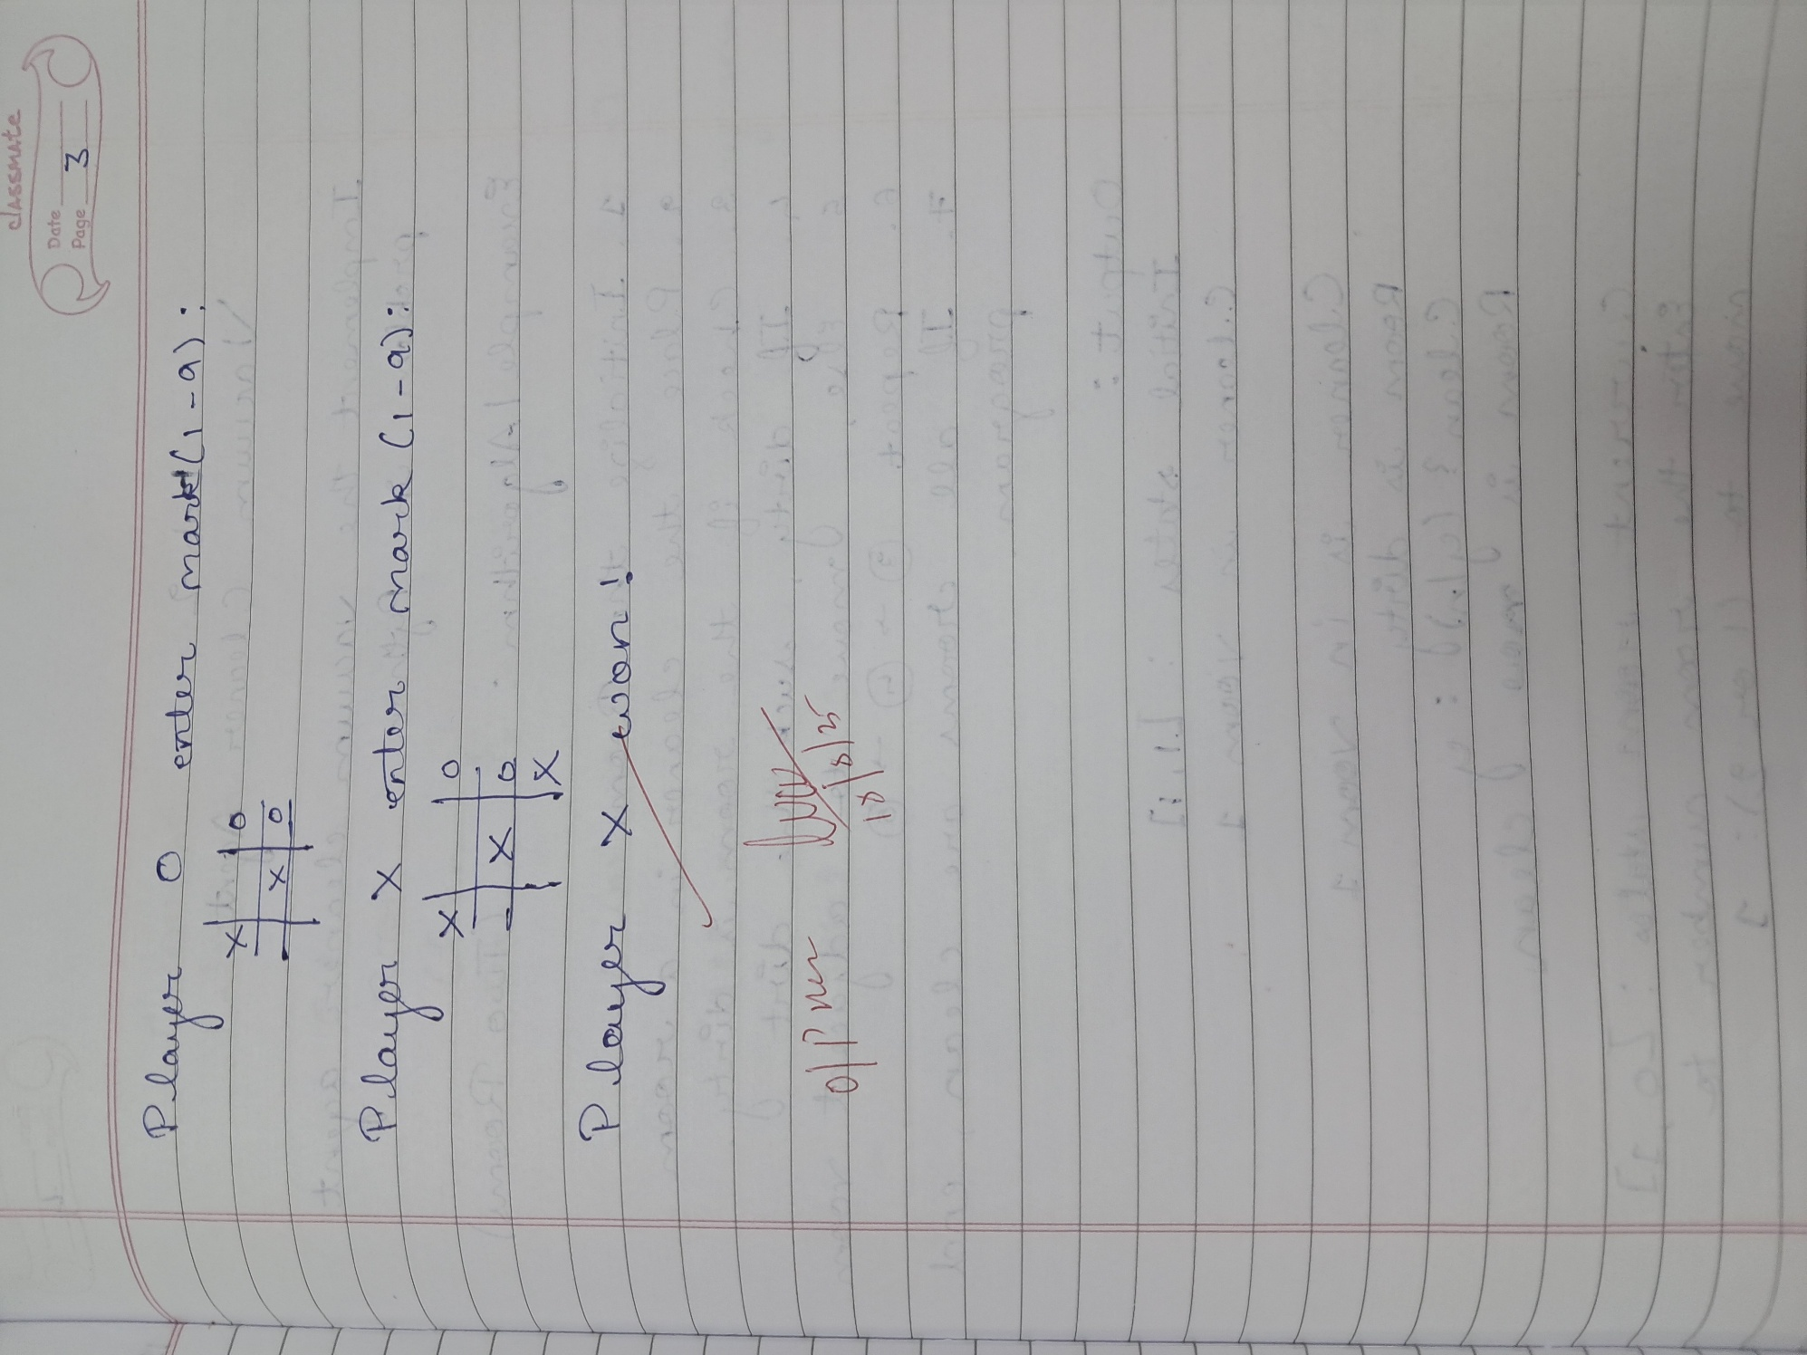

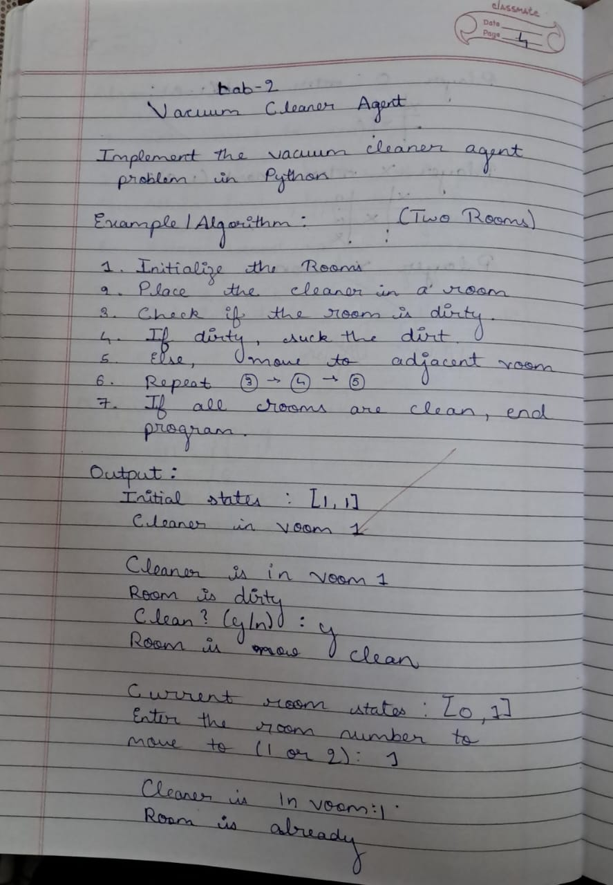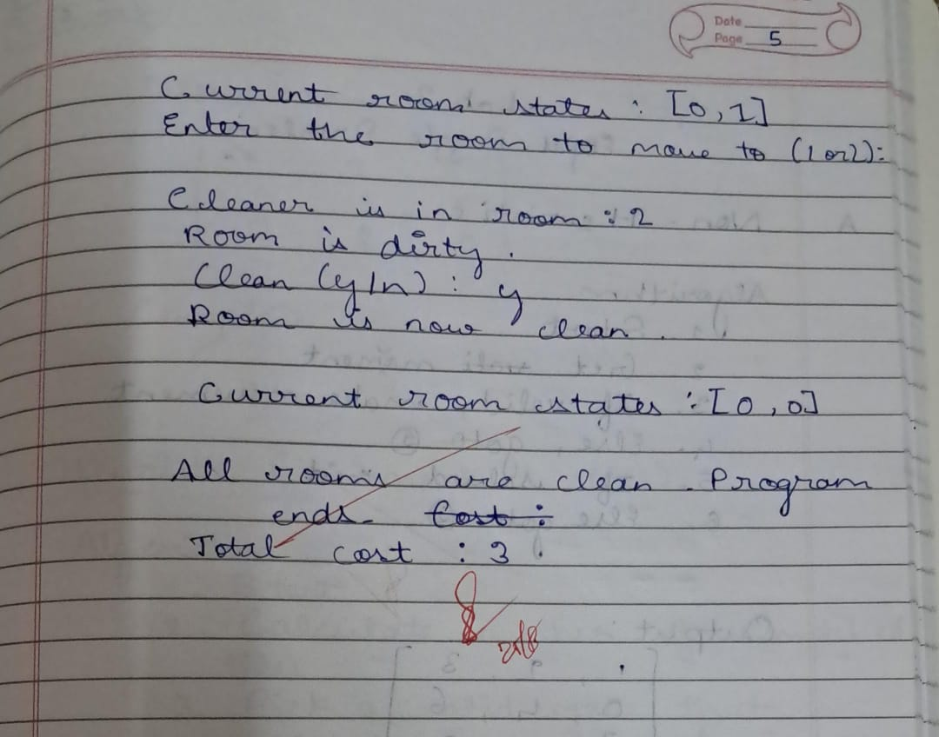

Code:

def print_board(board):

for row in board:

print(" | ".join(row))

print("-" * 9)

def print_cell_mapping():

mapping = [

"1 | 2 | 3",

"- - - - - - -",

"4 | 5 | 6",

"- - - - - - -",

"7 | 8 | 9"

]

print("\nCell Mapping:")

for line in mapping:

print(line)

print()

def check_winner(board):

for i in range(3):

if board[i][0] == board[i][1] == board[i][2] != " ":

return board[i][0]

if board[0][i] == board[1][i] == board[2][i] != " ":

return board[0][i]

if board[0][0] == board[1][1] == board[2][2] != " ":

return board[0][0]

if board[0][2] == board[1][1] == board[2][0] != " ":

return board[0][2]

return None

def is_board_full(board):

return all(cell != " " for row in board for cell in row)

def tic_tac_toe():

board = [[" " for _ in range(3)] for _ in range(3)]

current_player = "X"

print_cell_mapping()

while True:

print_board(board)

move = int(input(f"Player {current_player}, enter the cell number (1-9): ")) - 1

row, col = divmod(move, 3)

if 0 <= move < 9 and board[row][col] == " ":

board[row][col] = current_player

else:

print("Invalid move! Try again.")

continue

winner = check_winner(board)

if winner:

print_board(board)

print(f"Player {winner} wins!")

break

if is_board_full(board):

print_board(board)

print("It's a draw!")

break

current_player = "O" if current_player == "X" else "X"

tic_tac_toe()