## EXPERIMENT 1

**Subramanya L – 1BM21CS222**

# Hub with end devices

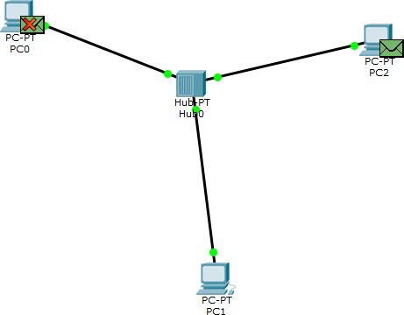

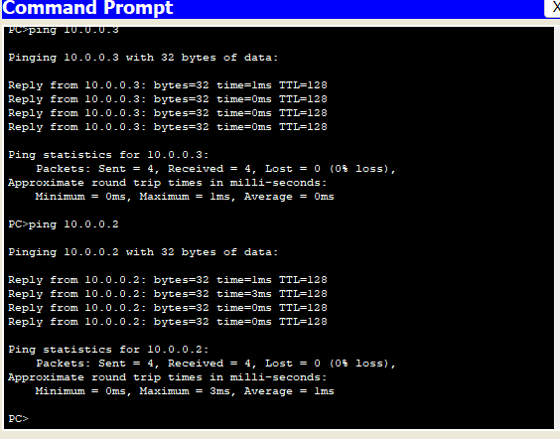

## Observation of hub with end devices

1. End devices are connected to hub with copper cross over.
2. Hub connects instantly with the end devices
3. IP address of each device must be unique
4. When a packet is transferred it is received by all end devices and then validated.
5. Capture/Forward is used to transfer packet.

# Switch with end devices

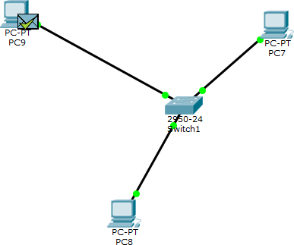

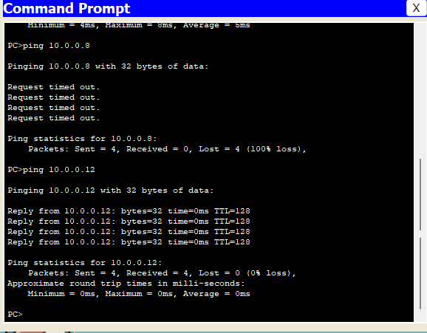

## Observation of switch with end devices

1. There is a 30 seconds delay in switch.
2. Switch acts like a hub during initialization.
3. Switch is connected with end devices with copper cross over.
4. Ipconfig command is used to check the IP address of the device.
5. Ping command is used to send packets to other end devices.

# Combination of hub and switch

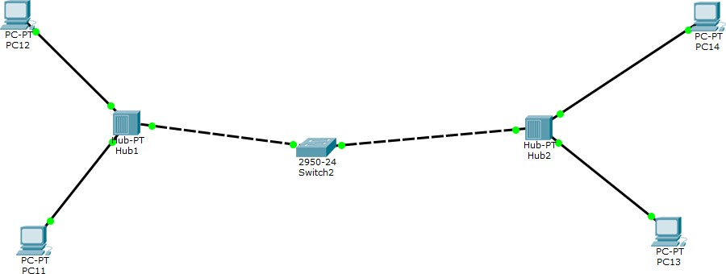

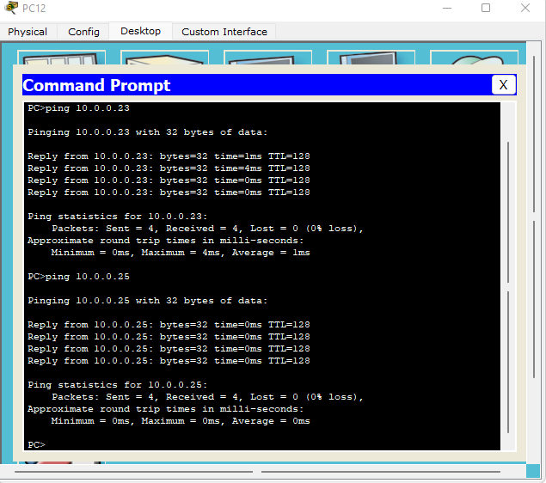

## Observation of hub and switch with end devices

1. Hub is connected to switch copper straight through.
2. Hub is connected to end devices by copper cross over.
3. When packet is transferred in own hub then it is transferred to all devices.
4. Switch acts as a connection between hubs.
5. There is a delay in connection between hub and switch