Game Design Document

Fill up the following document

1. Write the title of your project.

Mario Returns

1. What is the goal of the game?

The main goal of this game to reach to the end flag ! Mario/The Player can collect coins for extra points.

1. Write a brief story of your game.

**Mario** hears about the Mushroom People's plight and sets out on a quest to reach the end flag by dodging from obstacles and escaping from enemies !

1. Which are the playing characters of this game?

* Playing characters are the ones who respond to the user based on the input from the user.
* Cars, monkeys, dinos, wizards, etc., are the playing characters in the game.

|  |  |  |
| --- | --- | --- |
| Number | Character Name | What can this character do? |
| 1 | Mario | The playing character who can jump and move |
| 2 |  |  |
| 3 |  |  |
| 4 |  |  |
| 5 |  |  |
| 6 |  |  |
| 7 |  |  |
| 8 |  |  |

1. Which are the Non-Playing Characters of this game?

* Non-Playing characters are the ones that don't have an action or behavior when the user interacts with the game.
* Hurdles, stones, bananas, coins, etc., are non-playing characters in the game.

|  |  |  |
| --- | --- | --- |
| Number | Character Name | What can this character do? |
| 1 | Coins | Collect them for points |
| 2 | Tortise | An enemy |
| 3 | Bricks | Obstacle |
| 4 | End Flag | Finish line of the game |
| 5 |  |  |
| 6 |  |  |
| 7 |  |  |
| 8 |  |  |

Draw your imagination of this game. What does this game look like?

* Draw the game either on your computer or on paper.
* Add images of the game scenes to show each of the playing and non-playing characters at least once.

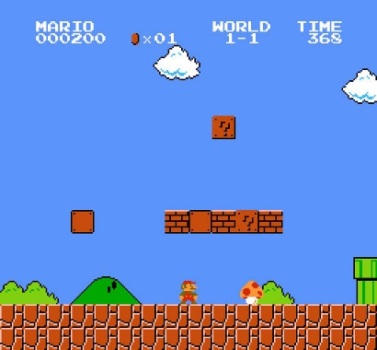

How do you plan to make your game engaging?

There are coins to collect for points, enemeis to escape from which makes the game very enganging ! s