This is main lunching Screen

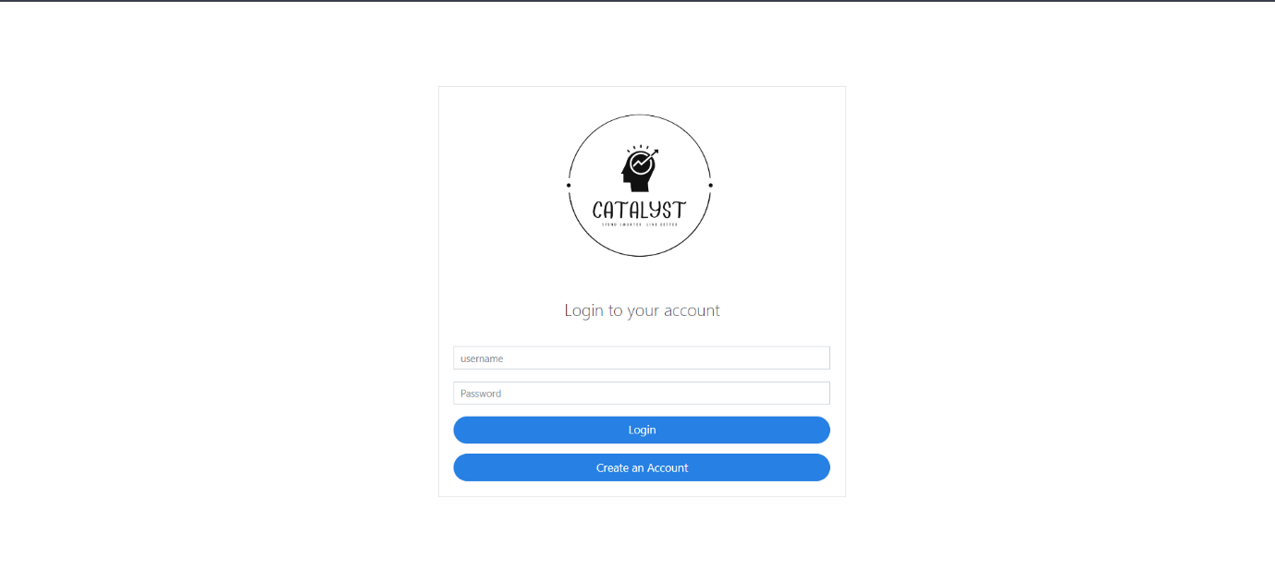

Step-1:Login to The Catalyst using username and password, If you haven’t register, click on the create and account button.

Step.2: It will redirect you to register page

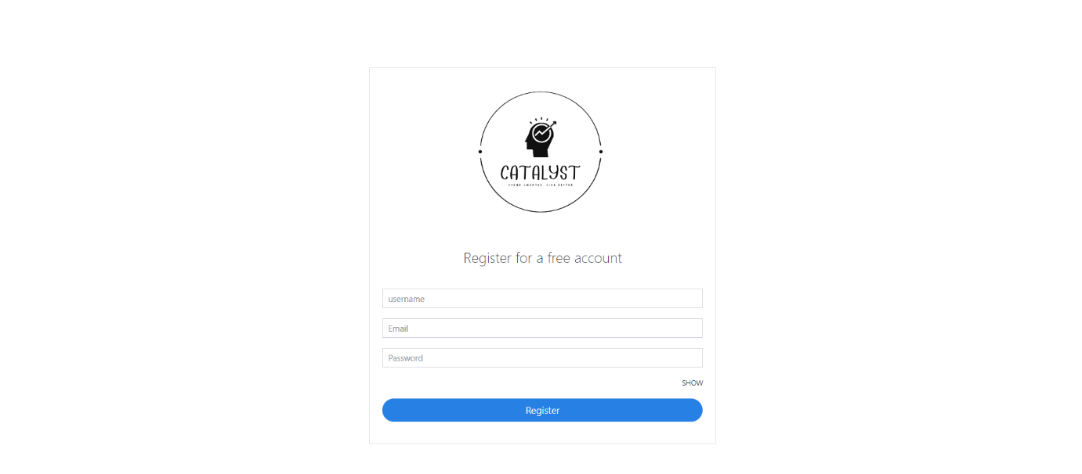

Step-3: Provide them the data, and you data is stored in the database, and a activation code will be provided to the specified email.

Step 4: Go the mail and activate your account.

Step 5: You will again redirect to the login page, fill your credential and you will be taken to the dashboard.

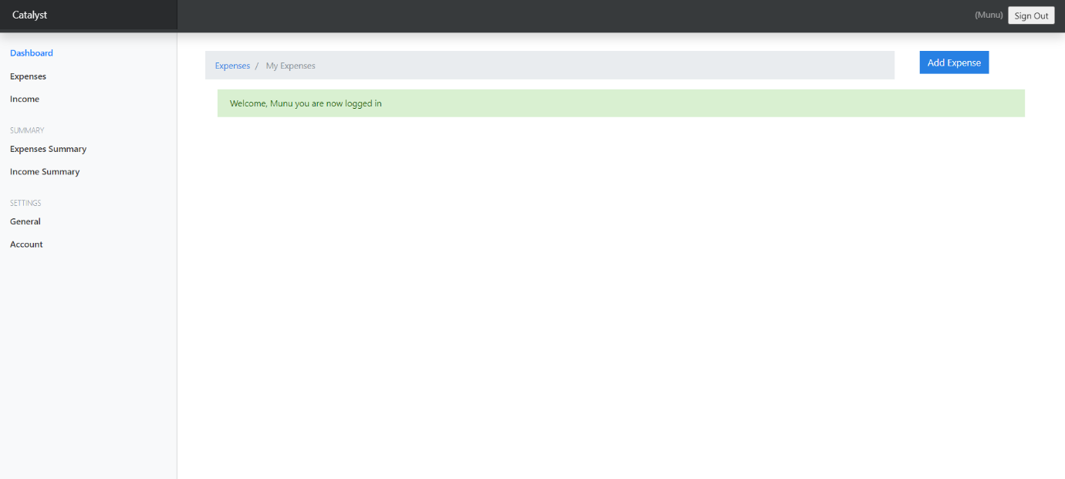

Step 6: You can now add expenses by clicking on “Add Expenses”.

Step 7: Add the amount, Describe the Description, Select the Category, Choose the date, and then click submit.

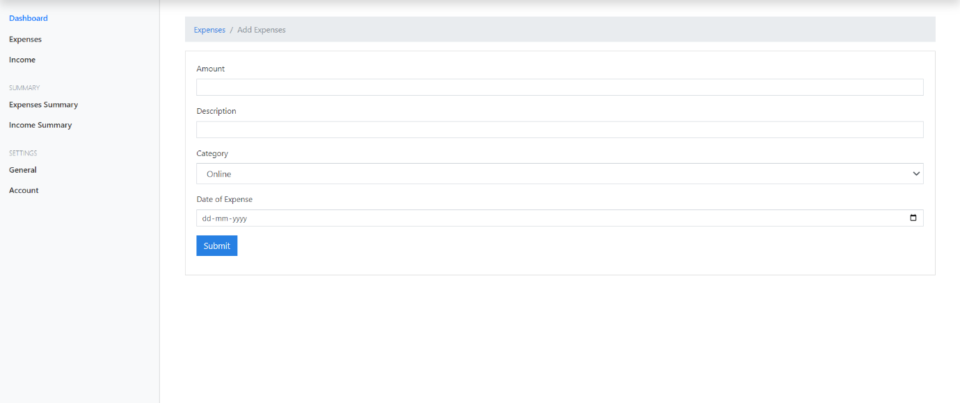

Step 8: Add your daily expenses here for getting the right information about each and every rupee you spent.

Step 9: You can change the currency any time.

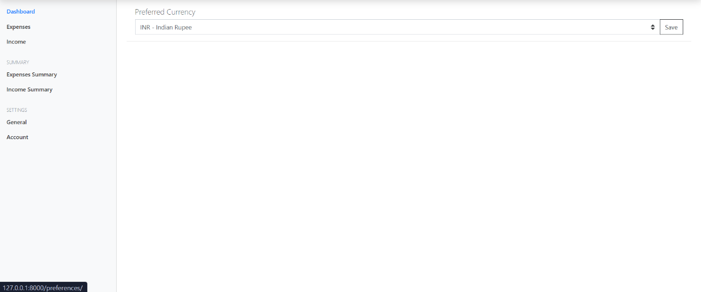

Step 10: You can use see the statistical view of you expenses.

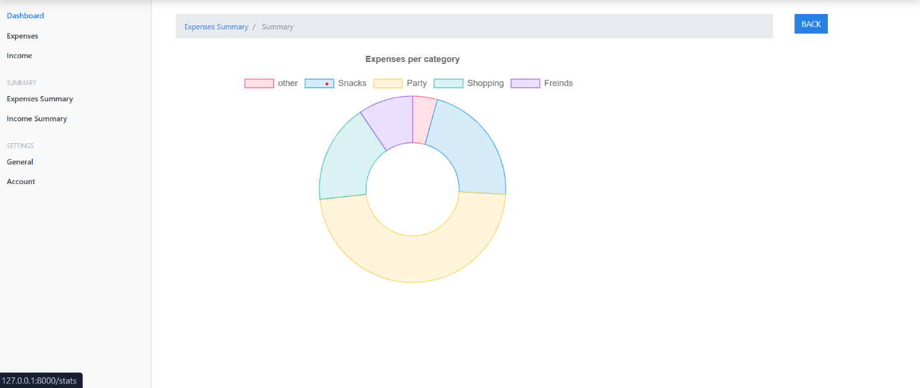

Step 11: You can see list of expenses, by clicking on expense summary.

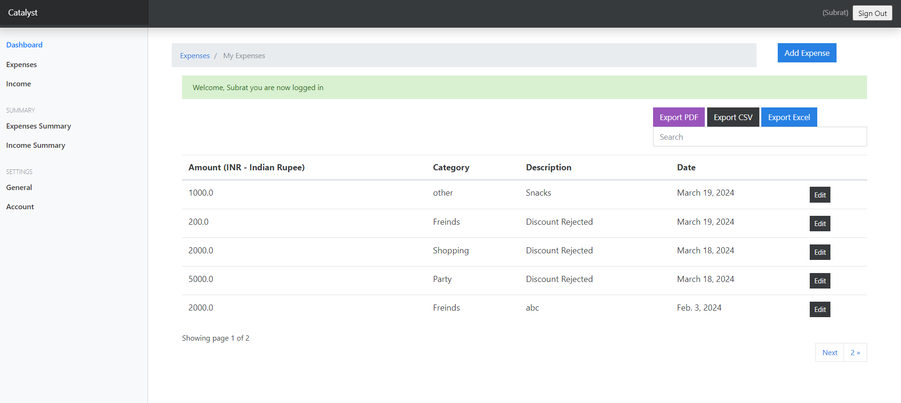

Step 12: You can do the same for Income as well.

Step 13: You can download csv file, Excel file and pdf of your expenses.

**Excel View**

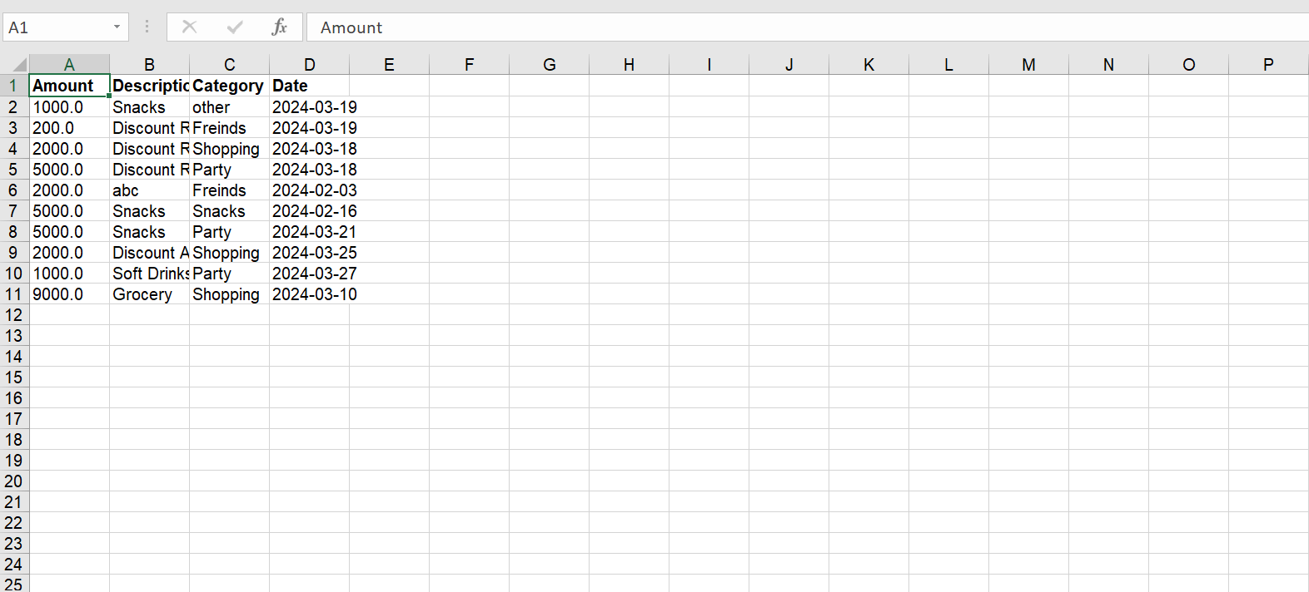

**CSV View**



**PDF View**

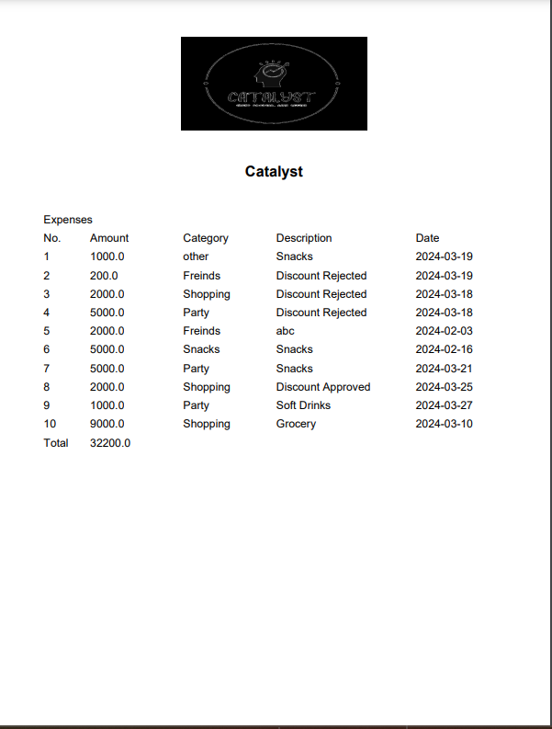

Step 14: You can now logout.