1. Provide the list of markets in which customer "Atliq Exclusive" operates its business in the APAC region.

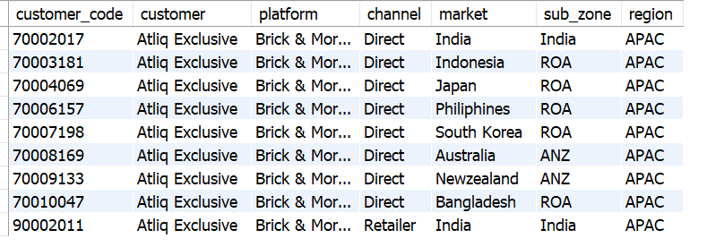

1. What is the percentage of unique product increase in 2021 vs. 2020

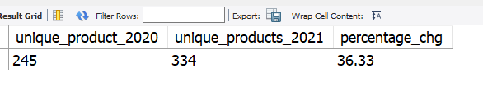

1. Provide a report with all the unique product counts for each segment and sort them in descending order of product counts.

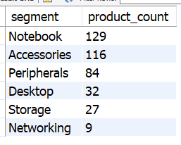

1. Follow-up: Which segment had the most increase in unique products in 2021 vs 2020?

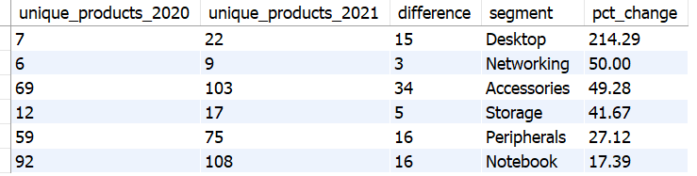

1. Get the products that have the highest and lowest manufacturing costs.

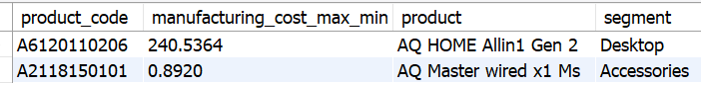

1. Generate a report which contains the top 5 customers who received an average high pre_invoice_discount_pct for the fiscal year 2021 and in the Indian market.

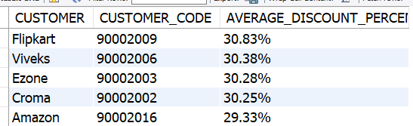

1. Get the complete report of the Gross sales amount for the customer **“Atliq Exclusive”** for each month.

|  |  |  |
| --- | --- | --- |
| **MONTH** | **FISCAL_YEAR** | **GROSS_SALES** |
| September | 2020 | 9.09 M |
| October | 2020 | 10.38 M |
| November | 2020 | 15.23 M |
| December | 2020 | 9.76 M |
| January | 2020 | 9.58 M |
| February | 2020 | 8.08 M |
| March | 2020 | 0.77 M |
| April | 2020 | 0.80 M |
| May | 2020 | 1.59 M |
| June | 2020 | 3.43 M |
| July | 2020 | 5.15 M |
| August | 2020 | 5.64 M |
| September | 2021 | 19.53 M |
| October | 2021 | 21.02 M |
| November | 2021 | 32.25 M |
| December | 2021 | 20.41 M |
| January | 2021 | 19.57 M |
| February | 2021 | 15.99 M |
| March | 2021 | 19.15 M |
| April | 2021 | 11.48 M |
| May | 2021 | 19.20 M |
| June | 2021 | 15.46 M |
| July | 2021 | 19.04 M |
| August | 2021 | 11.32 M |
|  |  |  |

8.In which quarter of 2020, got the maximum total_sold_quantity?

