Interview - 8

**Aptitude test - 2ques, 10min**

**Dsa Round - 3 ques, 45min**

**React coding - 3 ques, 45min**

**React Theory - 5 ques, 20min**

**Total = 2hrs**

**Aptitude Test – 10min**

**Q1. (3 Ants and Triangle)**

There are 3 ants sitting on three corners of a triangle. All ants randomly pick a direction and start moving along edge of the triangle. What is the probability that any two ants collide?

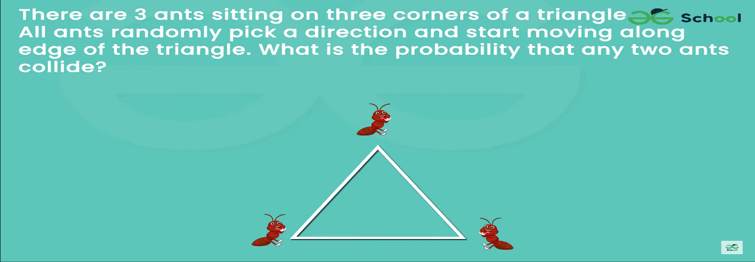

[Puzzle 21 | (3 Ants and Triangle) - GeeksforGeeks](https://www.geeksforgeeks.org/puzzle-21-3-ants-and-triangle/)

**Ans: 8**

**Q2. Give answer as—**

A. if only conclusion I is true.

B. if only conclusion II is true.

C. if either conclusion I or conclusion II is true.

D. if neither conclusion I nor conclusion II is true

E. if both conclusions I and II are true.

Statements:

All mangoes are bananas.

Some bananas are globe.

All globe are square.

Conclusions:

I. Some mangoes are square.

II. No mango is square.

**Ans: A**

[Syllogism - GeeksforGeeks](https://www.geeksforgeeks.org/syllogism-gq/)

**Dsa – 45min**

Q1. [Equilibrium Point | Practice | GeeksforGeeks](https://www.geeksforgeeks.org/problems/equilibrium-point-1587115620/1?page=1&company=Amazon&sortBy=submissions)

Q2. [Find Indexes of a subarray with given sum | Practice | GeeksforGeeks](https://www.geeksforgeeks.org/problems/subarray-with-given-sum-1587115621/1?page=1&company=Amazon&sortBy=submissions)

Q3. [Lowest Common Ancestor in a Binary Tree | Practice | GeeksforGeeks](https://www.geeksforgeeks.org/problems/lowest-common-ancestor-in-a-binary-tree/1?itm_source=geeksforgeeks&itm_medium=article&itm_campaign=bottom_sticky_on_article)

**React Coding 45 min**

Q1: Create a stopwatch application through which users can start, pause and reset the timer. Use React state, event handlers and the setTimeout or setInterval functions to manage the timer’s state and actions.

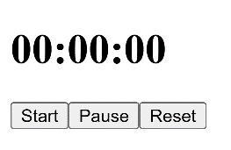

Q2: Find the issue in the below code snippet after rendering the list of names.

import React from "react";

function App() {

const names = ["Brian", "Paul", "Krug", "Halley"];

const listItems = names.map((name) => <li>{name}</li>);

return <ul>{listItems}</ul>;

}

export default App;

Question 3

Analyze the below code and advise what is wrong with using setState() inside the render() method:

import React, { Component } from "react";

class App extends Component {

state = {

counter: 0,

};

render() {

this.setState({ counter: this.state.counter + 1 });

return <div>Counter: {this.state.counter}</div>;

}

}

export default App;

Q3: What will be the output when the user types in the input field:

function App() {

const [value, setValue] = useState("");

function handleChange(event) {

setValue(event.target.value);

}

return (

<div>

<input type="text" value={value} onChange={handleChange} />

<p>You entered: {value}</p>

</div>

);

}

**React Theory – 20min**

[Top 50+ React Interview Questions and Answers (2024) (geeksforgeeks.org)](https://www.geeksforgeeks.org/react-interview-questions/)

Q1. Explain one way data binding in React?

Q2. Explain the components of a react-router?

Q3. Explain the lifecycle methods of components?

Q4. Explain the methods used in mounting phase of components?

Q5. What is this.setState function in React?