TRINAMIX
Conversion Workbench — Feature Verification Guide
Step-by-step UAT checklist — each feature shown on the live app
How to use: follow the steps for each feature and confirm the expected result against the screenshot below it, captured from the live app. A few interaction-only steps show a dashed box with a note — capture those during UAT. AI-powered features are marked green.
Tester | Date | Environment | Overall result

0. One-time setup
Sign in
1. Open https://tx-conversion-workbench.onrender.com in a browser.
2. Sign in with your Conversion Workbench credentials.
3. Confirm the dashboard loads.
Expected: You land on the dashboard with the left navigation visible.
Screenshot: the dashboard right after sign-in
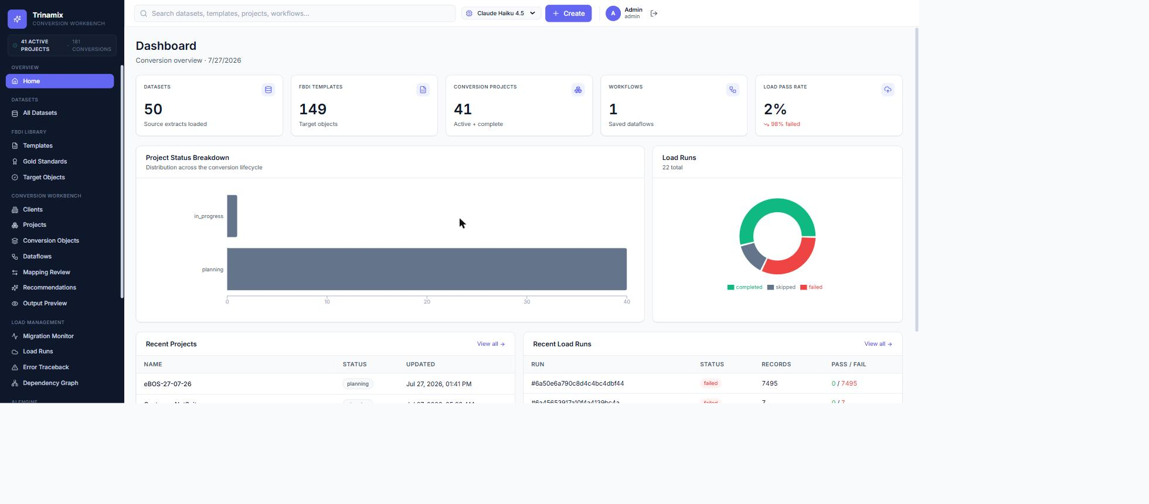
Choose the client
1. Use the client picker at the top of the page.
2. Select the client you're working on (e.g. NextPower).
Expected: The selected client name shows, and lists are scoped to that client.
Screenshot: the client picker with the client selected
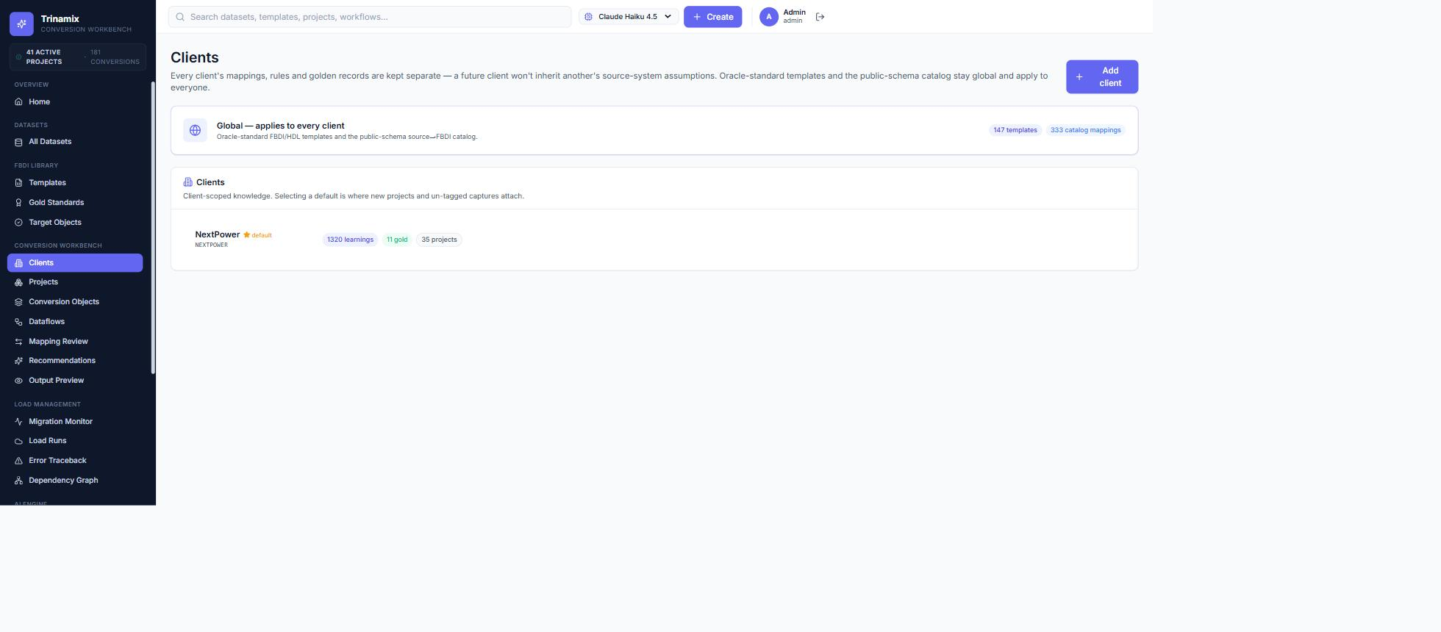

1. Everyday features
Bring in your data (multi-sheet workbook)
1. Go to Datasets and click Create Dataset.
2. Drop or browse to a workbook that has more than one tab (e.g. a Customer + Address workbook).
3. When the sheet picker appears, tick the sheets you want to import.
4. Click 'Upload N sheets & profile'.
Expected: One source dataset is created per selected sheet, each showing that sheet's own columns (not just the largest sheet).
Screenshot: the Create Dataset modal showing the multi-sheet picker with checkboxes
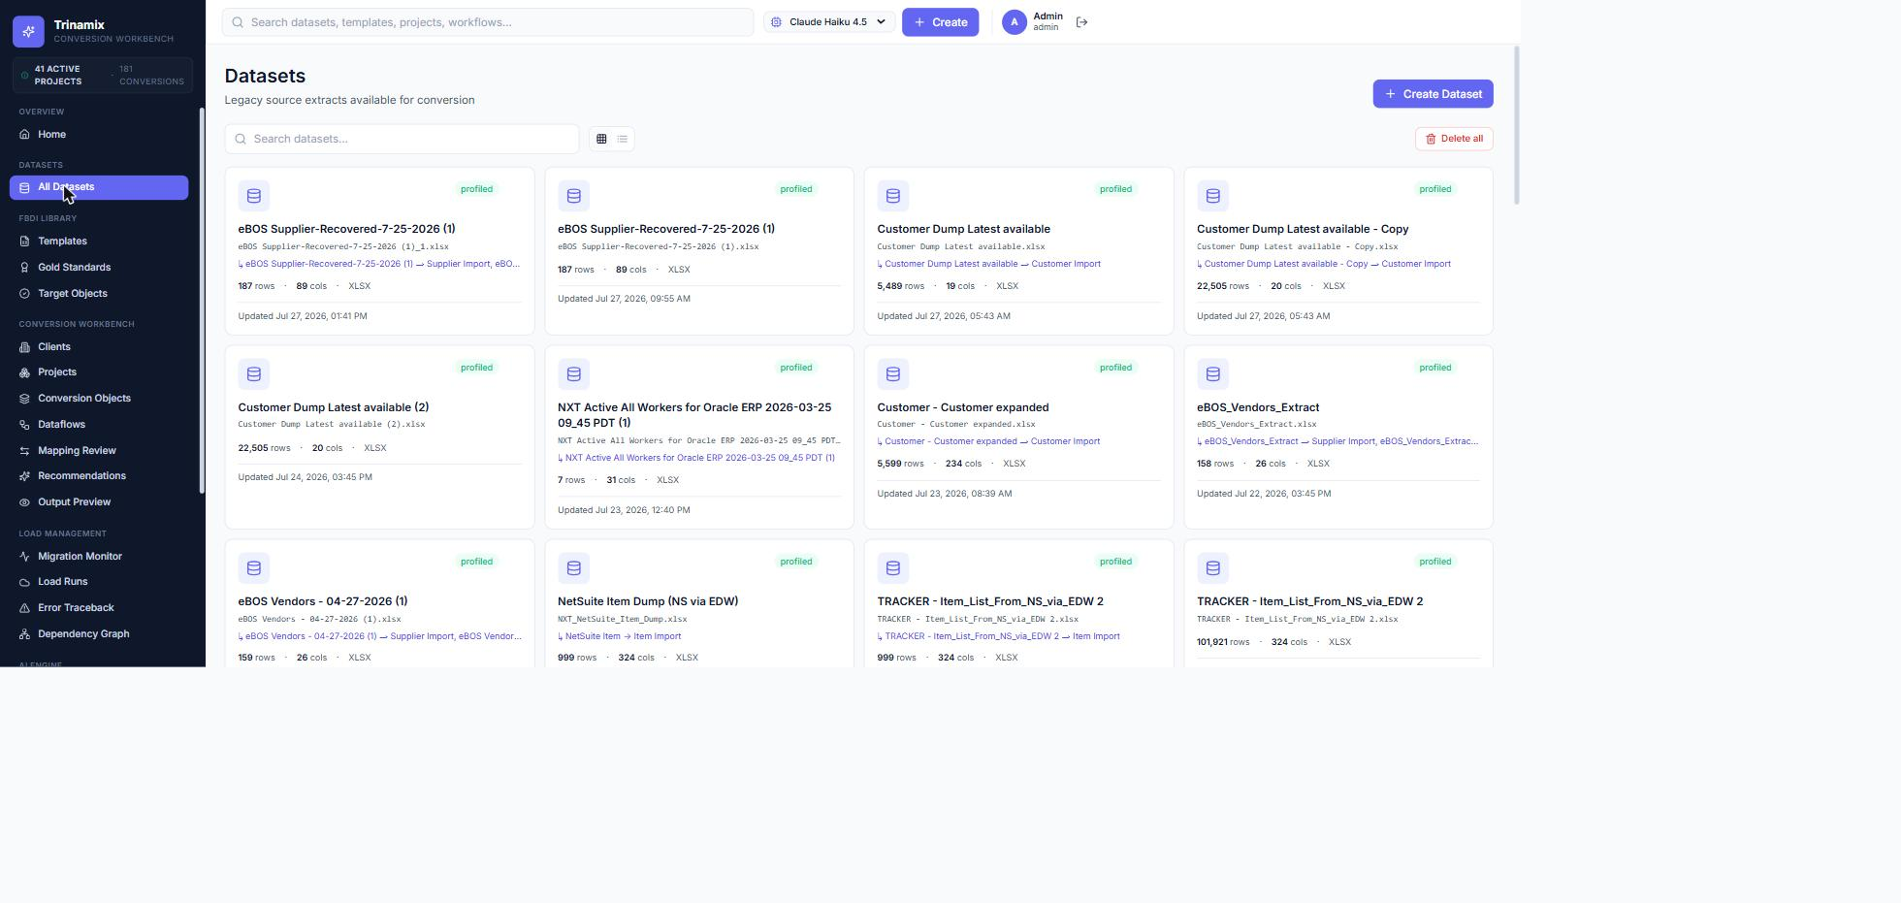
Shown: the Datasets area. The multi-sheet picker with checkboxes appears in the Create Dataset dialog while a multi-tab workbook uploads.
Organize by client and project
1. Go to Projects and open (or create) a project for the client.
2. Review the conversions listed under the project.
Expected: The project shows its interface objects (conversions) and their status.
Screenshot: the Project Overview with its conversions list
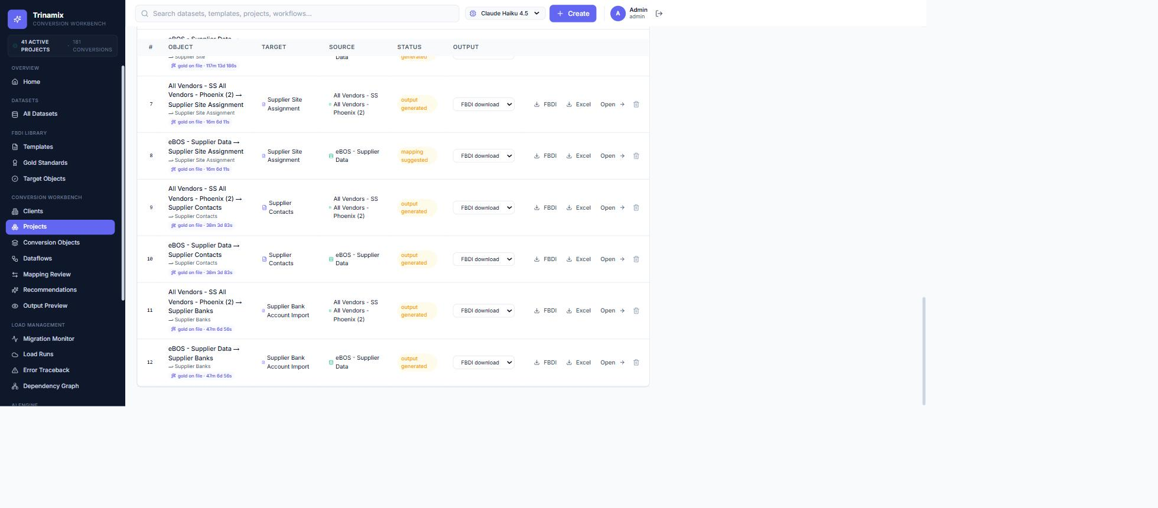
Oracle template library
1. Open FBDI Templates from the left navigation.
2. Confirm the Oracle interfaces are present (Supplier, Item, BOM, Customer, Employee).
Expected: Each template lists its fields and sheets.
Screenshot: the FBDI Templates list
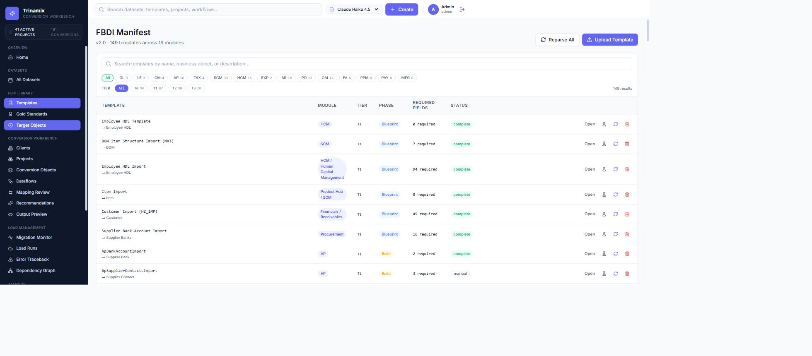
Review and adjust mappings
1. Open a conversion and go to Mapping Review.
2. Change a mapping, set a fixed value on a field, or approve a suggestion.
Expected: The change is saved and reflected in the mapping row.
Screenshot: the Mapping Review table with a field selected
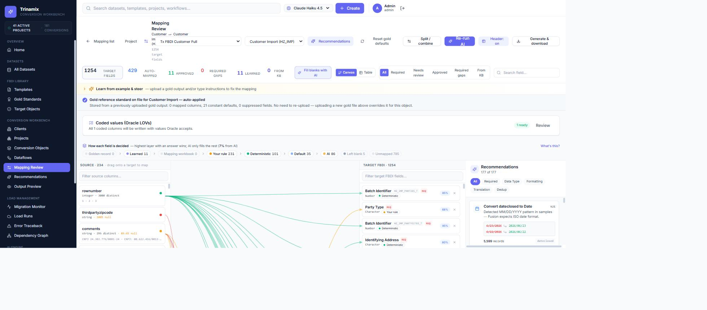
Export the mapping as Excel (Issue #3)
1. In Mapping Review, click 'Export mapping (Excel)'.
2. Open the downloaded workbook.
Expected: A Summary sheet lists a count per confidence band, plus one sheet per non-empty band (Target FBDI Field / Suggested Source Field / Confidence % / Reason / Excluded).
Screenshot: the downloaded workbook — Summary tab and one confidence-band tab
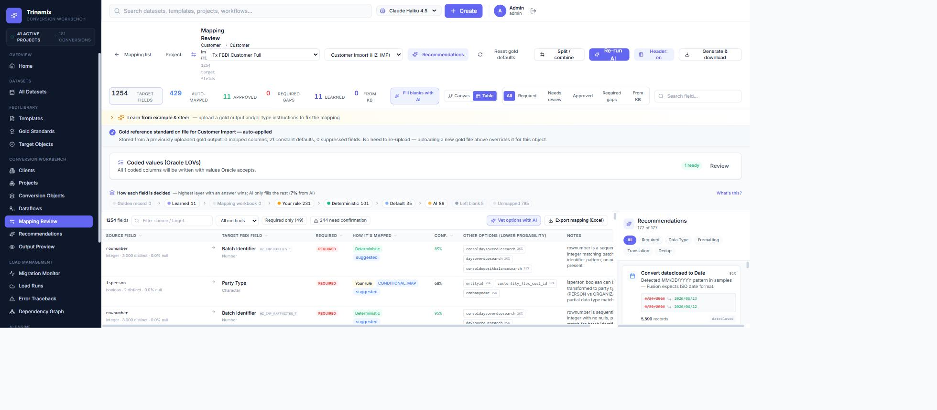
The 'Export mapping (Excel)' button is top-right of the table. The downloaded workbook has a Summary tab plus one tab per confidence band.
Generate load-ready output
1. Open a conversion and go to Output Preview.
2. Click Re-generate, then 'This file (.csv)' to download the FBDI CSV bundle.
3. On Project Overview, click the per-row 'Excel' button to download the filled-in Oracle template.
Expected: The CSV bundle downloads and opens cleanly; the .xlsm opens with your data in the correct sheet (e.g. POZ_SUPPLIERS_INT), sample rows removed.
Screenshot: the Output Preview and the opened filled Oracle template
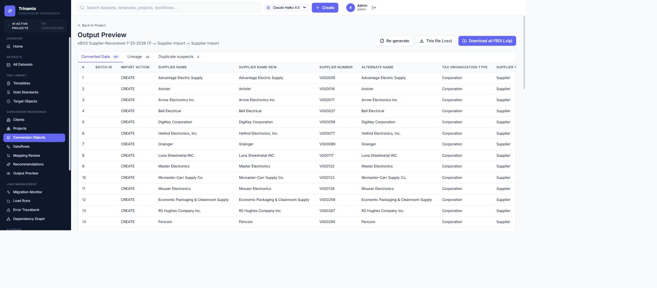
Output Preview with the 'This file (.csv)' and 'Download all FBDI' buttons. The per-row 'Excel' button on Project Overview downloads the filled-in Oracle .xlsm.
Combine many sources into one
1. Open a project where one interface has two source files (e.g. eBOS + NetSuite supplier).
2. Click 'Download all FBDI' (or 'Download all (Excel templates)').
Expected: One merged, de-duplicated file per interface — not one per source.
Screenshot: the downloaded .zip contents (one file per interface)
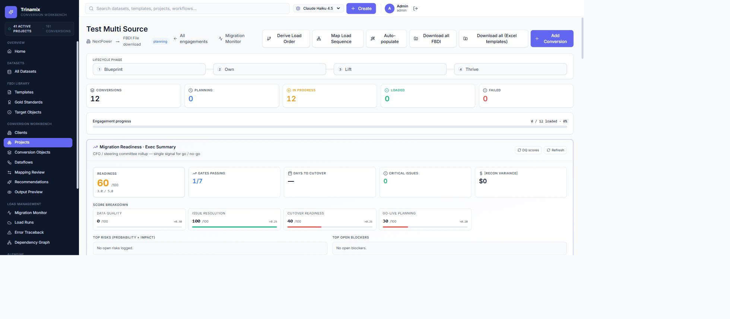
'Download all FBDI' and 'Download all (Excel templates)' merge every source for an interface into one de-duplicated file.
Cutover readiness score
1. Open a conversion's detail page.
2. Find the 'Cutover readiness' card.
Expected: A 0-100 score, a band (Ready / Needs minor work / …), coverage %, and an effort estimate.
Screenshot: the Cutover readiness card
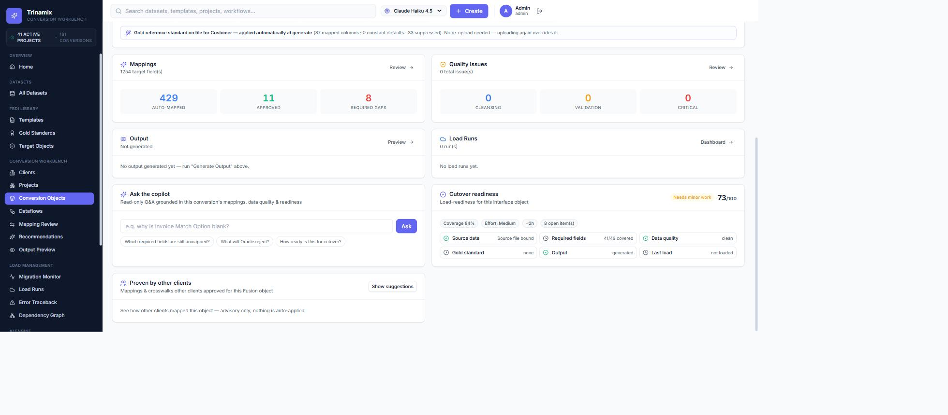
Sample test data
1. Go to FBDI Templates.
2. Click the 'Sample data' (flask) button on a template row.
3. Open the downloaded file.
Expected: Realistic, type-valid sample rows for that interface (for a load rehearsal or demo).
Screenshot: the downloaded sample-data file

Use the 'Sample data' (flask) button on a template row; a type-valid sample file downloads to your computer.
Load and reconcile
1. Open the Load Runs / Reconciliation area for a conversion.
Expected: Source vs output vs loaded counts with a written reconciliation summary.
Screenshot: the Reconciliation view
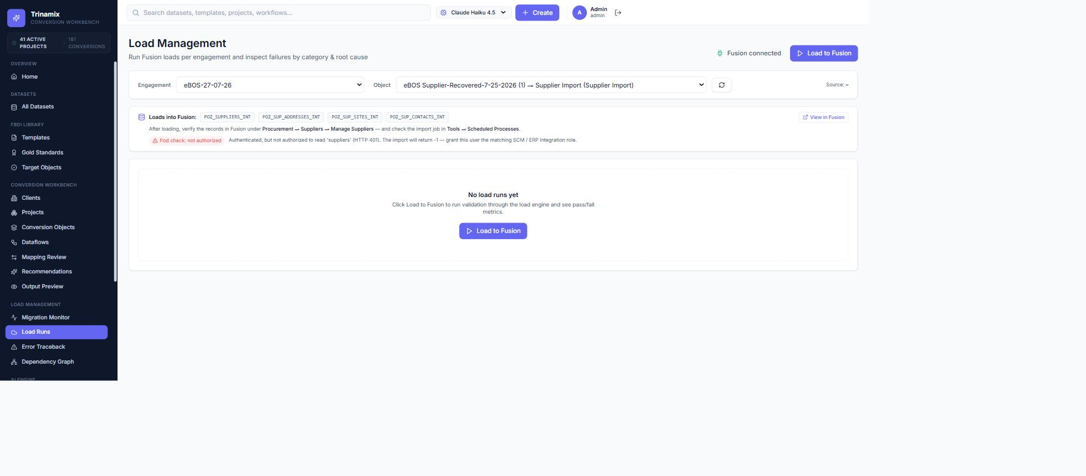
Reusable knowledge library
1. Open Gold Standards and Learning Center from the left navigation.
Expected: Approved mappings and gold-standard files are listed and reused on new conversions.
Screenshot: the Learning Center (or Gold Standards) list
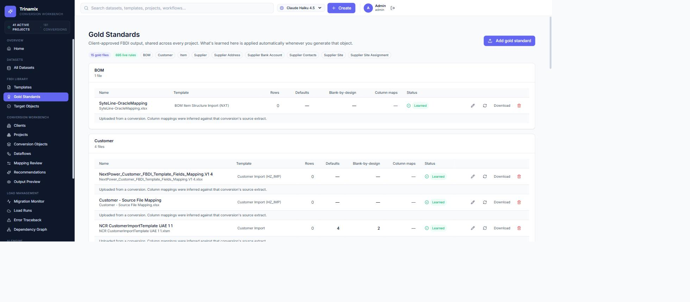

2. AI-powered features
Each AI feature is assistive and reviewable; if the AI service is unavailable the tool falls back to its built-in rules.
Auto-map fields (confidence — Issue #4) AI
1. In Mapping Review, click 'Run AI Mapping'.
2. Review the Confidence % column and the top suggestion per field.
Expected: Genuine matches show a meaningful confidence (e.g. a lifecycle-phase source column maps to Lifecycle Phase around 80%), while unrelated columns stay low.
Screenshot: the Mapping Review table showing the Confidence % column

Find duplicate records AI
1. Open a conversion and go to Output Preview.
2. Open the 'Duplicate suspects' tab.
3. Optionally click 'Adjudicate with AI'.
Expected: Groups of records that are likely the same entity (e.g. 'Acme Inc' vs 'ACME, Incorporated') with a confidence and the fields matched.
Screenshot: the Duplicate suspects tab with at least one group
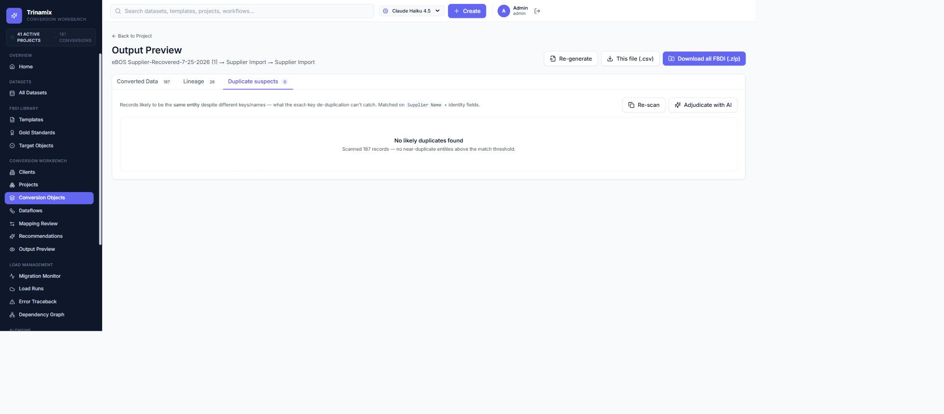
This sample was clean, so the scan reports no near-duplicates; suspected groups appear here when present, with 'Adjudicate with AI'.
Source data-quality review AI
1. Open a Dataset's detail page.
2. Open the 'Anomalies' tab.
3. Optionally click 'Explain risks with AI'.
Expected: Flags for nulls, mixed types, outliers, embedded units, casing variants, etc., each with severity, count and examples.
Screenshot: the Anomalies tab listing findings
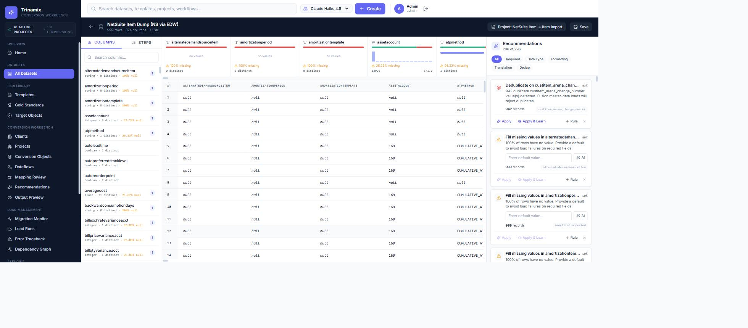
Per-column profiling flags missing %, distinct counts and type issues; the side panel proposes de-dup and fill rules.
Value crosswalks AI
1. In Mapping Review, select a mapped field.
2. Open the value-mappings panel and review the suggested legacy-value → Oracle-code pairs; accept one.
Expected: Legacy values are translated to valid Oracle lookup codes for that column.
Screenshot: the value-crosswalk panel with suggestions
Interactive — open a coded field's value panel (see 'Coded values (Oracle LOVs)' in Mapping Review) and capture during UAT.

Proven by other clients AI
1. Open a conversion's detail page.
2. Find the 'Proven by other clients' card and click Show suggestions.
Expected: Mappings/crosswalks other clients approved for the same object, ranked by how many clients use each.
Screenshot: the Proven by other clients card

The 'Proven by other clients' card; click 'Show suggestions' to list mappings other clients approved for this object.
Plain-English rules AI
1. In Mapping Review, open the rule author for a field.
2. Type an instruction in plain language (e.g. 'if status is X set it to Y') and generate the rule.
Expected: A structured transformation rule is drafted for you to confirm and save.
Screenshot: the rule author showing the drafted rule
Interactive — open the rule author on a field, type an instruction, and capture the drafted rule during UAT.

Draft data-quality rules AI
1. Open the Validation & Cleansing (Data Quality Rules) page.
2. Click 'AI suggest rules'.
Expected: Proposed cleansing and validation rules, for review and bulk-save.
Screenshot: the DQ Rules page with AI-suggested rules
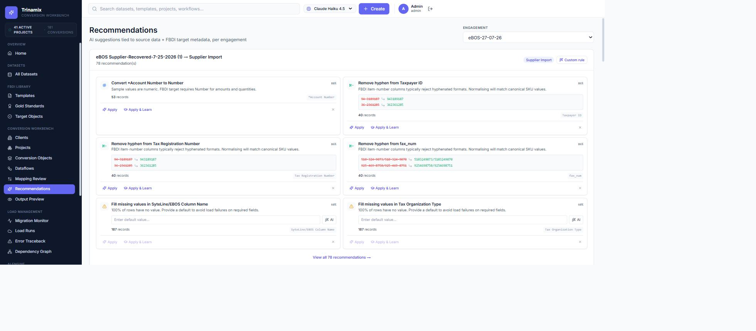
Ask the copilot AI
1. Open a conversion's detail page.
2. In the 'Ask the copilot' card, type a question or click a suggested one (e.g. 'which required fields are unmapped?').
Expected: A concise answer grounded in this conversion's data, with citations to where it came from.
Screenshot: the Ask the copilot card with a cited answer
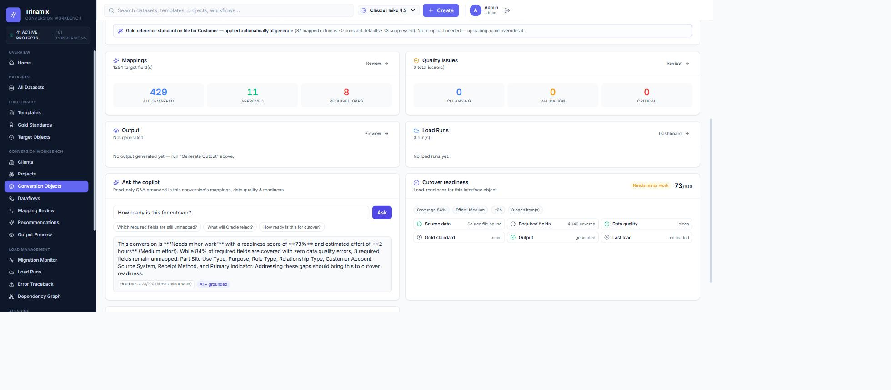
Draft a conversion plan (agentic) AI
1. Open Project Overview.
2. In the 'Agentic conversion plan (preview)' card, click Draft plan.
Expected: A per-interface plan (map → generate → validate) with blockers and the precedence layer for each step. Nothing runs until approved.
Screenshot: the Agentic conversion plan card with per-object steps
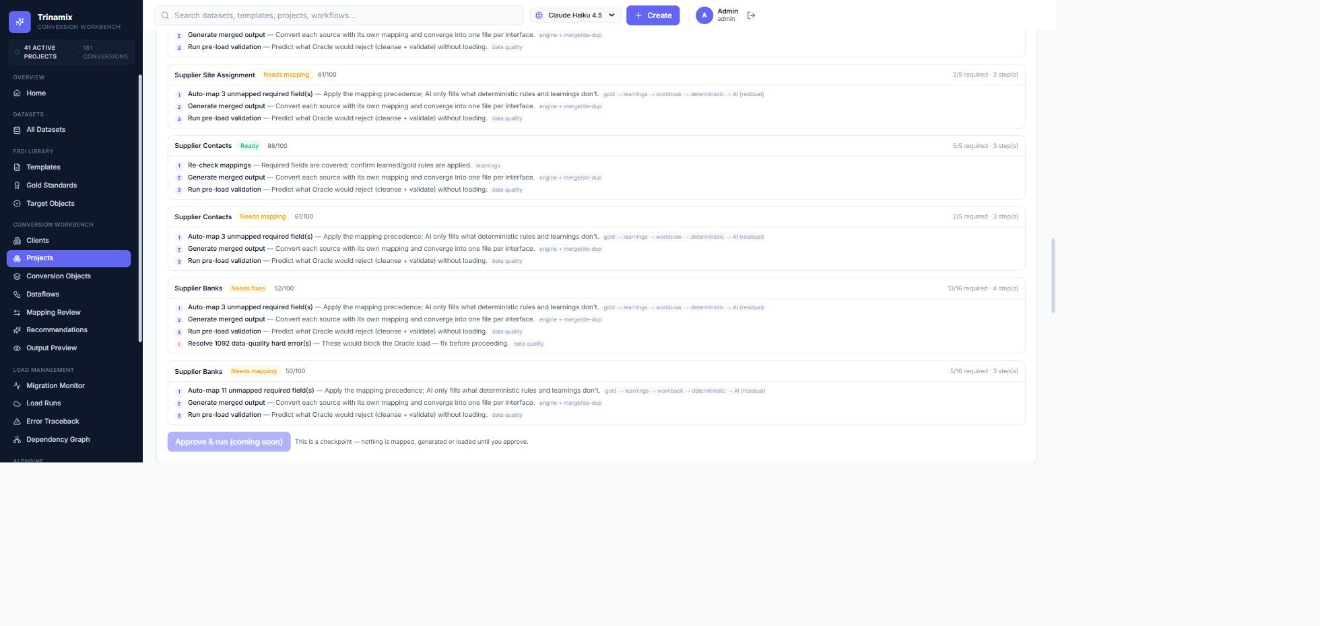
Explain load errors AI
1. Open a load run that produced Oracle rejections.
2. Click 'Explain errors'.
Expected: Each error is turned into a plain-English root cause and a concrete fix.
Screenshot: the load-error explanations
Requires a load run with Oracle rejections; capture the 'Explain errors' output during UAT.

