Trinamix Conversion Workbench
Legacy ERP to Oracle Fusion Cloud data conversion — architecture overview
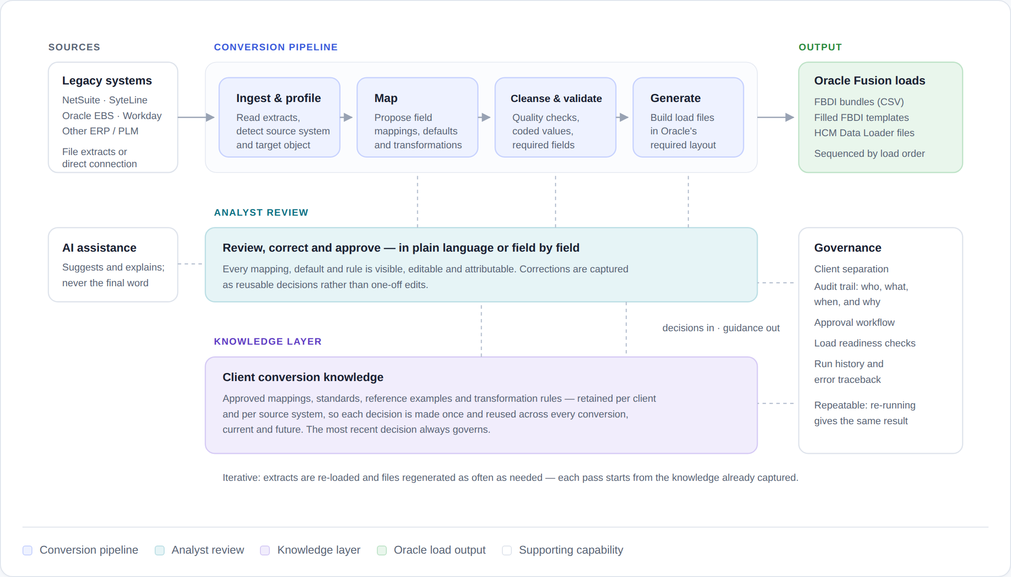
Conceptual overview. Component boundaries are indicative and do not represent deployment topology, data model or internal design.

How a conversion flows
Four stages, run and re-run as often as the data requires

Stage | What it does
Ingest & profile | Reads the legacy extract, detects which system it came from and which Oracle object it feeds.
Map | Proposes the field mapping, constant defaults and transformations for review.
Cleanse & validate | Applies data-quality checks, coded-value handling and required-field verification.
Generate | Builds the load files in the exact layout Oracle expects, in load-sequence order.
Two properties worth noting
Decisions are made once. A mapping, default or correction approved by an analyst is retained for that client and source system, and reused automatically across every conversion — current and future. Where decisions compete, the most recent one governs.
Runs are repeatable. Regenerating a conversion from the same inputs and the same decisions produces the same output, so a load can be rebuilt and reconciled with confidence.
Confidential — for client discussion only. · © Trinamix. All rights reserved.

