Connected Load Flow — Process Flow
Reading from a source database and loading straight into Oracle Fusion
This is the second way the Conversion Workbench moves data. Instead of exporting a file, mapping it, and loading the result by hand, the tool connects directly to the source database, pulls the data, converts it, and hands it to Oracle Fusion over its integration service. Oracle Fusion is the destination. Nobody touches a file in between.
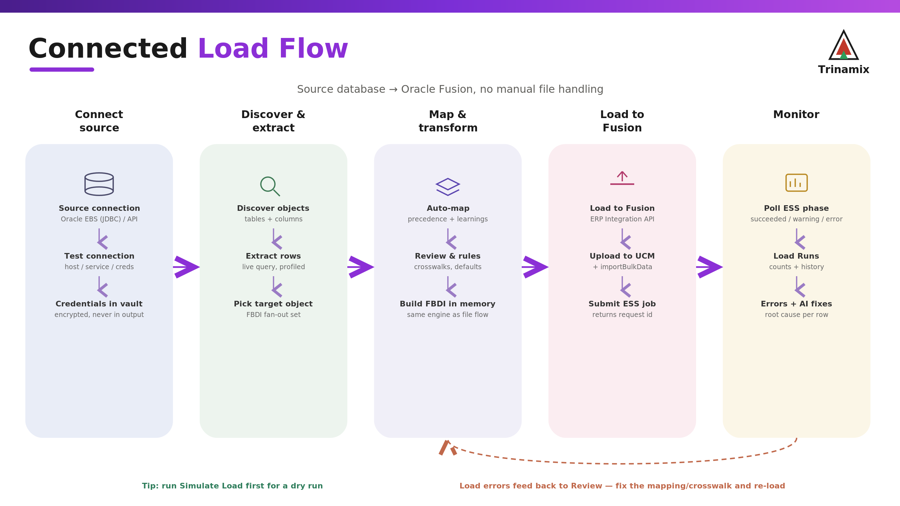
Source database to Oracle Fusion, with load errors feeding back to the mapping.

Stage 1 — Connect to the source
You set up a source connection once. For an Oracle EBS database that means the host, port, service name and a database account; the tool connects over JDBC. For a system that only exposes an API, such as NetSuite, you give it the base URL and the credentials it needs. The Test connection button proves it can reach the source before you rely on it. Credentials are stored encrypted and never appear in any output.

Stage 2 — Discover and extract
With a working connection, a discovery run asks the source what it holds. It reads back the available objects and their columns, and profiles them the same way an uploaded file would be profiled. From there you pick the Oracle object you are loading, and, as with the file flow, one source can feed a whole related set of objects. When mapping and generating, rows are read from the source live rather than from a stored file.

Stage 3 — Map and transform
This stage is the same engine the file flow uses. Each Oracle field is decided by the order of preference (golden record, learnings, mapping workbook, your rules, the deterministic matcher, defaults, then AI), you review and adjust in the canvas or table, and any value crosswalks, defaults or other rules are applied. The result is the FBDI data, built in memory rather than written to disk.

Stage 4 — Load into Oracle Fusion
You configure the Oracle Fusion connection once (its URL, a user, and a password). A quick preflight confirms the connection and that the target object is recognised. When you run Load to Fusion, the tool packages the converted data and calls Oracle's ERP Integration service: it uploads the file to UCM and submits the import job (importBulkData) in a single call. Oracle returns a request id, the tool records a load run against the conversion, and the conversion is marked as loaded.
Note. For a dry run, use Simulate Load instead. It validates the data and reports what would happen without submitting anything to Oracle.

Stage 5 — Monitor the load
A load in Oracle runs as a scheduled job, so the tool polls its phase and shows it as running, succeeded, warning or error. Each load run keeps its counts and history in the Migration Monitor and Load Runs screens. When rows fail, the tool captures them with the Oracle message, and adds a plain-English root cause and a suggested fix. From there the loop closes: you correct the mapping or crosswalk and load again.

How this compares to the file flow
 | File flow | Connected flow
Source | Uploaded Excel/CSV | Live database or API connection
Delivery | Download the FBDI zip | Pushed to Oracle via importBulkData
Oracle step | Load Interface File for Import, by hand | Submitted automatically, request id returned
Monitoring | Outside the tool | ESS phase, load runs and errors in the tool
The mapping, transformation and learning behaviour is identical across both. The connected flow only changes how the data comes in and how it goes out.

