Connected Load Flow — User Guide
Setting up source and destination connections and loading directly into Oracle Fusion
Use this flow when you would rather the tool read from the source system and write to Oracle Fusion itself, instead of exporting a file and loading it by hand. The steps below assume you already know the file-based workflow; the mapping and review part is the same, so most of this guide is about the two connections and the load.
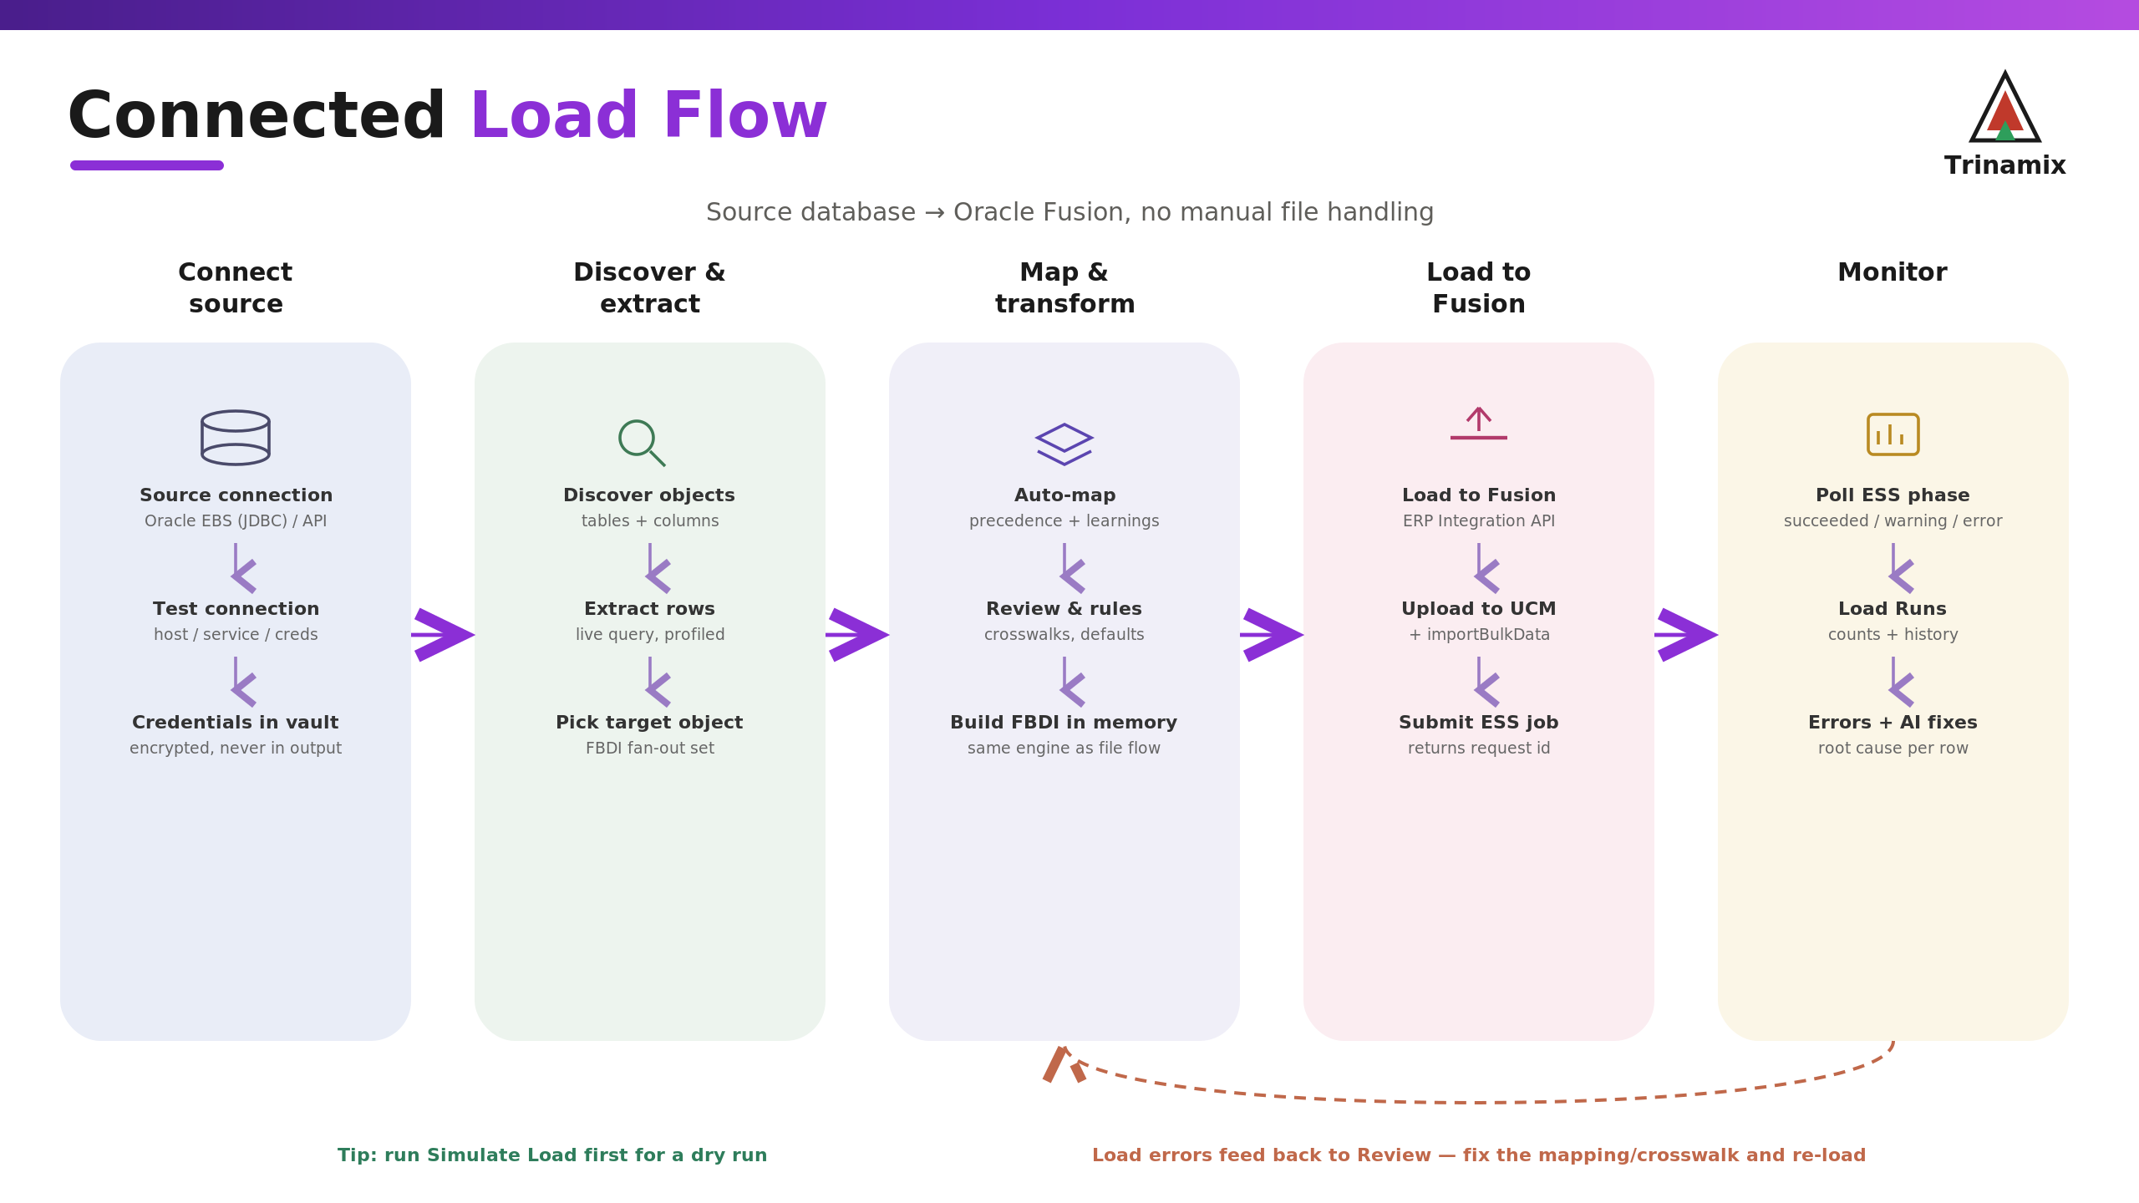
The connected load, end to end.

1. Set up the source connection
Open Source Connections and add one. Choose the system type. For an Oracle EBS database, enter the host, port, service name, and the database username and password. For an API system such as NetSuite, enter the base URL and the credentials it requires.
- Save the connection, then click Test connection. A green result means the tool reached the source; a red one shows the error so you can fix the host, port or credentials.
- Passwords are stored encrypted. They are used only to reach the source and never appear in any generated data.
Note. If you are just trying the flow and have no live database yet, a mock connection lets you walk through discovery without a real system.

2. Discover the source and extract
With the connection saved, start a discovery run. The tool connects, lists the objects and columns it finds, and profiles them. Pick the object you want to load; the tool proposes the matching Oracle FBDI object (and its related fan-out set where there is one). From here the data is read live from the source each time you map or load, so you are always working against current data.

3. Map and review
This is the ordinary Mapping Review screen. Run AI Auto Map, then check the result in the canvas or table, approve or override fields, pin fixed values, and add any crosswalks or rules the object needs. Everything you accept is saved as a learning, exactly as in the file flow, so the next run against this source needs less work.

4. Set up the Oracle Fusion connection
Open the Fusion connection settings and enter the environment URL, a user, and a password with rights to submit imports. Click Test to confirm the tool can reach it. You only do this once per Fusion environment.

5. Load into Oracle Fusion
- Optional but recommended: run Simulate Load first. It checks the data and shows what would happen, without sending anything to Oracle.
- When you are ready, click Load to Fusion. The tool builds the converted data, uploads it to Oracle's UCM, and submits the import job in one step. Oracle returns a request id, the conversion is marked as loaded, and a load run is recorded.

6. Watch the load and handle errors
Open Load Runs or the Migration Monitor to follow the job. The tool polls Oracle and shows the phase as running, then succeeded, warning or error, along with the row counts. If rows fail, open the run to see them: each carries Oracle's message plus a plain-English root cause and a suggested fix. Correct the mapping or crosswalk the fix points to, then load again. Because the fix is saved as a learning, the same error does not come back on the next run.

When something looks off
- Test connection fails. Recheck the host, port and service name for a database, or the base URL for an API, and confirm the account has access. The error text names the cause.
- Load to Fusion is refused. The Fusion connection is not configured, or its user cannot submit imports. Set the URL, user and password and test the connection first.
- The Oracle job stays in warning or error. Open the load run, read the per-row errors and their suggested fixes, correct the mapping, and re-load.
- You want to keep a copy of the file. The connected flow still lets you Generate and download the same FBDI zip; loading directly and downloading are not mutually exclusive.

The steps, in brief
Step | What you do | Where
Connect source | Add and test the source connection | Source Connections
Discover | Run discovery, pick the object | Source / Discovery
Map & review | Auto-map, approve, add rules | Mapping Review
Connect Fusion | Enter and test the Fusion connection | Fusion Connection
Load | Simulate, then Load to Fusion | Conversion
Monitor | Follow the run, fix errors, re-load | Load Runs / Migration Monitor

