Conversion Workbench — Features Overview
What the tool does, and how it is put together

In short
The Conversion Workbench converts legacy ERP and PLM master data into Oracle Fusion load files, FBDI for ERP objects and HDL for HCM, and keeps every analyst decision as a reusable rule so later conversions run with far less manual work. The diagram below shows how the pieces fit.
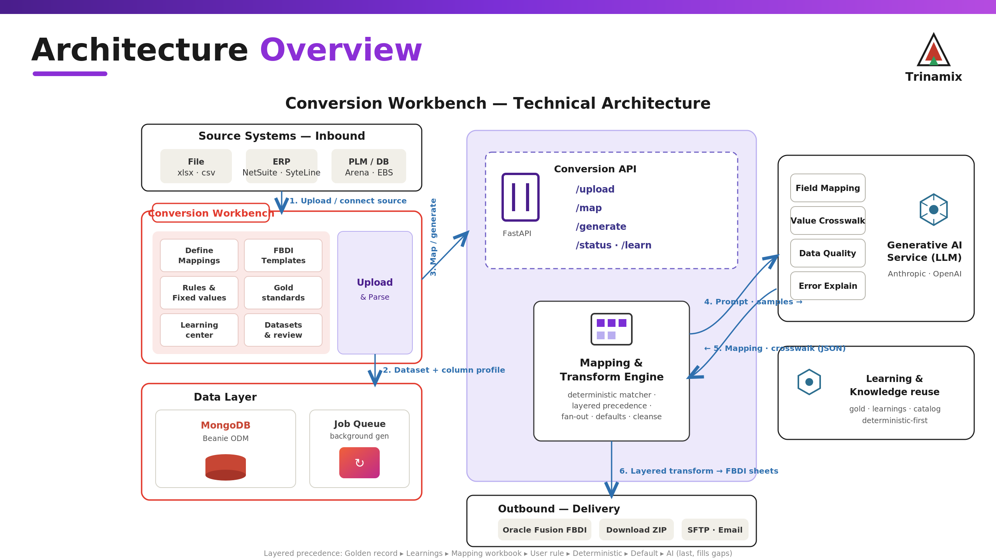
How the tool is put together.

Sources
- Excel and CSV files, including the messy exports real systems produce; the parser handles wrong file signatures, HTML-as-xls, UTF-16 and corrupt stylesheets.
- NetSuite, Infor SyteLine, Arena/eBOS (EBOS, Ratana Lee, Anaplan), Workday and Salesforce.
- Direct database and Oracle EBS connections, with synonym and view resolution.
- Column profiling on upload (type, distinct count, fill rate, samples), stored so it survives a restart.

What it produces
- Oracle Fusion FBDI: one CSV per interface sheet, zipped, in the template's column order and with Oracle's exact headers.
- Oracle HCM HDL (.dat) for HCM objects.
- The full multi-sheet set per object: Customer (19 sheets), Item / Product Hub (17 sheets), Supplier (6 objects), and others.
- One source file can produce a whole related object set in a single pass.

Mapping
- A fixed order of preference: golden record, learnings, mapping workbook, your rules, the deterministic matcher, defaults, and AI last.
- A deterministic matcher that reads column names, a synonym dictionary, field descriptions, the actual values against the target list, sample patterns and data types, so most fields never reach the AI.
- AI only for the leftover fields, batched with samples and a confidence score; the model is selectable to manage cost.
- On large objects the AI pass is skipped, and the deterministic and learned layers do the work.
- Ranked alternative source columns offered for each field.

Transformations
- Value crosswalks (for example Approved becomes SPEND_AUTHORIZED).
- Conditional logic on a source column (Email Transactions = Yes becomes EMAIL).
- Phone and fax splitting into country, area, number and extension.
- Boolean mapping, conditional dates, concatenation, coalesce, prefix/suffix, date reformatting and computed values.
- Fixed constants pinned into a field for every row.

The knowledge base
- Rules are stored as column mappings, field suppressions, default values, do-not-map flags and reference standards.
- They are scoped to a client, or marked global when they describe a source system rather than one engagement.
- Approvals, gold-verified values, fixed values and rules are captured automatically.
- Stored rules apply ahead of AI on the next matching conversion.
- The Item and Supplier analyst mapping documents are already loaded as rules, value crosswalks included.
- The Rule Library and Crosswalk Library let you read and edit them; noisy source columns can be flagged as do-not-map so AI leaves them alone.

Gold standards and steering
- Upload a known-good output and the tool reads its mappings, defaults and blank fields and applies them at generate.
- Gold files can be kept in a shared library without a project, uploaded several at a time.
- A typed instruction can nudge a mapping in plain English.

Coded values
- Each field's allowed values and lookup type are read from the FBDI template.
- The tool reports how many source values resolve against the target list, by exact match, meaning, synonym or fuzzy match.
- Lookup codes can be imported and crosswalks managed; coded columns that still need attention are flagged before you generate.

Data quality
- Legacy placeholders (NULL, N/A, NONE) are cleared to empty cells.
- Dates are normalised to Oracle's YYYYMMDD.
- Hyphens are preserved in item numbers, class codes and part numbers.
- AI can flag data-quality problems, suggest cleansing, and explain load errors with a fix.
- Validation and Simulate Load run before the real load.

Generation
- Runs in the background with a live status, so large loads do not time out.
- Writes one sheet at a time to keep memory flat on wide files.
- Fills only the sheets that carry real data and leaves the optional ones as empty headers.
- Produces a CSV zip quickly, with an XLSX option, and can bundle a whole object set for download.
- Repairs a conversion that is on the wrong template automatically, at mapping time.

The review screen
- A drag-to-map canvas and a table view, with a bar showing which layer decided each field.
- Fields that repeat across interface sheets carry their sheet name so the copies are distinct.
- Fixed-value, override, custom-rule and reset-default controls on each field.
- A suggestions panel with Apply and Apply & Learn.
- The highest-priority mapping per field wins, so a rejected mapping never exports as a suggestion.

Environments and platform
- DEV, QA, UAT and PROD with promotion between them.
- Migration Monitor, Load Runs, Error Traceback and a Dependency Graph for the load sequence.
- Dataset management (delete, replace, cascade) and a new-engagement flow for file or database sources.
- Built on FastAPI with MongoDB and GridFS, a React and TypeScript front end, hosted on Render, with seeders that run on startup.

Still to come
- Extensible Flexfields for Item. Most of NextPower's item attributes load as EFF rather than standard columns; the design is written up and waiting on the client's flexfield configuration export.
- Supplier value crosswalks for Tax Organization Type and Supplier Type, once the real source values are available.

