Conversion Workbench — Process Flow
How a source extract becomes an Oracle Fusion load file
A source extract goes in on the left and a load-ready Oracle file comes out on the right. The five stages are shown below; the thing to notice is the loop back from the end to the mapping stage, which is how corrections you make on one run help the next one.
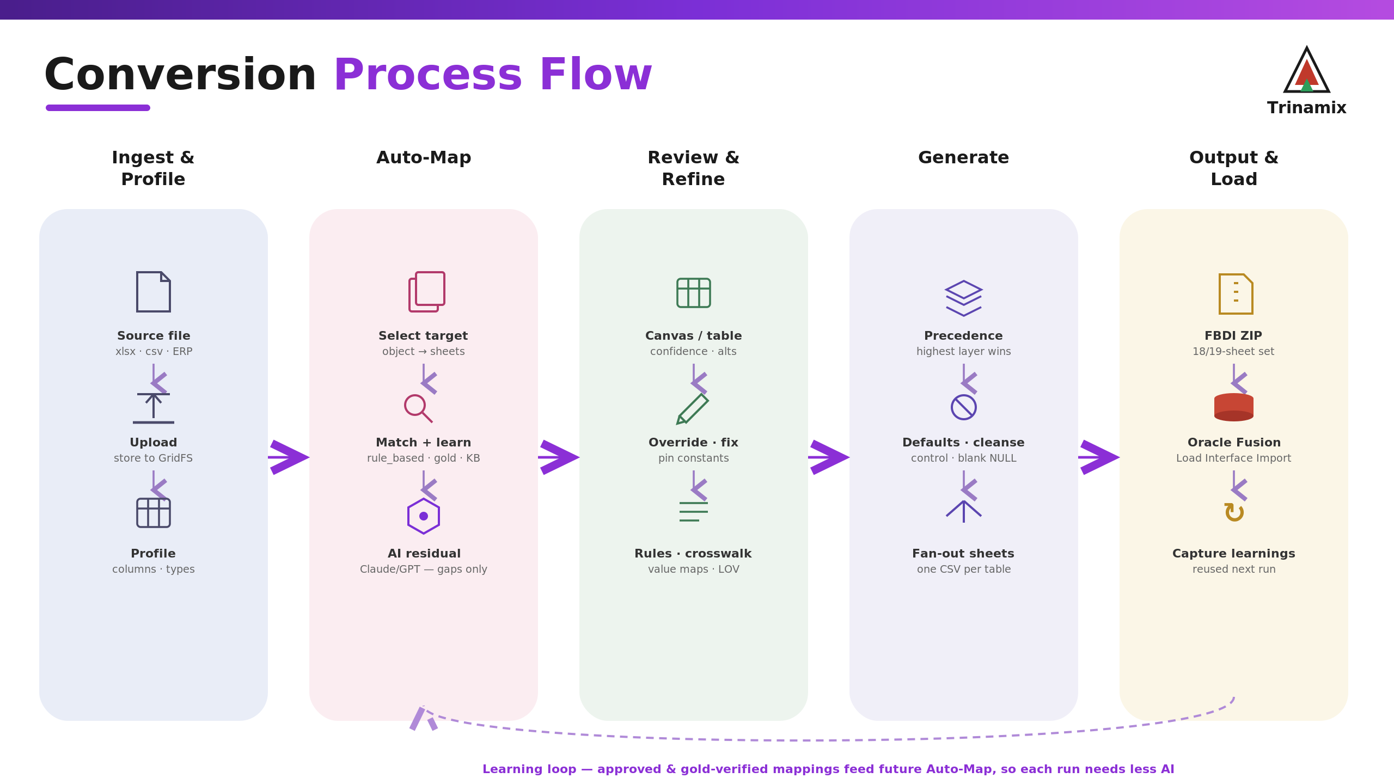
The five stages, with the learning loop underneath.

Stage 1 — Bring in and profile the source
The input is a source file (Excel or CSV) or a live database/EBS connection. Uploaded files are kept durably; database sources are queried on demand. The parser copes with the state real exports arrive in, including files that lie about their type, HTML saved as xls, UTF-16, and broken stylesheets. Every column is profiled for its type, distinct count, fill rate and a few sample values. Finally you choose the Oracle object; one dataset can fan out to a whole related set, for example Supplier plus its Address, Site, Site Assignment, Contacts and Bank objects.

Stage 2 — Map
With the source columns and the object's fields in hand, the tool decides each field by working down a fixed order of preference and taking the first layer that has an answer: a golden record, then stored learnings, then the analyst mapping workbook, then any rules you wrote, then the deterministic matcher, then a standard default, and last of all AI. Because AI only sees what the earlier layers could not place, most runs make very few AI calls, and none at all once enough learnings have accumulated. On the largest objects the AI pass is skipped entirely. If the conversion happens to be sitting on a flat, single-sheet template, this stage quietly moves it onto the real multi-sheet one first.

Stage 3 — Review and refine
A reviewer works through the canvas or the table, approving or rejecting suggestions, swapping in a different source column, pinning a fixed value, or attaching a transformation such as a value crosswalk, a phone split, or a conditional date. AI suggestions can be taken with Apply, or with Apply & Learn to keep them. A gold file or a typed instruction can steer the whole mapping. Everything accepted here becomes a reusable rule.

Stage 4 — Generate
Generation reads the approved mapping and the source data and writes the file row by row. It applies each transformation, clears legacy placeholders like NULL and N/A to empty cells, formats dates as YYYYMMDD, and adds the control constants and defaults. The output is one CSV per interface sheet, in the template's column order and with Oracle's exact headers, zipped together; child sheets are left as empty headers unless a real source column feeds them. It runs as a background job, so even a large load never hits the gateway timeout.

Stage 5 — Output and load
Validate or simulate the load in the tool, download the zip, and run it through Oracle Fusion's Load Interface File for Import. The conversion is then promoted through DEV, QA, UAT and PROD, with the history kept in Migration Monitor and Load Runs.

The learning loop
Approvals, gold-verified values, fixed values and rules are all stored as learnings, scoped to the client or marked global when they are really about a source system. They come back into the mapping stage on the next run at the learnings layer, which is why the tool leans on AI less and needs less review the longer an engagement goes on.

Two rules worth remembering
Check the file you download, not the preview, because the preview does not run the final control-default pass. And regenerate after any deployment, because a redeploy clears the previously generated files.

