Conversion Workbench — User Guide
Turning legacy ERP and PLM data into Oracle Fusion load files

What the tool is for
The Conversion Workbench takes a data export from an old system and turns it into a file Oracle Fusion can load. You point it at an extract from NetSuite, Infor SyteLine, Arena/eBOS, Workday, Anaplan, Salesforce, or a database. It works out which source column belongs in each Oracle field, fills in the codes and defaults Oracle expects, and hands back the FBDI zip (or an HDL .dat file for HCM objects).
The part that saves time is the memory. Anything you correct is kept as a rule, so the next file from the same system needs far less attention than the first.
There are five steps: bring in the source, let the tool map it, check the mapping, generate the file, and load it into Oracle. The diagram below shows the whole run.
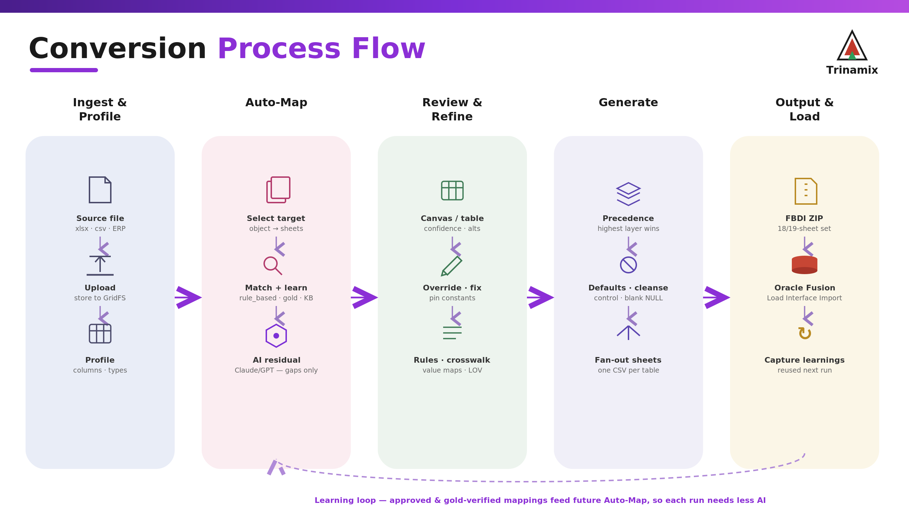
The conversion run, start to finish.

Before you start
Sign in, and take a moment with the layout. The bar at the top has a model picker (Haiku, Sonnet or Opus) that decides which AI model handles the leftover mappings; the default is fine unless you are deliberately trading cost against quality. Down the left are the areas you will use: Datasets and the FBDI Library for your sources and templates, the Conversion Workbench itself (Projects, Conversion Objects, Mapping Review, Output Preview), Load Management for tracking loads, and the AI Engine (Learning Center, Rule Library, Crosswalk Library) where the reusable rules live.
A few words come up a lot. A project groups the conversions for one client. A dataset is a source file that has been read and profiled. A conversion is one dataset pointed at one Oracle object. A learning is a rule the tool has kept, such as a column mapping or a default, that comes back automatically next time.

Step 1 — Bring in the source
Start a conversion from the Create button or from inside a project, and say whether the source is a file or a database connection. Upload the file and the tool reads it, records the type, fill rate and a few sample values for every column, and keeps a durable copy. Then pick the Oracle object you are loading, for example Supplier Import or Item Import. A single file can feed several related objects at once.
Note. Check the Source Dataset panel before you go further. The row and column count (for example 2,662 x 58) is the quickest way to confirm you have the right extract. If it is the wrong file, use Replace.

Step 2 — Let the tool map it
Click AI Auto Map. For every Oracle field the tool decides on a source column, a constant, or a rule, and it works through a fixed order of preference so the most trustworthy answer wins:
golden record, then learnings, then the mapping workbook, then your own rules, then the deterministic matcher, then a standard default, and only then AI.
AI is the last resort, used only for the fields nothing else could place. On the big objects (Item has about 1,365 fields, Customer around 1,250) most fields are settled deterministically or from earlier learnings, and the AI pass is skipped so the run stays quick. When it finishes you get a tally: how many were auto-mapped, approved, still open, learned, or pulled from the knowledge base.

Step 3 — Check the mapping
This is where you review and fix. There are two views. The canvas puts source columns on the left and Oracle fields on the right and lets you drag a connection between them; a field that exists on more than one interface sheet, such as Item Number (the key that ties every item table together), carries its sheet name so you can tell the copies apart. The table view is a plain list with the confidence, status and chosen value for each field.
On any field you can approve or reject what the tool proposed, point it at a different source column, or pin a fixed value into every row when the value is something you maintain by hand (a country code, or a constant like CORPORATION). You can also attach a transformation, for example a value crosswalk, a phone-number split, or a conditional date. If a gold file baked in a constant that is wrong for this client, clear it with Reset gold defaults.
The panel on the right offers suggestions as you go: crosswalks for coded fields, defaults for required fields that have no source, and hints where the same thing is mapped twice. Apply takes the suggestion; Apply & Learn also saves it so it comes back next time. If you have a known-good output, upload it under Learn from example and the tool will read the mappings, defaults and blanks straight out of it, or you can just type an instruction in plain English.

Step 4 — Generate the file
Generate Output builds the file in the background, so a large load never trips the connection timeout. As it writes, it applies each mapping and transformation, clears out legacy placeholders like NULL and N/A so they load as empty cells, puts dates into Oracle's YYYYMMDD format, and drops in the control constants and defaults. The result is one CSV per interface sheet, zipped, with the columns in the order Oracle expects and the exact headers from the template. Only the sheets that actually carry data are filled; the optional child sheets stay as empty headers unless a real source column feeds them, which is how a hand-filled template looks anyway.
Note. Two habits save a lot of confusion. Check the file you download, not the on-screen preview, because the preview skips the last pass that writes the control defaults. And regenerate after every deployment, since a redeploy clears whatever was generated before.

Step 5 — Load it into Oracle
Download the zip (or the .dat for HCM) and run it through Oracle Fusion's Load Interface File for Import process. It is worth running Validation or Simulate Load in the tool first, so you catch the obvious data problems before the real load.

Environments
A conversion moves through DEV, QA, UAT and PROD. Promote to environment advances one that has passed, and Migration Monitor and Load Runs keep the history.

Why it gets faster over time
Every approval, gold-verified value, fixed value and rule you set is written to the Learning Center as a reusable rule, tied to the client (or marked global when it is really knowledge about a source system). The next file from that system arrives with those rules already applied, so there is less to review each time. The Rule Library and Crosswalk Library let you look at and edit them directly.

When something looks off
- The output is one flat CSV instead of the full set of sheets. The conversion is on the wrong template. Run AI Auto Map, which moves it onto the real multi-sheet template, then generate again.
- A mapped field comes out blank or shows an old value. Regenerate (a deploy wipes the previous output) and check the downloaded file rather than the preview.
- A field shows the raw source value instead of the converted one. The rule was added after the last mapping run. Re-run AI Mapping, then generate.
- The same field shows up several times in the canvas. Those are the per-sheet keys (Item Number on each interface table). They now carry their sheet name so you can tell them apart.
- Oracle rejects a coded value. Open the Crosswalk Library and confirm the source value maps to the right Oracle code.

The five steps, in brief
Step | What you do | Where
Bring in the source | Upload or connect, pick the Oracle object | Create / Datasets
Map it | Run AI Auto Map | Conversion / Mapping Review
Check it | Approve, override, fixed values, rules, crosswalks | Mapping Review
Generate | Generate Output (runs in the background) | Conversion / Output Preview
Load | Download the zip, run Load Interface for Import | Conversion / Load Management

