Trinamix Conversion Workbench
Hosting & Infrastructure Specification
Prepared for the Database Administration and Infrastructure teams
Target: corporate cloud subscription (Microsoft Azure, AWS or Oracle Cloud Infrastructure)
Document version 1.0 — 30 July 2026
Prepared by the Conversion Workbench development team. Every figure here is taken from the repository or from a measured run; nothing is estimated unless it says so.

1. What this application is
The Conversion Workbench is an internal data-migration tool. It reads extracts from legacy ERP systems (NetSuite, Infor SyteLine, Arena eBOS and optionally Oracle EBS), applies mapping and transformation rules, and produces Oracle Fusion Cloud load files — FBDI workbooks and HCM Data Loader .dat bundles. Those files reach Fusion by one of two paths, described in §4.1.
It is not a transaction system and it is not customer-facing. Load is bursty and human-paced — a handful of analysts generating files during a migration cycle, not continuous traffic.

Why this matters for sizing
- Traffic to Oracle Fusion is outbound only, and only on the direct-load path. There is no inbound path from Fusion.
- Legacy extracts arrive as files uploaded through the browser. There is no scheduled feed.
- The workload is CPU- and memory-bound during file generation, and close to idle otherwise.
- Availability requirement is business-hours. This is not a 24/7 tier-1 service.

2. Architecture at a glance
The next page shows the target deployment. Every version, port and path in it was taken from the repository — Dockerfiles, render.yaml, app/config.py — not from recollection.
Layer | What it is
Presentation | Single-page React application, served as static files by nginx. No server-side rendering, no session state.
Application | FastAPI (Python 3.12) under uvicorn. Stateless — any replica can serve any request.
Data | MongoDB. 43 collections plus a GridFS bucket that holds the durable copy of every uploaded source file.
Files | A shared read-write-many volume for working files. It is a cache, not the system of record — see §6.
Egress | Outbound HTTPS to the Oracle Fusion pod (direct-load path) and, optionally, to an AI provider. Both are outbound only.

Target deployment architecture
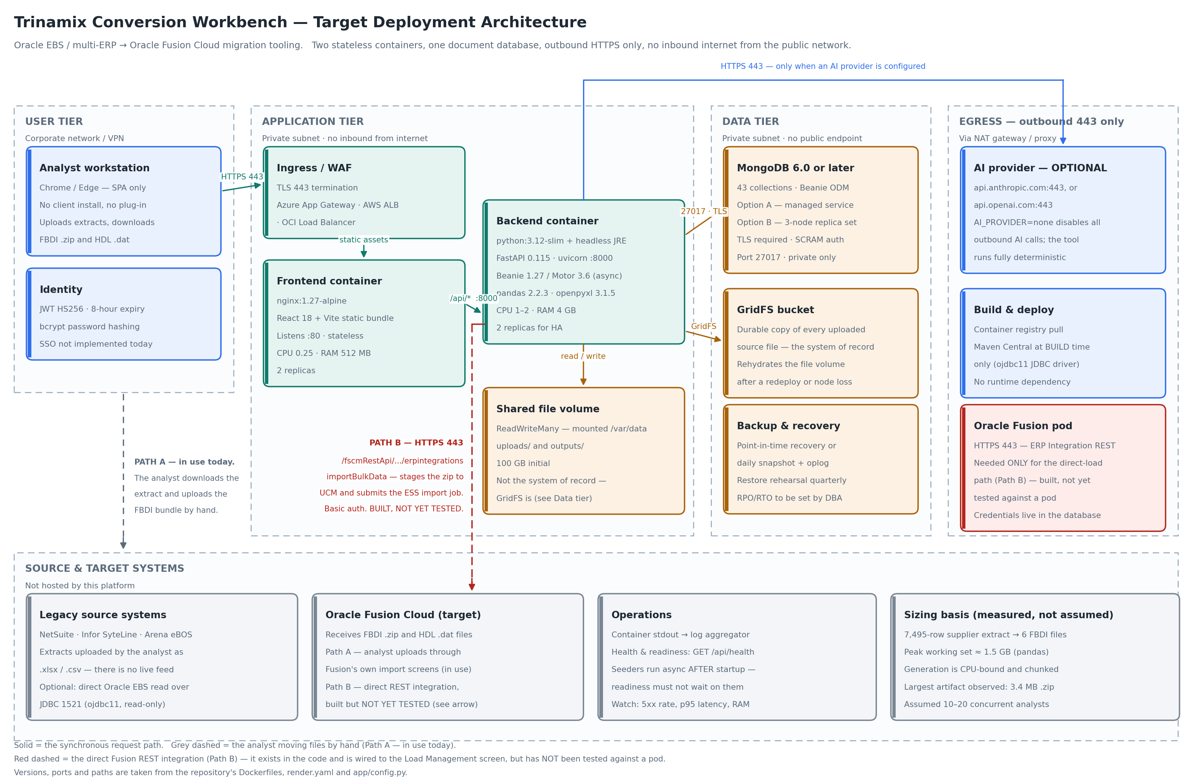

3. Component inventory
Component | Base image / runtime | Listens on | State
Frontend | nginx:1.27-alpine | TCP 80 | Stateless. Static bundle only.
Backend | python:3.12-slim  + default-jre-headless | TCP 8000 | Stateless. Writes to the shared volume and to MongoDB.
Database | MongoDB 6.0 or later | TCP 27017 | Stateful. The system of record.
File volume | RWX block or file share | n/a | Stateful but reconstructible from GridFS.
The Java runtime in the backend image is there only for the Oracle JDBC driver (ojdbc11), used when an analyst points the tool at an Oracle EBS database directly. If that feature is not in scope for your rollout, the JRE and the driver can be dropped from the image.

4. Network and firewall requirements
This is the complete list. Anything not on it is not needed.
Source | Destination | Port | Purpose
Analyst workstation  (corporate network / VPN) | Ingress / load balancer | 443/tcp | The only inbound path. TLS terminates here.
Ingress | Frontend container | 80/tcp | Static assets.
Ingress | Backend container | 8000/tcp | All /api/* traffic.
Backend container | MongoDB | 27017/tcp | Application data. TLS required.
Backend container | Oracle Fusion pod  (*.oraclecloud.com) | 443/tcp | ERP Integration REST. Required for the direct-load path — see §4.1.
Backend container | api.anthropic.com  or api.openai.com | 443/tcp | OPTIONAL — only when AI_PROVIDER is set. Omit the rule to disable.
Backend container | Oracle EBS database | 1521/tcp | OPTIONAL — direct source read. Read-only account.
Build agent | Container registry  Maven Central | 443/tcp | Build and deploy time only. No runtime dependency.

Not required
- No inbound access from the public internet to any component.
- No SMTP or email relay. The application sends no mail.
- No message broker, queue or scheduler.
- No shared filesystem mounted to any other corporate system.
- No inbound path from Oracle Fusion. The integration is outbound only — the application calls Fusion, never the reverse.

4.1 How files reach Oracle Fusion
There are two paths, and the distinction matters to whoever writes the firewall rule.
Path | Detail
A — manual  (in use today) | The analyst downloads the generated bundle and uploads it through Fusion's own import screens. No connectivity from this application is needed.
B — direct load  (BUILT, NOT YET TESTED) | The application calls the Fusion ERP Integration REST service at /fscmRestApi/resources/11.13.18.05/erpintegrations, using importBulkData: it stages the FBDI zip to UCM and submits the ESS import job in one call. There is also a Test Connection check against the same API. Authentication is HTTP basic.
Path B is written, wired to the Load Management screen and covered by the object-to-ESS-job metadata for twenty business objects — but it has not been exercised against a real pod. Treat it as functionality that exists and is unproven, not as a plan. If you would rather not open the rule until it has been tested, the application is fully usable on Path A in the meantime.
The Fusion service account needs the SCM / ERP Integration privileges for the objects being loaded. The Test Connection check distinguishes unreachable, authenticated-but-unauthorised, and module-not-provisioned, so a misconfigured account is diagnosable before a load is attempted.

5. Compute sizing
The figures below come from measured behaviour on a real supplier migration: a 7,495-row NetSuite extract expanded into six FBDI workbooks across 3,872 suppliers.
Component | vCPU | Memory | Replicas | Notes
Frontend | 0.25 | 512 MB | 2 | Trivial load. Two replicas for rolling deploys, not capacity.
Backend | 1–2 | 4 GB | 2 | Peak working set is roughly 1.5 GB during generation. 4 GB gives headroom for two concurrent jobs per replica.
MongoDB | 2 | 8 GB | 3 (replica set) | Or the equivalent managed tier. See §7.

Scaling behaviour
- Generation is CPU-bound and processes rows in chunks, so memory stays bounded as extracts grow.
- Horizontal scaling of the backend is safe: replicas share nothing except MongoDB and the file volume.
- If a single extract ever exceeds roughly 100,000 rows, raise backend memory before adding replicas.

6. Storage
Item | Requirement
Shared volume | ReadWriteMany, mounted at /var/data. Azure Files, AWS EFS or OCI File Storage are all suitable. 100 GB is a comfortable start.
Contents | /var/data/uploads (source extracts) and /var/data/outputs (generated FBDI and HDL bundles).
Durability | The volume does NOT need to be backed up. Every uploaded file also lives in MongoDB GridFS, and the application rehydrates the volume from GridFS automatically after a redeploy or node loss.
Growth | Roughly the size of the extracts plus the generated bundles. The largest artifact observed to date is a 3.4 MB zip.
This is worth stating plainly to avoid over-engineering: the file volume is a working cache. Losing it costs regeneration time, not data.

7. Database — for the DBA team
MongoDB is the system of record. Both hosting options below are supported by the application without any code change; the only difference is the connection string.

7.1 Option A — managed service
Aspect | Detail
Candidates | MongoDB Atlas, Azure Cosmos DB for MongoDB (vCore), or AWS DocumentDB. Atlas is the reference platform and the one currently in use.
Sizing | M10 equivalent or above: 2 vCPU, 8 GB RAM, 40 GB storage.
Networking | Private endpoint or VNet/VPC peering. Do not expose a public endpoint.
Advantages | Backup, patching, failover and monitoring are handled by the provider. Lower operational load on the DBA team.
Watch out for | Cosmos and DocumentDB are API-compatible rather than identical. Confirm GridFS support and aggregation coverage before committing.

7.2 Option B — self-hosted, DBA-managed
Aspect | Detail
Topology | Three-node replica set. One primary, two secondaries, majority write concern.
Version | MongoDB 6.0 or later. WiredTiger storage engine.
Sizing | 2 vCPU, 8 GB RAM, 100 GB SSD per node to start.
Security | TLS in transit, SCRAM authentication, a dedicated application user scoped to one database. Encryption at rest per corporate standard.
Backup | Point-in-time recovery, or a daily snapshot plus oplog. RPO and RTO to be set by the DBA team — the application has no opinion.
Advantages | Full control, data stays inside the corporate estate, no third-party processor.

7.3 What the application does to the database
Item | Detail
Database name | conversion_workbench (configurable via MONGODB_DB).
Collections | 43. Created automatically on first startup.
Indexes | Declared in the application models and created by the ODM at startup. No manual DDL is required, and none should be applied by hand.
GridFS | One bucket holding a durable copy of each uploaded source file. This is the largest consumer of storage.
Access pattern | Read-heavy. Writes are small and bursty, concentrated when an analyst approves mappings or generates output.
Transactions | Not used. The application does not require a multi-document transaction.
Connection | Async driver (Motor 3.6) with the default pool. A single connection string is the only configuration.
Data volume | Modest. Tens of thousands of documents per migration project, not millions.
One operational note that matters at startup: the application runs a set of idempotent seeders in the background AFTER it reports ready. They parse template workbooks and can take a minute or two. Readiness probes must not wait on them, and a restart during seeding is safe.

8. Configuration
All configuration is environment variables. Nothing is read from a config file at runtime.
Variable | Required | Purpose
MONGODB_URI | Yes | Connection string. Hold it in a secret store, not in the deployment manifest.
MONGODB_DB | No | Database name. Defaults to conversion_workbench.
JWT_SECRET | Yes | Signing key for session tokens. Generate per environment; rotating it logs everyone out.
DATA_DIR | Yes | Mount path of the shared volume. Set to /var/data.
ADMIN_EMAIL  ADMIN_PASSWORD | Yes | Seeds the first administrator on an empty database. Change the password immediately after the first deployment.
AI_PROVIDER | No | none, anthropic or openai. Defaults to none, which disables all outbound AI calls.
ANTHROPIC_API_KEY  OPENAI_API_KEY | No | Only when AI_PROVIDER is set. Hold in a secret store.
FRONTEND_ORIGIN | Yes | Allowed CORS origin — the public URL of the frontend.
FERNET_KEY | Yes, if  Path B or the  EBS reader  is used | Encryption key for stored connection credentials. IF IT IS NOT SET, credentials are written to the database in plaintext with a PLAIN: prefix. See §10.

9. Deployment and operations
Topic | Detail
Packaging | Two container images, built from the Dockerfiles in the repository. Any container platform will do: AKS, EKS, OKE, Azure Container Apps, ECS or plain Docker Compose for a pilot.
Health and readiness | GET /api/health returns 200 when the process is serving. Use it for both probes.
Startup | Background seeders run after readiness is reported. Give the container a generous liveness grace period on first boot against an empty database.
Rolling updates | Safe. The backend is stateless and holds no in-memory session.
Logging | Structured output to stdout. Forward to the corporate log platform.
Metrics to watch | 5xx rate, p95 request latency, backend container memory during generation.
Backup scope | MongoDB only. The file volume is reconstructible.
Disaster recovery | Restore MongoDB, redeploy both containers, point them at the restored database. The file volume repopulates itself on demand.

10. Security posture
- Authentication is username and password with JWT session tokens (HS256, eight-hour expiry). Passwords are bcrypt-hashed.
- Single sign-on is not implemented. If corporate SSO is mandatory, raise it before rollout — it is a development item.
- It stores supplier, customer, item and employee master data. Classify the database as you would the source ERP.
- Employee HDL conversions may include personal data. Confirm the retention policy for the file volume and GridFS with your data-protection owner.
- Connection credentials for Oracle Fusion and Oracle EBS are stored IN THE DATABASE, not in the environment. They are encrypted with Fernet only when FERNET_KEY is set; without it they are written as plaintext with a PLAIN: prefix. Set FERNET_KEY before anyone saves a connection.
- Application secrets other than those — the Mongo URI, the JWT signing key, AI keys — are read from the environment and never written to disk.
- When AI_PROVIDER is set, column names and sample values go to the provider for mapping suggestions. If policy forbids that, leave it at none — every deterministic feature still works.

11. Open items for the receiving teams
# | Question | Owner
1 | Managed MongoDB or self-hosted replica set? Section 7 sets out both. | DBA
2 | RPO and RTO targets for the database. | DBA
3 | Is outbound HTTPS to an AI provider permitted? If not, we deploy with AI_PROVIDER=none. | Security / Infra
4 | Is corporate SSO mandatory for internal tools? It is not implemented today. | Security
5 | Which container platform is preferred, and is a ReadWriteMany volume available on it? | Infra
6 | Is direct Oracle EBS connectivity in scope? If not, the JRE and JDBC driver leave the image. | Infra / Apps
7 | Retention policy for uploaded extracts and generated bundles. | Data protection
8 | Open the outbound 443 rule to the Fusion pod now, or wait until the direct-load path has been tested? | Infra / Apps
9 | Provision FERNET_KEY as a managed secret before any Fusion or EBS connection is saved. | Infra / Security
10 | Which Fusion service account, and does it hold the SCM / ERP Integration roles for the objects in scope? | Apps / Security

