**Subrota Debnath**

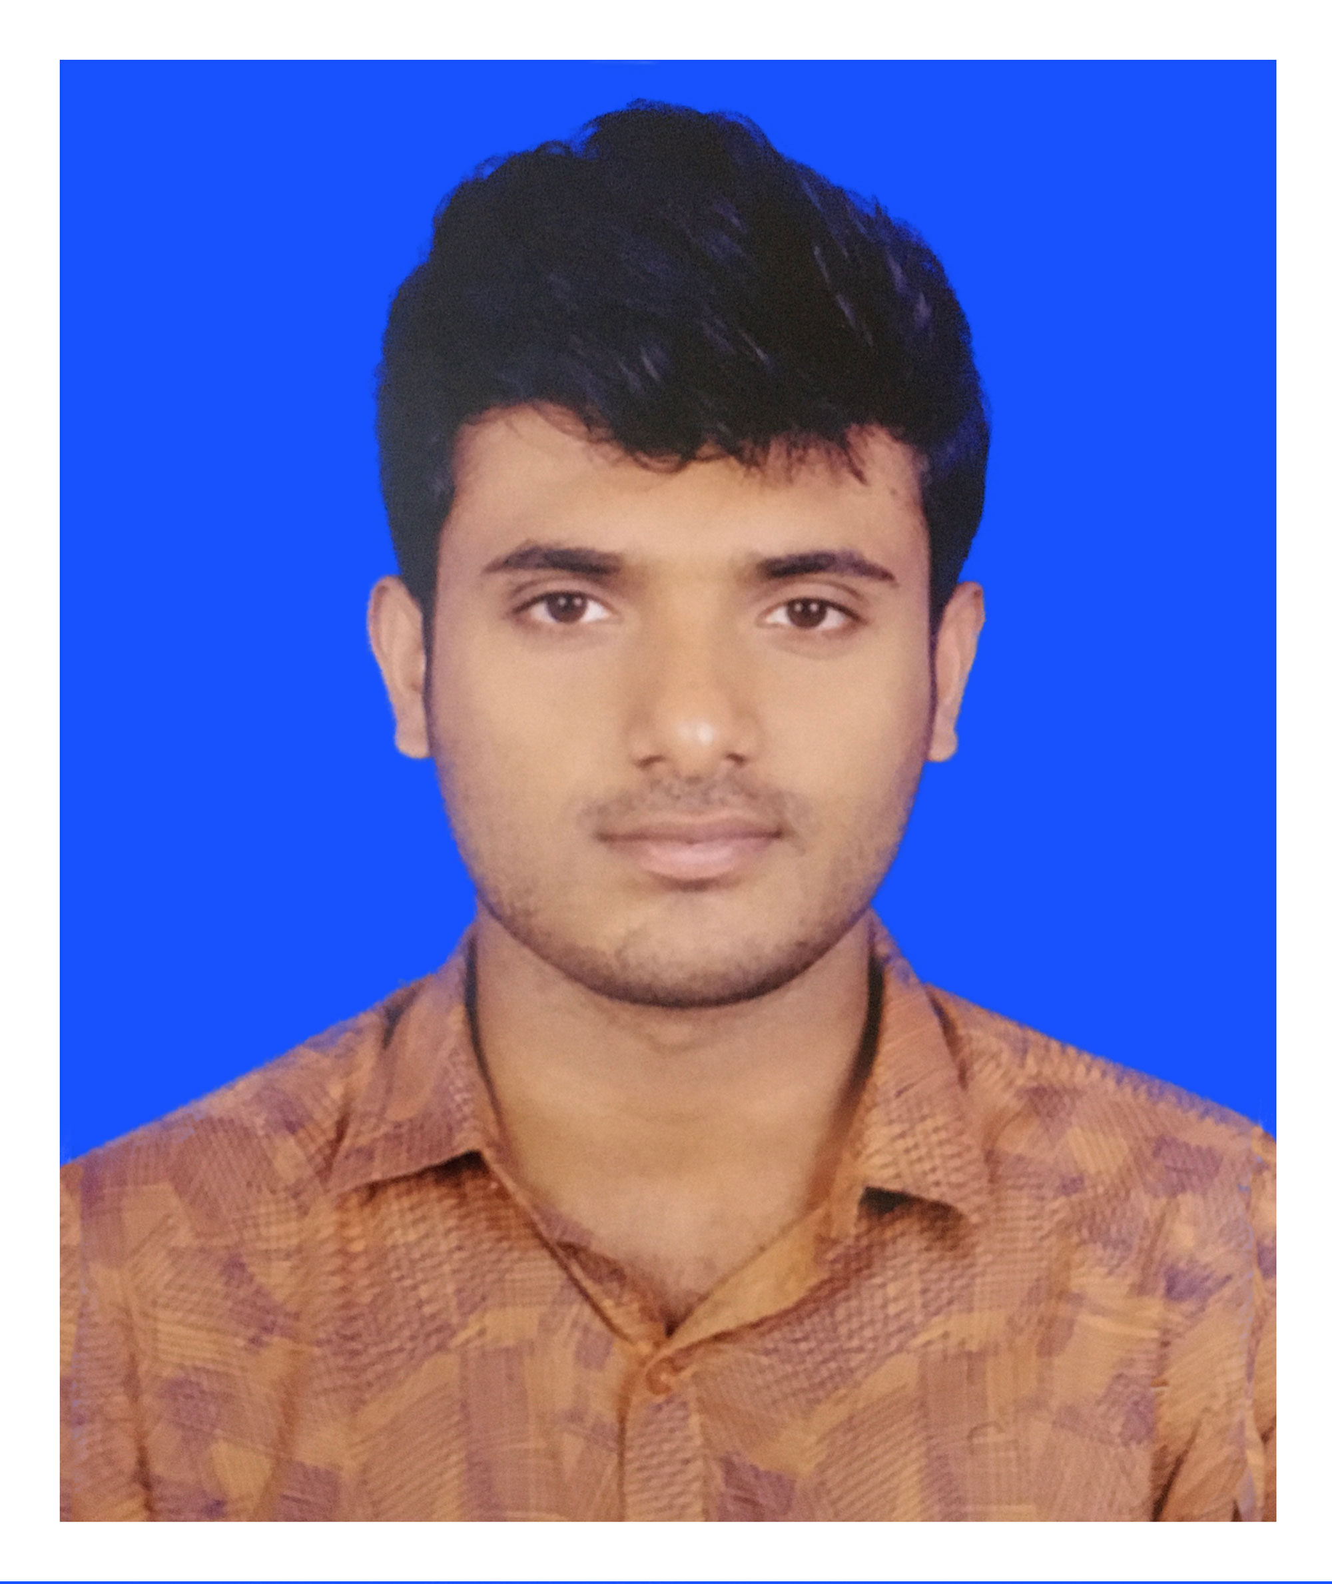

**Android Application Developer**

+880 1854397708

[subrota.shuvro@gmail.com](mailto:subrota.shuvro@gmail.com)

340/5, Rajia Villa, Jafrabad,

Mohammadpur, dhaka-1207.

**Career Object**

To obtain a position where I can gain experience in a professional environment and acquire new skills that will guide me to my career objectives and where enterprising spirit and effort is valued, individual as well as team performance is rewarded and creativity is encouraged.

**Experience**

April 2019 - Present

**Android Developer (part-time)**

Onutiative Ltd

Wakil Tower (8th Floor) Ta-131,

Gulshan Badda Link Rd, Dhaka 1212.

July 2019 - Present

**General Secretary,**

July 2018 - July 2019

**Administrative Head**  
Electronics, Communication and Robotics Club of IST (ECRC-IST)

institute of science and technology

Dhaka, Bangladesh.

**Projects**

**School Supervision Tools (SST)**

Students attendance, School environment checking, Assessment Management & Reporting System for BRAC Education

**Modules**: Android Application

**Expertise’s**

**Java, Flutter, Dart, Kotlin**

**Credentials**  
**Mobile Application Development (Android)**

March - June, 2018

BASIS Institute of Technology & Management (BITM)

**Education**

2015 – Present

**Bachelor of Science (BSc)**  
Electronics and Communication Engineering (ECE)  
Institute of Science and Technology (IST)