As a Data leader for a mortgage company, I need to create a portfolio of analytical initiatives that may impact the key metrics within the primary functions(Account opening, Marketing and Account management) linked to their individual P&L . This is a case of Operational KPIs translating into Financial performance across these lines.

A mortgage company’s P&L would be impacted by Costs , Revenue and Risks .(Business problem captured inside the Initiatives )

Marketing
Key P & L deciders are Advertising spend , Loan Volumes, conversion percentages.
Cost per customer interaction
Cost per funded loan
Loan amount per customer ( averaged out)
Customer onboarding cost .

Problem- Customer acquisition
Initiatives - I will try to target and reach out to customers who have not had loan defaults in the past if they have been past customer, for this , I would use descriptive analysis from historical database and also use ML algos such as KNN to classify customers across different segments with varied degree of loan defaults such as not paid and loan withdrawal , paid off within timelines without penalty or paid off with overpayments during remaining period . This method aligns with supervised learning as we know on what basis we want to label the customers .

I will follow a different approach for attracting new customers . I will use predictive analytics for forecasting on the basis of interest rates prevalent in the market from competitors and also trend of Bank of England rates against which mortgage rate would be based. Hence , would be able to forecast the probability of customers opting for a loan.

Account opening
Cost of performing KYC checks on customer data
Cost of providing preferential Interest rates to premier customers vs standard rates to regular customers
Cost of engagement with solicitor (if customer buys a house by engaging them)
Turnaround time from loan approval to disbursement
Cost of performing credit checks on customers
Amount of credit that can impact the decision of loan provision.

Problem statement - Decision to provide loan and open account

Initiatives - I would focus more on KYC and credit checks here as they are strong determinants of the reliability of a long term loan such as a mortgage. Use prescriptive analysis based on credit ratings of prospective customers and KYC checks to know their background on various factors such as criminal record , length of stay in the country , other existing loans , number of dependents in family, visa status , number of years of employment left etc . Would further enhance the decision to open a mortgage account using ML algo on decision trees with the above factors .

Account management
Account servicing costs
Percentage of loans defaulting
Cost for engaging customers towards the end of the mortgage period for retaining customers .
Cost of giving best interest rates to existing customers .
Cost of engaging customer if defaulting on payments
Early repayment charges / payout

Problem statement - Retain customer
Probability of customers defaulting during mortgage term from their spending pattern . Making repeated repayments shows the tendency of customers trying to pay off earlier and hence likelihood of not renewing loan at same interest rates .
Inititative - Incorporate sentiment analysis for the above behaviour .
Perform Continuous credit checks and periodic KYCs

2. Imagine that you chose to build a decision tree model to support one of your initiatives. Describe this model, explain this concept to your stakeholders and give a reason it is popular.

Answer - Will use decision trees with factors ranging from credit ratings of prospective customers and KYC checks to know their background on various factors such as criminal record ,length of stay in the country , other existing loans , number of dependents in family, visa status, number of years of employment left etc .

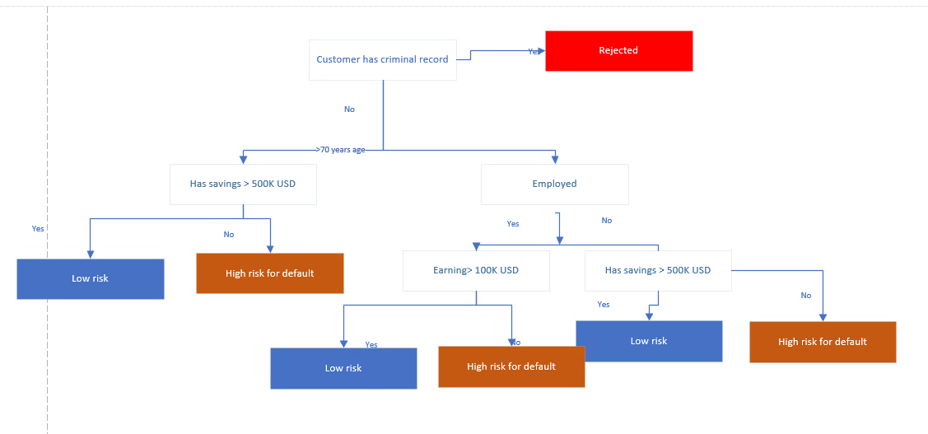

The above decision tree model is easy to interpret for both numerical and categorical decisions at each level , and resonates with the thinking of senior leaders who often make data driven decisions by taking several factors but then narrowing them down to make a decisive decision .

After illustrating such models through visually appealing flowcharts , business stakeholders, loan underwriters, and KYC or compliance teams would be convinced of the effectiveness of the model . It has a transparent nature with all decision making factors mentioned in line.
Rules can be created at any stage of the workflow for manual actioning or review before the model makes a decision of its own . Hence , exception flow can be taken into account as well .

