Customer Behaviour, Offer Response & Churn Analysis
BFSI Business Analytics Portfolio Project

Final Business Analysis
Overall offer response  63.84% | Overall churn  14.20%

Project scope: The project follows the business-analysis intent of the supplied banking project guide: understand offer response, identify churn-related characteristics, validate important relationships statistically, and translate the findings into evidence-based business actions. The original K-Means stage was explored during development but was not included in the final deliverable, so this report does not present unsupported customer clusters.

1. Business Problem
Business context. A banking business wants to improve response to a credit-card upgrade offer while identifying customers who may require retention attention.
Core questions. Which customer characteristics are associated with stronger observed offer-response rates? Which characteristics are associated with higher observed churn? Are the most important observed differences statistically meaningful?

2. Analytical Approach
- Python was used for data cleaning, type handling, missing-value treatment, category standardization, date normalization, duplicate investigation, descriptive analysis, and statistical testing.
- MySQL was used for database setup, table validation, customer/account relationship checks, business KPI analysis, and creation of a reusable customer_analytics view.
- The analysis focused on customer characteristics and behavioural variables including region, income, product count, spending, transactions, utilization, and late payments, with offer response and churn treated as outcome variables.

3. Data & Quality Validation
Metric | Current result
Customer records in MySQL | 11,523
Account records in MySQL | 10,996
Customer IDs matched across both tables | 10,391
Customers without a matching account | 1,132
Accounts without a matching customer | 605
Interpretation. The source tables do not have complete one-to-one coverage. Combined customer/account analyses therefore use the matched population, while the unmatched records are documented as a data-integration limitation rather than being forced into the analysis.

4. Baseline Business KPIs
Across the 10,996 account records used for account-level outcome analysis, 7,020 customers responded to the marketing offer, producing an observed response rate of 63.84%. A total of 1,561 customers were recorded as churned, producing an observed churn rate of 14.20%.

5. Product Relationship Depth & Offer Response
Product relationship depth produced one of the clearest differences in observed offer response. Single-product customers had a 28.83% response rate, while customers with two or more products had an 82.90% response rate. Within the multi-product group, the earlier SQL analysis showed relatively little difference between customers with 2, 3, 4, and 5 products.
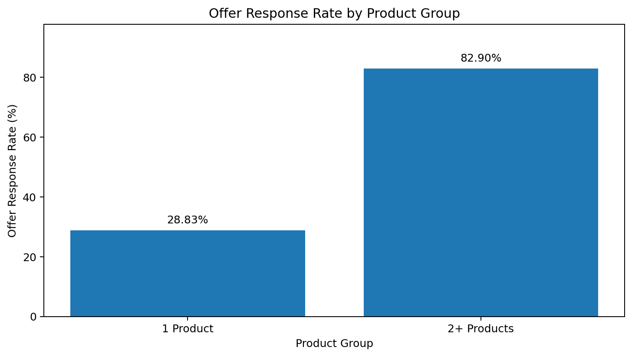
Figure 1. Observed offer response rate by product group.

6. Credit Utilization & Offer Response
Observed offer response remained relatively high below 50% utilization, at 67.06% for 0–25% and 67.54% for 25–50%. It declined to 35.39% for 50–75% and 25.00% for 75–100%. The 75–100% group contains only 40 customers, so its estimate should be interpreted cautiously.
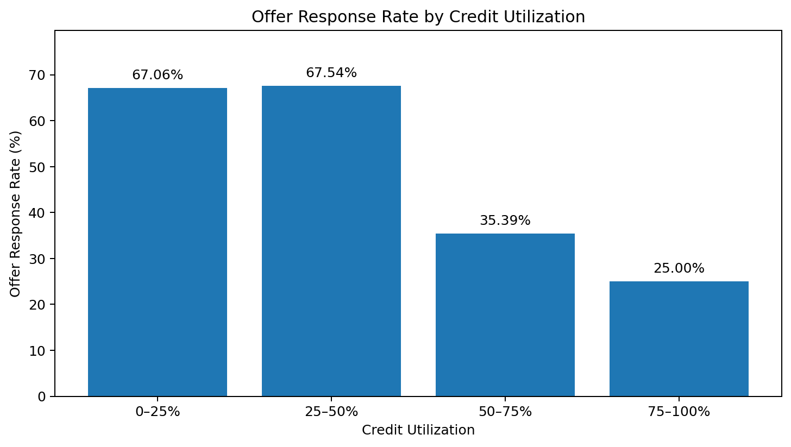
Figure 2. Observed offer response rate by credit-utilization band.

7. Late Payments & Churn
Observed churn was relatively stable for customers with 0–2 late payments, at approximately 12.8%. It increased to 34.35% for customers with 3 late payments and 35.04% for customers with 4 late payments. The five-late-payment group was small and was therefore interpreted cautiously.
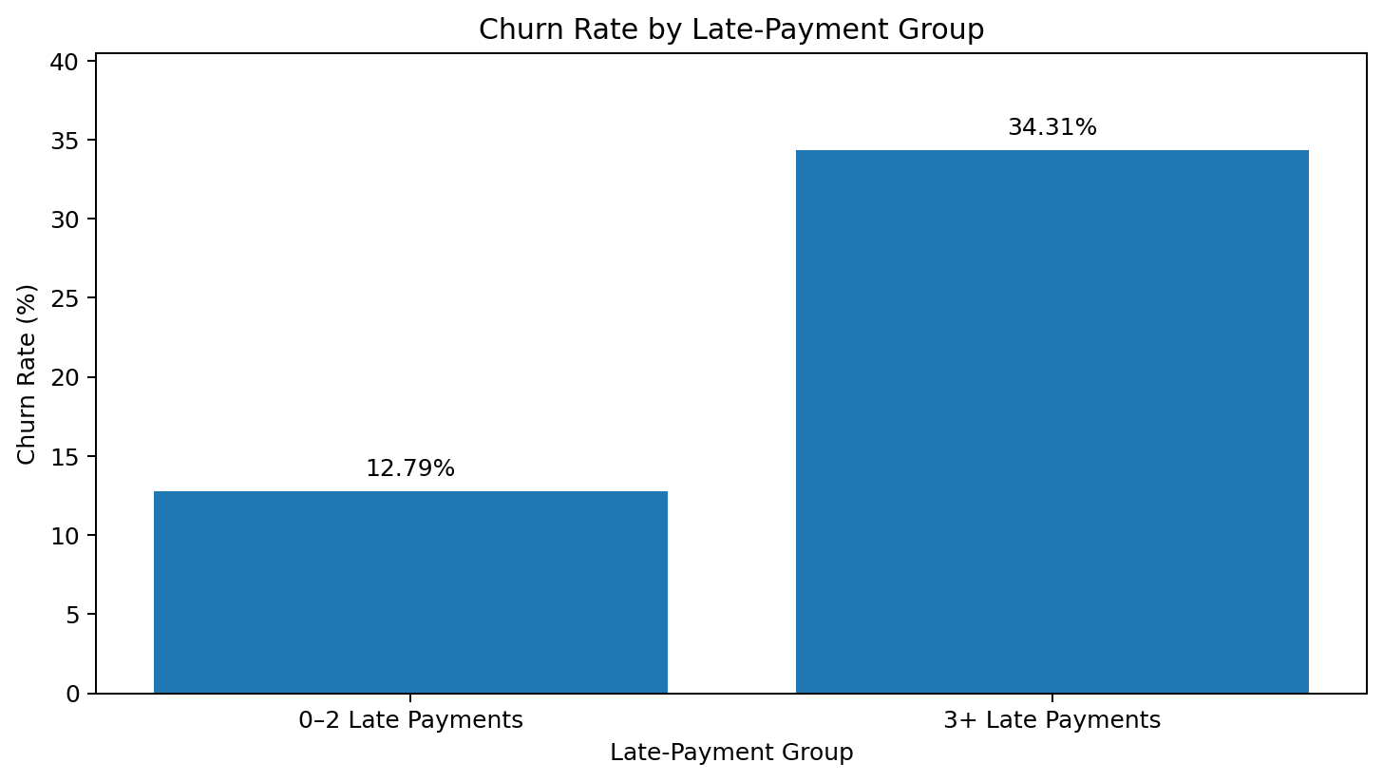
Figure 3. Observed churn rate by late-payment group.

8. Offer Response Status & Churn
Customers who did not respond to the offer had an observed churn rate of 25.55%, compared with 7.76% among customers who responded. This is a strong observed association in the dataset, but it does not establish that responding to the offer causes lower churn.
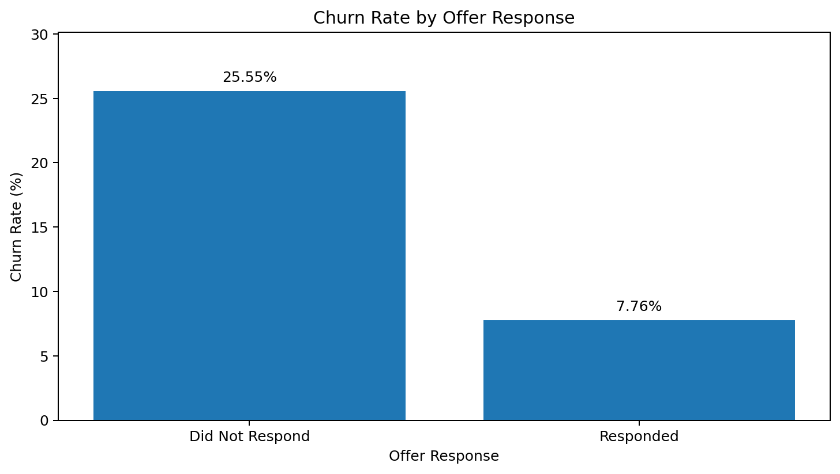
Figure 4. Observed churn rate by offer-response status.

9. Additional Analysis
Other variables were tested to determine whether they provided meaningful standalone separation.
- Region: response rates across the four known regions were relatively close, ranging from 62.72% to 65.57%.
- Income: response rates ranged from 62.62% to 64.72%, while churn rates ranged from 13.57% to 14.71%.
- Transaction activity: response rates ranged from 63.33% to 66.20%, while churn rates ranged from 13.17% to 14.71%.
- Monthly spend: response rates ranged from 62.56% to 65.49%, while churn rates ranged from 13.38% to 14.86%.
These variables therefore did not show strong standalone separation in the current descriptive analysis, although they may still provide useful context when considered jointly with stronger behavioural indicators.

10. Statistical Validation
Chi-square tests of independence were used to validate two strong categorical relationships identified during the SQL analysis.
Relationship | Chi-square | df | p-value
Product group × offer response | 3175.81 | 1 | < 1e-300 / displayed as 0.0
Late-payment group × churn | 254.02 | 1 | 3.455 × 10⁻⁵⁷
Interpretation. Both tests provide strong statistical evidence against independence between the tested categorical variables. The tests support the descriptive patterns but establish association, not causation.

11. Business Recommendations
Based on the observed patterns, the following actions are potential areas for further business investigation:
Cross-sell / relationship deepening: Single-product customers show substantially lower observed offer response and higher observed churn than multi-product customers. This group is a potential area for targeted relationship-deepening or cross-sell analysis.
Retention / risk attention: Customers with higher late-payment counts show materially higher observed churn. These customers may warrant additional retention or risk-focused attention.
Campaign context: Credit utilization may be useful as a campaign-context variable because observed offer response declines materially at higher utilization levels.
Avoid single-variable targeting: Income, transaction count, monthly spend, and region showed limited standalone separation. These should be treated as supporting context rather than as strong individual decision rules based on this analysis alone.

12. Limitations & Interpretation
- Customer/account coverage is incomplete: 1,132 customers lack a matching account record and 605 account records lack a matching customer record.
- Combined analyses represent the 10,391 matched customer IDs rather than the full 11,523 customer rows.
- The analysis is observational and identifies associations rather than causal effects.
- Small groups, including 75–100% utilization and five late payments, should be interpreted cautiously.
- The results are based on the current imported dataset and should be validated against additional business data before operational use.

13. Tools & Techniques
- Python: Pandas, NumPy, Matplotlib, SciPy, Jupyter Notebook.
- SQL/MySQL: joins, GROUP BY, CASE WHEN, aggregate functions, subqueries, data validation, and SQL views.
- Analytics: descriptive analysis, contingency tables, chi-square tests of independence, and business interpretation.

14. Final Conclusion
The project produced a focused, evidence-based view of customer behaviour related to marketing response and churn. The clearest observed differences were associated with product relationship depth, credit utilization, late-payment behaviour, and offer-response status. The strongest relationships were statistically validated using chi-square tests.
The resulting analysis provides a defensible basis for further cross-sell and retention investigation while documenting the data-coverage limitations and maintaining the distinction between association and causation. The final scope intentionally prioritizes explainability and interview-defensible analysis rather than presenting an incomplete machine-learning segmentation model.

