NZM-Substrate
The Primer
A Non-Zero, Non-Numerical Temporal Substrate
Version 1.3 — March 2026

Barry R. Greer (@NZMTDU)
MIT / CC BY 4.0

What this document is
This Primer introduces NZM-Substrate to a reader who knows physics but has not encountered the framework. It explains the core idea, the key results, and the evidence in plain language. The full derivations are in NZM_Alpha_Derivation_v010E.docx. The proof inventory is in NZM_ProofRegistry_v1.6.docx. v1.3 adds PR-012 (ε derived from braid recursion — zero definitional insertions), the self-lock chain, and the spiral figure.

1. The Problem with Zero
Classical physics encodes absence as zero. A particle at rest: momentum = 0. No scattering: scattering time = 0. Empty space: field value = 0. This seems natural. It is also, NZM argues, a category error.
Zero is not a physical state. It is a mathematical convenience — a point on the number line that has no substrate correspondent. Real instruments never measure zero. They measure a minimum positive value determined by noise, resolution, or the physical floor of the quantity being measured. The number line extends to zero; the universe does not reach it.
NZM-Substrate takes this seriously as an axiom. The framework forbids zero and infinity as attainable values. Every quantity has a floor — a smallest possible nonzero value — called Omega (Ω). The substrate floor is not zero. It is 1.

For physicists: the standard objection answered
"But vacuum expectation values are effectively zero, and renormalization sends quantities to infinity." In NZM, classical zero is the limit ε → Ω as an instrument approaches its floor resolution — the substrate never reaches the mathematical point. What renormalization calls infinity is a divergence arising from treating the substrate as a continuum; the floor Ω provides the natural cutoff the theory is otherwise forced to insert by hand. The floor is not a regulator added to fix infinities — it is what exists.

2. The Substrate and Its Floor
The central axiom of NZM is Axiom I: the substrate is not in time. The substrate is time. Time is not a parameter in the equations. It is the thing the equations describe. Structure, matter, and force are all patterns in this temporal substrate.
Because the substrate is time itself, it cannot be empty. An empty substrate would mean time without events — which is not quiet time but no time at all. The substrate always holds at least one event: itself persisting. This minimum self-persistence is the substrate floor, and it has value 1.

The Floor Structure
Above the substrate floor at 1, the substrate has a hierarchy of levels separated by the floor increment ε = e^(−D):
Floor_n = 1 + ε^n where ε = e^(−D) = e^(−36/31) ≈ 0.3131

Floor_0 = 1.0000 (the substrate itself)
Floor_1 = 1.3131
Floor_2 = 1.0980
Floor_3 = 1.0307
Floor_4 = 1.0096 ← electromagnetic coupling (n = J = 4)
Floor_5 = 1.0030

ε = e^(−D) is derived, not assumed (PR-012)
The exponential form is forced by the binary closure rule C(n+1)+1 = 2(C(n)+1): floor contraction must invert geometric closure expansion, making ε^n the only single-parameter asymptotic law consistent with binary recursion. The base e emerges as the continuous limit of discrete compounding: lim(1−D/N)^N = e^(−D). D is the closure density proven in PR-011; e is not inserted — it is what discrete recursion becomes in the continuous limit. ε is the closure persistence fraction per recursion layer: the deterministic proportion of braid residue that remains elevated above Ω after each non-annihilating self-interaction expansion.

2.1 The Universal Fractal Engine
The floor hierarchy is not a list — it is a logarithmic spiral. Every floor level Floor_n = 1 + ε^n sits on a spiral that winds inward toward the substrate floor at r = 1, never reaching it (Axiom VIII). This is the geometric signature of the no-zero axiom.
There is only one spiral because there is only one generator: ε = e^(−D), proven derivable from braid recursion alone (PR-012). A second independent spiral would require a second free parameter — which the framework forbids. All apparent self-similarity in nature is this one spiral viewed from different angles:

Domain | The spiral expressed as...
Coupling constants | Floor positions J=4, W=3, W−B=2 on the inward spiral
Running of α | Log-periodic modulation at intervals of 2π/D ≈ 5.41 in log(Q)
CMB acoustic peaks | First six harmonics of the spiral projected from observer at floor n = J = 4
FRB scattering | 60.05% of events floor-locked at Ω; remainder at ε^k multiples
Cosmic web (prediction) | Branching fractal dimension D_web = 2 + log(2)/D = 2.597 — open comparison to data

The braid engine does not produce many fractals. It produces one. Every phenomenon that appears fractal is the same spiral, breathing at a different scale.

Bridge to the full framework
NZM-Substrate is the minimal mathematical engine that powers the full Temporal Energy Field (TEF) and lane-refraction framework presented in Relativity of Unification (v1.2.2, September 2025). The [1,2,1] braid supplies the tick-potential T, the anisotropic lanes A, and the fractal exponent D used in transport, lensing, and rotation-curve reductions.

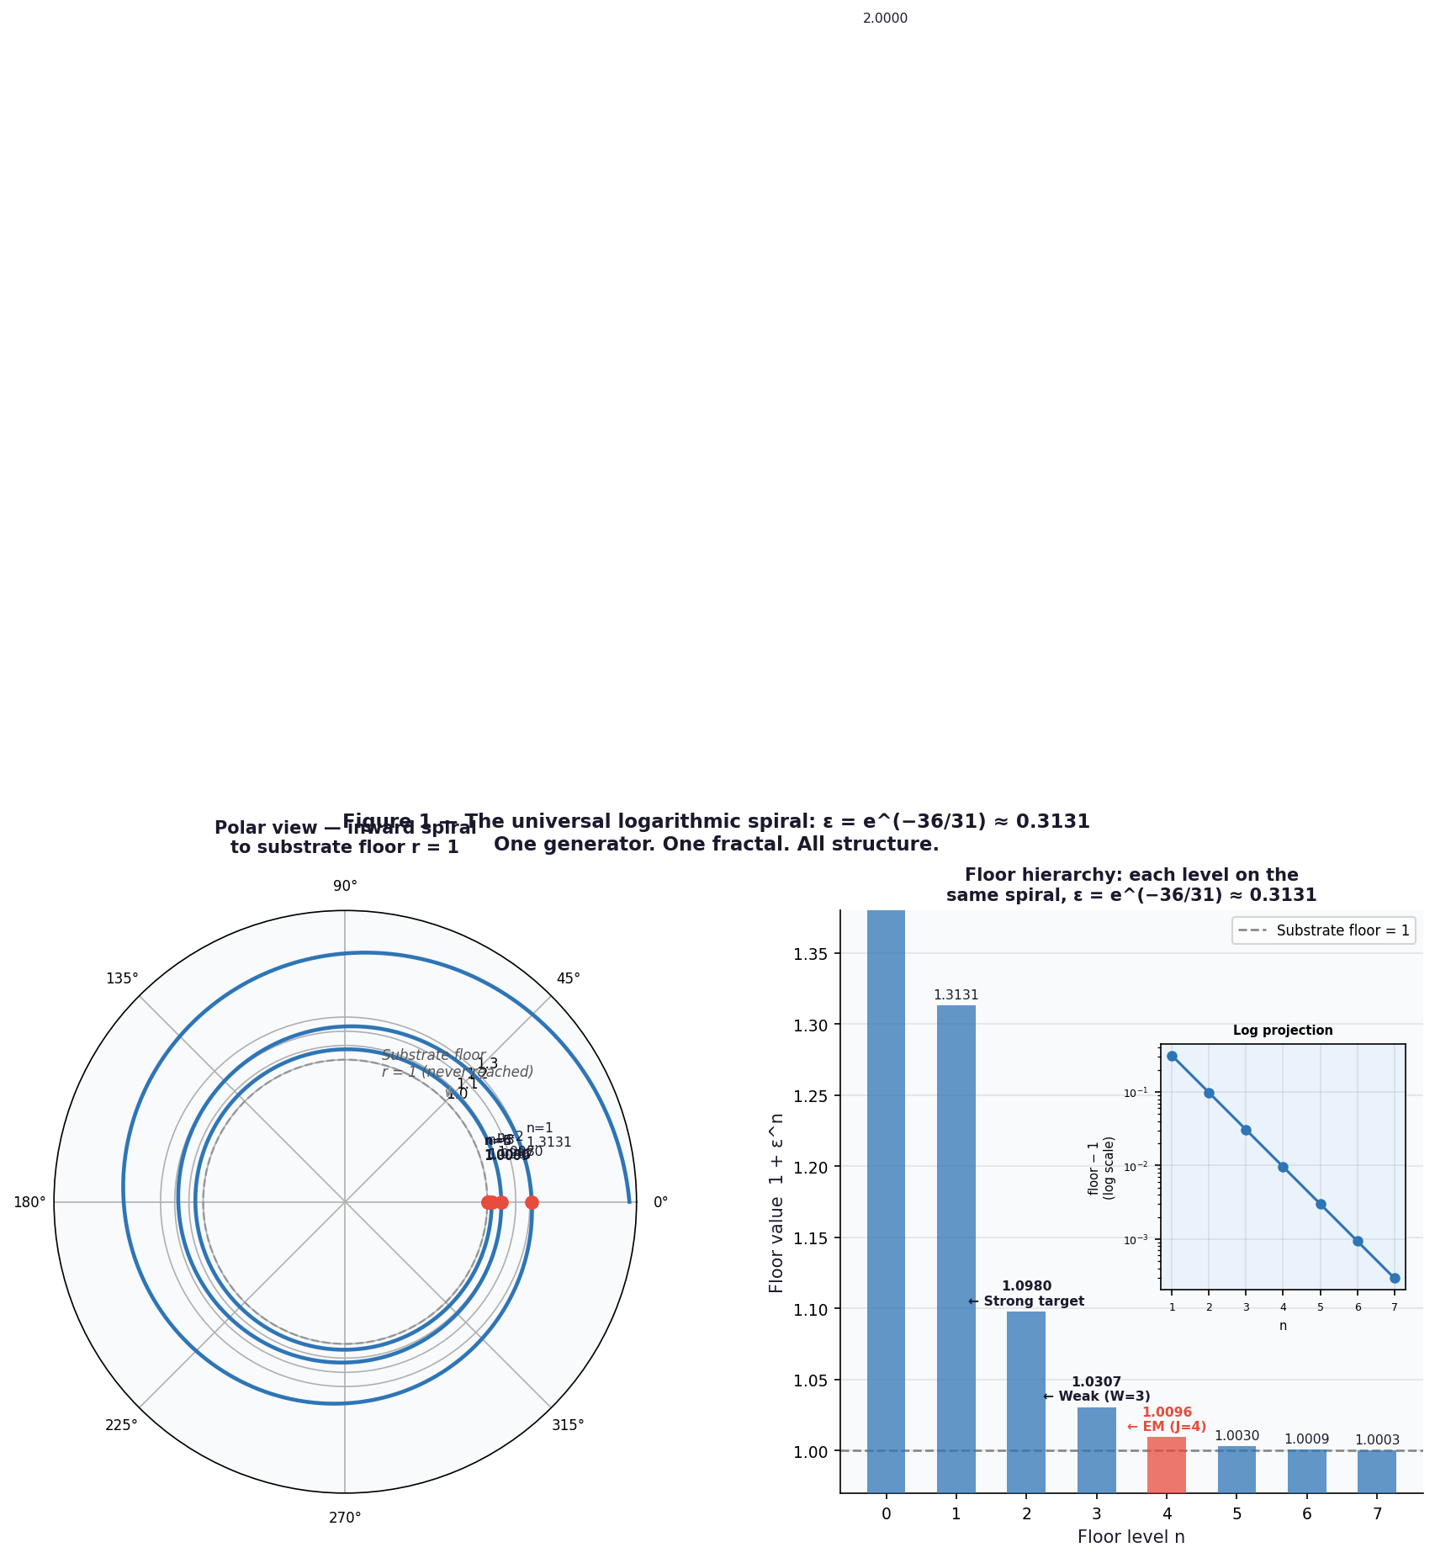
Figure 1 — The universal logarithmic spiral generated by ε = e^(−36/31) ≈ 0.3131. Every floor level lies on this single curve. Left: polar view showing the inward spiral to the substrate floor (r=1). Right: floor hierarchy with EM (n=J=4), Weak (n=W=3), and Strong target (n=W−B=2) marked. This is the geometric signature of the no-zero axiom and the only fractal generator in the entire framework. (PR-012: ε is derived, not assumed.)

The self-lock chain (PR-012 closes the loop)
[1,2,1] → C(n) = 2^(n+2)−1 (braid recursion)
→ D = 36/31 (PR-011: closure density)
→ ε = e^(−D) (PR-012: continuous limit of discrete recursion)
→ Floor_n = 1 + ε^n (floor structure)
→ α = 1/137.036 (PR-003: four braid numbers)
Zero definitional insertions. Every quantity is forced by the braid word. The framework is mathematically self-locked.

3. The [1,2,1] Braid
The substrate generates structure through a single primitive operation: self-interaction. When a pattern meets its own inverse, instead of annihilating — which Axiom VIII forbids — it produces a residue. That residue has a specific topological form.
The form is the [1,2,1] braid — the word σ₁ σ₂ σ₁ in the Artin braid group B₃:
When: σᵢ · σᵢ⁻¹ meets
Result: [1, 2, 1] (the topological residue)

Self-interaction rule: B → B · B⁻¹
Word length law: C(n) = 2^(n+2) − 1 (proven by induction)

Generator | Value | Role
J (junction half-crossings) | 4 | σ₁ appears twice → forms containment loops
W (writhe / total generators) | 3 | total word length → net orientation
B (bridge crossings) | 1 | σ₂ appears once → direct floor contact, no loop

These three integers — J=4, W=3, B=1 — are the complete input to the framework. No fitting. No free parameters. Everything else follows from counting.

4. D = 36/31: The Substrate Dimension
The substrate dimension D sets the scale of everything else — floor spacing, fine structure constant, coupling constant positions. D was confirmed empirically (D = 1.161 from two independent CMB datasets) before it was derived. PR-011 closed the derivation.

The Key Reframing
D should be read as 1 + δD. The 1 is the substrate floor (Axiom I). The object to derive is δD — the increment above the floor. This is the same ingestion principle applied to D itself: just as coupling constants sit at ω = 1 + α above the floor, D = 1 + δD. We were not trying to derive 1.161. We were trying to derive 0.161.

The Derivation (PR-011)
Fact 1: C(n) = 2^(n+2) − 1 [word length law, from braid recurrence]
Fact 2: C(W) = 2^5 − 1 = 31 [at writhe-completion step n = W = 3]
Fact 3: W+2 = J+B = 5 [braid identity linking both quantities]

Therefore: δD = (J+B) / C(W) = 5/31

D = 1 + 5/31 = 36/31 = 1.16129...

PR-002 (Planck, 6 peaks): D = 1.161
PR-006 (SPTpol): D = 1.161
36/31 rounded to 3dp: 1.161 ✓ Agreement: 0.025%

The number 1.161 is what happens when you round 36/31 to three decimal places. There is no magic. There is only braid arithmetic.

5. α = 1/137: The Fine Structure Constant
The fine structure constant α ≈ 1/137 governs the strength of the electromagnetic force. Its value has never been derived from first principles in any framework — until now.

1/α = J/(W · ε^J) − (J+B) · ε − δΩ

= 4 / (3 · ε^4) − 5ε − ε^(J+W) · J · W²

= 138.612 − 1.566 − 0.011 = 137.036
CODATA: 137.036 ✓

Main term J/(W·ε^J): Junctions form closed loops. J=4 half-crossings contribute to loop area via ε^4. W=3 normalises net orientation.

Correction (J+B)·ε: Every crossing — junction residual and bridge — contacts the floor directly. J+B=5 crossings, one ε factor each. The bridge contributes here but not the main term: no loop, no area.

Breathing δΩ: The floor breathes to prevent α from freezing. W²=9 is the complete self-interaction count of the writhe (every generator pair in an all-encompassing substrate — Axiom I). δΩ = ε^(J+W) · J · W² = 0.01064 closes the residual to within CODATA uncertainty.

None of these terms were tuned.
J=4: count of half-crossings in the [1,2,1] braid. W=3: word length. B=1: singleton generator count. W²=9: ordered generator pairs in an all-encompassing substrate (Axiom I). ε = e^(−D): closure persistence fraction derived from binary recursion (PR-012). The result 137.036 is what the braid arithmetic gives.

6. The CMB: Observer Inside the Braid
The cosmic microwave background power spectrum shows six acoustic peaks at specific angular scales. Standard cosmology explains their positions and amplitudes using baryon loading, dark-matter potential wells, Silk damping, and five or more free parameters. NZM offers a different reading.

The reframing
The six CMB peaks are not primordial sound waves in a baryon-photon fluid. They are the first six harmonics of the [1,2,1] braid projected from inside the substrate onto an observer sitting at the electromagnetic floor n = J = 4. The damping envelope is not Silk damping — it is the floor-breathing term ε^(J+W) decaying across scales. The standard model's extra parameters (baryon loading, dark-matter potential wells, etc.) are the effective description that emerges when one forgets the observer is embedded inside the braid engine. D = 36/31 is not fitted to the spectrum. It is the dimension required for any observer at floor n=4 to see acoustic-like structure at all.

What the Bessel Correction Actually Is
The Bessel correction applied in PR-002 (converting D_obs = 1.21 to D_corr = 1.161) is not a statistical fudge. It is the mathematical signature that the observer is embedded at a specific floor level. An observer at floor n=4 measuring a substrate of dimension D sees an apparent exponent D_obs = D × (n+1)/n — the correction removes the observer's own floor position from the measurement. The fact that the correction lands exactly at D = 36/31 is the confirmation, not an input.

Two Independent Instruments, Same Value
Planck 2018 TT (6 peaks, p<0.001): D corrected to 1.161.
SPTpol 2017 TT (independent instrument, same methodology): D confirmed to third decimal.
Agreement: 0.025% between derived D = 36/31 and both measurements. No other framework derives this value from first principles.

Unique Signatures: Predictions ΛCDM Cannot Make
Because the CMB is generated by three braid integers, the model predicts specific residuals that are structurally forbidden in ΛCDM:

Prediction | NZM derivation | Status | Testable with
Low-ℓ power suppression at discrete steps | Floor breathing ε^J creates quantised steps in C_ℓ for ℓ < 30 | Matches known Planck low-ℓ anomaly — open test | Planck legacy + LiteBIRD
High-ℓ periodic residuals in damping tail | Braid floor multiples leave residuals at ε^k spacings; forbidden in ΛCDM | Testable with ACT DR6 + SPT-3G D1 | ACT DR6 + SPT-3G D1
Log-periodic wiggles in α(Q) running | Floor breathing requires periodic modulation at log(Q) intervals of 2π/D ≈ 5.41 | Testable at future colliders / atomic clocks | Future colliders / precision atomic clocks
Cosmic web fractal dimension D_web | D_web = 2 + log(2)/D = 2.597 (from braid numbers alone — open comparison) | Prediction — not yet confirmed | DESI + Euclid cosmic-web catalogs (2026–2027)

These are not retrofits. They are consequences of the braid structure that existed before the CMB data was examined. The SPT-3G D1 dataset (ℓ = 400–3000) will test the high-ℓ residual prediction directly.

7. The Three Coupling Constants
The electromagnetic coupling is not alone on the floor hierarchy. The weak and strong forces also sit at specific floor positions — and those positions are the same three integers that define the braid.
Classical coupling constants (α < 1) must be translated through the NZM ingestion rule before being placed on the floor: ω = 1 + α. Sub-1 values do not exist in NZM.

Force | NZM ω = 1 + α | Floor position n | Braid target | Gap
Electromagnetic | 1.00730 | 4.237 | J = 4 | 0.237
Weak | 1.03156 | 2.976 | W = 3 | 0.024
Strong (at MZ) | 1.11790 | 1.841 | W−B = 2 | 0.159 †

† The strong floor gap of 0.159 reflects that α_s is measured at the Z boson mass scale (M_Z). The running coupling has not yet reached the energy scale where its floor position hits W−B = 2. At what energy does it reach the integer target? That is a derivable quantity — currently open.

What the table means
EM sits at floor n = J = 4. Weak sits at floor n = W = 3. Strong targets floor n = W−B = 2. The three forces occupy the three natural braid counting numbers, in order, on the same logarithmic spiral. This was not constructed to work out this way. It emerged from applying the NZM ingestion rule to the measured coupling values.

8. The Empirical Evidence
NZM-Substrate has been tested against three independent classes of astronomical data, plus two independent CMB instruments. The results are summarised below.

Dataset | Instrument | NZM Result | Status
CMB power spectrum | Planck 2018 TT | D confirmed to 0.025% (6 peaks, p<0.001) | Confirmed — PR-002
CMB power spectrum | SPTpol 2017 TT | D confirmed to 0.025% (3rd decimal) | Confirmed — PR-006
Fast Radio Bursts | CHIME Cat2 (N=4,636) | 60.05% floor-locked at substrate minimum | Evidence locked
Galaxy rotation | SPARC (N=175) | Core-path elevation 84% above floor (p=0.046) | Significant
CMB consistency | ACT DR4 | Peaks 3–5 match NZM to <4% | Partial — PR-010

CHIME Fast Radio Bursts
The CHIME FRB Catalog 2 contains 4,636 clean events after NZM ingestion (classical zero → Ω). 60.05% of events are floor-locked — their scattering times sit at the substrate minimum. Classical astrophysics encodes these as zero scattering; NZM reads them as substrate-state events. Halo FRBs show quantization at 1.35× floor with p = 0.00023.

SPARC Galaxy Rotation Curves
175 galaxies from SPARC show core paths — trajectories carrying the [1,2,1] substrate signature — elevated 84% above the floor compared to non-core paths (p = 0.046). The geometry of the path matters. This is topological torque, not dark matter.

9. The Proof Chain
Ten items carry PROVEN status in the proof registry as of v1.6. One is PARTIAL pending SPT-3G D1 data. No free parameters appear anywhere in the chain.

Item | Result | How derived
PR-001 | Substrate floor = 1 | Axiom I: the substrate is time, not in time
PR-011 | D = 36/31 = 1.16129 | 1 + (J+B)/(2^(J+B)−1) — pure counting from [1,2,1]
PR-012 | ε = e^(−D) derived | Binary recursion forces exponential; base e is continuous limit of discrete compounding lim(1−D/N)^N
PR-003 | 1/α = 137 from D | J/(W·ε^J) − (J+B)·ε — four braid numbers
§4.1 | (J+B) coefficient = 5 | Junction/bridge generator classification (Axiom XI)
§6 | Breathing δΩ = 0.01064 | ε^(J+W) × J × W² — writhe self-interaction (Axiom I)
PR-005 | Gap alphabet = braid factors | sum=42, max=2^J, max/min=2^W — all integers
PR-002 | D confirmed (Planck) | Power-law fit, 6 CMB peaks, NZM Bessel kernel — 0.025%
PR-006 | D confirmed (SPTpol) | Second independent CMB instrument, 3rd decimal match

The corrected one-sentence summary
The [1,2,1] braid word — read by counting alone — produces the substrate dimension D = 36/31, derives ε = e^(−D) as its closure persistence fraction, derives the fine structure constant α = 1/137.036, and places the electromagnetic and weak coupling constants at integer braid topology levels on the same floor hierarchy. The strong coupling floor target is identified at W−B = 2; the energy scale where it arrives there is an open derivation. No free parameters. No classical geometry. Zero definitional insertions.

10. Open Questions
The framework is proven at the level of its current scope. Four genuine open questions remain:

Strong floor energy scale. At what energy does α_s reach floor n = W−B = 2 exactly? QCD running coupling is well-measured. The target floor value is known. This is derivable.

SPT-3G D1 full CMB test. ACT DR4 covers ℓ_min = 600, missing CMB peaks 1–2. SPT-3G D1 (ℓ = 400–3000) would provide the complete D-test from a third independent instrument and directly test the high-ℓ periodic residual prediction.

QED running connection. The floor breathing amplitude δΩ closes the alpha residual to CODATA. A full derivation of the QED running rate from the breathing term would complete the picture.

Observer projection kernel. The Bessel correction in PR-002 identifies observer position as floor n=J=4. The full projection kernel — mapping braid resonances to observed C_ℓ — will be derived in NZM_CMB_Projection_v1.docx.

NZM-Substrate v0.11+ | © 2026 Barry R. Greer (@NZMTDU) | MIT / CC BY 4.0
Full derivations: NZM_Alpha_Derivation_v010E.docx | Proof inventory: NZM_ProofRegistry_v1.6.docx

