***AWS -CloudFront project-02***

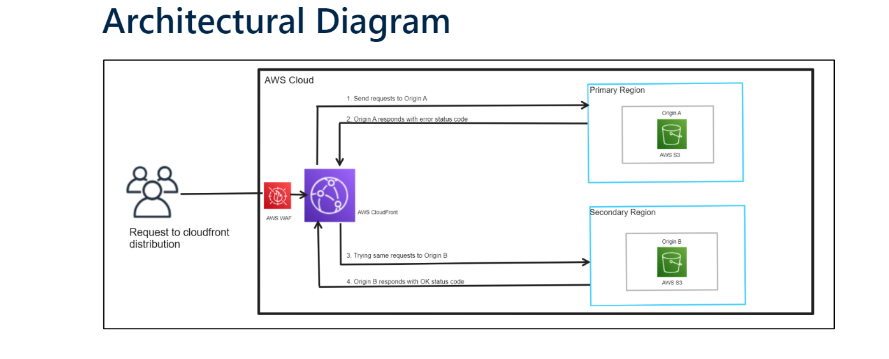

**1. Creation of two s3 buckets**

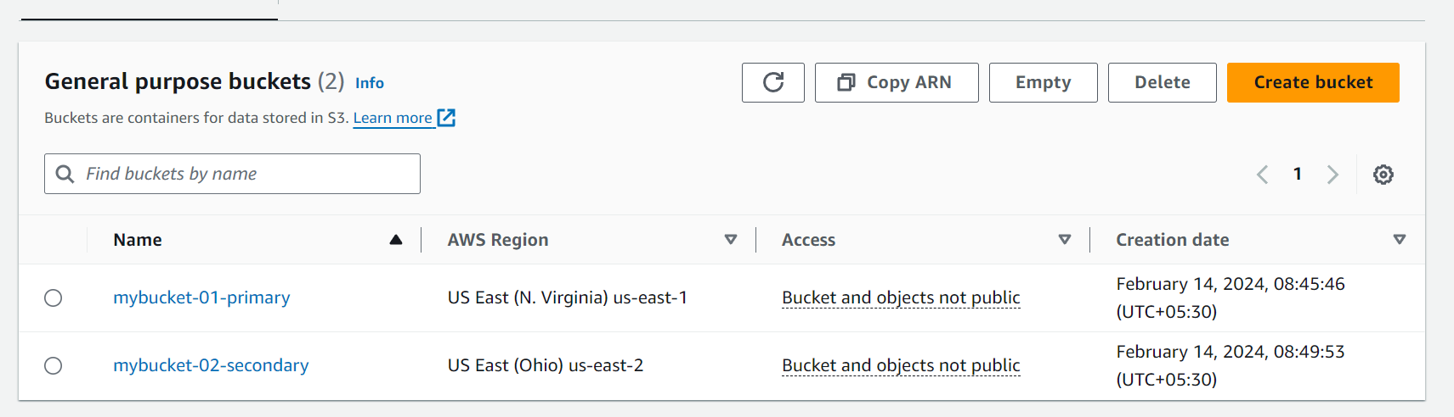

**2. Upload index.html for bucket-01**

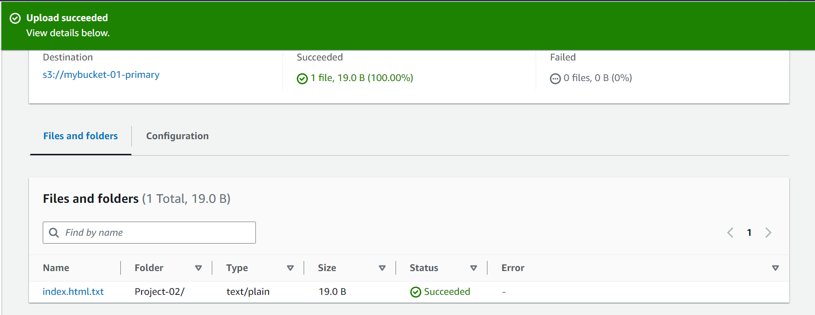

**3.Upload index.html for bucket-02**

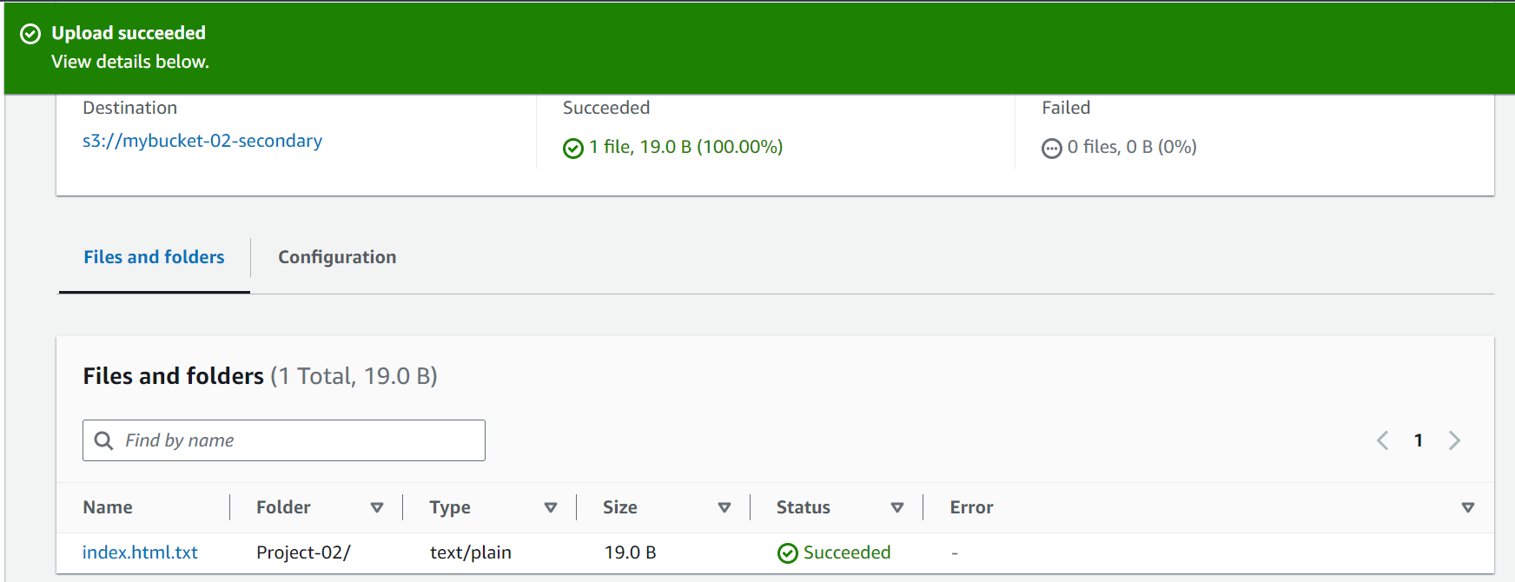

**4.Create origin**

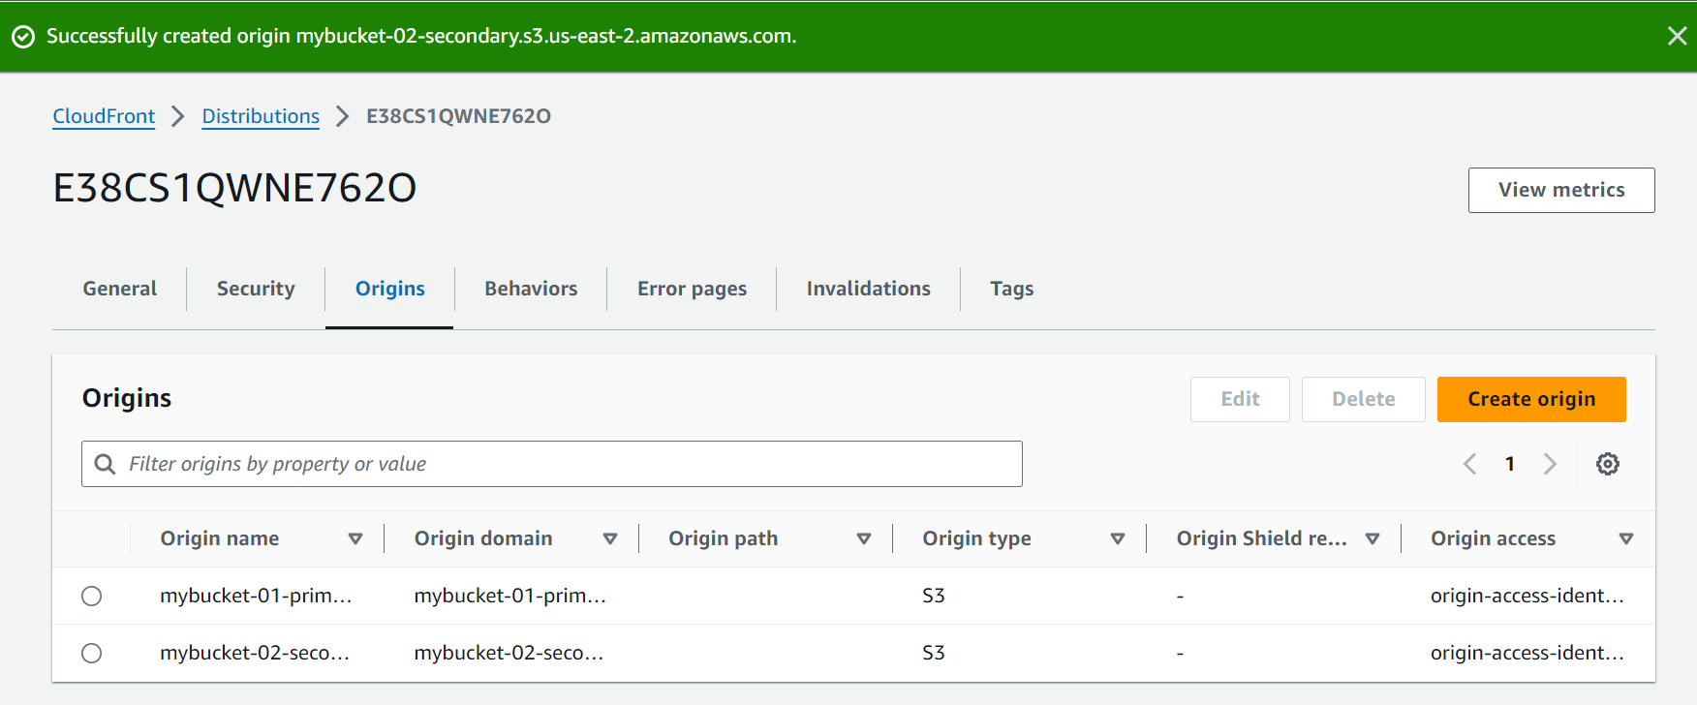

**5.Create origin group**

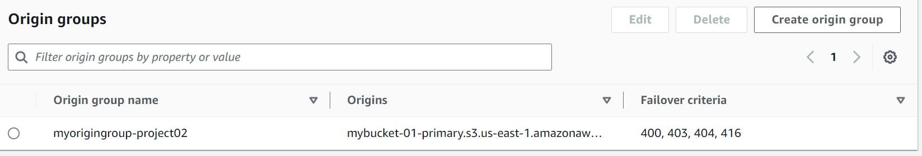

**6. Website Validation**

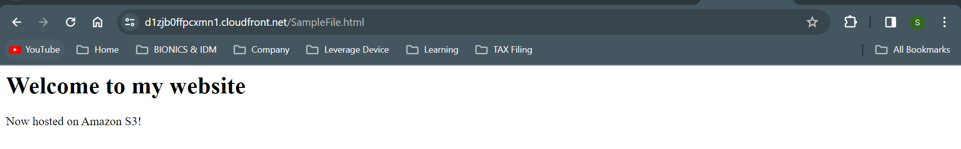

**7. Implementing Geographical restrictions and adding WAF**

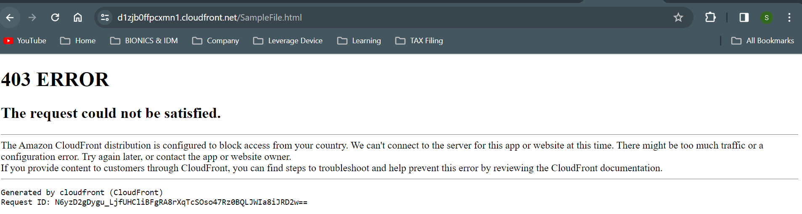

**8.Creating Invalidation**

