Multiplayer BattleTech: 3025
Software Design Specification

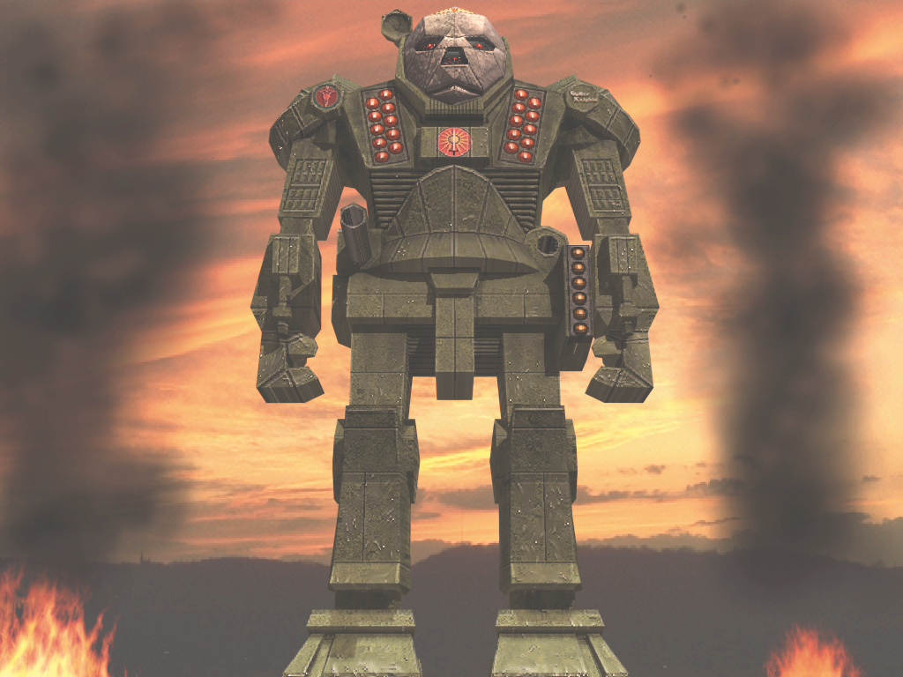
11/3/98
Doc Ver 1.1
Nick Laiacona
Phil Deluca
Chris Thacker
Steve Marvin

Table of Contents

1. Introduction 1
1.1. A Brief History of the Inner Sphere 2
1.2. The Houses 5
1.2.1. The Federated Suns (House Davion) 5
1.2.2. The Draconis Combine (House Kurita) 6
1.2.3. The Lyran Commonwealth (House Steiner) 7
1.2.4. The Free Worlds League (House Marik) 7
1.2.5. The Capellan Confederation (House Liao) 8
1.3. Interstellar Travel 8
2. Game Mechanics 10
2.1. Overview 10
2.2. The Player 10
2.2.1. Joining a House 10
2.2.2. Character Attributes 11
2.2.3. Rank 11
2.2.4. Rank Titles 12
2.2.5. Acquiring New BattleMechs 13
2.2.6. Trickle-up Rank Points 13
2.2.7. House Standing 14
2.2.8. Medals and Commendations 14
2.2.9. Leaving a House 15
2.3. The House 16
2.3.1. Player Types 17
2.3.2. Unit Types 19
2.4. Planetary Assaults 27
2.4.1. Planetary Map 27
2.4.2. Unit Combat 28
2.4.3. Unit Movement 29
2.4.4. Supply Lines 30
2.4.5. Intelligence 31
2.4.6. Climate 31
2.5. Interplanetary Combat 33
2.5.1. Interplanetary Supply Lines 33
2.5.2. Interplanetary Travel 33
2.5.3. ComStar Interdiction 34
3. Combat Missions 36
3.1. Mission Preparation 36
3.1.1. Match Making 36
3.1.2. Mission Generation 37
3.1.3. Player Mech Selection 43
3.1.4. Terrain Generation 44
3.1.5. Drone Configuration 44
3.2. Mission Execution 47
3.2.1. Duration of Mission 47
3.2.2. Changes From Solaris 47
3.3. Mission Results 48
3.3.1. Rank Point Awards per Player 49
3.3.2. Rank Table 50
3.3.3. Hex Balance Change 53
3.3.4. Mech Status 53
4. Game Interface 54
4.1. Overview 54
4.1.1. Display Settings 55
4.1.2. Text Font 55
4.1.3. Real Time Updates 55
4.1.4. Avoiding Race Conditions 55
4.1.5. Interface State Preservation 56
4.1.6. Character State Preservation 56
4.1.7. Hack Prevention 56
4.2. View Modes 56
4.2.1. Display Mode 57
4.2.2. Location Mode 58
4.2.3. Chat Mode 59
4.3. Interface Components 59
4.3.1. Main View 60
4.3.2. Location View 60
4.3.3. Detail View 60
4.3.4. User List View 60
4.3.5. Meeting Room List View 60
4.3.6. Mission Group List View 60
4.3.7. Communication View 60
4.3.8. Text Input Buffer 61
4.3.9. Alert Button 61
4.3.10. News Ticker 61
4.3.11.Orders Button 62
4.3.12. View Mode Switch 63
4.3.13. Top Level Display Buttons 63
4.3.14. Quick Function Buttons 64
4.3.15. Help 65
4.3.16. Options 66
4.3.17. Exit 66
4.3.18. Keyboard Commands 66
4.4. Planetary Map Display 67
4.4.1. Main View 67
4.4.2. Detail View 71
4.4.3. Keyboard Commands 73
4.5. Inner Sphere Map Display 74
4.5.1. Interface Flow 74
4.5.2. Main View 75
4.5.3. Detail View 80
4.5.4. Keyboard Commands 84
4.6. ComStar Display 85
4.6.1. Concepts 85
4.6.2. Main View 86
Message Type 88
4.6.3. Detail View 91
4.6.4. Keyboard Commands 94
4.7. Active Units Display 95
4.7.1. Terms 95
4.7.2. Interface Flow 95
4.7.3. Main View 96
4.7.4. Detail View 100
4.7.5. Keyboard Commands 101
4.8. Personal Info Display 102
4.8.1. Interface Flow 102
4.8.2. Main View 103
4.8.3. Detail View 107
4.8.4. Keyboard Commands 110
4.9. House Organization Display 111
4.9.1. Main View 111
4.9.2. Detail View 114
4.9.3. Keyboard Commands 117
4.10. Unit Info Display 118
4.10.1. Interface Flow 118
4.10.2. Main View 119
4.10.3. Detail View 122
4.10.4. Keyboard Commands 124
4.11. Mission Display 125
4.11.1. Main View 125
4.11.2. Detail View 129
4.11.3. Keyboard Commands 129
4.12. Locations 130
4.12.1 Location View 130
4.12.2. User List View 131
4.12.3. Meeting Room List View 132
4.12.4. Mission Group List View 133
4.12.5. City Locations 134
4.12.6. Field Locations 141
4.12.7. Training Locations 144
4.13. Finder Dialogs 150
4.13.1. Find Player Dialog 150
4.13.2. Find Unit Dialog 152
4.13.3. Find Planet Dialog 155
4.14. Introduction Sequence 159
4.15. Character Creation 160
4.16. Text Commands 161
4.16.1 Roleplaying Commands 161
4.16.2. Look 162
4.16.3. Other 162
4.16.4. TOS Commands 163
4.17. Other Dialogs 172
4.17.1. Options Dialog 172
4.17.2. Alert Dialog 172
4.17.3. Confirmation Dialog 172
4.17.4. Password Dialog 173
4.17.5. Create Room Dialog 173
4.17.6. Create Mission Group Dialog 173
4.17.7. Select Medal Dialog 173
4.17.8. Error Dialog 174
Appendix A: Inner Sphere Map 175
A.1. House Davion 175
A.2. House Kurita 180
A.3. House Steiner 185
A.4. House Marik 190
A.5. House Liao 194
Appendix B: BattleMechs 198
Appendix C: Rank Icons 200
Appendix D: Unit Icons 200
Appendix E: Medals and Commendations 200
Bibliography 200

1. Introduction

"Everyone understand their orders?"

"YES, SIR!" The cavernous 'Mech bay resounded with the confident shouts of the MechWarriors gathered for the final mission briefing.

"Then good luck to you, and God save the Prince. Mount up."

Captain Arroway watched as his troops moved quickly, confidently to their BattleMechs. It had been a long trip from Kittery system in the Federated Suns to the Capellan-held world of Indicass. It had been an even longer trip from the interstellar jump point over the system's primary to the system's third planet, Indicass III, the main supply depot for the Teng Salient. Nine Capellan worlds, jutting temptingly out into Davion space, with a single vulnerability: Indicass. Ripe for the taking, and totally unaware of the force about to descend upon it.

Arroway smiled grimly. Or so they hoped. Colonel Walston had been adamant about secrecy, and it was only now that Arroway had been allowed to reveal their mission and destination. But soldiers trained to handle BattleMechs are never stupid, and the intense assault training at Alcyone spoke volumes to his veterans. There were only so many nearby enemy worlds with such an unusual climate, and the most logical choice was Indicass. It had been an open secret amongst the warriors now for weeks. Espionage was a fact of life in the Inner Sphere, and Arroway would count his people lucky if they faced anything less than a regiment.

Sighing, Jon Arroway moved to his own 'Mech and strapped in, running through the checklist automatically. He was only a captain, and the generals had been planning this for weeks...months, really. There were nearly twenty-five regiments on the move, in three waves. His, the first, was tasked with establishing a beachhead on the chokepoints of the Teng Salient. By cutting off supply to the other worlds of the Salient, resistance would be short-lived, even to the crack militias of Teng and Warlock. The second wave was a composed of regulars from deep in Davion territory, moved in secrecy to avoid raising Capellan suspicions. The Davion guards along the worlds bordering the Salient would move in as the third wave, after the back of resistance had been broken, to clean things up and establish Davion rule. Arroway had seen the plan in its entirety, and it looked good, as long as the Capellans hadn't caught wind of it.
The alarm klaxon for atmospheric braking sounded, and Arroway unconsciously braced in his harness. In about ten minutes, the DropShips plunging through the dry atmosphere of Indicass III would execute a "hot drop" onto the surface of the planet. In-system defenses had looked minimal, but the Capellan artillery was excellent, and the Colonel had decided not to ground the transports. The Davion BattleMechs would drop to the surface on booster-packs and begin the assault, while the DropShips burned out of the system again, to rendezvous with the JumpShip Redoubtable. The assault forces would be on their own until reinforcements arrived from Immenstadt, two days later. It looked to be a long weekend.
Twenty minutes later, Captain Arroway began the battle for Indicass III.

Kesmai Corporation's MultiPlayer BattleTech® is the culmination of efforts that began in 1990. The initial version drew from Activision's original MechWarrior game, and in 1996 MultiPlayer BattleTech: Solaris was released, featuring head-to-head BattleMech dueling competition with an upgraded graphics engine. The latest version integrates and expands these two predecessors to create a game of incredible detail and epic scope. MultiPlayer BattleTech 3025 is a unique experience both online and in the BattleTech universe, giving players the opportunity to pilot BattleMechs, the massive war machines of the 31st century, in a struggle between the five Great Houses for dominion over the nearly 2000 worlds of the Inner Sphere.
Players start out as novice MechWarriors, honing their skills in training missions until they are ready to join the battle on their House's behalf. At the lowest levels, players strive against their peers in head-to-head combat for control of vital areas of the planet. At the same time, their officers are mapping out the strategy to take the planetary capital and drive the enemy from the system. The highest generals set into motion even larger offensives on an interstellar scale according to the overall strategies of the House leaders. As players achieve victory on the tactical level, they are promoted and given greater command over the strategic level, until the highest-ranking players achieve control of a military hierarchy composed of thousands of players.

The unique player-driven politics and strategy of MPBT has created one of the most active and cohesive player communities in any multiplayer game to date. Players are responsible for defining and pursuing their own strategies, and vigorous recruitment and training provide the surest avenue to victory. The strong sense of individual contribution and responsibility turns players into leaders, and a game into an adventure in strategy, tactics and politics. The detailed background and persistent history of the game lends it an authenticity unsurpassed in online gaming, and serves as a springboard for the imagination of the wargamer and roleplayer alike.

Enter MultiPlayer Battletech, and find your place in history.

1.1. A Brief History of the Inner Sphere

Having finally achieved a semblance of world government by the year 2086 in the form of the Terran Alliance, Humanity leapt to the stars with the development of the Kearny-Fuchida interstellar jump drive. Alliance colony ships, under the watchful eye (and hand) of the Alliance Parliament, began to seed the galaxy with human life, as government, private and even dissident groups all leapt at the chance for new frontiers. Over 600 worlds were settled within the first 100 years.

History will repeat itself, however, and the long communications lag made it impossible for the Alliance to administer worlds directly; it was only a matter of time before the colonies sought independence from the mismanagement of the Terrans so many light-years away. When a coalition of colonies along the outer reaches of known space declared its independence in 2236, the Alliance learned only after a bitter 18-month battle that it lacked the military and political support to suppress a rebellion, and the resulting backlash in Terran government ended with the Alliance withdrawing support from all frontier worlds, whether they requested it or not. This was even more disastrous, and the Terran Alliance collapsed under its own weight in 2314, after an unprecedented period of emigration known as the Exodus, in which many of Earth’s best and brightest fled to the now-independent colonies, and over 1500 new colonies were settled.

The Alliance Fleet Admiral stepped into the power vacuum, and the Terran Hegemony was formed under his sole guidance as Director General. The Terran Hegemony managed to create a détente of sorts with the emerging interstellar nations, and Terra reemerged as a guiding force in the Human Sphere. Scientific and technological progress was still a luxury reserved to the developed worlds, as the frontier worlds were too pressed with matters of survival. It was during this period that the first WorkMechs, the precursors to the BattleMech, were produced.

Inevitably, however, conflict arose between two of the early member-states, the Free Worlds League and the Capellan Confederation, and the true horrors of unrestrained interstellar war were first demonstrated. Orbital bombing, biosphere contamination, and hideously powerful weaponry were all used to devastating effect, and the staggering civilian casualties shocked even the most bloodthirsty aggressors. The very populations and resources over which forces clashed were being destroyed, and the perspective of an interstellar economy forced upon the combatants the realization of the futility of all-out war. Finally, in 2412, all ten members of the Hegemony met on New Olympia to sign the Ares Conventions, a remarkably chivalric set of interstellar laws governing the conduct of interstellar war. Instead of attempting to prevent war (an aim that had clearly proved impossible), the states of the Human Sphere sought a way to legitimize its conduct, banning it in populated areas and prohibiting military disruption of civilian economies.

As a result of the Ares Conventions, war became almost a continuous fact of life in the 25th Century. It was transformed, however, from an awesomely destructive event into a curious, stylized feint and counter-feint in which outmaneuvered forces often surrendered rather than fight unfavorable odds. Compliance with the Conventions was almost universal, drastically reducing the human and economic cost of war. Unfortunately, the Conventions also served to legitimize war as a means of resolving even the most minor dispute. The Age of War began, with hundreds of inconclusive little wars constantly being fought over the next 150 years.

The Terran Hegemony managed to remain largely neutral during this time, in part due to its overwhelming military superiority, a holdover from the Alliance. As one of the few governments able to invest heavily in military research, the Hegemony created the first BattleMechs, massive engines of destruction more maneuverable, adaptable, armored and heavily armed than anything else fielded in the Human Sphere. This was the ultimate expression of personal combat as allowed by the Ares Conventions, and it allowed the Hegemony to adopt the role of mediator, and enforce it.

It was that role as mediator that ended the Age of War through the efforts of one man, Ian Cameron. His personal charisma and trustworthy air earned him the friendship and ears of the rulers of the Hegemony member states, and in 2571, they supported him as the First Lord of a new unified Star League. In return, they each received a seat on the High Council, and official sanction of the now-established system of feudal authority and dynastic succession enjoyed by most of the member states. Most importantly, all now had free access to the Terran military research apparatus. The uncooperative stragglers were absorbed in the 20-year Unification War, after which a new age of Humanity dawned.

Over the next 150 years, the territories of the Star League experienced a new wave of scientific innovation and colonial expansion. Interstellar communications were finally developed, and terraforming techniques improved, allowing previously inhabitable worlds to be brought under the influence of humans. An interstellar currency and the removal of artificial trade barriers imposed by the Age of War created a trade and commerce boom, and the technology of the BattleMech reached its pinnacle of development, with neural integration devices and other technology that outstripped anything ever previously achieved.

All good things come to an end, however, and the avarice of the High Council Lords proved a match for the mettle of the Star League. A weak First Lord estranged the Council, and the assassination and usurpation of the First Lord by the traitor Stephan Amaris led to civil war as Aleksandr Kerensky, the commander of the Star League Defense Forces, gathered his troops from throughout the Human Sphere and began to advance back to Terra. Both Amaris and Kerensky called upon the Council Lords to aid their cause, but one by one each Lord refused to commit to either side. Nonetheless, although Amaris put up a formidable defense, Kerensky was unstoppable, and Terra was liberated. The cost was high, however, as hundreds of millions were dead, communications were cut off to the Territorial States, and the administrative machinery of the League was in a shambles.

Kerensky called the High Council to appoint a new Star Lord, but their first act was to remove Kerensky from his post and disperse his army to create garrisons for the Member States of the Lords. Jerome Blake was appointed the head of ComStar, the communications branch of the League, with orders to reopen contact with the human-occupied worlds. A new Lord was never appointed, as each Lord adamantly promoted himself for the post. The Council was dissolved, and each Lord retreated home to begin expanding his personal military retinue in anticipation of the conflict to come over the Succession.

Fearing the man who had blazed a path across the Human Sphere, the Lords called for Kerensky’s resignation. In disgust, he called together his most loyal troops and officers, gathered the logistical support which by now was more loyal to him than to the Council Lords, and mobilized them at the edge of Human space. The Council Lords mobilized, but to their astonishment, Kerensky moved not to subdue the Lords, but left human space, jumping beyond the Periphery into the cast unknown of unexplored space, never to be seen again.

Kerensky’s dramatic exit removed the last real obstacle to civil war, and within a year, each Lord had proclaimed himself the new First Lord of the Star League. Conflict quickly ensued, and the First Succession War began with a brutality and destructiveness not seen since the Age of War. The Ares Conventions were cast aside, and the warring Lords smashed cities, destroyed vital industrial facilities, and butchered billions of civilians. Few worlds escaped unscathed, and all were affected by the complete disruption of trade and commerce. By 2815, 28 years after the outbreak of hostilities, the interstellar shipbuilding capacity of the States had mostly been destroyed. Furthermore, the intense concentration of economic resources on military production had forced major curtailments of all other consumer goods, and the colony worlds suffered horribly without proper technological and economic support. The old adage of destroying the enemy’s ability to wage war had worked well, and peace broke out mainly because of an inability to support interstellar war any longer.

The atrocities committed prevented any true accord, and the ruling Houses quickly began to rebuild their military capacity as much as possible, and moved their surviving scientists and engineers on the few worlds whose industrial capacity remained intact. Within the decade, though, border disputes erupted into open warfare once more.

The Second Succession War lasted over three decades, and the devastation was as bad as its predecessor. As the war destroyed more industrial facilities and killed off more scientists and engineers, some types of specialzed knowledge and technology began to disappear completely. By the end of the Second Succession War, the Successor Stats’ overall level of technology had sunk to a level barely above that of Earth in the early 21st century. It was no longer a simple matter to construct advanced computers, large fusion power plants or starships. Instead, the Warlords of the Successor States began to cannibalize existing equipment for the spare parts to keep their current war machines in working order.

By the time of the Third Succession War in 2866, the Houses’ ferocity had dimmed, both due to reduced resources and a growing realization that the destruction of vital resources was undermining the Houses’ very means of survival. The old Ares Conventions were trotted out again, and war again became a formalized engagement of forces away from civilian or industrial targets. JumpShips and the ancient automated factories still capable of producing them, were declared utterly off limits, as the understanding of their manufacture had been lost to the vagaries of war.

In addition, the rise of feudalism was complete as the central governments no longer possessed the administrative machinery or absolute military resources to maintain cilivized control over their territories. Instead, each Warlord ruled a hierarchy of planetary nobles (often drawn from the leadership of his most elite ‘Mech units), awarding them full authority over worlds in exchange for the pledged service of their BattleMechs.

In the end, five major Successor States survive, the Draconis Combine, the Lyran Commonwealth, the Free Worlds League, the Capellan Confederation, and the Federated Suns. Each holds a “slice” of the territory surrounding Terra, known as the Inner Sphere. Each reigns supreme within its borders, and each maintains hundreds of BattleMechs and trained MechWarriors ready to fling themselves into battle at the request of their liege Lord. The old automated factories, little understood but easily maintained, continue to churn out a limited number of Mechs and JumpShips, and salvage is the most highly developed industry now.

At the center of it all lies Terra, and ComStar. Being the site of the Throne of the Star League, it symbolizes the seat of authority over the Human Sphere, and is coveted by each of the Successor Lords. This alone, however, would not guarantee its safety. It took ComStar to do that. In the face of the dissolution of the Star Legue, Jerome Blake (remember him?) read the face of the times and quickly worked to set ComStar up as a neutral body, maintaining the interstellar communications facilities throughout the Inner Sphere without which no empire could be maintained. Using the threat of a communications blackout over an entire House, ComStar managed to maintain its independence long enough to become a power in its own right. No Lord bereft of communication could hope to stand against a Lord in contact with his front line troops, and the problem of ComStar was postponed, in the eyes of the Successor Lords. As it turned out, that postponement became indefinite.

Stationed on Terra, ComStar weathered the decline of technology better than most, but did so in a decidedly peculiar fashion, beginning to look upon technology as a kind of religious scripture. What began as an effort to keep their scientific knowledge to themselves for their own security evolved into a semi-monastic order in which incantations are murmured reverently over the dials and levers of their apparatus. Now, three hundred years later, technology is nearly religion, and ComStar is the Church. MechWarriors are feudal knights serving their Lords in their BattleMech steeds and armor. The Future Age of Chivalry is upon us.

In Multiplayer BattleTech: 3025, each player enters as a novice MechWarrior. Whether he joins one of the Successor Houses or a mercenary company, he can expect to work and train with his teammates, and fight in the continuing conflicts between the Houses of the Inner Sphere. Being a military system, each player can expect to rise according to his ability within the command structure of the chosen House, even to the point of House Leader.

Combat in BattleMechs is similar to that of warring knights in the Age of Chivalry, with the BattleMech being a MechWarrior’s armor, arms and steed rolled into one. In addition, Solaris offers the equivalent of the joust, with gladiatorial games held between MechWarriors for the entertainment of the masses.

The Succession Wars continue at the behest of the House Leaders, who orchestrate the fight for conquest of the hundreds of worlds the Inner Sphere, and peace often comes only when ComStar, seeing the balance of power slipping too far to one side, Intervenes to force the conflict to a close. Entire worlds have been known to be ransomed, and the Lords begin girding themselves for war once again in a cycle ten thousand years old and counting.

1.2. The Houses

1.2.1. The Federated Suns (House Davion)

The Federated Suns is the largest alliance of worlds in the Inner Sphere, comprising over 500 inhabited worlds. Bound in a careful balance of local freedoms and centralized government, the neo-feudal system of the Federated Suns serves to protect the citizenry while taking leadership from the nobility, and ultimately the Prince. Despite the best efforts of House Davion to raise the standard of living for its subjects, there is a marked dichotomy of wealth, due to the uneven distribution of resources. Some worlds are incredibly rich, while most are relatively undeveloped in comparison.

Although it claims to hold tight to the principles of democratic government and personal freedom, the exigencies of centuries of war have made no less demands upon this state than any other. The Davions rule their sprawling empire from New Avalon through a warrior aristocracy, and at times the idealistic claims of the state propaganda machine ring hollow, when military necessity rein in the luxuries of the common man.
Nonetheless, the rulers of the Federated Suns have as often sought to rule through protection and the nurturing of individual concerns as through suppression. The result is a fiercely dedicated citizenry that has for centuries withstood the predations of the more totalitarian regimes of the nearby Capellan Confederation and Draconis Combine.

New Avalon, the capital and trend-setter of the Federated Suns, was settled originally by colonists of Western European descent (primarily from Scotland, Ireland, England, Germany and the Scandinavian countries), lending a strong monarchial tendency to House Davion. After the upheavals of the collapse of the Terran Alliance and the rise of the expansionist Terran Hegemony, the Crucis Pact that formed the Federated Suns in 2317 drew together scores of worlds discontented with Terran rule. Lucien Davion, Prime Minister of New Avalon at the forming of the FS, was succeeded by his younger brother, and the Davion dynasty began.

The Age of War tested House Davion sorely, and sowed the grudges that live on today in the near-ceaseless tensions with its closest neighbors. Although relations with the Free Worlds League and especially the Lyran Commonwealth are quite good, there seems little chance that anything will come of this, given the lack of a common border for mutual defense. The bitter and ongoing feud between Davion and House Kurita tends to overshadow most peace overtures, and seldom are the borders between these two giants quiet.

1.2.2. The Draconis Combine (House Kurita)

The ancient "Way of the Warrior" ostensibly binds all of the Draconis Combine to its hereditary rulers, the Kuritas. The all-powerful Coordinator of this vast empire descends directly from Shiro Kurita, a cunning and charismatic warrior-statesman steeped in the ancient samurai traditions of 17th century Japan. This unusual upbringing on New Samarkand, one of the largest colony worlds of the 24th century, prepared him for the fierce military and political battles that would be required of him as he secured and cemented the worlds of the emerging Draconis Combine. Shiro holds the dubious distinction of being the first to bring full-scale interstellar military operations into existence, as he expanded his Alliance of Galedon (originally a mercantile pact) into an empire with the speed and skill of none since Alexander the Great.

The Kuritas have always ruled with an iron fist, and their followers would have it no other way. In a famous letter, Shiro Kurita set the tone for the Draconis Combine (and indeed even the name) when he advised his 14-year old son to adhere to the "virtues of the dragon"; namely, "strength, cunning, and a willingness to destroy for the sake of its own power." This ruthless expansionism has marked the House indelibly, and to this day the Combine dreams of ruling the entire Inner Sphere.

Although the state-wide adherence to the ancient history and traditions of feudal Japan did not become officially sanctioned (and required) until the 27th century, the Combine has always cherished those values, often to the bewilderment of allies and enemies alike. What some see as xenophobia, Kuritans see as fierce self-reliance. What others see as ruthlessness, the Dracs see as self-mastery. And not all of the closely-held virtues of the Draconis Combine are military in nature. The ancient arts of poetry, calligraphy, and the peaceful rituals of an ancient culture all take their place, in what is to some the most alien of the major cultures of the Inner Sphere.

It is fortunate, perhaps, that the powerful Federated Suns borders one side of the Combine, while the mercantile Lyran Commonwealth abuts the other. Relatively poor economic skills have prevented effective competition with the Commonwealth, while the military might of the Davions has managed to blunt the further imperialistic ambitions of House Kurita for some time now. Of course, for the innocents caught between giants, it is not fortunate at all.

1.2.3. The Lyran Commonwealth (House Steiner)

Third in size, the Lyran Commonwealth is first in terms of economic might within the Inner Sphere. No other realm comes close to the standard of living or material wealth within the Commonwealth. Blessed with a surplus of resource-rich planets and a business acumen second to none, the ruling Steiner family continues to prosper despite the occasional military setback. Indeed, Lyran currency is stronger than that of ComStar, the mystical keepers of the galaxy's communications net.

Founded originally as a trade alliance sworn to mutual defense against the depredations of bandits and the increasing frequency of incursions from the new Draconis Combine, the Lyran Commonwealth was built around the ancient Greek system of a co-rulership of Archons, each the head of an independent city-state. However, as the difficulties of leading such a vast and vigorous alliance revealed themselves, self-interest began to drive the decisions of the nine Archons, until in 2375 Robert Marsden staged a successful and bloody coup and gathered the rich worlds of the Commonwealth into his hand.

It was Katherine Steiner, however, who in 2408 founded the current dynasty of Lyran rulers, when she succeeded her dead husband, Alistair Marsden, to the throne. Embodying the ideals the Commonwealth still reveres today, she was courageous, determined, shrewd, and perhaps most importantly, a woman of deep passion. That passion has more than once been deemed the mark of a ruthless leader, but it is an indivisible part of the Lyran psyche now.

The first of the Great Houses to employ BattleMechs, the Lyrans still enjoy better technology and slightly more powerful 'Mechs than the other Houses, although their unfortunate lack of strong generalship has always cost them their share of battles as well. A long-standing feud with the Free Worlds League has caused the worlds bordering the two states to change hands repeatedly over the years, but this economic juggernaut has always suffered far less from the disruption, resulting in a relatively even playing field with its more militarily competent rival.

1.2.4. The Free Worlds League (House Marik)

Founded in 2271, the Free Worlds League is the oldest of the Successor States, and the only one to predate the Terran Hegemony. Originating as an alliance of three highly independent states (Marik, Oriente and Regulus), the League has always maintained the closest thing to a representative government to be found in the Inner Sphere. Each region, and indeed each world, maintains its own government, culture and socioeconomic structure, and seeks always to preserve such independence as best they can. While this does tend to serve the individual interests of the member states better, it rarely serves the League as a whole.
No state has been more rife with internecine struggle, uprisings, secessions or political maneuvering than the Free Worlds League. Leaguers are consummate politicians, and no significant political movement in the Inner Sphere has failed to see the Free Worlds League secure themselves a place in the vanguard. The internal strife this produces has been the both the succor and bane of the peoples of the League, for as the individual liberties wax, the national identity and security tend to wane.

In an attempt to bring the military forces of the League into closer accord, the Free Worlds League took a page from history, and the tale of Cincinnatus. The Captain-Generalcy placed temporary command of all military forces into the hands of one person during times of strife, and gave extraordinarily sweeping political and economic powers at the same time. Although the appointment was originally intended to be for the duration of the crisis at hand, the near-constant conflicts of the Age of War served to institutionalize and consolidate the powers of leadership into a permanent position. As the League Parliament tended always to elect members of the Marik family, the position eventually became hereditary, but it is not as authoritarian a roe as that of the other four Great Houses. The Free Worlds League continues to hamstring its powerful military and free economy with internal bickering and lobbying.

1.2.5. The Capellan Confederation (House Liao)

The smallest and youngest of the Successor States is the Capellan Confederation, a narrow band of relatively rich worlds separating the Free Worlds league from the Federated Suns. Embattled from its beginnings in 2367, Franco Liao formed the Confederation out of several alliances of worlds breaking apart in a tug-of-war between the Free Worlds League, The Federated Suns, and the Terran Hegemony. The ruthless determination that was to mark this nation was first evidenced when Liao forces destroyed their own capital to defeat the occupying Davion forces within. Since that time, the enmity between the Liao and Davion Houses has been the stuff of legend.

The Capellan Confederation is commonly perceived as a monolithic police state, standing upon the backs of its people to elevate itself to the level of a Great House. In fact, this is a view born more of prejudice and misunderstanding than fact. While it is true that the highly centralized government of the Liao dynasty maintains a firm hold on the means of production and support in the state, the peoples of the Confederation actually enjoy a remarkable personal freedom within certain boundaries. The nobility often feels strong bonds to the people under its care, and works hard to shelter them from the excesses of an occasionally erratic Chancellor.

This strange alchemy, combined with a good supply of verdant and resource-rich worlds, has provided a synergy that has kept the Confederation intact against the storms of war that have continually raged throughout the Inner Sphere. Indeed, what the Capellans lack in might or flexibility, they more than make up for in focus. No state comes close to moving as of a single mind as does the Capellan Confederation, and this serves them well in the military as well as the political arena.

The near-fanatical loyalty of the Capellan troops and special operatives makes the Liao intelligence network the finest in the Inner Sphere, and the few elite troops available to operations of war are worth five times their number in regulars. It is fortunate, perhaps, that Liao is so centralized and small, or they would quickly move to a dominant role amongst the Great Houses. As it is, the rulers of the Confederation never cease their drive for primacy, and their embattled history has usually served to help them eventually emerge stronger from each devastating setback. The Capellan Confederation is easy to dismiss, but perilous to ignore.

1.3. Interstellar Travel

If communications are the nervous system of the Inner Sphere, interstellar travel could be likened to the circulatory system. Few worlds are so blessed as to be entirely self-sufficient, creating a need for a network to constantly distribute the vast amounts of food, resources, water or colonists to maintain life on countless worlds in the Successor States. And as war rages on, so too must the BattleMechs and MechWarriors be conveyed to battle to fight the ongoing struggle for supremacy in the Inner Sphere.

Travel between the stars is accomplished using a technology over 1000 years old: the Kearny-Fuchida hyper-displacement drive. The two scientists for which the drive is named first published their theories in 2018, although it was not until the next century that their work was to be realized.

The tremendous hyper-dimensional field used to effect the transfer is very susceptible to external influences, requiring ideal conditions for the drive to work. Because of the powerful gravitic and magnetic fields of a star, it is necessary to utilize the relatively calmer zones above and below the poles, known as the nadir and zenith jump points. From these zones, however, a JumpShip equipped with a K-F drive can travel up to 30 light-years instantaneously.

Due to the very large power requirements of the process and the declining state of technology in the post-League era, no modern JumpShip can carry a power source sufficient to allow unrestricted travel. Instead, a massive solar array called a "solar sail" is deployed after arrival at a destination, and the solar radiation thus absorbed is converted to power and stored for eventual use in another jump. It takes about a week to fully recharge, and great care must be taken not to damage the huge but fragile sail. Because of this, most JumpShips are incapable of more than minimal station-keeping maneuvering, and transport about a system is instead effected through DropShips, fusion-powered shuttles with high acceleration and large cargo capacities. These are the true workhorses of the Inner Sphere, relaying resources, people, supplies, troops and equipment for commerce, passenger and military use.

All the Successor States, as signatories of the Ares Conventions, have agreed to the wisdom of preserving the few interstellar vehicles that have survived the ravages of centuries of war, and so all such vehicles are protected from attack from all combatants in a system. By the same token, so too are such orbital vehicles prohibited from engaging in any conflict, thus preventing the kind of orbital assaults that once reduced whole cities to slag in the Age of War. Battles are fought on the ground, BattleMech to BattleMech...MechWarrior to MechWarrior.

2. Game Mechanics

2.1. Overview

This section details the game mechanics of Multiplayer BattleTech: 3025. We start off by defining the player’s attributes and goals in the game. We then define the attributes and goals of the House military of which the player is a part. Finally, we discuss how the player and the House achieve their goals through planetary assaults, interplanetary travel, and combat missions.

2.2. The Player

In Multiplayer BattleTech: 3025, the player is a member of the military of one of the five Successor States. The player’s goal is to increase his reputation and abilities by running combat missions for the House. The success of these combat missions translates into success for the House in the larger war. In this way, the goals of the player and the goals of their House are congruent. The better the House does, the better the player does and vice versa.

2.2.1. Joining a House

When the player enters the game for the first time, he is asked to choose a name for his character and a House to join. He can review descriptions of each of the Houses and choose the one that best suits him. Once he chooses his House, he is sent to the training area for that House. Each House has a special Training Unit which is responsible for indoctrinating new players and teaching them how to play the game.

Once a player achieves Rank 1 by gaining enough Rank Points from Training Missions, he can enlist in any company for which his House Standing qualifies him.

After he graduates from training the player chooses a BattleMech company in which to serve. Players run missions to gain rank and House standing. In time, the player can receive promotions from his superior officers and take command of a unit. At each new level of rank, new rights and responsibilities are endowed to the player. If he is a strong leader and a dedicated player, he may reach the highest rank in the game, that of House Commander. Along the way, the player can earn medals and commendations, form lasting friendships and rivalries with other players.

2.2.2. Character Attributes

A player’s character is defined by his Rank and House Standing. In addition, a player can receive Medals and Commendations. All of these things are effected either directly or indirectly by running Combat Missions. Combat Missions are the heart of the game, the more successful combat missions a player runs, the more powerful their character becomes.

2.2.3. Rank

A character’s Rank is the single most important attribute of the character. Rank determines status in the 3025 universe, but it also translates into real power. High rank is an indication of combat effectiveness and a willingness to lead. There are two types of Ranks: Minor Ranks and Major Ranks.

Minor Ranks are gained by accumulating Rank Points (RP). When the player accumulates enough Rank
Points to be qualified for a new Minor Rank, the new rank is automatically given. There are a total of 33 Minor Ranks in the game. At each new rank, up to the level of Regiment Commander, a new set of BattleMechs becomes available to the player. (See section 2.2.5. below)

Every tenth rank is a Major Rank. Like Minor Ranks, the player must first have the requisite Rank Points to receive a Major Rank. Unlike Minor Ranks, to achieve a Major Rank a player must be promoted by a superior officer. There are no minor ranks above rank 35, Regiment Commander.

There are a total of six major ranks. These major ranks correspond with command positions in a unit of the House military structure. With each level of command comes new rights and responsibilities.

Major Rank | Unit Type | Abilities
60 | House | Diplomacy / War
50 | Division | Theatre Level Strategy
40 | Brigade | Multi-planet Selection
30 | Regiment | Hex / Planet Movement (as Regiment)
20 | Battalion | Hex / Planet Movement (as Battalion)
10 | Company | Hex Movement (as Company)

A player cannot skip ranks. This means that even if the player is qualified for rank 11 and is currently rank 9, he must first be promoted to rank 10 before automatically gaining rank 11. Players who are currently awaiting promotion continue to earn Rank Points. Once the major rank is passed, they automatically move up to the highest minor rank they are qualified for. Likewise, demotions do not effect a player’s Rank Points. If a player is demote from rank 50 to rank 10, they automatically rise through the Minor ranks to rank 19.

The table below lists the Ranks available in the game and the Rank Points necessary to achieve them. Major Ranks are listed in bold.

Rank Table
Ranks | Rank Points | Ranks | Rank Points
0 | 0 | 21 | 34,800
1 | 120 | 22 | 38,160
2 | 240 | 23 | 42,000
3 | 636 | 24 | 46,320
4 | 1,200 | 25 | 51,120
5 | 1,920 | 26 | 54,960
6 | 2,640 | 27 | 59,280
7 | 3,600 | 28 | 64,080
8 | 4,800 | 29 | 69,360
9 | 6,240 | 30 | 75,120
10 | 7,920 | 31 | 79,920
11 | 8,880 | 32 | 85,200
12 | 10,320 | 33 | 90,960
13 | 12,240 | 34 | 97,200
14 | 14,640 | 35 | 103,920
15 | 17,520 | 40 | 103,920
16 | 19,440 | 50 | 103,920
17 | 21,840 | 60 | 103,920
18 | 24,720
19 | 28,080
20 | 31,920

2.2.4. Rank Titles

Each House has it’s own name for the ranks given to House members in Multiplayer BattleTech: 3025. Titles correspond to rank ensignias which are displayed next to the player’s handle in the game. With the exception of the first ten ranks, new titles are given every five ranks.

For the ranks in between new titles, the player is given a “Star” which is displayed next to the rank ensignia. Each House has its own icon for stars. All of the icons, and when and where they are displayed is described in the Game Interface.

The following table details the Rank Titles and the ranks to which they correspond. Major Ranks are listed in bold.

Rank Titles for the Five Houses
Rank | Davion | Kurita | Liao | Marik | Steiner | Stars
0 | Cadet | Cadet | Cadet | Cadet | Cadet | 0
1 | Corporal | Master Sergeant | Lance Corporal | Corporal | Sergeant | 0
2 | Corporal | Master Sergeant | Lance Corporal | Corporal | Sergeant | 1
3 | Corporal | Master Sergeant | Lance Corporal | Corporal | Sergeant | 2
4 | Sergeant | Talon Sergeant | Lance Sergeant | Master Sergeant | Leutnant | 0
5 | Sergeant | Talon Sergeant | Lance Sergeant | Master Sergeant | Leutnant | 1
6 | Sergeant | Talon Sergeant | Lance Sergeant | Master Sergeant | Leutnant | 2
7 | Sergeant-Major | Chu-I | Sub-Commander | Lieutenant j.g. | First Leutnant | 0
8 | Sergeant-Major | Chu-I | Sub-Commander | Lieutenant j.g. | First Leutnant | 1
9 | Sergeant-Major | Chu-I | Sub-Commander | Lieutenant j.g. | First Leutnant | 2
10 | Leftenant | Tai-I | Commander | Lieutenant s.g. | Hauptmann | 0
11 | Leftenant | Tai-I | Commander | Lieutenant s.g. | Hauptmann | 1
12 | Leftenant | Tai-I | Commander | Lieutenant s.g. | Hauptmann | 2
13 | Leftenant | Tai-I | Commander | Lieutenant s.g. | Hauptmann | 3
14 | Leftenant | Tai-I | Commander | Lieutenant s.g. | Hauptmann | 4
15 | Captain | Sho-sa | Force Leader | Force Commander | Kommandant | 0
16 | Captain | Sho-sa | Force Leader | Force Commander | Kommandant | 1
17 | Captain | Sho-sa | Force Leader | Force Commander | Kommandant | 2
18 | Captain | Sho-sa | Force Leader | Force Commander | Kommandant | 3
19 | Captain | Sho-sa | Force Leader | Force Commander | Kommandant | 4
20 | First Major | Chu-sa | Major | Major | Hauptmann-Kommandant | 0
21 | First Major | Chu-sa | Major | Major | Hauptmann-Kommandant | 1
22 | First Major | Chu-sa | Major | Major | Hauptmann-Kommandant | 2
23 | First Major | Chu-sa | Major | Major | Hauptmann-Kommandant | 3
24 | First Major | Chu-sa | Major | Major | Hauptmann-Kommandant | 4
25 | Second Major | Tai-sa | Lieutenant Colonel | Lieutenant Colonel | Leutnant Colonel | 0
26 | Second Major | Tai-sa | Lieutenant Colonel | Lieutenant Colonel | Leutnant Colonel | 1
27 | Second Major | Tai-sa | Lieutenant Colonel | Lieutenant Colonel | Leutnant Colonel | 2
28 | Second Major | Tai-sa | Lieutenant Colonel | Lieutenant Colonel | Leutnant Colonel | 3
29 | Second Major | Tai-sa | Lieutenant Colonel | Lieutenant Colonel | Leutnant Colonel | 4
30 | Leftenant Colonel | Sho-sho | Junior Colonel | Colonel | Colonel | 0
31 | Leftenant Colonel | Sho-sho | Junior Colonel | Colonel | Colonel | 1
32 | Leftenant Colonel | Sho-sho | Junior Colonel | Colonel | Colonel | 2
33 | Leftenant Colonel | Sho-sho | Junior Colonel | Colonel | Colonel | 3
34 | Leftenant Colonel | Sho-sho | Junior Colonel | Colonel | Colonel | 4
35 | Colonel | Tai-sho | Colonel | Lieutenant General | Leutnant-General | 0
40 | Major General | Warlord | Senior Colonel | General | Hauptmann-General | 0
50 | Field Marshal | General of the Army | Director | Major General | Kommandant-General | 0
60 | Prince* | Coordinator | Chancellor | Captain-General | Archon** | 0
* Alternate name for Prince may be "Marshal of the Armies."
** Alternate rank name for Archon may be "General of the Armies."

2.2.5. Acquiring New BattleMechs

At each new rank, up to rank 35, the player is given more BattleMechs to choose from in running Combat Missions. The list of available BattleMechs can be effected by other factors as well, such as loss of a supply line or a supply planet. The BattleMechs that a player can choose from varies from House-to-House.

2.2.6. Trickle-up Rank Points

Aside from running Combat Missions, Rank Points are also awarded through a “trickle-up” method. Commanding officers receive a percentage of the Rank Points earned by their units. This compensates the player for spending their time commanding their unit instead of actually running missions. It also rewards players who have a well organized, active unit.

Trickle-up Rank Points are awarded based on the following formula:

Trickle-up RP = Σ (Rank Points Awarded to each Member of Unit) * Multiplier

Trickle-up Rank Points are calculated and awarded once every 24 hours of real-time. The Multiplier is dependent on the player’s rank. The table below shows the multipliers for each rank.

Trickle-Up Calculation Table
Unit Type | Commander Rank | # of Slots | Multiplier | @ 1 RP per Slot
House | 60 | 11,662 | .003125 | 36.44375
Division | 50 | 2,332 | .00625 | 14.575
Brigade | 40 | 466 | .0125 | 5.825
Regiment | 30-35 | 116 | .025 | 2.9
Battalion | 20-29 | 38 | .05 | 1.9
Company | 10-19 | 12 | .1 | 1.2

2.2.7. House Standing

House Standing Points (HSP) measure how active and how effective the player is both in combat missions and as a commander. When a player earns Rank Points, those points are automatically added to the player’s House Standing Points. The only difference between Rank Points and House Standing Points is that House Standing Points decay over time.

House Standing Points are used to qualify for entry into elite units. may have a minimum required House Standing for joining the company. Some elite companies may set these values very high. These companies are generally the ones that see the most front line action and are used by there commanders to spearhead major offensives.

For each 24 hour period, a constant is subtracted from the player’s House Standing Points. This constant is determined by the player’s rank. The constant represents 10% of the average number of points a player is expected to gain over the average 24 hour period. Since this average increases as Rank increases, it is broken down by rank.

House Standing Decay Table
Ranks | Decay Rate
0-9
10-19
20-29
30-35
40
50
60

House Standing Points are unaffected by demotion or resignation.

2.2.8. Medals and Commendations

In addition to Promotions, commanding officers can also hand out Medals and Commendations. These medals do not effect the player’s standing in the game, but they do effect how other players perceive them. (which can be just as important) A list of the Medals and Commendations available in each House is provided in Appendix E.

2.2.9. Leaving a House

A player can choose to defect from his current House and choose a new House. The penalties for doing so are as follows:

- The players House Standing is set back to zero.
- His rank points are divided by two.
- He is stripped of all Major Ranks.
- He loses all Medals and Commendations.

He must then choose a new House and is sent to the Training Area for that House. If his Rank Points are still sufficient to qualify him, he can then enlist in a company.

Players can also be sent to the reserves, which is like being fired from you current position. Company commanders retain the right to send any member of their company to the reserves. See the section on Reserves (section 2.3.1.6) below for more info.

2.3. The House

The House is a hierarchical organization of military units commanded by players.

A hierarchical structure allows the users to prevent the overloading of a player overseeing the activity of other players. It affects the community by giving players a sense that they are part of something larger while preserving a cooperative spirit between members of smaller groups ("esprit d'corps").

Military units are organized in this hierarchical model. Each unit is a part of a larger group which eventually leads up to a structure called a "House," thereby transferring loyalty from the small units to the House. Every player works for the betterment of his unit, and he intuitively knows that all units are contributing to the fate of the House.

The key to making the hierarchy a community organism is allowing each level to be commanded by a human being, rather than an impersonal uncaring AI. The players hire and fire the people who occupy positions within the House, the ultimate award or censure available to a player. Anyone can gain rank; not everyone can be chosen to lead other players.

The company (CPY) occupies the lowest level of the hierarchy. Each company is composed of twelve "slots." A player is assigned to a slot until that player is removed from the company by various mechanisms, including promotion, being transferred to the reserves or another company, and so on.
Being assigned to a slot enables that player to operate anywhere his company is located, rather than having to operate with (q.v.) another company. CPY officers are integral to the unit and take up one slot per officer; officers from levels of the hierarchy higher than the company must operate with a company in order to run missions.

There are approximately 58,000 slots within the game, or approximately 11,600 slots per House. Assuming that all officers are operating with companies, the ratio of non-officers to officers is 1.6 to 1.

We tend to use a lot of 3025-specific jargon. Here are some House-specific terms defined for the new reader's sake.

House Organization Terms and Definitions
Term | Definition
Command | A level of responsibility over other players and at least one military company. Command is determined by other players higher in the military hierarchy.
House Standing | A relative measure of how well a House regards its members. It is based on rank though decreases as time passes between successful missions.
Rank | A relative measure of a player's standing within a community. Rank is determined by gathering rank points derived from mission successes or by the successes of subordinate players.
Slot | A position within a company. Players are assigned to slots to facilitate their operation with the company of which they are a member. Unassigned slots determine the number of players who can operate with the company when they are not members of the company.
Subordinate | A player, command level or military unit that falls below a given level in the House hierarchy. Generally speaking a subordinate anything can be manipulated by a superior officer. Subordinates are in the same chain of command as the player to which they are subordinate.
Superior | A player, command level, or military unit grouping that is above a given level within the House hierarchy. Superiors are in the same chaing of command as the player to which they are superior.

2.3.1. Player Types

There are five different categories of players within the game. These categories are defined by their place within the hierarchy of the House.

2.3.1.1. Trainee

A trainee is a new player who has not yet joined a "line" military unit. The trainee has no responsibilities until he earns his way through graduation by obtaining sufficient rank points to reach rank 1. When he does so, he must then choose a company to serve in from those presented and becomes a grunt.

The trainee can only run missions on the House's training planet he enters the game on. He can run missions that teach him the basic operations of a BattleMech and may be accompanied only by a Training Officer (TO) during a mission. The trainee is being taught how to operate BattleMechs and is probably receiving indoctrination on the policies and culture of his new House by the Training Officer.

The number of trainees is limited only by the size of the trainees database.

2.3.1.2. Grunt

A grunt is a player who has made it through graduation and currently holds no command position. Grunts can have any amount of experience, and players who no longer wish to be commanders will often return to the life of a grunt.

Grunts run missions to capture territory for their House. Grunts are assigned a slot within a company, which entitles them to the use of the company's command headquarters and guarantees them a seat in a 'Mech when their company is seeing action. By obtaining sufficient rank points and receiving a promotion from a superior officer, a grunt can become a company officer or officer.

The grunt's life is a simple one: run missions and win as many of them as you can. A grunt will begin forming tight bonds with players, especially during particularly difficult battles or extended campaigns while attacking or defending a House. The grunt is probably trying to prove his worth to his commanders so his name comes up for promotion as quickly as he can qualify for command.

There are approximately 7,200 grunts per House.

2.3.1.3. Company Officer

A company officer is a commander (CO) or executive officer (XO) of a Company, the basic unit of strategic combat in MPBT: 3025. Company COs and XOs are integral to the company and serve as a grunt with a few additional responsibilities. By obtaining sufficient rank points and receiving a promotion from a superior officer, a company officer can become a senior officer.

The company officers are responsible for placing their units in combat on any planet they're stationed. They are responsible for ensuring their company members are having fun on the planet if their company is in a battle for control of a world. The company officer is probably trying to impress his superiors so he can achieve a higher level of command and responsibility within the House.

There can be up to 3,600 company officers per House.

2.3.1.4. Senior Officer

Senior officers command groups of companies and are not integrated in a company roster. They range from Battalion officers responsible for 3 companies to the House Leader, responsible for the well-being of every House interest.

Senior officers' lives become less mission-oriented and more focused on the strategic levels of combat on the planetary and interstellar levels. These players, especially the ones at the higher places within the hierarchy, are dedicated to managing groups of people and maintaining operational coherence for the units for which they are responsible. They are also more responsible for the well-being of the House as a whole than company officers, and the top levels report directly to the House Leader.

Senior officers have been placed there by other senior officers as well as the House Leader. Senior officers are looking to impress other senior officers so they can lobby to become the next House Leader when it is required.

There can be up to 862 senior officers per House.

2.3.1.5. House Leader

The House Leader is a symbol of the House's standards as well as an operational-level commander who can manage large groups of people through delegation. The initial House Leader is picked by Kesmai, though a mechanism should be found to enable the players to select a new House Leader at appropriate times.
The House Leader spends the majority of his time organizing the House by making policy and alliances. The HL will rarely run missions, though he will be heavily involved with strategic concerns when not negotiating with other Houses. The success or failure of the House military is his responsibility.

2.3.1.6. Reservist

A reservist is a player who has been transferred to the reserves by leaving his unit, being removed from his unit by a superior officer, or being removed by an automated process for inactivity longer than 90 days. The frequency of these updates should be configurable.

When the player returns from inactivity, he receives a message indicating he's in the reserves and may then join a military unit if he qualifies for membership. The player has no affiliation besides his House and must operate with a company to run missions.

The number of reservists is limited only by the size of the reserves database.

2.3.2. Unit Types

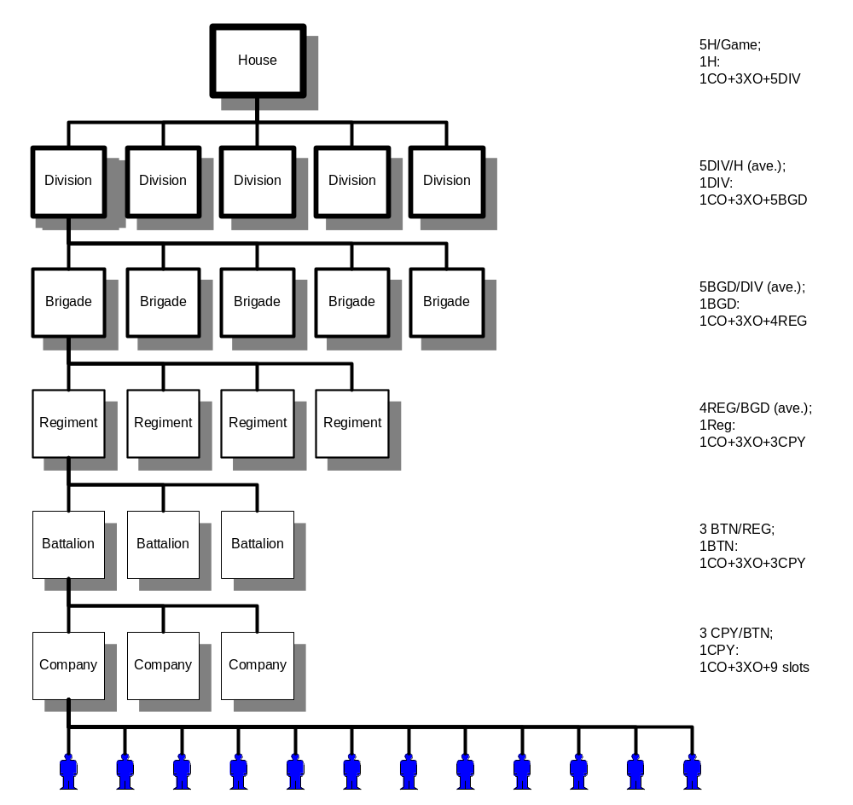

Table XX: Command Level Breakdown
Unit Type | # of Units in House | Commander Rank | # of Slots | # of Command Slots | Abilities
House | 1 | 60 | 11,662 | 2 | Diplomacy / War
Division | 5 | 50 | 2,332 | 10 | Ally Supply/Hex Transfer
Brigade | 25 | 40 | 466 | 50 | Multi-planet Selection
Regiment | 100 | 30-35 | 116 | 200 | Hex / Planet Movement (as Regiment)
Battalion | 300 | 20-29 | 38 | 600 | Hex / Planet Movement (as Battalion)
Company | 900 | 10-19 | 12 | 3,600 | Hex Movement (as Company)

2.3.2.1. Companies

Companies (CPYs) are the smallest permanent unit in the game. A Company is composed of 12 player slots. One of these slots is reserved for the CO and three more are reserved for XOs. The other eight are for grunts.

Companies are intended to be the basic community element that forms a House. A player's companions while running missions are likely to be drawn from his company. His company officers are likely to serve as his mentors once he's past training, thereby increasing community bonds once the people disperse across the House to fulfill other responsibilities. In a tribal sense, the company represents a hunting party or one's immediate family.

2.3.2.1.1. Officers

Every company has a commanding officer (CO) and three executive officers (XO). These officers have the responsibility for maintaining activity on the operational level of planetary combat by moving the company from hex to hex.

If all CPY officer positions are filled and an organizational structure implemented on the unit level, each officer will have three people reporting to him.

2.3.2.1.2. House Standing Requirement

Every company has a House Standing requirement which prevents players with House Standing lower than the threshold from joining the company. Some units are elite and don't accept average MechWarriors into their ranks.

House Standing allows players to group together along lines determined by dedication to the House. There are three levels: Open, Restricted, and Elite.

If a player attempts to join a unit and does not meet the House Standing minimum, he is informed he doesn't meet the recruitment requirements of the unit. If a member's House Standing drops below the next lower level, he is disqualified from membership in the unit and is sent to the reserves.

2.3.2.1.3. Command Abilities

The CPY officer has the following command abilities:

Planetary Hex Movement - may move the CPY on the planetary hex map as covered in Planetary Assaults.
Drop with Trainee – an officer may drop into a training mission to assist a new player as needed.
Hire/Fire subordinate – can change a subordinate grunt or officer's current command to a different subordinate command position. CPY XOs have no subordinate command positions to which they can appoint a grunt.

2.3.2.2. Battalions

Battalions (BTNs) have 38 people associated with them: 3 companies of 12 members apiece plus the two BTN officers.

BTNs will serve as the first link tying people into the greater whole of the House. BTNs are the smallest unit that can be landed on a planet, so most of the company grunt's running companions who are not in the same company will probably be from within his BTN. In a tribal sense, the BTN represents an extended family.

The BTN officer is serving to execute the will of higher-level officers. He is coordinating mission activities with each of his companies and lending a direct hand more often than any other "senior" officer. When he's not running missions he is probably observing strategic decision-making and checking planetary intel reports for anything unusual.

2.3.2.2.1. Officers

There is one CO and one XO for the BTN. They are supernumerary and must operate with a company (q.v.) in order to run missions. BTN officers are responsible for coordinating their company activities and may move their subordinate companies across interstellar space as well as planetary hexes.

2.3.2.2.2. Command Abilities

The BTN officer has the following command abilities:

Planetary Hex Movement – May move a subordinate unit on the planetary hex map as covered in Planetary Assaults.
Interstellar Movement – May move a subordinate unit to a different star system as covered in Interplanetary Travel.
Drop with Trainee – an officer may drop into a training mission to assist a new player as needed.
Hire/Fire subordinate – can change a subordinate grunt or officer's current command to a different subordinate command position.

2.3.2.3. Regiments

Regiments (REGs) have 116 people associated with them: 3 BTNs of 38 members apiece plus two REG officers.

The REG edges toward the limits of organizations people can readily identify with. The REG serves as a "tribe" within a larger "clan" entity, the House. Rivalries may exist between subordinate BTNs, but all to make a REG superior to all others in performance. A player will be associated with a REG while he's running, whereas the BTN and CPY details are important only to commanders running the tactical operations. In a tribal frame of reference, the REG is a clan of related families.

The REG officer has to manage his subordinate commands and will often be directing planetary strategy for the House when possible. He passes along significant data to the higher officers and wins ground by coordinating the activity of his CPYs.

2.3.2.3.1. Officers

There is one CO and one XO for the REG. They are supernumerary and must operate with a company (q.v.) in order to run missions. REG officers are responsible for coordinating their company activities and may move their subordinate companies across interstellar space as well as planetary hexes. They are also empowered to initiate hostilities on a planetary scale.

2.3.2.3.2. Command Abilities

The REG officer has the following command abilities:

Planetary Hex Movement – May move a subordinate unit on the planetary hex map as covered in Planetary Assaults.
Interstellar Movement – May move a subordinate unit to a different star system as covered in Interplanetary Travel.
Assault a Planet – may initiate hostilities on an enemy planet as covered in Planetary Assaults.
Drop with Trainee – an officer may drop into a training mission to assist a new player as needed.
Hire/Fire subordinate – can change a subordinate grunt or officer's current command to a different subordinate command position.

2.3.2.4. Brigades

Brigades (BGDs) have 446 people associated with them: 4 REGs associated with them plus two BGD officers.

The BGD is a means for players to identify themselves as within a discrete grouping of the House's warriors. Members of REGs in other BGDs are not likely to know each other well unless they take part in multiple campaigns together. BGDs are probably beyond the size where most people can relate themselves personally to an organization.

The BGD officer has to be able to filter and pass onward data relevant to strategic operations for the DIV officers. He also has to react to those items he is not passing along and handle them long enough for the greater strategic picture to be analyzed by higher level officers.

2.3.2.4.1. Officers

There is one CO and one XO for the BGD. They are supernumerary and must operate with a company (q.v.) in order to run missions. BGD officers are responsible for coordinating the activities of their REGs in low-level strategic operations.

BGD officers may hire and fire subordinate COs. The BGD CO has the added responsibility for firing/hiring the BGD XO. New officers must be from within the unit they are to lead or the reserves. If the BGD's subordinate CPYs are filled, a fired officer is automatically sent to the reserves.

2.3.2.4.2 Command Abilities

The BGD officer has the following command abilities:

Planetary Hex Movement – May move a subordinate unit on the planetary hex map as covered in Planetary Assaults.
Interstellar Movement – May move a subordinate unit to a different star system as covered in Interplanetary Travel.
Assault a Planet – may initiate hostilities on an enemy planet as covered in Planetary Assaults.
Identify Targets - The BGD officer may toggle planets to serve as targets in a campaign. The maps of subordinate officers display these identified planets until they are captured or toggled off. Missions can only be run on selected planets. If no planet is selected as a target, missions can be run anywhere.
Drop with Trainee – an officer may drop into a training mission to assist a new player as needed.
Hire/Fire subordinate – can change a subordinate grunt or officer's current command to a different subordinate command position.

2.3.2.5. Divisions

Divisions (DIVs) have 2332 people as part of the organization: 5 BGDs of 466 people each plus two DIV officers.

The DIV is a means for the House to address strategic needs, such as large-scale defenses and attacks. It is a larger organization than people can identify with personally. For the average player, the Division is a large chunk of the House population within which his role and his status is known. The DIV might not move as a cohesive entity very often, but it serves to help segregate and clearly define responsibilities for lower level commanders during large-scale operations.

These people will tend to be able to assimilate information from many disparate sources and feed that information back into strategic operations. They have no more than six direct reports (one from each subordinate BGD).

2.3.2.5.1 Officers

There is one CO and one XO for the DIV. They are supernumerary and must operate with a company (q.v.) in order to run missions. DIV officers are responsible for coordinating high-level strategic activities of their House.

2.3.2.5.2 Command Abilities

The DIV officer has the following command abilities:

Planetary Hex Movement – May move a subordinate unit on the planetary hex map as covered in Planetary Assaults.
Interstellar Movement – May move a subordinate unit to a different star system as covered in Interplanetary Travel.
Assault a Planet – may initiate hostilities on an enemy planet as covered in Planetary Assaults.
Identify Targets - The DIV officer may toggle planets or hexes to serve as targets in a campaign. The maps of subordinate officers display these identified planets or hexes until they are captured or toggled off. Missions can only be run on selected planets. If no planet is selected as a target, missions can be run anywhere.
Supply Ally – permits an a House set as an ally to use a controlled planet as though it were theirs for purposes of supply determination.
Planetary Hex Ownership – transfers ownership of a friendly hex to a House set as an ally. That hex has all the characteristics of a recently-captured hex for all purposes.
Drop with Trainee – an officer may drop into a training mission to assist a new player as needed.
Hire/Fire subordinate – can change a subordinate grunt or officer's current command to a different subordinate command position.

2.3.2.6. House

Houses have 11662 people as part of the organization: 5 DIVs of 2332 people each plus the House Leader and House XO.

2.3.2.6.1 Officers

There is one CO ("House Leader" or "HL") and one XO ("HXO") for the House. They are supernumerary and must operate with a company (q.v.) in order to run missions. House Leaders and XOs are responsible for making and breaking alliances with other Houses and setting policy for all House behavior.
The HL and HXO may hire and fire subordinate COs. The HL has the added responsibility for firing/hiring the HXO. New officers must be from within the unit they are to lead or the reserves. If the House's subordinate CPYs are filled, a fired officer is automatically sent to the reserves.

2.3.2.6.2 Command Abilities

The House officer has the following command abilities:

Planetary Hex Movement – May move a subordinate unit on the planetary hex map as covered in Planetary Assaults.
Interstellar Movement – May move a subordinate unit to a different star system as covered in Interplanetary Travel.
Assault a Planet – May initiate hostilities on an enemy planet as covered in Planetary Assaults.
Identify Targets – The House officer may toggle planets or hexes to serve as targets in a campaign. The maps of subordinate officers display these identified planets or hexes until they are captured or toggled off. Missions can only be run on selected planets. If no planet is selected as a target, missions can be run anywhere.
Supply Ally – Permits an a House set as an ally to use a controlled planet as though it were theirs for purposes of supply determination.
Planetary Hex Ownership – transfers ownership of a friendly hex to a House set as an ally. That hex has all the characteristics of a recently-captured hex for all purposes.
Set Alliances – May set other Houses to "Ally" or "Enemy." Houses change to enemy any time they attack the officer's House and alert the leader to that change. Setting changes do not normally send notification of the change in status. Settings are visible to all House officers.
Identify War Game Targets – May designate planets upon which a House set to ally may assault. The central "control" hexes of such a planet may never be taken. When the ally removes all units from the planet, all hexes revert back to the original owner. Experience is earned at one third the normal rate.
Drop with Trainee – an officer may drop into a training mission to assist a new player as needed.
Hire/Fire subordinate – can change a subordinate grunt or officer's current command to a different subordinate command position.

2.3.2.7. The Reserves

The reserves are a catch-all unit that does not appear on the House's TO&E. Players are assigned to the reserves under the following conditions:

- They resign from active service
- They are sent to the reserves for inactivity (players & scripts)
- They are fired from a command position and they do not qualify for any slots in the unit(s) formerly in his command

The reserves may not be moved. A player in the reserves may join any company upon his return to the game and may run missions by operating with a company normally.

2.3.2.8 Espionage Units

Liao is at a disadvantage militarily because of the vulnerability of their supply planets and capital. House Liao has five units called "espionage units" which can assist in the gathering of intel for the war effort. They do not appear on any House rosters but the one the Chancellor sees, and they are subordinate only to the Chancellor, not even his executive officer. There are five espionage units.

2.3.2.8.1 Special Rules

An espionage unit (ESP) differs from companies and any other unit in the following ways:

CO only – there are no additional slots besides that of the CO.
Cannot be operated with – No player may operate with the ESP.
Movement behind the lines – the ESP may move into any hex on the planetary map.
Ignore stacking restrictions – the ESP ignores stacking restrictions.
Stealth – the ESP is completely masked from the enemy and does not appear on hex or planetary unit counts, even when in the same hex as the enemy.

2.3.2.8.2 Officers

There is one commanding officer of an espionage unit. The ESP CO appears to be a member of the Reserves on all rosters. He can be drawn from any unit in the House.

2.3.2.8.3 Command Abilities

The ESP CO has the following abilities:

Planetary Hex Movement – May move the ESP on the planetary hex map as covered in Planetary Assaults.
Interstellar Movement – May move the ESP to a different star system as covered in Interplanetary Travel.
Change hex ownership – once every 24 hours, the ESP CO may change the ownership of any unoccupied hex the ESP unit is in to that of another House that has units on-planet.

2.4. Planetary Assaults

In order to win the larger war for control of the Inner Sphere, a House must first win smaller wars for control of individual planets. Taking a planet is not trivial and requires the coordination of hundreds of players running combat missions on the planet. Running successful missions allows the attacker to gain territory and the defender to keep territory. The goal of a planetary assault is to gain control of the planet’s capital. By controlling the capital, the House broadens its sphere of influence by opening up supply lines deeper into enemy space.

In this section, we refer to the officer currently in control of a unit as the commander. The commander can be the CO or XO of the unit. Commanders at the Regiment level and below are primarily responsible for the management of a planetary assault. A Regimental Commander or higher is required to initiate the assault.

2.4.1. Planetary Map

In Multiplayer Battletech: 3025, the surface of a planet is represented by a hex grid like the one depicted below. The colors of the hexes signify who currently controls that hex. A hex is always controlled by somebody; there are no neutral hexes.

The hex in the center of the map is the planet’s capital. Taking over the capital opens the flow of supply for the larger interplanetary conflict. Controlling the capital also effects the flow of planetary supply (see Planetary Supply Lines, below).

There are a total of 169 hexes on the map.

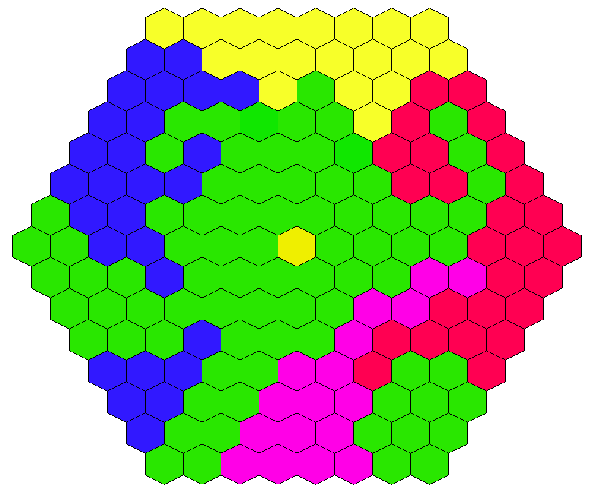
Planetary Map

Planetary Map Color Key
- Red – Kurita
- Yellow – Davion
- Blue – Steiner
- Green – Liao
- Purple – Marik
- Gold – Planet Capital

2.4.2. Unit Combat

To take control of a planet, an attacking force must start from the edge of the map and fight their way inward to the capital. Defending forces must start in the capital and move outward. The shortest path from the edge of the map to the center is eight hexes. This means that an attacking force must take control of at least seven hexes to reach the capital.

2.4.2.1. Hex Balance

Hex Balance is an abstract representation of the “balance of power” within a hex. This balance of power shifts as one House runs successful combat missions against another House. Hex Balance is measured in Hex Balance Points. Running successful combat missions earns Hex Balance Points, running unsuccessful missions loses Hex Balance Points.

The number of Hex Balance Points is constant. This means that if one side gains points by running a mission, another side is losing that same amount of points. There are a total of 10,000 Hex Balance Points per hex. The initial owner of the hex starts with all 10,000 points.

When a side acquires 6,000 Hex Balance Points (60% of the hex) they gain control of the hex. Controlling a hex allows units to move through the hex, it also opens up the flow of supply. (see sections 2.4.3. and 2.4.4. below) The last side to have 6,000 points keeps control of the hex until another side acquires 6,000 points.

If a side’s Hex Balance goes to zero, they are forced to retreat from the hex. (see 2.4.2.4. Retreating, below)
They may regroup and re-assault the hex or choose another target.

2.4.2.2. Assault Bonus

When a unit assaults a hex, they are given a one time, 500 point (5% of the hex) bonus. This is called the Assault Bonus. From this 500 point foothold, an attacking force must quickly win some missions to avoid being driven from the hex. Assaulting a well fortified and well trained enemy is very difficult -- the defender has an inherent advantage.

2.4.2.3. Mission Value

The number of Hex Balance Points a mission is worth is determined by two factors: the number of BattleMechs that are involved in the mission and the length of time the winning unit has been in the hex. The amount of time that a unit has been in a hex determines its “maturity modifier.” Basically, units do not come up to full strength until they’ve been in a hex for more than half an hour.

Base Mission Value = ( Number of Attackers + Number of Defenders ) * 4

Mission Value (PvP) = Base Mission Value * Winner’s Maturity Modifier

Fighting non-player opponents yields less points then fight player opponents. The Mission Value for a mission run against drones is divided by two. This offsets the fact that players will more than likely win against drones.

Mission Value (PvNP) = (Base Mission Value * Winner’s Maturity Modifier) / 2

The Mission Value is subtracted from the losing side’s Hex Balance and added to the winning side’s Hex Balance. If the losing side has less Hex Balance Points than the Mission Value, the winning side gets all of the losing side’s remaining Hex Balance Points and the losing side must retreat from the hex.

Maturity Modifiers
Maturity Level | Time in Hex | Maturity Modifier
Setting Up | Less than 16 minutes | 0.50
Digging In | Less than 31 minutes | 0.75
Fortified | 31 minutes or more | 1.00

2.4.2.4. Retreating

When a House now longer controls a portion of the Hex Balance for a hex, all units of that House are forced to retreat from the hex. The units have been completely overrun, the enemy is at their gates, they must be evacuated via dropship to space. Retreating units suffer the normal time penalty of moving to from the planet’s surface to space.

2.4.3. Unit Movement

Regiments, Battalions and Companies can move as a unit on the map. Units can only occupy a hex in which their side has hex balance. Moving a unit takes time, depending on how far the unit is moving. A time penalty is necessary in order to make tactics such as feints, flanking, and ambush possible. If moving a unit takes no time, there is no commitment of forces, and hence, no strategy.

The rules for unit movement are as follows. Units can move through a hex that is controlled by their House or into a hex that is adjacent to a hex controlled by their House. If the House does not already control a portion of the hex balance for the hex, the House is given the initial Assault Bonus described above. From a hex that a unit’s House does not control, a unit can only move to a hex their House does control or to space.

Units travel at a rate of 1 hex every 5 minutes. If a unit’s destination is more than 3 hexes away, the unit is “airlifted” to the destination hex. An airlift takes 15 minutes, regardless of the distance traveled. In other words, the maximum travel time for a unit travelling from hex to hex is 15 minutes.

When the order is given for a unit to move, it must first wait for any members of the unit that are running combat missions to complete their missions. Members of the unit cannot start new missions during this period. When all of the members of the unit have completed their missions, the unit moves as a whole. The unit cannot run missions until it reaches its destination.

2.4.3.1. Space Movement

Units can also be moved from space to the planet’s surface and vice versa. When a unit first arrives in a system, it is located on a JumpShip. It takes 5 minutes to travel from a JumpShip to the planet’s surface. Units are not dropped directly onto their destination hex. They must first land in a safe area and travel by land or air from there to where the action is.

If a unit’s House does not control the capital, the unit must start on a outer hex. From there, they automatically travel to their final destination, normal movement rules apply. If their destination is more than 3 hexes away from an outer hex, it will take another 15 minutes to move there. In other words, the maximum time it can take to go from a JumpShip to a contested hex is 20 minutes.

If a unit’s House does control the capital, the unit must start in the capital hex. They move from there to their final destination in the same manner as described above.

2.4.3.2. Jumpships

Jumpships are virtual locations which are created when units leave the planet’s surface or arrive via JumpShip from another system. There are as many JumpShips as there are units moving as a group.

A unit can leave the planet at any time via dropship. However, only a Senior Officer can call for a Jumpship and move a unit from one planet to another. Interplanetary Travel in discussed below.

2.4.3.3. Stacking Limit

The Stacking Limit is the maximum number of units from a single House that can move into a hex. When this limit is reached, the hex is considered “full” for that House. Other Houses may still move units into the hex, provided that they have not reached their stacking limit as well. A hex is considered full for a particular House when it contains 9 companies. Since each company contains a maximum of 12 players and up to five houses can be present in a single hex, the maximum number of players in a hex is 540.

While a unit is moving, it does not effect the stacking limit of the hexes it passes through. Units are allowed to move through a full hex on their way to another hex. A unit can stop moving if the hex it is currently passing through isn’t full.

2.4.4. Supply Lines

A crucial part of the Planetary Assault game is the concept of Supply Lines. Supply lines provide supply for units in the field. A unit is considered “in-supply” when it is connected to a supply line and “out-of-supply” when it is not. A supply line is formed by a series of controlled, adjacent hexes leading back to a source of supply. For the controller of the capital, the source of supply is the capital. For everyone else, it is any hex on the outer ring.

If the unit’s House does not control the capital, it must control a series of adjacent hexes from its current position to an outer hex to be in-supply. If the unit’s House does control the capital, it must control a series of adjacent hexes from its current position to the capital to be in-supply.

Planetary Supply Lines are dependent upon Interplanetary Supply Lines, which are discussed below. If the planet itself is not in-supply, then units on the planet are automatically out-of-supply.

2.4.4.1. Effects of Supply

Units which are in-supply have full access to parts and materials for maintaining their Battlemechs. In game terms, players who are operating with a unit in-supply have access to all of the mechs their rank qualifies them for. When a mech is damaged in combat, it is automatically repaired.

Units which are out-of-supply cannot repair their Battlemechs. When a player in an out-of-supply unit has his Battlemech damaged, it stays damaged. When the player’s Battlemech is destroyed, it is taken off of list of ‘Mechs to choose from. The exception to this rule is the last Battlemech on the player’s list. When this ‘Mech is destroyed, the player is given a replacement ‘Mech which is randomly damaged. When a unit gets back in-supply, their ‘Mechs are repaired and their ‘Mech List is returned to normal.

2.4.5. Intelligence

What a unit commander can and can’t see has a major impact on game balance and for this reason we cover it here in the Game Mechanics section. Commanders can see which House controls any hex on the map and what the Hex Balance is in the hex. Commanders can also see:

- The position and name of every unit in their House.
- The position of enemy units in hexes that their House controls.
- The position of enemy units in hexes adjacent to hexes their House controls.
- The position and name of enemy units in hexes where a unit from their House is present.

2.4.6. Climate

Each hex on the planetary map has a climate value associated with it. This value determines the type of climate units will encounter when running combat missions in the hex. The table below lists the different climate and their effects.

Terrain Types
Terrain Type | Effect
Desert | Hottest
Tropical | Hot
Temperate | Niether hot nor cold
Arctic | Cold

2.5. Interplanetary Combat

2.5.1. Interplanetary Supply Lines

Interplanetary supply lines serve two purposes with regards to units. A supply line is what is used to determine if an assaulting House's units (mechs) are "in supply" or "out of supply" while located on a planet (see Supply Lines in the Planetary Assaults section). Interplanetary Supply lines are also used to determine if a unit can move on a JumpShip from its current planet to a different planet within the Inner Sphere.

If a House occupies the central hex of a planet, the House is allowed to use that planet for purposes of interplanetary supply lines. This planet is now called a "supply planet" for the controlling House and its allies. A line of supply will then exist between the supply planet and all other planets within 30 light years for the controlling House.

Interplanetary Supply lines must begin at either the House Capital planet or a House Depot planet. To determine if a planet is considered in-supply, a supply line must be able to be generated from that planet all the way back to the Capital planet or a Depot planet. If a link in this chain is broken, supply is cut to every planet after that link.

Division Commanders may designate planets to act as supply planets for an ally including the House Capital and depot planets. The ally still must use its own Capital and Depot planets as the starting points for its interplanetary supply lines.

2.5.2. Interplanetary Travel

Units move between planets via JumpShips. Jumpships are transport ships used to carry a House's mechs. Jumpships travel by making a series of "jumps" from the starting planet to the destination planet. Jumpships may travel a maximum of 30 light years per jump. Jumpships will always make the minimum number of jumps to a destination unless otherwise directed. Jumpships can only move to a planet that is 30 or less light years away from a House supply planet. Jumpships may only move from a planet that is in supply. An exception to this rule exists for retreating from a planet and is described later. Jumpships must stop after each jump to refuel/recharge its engines to allow the JumpShip to make another jump. This recharging time takes 5 minutes.

2.5.2.1. Basic Interplanetary Unit Movement Example

Figure 1 contains four planets separated by the distances indicated in light years. For this example, an assumption is made that a supply path exists between planet A and a Depot planet. A House controls the central hex of planets A and B which makes these two planets supply planets for the House. The House wants to move units already on a JumpShip orbiting planet A to planet C. This "trip" will take two jumps (planet A to planet B and then planet B to planet C) since the distance between planet A and planet C is greater than 30 light years.

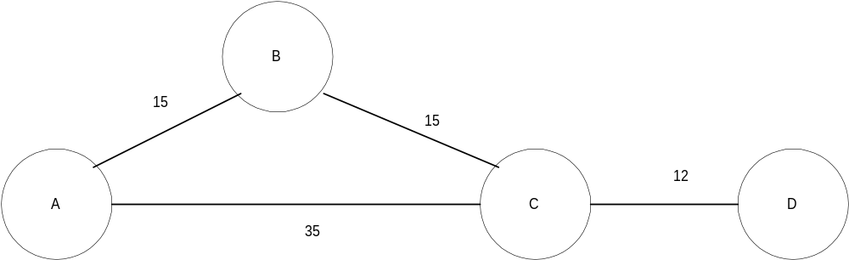

Figure 1

If a House's units are forced to retreat from a planet that currently is out of supply for a House, the JumpShip will make a series of jumps that will take it to the nearest House planet that is in supply. Once a JumpShip begins retreating, it may not be used to launch an attack on another planet until it has first reached a planet that is in supply for the House. The "path" that a retreating JumpShip takes will be to the closest House planet. This path is automatically regenerated after each jump. The recalculation is necessary due to the possibility of supply lines being created or lost when any planet changes possession to a different House.

For example, say a House (the defending House) controls the central hex on Planets A, B, C, and D in Figure 1. The defending House also controls a planet off the map which allows Planet A to be in supply that is safe from attack by another House. There are no other nearby planets. Another House (the attacking House) launches a devasting attack on Planets C and D. Planet C's central hex is captured by the attacking House thus cutting the supply lines to planet D. The defending House also suffers massive territorial losses on Planet D also and decides that it wants to retreat its units off of the planet. Once the "retreat" order is given to the JumpShip, the JumpShip will see that the closest House planet in supply is Planet B. The JumpShip will make two jumps (from Planet D to Planet C and from Planet C to Planet B). Even if Planet B was captured by another House, the retreating JumpShip will stop at Planet B and now the units the JumpShip contains may me used to assault Planet B or be moved to another planet since Planet B is "in supply".

Whenever a JumpShip is orbiting a planet, units may leave the JumpShip to travel to the surface. There is a 5 minute travel time to the surface from the JumpShip. This "drop time" is then added to the movement time it would take the unit to reach the desired hex. If a House's JumpShip is orbiting a planet the House does not control and a Regiment commander for the "assaulting" House has not given an assault order for this planet, House units on the JumpShip may not travel to the planet's surface.

2.5.3. ComStar Interdiction

A ComStar Interdiction occurs when one House has been subjugated by another House. Subjugated is defined as no longer able to mount a coherent and sustainable offensive to recapture lost territory without being detrimental to the House community. We don't want players to start leaving a House because it is constantly losing since House community development is a core goal of the game. A ComStar Interdiction is handled by the Product Support staff and takes effect during the morning maintenance cycle of the game.

A ComStar Interdiction is designed to restore a House to its initial settings. When the game is initially started, each House will control planets that are considered its "original planets". All of a House's units are deployed on the House's original planets when the game is started (initial starting deploy areas). When a Comstar Interdiction occurs, all of a House's original planets are restored to that House and all of the House's units are returned to their initial starting deploy areas regardless of where they are located in the Inner Sphere during the ComStar Interdiction.

All units not belonging to the House that is being "Interdicted" located on planets that are being returned to the "Interdicted" House, will return to their initial starting deploy areas. If the case exists where these initial starting deploy areas are not in control of the House, the units will be sent to closest hex location. Hex stacking limits are considered in determining the closest hex location.

Multiple Houses can be Interdicted at the same time if Product Support determines it is in the best interest of the game. Most likely though if more than one House is interdicted, all of the Houses will be interdicted and the entire game will be reset.

3. Combat Missions

This section describes the missions available to players in a combat hex and their relation to the players' record and the hex balance. It is intended to encompass all features needed, from interface changes in the role-playing and combat shells to the rank points awarded to a player in combat.
Features which refer to future versions are included to allow the technical designer insight into how best to prepare for the inclusion of those features to make maintenance easier at minimal development cost now.

The overall requirements the combat missions must satisfy are:

- Maximize player vs. player conflict in matchmaking and incentives. No other requirement is as important as this.
- The variety a player encounters while running missions should be maximized.
- Rank advancement as a result of missions should be fast enough at lower ranks to keep players involved and slow enough to make advancement to the next major rank a worthy rite of passage.
- The systems used should be simple to understand, design, and code. When possible the systems should use host configuration files to permit easy tuning of the numbers involved.

3.1. Mission Preparation

Mission Preparation is comprised of the functions on the host and client which occur before mission launch and affect the parameters of the mission and the preparation of the players.

3.1.1. Match Making

Matchmaking is the key feature of the 3025 mission system. The matchmaking system needs to
- maximize the number of players running missions against other players
- provide mission variety
- minimize the ability for players to run only those mission types they believe are optimal
- minimize the players' ability to predict whether or not their opponents are human

3.1.1.1. Wall Clock Method

To maximize player vs. player conflict it is necessary to have some degree of control over when the missions begin. This synchronization has to be fast enough so that the players won't feel held back yet slow enough to allow players to read, understand, and prepare for the mission objectives.

Because the end time of a mission is predictable yet variable based on the actions the players take, the start times are critical in matching up players. When there are few players in a hex each ready room needs more time between missions to maximize the chance that each group of players is ready at the same time. More players in a hex typically means a greater chance at any given time for players to be ready for another group of players, so the time between mission starts is shorter.

Players in the ready room can see the time remaining before the next set of missions begins. This is to prevent players from indicating they are ready for a mission and then finding out that there is only a little bit of time left to prepare for the mission.

If two ready rooms have been matched together and both rooms have finished all of the pre-combat activities (briefing, selecting 'Mechs, etc) and are ready for combat, they will drop into combat together even if the wall clock timer has not ended yet. This will prevent two ready rooms that are ready to fight quickly from having to wait all the way for the wall-clock timer to count down.

3.1.1.2. Mission Assignment Rules

When a ready room is issued a mission and the mission briefing data is generated, the host records the mission information as a mission assignment. This information is stored in a list of active ready rooms that each have no opposing ready room, which is the basis for new missions for the opposing side. Each time a ready room is formed and requests a mission, the host checks to see if any enemy ready rooms that have been issued a mission are not matched up.

The rules for mission assignment are simple:

- If there are no opposing ready rooms and it does not have a mission assignment, the ready room receives a random mission from the set of mission types available for this hex.
- If there are opposing ready rooms and it does not have a mission assignment, the ready room receives a mission that opposes a randomly-selected ready room's mission.
- If there are no opposing ready rooms and it has a mission assignment, the ready room gets that mission.
- If there are opposing ready rooms and it has a mission assignment, the ready room gets matched with a ready room that has the opposing mission assignment.
- If a ready room loses a partner and is not matched up with another partner, the ready room runs the mission against drones.
- If a ready room receives a mission assignment then cancels the mission, the ready room keeps the assignment but does not appear on the active ready room list. If it has an opposing ready room, that room now appears on the list of active ready rooms.

An "opposing ready room" is a ready room controlled by the enemy House(s), which is any non-allied and non-friendly House.

A "mission assignment" is defined when a ready room requests a mission. The ready room is assigned a mission type. The mission assignment stays with the ready room until the wall clock ticks a new mission, even if the ready room again requests a new mission.

3.1.2. Mission Generation
This section contains all the information needed to assemble a mission.

3.1.2.1. Climate
Climate controls the temperature in and artwork used to create the arena. The climate is determined when the mission briefing is generated based on parameters supplied by the hex. Each hex has a climate constrained by the planet's characteristics.
The possible climates are:

Desert Hottest
Tropical Hot
Temperate Not Hot or Cold
Arctic Cold

3.1.2.2. Mission Briefing

These are the parameters defined when the mission briefing is generated and displayed.

3.1.2.2.1. Assign Type & Side to Each Ready Room

The type of mission (Recon Location, 'Kill All Mechs, etc.) and the ready room's role is assigned when the players receive the briefing. A ready room receives either Side A (the burden to accomplish the mission goal is usually on Side A) or Side B.
The mission type assigned is based on the hex balance the attacker of the hex possesses. The range of hex balance the controller has determines the stage the attack on the hex is in. Each mission can be run during any stage of the attack but has different probabilities of appearing.

Stage 1 If the hex attacker has a hex balance < 20%, missions for Side A tend to be of the recon location/object and destroy object variety.
Stage 2 If the hex attacker's hex balance is >= 20% and < 40%, missions for Side A tend to be of the recon object/'Mech, traverse terrain, and destroy object/'Mech variety.
Stage 3 If the hex attacker's hex balance is >= 40% and < 60%, missions for Side A tend to be of the destroy object/'Mech/all 'Mechs variety.

Probabilities Table
Mission Type | Stage 1 | Stage 2 | Stage 3
Destroy All 'Mechs | 5 | 15 | 25
Destroy 'Mech | 5 | 10 | 25
Destroy Object | 15 | 20 | 15
Recon Location | 25 | 10 | 5
Recon 'Mech | 10 | 15 | 15
Recon Object | 25 | 10 | 5
Traverse Terrain | 15 | 20 | 10
Sums | 100 | 100 | 100

Side A's Briefing
The descriptions will vary. These are samples.
"Your mission is []"
[to destroy all opposing 'Mechs.]
[to destroy a 'Mech with a VIP aboard.]
[to destroy an important building.]
[to take sensor readings at a location on the battlefield.]
[to scan a BattleMech.]
[to take readings on a building at an important enemy location.]
[to reach a location on the battlefield.]

Side B's Briefing
The descriptions will vary. These are samples.
"Your mission is
[to destroy all opposing 'Mechs.]
[to keep a VIP in one of your 'Mechs alive; we will assign the VIP just before you depart.]
etc.

3.1.2.2.2. Assign Objective & Location

Every objective of a mission has a location and description. Side A receives a direction in which they should head to achieve the mission goal. Side B receives the probable location of enemy incursion. Both sides receive a description of the objective building.
"Destroy All 'Mech" missions have no additional objective description.

Location

The location always refers to one of the eight major compass directions and never to the distance to the objective or enemy. The starting location of both sides is assigned when the briefing is handed out and passed to the mission generation routine at combat run-time.
North is always located at the top of the arena as displayed on the overhead map. This corresponds with compass heading 360/0 degrees.
Example briefing text: "The objective is located in the North East sector of the engagement area."

Building

Building artwork and names are drawn from the set of buildings created and defined. The building information used in the generation of the mission is randomly selected from that set of buildings. All buildings are structurally similar for ease of definition and all share the same range of damage they can take before being destroyed.
This requires the addition of buildings that can be destroyed to the combat shell.

3.1.2.2.3. Define Victory Conditions

Each mission either has a single objective or multiple objectives. The players are briefed on what objective(s) must be completed in order to win the mission. When one side achieves the victory conditions, the mission ends.

Single Objective

There is only one mission objective for each side.

Inverse Objective
Each side has one objective which is the inverse of the other side's objective. When one side achieves its objective, the other side automatically fails.

Shared Objective
Each side has one objective which is the same as the other side's objective. When one side achieves the objective, the other side automatically fails.
Only the "Destroy All 'Mechs" mission has a shared objective.

Unique
Each side has an objective that is independent of the other side's. Each side's goal is not just to achieve its own objective but to prevent the other side from achieving theirs.

3.1.2.2.4. Determine the Mission Duration

The duration of the mission is defined for display in the briefing.
The default duration is 15 minutes, though it is a host configurable option. This information is displayed to the user.

3.1.2.3. Generating the Map

The map is generated in a specific order, described below. No object ('Mech, Mountain, Building, or Void) may be placed on any previously placed object.

1. Determine Arena Boundaries
The maximum arena boundaries are 4km x 6 km.

2. Placement of Objective
If the mission objective does not deal with a location or object, this step is skipped.
The objective can be placed no closer to any edge of the arena than 200 m.

3. Placement of Additional Buildings
The number of additional buildings & their locations must be determined at combat run-time. The number ranges from 0 to 5. Each building can be destroyed.
Additional buildings can be placed no closer than 100m to the edge of the arena and no closer than 20m to any other building.

4. Placement of 'Mech Starting Locations
'Mechs are placed at least 100m from the map's edge.
'Mechs start at least 10m from any building.
Side A is always placed first, since the objective's location is known and Side B's location depends on the objective's placement as well as Side A's starting location.

4.a. Missions with Mechs as Objectives

The distance between Side A and Side B is >100m and <= 3600m. The distance is randomly chosen and should be weighted to produce 3000m as an average distance. Shorter distances should occur with less frequency than high and mid-range distances.

Determination of the maximum distance is based on the following criteria:

- 'Mechs on an average have a maximum velocity of 60 Kilometers/Hour.
- Since both sides will move towards one another, the closure rate is 120 Kilometers/Hour.
- The maximum time it should take for the two sides to be in weapons range is 2.5 minutes.
- If it takes a maximum of 2.5 minutes to come within weapons range, the maximum distance is 3600m.

4.b. Missions with Other Objectives

The distance between Side A and the objective is >800m and <= 1800m. The most common distance is 1800m, with the shorter distances happening quite rarely. The distance is randomly chosen and should be weighted to produce 1500m as an average distance. Shorter distances should occur with less frequency than high and mid-range distances.
Determination of the maximum distance is based on the following criteria:
- 'Mechs on an average have a maximum velocity of 60 Kilometers/Hour.
- Since only one side will move towards one other side (the defending side will want to be near the object/mech/location that it is defending), the closure rate is 60 Kilometers/Hour.
- The maximum time it should take for the two sides to be in weapons range is 2.5 minutes.
- If it takes a maximum of 2.5 minutes to come within weapons range, the maximum distance is 1800m.

The distance between Side B and the objective is >10m and <=800m.
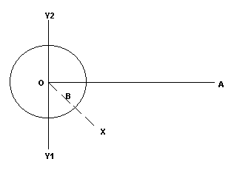

On the above picture, A is the starting location for Side A, B is the starting location for Side B and O is the starting location of the objective. (Note the above picture does not assume everything is in a "up is North" orientation.) The goal is to place B between A and O, but not always on the direct line between A and O. The circle around O represents the potential starting locations for B. After the objective (O) has been placed on the map, the starting location for A (A) is placed using the above rule that the distance between O and A is between 800m and 1800m. An angle is then generated randomly such that B is always on the same side of O as A is. The angle can be a maximum +/- 90 degrees. This angle is seen in the above picture as the angle between OX and OA. The length of line OX does not need to be known. The visual representation of these limits (+/- 90 degrees) are seen with Y1 and Y2. The distance between B and O is then determined (somewhere between 10m and 800m). B is then placed on the map along the line OX at its starting distance.

5. Placement of Voids

- Voids are spaces where no terrain can be placed in an overlapping position.
- Voids are allowed to overlap each other.
- Voids have radii no less than 20m and no larger than the distance between the center of the map and a corner. The average void size is 75m.
- There is no minimum or maximum distances between Voids.
- Objectives have Voids centered on them with a radius of 200m.
- Starting locations have Voids centered on them with a radius of 100m.
- Additional buildings have Voids centered on them with a radius of 100m.

6. Placement of Mountains

- Mountains may not be placed within 50m of the edge.
- Mountains can not be placed on top of an area declared as Void (see above).
- Mountains may not overlap a previously-placed mountain.
- The minimum and maximum number of mountains in Solaris need to be increased to 6 and 20.

3.1.2.4. Mission Type Descriptions

Each mission type has two opposing objectives; each is played by the different sides dropping into the mission.

3.1.2.4.1. Destroy a 'Mech

Side A is given the objective "destroy a specific 'Mech that will be identified in the mission." If that 'Mech is destroyed, Side A wins. The target is identified as "Target" and the target is always detectable, regardless of LOS.
Side B is informed that one of them is being hunted. They discover the target when they are in the mission. That target must stay alive throughout the mission or the side loses.

The mission ends when Side A has been destroyed, achieves the mission objectives, or the time limit expires.

3.1.2.4.2. Destroy (an) Object(s)

Side A is assigned a particular object to destroy. It is defined before the mission begins. If that object is destroyed, Side A wins. The general location of the object is identified by a waypoint in the area of the object.
Side B must prevent the destruction of that object. If the object is destroyed, Side B loses.
There can be multiple objects related to one another within a certain distance of each other. They should all be the same for ease of identification.

The mission ends when Side A has been destroyed, achieves the mission objectives, or the time limit expires.

3.1.2.4.3. Destroy All 'Mechs

Side A is assigned the task of eliminating all opposing 'Mechs while remaining alive. If Side A has operational 'Mechs at the end of the battle and Side B does not, Side A wins.
Side B is assigned the task of eliminating all opposing 'Mechs. If Side B has operational 'Mechs at the end of the battle and Side A does not, Side B wins.
If neither side achieves victory, no mission victory points are awarded.

The mission ends when Side A has been destroyed, achieves the mission objectives, or the time limit expires.

3.1.2.4.4. Traverse Terrain

Side A is assigned to reach a location on the opposite side of the combat area. They are "reinforcing units in another combat area" or something critical. If half of Side A (rounded up) makes it to the designated area, Side A wins.
Side B is assigned to prevent the enemy from reaching that location.

The mission ends when Side A has been destroyed, achieves the mission objectives, or the time limit expires.

3.1.2.4.5. Recon a Location

Side A must get a 'Mech within 200m of a point on the map and scan the area. Once the scan is complete, that member of Side A has to remain alive for 30 seconds (or until the mission timer ends) while transmitting the recon data. If they do, Side A wins. Ideally this ability would be restricted to certain 'Mechs. More than one 'Mech may be scanning or transmitting at the same time.
Side B must prevent Side A from completing the transmission..

The mission ends when Side A has been destroyed, achieves the mission objectives, or the time limit expires.

3.1.2.4.6. Recon a 'Mech

Side A must get within a certain distance of an opposing 'Mech 100m and scan it. Once the scan is complete, that member of Side A has to remain alive for 30 seconds (or until the mission timer ends) while transmitting the recon data. More than one 'Mech may be scanning or transmitting at the same time.
Side B must prevent Side A from completing the transmission..

Side B is told something we don't know yet. It might be "destroy all opponents" but they have to know they're being scanned.

The mission ends when Side A has been destroyed, achieves the mission objectives, or the time limit expires.

3.1.2.4.7. Recon an Object

Side A must get within 200m of an object and scan it. Once the scan is complete, that member of Side A has to remain alive for 30 seconds (or until the mission timer ends) while transmitting the recon data. More than one 'Mech may be scanning or transmitting at the same time.
Side B must prevent Side A from completing the transmission..

The mission ends when Side A achieves its goal, Side A has no more operational BattleMechs, or the mission timer runs out.

3.1.3. Player Mech Selection

3.1.3.1. Default Selection
The player's last used BattleMech serves as the default; it is stored for the current session only. If the player has no previous 'Mech selection, the default 'Mech for a player is the top 'Mech on his selection list.

3.1.3.2. BattleMech Availability
[INSERT TABLE OF MECH AVAILABILITY BY HOUSE AND RANK.]

3.1.3.3. Supply Issues
If a ready room is in a hex in supply, the players have access to all 'Mechs appropriate to their House and Rank and will start the mission with fully operational 'Mechs.

- If a ready room is in a hex that is out of supply, any 'Mech the players begin a mission with is randomly damaged. If a 'Mech is destroyed in combat, that 'Mech is removed from their selection list until the hex the player is running missions in is brought back into supply or the company is moved to a location in supply.
- If the player has only one 'Mech on the selection list, it can never be removed from the list and always starts out damaged (until the hex is brought back into supply or the company is moved to a location in supply).

3.1.4. Terrain Generation

This section describes how the terrain features are generated. Currently, the only terrain feature is mountains.

3.1.4.1. Mountains

Mountains are generated by selecting a radius for the mountain and then scaling it for the height. Mountains that are short will look like small rolling hills on the map.
The number of mountains appearing is a host configurable item.

3.1.5. Drone Configuration

This section describes how drone BattleMechs are chosen and controlled by AI.

3.1.5.1. Drone Selection

The drone 'Mechs will be chosen to maximize their chances of winning based on three parameters.

3.1.5.1.1. Available Enemy 'Mechs

Each drone represents a member of a company on the opposing side. That "slot's" 'Mech replacement table is the source of the possible drones. If there are no occupied slots, the replacement list appropriate to a CPY CO in that House is used.

3.1.5.1.2. Mission Type

Mission type drives the selection of drone opponents, as it hopefully will the choices of the players. Each mission calls for a table from which drones are drawn. The fastest drone should be about the same speed as the fastest player, and outweigh the player when possible.

Destroy a 'Mech
The range of 'Mechs is wide for drones on either side.

Destroy (an) Object(s)
On side A, drones will favor lighter faster 'Mechs.
On side B, drones will favor more heavily armed 'Mechs.

Destroy All 'Mechs
On side A, drones will favor more heavily armed 'Mechs.
On side B, drones will favor more heavily armed 'Mechs.

Traverse Terrain
On side A, drones will favor lighter faster 'Mechs.
On side B, drones will favor lighter faster 'Mechs.

Recon a Location
On side A, drones will favor lighter faster 'Mechs.
On side B, drones will favor more heavily armed 'Mechs.

Recon a 'Mech
On side A, drones will favor lighter faster 'Mechs.
On side B, drones will favor more heavily armed 'Mechs.

Recon an Object
On side A, drones will favor lighter faster 'Mechs.
On side B, drones will favor more heavily armed 'Mechs.

3.1.5.2. Drone AI

Drones will behave in ways that maximize their chances of winning the mission. Each mission calls for different behaviors.

The missions will call for a group AI passing priorities to each individual in the collective, and then will require that each individual work to accomplish those priorities.
A randomness factor needs to be considered for all drone actions such that drones will not always act the same given certain conditions.

3.1.5.2.1. Group AI General Rules
These rules govern how the drones function as a lance.
Drones on Side A have two modes of lance behavior: near the objective, getting to the objective.
Drones on Side B have one mode: defend objective.

3.1.5.2.2. Individual AI General Rules
Individual rules govern how each drone overcomes enemies and terrain. They will handle target identification and selection, threat assessment, and pathfinding.
Each of these example rules represents the ideal effects the AI controlling a drone will strive to achieve.
- Plot course to objective.
- Move to the optimal attack range (highest drone current damage potential vs. player current damage potential) (90m, 270m, 450m, 540m, 630m, 720m).
- Avoid shutting down.
- Shoot the legs of any opposing 'Mech.
- Shoot the center torso of any legged Target.
- Shoot the center torso of any 'Mech in range.
- Achieve objective.

3.1.5.2.3. Mission-Specific AI Goals
These are the general goals for drones within a mission of that type.

Destroy a 'Mech
Side A wants to find, move to and destroy a specific player BattleMech. The group will find the shortest path with the least opposition. If there is an opportunity to destroy the Target, it will take it.
Side B wants to protect the Target by employing appropriate formations and destroying any 'Mechs that approach.

Destroy (an) Object(s)
Side A wants to find, move to and destroy a stationary objective. The group will find the shortest path with the least opposition. If there is an opportunity to destroy the Target, it will take it.
Side B wants to protect the Target by employing appropriate formations and destroying any 'Mechs that approach.

Destroy All 'Mechs
Side A wants to coordinate drone activities to concentrate firepower on one 'Mech at a time until each is destroyed, based on some sort of group threat assessment.
Side B wants to coordinate drone activities to concentrate firepower on one 'Mech at a time until each is destroyed, based on some sort of group threat assessment.

Traverse Terrain
Side A wants to get two 'Mechs to the designated side of the map.
Side B wants to kill more at least one more 'Mech than half (rounded up) of the opposing forces.

Recon a Location
Side A wants to get a 'Mech within the scan radius of the objective and then keep it alive for the Transmission Time. It will choose the shortest path with the least resistance.
Side B wants to destroy any 'Mech that comes within three times the scanning radius of the target and will assign adequate forces to disable that 'Mech. Side B will not roam more than five scanning radii from the target.

Recon a 'Mech
Side A wants to get a 'Mech within the scan radius of the objective and then keep it alive for the Transmission Time. It will choose the shortest path with the least resistance.
Side B wants to destroy any 'Mech that comes within three times the scanning radius of the target and will assign adequate forces to disable that 'Mech. Side B will not roam more than five scanning radii from the target.

Recon an Object
Side A wants to get a 'Mech within the scan radius of the objective and then keep it alive for the Transmission Time. It will choose the shortest path with the least resistance.
Side B wants to destroy any 'Mech that comes within three times the scanning radius of the target and will assign adequate forces to disable that 'Mech. Side B will not roam more than five scanning radii from the target.

3.2. Mission Execution
This section describes some of the basic governing constraints of a combat mission. The mission ends when one of the two sides meets its victory conditions defined in the Mission Generation section.

3.2.1. Duration of Mission

The average mission duration should range from 4 to 7 minutes.

This time is based on the following assumptions:
- The maximum time it takes the Mechs to go from their starting locations to being within weapon range of the opposing side should be 2.5 minutes.
- The maximum time it takes for one side to destroy all of the other side's Mech should be about 3 minutes.
- If there is still an objective to reach, after destroying all opposing Mechs, the attacking Mechs should take a maximum of 1.5 minutes to get to within weapons range of the objective.
- The maximum time it takes to destroy and objective should be 30 seconds.

3.2.2. Changes From Solaris
Missions are a big change to the way the game works in combat and in role-playing. There are changes to the interface display, controls, and feature set of the combat shell.

3.2.2.1. Combat Shell Changes
This section describes the changes needed to the Solaris combat shell to support missions.

Display Changes
The combat shell needs to be modified to display information necessary for the mission objectives to be identified and achieved.

Primary Target Indicator
Target is also identified as "Primary Target" in addition to the standard target information displayed.
Target always has bogey indicator and is always on radar. This means ignore LOS detection issues.

Scan Time Counter
This is a count-down counter on the HUD that starts at (Scan Length) and ends at zero.
The counter begins when the player initiates a scan.
'Mechs that are scanning always have a "Primary Target" designation appear on the enemy's displays.
'Mechs performing a scan have a
SCAN IN PROGRESS
Message displayed above the area where chat appears on the screen.

Scan Detected
A message flashes across the HUD when another 'Mech has a transmission time counter:
ENEMY SCAN IN PROGRESS
It side-scrolls across the bottom of the screen above where chat messages appear.
If a 'Mech's sensors have been damaged destroyed, the player cannot initiate a scan and cannot detect when a scan or transmission is in progress.

Transmission Time Counter
This is a count-down counter on the HUD that starts at (Transmission Length) and ends at zero.
The counter begins at the end of the Scan Time.
'Mechs that are transmitting always have a "Primary Target" designation appear on the enemy's displays.

Transmission Detected
A message flashes across the HUD when another 'Mech has a transmission time counter:
ENEMY TRANSMISSION DETECTED
It side-scrolls across the bottom of the screen above where chat messages appear.
A binary stream scrolls across the bottom of the HUD after the "transmission detected" message appears above where chat messages appear.
Only the 'Mech making the transmission and any 'Mech targeting that 'Mech see the binary stream. If a 'Mech's sensors have been damaged destroyed, the player cannot initiate a scan and cannot detect when a scan or transmission is in progress.

Waypoint Displays
Waypoints are areas on the map designated by a marker and a unique identifying tag.
"Recon a Location" calls for a circle to be drawn on the command map. This circle identifies the area which must be entered and scanned by a member of Side A in order to win the mission.
Players in a mission need to manipulate (designate/move/identify) waypoints and communicate those changes with other players. This is a feature to be designed for a future version.

Control Changes
This describes the additional controls necessary within the combat shell.

Cycle Friendly Targets
This key allows the player to cycle through friendly targets.

Cycle Enemy Targets
This key allows the player to cycle through enemy targets.
This is the default functionality of the Enter key.

Initiate Scan
A command that starts scanning a target if the player is within the scan radius of the target.
Initiating a scan does not generate heat or other effects within combat except alerting all enemy units that a scan is in progress.

If a 'Mech's sensors have been damaged destroyed, the player cannot initiate a scan and cannot detect when a scan or transmission is in progress. If a 'Mech attempts to initiate a scan outside of the scan radius or has no scanning objective, the message
NOT IN SCANNING RANGE OF TARGET
appears above the location of the chat messages.

Feature Changes
The mechanics of combat change slightly to support missions.

Objects can be Destroyed
Non-'Mech objects like buildings can be destroyed. They show states of damage similar to the way 'Mechs display damage.

3.3. Mission Results
The mission results are the data that is returned to the Role Playing shell which affect the player's permanent records as well as the results the combat mission has on the status of the hex the mission took place.

3.3.1. Rank Point Awards per Player
Rank points (RP) are awarded independently of Mission Points (Hex Balance). Missions worth more points will not necessarily contribute more Rank Points except indirectly because Rank Points are primarily determined by the number of participants in the mission. Rank Points are only awarded on a victorious mission. Failed missions never remove Rank Points.

It is important to note that more Rank Points are earned by going against players than against drones. Drones are easier to beat than humans and the designers are trying to encourage player vs. player conflict.
RP reflect three values the military will use to evaluate their eligibility for promotion:
- Difficulty - The difficulty of the mission
- Team Size - The size of the player's team
- Survival - The number of players whose 'Mechs are not destroyed

The values for the RP are based on a player winning half of his battles while running missions for three hours per night at an average of five minutes per mission.
The designers picked a ballpark time in hours based on the number of days they wanted the players to take to achieve each rank. The basic guidelines were:
- Progress early in a rank should be fast to keep the player's interest.
- Beginners should advance one to three ranks in their first session that includes combat.
- The curve between major ranks should be similar.

By running successful missions at that rate, a player will achieve enough ranking points to qualify to be a REG CO depending on the number of hours per day they play.
- Normal at 3 hours/day, 433 hours, 6 successes/hour at 40 RP per success: 144.33 days, or 4.81 months.
- Hard Core at 6 hours/day, 433 hours, 6 successes/hour at 40 RP per success: 72.17 days, or 2.41 months.
- Maniac at 11 hours/day, 433 hours, 6 successes/hour at 40 RP per success: 39.36 days, or 1.31 months.
The designers loosely based progression to each rank on the length of time it would take a Normal player to reach Regimental (REG) CO. Each step had to represent significant effort to be worthwhile yet be short enough so the player did not lose interest. The first two "stars" in each major rank are easier to achieve than the last two stars in the previous major rank to make progress seem like it has accelerated.
Rank 35 served as the designers' standard because they wanted to make achieving REG CO eligibility relatively difficult. REG COs are the officers from which all higher House officers are derived.
To determine the number of points awarded per mission on average, the designers picked a ballpark number (100,000) of XP for the REG CO and divided it by the estimated number of missions the REG CO would need at the "Normal" rate. They rounded the result to something even then reverse engineered a formula to produce it.

3.3.1.1. Definitions Used in Calculating Rank Points

DiffConst The difficulty constant which defines the overall weight of the value "Difficulty". Default value: 15.
TeamConst The team constant which defines the overall weight of the value "Team Size". Default value: 20.
SurvConst The difficulty constant which defines the overall weight of the value "Survival". Default value: 20.
Opp The number of players on the losing side. If the losers are drones, this number is "2."
Team The number of players on the winning side.
Surv The number of operational BattleMechs on the winning side.
Difficulty The difficulty of the mission.
Team Size The size of the player's team.
Survival The number of players whose 'Mechs are not destroyed.

3.3.1.2. Equations for Calculating Rank Points

These are the calculations used to arrive at each value.
The calculations are geared to produce a result between 85 (best case: Opp=4, Team=1, Surv=1) and 24 (worst case: Opp=1, Team=4, Surv=0).
The designers wanted the difficulty to weigh in heaviest, followed by team size with survival a bonus. The designers believe this will encourage large team missions, since the rewards are greater for large groups and individuals will have a very hard time making progress alone.

3.3.1.2.1. Difficulty Equation
Difficulty = DiffConst*(Opp/Team)

3.3.1.2.2. Team Size Equation
Team Size = TeamConst*(Team/4)

3.3.1.2.3. Survival Equation
Survival = SurvConst*(Surv/Team)

3.3.1.2.4. Rank Points Equation
Rank Points = (Difficulty) + (Team Size) + (Survival)

3.3.2. Rank Table

This table shows the number of XP needed for a player to be eligible to hold the next rank at a given rank. Other information to place that value in context is provided.

3.3.2.1. Rank Table Key

Next Rank This is the rank to which a player is being promoted.
Hours to Advance The approximate number of hours a player must play to reach the Next Rank.
SumH The total number of hours a player must play to reach the Next Rank.
Missions Required The number of missions the player must run successfully in order to reach the Next Rank.
Total Missions The total number of missions the player must run successfully in order to reach the Next Rank.
RP Required The additional rank points (RP) the player must acquire to reach the Next Rank.
Total RP The total number of rank points required to reach the Next Rank.
Days (Norm) The number of 3-hour days a normal player must run successful missions at 6 average successes per hour.
Months (Norm) The number of months a normal player must run successful missions at 6 average successes per hour.
Days (HC) The number of 6-hour days a hard core player must run successful missions at 6 average successes per hour.
Months (HC) The number of months a normal player must run successful missions at 6 average successes per hour.
Days (Maniac) The number of 11-hour days a maniac player must run successful missions at 6 average successes per hour.
Months (Maniac) The number of months a maniac player must run successful missions at 6 average successes per hour.

Next Rank | Major Rank | Hours to Advance | SumH | Missions Required | Total Missions | RP Required | Total RP | Days (Norm) | Months (Norm) | Days (HC) | Months (HC) | Days (Maniac) | Months (Maniac)
2 |  | 1.00 | 1.00 | 6.00 | 6.00 | 240 | 240 | 0.33 | 0.01 | 0.17 | 0.01 | 0.09 | 0.00
3 |  | 1.65 | 2.65 | 9.90 | 15.90 | 396 | 636 | 0.88 | 0.03 | 0.44 | 0.01 | 0.24 | 0.01
4 |  | 2.35 | 5.00 | 14.10 | 30.00 | 564 | 1,200 | 1.67 | 0.06 | 0.83 | 0.03 | 0.45 | 0.02
5 |  | 3.00 | 8.00 | 18.00 | 48.00 | 720 | 1,920 | 2.67 | 0.09 | 1.33 | 0.04 | 0.73 | 0.02
6 |  | 3.00 | 11.00 | 18.00 | 66.00 | 720 | 2,640 | 3.67 | 0.12 | 1.83 | 0.06 | 1.00 | 0.03
7 |  | 4.00 | 15.00 | 24.00 | 90.00 | 960 | 3,600 | 5.00 | 0.17 | 2.50 | 0.08 | 1.36 | 0.05
8 |  | 5.00 | 20.00 | 30.00 | 120.00 | 1,200 | 4,800 | 6.67 | 0.22 | 3.33 | 0.11 | 1.82 | 0.06
9 |  | 6.00 | 26.00 | 36.00 | 156.00 | 1,440 | 6,240 | 8.67 | 0.29 | 4.33 | 0.14 | 2.36 | 0.08
10 | CPY XO | 7.00 | 33.00 | 42.00 | 198.00 | 1,680 | 7,920 | 11.00 | 0.37 | 5.50 | 0.18 | 3.00 | 0.10
11 |  | 4.00 | 37.00 | 24.00 | 222.00 | 960 | 8,880 | 12.33 | 0.41 | 6.17 | 0.21 | 3.36 | 0.11
12 |  | 6.00 | 43.00 | 36.00 | 258.00 | 1,440 | 10,320 | 14.33 | 0.48 | 7.17 | 0.24 | 3.91 | 0.13
13 |  | 8.00 | 51.00 | 48.00 | 306.00 | 1,920 | 12,240 | 17.00 | 0.57 | 8.50 | 0.28 | 4.64 | 0.15
14 |  | 10.00 | 61.00 | 60.00 | 366.00 | 2,400 | 14,640 | 20.33 | 0.68 | 10.17 | 0.34 | 5.55 | 0.18
15 | CPY CO | 12.00 | 73.00 | 72.00 | 438.00 | 2,880 | 17,520 | 24.33 | 0.81 | 12.17 | 0.41 | 6.64 | 0.22
16 |  | 8.00 | 81.00 | 48.00 | 486.00 | 1,920 | 19,440 | 27.00 | 0.90 | 13.50 | 0.45 | 7.36 | 0.25
17 |  | 10.00 | 91.00 | 60.00 | 546.00 | 2,400 | 21,840 | 30.33 | 1.01 | 15.17 | 0.51 | 8.27 | 0.28
18 |  | 12.00 | 103.00 | 72.00 | 618.00 | 2,880 | 24,720 | 34.33 | 1.14 | 17.17 | 0.57 | 9.36 | 0.31
19 |  | 14.00 | 117.00 | 84.00 | 702.00 | 3,360 | 28,080 | 39.00 | 1.30 | 19.50 | 0.65 | 10.64 | 0.35
20 | BTN XO | 16.00 | 133.00 | 96.00 | 798.00 | 3,840 | 31,920 | 44.33 | 1.48 | 22.17 | 0.74 | 12.09 | 0.40
21 |  | 12.00 | 145.00 | 72.00 | 870.00 | 2,880 | 34,800 | 48.33 | 1.61 | 24.17 | 0.81 | 13.18 | 0.44
22 |  | 14.00 | 159.00 | 84.00 | 954.00 | 3,360 | 38,160 | 53.00 | 1.77 | 26.50 | 0.88 | 14.45 | 0.48
23 |  | 16.00 | 175.00 | 96.00 | 1,050.00 | 3,840 | 42,000 | 58.33 | 1.94 | 29.17 | 0.97 | 15.91 | 0.53
24 |  | 18.00 | 193.00 | 108.00 | 1,158.00 | 4,320 | 46,320 | 64.33 | 2.14 | 32.17 | 1.07 | 17.55 | 0.58
25 | BTN CO | 20.00 | 213.00 | 120.00 | 1,278.00 | 4,800 | 51,120 | 71.00 | 2.37 | 35.50 | 1.18 | 19.36 | 0.65
26 |  | 16.00 | 229.00 | 96.00 | 1,374.00 | 3,840 | 54,960 | 76.33 | 2.54 | 38.17 | 1.27 | 20.82 | 0.69
27 |  | 18.00 | 247.00 | 108.00 | 1,482.00 | 4,320 | 59,280 | 82.33 | 2.74 | 41.17 | 1.37 | 22.45 | 0.75
28 |  | 20.00 | 267.00 | 120.00 | 1,602.00 | 4,800 | 64,080 | 89.00 | 2.97 | 44.50 | 1.48 | 24.27 | 0.81
29 |  | 22.00 | 289.00 | 132.00 | 1,734.00 | 5,280 | 69,360 | 96.33 | 3.21 | 48.17 | 1.61 | 26.27 | 0.88
30 | REG XO | 24.00 | 313.00 | 144.00 | 1,878.00 | 5,760 | 75,120 | 104.33 | 3.48 | 52.17 | 1.74 | 28.45 | 0.95
31 |  | 20.00 | 333.00 | 120.00 | 1,998.00 | 4,800 | 79,920 | 111.00 | 3.70 | 55.50 | 1.85 | 30.27 | 1.01
32 |  | 22.00 | 355.00 | 132.00 | 2,130.00 | 5,280 | 85,200 | 118.33 | 3.94 | 59.17 | 1.97 | 32.27 | 1.08
33 |  | 24.00 | 379.00 | 144.00 | 2,274.00 | 5,760 | 90,960 | 126.33 | 4.21 | 63.17 | 2.11 | 34.45 | 1.15
34 |  | 26.00 | 405.00 | 156.00 | 2,430.00 | 6,240 | 97,200 | 135.00 | 4.50 | 67.50 | 2.25 | 36.82 | 1.23
35 | REG CO | 28.00 | 433.00 | 168.00 | 2,598.00 | 6,720 | 103,920 | 144.33 | 4.81 | 72.17 | 2.41 | 39.36 | 1.31

3.3.3. Hex Balance Change

The end result of every mission is a change in hex balance for the two Houses involved in the mission. The
winner gains hex balance and the loser loses an equal amount of hex balance.
The amount of hex balance change is defined in the Game Mechanics section.
The hex balance change for all five Houses for the mission just completed is returned to the role-playing shell.

3.3.4. Mech Status

All Mech status information is sent back to the Role Playing Shell. A Mech's status consists of its operational status and its persistence data.

3.3.4.1. Operational Status
A 'Mech is considered to be operational if the head and center torso are still intact, the gyro and engine are still functioning and the 'Mech has at least one leg.

3.3.4.2. Persistence data
The states of all the 'Mechs need to be sent back to the ready room.

4. Game Interface

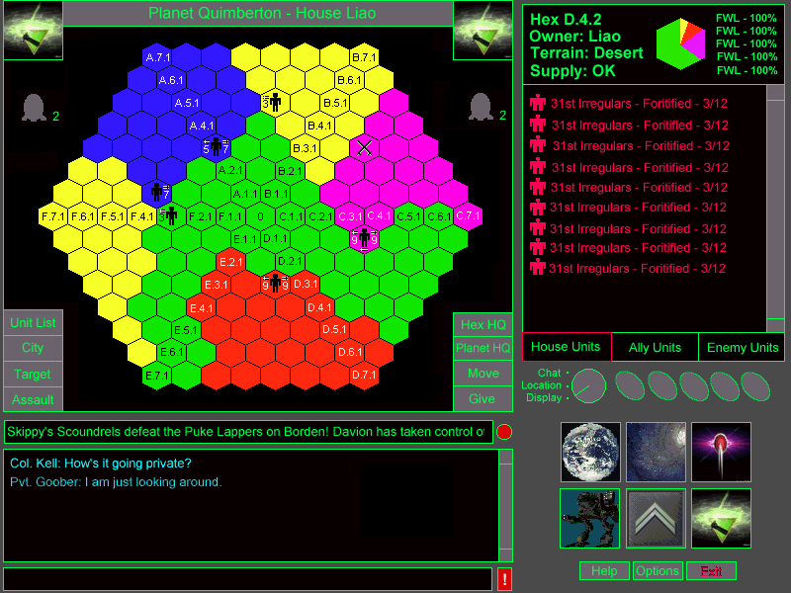

4.1. Overview

This section details the user interface for Multiplayer BattleTech:3025. We start by discussing the general paradigms and interface components. We then detail the functionality of each of the major displays, locations and dialoges.

One of our primary goals with the design of this interface was to make every functional area no more than three clicks away from every other functional area. To this end, we introduced six top level buttons which lead to the major functional areas of the game interface.

Our second challenge was to facilitate player communication and to give them a “place” in which to talk. We wanted to preserve the sense of place in the role-playing shell while removing the cumbersome and obscure directional buttons of Multiplayer BattleTech: Solaris. To this end, the Location system was introduced.

We also wanted to make it easy for players to find the action and quickly get into the fray. So we added the Active Units Display.

Throughout this section, we make use of some specialized terms used to describe concepts for this interface. Here are some of the terms and their definitions:

Term | Definition
Interface Component | General term for a piece of the screen dedicated to a specific function.
View | For the purposes of this document, a “View” is a static window in which data and user controls (edit boxes, buttons, scroll bars et al) are displayed. Views are often multi-purpose and are dependent on the current context of the interface.
Display | For the purposes of this document, a “Display” is a context in which data is displayed in one or more “Views”. Displays are always shown in “Display Mode” which is described below.
View Mode | A global context for the interface which govern which views are shown on the screen.
Dialog | Dialogs are modal, static, pop up windows which prompt the user for information. Dialogs are only brought up at the user’s request, with the exception of error messages.
Multi-part Action | A “Multi-part Action” is an action which requires two or more steps to perform. They typically take the form of Verb + Noun or Verb + Noun + Noun. (i.e. Select the Move Button, select the units to move, then select a destination.)

4.1.1. Display Settings

The interface for Multiplayer Battletech: 3025 is displayed at 800x600 resolution, 16 bit color. By default, the screen will automatically switch to this resolution and color depth when the game starts. Players will also have the option of running the game in a window by editing their display preferences in the Options Dialog.

4.1.2. Text Font

All text will be displayed in a unique BattleTech font. This font will be a proportional True Type font.

4.1.3. Real Time Updates

All data displayed to the user about the game world should update in real time, automatically at an interval no greater that five seconds. It is vitally important that the game is optimized for fast updates and minimal delay when switching between display contexts.

4.1.4. Avoiding Race Conditions

Certain two or three part actions require a set of circumstances to hold true in order to work. If a player is in the middle of one of these actions and the situation changes to make the action illegal, the action is automatically cancel. For example, if a player is about to perform a rank 20 or higher command, such as move unit, and is sent to the reserves in the middle of doing so, the action is canceled and the interface is updated in accordance with his new rank. Similarly, if a player is in the middle of granting supply to an ally and the House leader suddenly declares war on the ally, the action is cancelled.

If the race condition is not trapped before the player manages to execute an illegal command, the host is responsible for consistently choosing who “won” the race condition.

4.1.5. Interface State Preservation

The User Interface remembers the state of each screen that the user has visited and preserves that state over the course of a session. For example, if the player is looking at a particular company in the House Organization Chart and then switches to the Planet Map to check on the status of a conflict, when he returns to the House Organization Chart the same company will be selected. If the user exits the game, the User Interface will revert to its default state when the player returns.

An exception to this rule are multi-part actions. If the user is in the middle of a multi-part action and suddenly switches displays or view modes, the action is cancelled.

4.1.6. Character State Preservation

In addition to preserving the state of the interface on a session-by-session basis, the host also remembers the players current Location, Planet, and Hex. The current hex is changed whenever the player moves to a Company Ready Room or Hex HQ. The current Planet changes when the player moves to a location on the Planet. When the user logs into the game, their character starts out wherever they were.

4.1.7. Hack Prevention
This is what changes we recommend to the current suite of hack detection and prevention measures employed by Solaris. Hacking is considered a form of cheating.
Anyone caught cheating has their 'Mech completely destroyed and is removed from combat.

4.1.7.1. Golden Rule of Hack Prevention
The client is always considered to be insecure. No data that can adversely affect combat if it is manipulated by a user should be kept on the client side without the host verifying the data periodically.

4.1.7.2. Data Hacking
In order to prevent players from cheating in combat, 'Mech data will be kept on both the client and the host, and the two will be checked periodically for discrepancies.

4.1.7.3. Movement Hack Prevention
If the client stops sending packets to the host, the host continues updating the position of the player based on the last speed and direction received by the host. The current system relies on receiving packets from the client, which allows easier hacking and "warping".

4.2. View Modes

The user interface for Multiplayer BattleTech: 3025 is designed to make player-to-player communication easy and always available. To this end, the game is essentially designed in two layers: Locations and Displays.

Locations are essentially conference rooms. Players in the same location can easily communicate with each other by simply typing to talk. A picture of the current location is displayed. A user list shows other players currently in the same room.

Displays display the game information to the player and allow them to interact with the game. When a player is looking at a display they are still in the same location and able to communicate with other players. This allows for a wide variety of interactions, from reviewing the battle plans for a planetary assault, to interview a new recruit while looking at the personal record, to writing a Com Star message as notes for a meeting.

There is also a full screen chat mode, for rooms in which there is a lot of activity the player doesn’t want to miss. It functions the same way as the Location layer without the ability to move from location to location.

The current View Mode can be changed manually using the View Mode Switch. The View Mode will also change automatically. If the user action in Location Mode brings up a Display, then the interface automatically switches to Display Mode and vice versa.

4.2.1. Display Mode

Display Mode is used to display information about the game world and allow the user to act on that information. The primary purpose of this mode is to allow the user to interact with the game world. However, the user can still interact with other players in the same location via a smaller Communication View (D). The Main View (A) serves as the primary window while the Detail View (B) provides a more in depth look at the object currently selected in the Main View. The diagram below depicts the layout of the Display View Mode.

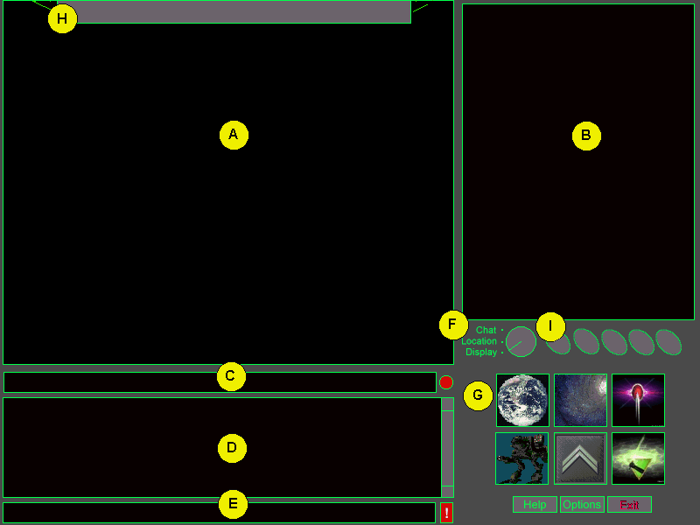
Display Mode

Display Mode Layout
A. Main View
B. Detail View
C. News Ticker
D. Communication View
E. Text Input Buffer
F. View Mode Switch
G. Top Level Display Buttons
H. Main View Title Bar
I. Quick Function Buttons

4.2.2. Location Mode

Location Mode is more for role-playing with other players than interacting with the game world. The Location mode features a larger Communication Window and a Location View. The Location View (A) depicts the players current location. This gives the player a stronger feeling of “place”. By clicking on hotspots in the Location View, the player can navigate through the different locations in the game world. The User List View (B) is a list of all the players in the user’s current location. The diagram below depicts the layout of the Location View Mode.

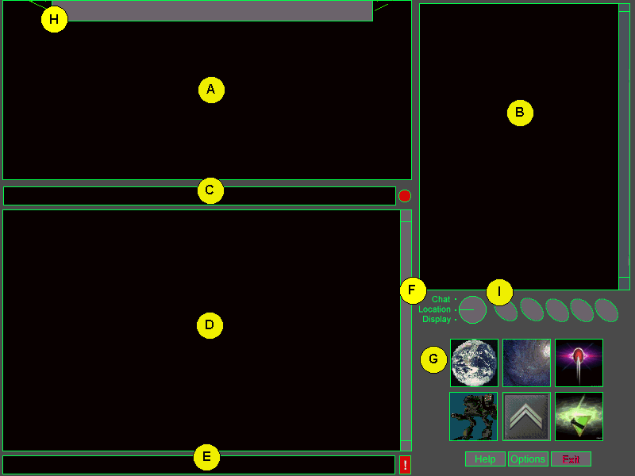
Location Mode

Location Mode Components
A. Location View
B. User List / Meeting Room List / Mission Group List Views
C. News Ticker
D. Communication View
E. Text Input Buffer
F. View Mode Switch
H. Location View Title Bar
I. Quick Function Buttons
G. Top Level Display Buttons

4.2.3. Chat Mode

Chat Mode is used when real time chat is the user’s primary activity. The Communication View is full size in this mode to accommodate a heavy volume of text communication. The User List View is also present in this mode. The diagram below depicts the Chat View Mode.

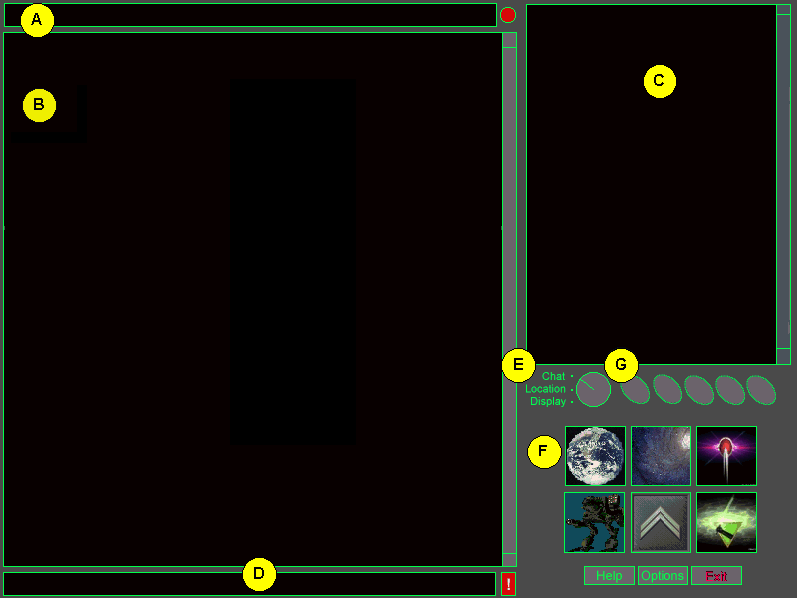
Chat Mode

Chat Mode Components
A. News Ticker
B. Communication View
C. User List View
D. Text Input Buffer
E. View Mode Switch
F. Top Level Display Buttons
G. Quick Function Buttons

4.3. Interface Components

The Interface for Multiplayer BattleTech: 3025 is comprised of a views and top level buttons. The content and arrangement of the views changes depending on the current View Mode and the current display or location. The top level buttons are always available.

4.3.1. Main View

The Main View is visible in Display Mode and is the primary data area for that mode. Functions are arrayed across the bottom of this view. In the case of the ComStar and Active Units Displays, the Main View also sports a vertical scroll bar. The content and functionality of the Main View depend on the display being presented.

4.3.2. Location View

The Location View is visible in Location Mode. It displays a picture of the player’s current location. This picture is hot and clicking on the different parts of the picture can take the user to different locations or displays.

The Location View Title Bar contains the name of the player’s current location. When the player runs the mouse over a hot spot on the Location View, the title bar changes to show where that hotspot leads.

The functionality of this view is fully described in the Locations Section (4.12), below.

4.3.3. Detail View

The Detail View is visible in Display Mode and provides detailed information about objects selected from the Main View. It usually has a scroll bar and is usually broken down into two or three sections. Functions are arrayed across the bottom of this view when available. The contents of the Detail View depend on the display being presented.

4.3.4. User List View

The User List View is a list of all the players in the same location as the user. It is present in Chat Mode and Location Mode. The functionality of this view is fully described in the Locations (4.12), below.

4.3.5. Meeting Room List View

The Meeting Room List View is displayed when the user selects a Meeting Room Hotspot from the Location View. It allows the user to create or join meeting rooms. The functionality of this view is fully described in the Locations (4.12), below.

4.3.6. Mission Group List View

The Mission Group List View is displayed when the user selects a Mission Group Hotspot from the Location View. It allows the user to create or join mission groups. The functionality of this view is fully described in the Locations (4.12), below.

4.3.7. Communication View

The Communication View is a communication buffer for incoming chat. It is always on screen, but sized differently depending on the current view mode. This view has a vertical scroll bar and cut and paste functionality.

4.3.8. Text Input Buffer

The Text Input Buffer is a one line text buffer used for communicating with other players in the same location and issuing text commands. The Text Input Buffer is always on screen and always active.
The available text commands are described in the Text Commands section, below.

By default, the Text Input Buffer has focus for keyboard input. Dialogs with edit boxes take focus when they appear, but return focus to the Text Input Buffer when they are done. Edit boxes elsewhere in the display (such as a Comstar message) can also take focus if the user clicks on them. Pressing the <ESC> key, changing displays or view mode, or clicking on the Text Input Buffer all return focus to the Text Input Buffer.

Hitting return sends the text currently in the Text Input Buffer.

4.3.9. Alert Button

To the right of the text buffer is a red exclamation point. This is the Alert Button, used to complain about other players who are being offensive or abusive. The Alert Button brings up the Alert Dialog.

4.3.10. News Ticker

The News Ticker is a side scrolling, read only text box which displays the News Ticker Stories described below to the user. The News Ticker also serves to immediately display new orders to the player when they are received. See the ComStar Display section and the Orders Button, below.

4.3.10.1. News Ticker Stories

News Ticker Stories are generated by game events and also pulled from text files on the host.

4.3.10.1.1. Combat Mission Results

When a Combat Mission is completed in a given hex, the following news story is sent to all players in that same hex:

<Unit Name> of House <House Name> wins a battle against <Unit Name> of House <House Name>…

4.3.10.1.2. Hex Capture

When a House gains control of a hex, the following news story is sent to all players on that planet:

House <House Name> has taken control of Hex <Hex Coordinates> from House <House Name>…

4.3.10.1.3. Planet Capture

When a House gains control of the capital hex of a planet, the following news story is sent to everyone in the game:

House <House Name> has taken control of <Planet Name> from House <House Name>…

4.3.10.1.4. Medal Awarded

When a player is awarded a Medal or Commendation from his superior officer, the following news story is sent to all members of his House:

<Rank Abbreviation> <Player Name> has been awarded the <Medal Name> by <Rank Abbreviation> <Player Name>!

4.3.10.1.5. Major Rank Promotion

When a player receives a major rank promotion, the following news story is sent to all members of his House:

<Rank Abbreviation> <Player Name> has been promoted to <Rank>!

4.3.10.1.6. House Announcements

House announcements are displayed every fifteen minutes to the members of the specified House. These announcements are pulled from a text file on the host maintained by product support.

4.3.10.1.7. Global Announcements

Global announcements are displayed every fifteen minutes to the everyone in the game. These announcements are also pulled from a text file on the host maintained by product support.

4.3.11.Orders Button

To the right of the News Ticker is the Orders Button. The Orders button is a circular red button which flashes when new orders are received. Clicking on the button dismisses the order and returns the News Ticker to its normal broadcasts. This does not effect the status of the order in the user’s inbox.

4.3.12. View Mode Switch

The View Mode Switch controls and displays the current View Mode. Clicking on the labels to the left of the knob moves the knob to the selected mode and changes the current View Mode accordingly. Clicking on the knob itself cycles through the View Modes.

4.3.13. Top Level Display Buttons

There are six top level display buttons in the lower right hand corner of the interface. These buttons are used to access the six main game displays. The Top Level Display Buttons are described below.

4.3.13.1. Planet Map Button



The Planet Map button brings up the Planetary Map Display for the planet on which the player currently resides. The Planetary Map Display is described below.

4.3.13.2. Inner Sphere Map Button



The Inner Sphere Map button brings up the Inner Sphere Map Display. The Inner Sphere Map Display is described below.

4.3.13.3. ComStar Button



The ComStar button brings up the Comstar Display. The ComStar Display is described below.

The ComStar button is also used to indicate the status of the user’s inbox. The ComStar button flashes briefly when a new comstar message is received. When there are no new unread messages in the user’s inbox, the border of the button is green. A red border indicates that new unread messages are waiting. If the border is read and the user reads a new Comstar message, the border becomes green again until another message arrives in the inbox.

4.3.13.4. Active Units Button

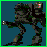

The Active Units Button brings up the Active Units Display. The Main View of the Active Units display is brought up in “Active Units Mode.” The Active Units Display is described below.

4.3.13.5. Personal Info Button



The Personal Info button brings up the Personal Info Display with the player’s character information. The Personal Info Display is described below.

The face of this button is a larger version of the rank icon for the player’s current rank. See Appendix C for a list of the rank icons for each House.

4.3.13.6. House Organization Button



The House Organization Button brings up the House Organization Display for the player’s current House. The House Organization Display is described below.

The face of this button is the symbol of the player’s current House. If the player is a member of ComStar, the ComStar icon is displayed instead of a House symbol.

4.3.14. Quick Function Buttons



The Quick Function buttons allow the player to access the Find Player and Find Unit Dialogs and to quickly send a ComStar to a player who is currently on screen.

4.3.14.1. Find Player Button



The Find Player Button brings up the Find Player Dialog. It then brings up the Personal Info Display for the selected player. The Find Player Dialog is described below.

4.3.14.2. Find Unit Button



The Find Unit Button brings up the Find Unit Dialog. It then brings up the Unit Info Display for the selected unit. The Find Unit Dialog is described below.

4.3.14.3. Buddy Button



The Buddy Button brings up the Find Player dialog with the players from the user’s buddy list preloaded into the Results Roster. The user’s buddy list can be edited by bringing up the user’s Personal Info Display and selecting the Buddy List Detail View Mode.

4.3.14.4. Quick ComStar Button

The Quick Comstar Button allows the player to quickly send a Comstar to any player that is displayed in the Main View, the Detail View, or the User List View. Brings up the Comstar Display with the player’s name already in the “To:” field.

4.3.14.5. Info Button


The Info button allows the player to quickly get more information about a unit or player that is displayed on the screen. The Main View, the Detail View, and the User List View. Brings up the Personal Info Display or Unit Info Display for the selected player or unit.

4.3.15. Help

The Help Button launches a standard Windows help file. The user can task switch back and forth between the help file and the application.

4.3.16. Options

The Options Button brings up the Options Dialog. The Options Dialog contains out-of-character user settings and is described below.

4.3.17. Exit

The Exit Button is available in the unlikely event that the player wishes to leave the game.

4.3.18. Keyboard Commands

The following keyboard commands are available throughout the game interface. In addition, there are display specific keyboard commands which only work on a particular display.

Key Combo | Action
<ESC> | Cancels multi-part actions.
<F1> | Same as the Help Button.
<Alt-P> | Same as the Planet Map Button.
<Alt-I> | Same as the Inner Sphere Map Button.
<Alt-C> | Same as the ComStar Button.
<Alt-A> | Same as the Active Units Button.
<Alt-M> | Same as the Personal Info Button.
<Alt-H> | Same as the House Organization Button.
<Alt-X> | Same as the Exits Button.

4.4. Planetary Map Display

Planet Map Display

The Planetary Map Display is an abstract graphical representation of the strategic situation as two or more sides vie for control of the planet's central hex to extend interstellar supply lines from this planet. It should provide at a glance the information a grunt needs in order to find combat and play and a commander needs in order to direct battle efficiently.

4.4.1. Main View

4.4.1.1. Planetary Map

The Planetary Map is a grid of 169 hexes. Each hex represents a section of strategic territory on the planet’s surface. A hex looks like this:

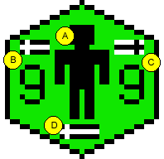
Hex Components

Hex Components
- Unit Present Icon
- House Units Counter
- Enemy Units Counter
- Ally Present Icon

4.4.1.1.1. Unit Present Icon

In any hex in which one or more units are known to be present, the Unit Present Icon (A) appears. The location of units from the player’s House is always known. Allied units and enemy units are visible is the unit is adjacent to a hex controlled by the player’s House or is adjacent to a hex containing a unit from the player’s House. Enemy unit and ally unit locations are only displayed if the player is of rank 10 or higher.

If any of the units are currently in combat, the Unit Present Icon blinks at a rate no faster than once per half second.

4.4.1.1.2. House Units Counter

If a player is of rank 10 or above, the House Units Counter (B) is displayed for all hexes in which units from the player’s House are present. The number of House units is displayed underneath the small white sword on a black background.

4.4.1.1.3. Enemy Units Counter

When enemy units are known to be present in a hex, the Enemy Units Counter (C) appears. The Enemy Units Counter is only displayed if the player is of rank 10 or higher. The number of enemy units (up to nine) is displayed underneath the small black sword on a white background.

4.4.1.1.4. Ally Present Icon

If a player is of rank 10 or above, the Ally Present Icon is displayed in all hexes which are known to contain units from an allied House.

4.4.1.1.5. Contested Hex Icon



If control of a hex is contested (i.e. more than one House owns a share of the hex balance for the hex) but the number of units in the hex is not known, the Contested Hex Icon is displayed. If any units are currently in combat in the hex, the Unit Present Icon blinks at a rate no faster than once per half second. The Contest Hex Icon is only displayed for players of rank 10 or higher.

4.4.1.1.6. Hex Color

The color of the hex denotes the current owner of the hex. The owner of the hex is the last House to control 60% or more of the hex balance for the hex. The color coding for hexes is as follows:

Planetary Map Color Key
- Red – Kurita
- Yellow – Davion
- Blue – Steiner
- Green – Liao
- Purple – Marik

4.4.1.1.7. Hex Coordinates

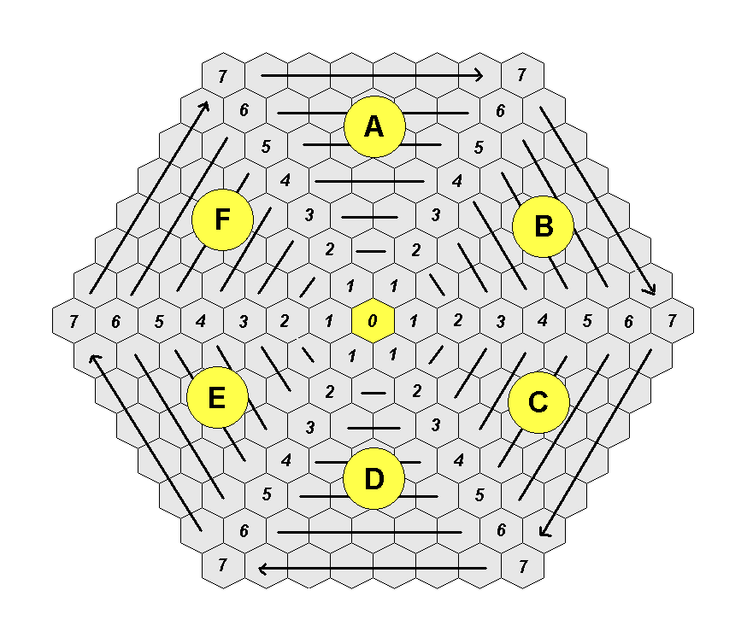
The Hex Coordinate System

The planet is comprised of seven concentric rings of hexes around a central hex. The planet is divided into six sectors, A B C D E F. Each ring is numbered 0 through 7, from the center hex to the outside ring. Each hex within a ring is numbered clockwise, from 1 to 7 (as available). The specific location of a hex can be found using the three-character coordinate system: F.1.1, A.7.5, D.5.4 and so forth.

4.4.1.2. Jumpship Indicator

If enemy, ally, or House forces are present in-system, a JumpShip icon appears in the upper left (enemy, gray) or upper right (House or allied, colored ) of the main display.

4.4.1.3. Title Bar

The Title Bar for the Planetary Map Display displays the planet's name and the current controller of the planet. To the left of the Title Bar is the House Icon for the House that currently controls the planet. To the right of the Title bar is the House icon of the original controlling House for the planet.

4.4.1.4. Hex HQ Button

Changes the player's current location to the HQ of the hex currently selected.

4.4.1.5. Planet HQ Button

Changes the player's current location to the HQ of the planet being viewed. The user appears in the general population and may move to a filtered briefing room.

4.4.1.6. City Button

Changes the player's current location to the main city location on the planet being viewed. The player may not move to the city of an enemy-held planet.

4.4.1.7 Move Unit Button

One or more companies must be selected on the secondary display screen. The player clicks on this button then clicks on a destination hex and confirms. At a time five minutes per hex, 15 minutes maximum, the company(-ies) sets up operation in that hex.

The validity of the path to that hex is checked when it is chosen and whenever there is a change in hex ownership on the planet. If the path becomes invalid, the unit stops moving at the break. Moves cannot be canceled.

If the player is not of rank 10 or higher, this button is grayed out and disabled.

4.4.1.8. Give Hex Button

Transfers control of the selected hex to an allied House. (Spies may use this to transfer control of a hex to their House as well.)

Using this hex brings up a list in the secondary display of all allied Houses with companies on-planet. The user selects one from the list and confirms.

If the player is not of rank 50 or higher or a spy, this button is grayed out and disabled.

4.4.1.9. Objective Button

Toggle button. The user clicks on a hex that highlights it as a target for attack. These are non-restrictive waypoints – the players may attack hexes not designated.

If the player is not of rank 20 or higher, this button is grayed out and disabled.

4.4.1.10. Assault Button

If there are no units on planet, the use of this button declares the planet open for attack and sends a message to all in-system forces.

If the player is not of rank 30 or higher, this button is grayed out and disabled.

4.4.2. Detail View

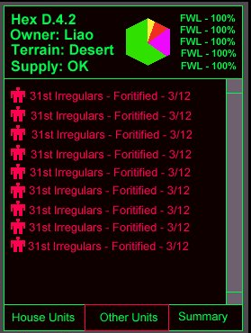
Planetary Map Detail View

The secondary display consists of two parts – Hex information and the list box.

4.4.2.1. Hex Information
This area contains additional information about the selected hex: the Hex ID, the controller of the hex, the terrain type of the hex, the availability of supply to the hex, and the relative hex balance of each House present in the hex.

Information | Values | Notes
Hex ID | A-F.1-7-1-7 or 0. | This is the three-letter coordinate that uniquely identifies the hex.
Controller | One of the five House names.
Terrain type | One of the terrain types (Desert, Tropical, Temperate, Glacial)
Supply | Yes or No | Yes if valid supply exists to the hex; no if not.
Relative hex balance | Hex-shaped pie chart with up to five Houses represented.

4.4.2.2. List box
The list box displays information about units in the hex based on which button is toggled on.

4.4.2.3. House Units
The information in this display is intended to provide, at a glance, critical information both a grunt and a commander will need to know about the company. That includes the company's place within a regiment, the regiment it belongs to, its maturity level, how many slots are open for opping with the unit, and whether or not it is actively running missions. (In transit?)
When this button is depressed, the Secondary display shows the companies belonging to the player's House in the currently selected hex. The information is enough to identify and describe the current operational situation of the company, in the following format:
ID-Name-Maturity-Online Players
For a string 35 characters long:
1234 12345678901234567890123 1 xx/12
When the unit is running or has run a mission in the last five minutes, the entry blinks at the same speed as the 'Mech icon, above.

- ID – The ID of the company describes its place in the regimental hierarchy. It is an eight character string that includes the company designation ((1,2,3)C) within a battalion ((1,2,3)B) within a given regiment. This string represents the first company in the second battalion of the regiment:
1C2B
The units are always sorted by name (see below), then battalion, then company, in reverse order of what is shown. In this way all units belonging to a given regiment and battalion are listed together.
- Name - The name by which the regiment is known. There are 23 characters available to display a unit's name.
Always Faithful
Hansen's Roughriders
Davion Assault Guards
1st Sword Of Light
Eridani Light Horse
21st Centauri Lancers
Robinson Rangers
Marion's Highlanders
- Maturity – the maturity level of the company. There are ten characters reserved:
1 - Setting Up
2 - Digging In
3 - Fortified
These represent the three levels of maturity in the victory point calculation.
- Players – the number of players the company currently has assigned to it, including the number of players operating with the company on a temporary basis. The number always appears as a fraction over the number 12, making it easier to determine which companies are suitable for operating with.

4.4.2.4. Enemy Units

A player only needs to know what unit is attacking his House in a particular hex and how long it's been there. To that end, a player need only see the unit's ID, name and maturity level, represented as above. Nothing player-configurable is visible in this screen.

If the unit has run missions in the last five minutes, or is currently doing so, the entry blinks as the enemy unit icon on the map does (fast, on for .5 seconds, off for .5 seconds).

4.4.2.5. Ally Units

This Detail View Mode contains the same information as the Enemy Units Detail View Mode, except it displays units from allied houses.

4.4.3. Keyboard Commands

The following keyboard commands are available in the Planetary Map Display:

Key Combo | Action
<CTRL+L > | Same as clicking Unit List.
<CTRL+ C> | Same as clicking City.
<CTRL+ T> | Same as clicking Target.
<CTRL+ A> | Same as clicking Assault.
<CTRL+ H> | Same as clicking Hex HQ.
<CTRL+ P> | Same as clicking Planet HQ.
<CTRL+ M> | Same as clicking Move.
<CTRL+ G> | Same as clicking Give.
<CTRL+U > | Same as clicking House Units.
<CTRL+ F> | Same as clicking Allied (friendly) Units.
<CTRL+ E> | Same as clicking Enemy Units.

4.5. Inner Sphere Map Display

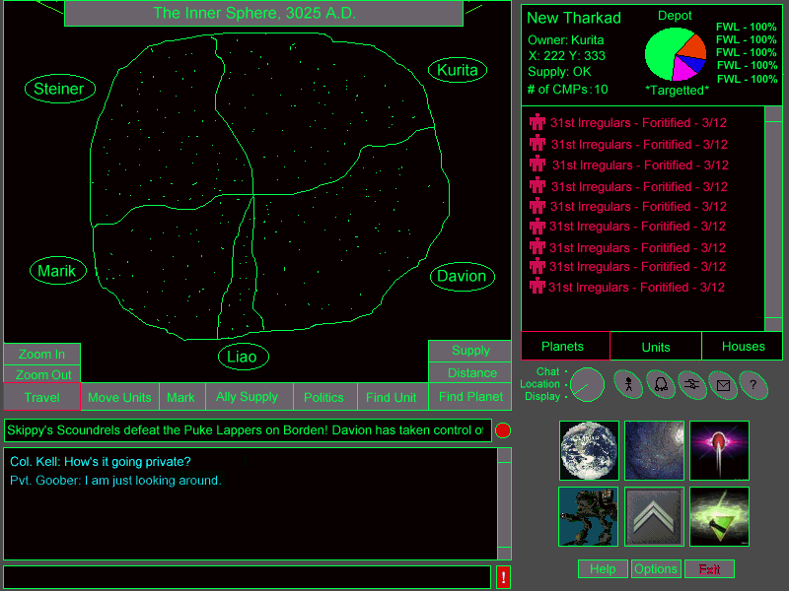
The Inner Sphere Map Display

The Inner Sphere Map is a star map which shows all of the inhabited worlds of the Inner Sphere. From here, the player can travel from planet-to-planet, move units from planet-to-planet, support an ally through granting the passage of supply or even declare war upon another House. Functions which are unavailable to the player at his current rank are grayed out and disabled.

4.5.1. Interface Flow

The user can access the Inner Sphere Map Display by pressing the Inner Sphere Map button in the lower right hand corner of the screen. When a player travels to another planet using the Inner Sphere Map, he is moved to the either the City Location or the Planet Map Display for the new planet. The City Location appears if the planet is currently controlled by the player’s House, otherwise the Planet Map is displayed.

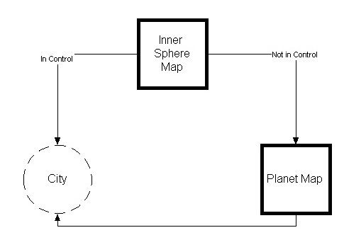
Interface Flow from the Inner Sphere Map

4.5.2. Main View

4.5.2.1. The Inner Sphere Map

The Inner Sphere Map is a two dimensional representation of the Inner Sphere. Planets positions, House borders and district borders are plotted based upon the FASA data provided in Appendix A. The map itself can be zoomed and scrolled to display a particular area in more detail. Planet names are displayed at higher zoom levels. For each planet, the map also shows the current owner, supply status, and whether or not the planet is under attack.

4.5.2.1.1. Zooming

The Inner Sphere Map can be zoomed using the Zoom Buttons or hot keys. There are five levels of magnification. At higher magnifications, there is more room on the screen and so more data is displayed. The diagram below shows the different magnification levels.

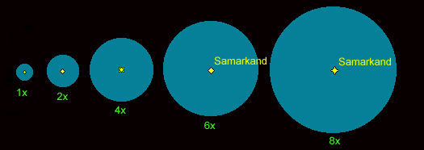
Zoom Levels

At 4x magnification and above, the district borders are displayed. At 6x magnification and above, the planet names are displayed. The chart below shows the effects of the different magnification levels.

Zoom  Level | Show House Borders? | Show District Borders? | Show Planet Names? | Light Years per Pixel | Area depicted in Main View  In Light Years
1x | Yes | No | No | 3.072 | 1573 x 1275
2x | Yes | No | No | 1.536 | 786 x 637.5
4x | Yes | Yes | No | 0.768 | 393.25 x 318.75
6x | Yes | Yes | Yes | 0.512 | 262.17 x 212.5
8x | Yes | Yes | Yes | 0.384 | 196.63 x 159.38

4.5.2.1.2. Scrolling

The map can be scrolled by grabbing and dragging anywhere on the map’s surface. This allows the player to quickly scan a particular region of space. The map cannot be scrolled beyond a 1573 x 1275 light year region.

4.5.2.1.3. Planet Ownership

The current owner of the planet is represented by the planet’s color. The Inner Sphere map uses the same colors for planets as the Planet Map uses for hexes. If the planet’s name is being displayed, the color of the planet’s name matches the planet’s color.

Inner Sphere Map Color Key
- Red – Kurita
- Yellow – Davion
- Blue – Steiner
- Green – Liao
- Purple – Marik

4.5.2.1.4. Supply Bubbles

Supply Bubbles are an easy way to represent which planets are currently in supply and which are not. A planet which is in supply is surrounded by a filled circle with a 30 light year radius. This is the maximum jump distance for a JumpShip and the maximum distance a planet can be from the supply chain and remain in supply. A planet which is controlled by the House but is not in supply is shown with an outlined circle.

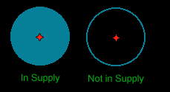
Planet Supply Status

When multiple supply bubbles are drawn in close proximity, they form a “supply cloud.” By looking at the planets which reside within this cloud, a player can immediately see which planets are in supply and which are out of supply.

In the example below, a cluster of Davion Planets has penetrated into Kuritan space. They still maintain a supply line back to a depot planet. Some of the planets have been cut from the supply chain and are currently out of supply and vulnerable to attack.

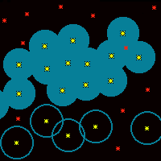
Example of a Supply Cloud

4.5.2.1.5. Planets Under Assault

A planet which has two or more opposing Houses on its surface is considered to be under assault. Planets which are under assault blink on the Inner Sphere Map.

4.5.2.1.6. Highlighted Planets

Under a number of different circumstances, planets will become highlighted on the map. When a planet is highlighted, a red circle appears around the planet as depicted below.

Highlighted Planet

4.5.2.1.7. Current Location

A player’s current location is always depicted with a bright green circle around it, slightly larger than the red highlight circle described above.

4.5.2.1.8. Travel Line

The Travel Line is a red, dotted, blinking line which shows a currently selected route for a JumpShip. If the journey requires multiple hops, the Travel Line is drawn from jump point to jump point. The Travel Line is also used with the Distance Button.

4.5.2.2. Zoom Buttons

The “Zoom In” and “Zoom Out” buttons allow the user to zoom the map in and out. Pushing the “Zoom In” button increases the zoom level of the map by one. Pushing the “Zoom Out” button decreases the zoom level by one.

4.5.2.3. Supply Button

The Supply Button allows the player to toggle the display of supply bubbles on the map. This information is only available to players of rank 20 or higher. Players can only see the supply bubbles for their House.

4.5.2.4. Distance Button

The Distance Button allows the player to compute the minimum time to move a unit or group of units between two planets. The Distance Button works the same way as the Move Units Button, except it doesn’t actually move any units. When a path has been selected, the distance is displayed in the Title Bar. Players of any rank can use the Distance Button.

4.5.2.5. Travel Button

The Travel Button allows the player to move from one planet to another. Unlike moving units, personal travel is instantaneous. A player can travel to any planet in the Inner Sphere, but the locations he can travel to on the planet may be pretty limited if it is not controlled by his House.

To use the Travel Button, the player clicks on the button and then on a destination planet. The player is then moved to either the Planet Map Display or the City Location for that planet. (As described in Interface Flow, above) If the player is moved to the Planet Map Display, his location is set as the Planet HQ for his House.

The Travel Button is available to players of rank 1 or above.

4.5.2.6. Move Units Button

The Move Unit Button allows a player to move a unit or group of units from one planet to another. This function is available to players of rank 20 or above.

- First, the user clicks on the Move Unit Button. The interface is now in Move Unit Mode. The cursor changes to a targeting cursor and Move Unit Button stays depressed.

- Next, the user selects the unit or group of units that he wishes to move. Units can be selected from either the Planets Detail View or the Units Detail View.

- Finally, the user clicks on the destination star. A Travel Line is rendered showing the quickest path to the destination. To cancel Move Unit Mode, the player can click on the Move Units Button again.

Players can only move units under their command. In addition, if the player is not the CO or an XO of the company he is moving and a CO or XO for that unit is in control of the unit, the player must take command of the unit if he wishes to move it. A player is considered “in control” of a unit if he is in the Company Ready Room of the unit, in one of the unit’s Briefing Rooms or running a Combat Mission with the unit.

4.5.2.7. Mark Planet Button

The Mark Planet Button allows the player to designate a planet as a possible target for planetary assault. This button is available to players of rank 40 or above.

- First, the user clicks on the Mark Planet Button. The interface is now in Mark Planet Button Mode. The cursor changes to a targeting cursor and Mark Planet Button stays depressed. Planets which are currently marked as targets are highlighted on the Inner Sphere map.

- The player can then click on one or more planets to toggle their status. To cancel Mark Planet Mode, the user clicks on the Mark Planet Button again.

4.5.2.8. Support Ally Button

The Support Ally Button allows a player to grant supply to a House with which the player’s House is at peace. Supply is granted on a planet-by-planet basis. The Support Ally Button is available to players of rank 50 or above.

- First, the user clicks on the Support Ally Button. The interface is now in Support Ally Mode. To cancel Support Ally Mode, the user can click on the Support Ally Button again.

- Next, the user clicks on a House from the House List in the Detail View. All of the planets which are currently granting supply to the selected House are highlighted on the map.

- Finally, the user clicks on one or more planets that are controlled by his House. Clicking on a planet toggles its status. If a selected planet is out of supply, it can not generate supply for another House. It can be selected however, so that it will grant supply in the future.

4.5.2.9. Politics Button

The Politics Button allows a House leader to declare war or peace upon another House. The player can toggle the disposition of their House against another House by clicking on the Politics Button and then selecting the target House from the House List in the Detail View.

If the player’s House is currently not at war with the target House, a confirmation dialog appears with the following text:

“You are about to declare war upon the House of <House name>. Is this your wish?”

If the player’s House is currently at war with the target House, a confirmation dialog appears with the following text:

“Do you wish to make peace with the House of <House name>?”

If the selected action is confirmed, then the action is performed. Obviously, the House leader cannot select his own House from the list. The Politics Button is only available to players of rank 60 or above.

4.5.3. Detail View

The Detail View of the Inner Sphere Display has three modes which are selected using a group of three radio buttons at the base of the Detail View. The button for the currently selected mode is highlighted. The appearance and functionality for each mode are described below. The three modes are:

Inner Sphere Map Detail View Modes
- Planets Mode
- Units Mode
- Houses Mode

4.5.3.1. Planets Mode

Planets Mode is the default display mode for the Detail View of the Inner Sphere Map Display. In this mode, the Detail View shows information about the currently selected planet from the Inner Sphere Map. The diagram below depicts the layout of the Detail View in this mode.

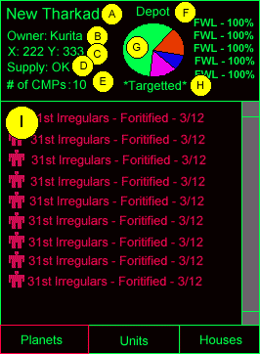
Detail View in Planets Mode

Detail View Components
- Planet Name
- Owner
- Location
- Supply Status
- Companies Present
- Planet Type
- Planet Balance Chart
- Target Status
- Unit List

4.5.3.1.1. Planet Name

The name of the currently selected planet is displayed in the upper left hand corner of the Detail View. (A)

4.5.3.1.2. Owner

The name of the House which currently controls the capital hex of this world is displayed here. (B)

4.5.3.1.3. Location

This is the (X,Y) coordinate of the planet (C) as provided from the FASA material in the Appendix of this document.

4.5.3.1.4. Supply Status

This is the current status of the planet’s supply. If this planet is in supply, then supply status is “OK.” If the planet is out of supply, supply status reads: “OUT.” (D)

4.5.3.1.5. Companies Present

The number of companies from the players House which are currently in orbit or on the surface of this planet. (E)

4.5.3.1.6. Planet Type

This field displays the type of the select planet. (F) There are two special planet types: Depot, and Capital. If a planet is not a depot planet or a capital planet, then this field is left blank. Otherwise the word “Depot” or “Capital” are displayed respectively.

4.5.3.1.7. Planetary Balance Chart

The Planetary Balance Chart is similar in function and appearance to the hex balance chart used in the Planetary Map Display Detail View. The only difference in presentation is that instead of a hex, a circle is used.

The planetary balance displayed here (G) is calculated by adding up the sum total of all the hex balance controlled by a particular side and then dividing that by the total amount of hex balance available on the planet:

Planetary Balance % = (Hex Balance Controlled * 100) / 1,690,000)

Just as with the Hex Balance Chart, the Planetary Balance Chart shows the percentages controlled by each House to the right of the pie chart.

4.5.3.1.8. Target Status

This field displays the current “target” status of the planet (H). If the planet has been targeted for assault using the Mark Planet Button described above, then the text: “*Targetted*” appears here. Otherwise, this field is blank.

4.5.3.1.9. Unit List

The Unit List is the most prominent feature of the Detail View in Planets Mode (I). This is a list of all the units from the players House that are in orbit or on the surface of the selected planet. For each unit, the following information is displayed:

4.5.3.2. Units Mode

The Units Mode of the Detail View allows the user to build a list of units for the purpose of moving them from planet-to-planet. Quite often, there will be situations where a commander wishes to call a wide array of forces from different locations to a single planet. This mode allows the commander to do this without having to search planet by planet and move units piecemeal. Units Mode looks like this:

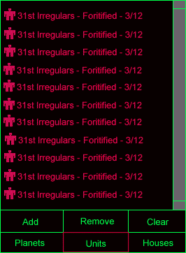
Detail View in Units Mode

By default, the Units Mode window is empty. The user can add units to the list using the Add Button, remove them using the Remove Button, or clear the list using the Clear Button. Clicking on the Add Button brings up the Find Unit Dialog. Using this dialog, the user can select a unit or group of units using various search criteria. The units selected from this search are used to populate the Unit List. The information displayed for each unit is the same as the unit list in Planets Mode.

To move a group of units, the player uses the Move Button in the Main View as he normally would. The user can select some or all of the units from the unit list using the standard method.

4.5.3.3. Houses Mode

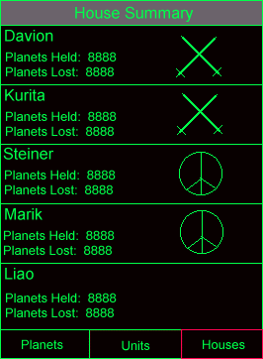

In Houses Mode, the Detail View displays a summary of each House and the disposition of the player’s House toward the other House. The player can also use this mode to select a House as part of a multi-part action such as declaring war or granting supply.

4.5.4. Keyboard Commands

The following keyboard commands are available in the Inner Sphere Map Display:

Key Combo | Action
<CTRL+ '+'> | Same as clicking Zoom In.
<CTRL+ '-'> | Same as clicking Zoom Out.
<CTRL+T> | Same as clicking Travel.
<CTRL+ M> | Same as clicking Move Units.
<CTRL+ X> | Same as clicking Mark.
<CTRL+ A> | Same as clicking Ally Supply.
<CTRL+ P> | Same as clicking Politics.
<CTRL+ F> | Same as clicking Find Unit.
<CTRL+ S> | Same as clicking Supply.
<CTRL+ D> | Same as clicking Distance.
<CTRL+L> | Same as clicking Find Planet.
<CTRL+ W> | Same as clicking Planets (worlds).
<CTRL+ U> | Same as clicking Units.
<CTRL+ H> | Same as clicking Houses.

4.6. ComStar Display

One of the most important parts of building community and participation in an online environment is communication. Players will want to be in touch with their superiors and subordinates in the game, as well as their friends, and the more game-related content we can “own”, the better (see JB’s more eloquent statements to this effect ☺).

The ComStar display is essentially a low-end email client, used to handle in-game messaging. Messages may be composed, read, saved, archived and managed with filtering and sorting.

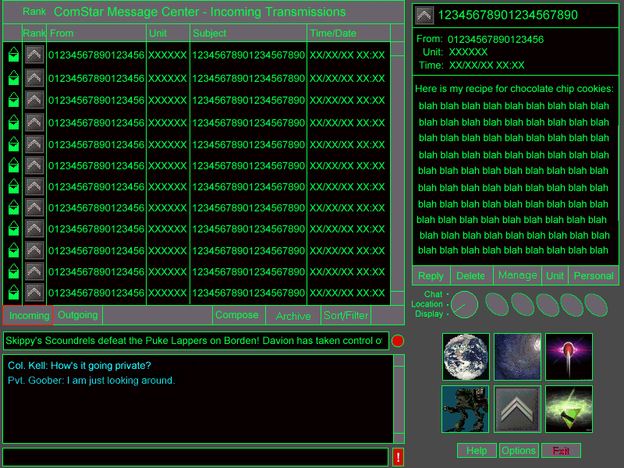
The ComStar Display

4.6.1. Concepts

4.6.1.1. Message Types

Messages in MPBT 3025 are of three types: System, Mail and Orders. The only difference is in a property set in the message.

System messages are messages generated by the host or client, set to type System. These often hold important information for the player that s/he may wish to save, such as promotion notifications, etc.
Mail messages have the Type property set to Mail. These are simply email messages sent between players. This is also the default type when in doubt.

Orders are messages with the Type property set to Orders. These are handled specially by the host and client and are intended to give officers a high-priority channel for important messages, usually game-related.

The Orders flag may also be set whenever a message is being sent to a subordinate. If for any reason a message is sent marked Orders to a player not in the sender’s chain of command, the Orders flag is ignored.

4.6.1.2. Message Properties

Messages have a number of properties that serve to uniquely identify and summarize them. These properties are:

Property | Type | Description
Date Sent | Date/Time | Timestamp for message creation
Date Received | Date/Time | Timestamp for message reception
Sender Rank | Text | Info on the sender on incoming messages
Sender Unit | Text | Info on the sender on incoming messages
Sender Name | Text | Info on the sender on incoming messages
Sender ComStar ID | Alphanumeric | Info on the sender on incoming messages
Conversation ID | Number | ID of original message
Message Type | Text | Mail, Orders and System
Subject of message | Text | Brief description of message content
Read/Unread flag | Boolean | Indicates whether a message has been read or not
ID | Number | Unique ID for the message
Parent ID | Number | ID to message this message is in reply to

4.6.1.3. Message Storage
Messages are stored in two files: incoming.txt and outgoing.txt. They are ASCII text files saved in a format suitable for printing or conversion. Many players will undoubtedly create text conversion programs to allow input into databases, spreadsheets and other programs, and we want to be careful to facilitate this.
The storage files may be become long, and while there are a few archiving features in the interface, it is likely that the player will choose to edit the files manually (or via a third-party program) for archiving and maintenance. The ComStar display must be robust enough to handle the resulting formatting errors in the mail files, within reason.

4.6.2. Main View

The Main View of the ComStar Display should be familiar to most users, as it is just a scaled-back version of a common email client interface.

4.6.2.1. The Browse Window

The primary display is a Windows-style “flexgrid” (spreadsheet style table) that may be sorted by each column. The example below shows the browse window in Incoming Mode. The Outgoing mode is identical in all respects except that the FROM field is replaced by a TO field, indicating the recipient of the messages displayed.

The browse window supports standard Windows selection methods, allowing multiple noncontiguous selections.

To open a message, the user double-clicks on the message header or uses the CTRL + O keyboard shortcut.
- If the message is opened from the Incoming window, the Read form is opened.
- If the message is opened from the Outgoing window and the message has already been sent, the Read form is opened.
- If the message is opened form the Outgoing window and the message has not been sent, the Compose form is opened.

4.6.2.1.1. Header Columns
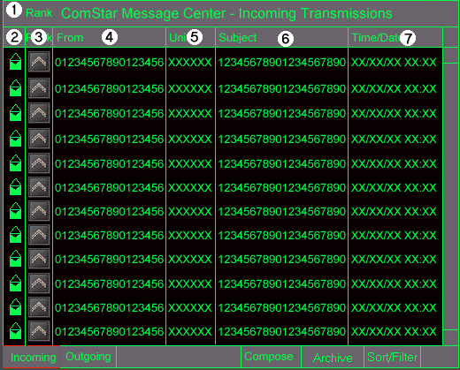

- Title bar — This area always contains the text: "ComStar Message Center -" followed by "Incoming Transmissions" or "Outgoing Transmissions" as appropriate to the current mode.
- Read/Unread Message Type Icon — There are six icons that may appear in this column, two for System messages, two for Orders and two for Mail, indicating Read/Sent or Unread/Unsent for each type.
The System icons are of a closed book for Unread, and an open book for Read messages.
The Orders icons are of a bird, with the Unread being an eagle with wings outspread, and Read being a bird with wings folded.
The Mail icons are of envelopes, with Unread being an unopened envelope, and Read mail being an opened envelope.
When in the Incoming display, the icons indicate whether the message has been Read or Unread. In the Outgoing display, these same icons indicate whether the message has been Sent or is Unsent.
Message Type | Incoming/Outgoing Icon
 | Read/Sent | Unread/Unsent
System message | Open book | Closed book
Orders Message | Eagle rampant | Eagle at rest
Mail Message | Open Envelope | Closed envelope

- Rank — The Rank of the Sender/Recipient is displayed in icon form here.
- From/To — The From field column the identity of the sender/recipient.
- Unit — The Unit column displays the official name of the sender/recipient’s unit.
- Subject — The Subject column displays as many of the characters in the message subject as will fit, truncating the rest.
- Date Sent/Received — This column contains the date and time the message was sent/received, displayed in MM/DD/YY HH:MM format. Date Sent is used for Outgoing messages, while Date Received is used for Incoming Messages.

The example above shows the browse window in Incoming Mode. The Outgoing mode is identical in all respects except that the FROM field is replaced by a TO field, indicating the recipient of the messages displayed.

4.6.2.2. Incoming Button
When the user clicks on the Incoming button, the browse window displays the message headers from the Incoming message file. The only difference is that the third column (item #4 above) is a TO field, and the data in the Rank, From and Unit columns all describe the Sender.

4.6.2.3. Outgoing Button
When the user clicks on the Outgoing button, the browse window displays the message headers from the Outgoing message file. The only difference is that the third column (item #4 above) is a From field, and the data in the Rank, From and Unit columns all describe the Recipient.

4.6.2.4. Compose Button
When the user clicks this button, the Compose/Reply form (q.v.) is opened in the Detail View.

4.6.2.5. Archive Button
The program offers simple archiving features. When the message file exceeds the maximum size recommended, a system message should be added to the Incoming box warning the player that it might be time to archive.

Archiving is very simple. The player selects messages from a filtered or unfiltered list and clicks the Archive button. This brings up a dialog with three buttons, indicated below.
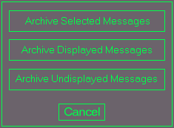

4.6.2.5.1. Archive Selected Messages
This button sends the highlighted messages to a text file selected through a standard Save As dialog.

4.6.2.5.2. Archive Displayed Messages
This button sends all the messages currently displayed (after sorting and filtering, and whether selected or not) to a text file selected through a standard Save As dialog.

4.6.2.5.3. Archive Undisplayed Messages
This button sends all but the messages currently displayed (after sorting and filtering, and whether selected or not) to a text file selected through a standard Save As dialog. This is a very fast way to clean out a lot of messages from a message file. Example: Georgy decides he only wants to keep his Orders for the last two weeks in his file, so he applies a filter to show only those messages and then applies this option. All messages other than those displayed will be removed from the message file and archived in the file indicated.

4.6.2.6. Sort/Filter Button
Simple sorting may be done in either the Incoming or Outgoing displays by clicking on the title cells of the flexgrid. The headers will be displayed in ascending order on the first click, and descending order on the second. The secondary subsort will always be Date Sent/Received.

Advanced sorting and filtering may be accomplished by clicking on the Sort/Filter button. This opens a dialog in which a simple set of sorting and filtering criteria may be entered and applied.

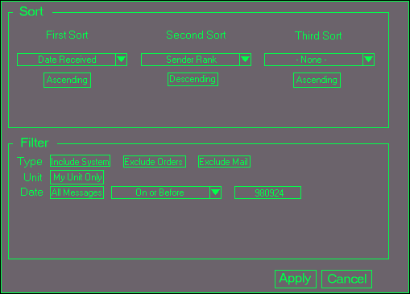

4.6.2.6.1. Filtering

Filtering is applied by using the checkboxes associated with each property listed. Although there are only three filtering criteria, these in combination with the sorting options should provide a reasonable amount of flexibility.

Filter: Message Type: System/Orders/Mail
This filter toggles the three message types on or off. Each button indicates whether that type (System, Orders or Mail) is included or excluded as shown in the example.

Filter: My Unit/All Units
This toggles between My Unit meaning only messages to or from members of the player’s unit chain of command will be displayed, or All Units, meaning messages from all units will be displayed.

Filter: Timestamp
The filter allows messages to be filtered from before, after or on a certain date.
The first toggle button switches between All Messages and Only Those Messages. If All Messages is selected, the other options for this line are grayed out. If Only Those Messages is selected, the Date/Time filtering options are enabled.
The first Date/Time filtering option is selected via a dropdown with the following values: On, Before, After, On or Before, On or After.
The date must then be entered in YYMMDD format into the text box to the right of the dropdown. Obviously, this scheme must be Y2K complaint.

4.6.2.6.2. Advanced Sorting

Sorting is applied through a simple set of dropdown boxes. Up to three sorting criteria may be applied, and a toggle button below the dropdown switches between Ascending and Descending sort order. Each drop down contains the following properties for sorting:

- Message Type
- Date Sent/Received
- Sender/Recipient
- Rank
- Unit
- Read/Unread

4.6.2.6.3. Preset Filter/Sorts
There are two preset filter/sorts for the system,available via keyboard shortcuts.

4.6.2.6.4. Orders View
The Orders View is accessible through ALT + O, and applies a filter criteria of "Orders Only" and sorted by Date Received for the Incoming mode and Date Sent for the Outgoing mode.

4.6.2.6.5. System Messages View
The System Messages View is accessible through ALT + S, and applies a filter criteria of "System Messages Only" and sorted by Date Received for the Incoming mode. No filter/sort is applied while in Outgoing mode.

4.6.3. Detail View
When not displaying or composing a message, the detail view of the ComStar screen shows the player roster appropriate to the current location. When reading a message, the Detail view is replaced with the Read form and when composing or replying to a message, the Detail view is replaced with the Compose/Reply form

4.6.3.1. Read Form
When reading messages, the player double-clicks on the message in the main browse window. This causes the selected message to be displayed in the secondary window to the upper right as shown below.

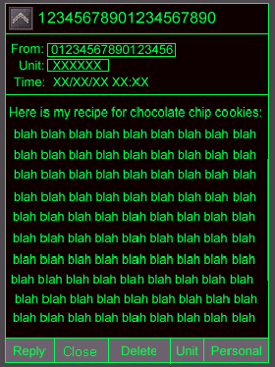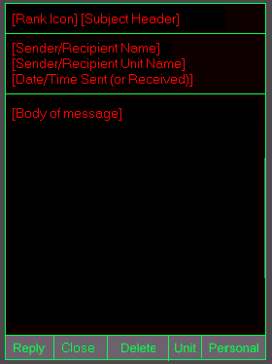

Once a message has been displayed in this fashion, it is marked Read.

The From: and Unit: fields of the compose form are themselves buttons that may be clicked to bring up the standard People Finder or Unit Finder features (q.v.) respectively.

The Date/Time: field of the Read form shows the date the message was sent, if applicable.

There are five buttons on the bottom of the Read form, described below.

4.6.3.1.1. Reply
The Reply button checks to make sure that all required fields are filled in, and then attempts to send the message to the host. Any missing required fields are indicated in a modal error dialog that pops up and returns the user to the compose form upon acknowledgement.

Clicking this button while in the Incoming display fills the address fields with the info for the original sender. Clicking this button while in the Outgoing display fills the address fields with the info for the original recipient. This is considered a “follow-up”.

4.6.3.1.2. Close
The Close button closes a message, marking it Read and replacing the upper-right display region with the Player Roster.

4.6.3.1.3. Delete
This deletes the message from the Outgoing file. There is a confirmation dialog indicating that this action is not reversible.

4.6.3.1.4. Unit
This button goes to the Unit Info screen keyed to the ID of the Recipient indicated in the TO: field.

4.6.3.1.5. Personal
This button goes to the Unit Info screen keyed to the ID of the Recipient indicated in the TO: field.

4.6.3.2. Compose/Reply Form
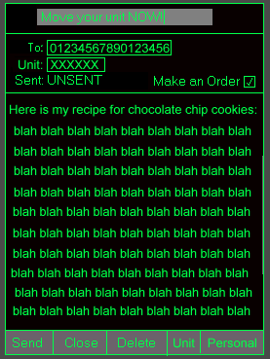

Composing a new message opens up a compose window that may or may not have certain properties set already, depending on whether the compose form was opened as the result of a Find or other system request. For instance, a message may be opened as a result of a request to a subordinate to move a unit. In this case, the recipient Name, Unit and Rank may already be included. If the message has been opened via the Compose button, all the fields will be blank.

The To: and Unit: fields of the compose themselves buttons that may be clicked to bring up the standard People Finder or Unit Finder features (q.v.) respectively. Information retrieved via this message is automatically applied to the message address.

The Date/Time: field of the Compose form shows the date the message was sent, if applicable. If the message has not been sent, the word UNSENT is displayed in this field.

The Make An Order checkbox is made available when the recipient of a message is a subordinate within the sender’s chain of command. This sets the message type to Orders, which will be displayed appropriately on the recipient’s client.

The reply form is identical to the compose form except that the recipient address may not be altered. The subject header may be altered as desired in a reply form.

There are five buttons on the bottom of the Compose/Reply form, described below.

4.6.3.2.1. Send
The Send button checks to make sure that all required fields are filled in, and then attempts to send the message to the host. Any missing required fields are indicated in a modal error dialog that pops up and returns the user to the compose form upon acknowledgement.

4.6.3.2.2. Close
The Close button saves a message to the Outgoing file, but does not send it. This is also the default action whenever another message is opened while composing or editing a message.

The message will be visible in the Outgoing display with the appropriate icon.

4.6.3.2.3. Delete
This deletes the message from the Outgoing file. There is a confirmation dialog indicating that this action is not reversible.

4.6.3.2.4. Unit
This button goes to the Unit Info screen keyed to the ID of the Recipient indicated in the TO: field.

4.6.3.2.5. Personal
This button goes to the Unit Info screen keyed to the ID of the Recipient indicated in the TO: field.

4.6.4. Keyboard Commands
Keyboard shortcuts for the ComStar screen are as follows:

CTRL + O | Open selected message
CTRL + ENTER | Send message
CTRL +R | Reply to selected message
CTRL + D | Delete selected message
CTRL + N | Compose New Message
CTRL + U | Unit info on selected message
CTRL + P | Personal info on selected message
CTRL + O | Filter: Orders only
CTRL + S | Filter: System messages only

4.7. Active Units Display

Active units Interface
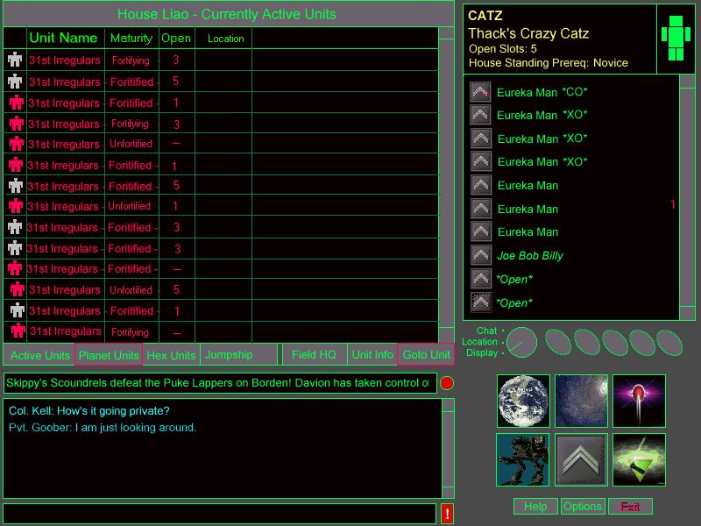

4.7.1. Terms
Current Planet | The planet being displayed in the Planetary Map screen.
Current Hex | The hex selected in the Planetary Map screen.
In combat | This means that either a member of the unit is in combat at the moment or that a member has been in combat within the last five minutes.

4.7.2. Interface Flow

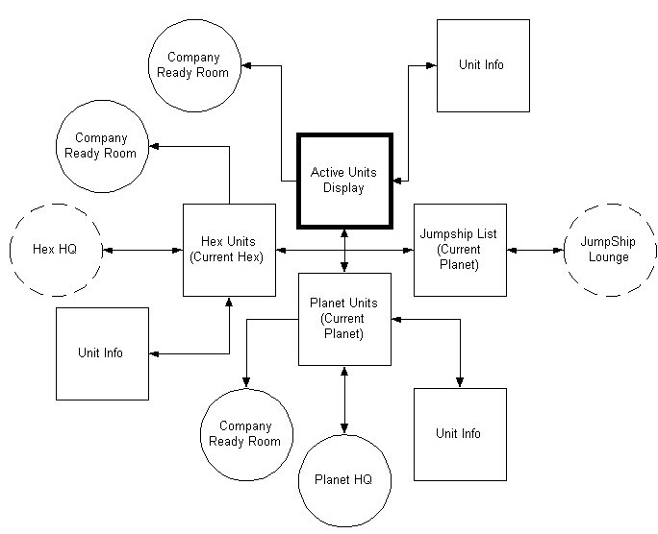
Interface flow from Active Units

4.7.3. Main View

4.7.3.1. Browse Window
The primary display of each mode is a Windows-style “flexgrid” (spreadsheet style table) that may be sorted by each column. Each column may be clicked to sort by that column, toggling between ascending and descending sort with each click. Single-line selection is allowed on this screen. Multiple selections are not allowed.

4.7.3.1.1. Display Modes
The four modes of the Units screen each display a different (and more refined) set of units.

Active Units Mode

This mode indicates vital data on every unit in the House that is currently in combat. The title bar of the Main Browse window contains the text:
[House name] -- Currently Active Units

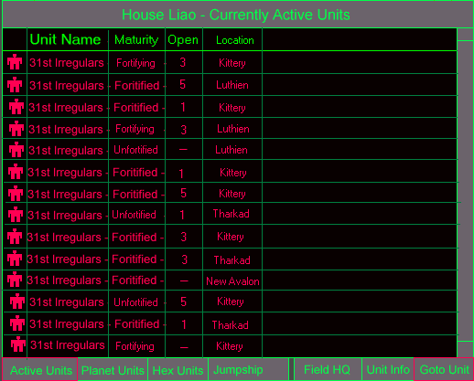

Planet Units Mode
This mode indicates vital data on every unit in the on the current planet. The title bar of the Main Browse window contains the text:

[House name] -- Units on Planet [Planet name]
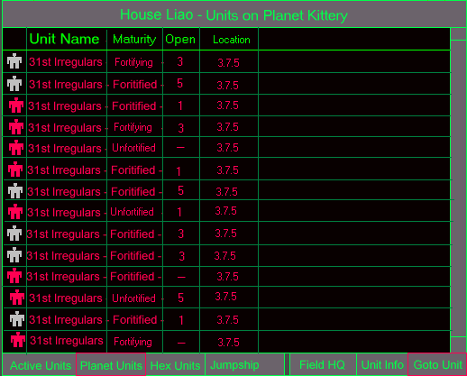

Hex Units mode
This mode indicates vital data on every unit in the in the current hex on the current planet. This mode indicates vital data on every unit in the on the current planet. The title bar of the Main Browse window contains the text:

[House name] -- Planet [Planet name] -- Units in Hex [current hex location]

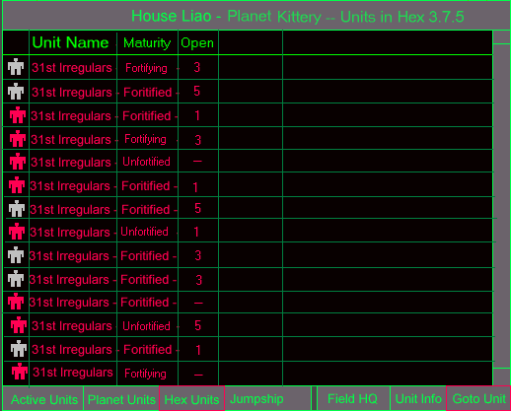

JumpShip Mode
This mode indicates vital data on every unit in the House JumpShip of the current planet. This mode indicates vital data on every unit in the on the current planet. The title bar of the Main Browse window contains the text:

[House name] -- Planet [Planet name] -- JumpShip

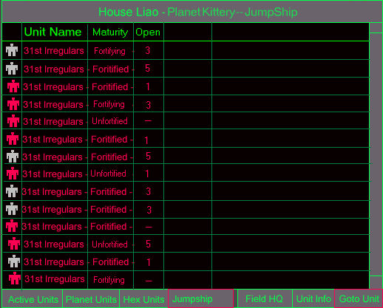

4.7.3.1.2. Column Headers

Combat Status
This is simply an icon indicating whether or not the unit is actively engaged in hostilities. If the unit is currently engaged in hostilities, the 'Mech icon will be red. If not, it will be gray.

Unit Name
This is the official name of the unit in question.

Maturity
This indicates the level of maturity of the unit in question in its current location. The levels of maturity are:

Maturity Level | % Mature
Unfortified | 50
Fortifying | 75
Fortified | 100

Open Slots
This column shows the number of open slots available in the unit in question. This is useful to determine whether or not a given unit is accepting new members or has room to Op (Op means to Operate With, q.v.).

Location
This shows the location of the unit in question. In Active Units mode, this displays the planet name. In
Planet Units mode, this indicates the Hex location on the planetary map. In Hex Units mode, this column is absent.

4.7.3.2. Controls

4.7.3.2.1. Active Units Button

The Active Units button sets the display to Active Units mode, in which all House units currently in combat are shown. This display could get quite long, as potentially every House unit could be in combat.

4.7.3.2.2. Planet Units Button
This button toggles Planet Units mode, which shows all House units on the current planet.

4.7.3.2.3. Hex Units Button
This button toggles Hex Units mode, which shows all House units in the current Hex.

4.7.3.2.4. Jumpships Button
Clicking this button toggles JumpShip mode, which opens a list of the Units in the Jumpship of the current planet. Locations for this screen are shown as "Jumpship".

4.7.3.2.5. Field HQ Button
Clicking this button takes the user to the appropriate HQ of the selected unit given the display mode.

Display Mode | Field HQ buttons takes user to:
Active Units | Planetary HQ of unit
Planet Units | Planetary HQ of unit
Hex Units | Hex HQ of unit
Jumpships | Jumpship where unit is located

4.7.3.2.6. Unit Info Button
Clicking this button opens the Unit Info screen on the currently selected unit.

4.7.3.2.7. Goto Unit Button
Clicking this button takes the user to the Company Ready Room of the unit in question.

4.7.4. Detail View
The Detail View for the Units screens behaves identically in all cases. When a user double-clicks on a row in the main browse window, the detail view shows selected information about that unit, as described below.

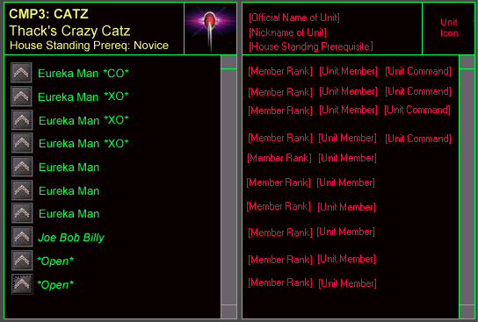
Active Units Detail View

The top window contains the Unit's official name and nickname, the number of open slots and the House Standing required to be allowed to join. The top right window contains a 'Mech icon color-coded red for "in combat" and gray for "no in combat".

The larger bottom window lists the members of the chosen unit, in order of command precedence, and with the member's rank icon displayed before the name.

4.7.5. Keyboard Commands

Keyboard shortcuts for the Active Units Display are as follows:

<CTRL+ A> | Active unit mode
<CTRL+ P> | Planet units mode
<CTRL+ H> | Hex units mode
<CTRL+ J> | JumpShip mode
<CTRL+ F> | Same as clicking Field HQ
<CTRL+ U> | Same as clicking Unit Info
<CTRL+ G> | Same as clicking Goto Unit

4.8. Personal Info Display

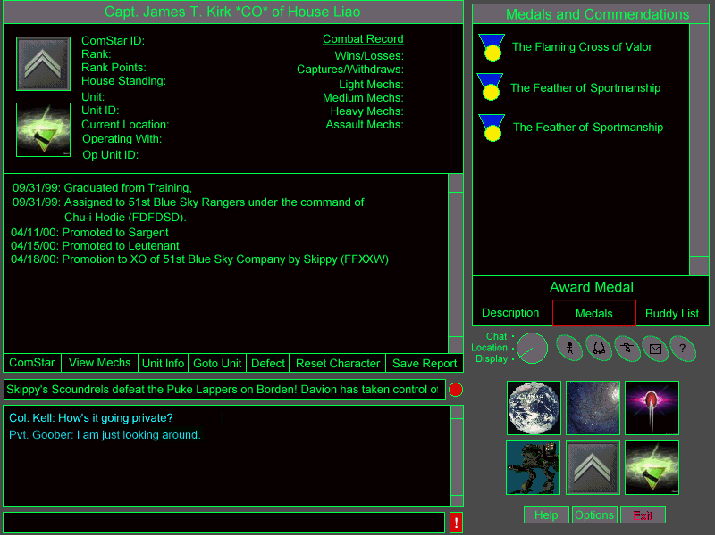
Personal Info Display

The Personal Info Display displays information about a the player’s character or another player’s character. The user can inspect a character’s current rank and unit affiliation, combat history and career history. It also allows the user to view Medals and Commendations the player has received, a description of the player’s appearance, and their buddy list. This screen also allows a player to create a new character or defect from their current House.

4.8.1. Interface Flow

The Personal Info Display can be accessed via the Personal Info Top Level Display Button. This will display information about the player’s character. To view another player’s info, the user can click on the Info Quick Function Button and then click on a player. The user can also click on the Personal Info Button in the Detail View of the ComStar Display to learn more about a player who has send them a ComStar.

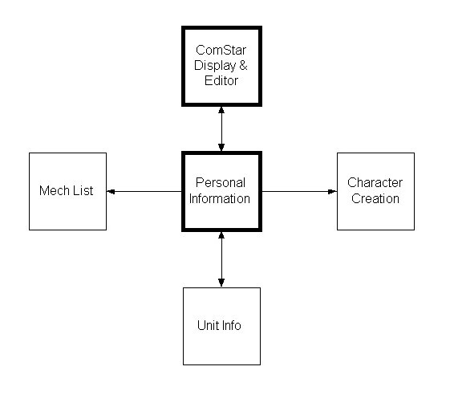
Interface flow from Personal Info

4.8.2. Main View

The Main View is broken down into two sections: the Character Summary and the Character History. The left hand column of the Character Summary contains information about the player and the player’s current unit affiliation. The right hand column contains the players combat statistics. The Character History is a chronicle of the major events in the player character’s military career.

4.8.2.1. Title Bar

The Title Bar of the Main View displays the character’s name in the following format:

<Rank Abbreviation> <Name> [CO || XO] (<ComStar ID>) of House <House Name>

4.8.2.2. Character Summary

4.8.2.2.1. ComStar ID

This is the player’s unique ComStar ID code. This is an alphanumeric string which is randomly generated when the player’s character is created.

4.8.2.2.2. Rank

The player’s current Rank is displayed in this field in the following format:

<Rank> (<Rank Abbreviation>)

4.8.2.2.3. Rank Icon

To the left of the character’s rank, rank points and House standing is the Rank Icon. This is the rank icon for the player’s current rank. This is the larger version of the Rank Icon, the same one that is used for the Personal Info Top Level Display Button.

4.8.2.2.4. Rank Points

This field displays the player’s current rank points.

4.8.2.2.5. House Standing

This field displays the player’s current House Standing. House standing is either: Cadet, Novice, Veteran, or Elite.

4.8.2.2.6. Unit

If the player is a permanent member of a unit, the unit name is displayed here. Otherwise, this field reads: *Reserves*.

4.8.2.2.7. Unit Icon

If the player is a permanent member of a unit, the unit icon is displayed to the left of the Unit, Unit ID, Current Location and Current Status fields.

4.8.2.2.8. Unit ID

If the player is a permanent member of a unit, the Unit ID is displayed here. Otherwise, this field reads: “RESERVE”.

4.8.2.2.9. Current Location

If the player is currently online, this field contains the player’s current location. It is displayed in the following format:

<Planet Name>, <Location Name> [*Battle*]

If the player is currently engaged in a combat mission, the string: “*Battle*” is appended. If the player is currently offline, this field reads: “*Off Duty*”.

4.8.2.2.10. Operating With

If the player is operating with a unit other than the unit he is assigned to, the “Operating with” field appears. This field displays the name of the unit the player is currently operating with.

4.8.2.2.11. Op Unit ID

If the player is operating with a unit other than the unit he is assigned to, the “Op Unit ID” field appears. This field displays the name of the ID of the Unit the player is currently operating with.

4.8.2.2.12. Combat Record

The player’s combat record is displayed in the right hand column of the Character Summary. All of this information is given in the same format: <# of Wins>/<# of Losses>.The following statistics are tracked:

Combat Record Stats
- Wins/Losses
- Captures/Withdraws
- Light Mech Record
- Medium Mech Record
- Heavy Mech Record
- Assault Mech Record

4.8.2.3. Character History

The Character history allows both the player and his superior officers to track the progress of his career. As important events occur in the player’s career, they are automatically documented in the character history.

4.8.2.3.1. Graduation

When the character graduates from Mechwarrior Training, the following string is added to the Character History:

<Month>/<Date>/<Year>: Graduated Mechwarrior Training.

4.8.2.3.2. Minor Rank Promotions

When the character receives a minor rank promotion, the following string is added to the Character History:

<Month>/<Date>/<Year>: Promoted to the rank of <Rank>.

4.8.2.3.3. Major Rank Promotions

When the character receives a major rank promotion, the following string is added to the Character History:

<Month>/<Date>/<Year>: Promoted to the rank of <Rank>, <CO/XO> of <Unit Name> (<Unit ID>) by <Promoter’s Rank> <Promoter’s Name> (<Promoter’s ComStar ID>).

4.8.2.3.4. Resignations

When the character leaves a unit, the following string is added to the Character History:

<Month>/<Date>/<Year>: Resigned from <Unit Name> (<Unit ID>).

4.8.2.3.5. Medals and Commendations

When the character receives a medal or commendation, the following string is added to the Character History:

<Month>/<Date>/<Year>: Received <Medal Name> from <Medal Giver’s Rank> <Medal Giver’s Name> (<Medal Giver’s Comstar ID>).

4.8.2.3.6. Joined a Unit

When the character is added to a unit, the following string is added to the Character History:

<Month>/<Date>/<Year>: Joined <Unit Name> under the command of <CO’s Rank> <CO’s Name> (<CO’s Comstar ID>).

4.8.2.3.7. Sent to Reserves

When the character is removed from a unit, the following string is added to the Character History:

<Month>/<Date>/<Year>: Sent to the Reserves by <Officer’s Rank > <Officer’s Name> (<Officer’s Comstar ID>).

4.8.2.3.8. Defected from House

When the character defects from a House, the following string is added to the Character History:

<Month>/<Date>/<Year>: Defected from House <House Name> to House <House Name>.

4.8.2.4. ComStar Button

This button allows the user to send a ComStar to the character being displayed. This button is disabled if the player is looking at his own character.

4.8.2.5. View Mechs Button

The View Mechs Button brings up the Mission Display in BattleMechs View Mode. This displays the mechs that this character is currently qualified to operate.

4.8.2.6. Unit Info Button

The Unit Info Button brings up the Unit Info Display for the player’s unit. If the player is not a member of a unit, then this button is disabled.

4.8.2.7. Goto Unit Button

The Goto Unit Button sends the user to the Briefing Room of the character’s unit. This button is disabled if the displayed player is not a member of a unit or that unit is not a company.

4.8.2.8. Defect Button

The Defect Button allows the player to defect from his current House. This button is only available if the player is looking at his own character. Clicking the Defect Button brings up the following confirmation dialog:

“You are about to defect from House <House Name>. Are you sure? If so, type “defect now” on the line below:”

If the user types in “defect now”, (case insensitive) then they are sent back to the Character Creation Screen to select another House. Otherwise, nothing happens.

4.8.2.9. Reset Character Button

The Reset Character Button works in much the same way as the Defect Button, except it allows the user to completely wipe the slate clean and start over. Resetting one’s character is the same as starting a new character from scratch. Clicking the Reset Character Button brings up the following confirmation dialog:

“Do you wish to permanently delete your character? If so, type “permanently delete this character” on the line below:”

If the user types in “permanently delete this character”, (case insensitive) then they are sent back to the Character Creation Screen to start a brand new character. Otherwise, nothing happens.

4.8.2.10. Save Report Button

The Save Report Button allows the user to save the Personal Information report to a file. The File outputted is a flat text file. When the user clicks on this button, they are prompted for a filename to which the report will be written. A standard Windows “Save As..” Dialog is used to prompt the user for a filename.

4.8.3. Detail View

The Detail View of the Personal Info Display has three modes which are selected using a group of three radio buttons at the base of the Detail View. The button for the currently selected mode is highlighted. The appearance and functionality for each mode are described below. The three modes are:

Personal Info Detail View Modes
- Description Mode
- Medals Mode
- Buddy List Mode

4.8.3.1. Description Mode

In Description Mode, the Detail View contains a text description of the player’s character. This can be whatever text the player wishes to enter. The Description field is read only to everyone except the player himself. The player can click on the description and edit it as often as he likes.

4.8.3.2. Medals Mode

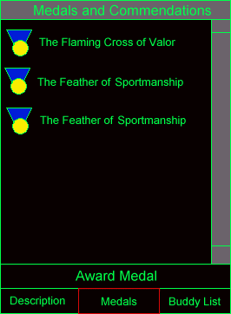
Medals Detail View Mode

In Medals Mode, the Detail View contains a scrollable list of the Medals and Commendations the player has earned of the course of his career. Note that if a player defects to another House, all Medals and Commendations are lost.

4.8.3.2.1. Award Medal Button

If the player who is reviewing this record is one of the player’s Superiors, he may click on the Award Medal Button to give the player a medal. The Select Medal Dialog will appear and the selected medal will be added to the player’s list. Awarding a medal also triggers a blurb on the News Ticker. (see News Ticker, above).

If the player is not qualified to hand out medals or is not a superior officer to the player currently being displayed, this option is grayed out and disabled.

4.8.3.3. Buddy List Mode

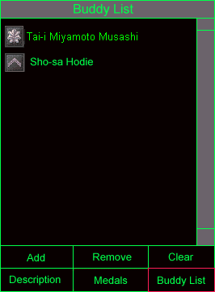

In Buddy List Mode, the Detail View contains a list of the players currently on the user’s buddy list. The Buddy List is used in conjunction with the Buddy List Quick Function Button. It allows a player to quickly check on the whereabouts of a pre-selected group of people (his buddies!).

4.8.3.3.1. Add Button

The Add Button allows a player to add a new buddy to the buddy list. Clicking on this button brings up the Find Player Dialog. The user may select one or more players from the Find Player Dialog to add to his buddy list. The Find Player Dialog is described below.

4.8.3.3.2. Remove Button

The Remove Button allows a player to remove a person from their buddy list. The user clicks on the Remove Button and then clicks on the player he wishes to remove from the list.

4.8.3.3.3. Clear Button

The Clear Button allows a player to clear his buddy list. Clicking on this button removes all of his buddies from the buddy list.

4.8.4. Keyboard Commands

Keyboard shortcuts for the Personal Info Display are as follows:

Key Combo | Action
<CTRL+C> | Same as clicking ComStar
<CTRL+ V> | Same as clicking View Mechs
<CTRL+ I> | Same as clicking Unit Info
<CTRL+G> | Same as clicking Goto Unit
<CTRL+ R> | Same as clicking Save Report
<CTRL+ D> | Same as clicking Description
<CTRL+M > | Same as clicking Medals
<CTRL+ B> | Same as clicking Buddy List

4.9. House Organization Display

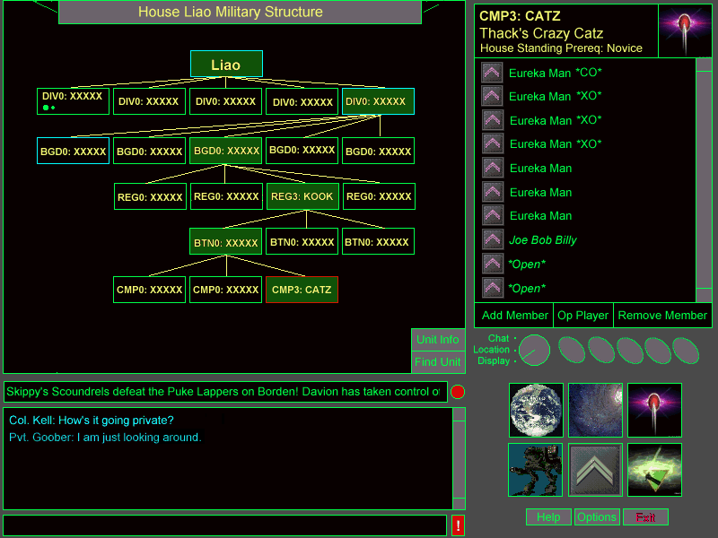
The House Organization Display

4.9.1. Main View

The Main view consists of the a House Organization chart in the center of the screen and two buttons, Unit Info and Find Unit.

4.9.1.1. Title Bar

The main view title displays the House name belonging to the House Organization chart that the user is currently viewing. A user can only look at the House organization chart for the House which he belongs.

4.9.1.2. House Organization Chart

The House organization chart is modeled after a typical top down organization chart. The highest ranking unit, the House Leader unit, is located at the top of the chart and the lowest ranking units are located at the bottom of the chart. There are five "levels" underneath the House Leader unit. By single-clicking on a unit in the chart, the next layer down will open up displaying all units that are subordinate to the unit clicked on. Thus, a user can easily determine chains of command by opening the various levels of the House Organization chart. All subordinate units of the unit that was "opened" are connected back to the unit using lines to form a tree like structure. If a unit has subordinate units open under it and the user single clicks on that unit, all of the subordinate units will be closed and the House Organization chart closes back up to the level of the unit clicked on.

When a user first sees this screen logging on, the House Orgainzation chart will be open to the user's unit, assuming the user has been assigned to a unit. The user's unit will also be selected so that the detailed view show the user's unit's basic information. Units that are in the user's direct chain of command are bordered in a different color (cyan) so that if a user has some other part of the orgainzation chart open and wants to get back to his unit, he can always find the highest level cyan bordered unit and start opening its sub-units. If the user is currently in the reserves, the House reserves unit will be bordered in a different color (cyan). An example of this is shown below in Figure 4.

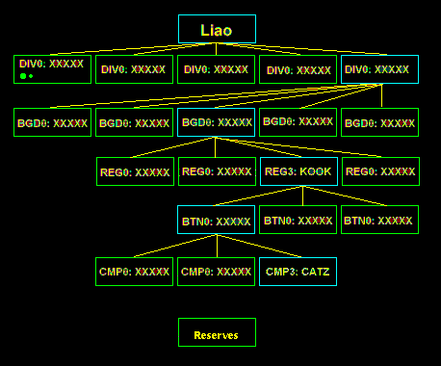
Figure 4

4.9.1.2.1. Single Clicking On House Organization Chart

Whenever a unit is single clicked (i.e. selected), the unit's basic information is displayed in the detailed view. A single click will also open/close all sub-units one level down from the current unit. An exmple of how single clicking is shown below.

The player is currently looking at the division level of House Liao (Figure 1). The player's division is highlited in a different color than the other divisions (in figure 1, the far right division).

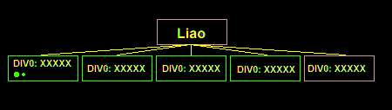
Figure 1

The player decides he wants to see more information about the brigades belonging to the divison he is in (the division on the far right of the screen). The player single clicks on that divison and will then see the following screen (figure 2):

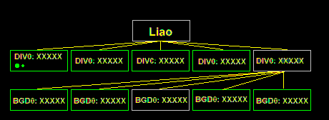
Figure 2

The player can now see the list of brigades under the division he is in. The player's brigade is highlited just like the division was. If the player single clicks on the same divison again, he will see figure 1 again. If the player while viewing figure 2, decides he wants to see the brigades belonging to the center division, by single clicking on the center division, he will see figure 3.

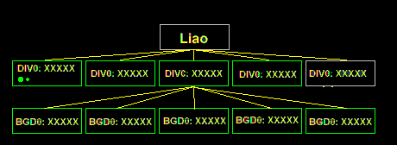
Figure 3

Notice that the player is now looking at brigades in a division that the player does not belong to. The player's division is still highlited at the division level.

4.9.1.2.2. Double-Clicking on House Organization Chart

Double-clicking a unit in the House Organization chart will bring up the Unit Info for that Unit. A player can then goto the selected unit via the Unit Info screen.

If a user closes all of the levels of the House Organization chart, the only things the user will see for the organization chart in the main view is the House Leader Unit and the Reserves Unit.

4.9.1.2.3. House Organization Chart Displayed Unit Information

Each unit in the main view will have an identifier (Unit Identifier): Div#: XXXXX where # is the number of the unit (i.e. division 4) and XXXXX is the 5 letter Unit ID descriptor. On the example screen this would be "CMP3: CATZ" where 3 is the number of the unit and "CATZ" is the Unit ID descriptor. Below this text can exist two different sized round dots. If a CO exists for the unit, a large (radius = ?? pixels) solid circle (color = white). If the CO position is unfilled, a large circle is displayed with a different color (red). For each XO for the unit, a small solid circle will be displayed (radius = ?? pixels) (color = white). If the XO position is filled, the circle will be a different color (red). The example of this can be seen in figure 5. Every unit except for companies have 1 CO and 1 XO. Companies have 3 XOs, thus there will be 3 XO dots displayed on the unit.

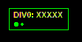
Figure 5

4.9.1.3. Unit Info Button

Clicking the Unit Info button after selecting a unit or clicking the Unit Info button and then selecting a unit will switch the Display mode to the Unit Information screen with the desired unit's data displayed.

4.9.1.4. Find Unit Button

Clicking the Find Unit button will bring up the Find Unit dialog. The Find Unit dialog will allow a player to search on these conditions: rank, open slots, show me player X's unit, etc. The Find Unit dialog will display all matches in a scroll buffer in which the user can click on one and hit Select to return to the House Organization chart. Once a unit has been selected and the dialog goes away, the House Organization chart will open the necessary units and sub-units to show where in the House organization the unit that was selected exists. See section ?? for more information on the Find Unit dialog.

4.9.2. Detail View

The detail view shows basic information about the unit that is currently selected in the Main View. The detail view is divided into 4 main areas: A basic info area, a bitmap, a listing of players belonging to the unit selected and three buttons (Op Player, Remove Member, Add Member). All members of a unit will see the Op Member button and the Remove Member button. The unit's XO(s) and CO will also see the Add Member button, other members of the unit will see the button as being greyed out. If there are no open slots available in a unit, the Op Player and Add Member buttons will not process the mouse click and a noise (beep) will be played. If while there are no open slots, the User is in Help Mode and clicks on the Op Player button or the Add Member button, the help context will inform the user that there are currently no open slots thus, no players can be opped or added.

The basic Info area contains 3 lines of info.

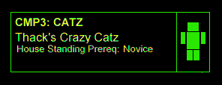

On the first line is the Unit Identifier, with the same text as the one displayed on the unit selected in the Main view. In the example is "CMP3: CATZ." The font will be larger and "bolded" to clearly stand out. The second line consists of the full unit name, "Thack's Crazy Catz". Again the font should be large. The third line of the basic info area displays the House Standing Prerequisite needed in order to join the current unit selected. Some units will be "elite" units only allowing experienced players in. All letters should be ?? color except for "House Standing Prereq:" which should be ?? color. The CO can change the Unit Identifier, Unit Name or the House Standing Prereq.

4.9.2.1. Unit Identifier

The Unit Identifier can be double clicked which changes the interface to Change Unit Identifier Mode. When the interface is in the Change Unit Identifier Mode, the four letters of the Unit Identifer are replaced with a blank text input box and a blinking cursor. The player then can enter a new 4 letter Unit Identifier. Hitting ESC while in this mode or clicking elsewhere on the screen will revert the Unit Identifier to what it was previously. The player hits enter to accept the new Unit Identifier. The Unit Identifier is then checked against the Reserved Word List. If the Unit Identifier uses a reserved word, an error message is displayed and the unit identifier reverts back to what it was, otherwise the Unit Identifier is updated on all players' screens. Only the CO can change the company's Unit Identifier.

4.9.2.2. Unit Name

The Unit Name can be double clicked which changes the interface to Change Unit Name Mode. When the interface is in the Change Unit Name Mode, the letters of the Unit Name are replaced with a blank text input box and a blinking cursor. The player then can enter a new ?? letter Unit Name. Hitting ESC while in this mode or clicking elsewhere on the screen will revert the Unit Name to what it was previously. The player hits enter to accept the new Unit Name. The Unit Name is then checked against the Reserved Word List. If the UnitName uses a reserved word, an error message is displayed and the Unit Name reverts back to what it was, otherwise the Unit Name is updated on all players' screens. Only the CO can change the Unit Name.

4.9.2.3. House Standing Prereq.

The House Standing Prereq. is a toggle button which switches between Novice, Intermediate, Expert each time it is pushed. This can only be set by the CO of the company.

4.9.2.4. Unit Insignia

To the right of the info area is a bitmap of size ?? by ??. This bitmap contains the insignia of the unit. Insignias will exist for the House Leader down to the Regiment level. All sub-units of a Regiment will all have the same insignia. The bottom of the bitmap area will align with the bottom of the basic info area forming the top of the listing of players area.

4.9.2.5. Unit Roster

The Unit Roster area contains a scroll bar on the far right side of the screen which works like any Windows scroll bar. Support for the wheel on top of newer mice should be supported. The rest of the listing area is used for displaying the rank and names of all of the players currently belonging to or operating with the unit. A graphical icon displaying the rank of a player is located on the far left of the listing. The player's name consisting of a maximum of ?? characters follows. The player's name is written using ?? font and ?? color. If the player is a CO, XO or member of COMSTAR an additional field is appended to the end of the name. A CO has "*CO*" added, an XO has "*XO*" added and COMSTAR players have "COMSTAR" displayed. The color of the additional field is ??. If a player is operating with a unit, but not formally a member of the unit, that player's name will be in italics and displayed in color ??. If the slot is open, the lowest rank that satisifies the House Standing Prereq. will be used in determining the rank icon. The player's name will be "*Open*" in ?? color.

4.9.2.6. Op Player

Clicking the Op Player button will bring up the Find Player dialog (see section ##) if there is an open slot available. A player can only be opped if there is an open slot otherwise the command is ignored. Any player that is currently a permanent member of a unit may op a user to his unit. If a unit's member successfully finds another player to op using the Find Player dialog, clicking the "Select" button on Find Player will Op the selected player if there is currently an Open Slot. If there are no open slots and a unit's member has attempted to Op another player, a dialog will be displayed informing the player there are currently no more open slots available. Once a player has been opped, the detail view will refresh itself to show the new player that has been opped for all players currently looking at that unit's roster. A player can not be oped into a slot normally reserved for a CO or XO. If a player that is currently Oped ends his game session, the slot that was taken up by the player will revert back to an open slot.

4.9.2.7. Add Member

Clicking the Add Member button will prompt the player to choose what slot in the player listing area to add a member to if there is an open slot available. If there are no open slots in a unit that a CO or XO has access for adding players, the Add Member command will be ignored. The mouse cursor will change to a ?? shape prompting the player to choose which slot is to be used to add a member to. The slot chosen must be an open slot. After a slot is chosen, the Find Player dialog (see section ##) is automatically displayed for the user. Only the CO or XO may add a player to a unit and only the CO may add a player into an XO position. If an XO attempts to add a player into an open XO slot, the command will be rejected. If another player is inserted into the open slot that the current player was attempting to add a player to, the host will check to see if there are any other open slots of the same type (either grunt or XO) and will place the player there. If there are no other slots of the same type, an error message will be displayed. A player being added to a unit does not need to be online during the Add Member process. A COMSTAR message is sent to the player added informing him of his new status.

The CO can promote a "grunt" to an open XO slot using the Add Member button, selecting the XO slot, and then entering the players name in the Find Player dialog. The player will be automatically moved from his current slot to the XO slot. If the CO wants to switch two players (one an XO the other a grunt), the CO must first place one of the players in the Reserves by using the Remove Member button. Then the CO uses the Add Member button for each player to get them reassigned to their new positions.

4.9.2.8. Remove Member

Clicking Remove Member will place the interface in Remove Member Mode. The cursor will change to a ??. The player then selects a player from the listing of players. A confirmation dialog will appear asking if the user is sure about removing the player. Any player may remove himself, otherwise the command is ignored if the player is not a CO or XO. A CO or XO can remove any grunt. Only a CO may remove an XO. The removed player will be sent to the reserves. If the player that is removed is in combat or is in the Company Ready Room, the removed player will be sent to the Unit HQ. A dialog message will be sent to the user informing him that he has been removed from his current unit and is now in the reserves for the House. If a player removes himself from a unit (i.e. resigns) , a COMSTAR(?) message will be sent to that unit's CO and XO(s) that are currently online.

4.9.3. Keyboard Commands

Keyboard shortcuts for the House Organization Display are as follows:

Key Combo | Action
<CTRL+I> | Same as clicking Unit Info
<CTRL+ U> | Same as clicking Find Unit
<CTRL+ A> | Same as clicking Add Member
<CTRL+ O> | Same as clicking Op Player
<CTRL+ R> | Same as clicking Remove Member

4.10. Unit Info Display

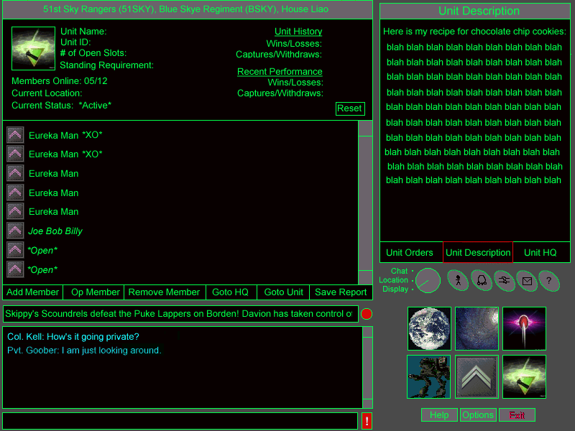
Unit Info Display

The Unit Info Display displays information about a unit and allows the officers associated with the unit to modify the roster, issue orders, and edit the description of the unit. The unit information screen also provides a short cut directly to a company’s briefing room or a unit’s headquarters.

4.10.1. Interface Flow

The Unit Info Display does not have its own top level display button. Instead, it is accessed from the House Org Chart, ComStar, and the Personal Information Displays. The Unit HQ Locations also access the Unit Info Display. Finally, the Unit Information Display can be accessed by clicking on Info Quick Function Button and then clicking on a unit. The unit information that is displayed is dependent upon the unit selected in the previous screen.

From the Unit Info Display, the user can travel directly to the Unit HQ or the Briefing Room for the displayed unit.

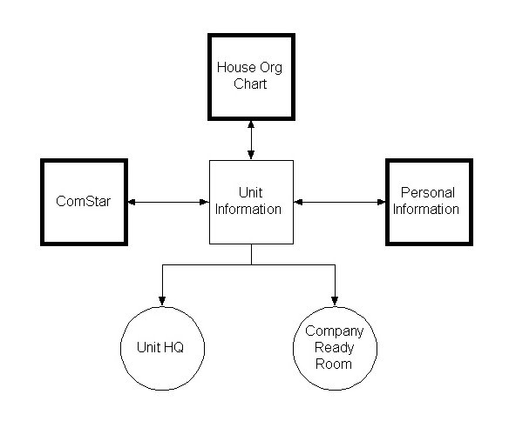
Interface flow Unit Info Display

4.10.2. Main View

The Main View of the Unit Info Display is broken down into two parts: the Unit Summary and the Unit Roster.

4.10.2.1. Title Bar

The Unit Info Display Title Bar has the following format:

<Unit Name> (<Unit ID>), of the <Regiment Name> (<Regiment Unit ID>), House <House Name>

4.10.2.2. Unit Summary

4.10.2.2.1. Unit Name

This field displays the name of the unit. To change the name of the unit, the user can double click on this field. The field becomes an edit box and a new name can be entered. Only the CO of the Company can edit the unit’s name.

4.10.2.2.2. Unit ID

This field displays the unit’s unique ID. To change the Unit ID, the user can double click on this field. The field becomes an edit box and a new name can be entered. Only the CO of the Company can edit the unit’s ID. The ID must be no longer than six characters and must be unique.

4.10.2.2.3. Open Slots

The Open Slots field displays the number of slots in the unit that do not currently have permanent members assigned to them.

4.10.2.2.4. Standing Requirement

This field displays the House Standing Requirement for the unit. In order to join this unit, a player must have a House standing equal to or greater than the House Standing Requirement. This field is only displayed for companies.

Double clicking on this field cycles through the possible settings for this field. The possible settings are: Open, Restricted, or Elite. Only the CO of the unit or the CO’s superior in the chain of command can alter the House Standing Requirement for the unit.

4.10.2.2.5. Members Online

This field displays the number of members of the unit that are currently online. This includes temporary members that are operating with the unit.

4.10.2.2.6. Current Location

This is the current location of the unit. This field only appears if the unit is a company. Units can either be on planet or in orbit, moving or stationary. If the unit is stationary, the current location is displayed in the following format:

If on planet:

<Planet Name>, <Hex Coordinates>

If in space:

Orbiting <Planet Name>

If the unit is moving, the unit’s destination is shown:

If on planet:

<Planet Name>, <Hex Coordinates> *In Transit*

If in space:

<Planet Name>, on route to: <Planet Name>

4.10.2.2.7. Current Status

This is the current status of the unit. This field only appears if the unit is a company. The table below shows the possible status types for a unit and their meaning.

Status | Meaning
Active | The unit is in a contested hex.
Moving | The unit is moving.

4.10.2.2.8. Combat Record

This button allows an officer to reset the performance tracking for the unit. This allows the officer to easily measure the performance of a unit over time.

4.10.2.2.9. Unit Icon

The Unit’s Icon is displayed in the upper left hand corner of the Main View.

4.10.2.3. Unit Roster

CO/XO?
Name
Rank
Comstar ID
Performance Summary
Op With?

4.10.2.4. Add Member Button

The Add Member Button works the same way as the Add Member Button in the Detail View of the House Organization Chart. The user clicks on the button and then clicks on an open slot in the Unit Roster.

4.10.2.5. Op Member Button

The Op Member Button works the same way as the Op Member Button in the Detail View of the House Organization Chart. The user clicks on the button and then clicks on an open slot in the Unit Roster.

4.10.2.6. Remove Member Button

The Remove Member Button also works the same way as its counterpart in the Detail View of the House Organization Chart.

4.10.2.7. Goto HQ Button

Clicking on the Goto HQ Button moves the player to the headquarters of the unit being displayed. If the player is not a member of this unit, this option is disabled and grayed out.

4.10.2.8. Goto Unit Button

Clicking on the Goto Unit moves the player to the Briefing Room for the unit being displayed.

4.10.2.9. Save Report Button

The Save Report Button allows the user to save the Unit Information report to a file. The File outputted is a flat text file. When the user clicks on this button, they are prompted for a filename to which the report will be written. A standard Windows “Save As..” Dialog is used to prompt the user for a filename.

4.10.3. Detail View

The Detail View of the Unit Info Display has three modes which are selected by a group of three radio buttons at the base of the Detail View. The button for the currently selected mode is highlighted. The appearance and functionality for each mode are described below. The three modes are:

Unit Info Detail View Modes
- Unit Info Mode
- Orders Mode
- Unit HQ Mode

4.10.3.1. Unit Info Mode

In Unit Info Mode, the Detail View contains a description of the unit. This might include information about how long the unit has been around, its primary duties, or anything else the players which to put in here. The Unit Info field is read only to everyone except the CO for the unit. The CO can click on the description and edit it as often as he likes.

4.10.3.2. Orders Mode

Orders Mode is very similar to Unit Info Mode, except that it is meant to communicate the current orders for the unit to members of the unit or other units. The Orders field is read only for everyone except the CO and officers within the command chain of the unit.

4.10.3.3. Unit HQ Mode

Unit HQ mode displays the text description of the Unit’s Headquarters. This text description is display in the Communication View anytime a player enters the Units HQ. The CO or the XO of the unit can edit this field. For more information on the Unit HQ locations, see the section on Locations below.

4.10.4. Keyboard Commands

Keyboard shortcuts for the Unit Info Display are as follows:

Key Combo | Action
<CTRL+A> | Same as clicking Add Member
<CTRL+ P> | Same as clicking Op Member
<CTRL+ R> | Same as clicking Remove Member
<CTRL+ Q> | Same as clicking Goto HQ
<CTRL+ G> | Same as clicking Goto unit
<CTRL+ R> | Same as clicking Save Report
<CTRL+ O> | Same as clicking Unit Orders
<CTRL+ D> | Same as clicking Unit Descriptions
<CTRL+ H> | Same as clicking Unit HQ

4.11. Mission Display

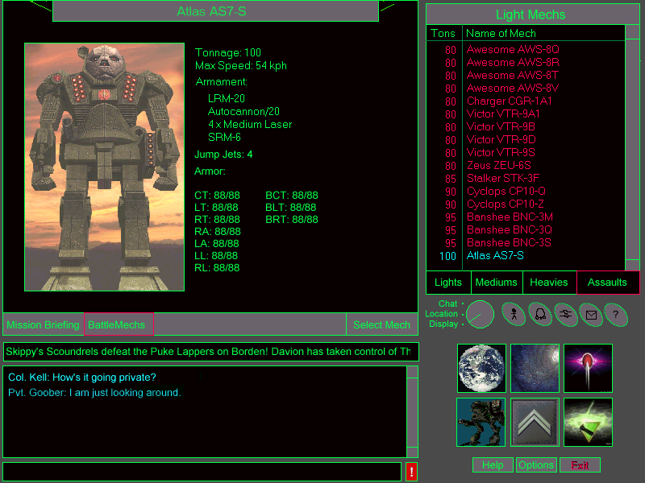
Mission Display

The Mission Display allows the player to review the mission briefing for a combat, training, or dueling mission, and select a ‘Mech to use during the mission. Player’s can also configure the settings for a training or dueling mission.

4.11.1. Main View

The Main View in the Mission Display has two modes: Mission Briefing Mode and Battlmech Selection Mode. The user can switch between these two modes using the Mission Briefing and Battlemechs buttons in the lower left hand corner of the Main View.

If the user has come to this screen via the View ‘Mechs button in the Personal Info Display, the Mission Briefing Button is grayed out and disabled. Otherwise, the Mission Briefing Button is selected by default.

4.11.1.1. Mission Briefing View Mode

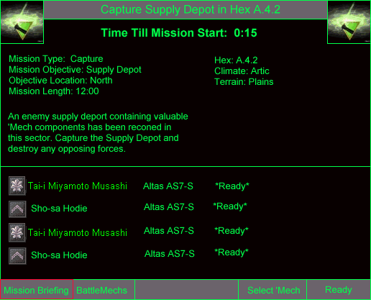
Mission Briefing View Mode

4.11.1.1.1. Time Till Mission Start

This field displays the time in minutes and seconds till the start of the mission.

4.11.1.1.2. Mission Type

This field displays the type of the mission. In training missions and in duels on Solaris, this field becomes a drop down list box containing the available mission types. The player can select the type of mission he wishes to run. Otherwise, if this is a combat mission, this field is read only.

4.11.1.1.3. Mission Objective

This field displays the objective or target for the mission. In training missions and in duels on Solaris, this field becomes a drop down list box containing the available mission objectives for the selected mission type. The player can select the objective of the mission he wishes to run. Otherwise, if this is a combat mission, this field is read only.

4.11.1.1.4. Objective Location

This field displays the approximate location of the mission objective. In training missions and in duels on Solaris, this field becomes a drop down list box containing the following options:

Objective Locations
- North
- North East
- North West
- East
- West
- South
- South East
- South West

The player can select the location of the objective. Otherwise, if this is a combat mission, this field is read only.

4.11.1.1.5. Mission Length

This field displays the maximum length of the mission in minutes and seconds. In training missions and in duels on Solaris, this field can be edited as well.

4.11.1.1.6. Mission Description Text

Thie field displays a text description of the mission. The mission description text is formulated based on the variables above.

4.11.1.1.7. Hex

This is the hex in which this mission is currently being run. If this is a training mission or Solaris duel, then this field is replaced with the text: “Practice Mission.”

4.11.1.1.8. Climate

This field displays the climate of the hex in which this mission is currently being run. If this is a training mission or Solaris duel, then this field is a drop down list box. The player can select the desired climate from the list.

4.11.1.1.9. Terrain

This field displays the terain of the hex in which this mission is currently being run. If this is a training mission or Solaris duel, then this field is a drop down list box. The player can select the desired terrain from the list.

4.11.1.1.10. Mission Roster

The Mission Roster is a list of players that are part of the Mission Group which will execute the mission. The following informatin is displayed for each member of the group:

- Rank Icon – The Rank Icon of the player’s current rank.
- Name – The player’s name.
- ‘Mech – The player’s currently selected ‘Mech.
- Status – The status of the player: Ready or Not Ready.

4.11.1.1.11. Select ‘Mech Button

The Select ‘Mech Button selects the ‘Mech currently highlighted in the Detail View for use in this mission.

4.11.1.1.12. Ready Button

The Ready Button is used to indicate that the player is ready to being the mission. This button has the same functionality as the Combat Ready Hotspot in the Location View.

4.11.1.2. BattleMech Selection View Mode

The BattleMech Selection View Mode consists of the following elements:

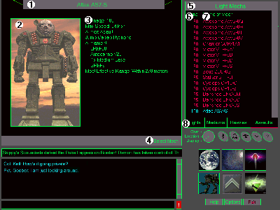
BattleMech View Mode

- Name of BattleMech (title bar) — The name of the 'Mech being displayed can be found here. At either end of this space, the Weight Class of the current Mech should be printed as well.
- 'Mech Picture — A picture of the BattleMech is displayed here.
- 'Mech Statistics — The appropriate data from the 'Mech Technical readouts is displayed here. This information consists of at least:
- Weight in tons
- Maximum Speed
- Weapons
- Number of Jump Jets
- Armor Amount and Location
- Select 'Mech Button — This button selects the 'Mech displayed as the player's vehicle for the upcoming combat and returns the player to the Location display.

4.11.2. Detail View

The Detail View of the Mission Display is in the upper right of the screen and consists of the following elements:

- Class of Mech (title bar) — This title bar displays the Weight Class of the 'Mechs being displayed in the selection list below.
- Tons (column header) — This column indicates the weight class of the 'Mechs being displayed. 'Mechs are sorted by this column, not by name.
- Name of Mech (column header) — This column shows the name of the 'Mechs being displayed. Name is in the format [Name][variant code].
- Weight Class selection buttons — These four buttons, labeled Light, Medium, Heavy and Assault switch the Detail View between displaying those four weight classes of BattleMechs. The selected button is highlighted in some way until another is chosen. The default choice is Light.

When a row in the Detail View is clicked, the data for that Mech is displayed in the BattleMech Data Display to the left. The selected Mech is highlighted in the list.

The list displayed in this view is subject to the effects of supply and lists only the ‘Mechs the player is currently qualified to operate. See BattleMech Acquisition and the Effects of Supply in the Game Mechanics section.

4.11.3. Keyboard Commands

Keyboard shortcuts for the Mission Display are as follows:

Key Combo | Action
<CTRL+S> | Same as clicking Select Mech
<CTRL+ L> | Same as clicking Light
<CTRL+M > | Same as clicking Medium
<CTRL+ H> | Same as clicking Heavy
<CTRL+ A> | Same as clicking Assault

4.12. Locations

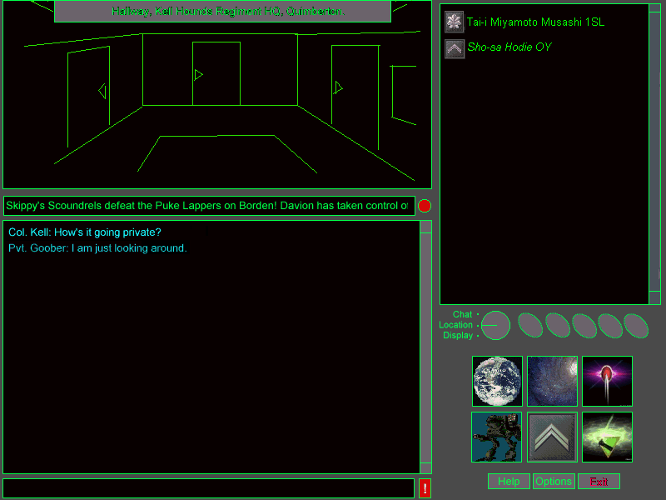
Location View

Locations are areas in which players can meet and chat with other players. A location is essentially a text based conference room with some limited roleplaying functionality. Players can navigate from location to location by clicking on hot spots in the Location View. The User List View to the right of the Location view shows other players that are currently in the user’s location.

4.12.1 Location View

The Location View contains a clickable picture of the player’s current location. The image can have one or more hotspots. The different types of hotspots are described below. The different types of locations are described below in the City Locations, Field Locations, and Training Locations sections.

4.12.1.1. Location View Title Bar

The Location View Title Bar contains the name of the player’s current location. When the mouse rolls over a hot spot in the Location View, the Location View Title Bar changes to reflect the function of the hotspot.

4.12.1.2. Location Hotspot

When a Location Hotspot is clicked, the user is sent to a specified location. Rolling the mouse over a Location Hotspot displays the name of the new location in the Location View Title Bar.

4.12.1.3. Display Hotspot

When a Display Hotspot is clicked, the specified display is brought up. Rolling the mouse over a Display Hotspot displays the title of the display in the the Location View Title Bar.

4.12.1.4. Meeting Room Hotspot

Certain types of locations allow the user to create private or public meeting rooms. The user may click on this hot spot to create or join a meeting room off of the current location.

4.12.1.5. Mission Group Hotspot

Certain types of locations allow the user to create Mission Groups. The user may click on this hot spot to create or join a mission group off of the current location.

4.12.1.6. Combat Ready Hotspot

Clicking on this hot spot will signal the user's readiness for combat.

4.12.1.7. Text Description

Whenever the player enters a new location, a text description of the location is printed out in the Communications View. The text description adds a little bit of individuality to the location and also hints at the functions available in the location.

Unit Headquarters are special in that their text descriptions can be edited by the CO of the unit. See the section on the Unit Info Display, above.

4.12.1.8. Ambient Sounds

In addition to a text description, different locations have different ambient sounds associated with them. These are low level background sounds that give the user a even more of a feeling of place.

4.12.2. User List View

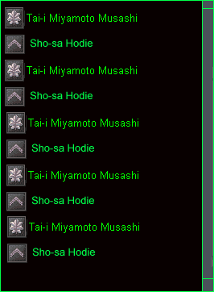
User List View

The User List View is a scrollable list which displays the users present in the player’s current location. For each player, their rank icon, rank abbreviation and name are displayed. Double clicking on a player in this list will bring up the player’s personal info in the Personal Info Display.

4.12.3. Meeting Room List View

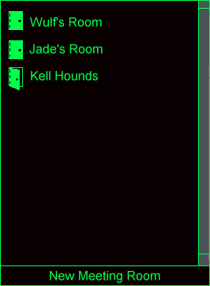
Meeting Room List View

The Meeting Room List View replaces the User List View when the user clicks on a Meeting Room Hotspot in the Location View. It is a scrollable list of the meeting rooms available at this location. Rooms can be public or private. Private rooms are indicated by a closed door icon next to the name. Public rooms have an open door icon next to their name.

The user can click on a room to attempt to enter a room. If the room is a private room, the user will be prompted for a password by the Password Dialog. The Password Dialog is described below. If the user enters the correct password or if the room is a public room, the player’s location changes to that of the selected room and the Meeting Room List View is dismissed.

To create a new meeting room, the user can click in the New Meeting Room Button. This button brings up the Create Room Dialog, which will prompt the user for a room name, and optional password. The Create Room Dialog is described below.

Pressing the Escape key or changing view modes dismisses the Meeting Room List View.

4.12.4. Mission Group List View

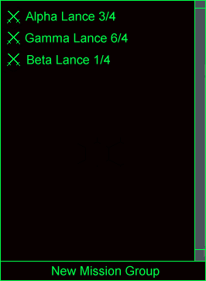
Mission Group List View

The Mission Group List View replaces the User List View when the user clicks on a Mission Group Hotspot in the Location View. It is a scrollable list of the mission groups active in the player’s current location. For each mission group, the name of the mission group, the number of players currently in the Mission Group Briefing Room, and the number of players in the mission group is displayed.

The user can click on a mission group to enter the mission group briefing room. The player’s location changes to that of the selected room and the Mission Group List View is dismissed.

To create a Mission Group, the user can click on the New Mission Group Button. If the Mission Group is being formed in a Company Ready Room, the player must either be a member of the company or operating with the company. Otherwise, this button is grayed out and disabled. The New Mission Group Button brings up the Create Mission Group Dialog, which will prompt the user for a group name. The Create Mission Group Dialog is described below.

Pressing the Escape key or changing view modes dismisses the Mission Group List View.

4.12.5. City Locations

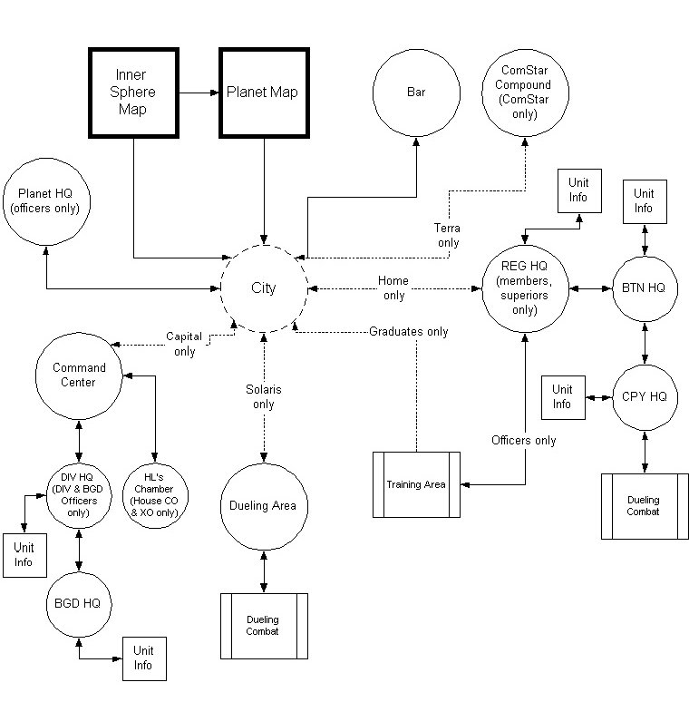
City Locations Interface Map

Every planet in the Inner Sphere has City Locations which are associated with the central hex of the planet. When a house has control of the central hex, they have access to the City Locations for that planet. The locations that are available vary from planet-to-planet.

Regiment HQs are only available on planets which are the homeworld for a regiment. Command Centers are only available on capital planets. If a planet with a Regiment HQ comes under the control of another house, the Regiment HQ is no longer accessable to players from that regiment.

Solaris and Terra are special planets in that they cannot be assaulted. Terra is under the permanent control of ComStar and for the purposes of this game, so is Solaris. Terra features the ComStar Compound location and Solaris features the Tram and Dueling Arena locations.

Every planet has at a minimum a Starport, Planet HQ, and Bar location.

4.12.5.1. Starport

This is a large tarmac with building surrounding it. The viewpoint is at the edge of the tarmac looking at several buildings.

Hotspot | Type | Description | Destination | Restrictions
Bar | Location | A rough building, the sign shows a beer stein or some other alcohol-related container. | Bar Location
Planet HQ | Location | A mobile HQ vehicle rolling away from the main city. | Planet HQ Location
Comstar Compond | Location | A white hexagonal building with ComStar's logo over the gate. | Comstar Compond Location | Only available on Terra.
Regiment HQ | Location | A fenced area with a BattleMech on the gate sign. | Regiment HQ Location | REG members and REG superior officers only.
Tram | Location | A fenced area with a BattleMech on the gate sign. | Tram Location | Only available on Solaris.
Command Center | Location | An austere building with the House flag flying from the top. It is next to the REG HQ. | Command Center Location | Only available on capital planets.
Dropship | Display | A Dropship on the tarmac. | Inner Sphere Map Display

4.12.5.2. Bar

Looks like a military bar with companels at each booth and other high-tech accoutrements The viewpoint is in the middle of the bar with booths to the left and the bar to the right. The door to the city is up some stairs in front of the user.

Hotspot | Type | Description | Destination | Restrictions
Double door | Location | The door back out to the street. | Starport Location
Door | Meeting Room | A door into a back room. | Meeting Rooms
ComStar Booth | Display | A small computer display in the corner of the room. | ComStar Display

4.12.5.3. Command Center

The command center is where all the major military planning occurs. This area is utilitarian and has armed guards standing by. A stately table rests in the middle of the room. There is a large wall-window to the right which shows the starport tarmac. At the far end of the room are two doors, one marked with the House Leader's crest and the other with the map of the House. These doors lead to the Division conference rooms and the House Leader/XO conference room. A set of double doors to the left is open to reveal soldiers sitting in chairs arranged in rows.

Hotspot | Type | Description | Destination | Restrictions
Starport | Location | Doors to the street. | Starport Location
HL HQ | Location | Adoor marked with the HL crest. Inactive unless you're the House Leader or HXO. | House Leader HQ Location | Must be HL or HXO to enter.
DIV #1 HQ | Location | A door marked with the Division crest. | DIV HQ Location | Must be Division CO/XO or HL or HXO to enter.
DIV #2 HQ | Location | A door marked with the Division crest. | DIV HQ Location | Must be Division CO/XO or HL or HXO to enter.
DIV #3 HQ | Location | A door marked with the Division crest. | DIV HQ Location | Must be Division CO/XO or HL or HXO to enter.
DIV #4 HQ | Location | A door marked with the Division crest. | DIV HQ Location | Must be Division CO/XO or HL or HXO to enter.
DIV #5 HQ | Location | A door marked with the Division crest. | DIV HQ Location | Must be Division CO/XO or HL or HXO to enter.
Table | Display | An oak table with some inportant looking papers on it. | House Org Chart Display | Must be a member of the house.

4.12.5.4. Division Headquarters

This is an elegant conference room. A table stands in the middle of the room and there are doors around the walls. To the center is a door marked with the outline of the House and another with the outline of the division's brigades highlighted within the House map. Another door to the right is guarded by generic soldiers. The division crest is displayed high on the wall. To the left is a double door showing soldiers lined up in rows.

Hotspot | Type | Description | Destination | Restrictions
Command Center | Location | Te door in the center marked with the House map. | Command Center Location
BGD #1 HQ | Location | The door with the brigades highlighted. | BGD #1 HQ | BGD Officers only
BGD #2 HQ | Location | The door with the brigades highlighted. | BGD #2 HQ | BGD Officers only
BGD #3 HQ | Location | The door with the brigades highlighted. | BGD #3 HQ | BGD Officers only
BGD #4 HQ | Location | The door with the brigades highlighted. | BGD #4 HQ | BGD Officers only
BGD #5 HQ | Location | The door with the brigades highlighted. | BGD #5 HQ | BGD Officers only
Create private room | Meeting Room | The door being guarded. | Meeting Rooms
Table | Display | The table. | House Org Chart Display

4.12.5.5. Brigade Headquarters

This is another conference room. There is a table and three doors leading out of the room. To the center is a door marked with the Division crest. To the right is a door being guarded by non-descript soldiers. To the left is a double door showing soldiers in chairs arranged in rows. The brigade crest is prominently displayed on the wall.

Hotspot | Type | Description | Destination | Restrictions
DIV HQ | Location | The door in the center marked with the Division crest will return the user to the Division Conference Room. | DIV HQ Location
Create private room | Meeting Room | The guarded door will create a private room. | Meeting Rooms
Table | Display |  | House Org Chart Display

4.12.5.6. Regimental Headquarters

This is a high-class officer's lounge. A small bar is to the right side of the room. On the left side of the room is a large-screen video display. A door to the on the far wall to the right has the regimental crest painted on it. Three doors on the far side of the room in the center and to the left show company designations. A wall chart hangs to the left of the video screen. A door leads off to the right, guarded by generic soldiers.

Hotspot | Type | Description | Destination | Restrictions
Starport | Location |  | Starport Location
BTN #1 HQ | Location |  | BTN HQ Location
BTN #2 HQ | Location |  | BTN HQ Location
BTN #3 HQ | Location |  | BTN HQ Location
Private Room | Meeting Room |  | Meeting Rooms
House Info | Display |  | House Org Chart Display
Training Area | Location |  | REG Training Area | Officers Only

4.12.5.7. Battalion Headquarters

This is a high-class officer's lounge. A small bar is to the right side of the room. On the left side of the room is a large-screen video display. A door to the on the far wall to the right has the regimental crest painted on it. Three doors on the far side of the room in the center and to the left show company designations. A wall chart hangs to the left of the video screen. A door leads off to the right, guarded by generic soldiers.

Hotspot | Type | Description | Destination | Restrictions
REG HQ | Location | The door with the regimental crest leads back to the regimental HQ. | REG HQ Location
CPY 1 | Location | This door has the 1st company's markings on it. | CPY HQ Location
CPY 2 | Location | This door has the 2nd company's markings on it. | CPY HQ Location
CPY 3 | Location | This door has the 3rd company's markings on it. | CPY HQ Location
House Org Chart | Location | The wall chart will change the location to a display of the House org chart open to the BTN's level. | House Org Chart Disply
Private Room | Meeting Room | The door guarded by soldiers leads to the private rooms. | Meeting Rooms

4.12.5.8. Company Headquarters

This is a small office with a coffee machine to the left. The viewpoint is looking out to an officer's lounge over a small conference table. On the table are some papers and some pictures. There are two large metal doors labelled “A” and “B” in big red letters.

Hotspot | Type | Description | Destination | Restrictions
BTN HQ | Location |  | BTN HQ Location
House Org Chart | Display |  | House Org Chart Display
Door A | Mission Group |  | Alpha Mission Groups
Door B | Mission Group |  | Beta Mission Groups

4.12.5.9. Tram

This is an enclosed train station, free of most dirt, garbage, and grafitti. A high-tech monorail waiting to be boarded is barely visible to the right, doors open. A ticket counter shows the destinations available to the traveler: each of the five arenas and the starport on Solaris, graphically represented.

Hotspot | Type | Description | Destination | Restrictions
Starport | Location | Starport icon | Starport Location
Arena #1 | Location | Arena #1 Icon | Arena #1
Arena #2 | Location | Arena #2 Icon | Arena #2
Arena #3 | Location | Arena #3 Icon | Arena #3
Arena #4 | Location | Arena #4 Icon | Arena #4
Arena #5 | Location | Arena #5 Icon | Arena #5

4.12.5.10. Arena

The inside of any major stadium in the US. Generic for all five arenas. The name of the arena appears on a sign along the top. There are two large gateways labelled “A” and “B” in big red letters.

Hotspot | Type | Description | Destination | Restrictions
Tram | Location | Tram in the distance | Tram Location
Gate A | Mission Group |  | Alpha Mission Groups
Gate B | Mission Group |  | Beta Mission Groups
VIP Lounge | Meeting Room |  | Meeting Rooms

4.12.5.11. ComStar Compound

White room with religious overtones and white-robed acolytes standing with arms in opposite sleeves. A large ComStar symbol dominates the background like a cross in a church.

Hotspot | Type | Description | Destination | Restrictions
Starport | Location | An archway with buildings in the background. | Starport Location
First Circuit | Location | A set of double doors with a single star surrounded by five, all within a modified ComStar symbol. | First Circuit Location
Inner Sphere Council Chambers | Location | A door with the map of the Inner Sphere. | Inner Sphere Council Chambers

4.12.5.12. Inner Sphere Council Chambers

This is a room where the most powerful people in the Inner Sphere conduct meetings and other politics. It is an ornately decorated room with six large tables, arranged in a circle, and chairs for aids behind each table.

Hotspot | Type | Description | Destination | Restrictions
Door | Location | Marble Archway | Comstar Compound Location
Davion Chambers | Location | A door against the far wall with the Davion House crest. | House Chamber Location | must be House HL/XO, DIV C/XO
Liao Chambers | Location | A door against the far wall with the Liao House crest. | House Chamber Location | must be House HL/XO, DIV C/XO
Kurita Chambers | Location | A door against the far wall with the Kurita House crest. | House Chamber Location | must be House HL/XO, DIV C/XO
Marik Chambers | Location | A door against the far wall with the Marik House crest. | House Chamber Location | must be House HL/XO, DIV C/XO
Steiner Chambers | Location | A door against the far wall with the Steiner House crest. | House Chamber Location | must be House HL/XO, DIV C/XO

4.12.6. Field Locations

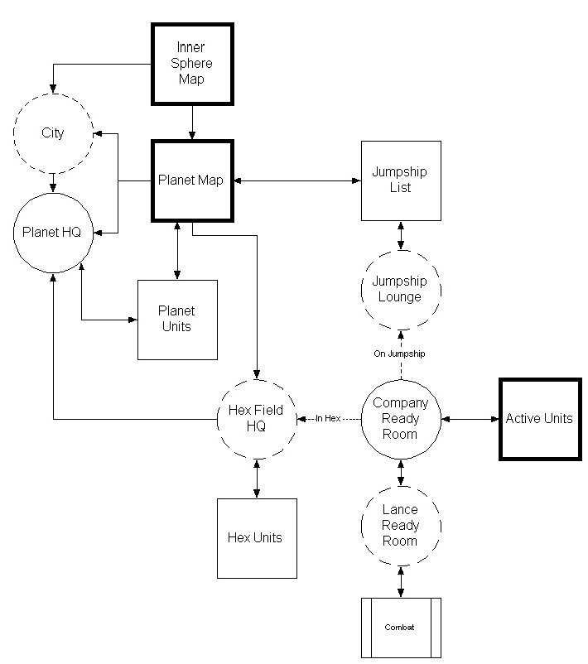
Field Locations Interface Map

In addition to City Locations, every planet has locations in the field which are accessable by players from every house. It is important to note that these locations are duplicated for each of the five houses. Each house has its own Planet HQ, Jumpship Lounge, and so forth.

Hex HQs are also unique to each house. They are dynamically created upon demand.

4.12.6.1. Company Ready Room

Small tent with a table in the middle, covered with charts, papers, and paper weights. A window flap reveals a DropShip and the door flap is open to reveal 'Mechs off in the distance. A mobile command unit is parked in the foreground outside.

Hotspot | Type | Description | Destination | Restrictions
Dropship | Location | The DropShip in the window. | JumpShip Lounge Location
Mechs | Mission Group | The 'Mechs seen through the door flap. | Mission Groups
Table | Display | The charts on the table. | Planet Map Display
Mobile Command Unit | Location | Mobile command unit parked out front. | Hex HQ Location for the Company’s current hex.

4.12.6.2. Mission Group Ready Room

This is a clear area outside. The viewpoint is set immediately behind a table around which stand non-descript techs and soldiers and upon which rests a map and some sheets of papers weighed down by rocks, bits of armor, MREs, or pistols. To the left and right are the legs of a total of four BattleMechs. Off in the distance to the left, smoke is rising from behind a hill. At the far side of the clearing to the left an ammo truck is rolling into the clearing. At the far side of the clearing to the right is the back of the company ready room tent.

This is the area to which players return from combat and from which they enter combat.

Hotspot | Type | Description | Destination | Restrictions
Company Ready Room | Location | The exit to the right leads to the combat ready room. | Company Ready Room
Combat | Combat Ready | The 'Mech hangar door leads to combat if the players need to signal readiness; otherwise it remains inactive. | n/a
Mission Briefing | Display | The table with the maps on it changes the location to a mission briefing display. | Mission Display

4.12.6.3. JumpShip Lounge

The interior of a dome with portholes showing space. A holographic globe of the planet below sits in the center of the room. To the side of the room is a computer terminal. There is also a large metal door with a Battlemech emblem on it.

Hotspot | Type | Description | Destination | Restrictions
Door | Display | Large metal door. | Active Units Display in Jumpship Mode
Computer | Display | Computer terminal. | Inner Sphere Map Display
Planetary Map | Display | A holographic globe of the planet below. | Planetary Map Display

4.12.6.4. Hex HQ

The interior of a mid-sized tent. Some soldiers stand at attention on guard. A small table with maps and charts covered with miniature BattleMechs is in the center.

Hotspot | Type | Description | Destination | Restrictions
Planet HQ | Location | A mobile HQ vehicle rolling away. | Planet HQ Location
Units in Hex | Display | The central table with small BattleMechs on it. | Active Units Display in Hex Units Mode

4.12.6.5. Planetary Headquarters

The interior of a large temporary structure with a briefing table in the center and computers around the room. Soldiers wearing comm gear sit at some computers.

Hotspot | Type | Description | Destination | Restrictions
Starport | Location | An open door to the outside. | Starport Location
Planet Units | Display | A table in the center of the room. | Active Units Display in Planet Units Mode

4.12.7. Training Locations

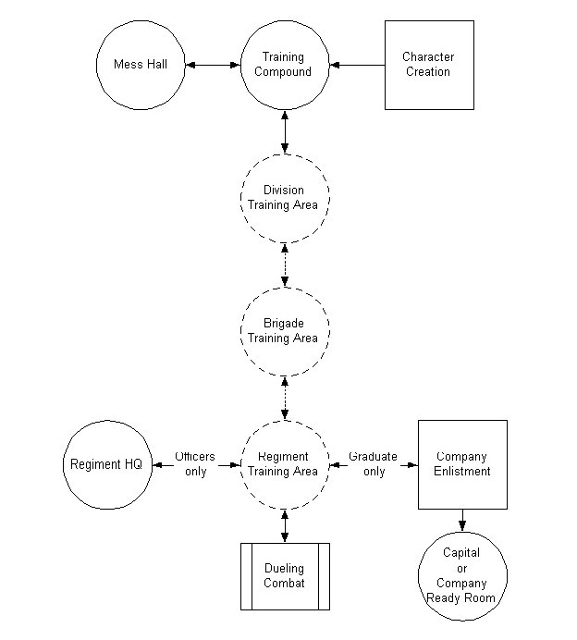
Training Area Interface Map

After the player creates a new character, they start off in the Training Compound Location for the house they selected. Each house has its own training area. Officers from the house may visit the training area to recruit newbies for their unit or just to help out.

Training Area locations are opened or closed based on the availability of slots in the units they represent. For example, if there are no slots available in Division #3, then the new player cannot enter the training area for Division #3. Likewise, if there are no slots in Brigade #2 of Division #1, Brigade #2 is closed, and so forth.

If a player is in the training area for a unit that has just had its last slot filled, the player will be allowed to stay there but cannot run combat training missions in that area. The player will be able to exit the area and find a new area which is open in which to run missions.

Once a player recieves enough rank points from running combat missions, they are promoted to rank 1. At this point, they have graduated training and can join an open unit.

4.12.7.1. Training Compound

A large training compound with five structures reminiscent of barracks in Starship Troopers (the movie) and one additional low structure serving as a mess hall. A VIP limo waits to bring officers back to the command center.

Hotspot | Type | Description | Destination | Restrictions
Recruit's Mess | Location | This is the low structure in the artwork. It has a crossed knife and fork above the door. | Recruit’s Mess Location
Division #1 Recruitment | Location | A structure with the House's "first" division's symbol above the door. | DIV Recruitment Location | Only available if there are open slots in this unt.
Division #2 Recruitment | Location | A structure with the House's "second" division's symbol above the door. | DIV Recruitment Location | “”
Division #3 Recruitment | Location | A structure with the House's "third" division's symbol above the door. | DIV Recruitment Location | “”
Division #4 Recruitment | Location | A structure with the House's "fourth" division's symbol above the door. | DIV Recruitment Location | “”
Division #5 Recruitment | Location | A structure with the House's "fifth" division's symbol above the door. | DIV Recruitment Location | “”
Limo | Location | Should be a sleek hover limo with staff flags flying from the front. | Command Center Location | Officers only.

4.12.7.2. Recruit's Mess

A large cafeteria with multiple flimsy tables. Recruits in gray tee shirts sporting stubble on their heads sit at these tables eating. A line of recruits holding trays forms at one side. A nice place to eat some slop after a hard day of training.

Hotspot | Type | Description | Destination | Restrictions
Door | Location | Exit to the Training Compound. | Training Compound

4.12.7.3. Division Recruitment Area

This has five offices, each with the crest of a subordinate brigade above the door. The door to the training compound is to the right.

There are up to six hot spots. They are determined by the Brigades which have subordinate companies with a zero enlistment threshold and empty slots.

Hotspot | Type | Description | Destination | Restrictions
BGD #1 Recruitment | Location | This door has the "1st" BGD's crest above it. | BGD Recruitment Location | Only available if there are open slots in this unt.
BGD #2 Recruitment | Location | This door has the "2nd" BGD's crest above it. | BGD Recruitment Location | “”
BGD #3 Recruitment | Location | This door has the "3rd" BGD's crest above it. | BGD Recruitment Location | “”
BGD #4 Recruitment | Location | This door has te "4th" BGD's crest above it. | BGD Recruitment Location | “”
BGD #5 Recruitment | Location | This door has the "5th" BGD's crest above it. | BGD Recruitment Location | “”
Door | Location | Large door with the universal "EXIT" symbol, whatever that is. | DIV Recruitment Location

4.12.7.4. Brigade Recruitment Area

This is a well-appointed office with five large filing cabinets along the wall. Each filing cabinet has a Regimental crest on the top drawer or is blank. There is a door to the right.

There are up to six active hot spots. They are determined by the Regiments which have subordinate companies with a zero enlistment threshold and empty slots.

Hotspot | Type | Description | Destination | Restrictions
REG #1 Recruitment | Location | This filing cabinet has the crest of the "1st" Regiment within the Brigade on the top drawer. | REG Recruitment Location | Only available if there are open slots in this unt.
REG #2 Recruitment | Location | This filing cabinet has the crest of the "2nd" Regiment within the Brigade on the top drawer. | REG Recruitment Location | “”
REG #3 Recruitment | Location | This filing cabinet has the crest of the "3rd" Regiment within the Brigade on the top drawer. | REG Recruitment Location | “”
REG #4 Recruitment | Location | This filing cabinet has the crest of the "4th" Regiment within the Brigade on the top drawer. | REG Recruitment Location | “”
REG #5 Recruitment | Location | This filing cabinet has the crest of the "5th" Regiment within the Brigade on the top drawer. | REG Recruitment Location | “”
DIV Recruitment | Location | The door to the right. | DIV Recruitment Location

4.12.7.5. Regiment Training Area

This area is a briefing room with wall charts, a digital white board, a door with a "live fire range" symbol, another door with the regimental crest on it and an exit to the BGD recruitment area. The regimental crest is prominently displayed in the center of the room above the displays. There are two large metal doors labelled “A” and “B” in big red letters.

Hotspot | Type | Description | Destination | Restrictions
Door A | Mission Group |  | Alpha Mission Groups | Only available if there are open slots in this unt.
Door B | Mission Group |  | Beta Mission Groups | “”
Reg HQ | Location | The door with the regimental crest serves as a means for officers to return to the regimental HQ. | REG HQ Location | Officers Only
BGD Recruitment | Location |  | BGD Recruitment Location

4.13. Finder Dialogs

The Finder Dialogs are a collection of modal dialogs that allow a user to select a player, unit, or other object that is not currently displayed on the screen. Since they are modal, they trap focus until they are dismissed by the user.

When a Finder Dialog is used as part of a two-part action, they can return a single object or a list of objects. The Find Player and Find Unit Dialogs can also be called standalone using the Find Player and Find Unit Quick Function Buttons.

The Finder Dialogs all allow the user to <TAB> between the edit boxes and drop down list boxes in the search query.

4.13.1. Find Player Dialog

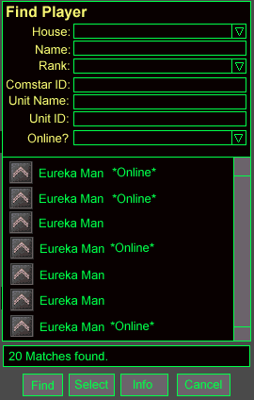
The Find Player Dialog

The Find Player Dialog is used by the ComStar Display, the House Organization Chart Display, the Unit Info Display, and the Find Player Quick Info Button. The user can fill in one or more fields in the Player Query and then press the Find Button. A list of players that match the search criteria are then outputted to the Results Roster.

4.13.1.1. Player Query

The following fields are available in the Player Query:

4.13.1.1.1. House

This field is a drop down list box which contains the name of the player’s current House as a default. This field is read only when the Find Player Dialog has been called as part of a two-part action, unless it was called by the Comstar Display.

4.13.1.1.2. Name

The Name field is an edit box. The user can fill in the name of the player for which to search.

4.13.1.1.3. Rank

The Rank field is a drop down list box containing all of the valid rank names for the currently selected House from the House field.

4.13.1.1.4. Comstar ID

The ComStar ID field is an edit box. The user can fill in the Comstar ID of the player for which to search.

4.13.1.1.5. Unit Name

The Unit Name field is an edit box. The user can fill in the name of the unit to which the player he is searching for belongs.

4.13.1.1.6. Unit ID

The Unit ID field is an edit box. The user can fill in the ID of the unit to which the player he is searching for belongs.

4.13.1.1.7. Online?

This field is a drop down list box containing three options: “Online”, “Offline”, and “Don’t Care”. It is set to “Don’t Care” as the default.

4.13.1.2. Search Results

The Search Results Field reports the results of the last search performed. If the search resulted in one or more matches, the following text appears in the Search Results field:

<# of Matches> Matches found.

If the query results in more than 200 matches:

Over 200 Matches found! 200 Matches displayed.

Otherwise, the Search Result field reports:

No Matches Found.

4.13.1.3. Results Roster

The Results Roster is a scrollable, selectable list box of players. For players that are currently online, “*Online*” appears after their names. Clicking on a player selects the player. Shift click can be used to select multiple players simultaneously. Double clicking selects a player and closes the Find Player Dialog.

4.13.1.4. Find Button

The Find Button executes the search based on the criteria entered in the Player Query. The results of the search are outputted to the Results Roster. The results from the previous search, if there was one, are cleared. If there are no matches to the Query, the list is cleared. This button is disabled until at least one field in the Player Query has been filled in.

If the user runs a query that results in more than 200 matches, only the first 200 matches are displayed. The rest are discarded.

4.13.1.5. Select Button

This button is used to return the selected player or list of players to the display which initially called up the Find Player Dialog as part of a two-part action. The Select Button is disabled until a player or group of players is selected in the Results Roster.

This button is only active when the Find Player Dialog is being used as part of a two-part action.

4.13.1.6. Info Button

Clicking on the Info Button fills in the fields of the Player Query with information about the currently selected Player. If a group of players are selected, than the last player to be selected is displayed in the Player Query.

4.13.1.7. Cancel Button

The Cancel Button closes the Find Player Dialog. If the Find Player Dialog was called as a part of a two-part action, the action is cancelled.

4.13.2. Find Unit Dialog

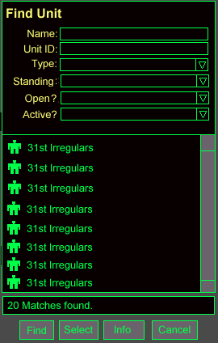
Find Unit Dialog

The Find Unit Dialog is used by the House Organization Chart Display, the Inner Sphere Map Display, the Unit Info Display, and the Find Unit Quick Info Button. The user can fill in one or more fields in the Unit Query and then press the Find Button. A list of units that match the search criteria are then outputted to the Results Roster.

4.13.2.1. Unit Query

The following fields are available in the Unit Query:

4.13.2.1.1. Name

The Name field is an edit box. The user can fill in the name of the unit for which to search.

4.13.2.1.2. Unit ID

The Unit ID field is an edit box. The user can fill in the ID of the unit for which to search.

4.13.2.1.3. Type

This field is a drop down list box which contains the type of unit for which to search. The possible types are:

Unit Types
- Reserves
- Company
- Battalion
- Regiment
- Brigade
- Division

4.13.2.1.4. Standing

This field is a drop down list box which contains the House Standing Requirement of the unit for which to search. The possible types are: Open, Restricted, and Elite.

4.13.2.1.5. Open?

This field is used to search for a unit which has open slots. It is a drop down list box with the following options: Yes, No, Don’t Care.

4.13.2.1.6. Active?

This field is used to search for a unit which is currently active. Active units are units which are currently reside in a hex which is contested. The “Active?” field is a drop down list box with the following options: Yes, No, Don’t Care.

4.13.2.2. Search Results

The Search Results Field reports the results of the last search performed. If the search resulted in one or more matches, the following text appears in the Search Results field:

<# of Matches> Matches found.

If the query results in more than 200 matches:

Over 200 Matches found! 200 Matches displayed.

Otherwise, the Search Result field reports:

No Matches Found.

4.13.2.3. Results Roster

The Results Roster is a scrollable, selectable list box of units. Clicking on a unit selects the unit. Shift click can be used to select multiple units simultaneously. Double clicking selects a unit and closes the Find Unit Dialog.

4.13.2.4. Find Button

The Find Button executes the search based on the criteria entered in the Unit Query. The results of the search are outputted to the Results Roster. The results from the previous search, if there was one, are cleared. If there are no matches to the Query, the list is cleared. This button is disabled until at least one field in the Unit Query has been filled in.

If the user runs a query that results in more than 200 matches, only the first 200 matches are displayed. The rest are discarded.

4.13.2.5. Select Button

This button is used to return the selected unit or list of units to the display which initially called up the Find Unit Dialog as part of a two-part action. The Select Button is disabled until a unit or group of units is selected in the Results Roster.

This button is only active when the Find Unit Dialog is being used as part of a two-part action.

4.13.2.6. Info Button

Clicking on the Info Button fills in the fields of the Unit Query with information about the currently selected unit. If a group of units are selected, than the last unit to be selected is displayed in the Unit Query.

4.13.2.7. Cancel Button

The Cancel Button closes the Find Unit Dialog. If the Find Unit Dialog was called as a part of a two-part action, the action is cancelled.

4.13.3. Find Planet Dialog

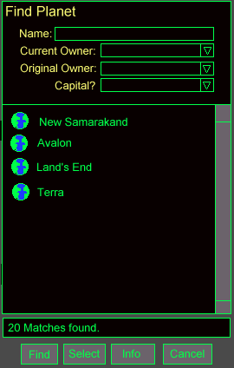

The Find Planet Dialog is used by the Inner Sphere Map Display. The user can fill in one or more fields in the Planet Query and then press the Find Button. A list of planet which match the search criteria are then outputted to the Results Roster.

4.13.3.1. Planet Query

The following fields are available in the Planet Query:

4.13.3.1.1. Name

The Name field is an edit box. The user can fill in the name of the planet for which to search.

4.13.3.1.2. Current Owner

The Current Owner field is a drop down list box. The user can restrict the search to only include planets owned by a certain House.

Owner Field Options
- Davion
- Kurita
- Steiner
- Marik
- Liao
- ComStar

4.13.3.1.3. Original Owner

The Original Owner field is also a drop down list box. The user can restrict the search to only include planets that were originally owned by a certain House. The same options are available in this field as in the Current Owner field.

4.13.3.1.4. Capital?

This field allows the user to search for the capital of a given House. It is a drop down list box with the following options: Yes, No, Don’t Care.

4.13.3.2. Search Results

The Search Results Field reports the results of the last search performed. If the search resulted in one or more matches, the following text appears in the Search Results field:

<# of Matches> Matches found.

If the query results in more than 200 matches:

Over 200 Matches found! 200 Matches displayed.

Otherwise, the Search Result field reports:

No Matches Found.

4.13.3.3. Results Roster

The Results Roster is a scrollable, selectable list box of planets. Clicking on a planet selects it. The Find Planet Dialog does not support selecting multiple planets. Double clicking selects a planet and closes the Find Planet Dialog.

4.13.3.4. Find Button

The Find Button executes the search based on the criteria entered in the Planet Query. The results of the search are outputted to the Results Roster. The results from the previous search, if there was one, are cleared. If there are no matches to the Query, the list is cleared. This button is disabled until at least one field in the Planet Query has been filled in.

If the user runs a query that results in more than 200 matches, only the first 200 matches are displayed. The rest are discarded.

4.13.3.5. Select Button

This button is used to return the selected unit or list of units to the display which initially called up the Find Planet Dialog as part of a two-part action. The Select Button is disabled until a unit or group of units is selected in the Results Roster.

This button is only active when the Find Planet Dialog is being used as part of a two-part action.

4.13.3.6. Info Button

Clicking on the Info Button fills in the fields of the Planet Query with information about the currently selected unit. If a group of units are selected, than the last unit to be selected is displayed in the Planet Query.

4.13.3.7. Cancel Button

The Cancel Button closes the Find Planet Dialog. If the Find Planet Dialog was called as a part of a two-part action, the action is cancelled.

4.14. Introduction Sequence

The introductory sequence for MultiPlayer BattleTech 3025 is limited to static images due to the necessity of minimizing download size.

The introductory sequence for MPBT: 3025 is a series of static images accompanied by music. The following chronology describes the images and mood of the music. As each image fades out, the next image should be fading in, so that the two images overlap, seeming to fade into one another. This is as distinguished from completely fading out and then fading the next image in. Each image should be visible for study and enjoyment for about five seconds or so. The music should be continuous, but altering smoothly between frames to convey the mood of the next image. (Note that this last is probably the more difficult of the two, and the sound guys can certainly have a little license here to make the piece work better).

# | Image | Music
1 | A MechWarrior, face and gender unknown, adjusting helmet and walking away from the camera towards the open cockpit of an Atlas (TBD) | Low tones, brooding music with the beginnings of percussion as if of the opening steps of a march
2 | Line of 4-10 Mechs of various types moving quickly in a loose formation towards a battle out of sight beyond a nearby hill. Same Atlas is leading. | More tension, anticipation of action. Perhaps far off horns...the sense of an approaching conflict
3 | Middle of a pitched battle between an undetermined number of Mechs, with explosions, missiles and beams firing to and from offscreen. Center view is of the Atlas, taking fire while firing in two directions at once, torso twisted to fire at one opponent while hitting a nearby opponent with an arm mounted weapon. Nearby opponent hit must be in view, and can be a fatal hit (though not obscured by explosion or anything). | Battle! The music hits its stride, with the clash of mighty forces and an outcome momentarily in doubt. Sound should be full and rich, but not so cluttered as to sound like noise.
4 | Image from behind of the Atlas and three of its companions standing on an overlook, the evidence of battle around them, looking out over a valley with a city and starport, with DropShips landing/taking off from the port. | Triumphant but grim. Nothing so terrible as a battle won, and all that. Work out the strains of battle and begin to insert strains of majesty and import, in anticipation of moving the struggle to a higher ground.
5 | Using silhouettes of the Mechs in the last image, located in the same places (fade to silhouette, essentially), switch the background to a picture of the Inner Sphere with borders that look like ribbons standing on end. The borders should be thin but three-dimensional, snaking between the stars hanging in view of the onlooking Mechs. Possibly have the borders on fire...if it looks good. The idea here is to switch smoothly from victorious Mechs looking out over a captured city to looking out over the Inner Sphere at large. | The sound of Empire, with a swirl of pomp and circumstance that winds down into a contemplative and anticipatory note.
6 | Title Screen — Same as last image, but with the title written in an appropriate font across the stars. | Theme music
7 | Credits — Half-faded last image, with credits superimposed over the whole. | Continued theme music
8 | Character Creation — Half-faded image from #1 (the MechWarrior and Atlas) with appropriate controls and text overlaying. Gray out the image sufficient to read easily, but make sure the image is still visible. | Described in the Character Creation section, below.

4.15. Character Creation
Character creation in MPBT: 3025 is very simple. The only choices necessary are Name and House affiliation.
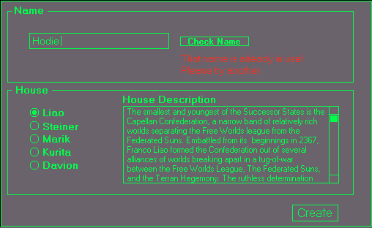
Character Creation Screen

The player Name is chosen by typing it into the text box within the Name section. Because handles are unique, the player will not be allowed to choose a name that is already in use. The player may check the name desired by typing it into the text box and clicking on the Check Name button. This will poll the database to see if the name is in use. If the name is in use or is on the restricted list, a warning will appear and the player will be prompted to try another name. If the name is available, the player will be allowed to create the character with that handle.

Result of Check Name button | Warning message displayed | Warning Message Behavior
Name is in use | That name is already in use!  Please try another. | Warning message blinks red
Name is restricted | That name is restricted!  Please try another. | Warning message blinks red
Name is available | That name is available.  Please select a House. | Warning message green  No blinking

The player's House affiliation determines where and with whom he starts the game. The order in which the choices are presented is determined by the current House membership. The least populated House will be highest on the list, down to the most populated on House on the bottom. The default choice is always the top (least populated) House. When the radio button for a House is selected, the Introductory House Description (q.v.) for that House is displayed in a scrolling text box. This gives the player a chance to learn a little something about the House prior to selecting it.
Once the player has made choices for both Name and House, the only other button left is the Create button. The Create button double-checks the player name one last time (in case the player forgot to do so or the name has been taken in the interim). If the name is not allowed, the player is returned to the creation screen. Otherwise, the character is created with the given name and the player moves to initial training.

4.16. Text Commands
The text commands in the game are used for a variety of purposes, ranging from sysop commands, to TOS tools, and roleplaying effects. Most are self-explanatory.
When a command targets a player, either the ComStar ID or the unique handle may be used. This is represented in the charts as <player>.

4.16.1 Roleplaying Commands

4.16.1.1. Emote
"Emote" commands allow players to express the non-verbal responses their character would evince in normal conversation, such as smiles, salutes, laughter, etc. The format for this command is to precede the name of the command with a forward slash, which will cause the player's name to appear in the chat buffer followed by the given text string. The following example assumes that Pvt. Jones types it:

Command | Result in buffer
/salute | Jones salutes.

The command is activated using the "/" key. If another "/" is used, the player's rank is printed before the name. For instance, using Pvt. Jones again:

Command | Result in buffer
//salute | Pvt. Jones salutes.

This allows players to act in character in both military and non-military situations. This feature works with all of the following commands.

Command | Buffer string | Description
/salute | <player rank> <player> salutes. | Obvious
/laugh | <player> laughs. | "
/frown | <player> frowns. | "
/smile | <player> smiles. | "
/chuckle | <player> chuckles. | "
/nod | <player> nods. | "
/shake | <player> shakes head.
/hand | <player> raises a hand. | "
/clap | <player> applauds. | "
/busy | <player> tries to look busy. | "
/wink | <player> winks. | "
/wince | <player> winces. | "
/wave | <player> waves. | "
/bow | <player> bows. | "
/yes | <player> understands. | "
/no | <player> does not understand. | "
/page <?> | <player> <text following ‘/page’> | This command sends a message to all game staff that are online.
/act <?> | <player> <text following '/act'> | This command is used to perform any other action not already defined. For instance, by typing "/act looks stupid", the buffer would say "Pvt. Jones looks stupid."

The commands are not case-sensitive.

I would like to see (at multiple player requests) an “/AFK” command that somehow (either through appending the player’s handle or changing the color/appearance of their name to other players) to denote when the player is away from the keyboard

4.16.2. Look

The look command is also preceded by a forward slash. There are two forms of this command:
Command | Effect
/look | This causes the location description to be printed to the chat buffer.
/look <player> | This causes the personal description of the player named to be printed to the chat buffer.

4.16.3. Other
There are a few other commands available to all players.

/page | Ability to send a page to all SysOps, GM’s or assistants that are currently online in that process. SysOps and GM’s can disable receiving these pages (see Page Off), but assistants always receive them. Player should receive a game message that their page was sent. Players can choose to enter text that will be sent with the page. The page will be uniquely identified as a special page to those receiving it.
Mute <player> | "Players can mute a player handle. They will not see text from that player or hear voice, even if the muted player exits and reenters the game. Mute will automatically expire when the player who has used the mute command leaves the game or uses the Unmute command. The Mute command should not mute any account that has the assistant, GM, Trainer, or Sysop flags, so to ensure that players can receive TOS warnings by staff."  In game message displayed to user when they try to mute a flagged Assistant, GM, Trainer or Sysop account.  “You can not mute game assistants”.  If Legacy games can not implement the above regarding how mute should work with game op flags then the following guidelines applies:  The Mute command should not mute any account that has the Assistant, GM, Trainer, or Sysop flags, to ensure that players can receive TOS warnings by staff. Development might want to consult with product support on how best this can be implemented.  In game message displayed to user when they try to mute an Assistant, GM, Trainer or Sysop account.  “You can not mute game assistants”.
Unmute <player> | Unmutes a muted player.

4.16.4. TOS Commands

4.16.4.1. Standard
Product Support and their assistants requires tools within each game supported by Kesmai Studios to enforce terms of service problems.

4.16.4.1.1. Special Access Flags
SysOp flag: Only Kesmai Product Supportwould have this. SysOp flag would have all game powers and be able to set all lower-level flags on accounts.
Staff Leader: SL flag would be able to set GM and Assistant flags on player accounts.
GM flag: GM flag would be able to set the assistant
flag on player accounts.
Assistant flag: All game assistants would have this flag. Assistant flags can not set flags on accounts.

Each action that uses these flags must have them verified on the host before performing the action. No reliance on FE information is allowed for any special flag commands.

4.16.4.1.2. Required Logs
Game Log: Contains chat and game event information for a given process.
Debugging Log: Contains debugging information for a process.
Complaint Log(s): The separate log file generated by each user complaint or by some SysOp actions. The complaint log should begin with a distinctive “start of complaint” line and end with a distinctive “end of complaint” line. The Complaint Log should have the complaint line duplicated as the second line in the file after the “start of complaint” line. The Complaint log would be sent to PS on a daily basis by Ops unless the delivery is done by the Tostool instead.
SysOp Log: The log used to record each occurrence of a SysOp, SL, GM or assistant using one of the commands below. In addition, a method of extracting all outstanding blacklists and ejects from this file to a permanent file will be needed. A script that does this is fine; this script would be run by Ops to create the permanent file bans.log. Both the SysOp log and the bans.log would be sent to PS on a daily basis.
All logs require the date/time stamp to be at the beginning of each line of log entry. Logs that indicate user chat or action should have the player’s ARIES id, game handle and email address following the date/time stamp and before the information.

In the table below, PERSISTENT means that the command’s effect will persist if the affected user exits and reenters the game, which implies a database record change. For commands that affect users, ON/OFFLINE means that the command will function even if the target user is not in the game, and ONLINE means that the command will only function on a user that is currently in the game.

Game must support message dialog display of sufficient length for the messages described.

4.16.4.1.3. Baseline Requirements:

TOOL | Description
Reserved titles and handles to indicate official assistant. | Special title, prepended to the in-game handle, that identifies game assistants to the player base. This title is automatically given to the assistant when the assistant flag is given to them. This title will vary from game to game. For example in Legends of Kesmai the reserved title is [Guide], so an assistant named Fred will appear as [Guide] Fred. Ideally this title will be in a different color and be enclosed in square brackets. SysOps and GM’s could choose to turn the titles on their accounts on or off, but assistants would always have a title. Specific title names would be chosen by PS and the producer.  Current reserved game handles:  Legends of Kesmai [Guide] Air Warrior [AWAR]  MPBT Solaris [MPBT] Harpoon [HRPN]  SE [EMPR]  Also, handles like SYSOP, TRAINER, HELPER, STAFF should not be allowed to normal players.  Also, no player should be able to add the string for any reserved title to their handle (ie. In Air Warrior, I could not make a handle that said “Gordon[AWAR]” or “Gordon AWAR”.) and the player should be told why the handle cannot change (ie. The string “AWAR” is not allowed in handles).
Restricted Names File | The host should use a text file that can be edited as needed by a text editor to contain “restricted” text strings. When a player creates a handle or team name, the host should check the input against this file and reject names that match the contents of this file. The player would receive notification that the handle or team name was invalid.  There should be two types of entries in this file, allowing restriction by two different criteria: 1. Word restriction, meaning that only the entire word is matched. If the string appears as part of another word, it’s not restricted. 2. Substring restriction, meaning that the string cannot appear anywhere in the handle or team name, even as part of another string. For example, you would want “fuck” to be a substring restriction (Legends enters this as *fuck) so that it cannot appear at all in a handle or team name, whereas “ass” you would want as a word restriction, so you don’t restrict things like “Brassman”.

4.16.4.2. MPBT:3025 Sysop Commands
Sysops in MPBT come in four levels:

TOS Sysop Level | Rank displayed in game | Description
Assistant | Adept | This is the level of the rank and file Helpers.
GM | Precentor | This is the level of the top Helpers in the game.
SL | Precentor Martial | This is the level of the staff lead for the game
Sysop | Primus | This is the highest level of sysop powers in the game, available only to Product Support.

The TOS Sysop Levels correspond to the sysop levels in the TOS document, and are designed to segregate certain more "dangerous" functions from the rank and file Helpers. Although it is not in the TOS document, a forth level of tools is needed. The “Precentor Martial” or staff lead with his primary staff being Precentors is the accepted standard for game staff organization

4.16.4.2.1. Adept (Assistant) Commands
Adepts have all of the TOS commands appropriate to their level. They also have the following capabilities:

Command/Ability | Description
/house Davion  /house Kurita  /house Steiner  /house Marik  /house Liao  /house ComStar | This command switches the allegiance of the Helper to the House indicated. Note that this command is a necessary prerequisite of a number of other Helper commands. This does not impose the normal penalties for switching Houses.
/ticker <message>  /ticker <House> <message> | This allows the Helper to send the text of <message> to the game ticker for everyone.  The second form allows the helper to send the message to the House indicated. Note that an announcement sent to ComStar is sent to all sysops, regardless of their current House allegiance.
/info <player> | This command displays the player info for a player with the following additional information:  - Exact rank points
/account <player> | Provides the SysOps, GM’s and assistant flags with the player’s e-mail address, Aries ID, and game access flags. This command may also show game specific information depending on the game.
/kick <player> | This command temporarily ejects the player from the game. They should be able to immediately return.
/gag <player> | Temporary squelching tool to gag a player for 10 minutes (or until the Ungag command is used to remove the gag). The gagged player will receive a message that they have been gagged. A gagged player should not be able to communicate to anyone in any manner (pages, private messages, etc.). They can still use the alert/complaint function, however. When this command is used it forces a game complaint to be filed. Complaint field is set to Gag. When Gag is in effect the gagged player can not use the page assistant command. Usage of this command is logged to the SysOp log.
/ungag <player> | Remove gag from player handle. Player will receive a game message that the gag has been removed.
/eject <player> # | Configurable time eject command. Should be able to eject for five minutes minimum, to 72 hours maximum. Command is expressed in <number> <days, hours, minutes>. When this command is used it forces a game complaint to be filed. The complaint field will be set to Eject. Usage of this command automatically sends email to the player who has been ejected and allow the Sysop, GM or Assistant to insert a couple lines of text stating the type of violation and time period of eject. If the game can automatically insert the time period of the eject into the email that would be the preferred method. Usage of this command is logged to the SysOp log with the date/time the eject will expire.  In game message displayed to user as the command is used on their account:  “You have been banned for “N” amount of hours. To appeal this ban e-mail <game name> support.”  Email text:  This is to notify you that your account has been ejected from <game name>.  The reason for this eject was <Sysop, GM or Assistant inserted text> which is a violation of the Rules of Conduct of <game name>, as listed on the in the game rules of conduct.  Should you have any questions, or wish to contest this action, you may do so by sending email to <product support e-mail address for that game>.
/uneject <player> # | Removes the time eject from <player handle>. Usage of this command automatically sends e-mail to the player who has had the eject removed. Usage of this command is logged to the SysOp log. This command can only be used to uneject someone ejected by this same Helper.  Email text:  This is to notify you the temporary ban on your account in <game name> has been removed.
/rename <player> <new player handle> | This command changes the player’s name to the specified name. The player can use normal means to rename their character.
/lockhandle <player> <new player handle> | Command replaces the handle of the specified player with the new name parameter and locks it so they can’t change it back. When this command is used it forces a game complaint to be filed. Complaint field is set to Lockhandle. Usage of this command automatically sends e-mail to the player who has had their handle changed. Usage of this command is logged to the SysOp log.  In game message displayed to user as the command is used on their account:  “Your handle has been changed. To request a different handle e-mail <game name> support.”  Email text:  This is to notify you that your handle has been changed and locked to a new name.  The reason for this handle change was <sysop inserted text> which is a violation of the Rules of Conduct of <game name>, as listed on the in the game rules of conduct.  Should you have any questions, or wish to contest this action, you may do so by sending email to <product support e-mail address for that game>.
/unlockhandle <player> | Removes lock on player handle name. Usage of this command automatically sends e-mail to the player. Usage of this command is logged to the SysOp log.  Email text:  This is to notify you that the lock on your handle in <game name> has been removed.
/lockteamname <unit nickname> | Ability to modify a team’s name, and lock the name so it can not be changed back by the team leader. When this command is used it forces a game complaint to be filed. Usage of this command is logged to the SysOp log. Usage of this command automatically sends e-mail to the team leader who has had their team name changed.  In game message displayed to user as the command is used on their account:  “Your team handle has been changed. To request a different handle e-mail <game name> support.”  Email text:  This is to notify you that your team name has been changed and locked to a new name.  The reason for this team name change was <sysop inserted text> which is a violation of the Rules of Conduct of <game name>, as listed on the in the game rules of conduct.  Should you have any questions, or wish to contest this action, you may do so by sending email to <product support e-mail address for that game>.
/unlockteamname <unit nickname> | Removes lock on team handle name. Usage of this command automatically sends e-mail to the team leader. Usage of this command is logged to the SysOp log.  Email text:  This is to notify you that the lock on your team name has been removed.
Jump <player or planet> | Jump to a player’s location in the game, or to a specified location in the game. Usage of this command is logged to the SysOp log? (This is used a lot and could fill up the SysOp log)
/invincible on  /invincible off | Prevents SysOps, GM’s and assistants from being killed in combat. Toggles on/off. Usage of this command is logged to the SysOp log.

4.16.4.2.2. Precentor (GM) Commands
Precentors have all of the TOS commands appropriate to their level, plus all of the special command abilities available to an Adept. They also have the following capabilities:

Command/Ability | Description
/rank <player> # | This allows the Helper to set the player's rankpoints to the minimum required to qualify for the rank indicated by #.
/rankpoints <player> # | This allows the Helper to set the player's rankpoints to #.
/wins <player> # | This allows the Helper to set the player's win record to #. Total battles are automatically adjusted.
/loss <player> # | This allows the Helper to set the player's loss record to #. Total battles are automatically adjusted.
/standing <player> # | This allows the Helper to set the player's House Standing to #.
/givemedal <player> # | Gives the medal # to the player.
/takemedal <player> # | Removes the medal # from the player.
/ungag <player> | Removes a gag from a player who has been gagged
/uneject <player> | The same as the previous uneject, except that any ejected player may be unejected.
/flag on <player> | Sets the sysop flag of a player to one of the game staff levels (assistant, gm, sl, sysop). A staff member should not be able to promote to his level. IE: A ‘GM’ can only set a player to the ‘assistant’ level, while the ‘SL’ can set a player to either ‘Assistant’ or ‘GM’, but not ‘Sysop’
/flag off <player > | Removes the sysop flag from a player from one of the game staff levels (assistant, gm, sl, sysop). A staff member should not be able to remove someone at his level. IE: A ‘GM’ can only remove a player from the ‘assistant’ level, while the ‘SL’ can remove a player's flag from either an ‘Assistant’ or ‘GM’, but not ‘Sysop’
/page off | Usage of this command allows the Sysop and GM flags to turn off Page Assistant. Usage of this command is logged to the SysOp log.
/page on | Usage of this command allows the Sysop and GM flags to activate Page Assistant on their account. The Sysop and GM flags default to having the Page Assistant command activated on their accounts.
/announce <message>  /announce <House> <message> | The first form allows the Helper to send the text of <message> to the chat buffer of everyone in the game highlighted in the sysop color.  The second form allows the helper to send the message to the House indicated. Note that an announcement sent to ComStar is sent to all sysops, regardless of their current House allegiance.
/Invisible on  /invisible off | This turns the SysOp or GM invisible with an option to prevent them from showing up in the game rosters and room displays. Toggles on/off. Usage of this command is logged to the SysOp log.

4.16.4.2.3. Precentor Martial (SL)

A Precentor Martial has all of the TOS commands appropriate to their level, plus all of the special commands available to Precentors and Adepts. They also have the following capabilities:
Command/Ability | Description
/Blacklist <player> | Ban with no time limit. When the SysOp uses this command it forces a game complaint to be filed. The complaint field will be set to Blacklist. Usage of this command automatically sends email to the player who has been blacklisted and allows the Sysop to insert a couple lines of text stating the type of violation. Usage of this command is logged to the SysOp log.  In game message displayed to user as the command is used on their account:  “You have been banned from the game. To appeal this ban e-mail <game name> support.”  Email text:  This is to notify you that your account has been banned from <game name>.  The reason for this ban was <sysop inserted lines> which is a violation of the Rules of Conduct of <game name>, as listed in the game rules of conduct.  Should you have any questions, or wish to contest this action, you may do so by sending email to <product support e-mail address for that game>.
/Unblacklist <player> | Removes the blacklist on the specified player. Usage of this command automatically sends e-mail to the player who has had the blacklist removed. Usage of this command is logged to the SysOp log.  Email text:  This is to notify you that the blacklist on your account in <game name> has been removed.

4.16.4.2.4. Primus (Sysop)
A Primus has all of the TOS commands appropriate to their level, plus all of the special commands available to Precentors and Adepts. They also have the following capabilities:

Command/Ability | Description
/hl on  /hl off | This command enables the Primus to act as the House leader of the House to which he currently belongs, using the interface normally as a HL. Note that this does not displace the current HL...it merely gives access to the same abilities and commands as the HL.

4.17. Other Dialogs

In addition to the Finder Dialogs, there are several minor dialogs which need to be discussed. Functions that activate these dialogs refer to them throughout this specification and this section details their appearance and function. All of these dialogs are modal and many of them return a value or parameter to the function which called them.

4.17.1. Options Dialog

The Options Dialog contains out-of-character user preferences and options. All of the settings in this dialog are saved in a INI file on the front end and are preserved from session to session. The folllowing settings can be configured via the Options Dialog:

Configurable Options
- Global Sound (on /off )
- Roleplaying Shell Sound (on/off)
- Combat Sound (on/off)
- Ambient Sounds (on/off)
- Combat Music (on/off)
- Joystick configuration
- Keyboard and Mouse configuration (combat only)
- Show Introductory Sequence on startup (yes/no)
- Run roleplaying shell in a window (yes/no)

4.17.2. Alert Dialog

The Alert Dialog can be activated by clicking on the Alert Button next to the Text Input Buffer. The Alert Dialog contains the following text:

This function allows you to register a complaint about another player’s abusive or vulgar behavior. Please reserve the use of this function for complaints about behavior that violates the Rules of Conduct for Multiplayer BattleTech: 3025. The last 100 lines of text you have seen will be sent to Kesmai Product Support. Kesmai Product Support will review this complaint and take appropiate action.

Below this disclaimer is a four line text buffer in which the user can enter his complaint. The user can then hit “OK” to register the complaint or “Cancel” to abort registering the complaint. User complaints are logged in a text file in the host using the standard ARIES complaint logging tools.

4.17.3. Confirmation Dialog

The Confirmation Dialog is a generic dialog which prompts the user for a “yes” or “no” response. In some cases, the user will also have to enter a line of text.

4.17.4. Password Dialog

The Password Dialog prompts the user for a password. The dialog contains the text: “Please enter the password:” followed by a 16 character text buffer. The player can hit “OK” to accept the password or “Cancel” to cancel the password. Passwords are not masked, as nothing of critical importance is guarded by a password in this game.

4.17.5. Create Room Dialog

The Create Room Dialog allows a user to create a meeting room. See the Locations section for more on meeting rooms. The dialog prompts the user for a room name and password. The password is optional. If the password is left blank, then the room is considered to be a public room. The player can then click “OK” to create the room or “Cancel” to abort.

4.17.6. Create Mission Group Dialog

The Create Mission Group Dialog allows a user to create a mission group. See the Locations section for more on mission groups. The dialog prompts the user for a group name. The player can then click “OK” to create the group or “Cancel” to abort.

4.17.7. Select Medal Dialog

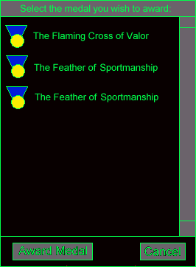

The Select Medal Dialog is activated by the Award Medal Button in the Personal Info Detail View. This dialog allows the player to select a medal to award to another player. A scrollable list displays all of the medal which the player is qualified to award. A list of medals and the rank necessary to hand them out is provided in Appendix E.

To award a medal, the player clicks on the desired medal and then clicks on the Award Medal Button. The dialog is dismissed and the player is awarded the medal.

4.17.8. Error Dialog

An Error Dialog is displayed whenever the game has encountered a situation in which it must abruptly terminate. Error Dialogs always display a text message indicating what happened and an “OK” button which allows the user to continue. If the game is terminated because of an ARIES message, such as losing connection with the host, the ARIES error condition is displayed to the user. In any case, the Error Dialog should always give as much information as possible as to the cause of the problem. This makes it much easier to find and fix bugs.

Appendix A: Inner Sphere Map

This Appendix contains all of the coordinates for the planets in Multiplayer Battletech: 3025. The planets are list by initial House affiliation. All coordinates are relative to Terra, which is at the center of the map at (0,0). Terra is owned by ComStar. Solaris, the dueling planet, resides in Steiner space, but is not owned by Steiner in this game. Solaris is marked below.

A.1. House Davion

Planet Name | X | Y | Planet Name | X | Y
Abbeville | 611.32 | -40.16 | Kluane | 197.95 | -201.08
Abruzzi | 150.74 | -306.96 | Kotzebue | 319.48 | -207.6
Acala | 135.36 | -125.44 | Kountze | 529.16 | 27.38
Addicks | 72.24 | -0.26 | Lackland | 552.9 | -175.26
Adelson | 477 | -247.5 | Larned | 297.05 | -23.21
Adrian | 453.27 | 28.43 | Latexo | 396.42 | 81.11
Agliana | 393.29 | -292.1 | Layover | 206.03 | -20.08
Alcyone | 130.92 | -199.25 | Le Blanc | 208.9 | 18.52
Algot | 86.59 | -83.46 | Leamington | 356.77 | -91.8
Allerton | 265.76 | 7.3 | Lee | 117.88 | -149.44
Almach | 101.71 | -62.07 | Leipsic | 310.61 | -104.84
Alsek | 318.44 | -240.2 | Lexington | 318.44 | -22.95
Alta Vista | 511.17 | 13.04 | Lihue | 427.97 | -200.29
Altoona | 555.5 | -4.17 | Lima | 237.85 | 54.51
Amiga | 166.65 | -85.28 | Lindsay | 208.38 | -353.12
Anaheim | 302.01 | -314.52 | Linneus | 454.31 | -8.08
Andalusia | 394.85 | -110.06 | Listowel | 151.52 | -68.07
Andro | 146.05 | -174.48 | Logandale | 144.48 | -36.25
Angol | 88.67 | -39.12 | Lothair | 268.62 | -340.08
Anguilla | 415.72 | 80.33 | Lucerne | 233.94 | 12.52
Anjin Muerto | 591.76 | -78.76 | Lyceum | 432.41 | 76.68
Ankaa | 75.37 | -9.39 | Macintosh | 361.73 | -267.32
Antietam | 333.82 | -138.22 | Macomb | 344.52 | -20.34
Argyle | 257.67 | -110.06 | Maia | 216.46 | -326
Armington | 424.58 | -306.44 | Malagrotta | 431.88 | -273.58
Arnaudville | 588.89 | 37.03 | Mallory's World | 112.4 | 6
As Samik | 349.99 | -289.23 | Manapire | 83.2 | -295.49
Ashkum | 112.93 | -101.97 | Manassas | 318.18 | -123.36
Ashley | 165.87 | -311.13 | Mandaree | 184.12 | -311.66
Atlas | 158.83 | -246.2 | Mansfield | 398.24 | -63.11
Aucara | 178.13 | -298.88 | Manteno | 190.91 | -72.5
Augusta | 284.79 | -99.89 | Mara | 122.84 | 8.87
Avawatz | 166.39 | -29.73 | Mararn | 531.25 | -221.94
Avigait | 154.39 | -277.49 | Marduk | 210.2 | 60.51
Axton | 128.31 | -114.23 | Marielund | 532.29 | -207.86
Bacum | 158.57 | -291.84 | Markesan | 223.51 | -75.37
Baranda | 453.27 | -261.32 | Marlette | 155.96 | -44.86
Barlow's End | 307.22 | 63.64 | Marodzi | 294.7 | -276.97
Barstow | 172.13 | -41.21 | Mauckport | 430.84 | -53.72
Basalt | 66.76 | -29.21 | Mayetta | 408.93 | 7.04
Basantapur | 367.73 | -286.88 | Maynard | 307.22 | 2.35
Bassfield | 594.1 | 4.96 | McComb | 224.29 | 58.16
Bastian | 299.92 | -161.44 | McGehee | 333.3 | 75.63
Bastrop | 568.28 | 61.03 | McHenry | 181 | -85.28
Batavia | 202.9 | -55.81 | McRae | 558.11 | -85.28
Baxley | 436.06 | -151.26 | Meinrad | 396.16 | -85.8
Beaumont | 589.15 | 40.16 | Mejicanos | 476.48 | -183.34
Beecher | 185.43 | -50.6 | Melcher | 370.6 | 38.86
Beenleigh | 185.43 | -271.23 | Memphis | 567.24 | -142.92
Beid | 125.71 | -245.93 | Mendham | 149.18 | -347.91
Belaire | 337.48 | -276.71 | Mentasta | 115.27 | -239.41
Bell | 105.1 | -110.84 | Mermentau | 526.03 | -39.64
Belladonna | 265.23 | -125.71 | Merope | 215.16 | -326.26
Bellevue | 330.96 | -58.15 | Mesartim | 103.8 | -55.03
Benedict | 477.52 | -11.48 | Metter | 538.03 | -98.84
Benet III | 265.23 | 58.68 | Midale | 191.17 | -365.38
Bergman's Planet | 268.36 | 75.63 | Milligan | 479.35 | 39.12
Beten Kaitos | 167.17 | -114.23 | Millray | 616.01 | 32.08
Bethel | 141.88 | -185.69 | Mineite | 475.18 | -31.3
Bettendorf | 267.32 | 26.08 | Mira | 104.32 | -52.42
Birmensdorf | 386.51 | -273.32 | Mirach | 109.8 | -27.12
Birqash | 278.27 | -268.62 | Mirage | 479.35 | 15.65
Blandinsville | 230.03 | -33.12 | Mokane | 430.84 | -23.21
Bluford | 451.44 | -80.85 | Molino | 464.48 | -135.88
Bogard | 271.75 | -32.6 | Monhegan | 117.1 | -185.69
Bonneau | 399.81 | -167.43 | Monongahela | 166.39 | -167.17
Boondock | 596.19 | 21.65 | Monroe | 406.85 | -45.12
Breed | 197.16 | 40.16 | Montcoal | 250.11 | -169.78
Bremond | 391.72 | 59.2 | Montour | 351.82 | -331.48
Bristol | 179.69 | -67.55 | Moravian | 110.06 | -133.53
Broaddus | 469.18 | 56.33 | Mordialloc | 221.94 | -265.76
Brockton | 536.73 | -120.23 | Morrill | 399.55 | 32.08
Brockway | 220.12 | -359.12 | Morven | 549.24 | -148.4
Broken Wheel | 539.07 | -175 | Moultrie | 475.96 | -172.13
Bromhead | 161.17 | -380.77 | Muskegon | 164.56 | -99.89
Brookeland | 444.14 | 71.2 | Nagel | 475.18 | 6.52
Brundage | 407.11 | 49.81 | Nahoni | 248.02 | -200.29
Brusett | 247.76 | -330.96 | Naka Pabni | 381.29 | -294.18
Bryceland | 410.24 | 98.84 | Narellan | 172.13 | -256.11
Cahokia | 291.31 | -73.55 | Necedah | 357.04 | -8.08
Caldwell | 334.35 | -328.87 | Neosho | 554.72 | -25.82
Cambiano | 354.69 | -244.11 | Neukirchen | 409.98 | -249.32
Cammal | 112.4 | -166.39 | New Aberdeen | 259.24 | 79.02
Capac | 312.96 | -56.85 | New Aragon | 70.16 | -88.93
Caph | 13.04 | -0.52 | New Avalon | 269.15 | -112.14
Carmacks | 185.43 | -238.89 | New Damascus | 276.45 | -208.38
Carmichael | 201.34 | -352.08 | New Ivaarsen | 228.98 | 34.95
Cartago | 141.09 | -10.17 | New Rhodes III | 103.28 | -15.91
Caselton | 117.36 | -35.99 | New Syrtis/New Sytri | 233.16 | -298.88
Cassias | 320.52 | 80.59 | New Valencia | 221.94 | -29.47
Cerulean | 416.5 | -81.37 | Newton | 320.26 | -30.77
Chakachamna | 302.53 | -182.82 | Niles | 402.15 | 121.01
Chanute | 467.88 | 23.73 | Niquinohomo | 411.28 | -228.72
Chebanse | 227.16 | -103.8 | Nizina | 312.44 | -230.29
Chenier | 585.76 | -41.73 | Noatak | 333.82 | -215.68
Chesterton | 115.27 | -72.24 | Nopah | 57.64 | -33.9
Chirikof | 338.78 | -235.5 | Northfield | 281.92 | -76.15
Cholame | 204.21 | -31.56 | Northwind | 34.43 | -2.87
Choudrant | 339.04 | 56.59 | Notwina | 297.57 | -195.6
Cimeron | 365.9 | 84.76 | Novaya Zemlya | 182.3 | -184.91
Clovis | 181.78 | 3.13 | Numenor | 286.36 | -108.49
Cogdell | 526.56 | -142.66 | Nunivak | 324.96 | -189.86
Cohagen | 375.55 | -318.96 | Odell | 252.72 | -98.32
Cohay | 615.49 | 11.48 | O'Fallon | 316.35 | -83.98
Colchester | 308 | -13.56 | Offerman | 578.45 | -52.68
Colia | 360.69 | 67.55 | Ogilvie | 197.69 | -234.2
Coloma | 291.05 | -73.55 | Okains | 243.33 | -270.97
Colorado | 347.65 | -200.82 | Okefenokee | 612.36 | -68.07
Conroe | 380.51 | 92.32 | Olancha | 168.74 | -6.52
Corella | 143.44 | -253.5 | Olindo | 467.35 | -236.81
Corydon | 218.55 | -39.12 | Oltepesi | 254.8 | -279.06
Cotocallao | 146.05 | -302.27 | Orbisonia | 151.52 | -156.48
Courcellete | 142.92 | -313.48 | Ottumwa | 402.15 | 33.64
Covington | 342.69 | -151 | Ozawa | 85.54 | 2.87
Crofton | 527.6 | -78.76 | Pajarito | 484.04 | 77.98
Crossing | 255.58 | 47.73 | Palmyra | 454.84 | -26.08
Csomad | 431.1 | -294.7 | Panpour | 345.56 | -294.96
Cumberland | 208.9 | -267.32 | Parma | 363.03 | -52.68
Dahar IV | 281.92 | 20.34 | Pascagoula | 433.45 | 57.9
Damevang | 348.69 | 64.94 | Pattison | 593.84 | 56.33
Daniels | 125.71 | -198.21 | Pattonsbrug | 380.51 | -6
Darwendale | 314.52 | -265.23 | Paulding | 307.74 | -101.97
David | 140.57 | 19.3 | Peabody | 333.56 | -23.73
Davisville | 485.61 | -27.64 | Perdido | 450.66 | -114.23
De Berry | 450.66 | 63.11 | Perkasie | 131.96 | -145
Defiance | 428.76 | -107.45 | Petrolia | 310.87 | -70.94
Deifenbaker | 200.03 | -344.52 | Pierce | 346.08 | -313.22
Delacambre | 544.55 | 4.96 | Pitkin | 497.08 | 77.72
Delavan | 272.28 | -95.97 | Pleiades Cluster | 218.29 | -322.35
Delos IV | 618.88 | 60.51 | Plymouth | 347.12 | -69.37
Delphos | 322.61 | -52.42 | Point Barrow | 366.16 | -130.92
Demeter | 92.32 | -70.16 | Potwin | 310.35 | -20.08
Deneb Kaitos | 65.2 | -13.04 | Princton | 417.02 | 26.6
Des Arc | 501 | -84.24 | Protection | 455.88 | 5.48
Deshler | 216.99 | 75.11 | Quentin | 46.42 | 12.52
DeWitt | 260.02 | -21.91 | Quincy | 350.52 | -34.16
Diboll | 479.61 | 67.81 | Quittacas | 159.35 | -221.68
Die Moot | 286.88 | -305.4 | Raman | 163 | 9.39
Dobson | 206.03 | 26.6 | Ramona | 332 | -38.6
Doneval II | 200.56 | 8.87 | Redfield | 141.35 | -214.64
Dothan | 437.62 | -135.36 | Redondo | 458.75 | -215.46
Drienfontein | 273.58 | -292.88 | Reisterstown | 318.44 | -150.48
Ebro | 568.8 | -130.66 | Remagen | 278.27 | -157.52
Edwards | 133.27 | -32.6 | Rentz | 575.59 | -98.84
El Dorado | 268.88 | -146.31 | Ridgebrook | 203.16 | -322.35
Elbar | 127.79 | -8.08 | Rio | 96.24 | -28.95
Electra | 217.25 | -325.22 | Robinson | 234.72 | -6.52
Elidere IV | 282.45 | 76.68 | Robsart | 172.39 | -343.21
Emerson | 171.87 | -117.1 | Rochester | 228.98 | 3.13
Emporia | 258.97 | -6.52 | Rosamond | 180.21 | -33.9
Enchi | 297.05 | -290.27 | Rosepine | 589.41 | -22.95
Errai | 52.68 | 4.43 | Rosiclare | 483.26 | -47.73
Estuan | 399.55 | -307.74 | Rowe | 336.17 | 48.51
Euclid | 352.6 | -71.2 | Royal | 224.55 | 44.86
Eustatius | 462.14 | -200.29 | Royalston | 137.96 | -226.11
Evansville | 296.27 | -36.51 | Ruchbah | 57.9 | -22.95
Exeter | 190.12 | -8.08 | Sabanillas | 437.62 | -177.87
Fairfax | 356.51 | 31.56 | Safe Port | 135.62 | -289.49
Fairfield | 289.49 | 46.16 | Saffel | 25.82 | 12
Fallon II | 371.12 | 49.03 | Saginaw | 302.27 | -96.5
Farnsworth | 566.46 | 31.82 | Sakhara V | 279.06 | 34.43
Farwell | 141.88 | -80.33 | Salem | 208.64 | -162.48
Fetsund | 450.66 | -243.07 | Sanilac | 148.66 | -59.46
Filtvet | 511.17 | -183.08 | Sauk City | 279.06 | -3.13
Fincastle | 326 | -164.56 | Saunemin | 248.28 | -56.85
Firgrove | 252.19 | -301.48 | Savonburg | 502.56 | -15.65
Flintoft | 193.25 | -336.17 | Schedar | 118.92 | -21.39
Flushing | 197.16 | -65.2 | Scituate | 88.67 | 221.94
Fomalhaut | 21.12 | 5.48 | Scudder | 197.95 | -96.76
Fortymile | 195.34 | -216.2 | Sekulmun | 214.12 | -222.2
Franklin | 252.98 | 10.95 | Semichi | 302.27 | -216.72
Frazer | 130.4 | -336.43 | Shaunavon | 161.7 | -326.26
Freisland | 237.07 | -119.71 | Shawnee | 557.85 | -65.98
Fuveau | 444.4 | -234.72 | Sherwood | 568.8 | -119.71
Galatia III | 91.54 | 14.87 | Shoreham | 124.92 | -219.59
Galax | 312.18 | -125.18 | Shubuta | 463.96 | -124.4
Gallitzin | 132.75 | -164.83 | Sirdar | 128.31 | -312.18
Galtor III | 195.86 | 73.81 | Skepptana | 534.64 | -192.73
Gambarare | 360.43 | -272.28 | Smolensk | 179.95 | -130.92
Gambier | 385.2 | -60.51 | Sodertalje | 498.39 | -237.33
Gillingham | 505.17 | -213.33 | Sodus | 289.75 | -65.72
Glenmora | 287.92 | 53.46 | Songgang | 330.69 | -302.27
Glentworth | 127.01 | -320.52 | Sonnia | 124.66 | -42.25
Goderich | 145.79 | -49.81 | Sparrevohn | 346.86 | -189.86
Goshen | 135.88 | -95.45 | St. Robert | 437.36 | -31.56
Great Gorge | 497.08 | -269.15 | Steeles | 294.18 | -143.18
Greeley | 453.27 | 40.68 | Steinhatchee | 526.82 | -97.8
Gronholt | 470.22 | -263.41 | Stein's Folly | 161.17 | -202.12
Grosvenor | 288.44 | -226.64 | Sterlington | 528.9 | 54.25
Groveld III | 390.42 | 114.49 | Stratford | 530.99 | 39.38
Gulkana | 356.77 | -179.43 | Strawn | 238.11 | -91.28
Gurnet | 93.37 | -257.93 | Streator | 256.37 | -76.41
Gurrnazovo | 427.19 | -242.8 | Sturgis | 420.67 | 69.37
Haappajarvi | 138.48 | -242.8 | Sullivan | 416.76 | -31.3
Hadnall | 137.96 | -264.97 | Sun Prairie | 328.09 | 29.21
Halloran V | 73.55 | -77.2 | Susulatna | 307.74 | -187.25
Harira | 554.98 | -101.45 | Sylvan | 426.93 | 3.13
Harpster | 215.16 | 83.2 | Sylvester | 366.68 | -115.53
Harrow's Sun | 264.19 | 71.72 | Symsonia | 491.09 | -96.5
Haynesville | 459.27 | 80.33 | Talcott | 201.6 | -124.92
Hazelhurst | 554.98 | 65.98 | Tallmadge | 278.53 | 42.25
Hean | 75.37 | -14.6 | Tancredi IV | 433.45 | 94.41
Hecheng | 334.61 | -265.49 | Tangipahoa | 594.62 | -21.65
Helen | 83.98 | 10.17 | Tarkio | 320.26 | 0
Hephzibah | 461.62 | -169 | Tatlawiksuk | 374.77 | -191.95
Hickok | 436.06 | -4.96 | Tawas | 136.92 | -56.33
Hivrannee | 631.66 | -6 | Taygeta | 200.03 | -298.09
Hobbs | 257.67 | -246.2 | Tecumseh | 140.57 | -105.88
Hobson | 215.94 | -263.15 | Tegaldanas | 312.96 | -282.19
Hoff | 266.54 | 37.03 | Tentativa | 352.86 | -304.88
Hoonaar | 464.75 | -267.32 | Thibodaux | 581.32 | -7.56
Horsham | 156.74 | -358.08 | Tishomingo | 318.44 | 46.68
Hortense | 492.39 | -145.79 | Tiskilwa | 215.68 | -91.02
Hoyleton | 510.65 | -52.16 | Torrence | 292.1 | -131.96
Humansville | 557.85 | -32.6 | Towne | 69.89 | 8.08
Huron | 317.92 | -72.5 | Tsamma | 451.97 | -45.12
Hyalite | 271.23 | -357.3 | Udibi | 318.96 | 70.42
Ikast | 102.23 | -286.62 | Ulan Batar | 126.23 | -101.45
Imbrial III | 296.79 | -49.81 | Ulysses | 417.02 | -17.73
Immenstadt | 82.93 | -280.36 | Uravan | 76.15 | -267.84
Ingenstrem | 320 | -227.42 | Urich | 433.19 | 19.04
Inman | 560.98 | 7.3 | Vackisujfalu | 470.48 | -288.97
Inner End | 592.54 | 75.89 | Valexa | 112.67 | -88.15
Ipava | 261.32 | -106.67 | Vandalia | 481.96 | -66.76
Islamabad | 324.44 | -256.37 | Vaucluse | 501.26 | -163.52
Jaboatao | 485.61 | -213.86 | Velhas | 69.89 | -281.14
Jaipur | 177.08 | -282.71 | Verde | 353.12 | 12.78
Jesup | 504.91 | -122.58 | Verdigreis | 376.07 | -333.56
Johnsondale | 162.22 | -23.21 | Verlo | 101.45 | -305.66
Jonzac | 116.32 | -300.18 | Vibrunum | 536.2 | -20.86
June | 409.46 | -266.54 | Vicente | 453.01 | -70.42
Junior | 403.2 | 1.04 | Victoria | 227.68 | -178.39
Kafr Silim | 119.71 | -290.53 | Waimalu | 411.8 | -179.95
Kaguyak | 299.92 | -238.11 | Waipahu | 430.32 | -189.6
Kaitangata | 233.68 | -282.19 | Wapakoneta | 240.46 | 69.89
Kaiyuh | 365.64 | -219.59 | Wappingers | 176.82 | -233.16
Kathil | 172.91 | -149.96 | Warren | 300.7 | -331.22
Kawich | 54.25 | -29.73 | Waunakee | 320.26 | 15.13
Kennard | 472.83 | 89.19 | Waxell | 281.92 | -181.52
Kentares IV | 150.74 | -13.3 | Wedgefield | 374.77 | -164.04
Kentwood | 632.96 | -20.34 | Weekapaug | 108.75 | -227.42
Kesai IV | 373.47 | 106.67 | Weippe | 320.26 | -309.83
Kestrel | 270.71 | -47.2 | Weldon | 433.45 | -93.63
Kettering | 450.66 | -98.32 | Wernke | 250.63 | -232.89
Keuterville | 276.71 | -315.05 | Wetumpka | 532.03 | -165.87
Keytesville | 378.42 | -31.04 | Willowick | 331.22 | -75.11
Kigamboni | 208.12 | -250.63 | Winfield | 542.2 | 23.73
Kilbourne | 576.89 | 44.08 | Woodbine | 508.3 | 23.99
Killarney | 405.8 | -205.51 | Wrentham | 172.13 | -328.35
Kirbyville | 511.69 | 51.64 | Wroxeter | 167.96 | -59.46
Kirklin | 280.88 | -68.07 | Xenia | 461.62 | -89.72
Kiserian | 288.44 | -281.66 | Xhosa VII | 175.52 | 14.6
Kittery | 82.93 | -225.85 | Ziliang | 69.11 | -266.54
Klathandu IV | 176.82 | 31.82 | Zolfo | 532.03 | -72.5

A.2. House Kurita

Planet Name | X | Y | Planet Name | X | Y
Abagnar | 383.64 | 317.65 | Leiston | 176.04 | 236.81
Abiy Adi | 352.6 | 317.39 | Leoben | 41.73 | 408.93
Ad Duwayd | 365.12 | 377.9 | Leyland | 311.4 | 396.42
Agematsu | 256.11 | 187.25 | Liezen | -21.12 | 383.64
Aix-la-Chapelle | 76.68 | 164.04 | Linqing | 344.78 | 313.22
Al Hillah | -23.47 | 180.21 | Ljugarn | 199.77 | 121.53
Al Na'ir | 60.77 | 31.56 | Lonaconing | 260.28 | 377.9
Albalii | 71.72 | 79.28 | Lothan | -9.91 | 222.72
Albiero | 151.79 | 359.9 | Lovinac | -29.47 | 393.81
Algate | 326.52 | 381.55 | Loysville | 294.44 | 322.87
Algedi | 66.76 | 96.24 | Ludwig | 163.52 | 77.72
Alleghe | -9.91 | 409.72 | Luthien | 169.26 | 252.72
Almunge | 165.09 | 400.59 | Luzerne | 125.44 | 354.95
Alnasi | 2.87 | 117.1 | Macksburg | 278.8 | 344.78
Alrakis | -20.08 | 82.67 | Maldonado | 214.12 | 323.91
Alshain | 58.68 | 281.14 | Mannedorf | 49.55 | 228.98
Altair | 9.39 | 14.08 | Marawi | 62.85 | 267.32
Altais | 37.56 | 110.84 | Marfik | -40.95 | 98.58
Altdorf | 336.17 | 120.49 | Markab | 98.58 | 23.47
Altenmarkt | 13.82 | 225.85 | Marlowe's Rift | 236.81 | 88.67
Altona | 286.1 | 425.36 | Marshdale | 164.83 | 333.04
Alya | 26.6 | 97.54 | Matamoras | 254.8 | 352.34
An Ting | 304.35 | 110.84 | Matar | 163.52 | 56.85
Ancha | 76.15 | 36.51 | Matsuida | 280.88 | 130.14
Annapolis | 166.13 | 131.96 | Maule | 32.08 | 247.5
Apriki | 174.74 | 122.58 | McAlister | 215.16 | 346.34
Ardoz | 46.68 | 248.02 | Meilen | 60.51 | 221.68
Arkab | 77.98 | 202.64 | Meinacos | 202.9 | 297.83
Arlington | 214.64 | 100.67 | Memmingen | 6.52 | 311.4
Ascella | 21.12 | 75.11 | Mersa Matruh | 132.49 | 170.56
Asgard | 127.79 | 268.62 | Midway | 249.85 | 204.99
Ashio | 74.07 | 68.07 | Minakuchi | 64.42 | 117.62
Asta | 4.17 | 25.82 | Minowa | 185.17 | 158.83
Athenry | 17.73 | 31.3 | Misery | 276.71 | 85.8
Atria | -16.17 | 52.16 | Miyada | 312.96 | 247.24
Aubisson | 4.43 | 147.87 | Mizunami | 348.69 | 234.2
Avon | 151.26 | 254.28 | Monistrol | 160.91 | 124.66
Awano | 96.76 | 162.48 | Monywa | 352.08 | 268.1
Babuyan | 88.67 | 225.33 | Moore | 5.74 | 64.68
Bad News | 425.89 | 197.16 | Moritz | -32.6 | 322.35
Baldur | 80.59 | 189.86 | Mozirje | -39.12 | 365.38
Balsta | 29.21 | 416.5 | Mualang | 97.28 | 268.1
Ban Na San | 363.03 | 222.72 | Multan | 366.95 | 332
Bangor | 178.13 | 352.86 | Murchison | 75.37 | 20.08
Barlow's Folly | 174.74 | 67.55 | Nadrin | 316.09 | 154.13
Basiliano | -37.29 | 344.52 | Najha | 35.99 | 213.07
Benjamin | 125.18 | 135.88 | Nakaojo | 289.75 | 184.91
Beta Mensae V | 320 | 130.4 | Nashira | 48.77 | 35.99
Bicester | 149.96 | 230.03 | New Bergen | 19.56 | 406.59
Biham | 72.5 | 37.03 | New Caledonia | -59.72 | 409.2
Bjarred | 245.15 | 411.8 | New Mendham | 180.73 | 59.98
Brailsford | 330.43 | 388.59 | New Oslo | 15.39 | 389.64
Braunton | 130.4 | 239.41 | New Samarkand | 362.77 | 250.89
Brihuega | 358.08 | 394.59 | New Wessex | -12.52 | 114.49
Brocchi's Cluster | 162.22 | 391.2 | Ningxia | 317.65 | 316.09
Bruben | -5.74 | 391.98 | Nirasaki | 34.69 | 19.56
Buckminster | 17.73 | 156.22 | Nowhere | 372.42 | 406.85
Budingen | 385.72 | 163.52 | Nox | 13.3 | 242.02
Byesville | 133.79 | 338.78 | Numki | 49.55 | 202.9
Cadiz | 123.1 | 150.48 | Nykvarn | 124.4 | 392.24
Caldrea | 34.16 | 195.08 | Odabasi | 71.72 | 215.68
Capra | 343.47 | 106.67 | Ogano | 83.72 | 213.07
Caripare | 148.13 | 293.92 | Omagh | 154.13 | 213.33
Casere | 78.5 | 346.86 | Orestes | -26.34 | 169.52
Cebalrai | -8.35 | 120.49 | Oshika | 241.24 | 178.39
Chandler | 47.47 | 209.16 | Osmus Saar | 150.74 | 175.52
Chapineria | 294.7 | 395.63 | Otho | 78.5 | 177.6
Charity | 318.44 | 268.36 | Outer Volta | 156.74 | 320.78
Chatham | 182.56 | 252.45 | Outpost | 15.39 | 430.32
Cheriton | 246.98 | 331.48 | Paracale | 100.67 | 217.51
Chichibu | 91.28 | 75.63 | Paris | 193.51 | 47.99
Chinmen Tao | 344.26 | 217.51 | Peacock | 137.7 | 185.69
Chirala | 389.11 | 243.07 | Pesht | 207.86 | 312.7
Chorley | 335.91 | 383.12 | Philadelphia | 193.25 | 210.73
Chupadero | 230.03 | 382.85 | Piedmont | 79.02 | 78.5
Clearfield | 266.02 | 330.43 | Pike IV | 20.34 | 39.64
Constance | 100.93 | 432.93 | Pilkhua | 33.9 | 208.12
Corsica Nueva | 195.86 | 229.24 | Pinnacle | 72.5 | 434.75
Cosenza | 328.87 | 163 | Polcenigo | 110.06 | 378.16
Coudoux | 182.3 | 386.24 | Pomme De Terre | 56.85 | 366.16
Courchevel | 95.97 | 347.91 | Pondicherry | 405.28 | 241.24
Csesztreg | -69.89 | 394.85 | Port Arthur | 132.75 | 257.67
Cylene | 106.93 | 25.3 | Predlitz | 44.08 | 357.82
Cyrenaica | 168.74 | 280.36 | Proserpina | 161.17 | 34.16
Dabih | 60.51 | 84.76 | Pusht-i-rud | 376.07 | 351.82
Damian | 73.55 | 463.44 | Qandahar | 320.78 | 361.47
Darius | 65.72 | 206.55 | Quarell | -30.77 | 234.72
Dawn | 29.47 | 378.68 | Radlje | 58.16 | 380.25
Dehgolan | 5.48 | 200.82 | Radstadt | 41.73 | 319.48
Delacruz | 375.81 | 114.23 | Ramgarh | 395.37 | 226.9
Delitzsch | 329.39 | 148.13 | Ramsau | -0.26 | 224.55
Deneb Algedi | 41.47 | 26.34 | Rasalhague | 39.64 | 393.29
Dieron | 13.04 | 15.39 | Reisling's Planet | 177.34 | 81.37
Diosd | -2.35 | 232.63 | Richmond | 131.96 | 459.53
Dnepropetrovsk | 302.01 | 170.3 | Rockland | 151.26 | 423.02
Donenac | 202.12 | 89.72 | Rodigo | -17.47 | 396.94
Dover | 133.79 | 203.16 | Rubigen | 30.77 | 219.85
Dromini VI | -21.12 | 66.76 | Rukbat | 42.51 | 109.8
Dumaring | 80.33 | 225.33 | Saaremaa | 140.05 | 138.22
Dyev | 5.74 | 41.21 | Sabik | -12.78 | 57.64
Dyfed | 127.27 | 215.68 | Sadachbia | 83.72 | 37.56
Ebensburg | 239.41 | 304.09 | Sadalbari | 139.01 | 43.29
Echo | 290.01 | 372.94 | Sakai | 110.32 | 207.86
Eguilles | 37.56 | 235.24 | Sakuranoki | 284.79 | 161.44
Eltanin | -1.83 | 100.67 | Salford | 342.43 | 406.85
Engadin | 20.08 | 339.56 | Sanda | 236 | 196.38
Espakeh | 304.61 | 344.78 | Satalice | 6 | 263.15
Falsterbo | 172.39 | 148.92 | Savinsville | 143.18 | 359.38
Fellanin II | 133.27 | 33.12 | Sawyer | 252.72 | 396.16
Feltre | -20.34 | 365.38 | Scheat | 170.04 | 42.25
Ferleiten | 25.56 | 357.04 | Schirmeck | 370.34 | 158.04
Fukuroi | 111.62 | 135.36 | Schuyler | 123.36 | 370.34
Galedon V | 336.17 | 175.26 | Schwartz | 177.87 | 430.58
Galuzzo | -15.65 | 253.24 | Senorbi | 348.69 | 151.26
Gandy's Luck | 252.45 | 93.89 | Sertar | 315.57 | 294.96
Garstedt | 127.27 | 385.46 | Setubal | 44.6 | 239.68
Goito | 45.12 | 335.91 | Shaul Khala | 221.42 | 134.57
Goubellat | 354.43 | 166.65 | Sheliak | 64.94 | 292.62
Gram | 54.77 | 145.79 | Shibukawa | 117.62 | 184.91
Gravenhage | 307.48 | 429.8 | Shimonita | 94.67 | 83.2
Grumium | -4.96 | 188.56 | Shimonoseki | 214.38 | 250.63
Gunzburg | 12.52 | 292.88 | Shimosuwa | 46.42 | 136.66
Hachiman | 255.06 | 153.61 | Shinonoi | 80.59 | 54.51
Hagiwawa | 124.66 | 113.19 | Shionoha | -5.74 | 135.62
Hainfeld | -13.56 | 270.97 | Shirotori | 18.26 | 191.43
Halesowen | 36.77 | 254.02 | Shitara | 41.99 | 88.41
Halstead Station | 78.76 | 44.34 | Sighisoara | 305.14 | 240.46
Handa | 277.23 | 141.88 | Silkeborg | 183.08 | 187.52
Hanover | 168.74 | 367.47 | Simferopol | 308.53 | 190.38
Hartshill | 326.52 | 411.28 | Sinope | 385.98 | 197.16
Harvest | -62.59 | 378.68 | Skallevoll | 67.29 | 440.23
Hassi'R'mel | 291.31 | 281.4 | Skandia | 22.95 | 253.76
Havdhem | 184.91 | 187.25 | Skat | 94.15 | 27.12
Heiligendreuz | 3.39 | 280.36 | Skokie | -41.99 | 325.48
Helsingfors | 145 | 154.13 | Slaithwaite | 328.87 | 396.68
Hermagor | 23.99 | 392.5 | Soul | 380.77 | 281.66
Herndon | 227.42 | 335.39 | Soverzene | 87.89 | 320
Hohenems | -18.52 | 351.56 | Spittal | 59.72 | 347.65
Holmsbu | 58.16 | 443.62 | St. John | -13.56 | 404.5
Homam | 147.61 | 52.42 | Stanzach | 14.6 | 318.7
Hongor | 393.55 | 317.13 | Stapelfeld | 220.12 | 396.68
Huaide | 380.25 | 289.23 | Sternwerde | 64.42 | 250.89
Huan | 307.48 | 99.1 | Styx | 26.08 | 25.82
Hun Ho | 252.45 | 137.96 | Suianheer | 423.28 | 248.8
Hyner | 206.03 | 330.96 | Sulafat | 48.77 | 185.95
Hyperion | -19.56 | 279.58 | Susquehanna | 52.68 | 424.32
Idlewind | 124.66 | 432.93 | Sutama | 91.54 | 124.92
Igualada | 292.88 | 115.27 | Svelvik | 17.47 | 415.19
Iijima | 213.07 | 197.95 | Sverdlovsk | 344.26 | 185.95
Imbros III | -2.09 | 34.43 | Tabayama | 411.28 | 235.24
Irece | 207.86 | 296.79 | Tamsalu | 169.26 | 165.87
Irurzun | 188.56 | 98.58 | Tanh Linh | 91.02 | 234.46
Isesaki | 279.58 | 195.6 | Tannil | 123.1 | 57.9
Itabiana | 128.31 | 310.35 | Tarazed | 127.27 | 253.76
Jabuka | -28.69 | 221.42 | Tarnby | 269.15 | 432.93
Jarett | 102.76 | 471.79 | Tatsuno | 206.29 | 156.48
Jeanette | 224.03 | 370.6 | Telos IV | 44.34 | 40.68
Jeronimo | 184.65 | 343.73 | Teniente | 187.78 | 310.09
Jezersko | 88.93 | 373.2 | Thannhausen | -8.61 | 294.7
Juazeiro | 164.04 | 304.35 | The Edge | -33.9 | 410.76
Junction | 136.14 | 79.54 | Thessalonika | 74.85 | 307.48
Kabah | 208.9 | 372.94 | Thestria | 293.45 | 80.68
Kaesong | 60.24 | 299.4 | Thimphu | 349.73 | 288.97
Kagoshima | 202.9 | 257.15 | Thule | 93.89 | 459.27
Kajikazawa | 89.19 | 143.96 | Thun | -18 | 262.1
Kamarod | 349.47 | 363.56 | Tiflis | 357.3 | 197.43
Kandis | -6.52 | 324.96 | Tinaca | 71.2 | 276.19
Kanowit | 88.15 | 242.54 | Toffen | 41.99 | 223.77
Karbala | -23.99 | 198.47 | Togura | 226.37 | 154.92
Karston | -10.43 | 279.58 | Tok Do | 94.41 | 169.26
Kaus Australis | 5.74 | 84.24 | Tripoli | 201.34 | 53.46
Kaus Borealis | 11.48 | 97.28 | Trolloc Prime | 33.9 | 172.65
Kaus Media | 7.82 | 80.85 | Trondheim | 73.28 | 408.93
Kawabe | 242.8 | 136.92 | Tsukude | 20.34 | 120.49
Kazanka | 448.58 | 231.85 | Tukayyid | -4.69 | 212.55
Kaznejoy | 332.52 | 133.79 | Turtle Bay | 154.13 | 404.5
Keihoku | 309.83 | 213.86 | Ueda | -14.6 | 236.02
Kempten | 45.64 | 310.87 | Umijiri | 124.92 | 107.45
Kervil | 34.43 | 46.42 | Unity | 226.64 | 290.01
Kessel | -13.3 | 84.24 | Unzmarkt | 0 | 368.25
Kiamba | 71.72 | 242.02 | Utrecht | 23.73 | 238.63
Kiesen | 51.38 | 218.29 | Valentina | 401.37 | 142.92
Kilmarnock | 174.21 | 265.49 | Valmiera | 190.64 | 133.27
Kimball II | -35.99 | 100.67 | Vanern | 160.65 | 142.4
Kirchbach | -39.38 | 386.24 | Vega | -3.65 | 107.97
Kirei Na Niwa | 300.44 | 148.66 | Verthandi | -55.29 | 399.55
Kitalpha | 113.97 | 97.8 | Vipaava | 61.81 | 373.99
Ko | -18.26 | 44.34 | Virentofta | 200.82 | 403.72
Kokpekty | 416.5 | 305.14 | Volders | -24.25 | 294.44
Komephoros | -34.43 | 92.84 | Vorarlberg | 24.52 | 306.44
Konstance | -20.34 | 97.28 | Waddesdon | 97.28 | 90.5
Koping Chian | 182.82 | 117.36 | Waldheim | 348.95 | 130.92
Korramabad | 376.07 | 367.73 | Weingarten | -19.56 | 303.05
Koulen | 375.03 | 231.33 | Weisau | 380.51 | 135.36
Koumi | 201.08 | 172.39 | Wheel | -30.77 | 267.32
Krenice | 57.38 | 232.37 | Wolcott | 148.4 | 340.34
Kufstein | -11.21 | 344.52 | Worrell | 295.49 | 232.37
Kurhah | 105.1 | 57.38 | Xinyang | 114.23 | 227.16
Kuzuu | 23.21 | 67.29 | Yamarovka | 112.67 | 276.97
Labrea | 140.05 | 328.35 | Yance I | 70.42 | 52.16
Lambrecht | 13.56 | 58.16 | Yardley | 167.96 | 211.77
Land's End | 411.54 | 322.87 | Yorii | -8.08 | 21.39
Lapida II | 113.97 | 51.64 | Yumesta | 171.35 | 227.16
Last Frontier | 80.85 | 391.46 | Zalaf | 391.72 | 214.12

A.3. House Steiner

Planet Name | X | Y | Planet Name | X | Y
A Place | -125.18 | 274.88 | Kolovraty | -243.33 | 375.55
Abbadiyah | -320.78 | 248.8 | Koniz | -93.37 | 262.1
Abejorral | -302.01 | 128.57 | Kookens Pleasure Pit | -166.65 | 348.95
Aberystwyth | -434.75 | 59.2 | Kostinbrod | -378.16 | 159.35
Abramkovo | -333.82 | -28.95 | Kowloon | -295.23 | 370.34
Accrington | -10.17 | 146.31 | Krievci | -227.42 | 229.24
Acrux | -355.47 | 15.39 | Krung Thep | -372.94 | 237.59
Adelaide | -252.72 | 318.18 | Kvistgard | -335.39 | 153.35
Aiguebelle | -388.33 | 102.49 | Kwangchowwang | -255.58 | 336.43
Akfata | -385.2 | 177.87 | Kwangjong-ni | -395.5 | 280.14
Al Jafr | -416.5 | 12.26 | La Blon | -32.08 | 73.55
Alarion | -323.13 | 138.22 | La Grave | -51.64 | 249.32
Alchiba | -68.33 | 1.83 | Laiaka | -101.45 | 54.77
Alcor | -75.37 | 29.21 | Lamon | -133.53 | 33.64
Alekseyevka | -407.11 | 185.43 | Lancaster | -270.71 | 111.36
Alexandria | -58.16 | 117.1 | Langhorne | -432.93 | 230.55
Algenib | -463.44 | 155.44 | Launam | -168.74 | -12.52
Algorab | -115.01 | 15.13 | Laurent | -44.6 | 305.66
Alioth | -59.46 | 14.08 | Laurieston | -107.45 | 94.41
Alkaid | -94.93 | 47.47 | Leganes | -78.5 | 161.7
Alkalurops | -36.25 | 45.64 | Leskovik | -91.28 | 336.17
Alma Alta | -185.17 | 187.78 | Lipton | -34.16 | 6.52
Alphecca | -47.2 | 62.59 | Loburg | -327.56 | 10.43
Althastan | -436.32 | -26.34 | Lost | -393.81 | 254.28
Alyina | -136.14 | 344 | Loxley | -315.05 | 226.11
Amminadav | -414.93 | 201.34 | Lucianca | -97.8 | 164.83
Anembo | -291.31 | 317.65 | Ludwigshafen | -244.89 | 284.53
Annunziata | -242.28 | 361.99 | Lyndon | -128.57 | 197.95
Antares | -125.97 | 300.44 | Lyons | -23.21 | 39.12
Anywhere | -168.74 | 439.97 | Ma'anshan | -392.5 | 275.14
Apolakkia | -117.36 | 343.47 | Machida | -220.12 | 340.87
Apollo | -130.66 | 436.32 | Madiun | -403.98 | -37.03
Apostica | -60.24 | 156.74 | Maestu | -35.73 | 289.23
Arcadia | -188.04 | -8.08 | Mahone | -234.98 | 309.83
Arc-Royal | -172.13 | 228.72 | Main Street | -381.29 | 354.69
Arcturus | -78.76 | 176.04 | Maisons | -349.21 | 4.43
Arganda | -156.22 | 36.51 | Malibu | -146.57 | 381.29
Aristotle | -185.17 | 65.72 | Mandaoaaru | -307.74 | 310.35
Arluna | -284.01 | 336.95 | Mariefred | -181.78 | 25.82
Atocongo | -172.39 | 247.5 | Maxie's Planet | -97.28 | 393.03
AuldHouse | -38.86 | 140.83 | Meacham | -28.95 | 189.08
Aur | -148.13 | 135.62 | Medellin | -243.07 | 328.09
Australia | -306.96 | 292.1 | Medzev | -257.67 | 47.2
Ayacucho | -406.85 | 53.46 | Melissia | -225.07 | 349.73
Babaeski | -138.75 | 310.61 | Menkent | -41.99 | 183.08
Baker 3 | -105.36 | 327.04 | Mercedes | -396.16 | 113.19
Ballynure | -82.93 | 248.54 | Mesa Verde | -137.7 | 117.62
Barcelona | -206.55 | 415.19 | Mezzana | -360.69 | 85.54
Baryshevo | -353.64 | 237.59 | Millerton | -346.34 | 287.92
Batajnica | -373.2 | 119.45 | Milton | -64.94 | 2.87
Baxter | -31.56 | 113.71 | Minderoo | -257.93 | 156.48
Benfled | -73.55 | 263.15 | Miquelon | -288.44 | 303.57
Bensinger | -129.88 | 448.58 | Mississauga | -226.9 | 297.31
Bessarabia | -25.82 | 279.32 | Mizar | -55.03 | 20.86
Beta VII | -156.22 | 387.81 | Mkuranga | -162.22 | 320.26
Biloela | -354.43 | -12.78 | Mogyorod | -215.94 | 380.51
Binyang | -373.73 | 21.65 | Montmarault | -59.72 | 265.49
Biota | -45.12 | 274.1 | Morges | -142.66 | 286.1
Biuque | -225.07 | 247.24 | Moriguchi | -368.51 | 292.88
Bjornlunda | -151.26 | 89.19 | Morningside | -35.99 | 169.52
Black Earth | -182.04 | 397.2 | Muphrid | -27.64 | 15.39
Blackjack | -158.31 | 367.73 | Neerabup | -342.17 | 336.69
Blair Atholl | -99.63 | 273.58 | Nekkar | -94.41 | 97.28
Blue Diamond | -38.86 | 20.86 | New Capetown | -254.28 | 263.15
Blue Hole | -188.3 | 351.82 | New Earth | -12.52 | 3.13
Blumenort | -210.73 | 299.14 | New Exford | -138.48 | 245.41
Bobruisk | -339.3 | 15.39 | New India | -462.4 | 47.99
Bolan | -281.14 | 5.48 | New Kyoto | -125.97 | 12.78
Bone-Norman | -186.99 | 428.76 | Newtown Square | -230.29 | 396.68
Borghese | -80.33 | 212.55 | Niangol | -377.64 | 245.15
Bountiful Harvest | -138.48 | 263.41 | Noisiel | -311.13 | 149.44
Breukelen | -88.93 | 142.66 | Nouasseur | -354.43 | 264.71
Brooloo | -269.41 | 287.14 | Novara | -388.33 | 116.84
Bucklands | -329.13 | 333.56 | Nuneaton | -338.52 | 143.18
Buena | -403.98 | 35.99 | Nusakan | -39.39 | 44.34
Butler | -127.27 | 378.68 | Odessa | -121.79 | 187.25
C.M.O. 26 | -306.96 | 205.25 | Orkney | -49.03 | 237.07
Calafell | -369.81 | 131.44 | Ormstown | -442.84 | 195.34
Caledonia | -122.05 | 37.56 | Pandora | -85.54 | 236.81
Callisto V | -156.74 | 125.18 | Pangkalan | -252.19 | 367.99
Cameron | -174.48 | 168.74 | Parakoila | -133.53 | 325.74
Camlann | 0.52 | 167.17 | Pasig | -166.65 | 335.65
Canal | -381.03 | 310.09 | Pencader | -353.64 | -53.2
Canonbie | -123.1 | 67.81 | Penobscot | -335.91 | -46.16
Carlisle | -307.74 | 89.72 | Persistence | -107.19 | 409.98
Carnwath | -63.64 | 83.2 | Phalan | -20.08 | 135.62
Carse | -15.91 | 241.24 | Phecda | -75.11 | -15.65
Carsphairn | -97.02 | 39.38 | Pherkad | -143.44 | 172.39
Carstairs | -77.72 | 140.57 | Planting | -54.25 | 367.99
Cavanaugh II | -310.61 | -52.16 | Pobeda | -246.98 | 190.91
Chaffee | -96.24 | 83.2 | Pocologan | -425.89 | 167.69
Chahar | -200.29 | 343.73 | Porrima | -115.01 | 140.57
Champadanga | -385.2 | 218.29 | Port Moseby | 3.39 | 161.7
Chapultepec | -242.54 | 346.6 | Poulsbo | -378.68 | -64.16
Chara | -29.47 | 6.52 | Premana | -369.81 | 62.07
Chateau | -76.41 | 399.02 | Qanatir | -380.51 | 259.24
Chhaprauli | -349.21 | 221.42 | Qarahta | -339.04 | 228.98
Chiavenna | -383.9 | 89.19 | Quilino | -326.52 | 155.96
Chukchi III | -182.3 | 91.28 | Qurayyat | -407.11 | 227.16
Ciampino | -334.35 | 168.48 | Radostov | -310.87 | 44.34
Ciotat | -155.96 | 75.11 | Rahne | -143.18 | 9.39
Clermont | -211.77 | 355.73 | Rajkot | -377.9 | -21.39
Clinton | -167.43 | 54.51 | Rapla | -415.19 | 84.24
Coldbrook | -425.63 | 127.53 | Rasalgethi | -42.25 | 214.12
Colinas | -158.83 | 109.01 | Rastaban | -33.9 | 265.23
Colmar | -66.76 | 302.01 | Recife | -289.23 | 276.71
Cor Caroli | -62.85 | 15.65 | Reese Station | -295.23 | 172.39
Corridan IV | -38.34 | 122.58 | Revivim | -406.85 | 18.52
Coventry | -260.02 | 222.2 | Richvale | -278.27 | 176.82
Crevedia | -129.62 | 161.7 | Ridderkerk | -46.68 | 354.43
Crimond | -69.63 | 232.63 | Rigil Kentarus | -2.87 | 2.61
Cruz Alta | -440.76 | 20.86 | Rijeka | -341.91 | 96.24
Cumbres | -155.44 | 203.68 | Roadside | -186.73 | 372.16
Cusset | -49.81 | 286.36 | Romulus | -90.5 | 382.85
Czarvowo | -320.26 | 62.07 | Rosice | -281.66 | 53.46
Dalkeith | -26.34 | 156.74 | Ryde | -45.64 | 93.63
Danxian | -350.52 | 17.47 | Sakhalin | -24.25 | 153.09
Dar-es-Salaam | -196.64 | 13.56 | Santana | -200.56 | 260.8
Deia | -177.6 | 306.44 | Sapienza | -422.24 | 146.57
Dell | -61.81 | 333.82 | Sappir | -370.86 | 220.64
Denizli | -113.97 | 350.52 | Saravan | -276.71 | 187.78
Derf | -131.96 | 398.24 | Sargasso | -218.81 | 270.71
Devin | -111.62 | 336.95 | Sarikavak | -429.8 | 8.35
Domain | -33.12 | 250.37 | Sarpsborg | -151 | 32.6
Dompaire | -75.37 | 302.79 | Seginus | -82.93 | 64.16
Donegal | -184.12 | 159.35 | Seiduts | -82.67 | 364.86
Drosendorf | -261.32 | 41.73 | Senftenberg | -210.73 | 8.08
Dukambia | -183.6 | 215.68 | Sevren | -44.86 | 316.09
Duran | -265.49 | 146.05 | Shahr Kord | -435.28 | -10.43
Dustball | -105.36 | 268.62 | Shaula | -31.04 | 271.75
Eaglesham | -33.64 | 135.88 | Sierpc | -305.4 | 44.6
Eaton | -81.63 | 113.71 | Skondia | -32.08 | 56.07
Edasich | -97.28 | 121.79 | Skye | -57.9 | 52.16
Eidsfoss | -154.92 | 59.46 | Smolnik | -255.58 | 111.88
Eilenburg | -222.2 | 19.56 | Soilihull | -189.86 | 46.68
Ellengurg | -300.18 | 261.84 | Solaris* | -123.36 | -7.04
Ellijay | -336.95 | 7.82 | Somerset | -160.91 | 429.54
Elume | -375.81 | 334.08 | Son Hoa | -424.84 | -36.77
Enders Cluster | -451.18 | 69.89 | Stanley | -417.54 | 111.88
Engadine | -354.43 | 358.08 | Stantsiya | -396.16 | -23.21
Enkoping | -137.96 | 104.58 | Steelton | -106.67 | 426.15
Enzesfled | -383.9 | 130.14 | Storfors | -315.05 | 202.9
Esteros | -159.61 | 271.23 | Strandfontein | -338 | 305.66
Etiler | -381.55 | 200.82 | Sudeten | -84.24 | 294.7
Eutin | -224.81 | 151.52 | Suk II | -29.47 | 258.45
Evciler | -95.97 | 359.9 | Summer | -44.86 | 26.34
Ewanrigg | -333.82 | 290.01 | Summit | -117.88 | 211.51
Fatima | -31.56 | 177.34 | Surcin | -92.06 | 196.64
Ferihegy | -393.55 | 163 | Svarstaad | -62.59 | 341.65
Fianna | -142.66 | 20.86 | Svinngarn | -133.01 | 111.88
Finsterwalde | -292.36 | 18 | Swartklip | -363.03 | 332
Firenze | -405.28 | 135.62 | Symington | -38.86 | 149.18
Florida | -430.58 | 74.59 | Syrma | -59.2 | 40.16
Ford | -192.99 | -29.73 | Tainjin | -368.25 | 275.93
Forkas | -213.07 | 161.44 | Tamar | -15.65 | 317.92
Fort Loudon | -32.6 | 210.99 | Tangua | -310.09 | 274.36
Freedom | -64.94 | 108.75 | Tapihue | -296.27 | 188.04
Furillo | -138.48 | 53.46 | Tetersen | -204.99 | 146.05
Gacrux | -86.59 | 11.21 | Teyvareb | -417.28 | -14.08
Galatea | -54.25 | 34.43 | Tharkad | -215.94 | 152.83
Gallery | -200.03 | 109.28 | Thorin | -23.73 | 8.08
Ganshoren | -43.81 | 159.61 | Thuban | -197.95 | 118.92
Garrison | -104.06 | 182.04 | Timbiqui | -336.69 | -59.72
Gatineau | -244.63 | 299.66 | Timbuktu | -450.66 | 155.96
Gibbs | -202.9 | 159.35 | Timehri | -263.41 | 299.92
Gienah | -184.65 | -13.04 | Timkovichi | -200.03 | 248.28
Ginestra | -111.62 | 164.83 | Tiruppur | -308.79 | 164.3
Gladius | -96.76 | 72.5 | Toland | -116.84 | 435.28
Glengarry | -77.46 | 77.72 | Tomans | -51.38 | 224.29
Goat Path | -155.7 | 356.77 | Trell I | -115.01 | 390.42
Goetville | -263.67 | 266.28 | Trent | -133.01 | 58.68
Golandrinas | -160.91 | 403.98 | Trentham | -313.48 | 346.08
Graceland | -101.45 | 248.28 | Triesting | -353.64 | 191.17
Graus | -101.45 | 299.92 | Tsarahavana | -356.25 | 304.35
Great X | -185.95 | 290.53 | Tsinan | -245.41 | 208.38
Greenlaw | -229.5 | 160.91 | Turinge | -161.96 | 97.8
Grunwald | -98.32 | 204.99 | Twycross | -109.28 | 368.55
Guatavita | -288.97 | 240.2 | Unukalhai | -46.68 | 70.42
Gypsum | -284.01 | 26.34 | Upano | -221.42 | 194.04
Halfway | -254.8 | 86.85 | Urjala | -421.45 | 70.16
Halifax | -444.92 | 130.14 | Uzhgorod | -215.94 | 57.38
Halmyre Deans | -127.01 | 99.1 | Valloire | -388.07 | 14.08
Hamilton | -152.05 | 224.03 | Vantaa | -73.28 | 354.69
Here | -151.52 | 448.84 | Veckholm | -117.1 | 125.18
Herzberg | -312.7 | 21.65 | Venaria | -399.55 | 84.76
Hesperus II | -124.66 | 47.2 | Vendrell | -318.7 | 127.01
Hillerod | -129.36 | 143.18 | Vermezzo | -364.86 | 163.78
Hinckley | -456.4 | 99.63 | Viborg | -469.44 | 80.85
Hollabrunn | -210.2 | 33.64 | Vihtijarvi | -357.56 | 147.87
Hood IV | -271.49 | 372.68 | Vindemiatrix | -100.67 | 27.12
Horneburg | -227.42 | 168.48 | Virtue | -372.16 | 177.87
Hot Springs | -172.13 | 371.12 | Vorzel | -237.07 | 181.78
Howick | -346.86 | 318.7 | Vulcan | -67.29 | 323.39
Hyde | -163.78 | 2.61 | Waldorff | -133.01 | 361.99
Icar | -84.24 | 417.54 | Westerstede | -209.42 | 171.61
Ilzra | -401.37 | 2.35 | Whittington | -107.19 | 107.45
Inarcs | -297.83 | 340.6 | Willunga | -336.69 | 348.43
Inchicore | -365.64 | 7.56 | Wiltshire | -443.1 | 144.48
Incukalns | -202.9 | 214.9 | Windsor | -279.58 | 277.49
Issaba | -409.98 | 267.84 | Winfield | -112.67 | 408.93
Izar | -60.51 | 98.32 | Winter | -302.01 | 353.64
Jatznik | -304.88 | 193.25 | Wotan | -143.44 | 412.06
Jaumegarde | -141.88 | 99.1 | Wroclaw | -213.07 | 242.8
Jerangle | -321.04 | 358.6 | Wyatt | -65.46 | -9.39
Jesenice | -269.15 | 351.3 | Yed Posterior | -44.6 | 120.23
Kamenz | -314.52 | 4.43 | Yed Prior | -62.59 | 125.18
Kandersteg | -121.79 | 230.03 | Yeguas | -162.48 | 284.53
Karkkila | -437.62 | 91.54 | York | -281.92 | 115.8
Kaumberg | -391.29 | 145.79 | Zanderij | -179.69 | 267.84
Kelang | -360.43 | 202.64 | Zaniah | -103.54 | 8.35
Kelenfold | -57.9 | 200.03 | Zaprudy | -322.87 | 93.63
Khartoum | -331.74 | 276.45 | Zavijava | -32.08 | -0.26
Khon Kaen | -387.81 | -46.68 | Zdice | -315.31 | 23.99
Kikuyu | -205.51 | 369.81 | Zebebelgenubi | -52.68 | 47.99
Kirkcaldy | -97.28 | 128.31 | Zebeneschamali | -78.5 | 91.02
Kitzingen | -225.07 | 47.47 | Zhongshan | -208.38 | 326.26
Kladnitsa | -417.8 | 129.88 | Zoetermeer | -78.76 | 333.56
Kobe | -15.13 | 284.01 | Zollikofen | -29.21 | 19.56
Kochab | -68.85 | 63.11 | Zvolen | -245.67 | 49.55
Kockengen | -112.67 | 151.79 | Zwenkau | -235.76 | 9.91
 |  |  | Zwipadze | -341.39 | 264.97

* Solaris resides in Steiner space, but is not owned by Steiner or any other House.

A.4. House Marik

Planet Name | X | Y | Planet Name | X | Y
Abadan | -70.94 | -96.76 | Kilarney | -316.35 | -117.36
Aconcagua | -278.8 | -190.38 | Kirkenlaard | -161.44 | -122.84
Acubens | -52.68 | -51.12 | Kiyev | -88.93 | -173.17
Adhafera | -106.15 | -51.64 | Kogl | -358.08 | -178.13
Aitutaki | -166.13 | -167.96 | Kosciusko | -305.4 | -91.8
Al Jubaylah | -185.43 | -284.27 | Kujari | -26.08 | -267.36
Albert Falls | -271.23 | -133.01 | Kutludugun | -334.35 | -192.21
Alhena | -83.2 | -14.6 | Kwamashu | -72.76 | -262.36
Alkes | -115.8 | -31.04 | Kyeinnisan | -101.71 | -151.79
Alorton | -356.77 | -86.59 | Kyrkbacken | 2.61 | -121.01
Alphard | -65.98 | -52.42 | Labouchere | -255.58 | -75.11
Alterf | -205.77 | -156.22 | Lahti | -395.89 | -225.07
Alula Australis | -24.52 | -4.69 | Lancaster | -116.84 | -88.93
Alula Borealis | -261.32 | -54.51 | Landfall | -406.85 | -203.42
Amity | -130.14 | -31.04 | Laureles | -187.52 | -153.35
Andurien | -39.9 | -318.7 | Lengkong | -241.24 | -261.32
Anegasaki | -49.81 | -218.55 | Lepaterique | -378.42 | -167.96
Angell II | -99.1 | -84.76 | Les Halles | -39.38 | -189.6
Ankolika | -219.07 | -223.24 | Lesnovo | -318.18 | -269.15
Antipolo | -95.71 | -271.23 | Leyda | -71.72 | -349.99
Ariel | -116.84 | -99.36 | Ling | -44.34 | -122.05
Asellus Australis | -100.93 | -114.75 | Loeches | -75.11 | -202.9
Asellus Borealis | -101.45 | -119.19 | Loongana | -297.31 | -110.32
Ashburton | -265.76 | -141.09 | Lopez | -38.08 | -333.3
Aspropirgos | -120.23 | -383.9 | Loric | -232.37 | -39.12
Asuncion | 5.22 | -102.49 | Loyalty | -228.72 | -145.79
Atreus | -192.73 | -165.35 | Lungdo | -83.46 | -122.84
Atsugi | -202.9 | -229.24 | Lurgatan | -20.34 | -333.82
Atzenbrugg | -381.03 | -178.13 | Mackenzie | -278.01 | -209.68
Augustine | -44.08 | -77.46 | Maderas | -351.3 | -88.15
Autumn Wind | -169 | -88.15 | Manihiki | -209.16 | -169.52
Avellaneda | -58.16 | -82.93 | Mankova | -255.32 | -274.36
Avior | -117.88 | -164.56 | Manotick | -375.81 | -135.09
Aylmer | -394.33 | -143.18 | Mansu-ri | -95.71 | -256.37
Ayn Tarma | -173.95 | -305.4 | Marcus | -59.46 | -15.65
Bainsville | -142.66 | -83.98 | Marik | -80.33 | -75.89
Barlaston | -124.66 | -268.88 | Maritgues | -96.76 | -215.16
Bayindir | -244.89 | -298.88 | Matheran | -66.24 | -171.87
Bedeque | -125.71 | -77.98 | Mauripur | -168.74 | -284.27
Bella I | -261.58 | -44.6 | Maxwell | -380.25 | -115.53
Berenson | -13.82 | -71.72 | McAffe | -182.82 | -45.64
Bernardo | -21.39 | -94.93 | McKenna | -66.76 | -133.53
Bismarck | -247.5 | -267.32 | Meadowvale | -136.14 | -324.96
Bondurant | -164.3 | -45.64 | Megrez | -213.07 | -42.25
Bordon | -63.64 | -33.64 | Merak | -120.49 | -62.85
Bowang | -317.92 | -160.65 | Merton | -396.16 | -122.84
Butzfleth | -109.01 | -377.12 | Miaplacidus | -63.11 | -57.38
Cajamarca | -245.41 | -164.3 | Midkiff | -200.29 | -112.93
Callison | -63.11 | -15.13 | Millungera | -285.05 | -72.76
Calloway VI | -58.68 | -201.34 | Milnerton | -86.06 | -234.46
Calseraigne | -8.35 | -370.86 | Molokai | -258.45 | -195.86
Cameron | -159.09 | -198.47 | Mosiro | -65.72 | -283.23
Camlann | -158.57 | -235.5 | Mundrabilla | -250.11 | -109.28
Campbelton | -171.87 | -112.67 | Muscida | -140.83 | -183.86
Campoleone | -302.53 | -294.44 | Nathan | -67.81 | -49.55
Cap Rouge | -124.66 | -310.35 | Negushevo | -289.49 | -276.19
Carbonis | -47.99 | -177.08 | Nestor | -172.13 | -26.08
Cascade | -225.07 | -47.99 | New Delos | -38.34 | -141.88
Castor | -41.47 | -17.47 | New Hope | -114.23 | -33.12
Cerillos | -373.2 | -81.89 | New Olympia | -151.52 | -131.44
Chagos | -266.02 | -228.2 | Newcastle | -210.47 | -182.3
Chalouba | -280.36 | -142.92 | Ngake | -175.52 | -200.29
Chertan | -75.37 | 15.65 | Niihau | -239.68 | -80.59
Chilung | -124.66 | -249.32 | Nockatunga | -291.57 | -54.51
Cirebon | -148.4 | -265.49 | Norfolk | -223.77 | -181.52
Claybrooke | -52.42 | -372.42 | Nova Roma | -83.98 | -135.09
Clipperton | -251.15 | -206.29 | Nullarbor | -159.87 | -252.45
Cole Harbour | -122.05 | -294.96 | Obrenovac | -189.08 | -338.52
Colfax | -234.98 | -49.55 | Oceana | -97.28 | -109.01
Conakry | -318.96 | -132.75 | Ohrensen | -16.43 | -122.84
Concord | -147.87 | -28.17 | Olafsvik | -178.13 | -241.24
Connaught | -54.77 | -40.68 | Oliver | -32.08 | -7.04
Conquista | -9.65 | -309.83 | Oriente | -76.68 | -213.86
Corbeanca | -353.64 | -237.85 | Panjang | -300.44 | -183.34
Coriscana | -189.6 | -110.06 | Paradise | -241.24 | -153.61
Cronulla | -33.38 | -253.24 | Park Place | -29.73 | -111.88
Curaumilla | -333.3 | -120.23 | Payvand | -204.21 | -320
Cursa | -51.9 | -351.67 | Pilpala | -23.73 | -378.68
Dalcour | -388.33 | -100.41 | Pingree | -203.42 | -65.46
Dalton | -116.84 | -231.85 | Piriapolis | -99.63 | -361.47
Danais | -149.44 | -40.68 | Pollux | -31.82 | -15.65
Daneshmand | -72.76 | -182.56 | Prato | -338.26 | -227.42
Dayr Khuna | -114.75 | -198.21 | Preston | -225.85 | -71.72
Denebola | -13.04 | -1.83 | Promised Land | -306.96 | -73.02
Deschenes | -87.89 | -300.18 | Rasalas | -152.05 | -94.67
Devil's Rock | -36.51 | -15.39 | Regulus | -153.35 | -94.67
Diamantina | -317.65 | -100.41 | Remulac | -73.81 | -39.64
Diass | -172.91 | -259.24 | Rexburg | -201.34 | -70.42
Dickinson | -147.87 | -113.71 | Rochelle | -114.75 | -15.91
Dieudonne | -75.89 | -26.08 | Rohinjan | -192.47 | -305.66
Dixie | -256.11 | -21.39 | Romita | -357.3 | -254.28
Drusibacken | -124.4 | -124.66 | Ruschegg | -176.82 | -323.91
Dubhe | -71.2 | -16.17 | Ryerson | -76.15 | -324.44
Edmondson | -341.65 | -103.8 | Rzhishchev | -297.05 | -224.03
El Giza | -69.89 | -373.47 | Sackville | -394.59 | -130.14
Elektrougli | -114.23 | -185.69 | Sadurni | -15.13 | -347.39
Eleusis | -167.96 | -345.04 | Saltillo | -313.48 | -83.2
Ellsworth | -212.29 | -241.76 | Salur | -80.85 | -197.16
Emris IV | -89.72 | -150.74 | San Nicolas | -393.81 | -169.78
Epsilon | -318.96 | -59.98 | Saonara | -172.65 | -316.09
Eromanga | -286.36 | -119.45 | Savannah | -80.33 | -46.94
Escobas | -218.81 | -127.53 | Scarborough | -15.65 | -274.36
Fadiffolu | -245.67 | -244.89 | Schererville | -342.43 | -88.15
Fagerholm | -82.67 | -366.16 | Scheuerheck | -149.18 | -331.48
Faleolo | -189.86 | -202.12 | Schiedam | -331.74 | -146.57
Fieferana | -174.48 | -271.23 | Second Chance | -22.95 | -130.92
Fletcher | -68.33 | -211.77 | Semenyih | -75.11 | -163
Fuentes | -73.55 | -146.57 | Sharqah | -222.72 | -294.7
Fujidera | -77.46 | -227.42 | Shasta | -219.33 | -129.88
Furud | -25.56 | -286.62 | Shenwan | -97.02 | -223.77
Futuna | -211.51 | -192.47 | Sheridan | -180.47 | -57.38
Galisteo | -359.12 | -72.5 | Shiloh | -88.93 | -4.96
Gallatin | -162.22 | -75.11 | Shiro III | -28.43 | -295.23
Gannett | -166.91 | -61.03 | Shuen Wan | -37.56 | -221.16
Gatchina | -273.32 | -297.83 | Siendou | -115.01 | -294.18
Ghaziabad | -310.35 | -239.68 | Sierra | -414.93 | -112.67
Giausar | -209.68 | -26.6 | Silver | -342.17 | -131.96
Gibraltar | -362.77 | -141.09 | Simpson Desert | -273.84 | -127.79
Gibson | -248.02 | -216.99 | Skvorec | -159.61 | -310.35
Glevakha | -208.64 | -306.44 | Sophie's World | -103.54 | -133.01
Gomeisa | -49.81 | -128.05 | Sorunda | -65.72 | -123.88
Goodna | -28.69 | -242.28 | Sterling | -193.25 | -97.28
Goth Khakar | -335.39 | -246.72 | Stewart | -120.23 | -52.42
Gouderak | -117.88 | -357.82 | Stotzing | -351.56 | -203.16
Graham IV | -23.73 | -10.43 | Suzano | 15.91 | -114.49
Granera | -99.1 | -333.3 | Talitha | -34.43 | -34.95
Griffith | -336.69 | -77.2 | Tamarind | -271.23 | -83.98
Guangzho | -110.84 | -287.92 | Tania Australis | -141.88 | -65.2
Hamilton | -35.99 | -81.99 | Tania Borealis | -107.71 | -52.94
Hammer | -373.2 | -143.96 | Tapachula | -262.89 | -214.38
Harmony | -142.92 | -172.13 | Tchamba | -303.57 | -148.92
Harsefeld | -18 | -143.18 | Teliman's Mistake | -245.67 | -313.48
Hassad | -30.25 | -161.96 | Tematagi | -273.32 | -268.88
Hazeldean | -412.85 | -166.91 | Thermopolis | -217.25 | -58.68
Hednesford | -368.51 | -232.89 | Thurrock | -75.15 | -385.46
Hellos Minor | -187.52 | -182.3 | Tiber | -124.92 | -148.66
Helm | -134.83 | -58.68 | Togwotee | -198.21 | -49.29
Hindmarsh | -197.16 | -274.1 | Tohelet | -295.49 | -266.28
Hiratsuka | -260.8 | -255.58 | Tongatapu | -172.13 | -142.92
Holt | -49.81 | -103.8 | Tormentine | -383.9 | -159.87
Home | -281.14 | -165.35 | Trellisane | -253.5 | -55.55
Hongqiao | -229.24 | -234.72 | Trinidad | -228.98 | -173.69
Howrah | -221.68 | -281.66 | Tuamotu | -237.33 | -187.25
Hudeiba | -79.28 | -287.92 | Uhuru | -140.31 | -12.52
Huntington | -399.02 | -188.3 | Umka | -130.92 | -364.6
Ibarra | -255.32 | -183.6 | Vakarel | -142.66 | -354.95
Ibstock | -22.43 | -129.1 | Valilyevskiy | -332.52 | -179.69
Ideyld | -203.16 | -98.32 | Van Diemen IV | -33.12 | -41.99
Iknogoro | -50.6 | -250.63 | Vanra | -48.77 | -164.56
Ingonish | -88.93 | -347.12 | Ventabren | 3.39 | -124.4
Ionus | -185.17 | -154.13 | Vikindu | -130.14 | -261.84
Ipswich | -48.77 | -234.98 | Villanueva | -88.41 | -351.56
Irian | -46.94 | -56.85 | Vosloorus | -200.29 | -257.93
Isabela | -273.32 | -244.63 | Wallacia | -38.6 | -270.19
Jiddah | -281.92 | -238.11 | Wallis | -200.56 | -195.34
Jouques | -111.62 | -213.6 | Wasat | -20.08 | -55.03
Jubka | -341.65 | -212.29 | Washburn | -156.74 | -104.58
Kakada | -292.88 | -125.71 | Watermael | -119.45 | -339.04
Kalidasa | -106.67 | -23.21 | Westover | -307.22 | -212.29
Kanata | -97.02 | -310.61 | Wilkes | -214.12 | -275.93
Karachi | -294.96 | -245.41 | Wing | -75.89 | -10.95
Karakiraz | -308 | -201.08 | Wisconsin | -160.13 | -299.4
Katlehong | -219.59 | -254.28 | Wolof | -301.48 | -158.04
Kearny | -128.31 | -276.97 | Xanthe III | -67.81 | -333.56
Keeling | -175.26 | -219.33 | Yanchep | -134.57 | -289.75
Kendall | -373.47 | -202.64 | Zion | 15.39 | -83.98
Keystone | -126.23 | -106.41 | Zortman | -214.64 | -77.98
 |  |  | Zosma | -50.6 | -10.43

A.5. House Liao

Name | X | Y | Name | X | Y
Acamar | 39.9 | -38.86 | Menkar | 91.54 | -92.84
Achernar | 77.98 | -32.6 | Menke | 91.54 | -333.82
Aldebaran | 25.04 | -64.94 | Menkib | 76.15 | -130.14
Aldertaine | 45.12 | -192.73 | Milos | 58.16 | -227.16
Algol | 65.46 | -68.33 | Minnacora | 77.98 | -172.13
Alrescha | 85.28 | -49.81 | Mitchel | 109.8 | -331.22
Altorra | -2.87 | -265.76 | Muridox | 107.45 | -385.46
Ambergrist | 84.24 | -259.76 | Nanking | 22.95 | -52.16
Andarmax | -3.39 | -389.9 | Nashuar | 98.84 | -184.91
Arboris | 43.55 | -51.9 | Necromo | 103.8 | -190.12
Ares | 96.24 | -175.52 | New Canton | 8.35 | -73.55
Armaxa | 107.45 | -207.6 | New Hessen | 84.76 | -57.12
Azha | 54.25 | -51.9 | New Home | 7.3 | -12.78
Bandora | 13.3 | -178.91 | New Macao | 78.24 | -123.36
Barras | 21.12 | -357.3 | New Procyon/Procyon | -4.96 | -10.43
Bellatrix | 54.77 | -354.69 | New Roland | -8.08 | -404.76
Bentley | -7.04 | -235.76 | New Sagan | 80.59 | -179.17
Betelgeuse | 5.74 | -309.57 | New Westin | 38.6 | -244.11
Bharat | 59.46 | -41.99 | Nihal | 44.34 | -313.48
Bithinia | -19.04 | -179.95 | Ningpo | 54.77 | -67.29
Boardwalk | -13.82 | -199.25 | Niomede | -0.26 | -352.6
Bora | 39.12 | -159.09 | No Return | 56.85 | -178.91
Borden | 51.9 | -373.99 | Old Kentucky | 2.09 | -142.92
Brighton | 79.8 | -202.12 | Outreach | -3.13 | -34.95
Bryant | 13.3 | -13.3 | Ovan | 30.77 | -207.6
Buchlau | 70.68 | -69.37 | Overton | 46.68 | -209.68
Buenos Aires | 18.26 | -345.04 | Palladaine | -3.13 | -290.53
Calpaca | -20.34 | -216.72 | Palos | 51.38 | -138.75
Campertown | -5.48 | -160.65 | Pella II | -30.77 | -228.98
Capella | 38.86 | -175.26 | Phact | 10.95 | -141.09
Capolla | 8.08 | -41.73 | Pleione | 51.9 | -80.33
Capricorn III | 88.41 | -188.04 | Pojos | 85.8 | -380.51
Carmen | 28.69 | -266.8 | Poznan | 63.11 | -81.89
Carver V | -5.48 | -20.86 | Preston | 13.3 | -215.94
Castrovia | 13.82 | -254.8 | Primus | 39.9 | -322.87
Cavalor | 61.55 | -391.2 | Principia | 0 | -360.95
Chamdo/Charndo | 10.43 | -153.61 | Prix | 38.6 | -331.22
Claxton | 15.65 | -266.54 | Propus | -12.52 | -185.43
Columbine | 75.63 | -348.95 | Purvo | 60.24 | -261.06
Cordiagr | 24.52 | -192.73 | Quemoy | 44.86 | -152.83
Corey | 21.65 | -137.44 | Quimberton | 83.98 | -262.25
Corodiz | 136.92 | -378.16 | Raballa | 21.91 | -159.09
Decatur | 54.77 | -339.04 | Randar | 62.33 | -177.34
Decus | 44.86 | -253.76 | Raphael | 45.64 | -315.31
Denbar | 69.63 | -237.33 | Relevow | 70.94 | -189.86
Dicon | 20.34 | -328.09 | Remshield | 98.32 | -141.09
Drozan | 31.56 | -373.2 | Renown | 41.99 | -401.37
Egress | 68.59 | -373.47 | Repulse | 16.43 | -400.59
Elgin | 1.56 | -51.38 | Rollis | 151.79 | -386.77
Elnath | 18.78 | -128.31 | Ronel | 96.5 | -2.61
Eom | -18.26 | -195.34 | Saiph | 4.69 | -68.59
Epsilon Eridani | 18.52 | -21.39 | Sakhalin | 62.33 | -142.92
Epsilon Indi | 29.47 | -15.65 | Sarmaxa | 53.72 | -164.83
Exedor | -13.3 | -209.68 | Sarna | 55.55 | -156.22
Fletcher | 47.2 | -23.73 | Sax | -1.56 | -377.9
Foochow | 89.72 | -98.32 | Second Try | 34.69 | -116.84
Foot Fall | 95.45 | -110.84 | Sendalor | 44.08 | -269.15
Frondas | -18 | -249.85 | Shensi | 54.25 | -92.84
Fronde | -6 | -253.76 | Sheratan | 41.21 | -21.65
Gan Singh | 41.99 | -80.33 | Shiba | 0.26 | -334.08
Geifer | 37.56 | -187.78 | Shipka | 80.85 | -111.62
Gei-Fu | 58.16 | -200.82 | Sian | 7.3 | -231.59
Genoa | 39.38 | -60.24 | Sigma Mare | 6.52 | -317.65
Glasgow | 28.69 | -217.51 | Sirius | -2.35 | -7.56
Grand Base | 46.42 | -301.48 | Slocum | 58.68 | -52.68
Gunthar | 39.64 | -386.51 | Small World | 52.16 | -7.04
Hall | -14.08 | -44.6 | Spica | 93.37 | -239.68
Hamal | 65.46 | -43.81 | St. Andre | 66.24 | -101.45
Harloc | 42.25 | -226.37 | St. Ives | 112.4 | -217.51
Heligoland | 86.85 | -146.31 | St. Loris | 90.76 | -244.11
Hexare | 31.3 | -235.24 | Styk | 42.51 | -98.32
Highspire | 101.19 | -120.23 | Taga | 89.72 | -209.16
Holloway | 65.46 | -304.09 | Tall Trees | 0.78 | -67.29
Homestead | 58.42 | -286.1 | Tallin | 120.75 | -269.41
Housekarle | 33.64 | -279.32 | Tantara | 102.23 | -255.06
Hsien | 5.74 | -54.77 | Teng | 128.84 | -274.36
Hunan | 71.85 | -96.76 | Terra Firma | 22.69 | -33.9
Hurik | 78.5 | -399.81 | Texlos | 111.62 | -274.88
Hustaing | 55.55 | -247.76 | Tigress | 75.37 | -29.73
Imalda | 30.25 | -242.28 | Tikonov | 103.8 | -42.51
Indicass | 73.02 | -251.15 | Truth | 79.02 | -160.65
Ingersoll | -5.22 | -173.69 | Tsinghai | -2.87 | -153.61
Ingress | 50.07 | -18.78 | Tsingtao | 94.15 | -156.48
Ito | 7.56 | -278.01 | Tsitsang | 52.42 | -109.54
Jacomarie | 13.04 | -385.98 | Turin | 21.39 | -371.12
Jacson | 111.62 | -349.47 | Tybalt | 90.76 | -20.6
Jasmine | -31.3 | -203.85 | Ulan Bator | 36.25 | -140.57
Jonathan | 101.45 | -93.89 | Vard | 74.85 | -358.08
Kaifeng | 72.5 | -153.61 | Vestallas | 67.29 | -216.72
Kansu | 68.33 | -60.24 | Victoria | 93.63 | -351.04
Kasdach | 21.12 | -315.83 | Ward | 72.76 | -411.8
Kashilla | -1.56 | -202.9 | Warlock | 121.27 | -260.02
Keid | 3.13 | -10.17 | Wazan | 6 | -141.88
Krin | -7.82 | -223.24 | Weatogue | 99.63 | -279.06
Kurragin | 3.39 | -204.99 | Wei | 64.42 | -120.23
Kurvasa | 39.9 | -354.69 | Westerhand | -5.48 | -278.53
Larsha | 119.45 | -396.68 | Woodstock | 44.6 | -37.03
Latice | 10.69 | -296.27 | Wright | 26.6 | -293.4
Lesalles | 9.91 | -166.39 | Xieng Khouang | 86.06 | -314.52
Liao | 34.43 | -68.07 | Yangtze | 76.15 | -43.81
Madras | 71.2 | -328.09 | Yunnah | 27.64 | -154.13
Maladar | 109.8 | -249.85 | Yuris | 135.88 | -353.64
Mandate | 89.19 | -127.27 | Zanzibar | 120.75 | -367.99
Masterson | 2.61 | -187.52 | Zaurak | 72.76 | -124.4
Matsu | 79.02 | -137.44 | Zurich | 20.34 | -63.64
Menkalinan | 0 | -71.2

Appendix B: BattleMechs

This is a list of all of the BattleMech types in Multiplayer BattleTech: 3025.

Light Mechs
- LCT-1M Locust
- LCT-1S Locust
- LCT-1V Locust
- STG-3G Stinger
- STG-3R Stinger
- WSP-1A Wasp
- WSP-1K Wasp
- WSP-1W Wasp
- COM-2D Commando
- JVN-10F Javelin
- JVN-10N Javelin
- SDR-5K Spider
- SDR-5V Spider
- UM-R60 UrbanMech
- VLK-QA Valkyrie
- JR7-D Jenner
- PNT-9R Panther

Medium Mechs
- ASN-101 Assassin
- CDA-2A Cicada
- WTH-1 Whitworth
- BJ-1 Blackjack
- PXH-1 Pheonix Hawk
- VND-1AA Vindicator
- VND-1R Vindicator
- CN9-A Centurion
- CN9-AH Centurion
- ENF-4R Enforcer
- HBK-4G Hunchback
- HBK-4H Hunchback
- HBK-4J Hunchback
- HBK-4N Hunchback
- HBK-4SP Hunchback
- TBT-5J Trebuchet
- TBT-5N Trebuchet
- TBT-5S Trebuchet
- DV-6M Dervish
- GRF-1N Griffin
- GRF-1S Griffin
- SHD-2H Shadow Hawk
- SHD-2K Shadow Hawk
- WVR-6K Wolverine
- WVR-6M Wolverine
- WVR-6R Wolverine

Heavy Mechs
- DRG-1C Dragon
- DRG-1N Dragon
- OSR-2C Ostroc
- OTL-4F Ostsol
- RFL-3C Rifleman
- RFL-3N Rifleman
- CLPT-C1 Catapult
- CPLT-C4 Catapult
- CPLT-K2 Catapult
- CRD-3D Crusader
- CRD-3L Crusader
- CRD-3R Crusader
- CRD-4K Crusader
- JM6-A JagerMech
- JM6-S JagerMech
- TDR-5S Thunderbolt
- GHR-5H Grasshopper
- WHM-6D Warhammer
- WHM-6K Warhammer
- WHM-6R Warhammer
- MAD-3D Marauder
- MAD-3M Marauder
- MAD-3R Marauder
- ON1-K Orion
- ON1-V Orion
- ON1-VA Orion

Assault Mechs
- AWS-8Q Awesome
- AWS-8R Awesome
- AWS-8T Awesome
- AWS-8V Awesome
- CGR-1A1 Charger
- VTR-9A1 Victor
- VTR-9B Victor
- VTR-9S Victor
- ZEU-6S Zeus
- BLR-1D Battlemaster
- STK-3F Stalker
- CP10-Q Cyclops
- CP10-Z Cyclops
- BNC-3M Banshee
- BNC-3Q Banshee
- BNC-3S Banshee
- AS7-D Atlas

Appendix C: Rank Icons

Appendix D: Unit Icons

Appendix E: Medals and Commendations

Bibliography

