Assignment Report

ITECH3201 Assignment 2 Report

Reece Parry 30305521 & Lucas Smith 30315155

Contents

User stories 2

Custom environment 2

Map 2

Suspects 2

Class diagrams 2

Lab 7 2

Lab 8 2

Sequence diagrams 2

Video link 2

# User stories

As a user, we want to be able to fly to different locations.

# Custom environment

## Map

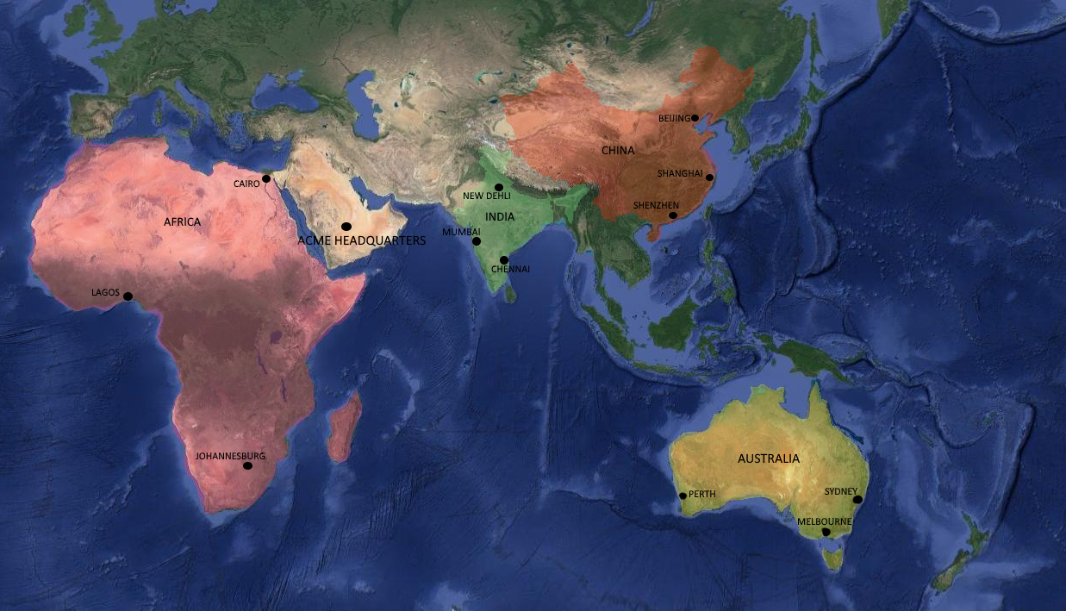

Original file to be included in assignment submission.

## Suspects

# Class diagrams

## Lab 7

## Lab 8

# Sequence diagrams

# Video link