Assignment Report

ITECH3201 Assignment 2 Report

Reece Parry 30305521 & Lucas Smith 30315155

Contents

User stories 2

Custom environment 2

Map 2

Suspects 2

Class diagrams 3

Lab 7 3

Lab 8 3

Sequence diagrams 4

Quit command 4

Commands command 4

Video link 4

# User stories

As a user, I want to be able to fly to different destinations.  
As a user, I want to be able to move to different locations within these destinations.  
As a user, I want to be able to talk to NPCs so that I can gather clues.   
As a user, I want to be able to interact with suspects so I can compare with my clues.  
As a user, I want to be able to identify suspects by contrasting them with my gathered clues.  
As a user, I want to be able to apprehend suspects using my gathered clues.  
As a user, I want to be able to quit the game.  
As a user, I want to be able to be able to apprehend a suspect.  
As a user, I want to be able to win the game by apprehending the correct suspect.

# Custom environment

## Map

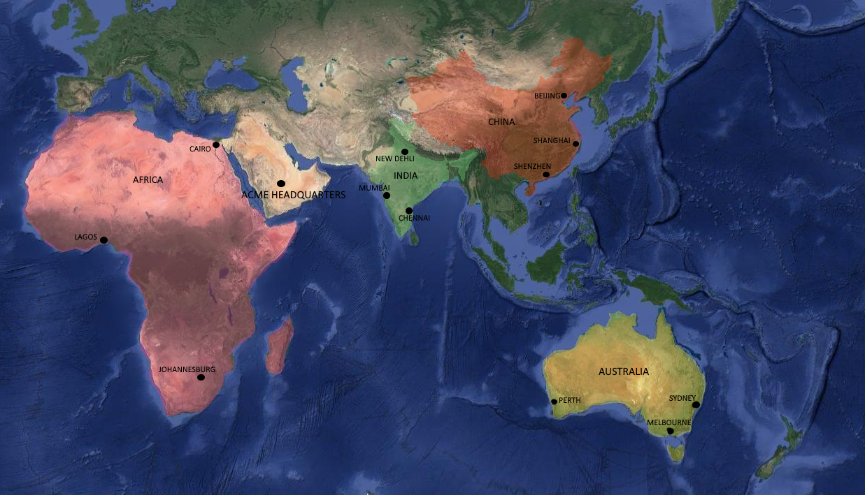

This is the original digital version – hand-drawn version to be included in assignment submission as per submission requirements.

## Suspects

William is a male with brown and blue eyes, his hobby is long sandy walks on the beach, his unique feature is his monobrow and he drives a commodore

John is a male with blonde hair and blue eyes, his hobby is hunting, his unique feature is his scar and he drives an audi

Jessica is a female with blonde hair and brown eyes, her hobby is knitting, her unique feature is her dimples and she drives a hyundai

Kate is a female with red hair and green eyes, her hobby is the gym, her unique feature is her muscles and she drives a rangerover

# Class diagrams

Original files will be included as images are large and hard to read

## Lab 7

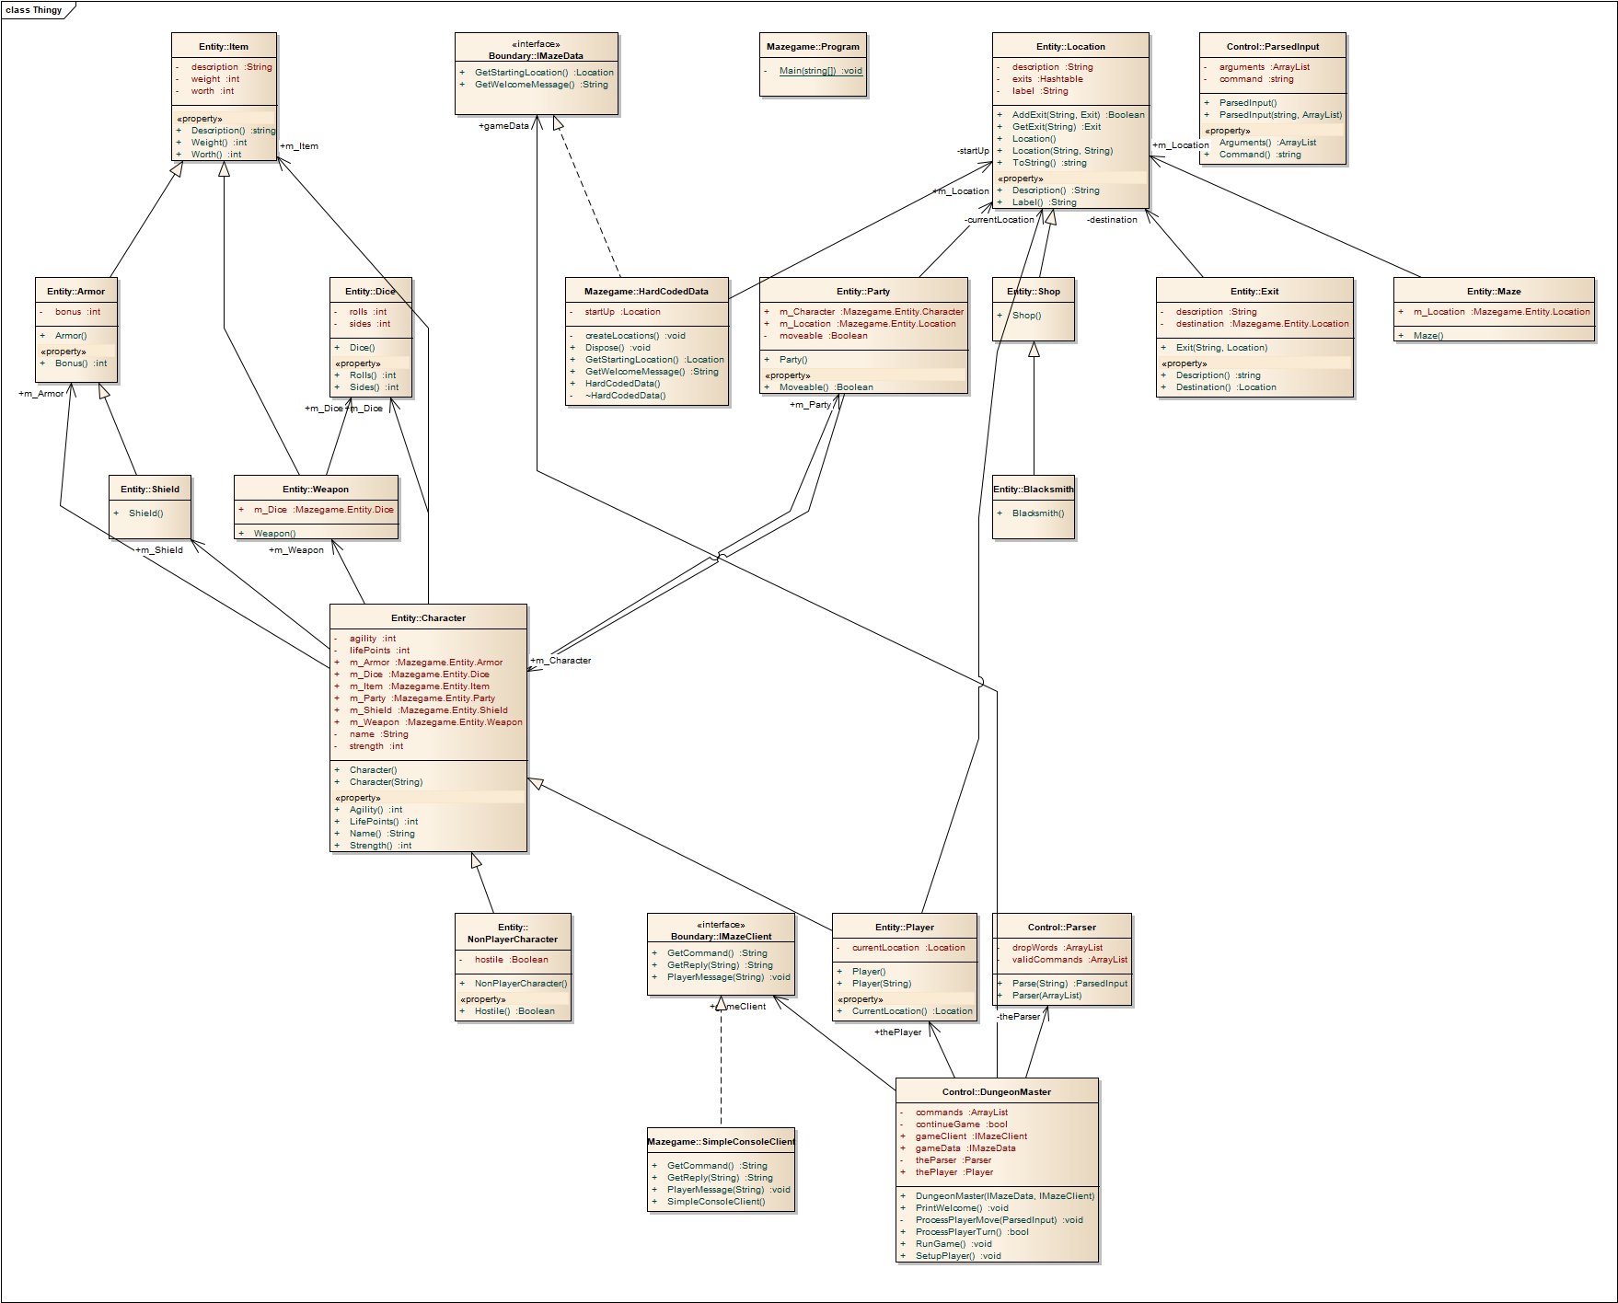

## Lab 8

Lab 8 image is included in submission (won’t fit well here)

# Sequence diagrams

## Quit command

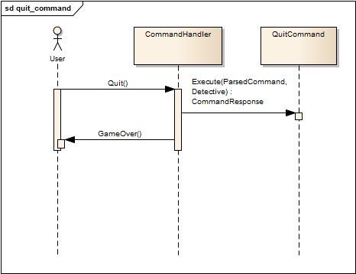

## Commands command

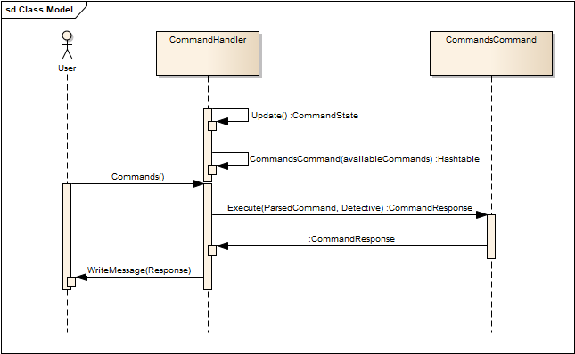

# Video link

<https://youtu.be/noEsbRBPGaI>