Colin Quinn, Quiz 1

**QUIZ 1**

**CHAPTER 1**

**20 Minute Quiz**

1. **Write the answers on a blank sheet of paper.**
2. **Make sure you write your name on every page.**
3. **Mark each page with Quiz 1.**
4. **Write legibly.**
5. **Must show steps for any credit.**

Colin Quinn, Quiz 1

1. Provide the equation for encrypting and decrypting shift cipher. What is the size of key space of shift cipher? Explain your choice

Encryption: Let x be a number based on indexes from the alphabet, such as A = 0, B = 1, etc…

Use the formula y = (x + k) mod 26 to find the index of the now encrypted letter.

Using the same indexes, convert the result y into the encrypted letter.

Decryption: The same process occurs for decryption, however rather than (x + k), we subtract them.

The formula here is y = (x – k) mod 26

The key space here is 26 because there are 26 letters in the alphabet.

1. Decrypt the word “nc” using the affine cipher with a = 9 and b = 13

Using modular inverse of f(x) = 9x + 13, we can substitute the inverses of each where A’ = 3 and B’ = 13.

Now we have f(x’) = 3x + 13. Plugging in the string “nc” here results in the output of the word “at”.

Colin Quinn, Quiz 1

1. Perform the following mod arithmetic operations (must show steps for the work)
2. 38 mod 7

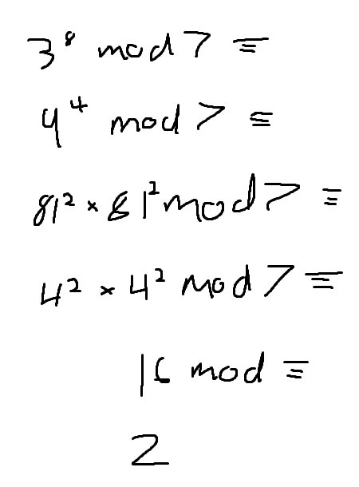

1. 2. 3/5 mod 7

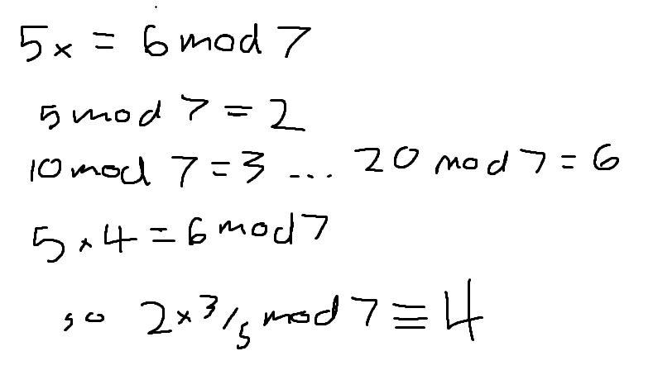

1. -5 * 5 mod 7

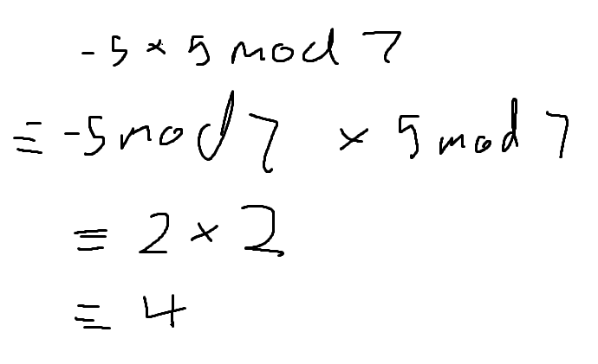

1. 30. 9 mod 7

