# **Exercises-Chapter 1**

# Introduction to OS

## What are the three main purposes of an operating system?

An operating system has three main functions:

(1) manage the computer's resources, such as the central processing unit, memory, disk drives, and printers,

(2) establish a user interface, and

(3) execute and provide services for applications software.

## Keeping in mind the various definitions of operating system, consider whether the operating system should include applications such as Web browsers and mail programs. Argue both that it should and that it should not, and support your answers.

Reasons for:

There are users who would like for OS to come with programs such as web browser or e-mail client out-of-the-box so that they don’t have to install them themselves. This is simply convenient for users who just want out-of-the-box system and don’t care about details of those programs

Reasons against:

Tight coupling of applications to OS is not something every user wants. Some users want functionality of OS but choose their own applications for high-level tasks which are not in itself part of OS.

## What is a “kernel”?

A kernel is the one program that is always running on the computer.

## Describe the role of each of these system units in executing a user program

## - CPU

## Goes through a fetch-decode -execute cycle. It is master and all other controllers are slaves. No controller can do anything unless directed by CPU’s instruction.

## 

## - Controller of the Keyboard device

Interact with Disk controller

## RAM

Holds all data and programs in it that are currently running

## Disk Controller

Holds all other programs and data

## What are interrupts and traps. How are interrupts handled? Give two examples of interrupts and two of traps.

Interrupts are signals sent to the CPU by external devices, normally I/O devices. They tell the CPU to stop its current activities and execute the appropriate part of the operating system.

Traps (also known as an exception or a fault) are typically a type of synchronous interrupt caused by an exceptional condition.

How are interrupts handled?

An interrupt occurs—an interrupt vector of addresses is then indexed by a unique device number, given with the interrupt request, to provide the address of the interrupt service routine.

Ex: Interrupt

Hardware issue (printer paper jam)

Key press (CTRL ALT DEL)

Ex: Trap

## What steps does the computing system take to support I/O request by user. Explain in detail from the initial step of I/O request up to the completion of I/O

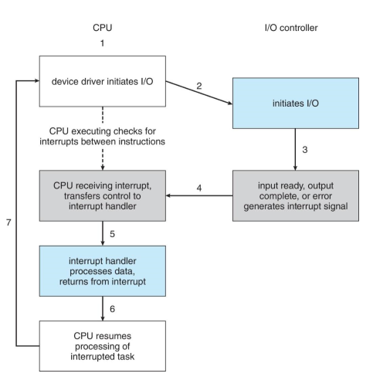

## What are privileged instructions? Which of the following instructions should be privileged?

A privileged instruction is an instruction that is only executable in kernel mode

## a. Set value of timer. Privileged

## b. Read the clock.

## c. Clear memory. Privileged

## d. Issue a trap instruction.

## e. Turn off interrupts. Privileged

## f. Modify entries in device-status table. Privileged

## g. Switch from user to kernel mode. Privileged

## h. Access I/O device. Privileged

## Some CPUs provide for more than two modes of operation. What are two possible uses of these multiple modes?

Some CPUs have supported multiple modes. Multiple modes could be used to provide a finer-grained security policy. For example, rather than distinguishing between just user and kernel mode, you could distinguish between different types of user mode. Perhaps users belonging to the same group could execute each other’s code.

Another possibility would be to provide different distinctions within kernel code. For example, a specific mode could allow USB device drivers to run. This would mean that USB devices could be serviced without having to switch to kernel mode, thereby essentially allowing USB device drivers to run in a quasi-user/kernel mode.