**LAB 1: A script to add product in database.**

**Source Code:**

**Index.php:**

<?php

include 'config.php';

include 'nav.php';

$productSaved = FALSE;

// create necessary tables;

$table1 = "CREATE TABLE IF NOT EXISTS `cart` (

`id` int(11) NOT NULL AUTO_INCREMENT,

`name` varchar(100) NOT NULL,

`image` varchar(255) NOT NULL,

`expirydate` varchar(20) NOT NULL,

`discount` int(11) NOT NULL,

`price` int(11) DEFAULT NULL,

`quantity` int(11) DEFAULT NULL,

PRIMARY KEY (`id`)

)";

$table2 = "CREATE TABLE IF NOT EXISTS`order` (

`id` int(11) NOT NULL AUTO_INCREMENT,

`name` varchar(100) NOT NULL,

`number` varchar(20) NOT NULL,

`email` varchar(100) NOT NULL,

`method` varchar(50) NOT NULL,

`house_no` varchar(50) NOT NULL,

`city` varchar(50) NOT NULL,

`street` varchar(100) NOT NULL,

`state` varchar(50) NOT NULL,

`country` varchar(50) NOT NULL,

`pin_code` varchar(20) NOT NULL,

`total_products` int(11) NOT NULL,

`total_price` int(10) NOT NULL,

PRIMARY KEY (`id`)

)";

$table3 = "CREATE TABLE IF NOT EXISTS `products` (

`id` int(11) NOT NULL AUTO_INCREMENT,

`name` varchar(100) NOT NULL,

`image` varchar(255) NOT NULL,

`expirydate` varchar(20) NOT NULL,

`discount` int(11) NOT NULL,

`price` int(11) DEFAULT NULL,

PRIMARY KEY (`id`)

)";

$create1 = mysqli_query($conn,$table1);

$create2 = mysqli_query($conn,$table2);

$create3 = mysqli_query($conn,$table3);

if(isset($_POST['submit'])){

$error = array();

$product_Name = isset($_POST['name'])?$_POST['name']:'';

$product_Price = isset($_POST['price'])?$_POST['price']:'';

$product_expiry = isset($_POST['expiry']) ? $_POST['expiry'] : 2024;

$product_discount = isset($_POST['discount']) ? $_POST['discount'] : 0;

if(empty($product_Name)){

$error[] = 'Please enter product name';

}

if(empty($product_Price)){

$error[] = 'Please enter product price';

}

if(!is_dir(UPLOAD_DIR)){

mkdir(UPLOAD_DIR,0777,true);

}

$file_name = $_FILES['file']['name'];

$file_size =$_FILES['file']['size'];

$file_tmp =$_FILES['file']['tmp_name'];

$file_type=$_FILES['file']['type'];

$tmp = explode('.', $file_name);

$file_ext = end($tmp);

$extensions = array("jpeg", "jpg", "png");

if(empty($error)){

$insert_product = mysqli_query($conn,"INSERT INTO products(name,price,image) VALUES('$product_Name','$product_Price','$file_name')");

if($insert_product == 1){

move_uploaded_file($_FILES['file']['tmp_name'], UPLOAD_DIR . $file_name);

$message[] = 'Product added successfully';

}else{

$message[] = 'Error adding product';

}

}

}

?>

<!DOCTYPE html>

<html>

<head>

<meta http-equiv="X-UA-Compatible" content="IE=edge,chrome=1" />

<meta name="viewport" content="width=device-width, initial-scale=1, user-scalable=yes" />

<meta charset="UTF-8" />

<!-- The above 3 meta tags must come first in the head -->

<title>Save product details</title>

<script src="https://code.jquery.com/jquery-3.2.1.min.js" type="text/javascript"></script>

<link rel="stylesheet" href="https://cdnjs.cloudflare.com/ajax/libs/font-awesome/6.0.0/css/all.min.css">

</head>

<body>

<?php

?>

<div class="form-container">

<h2>Add a product</h2

<form action="" method="post" enctype="multipart/form-data">

<label for="name">Name</label>

&nbsp;

<input type="text" id="name" name="name" value="<?php echo isset($product_Name) ? $product_Name : ''; ?>">

<label for="price">Price</label>

&nbsp;

<input type="number" id="price" name="price" min="0" value="<?php echo isset($product_price) ? $product_price : '0'; ?>">

<label for="expiry">Expiry Date:</label>

&nbsp;

<input type="text" id="expiry" name="expiry" value="<?php echo isset($product_expiry) ? $product_expiry : '2024'; ?>">

<div>&nbsp;</div>

<div></div>

<label for="discount">Discount</label>

<input type="number" id="discount" name="discount" min="0" value="<?php echo isset($product_discount) ? $product_discount : '0'; ?>">

<label for="file">Image</label>

&nbsp;

<input type="file" id="file" name="file" >

<button type="submit" id="submit" name="submit" class="button">

Submit

</button>

</form>

<?php

if ($productSaved) {

?>

<a href="getProduct.php?id=<?php echo $lastInsertId; ?>" class="link-to-product-details">

Click me to see the saved product details in <b>getProduct.php</b> (product id: <b><?php echo $lastInsertId; ?></b>)

</a>

<?php

}

?>

</div>

</body>

</html>

**Config.php:**

<?php

define('UPLOAD_DIR', 'uploaded_img/');

$conn = mysqli_connect('localhost', 'root', '', 'ecom') or die('connection failed');

?>

**Output:**

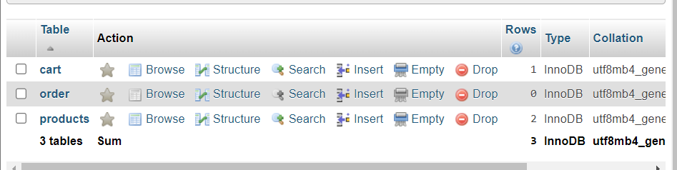

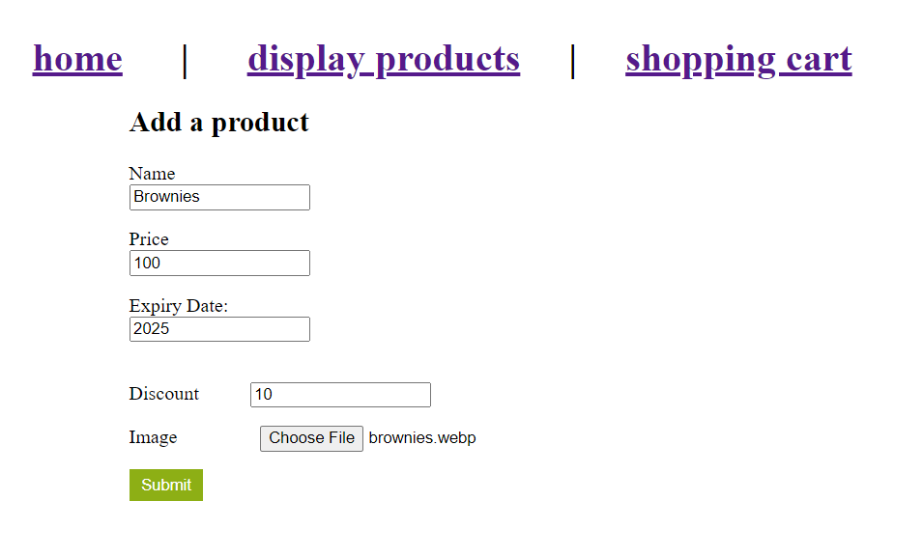

**Lab 02: A script to display the product in webpage.**

**Source Code:**

**Display.php**

<?php

@include 'config.php';

@include 'nav.php';

if(isset($_POST['add_to_wishlist'])){

$product_Name = $_POST['product_name'];

$product_Price = $_POST['product_price'];

$product_Image = $_POST['product_image'];

$product_expiry = $_POST['product_expiry'];

$product_discount = $_POST['product_discount'];

$product_quantity = 1;

$select_wishlist = mysqli_query($conn,"SELECT * from wishlist WHERE name = '$product_Name'");

if(mysqli_num_rows($select_wishlist)>0){

$message[]= "Product already added to wishlist";

}else{

$insert_products = mysqli_query($conn,"INSERT into wishlist(name,price,image,quantity) VALUES ('$product_Name','$product_Price','$product_Image','$product_quantity')");

$message[]= "Product added to wishlist";

}

}

if(isset($_POST['add_to_cart'])){

$product_Name = $_POST['product_name'];

$product_Price = $_POST['product_price'];

$product_Image = $_POST['product_image'];

// $product_expiry = $_POST['product_expiry'];

// $product_discount = $_POST['product_discount'];

$product_quantity = 1;

$select_cart = mysqli_query($conn,"SELECT * from cart WHERE name = '$product_Name'");

if(mysqli_num_rows($select_cart)>0){

$message[]= "Product already added to cart";

}else{

$insert_products = mysqli_query($conn,"INSERT INTO cart(name,price,image,quantity) VALUES ('$product_Name','$product_Price','$product_Image','$product_quantity')");

$message[]= "Product added to cart";

}

}

?>

<!DOCTYPE html>

<html lang="en">

<head>

<meta charset="UTF-8">

<meta http-equiv="X-UA-Compatible" content="IE=edge">

<meta name="viewport" content="width=device-width, initial-scale=1.0">

<title>products</title>

<!-- font awesome cdn link -->

<link rel="stylesheet" href="https://cdnjs.cloudflare.com/ajax/libs/font-awesome/6.0.0/css/all.min.css">

<!-- custom css file link -->

<link rel="stylesheet" href="style.css">

</head>

<body>

<?php

if(isset($message)){

foreach($message as $message){

echo '<div class="message"><span>'.$message.

'</span> <i class="fas fa-times"

onclick="this.parentElement.style.display = `none`;"></i> </div>';

};

};

?>

<div class="container">

<section class="products">

<h1 class="heading">latest products</h1>

<div class="box-container">

<?php

$select_products = mysqli_query($conn, "SELECT * from products");

if(mysqli_num_rows($select_products)>0){

while($fetch_product = mysqli_fetch_assoc($select_products)){

?>

<form action="" method="post">

<div class="box">

<img src="<?php echo UPLOAD_DIR,$fetch_product['image']; ?>" alt="">

<h3><?php echo $fetch_product['name']; ?></h3>

<div class="price">Rs.<?php echo $fetch_product['price']; ?>/-</div>

<input type="hidden" name="product_name" value="<?php echo $fetch_product['name']; ?>">

<input type="hidden" name="product_price" value="<?php echo $fetch_product['price']; ?>">

<input type="hidden" name="product_image" value="<?php echo $fetch_product['image']; ?>">

<input type="submit" class="btn" value="add to cart" name="add_to_cart">

<input type="submit" class="btn" value="add to wishlist" name="add_to_wishlist">

</div>

</form>

<?php

};

};

?>

</div>

</section>

</div>

<!-- custom js file link -->

<script src="js/script.js"></script>

<script>

const deleteProduct = async (id) => {

const response = await fetch("ajax/delproduct.php",{

method:"POST",

headers: {

'Content-Type': 'application/x-www-form-urlencoded',

},

body: 'id=' + id,

})

const res = await response.text()

if (res == "success"){

location.reload()

}

}

</script>

</body>

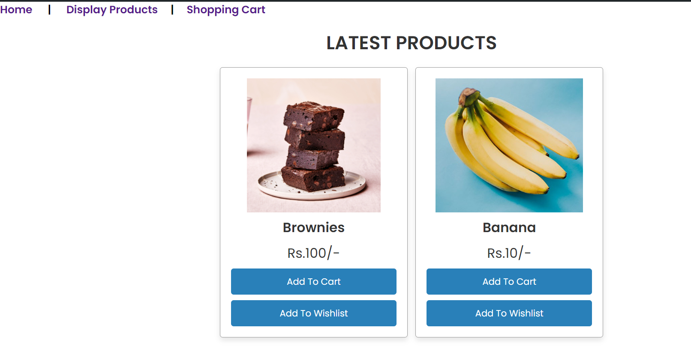</html>

**Output:**

**LAB 03: A script to add the product in shopping cart.**

**Source Code:**

<?php

@include 'config.php';

include 'nav.php';

if(isset($_POST['update_update_btn'])){

$update_value = $_POST['update_quantity'];

$update_id = $_POST['update_quantity_id'];

$update_query = mysqli_query($conn, "UPDATE cart SET quantity='$update_value' WHERE id ='$update_id'");

if($update_query){

header('location:cart.php');

}

}

if(isset($_GET['remove'])){

$remove_id=$_GET['remove'];

mysqli_query($conn,"DELETE from cart where id ='$remove_id'");

header('location:cart.php');

}

if(isset($_GET['delete_all'])){

mysqli_query($conn,"DELETE from cart");

header('location:cart.php');

}

?>

<!DOCTYPE html>

<html lang="en">

<head>

<meta charset="UTF-8">

<meta http-equiv="X-UA-Compatible" content="IE=edge">

<meta name="viewport" content="width=device-width, initial-scale=1.0">

<title>shopping cart</title>

<link rel="stylesheet" href="https://cdnjs.cloudflare.com/ajax/libs/font-awesome/6.0.0/css/all.min.css">

<link rel="stylesheet" href="style.css">

</head>

<body>

<div class="container">

<section class="shopping-cart">

<h1 class="heading">shopping cart</h1>

<table>

<thead>

<th>image</th>

<th>name</th>

<th>price</th>

<th>quantity</th>

<th>total price</th>

<th>action</th>

</thead>

<tbody>

<?php

$select_cart = mysqli_query($conn, "SELECT * from cart");

$grand_total = 0;

if(mysqli_num_rows($select_cart)>0){

while($fetch_cart = mysqli_fetch_assoc($select_cart)){

?>

<tr>

<td><img src="uploaded_img/<?php echo $fetch_cart['image']; ?>" height="100" alt=""></td>

<td><?php echo $fetch_cart['name']; ?></td>

<td>Rs.<?php echo number_format($fetch_cart['price']); ?>/-</td>

<td>

<form action="" method="post">

<input type="hidden" name="update_quantity_id" value="<?php echo $fetch_cart['id']; ?>" >

<input type="number" name="update_quantity" min="1" value="<?php echo $fetch_cart['quantity']; ?>" >

<input type="submit" value="update" name="update_update_btn">

</form>

</td>

<td>$<?php echo $sub_total = ($fetch_cart['price'] * $fetch_cart['quantity']); ?>/-</td>

<td><a href="cart.php?remove=<?php echo $fetch_cart['id']; ?>" onclick="return confirm('remove item from cart?')" class="delete-btn"> <i class="fas fa-trash"></i> remove</a></td>

</tr>

<?php

}

}

?>

<tr class="table-bottom">

<td><a href="display.php" class="option-btn" style="margin-top: 0;">continue shopping</a></td>

<td colspan="3">grand total</td>

<td>$<?php echo $grand_total += $sub_total; ?>/-</td>

<td><a href="cart.php?delete_all" onclick="return confirm('Are you sure you want to delete all?');" class="delete-btn"> <i class="fas fa-trash"></i> delete all </a></td>

</tr>

</tbody>

</table>

<div class="checkout-btn">

<a href="checkout.php" class="btn <?= ($grand_total > 1)?'':'disabled'; ?>">Procced to checkout</a>

</div>

</section>

</div>

<script src="script.js"></script>

</body>

</html>

**Output:**

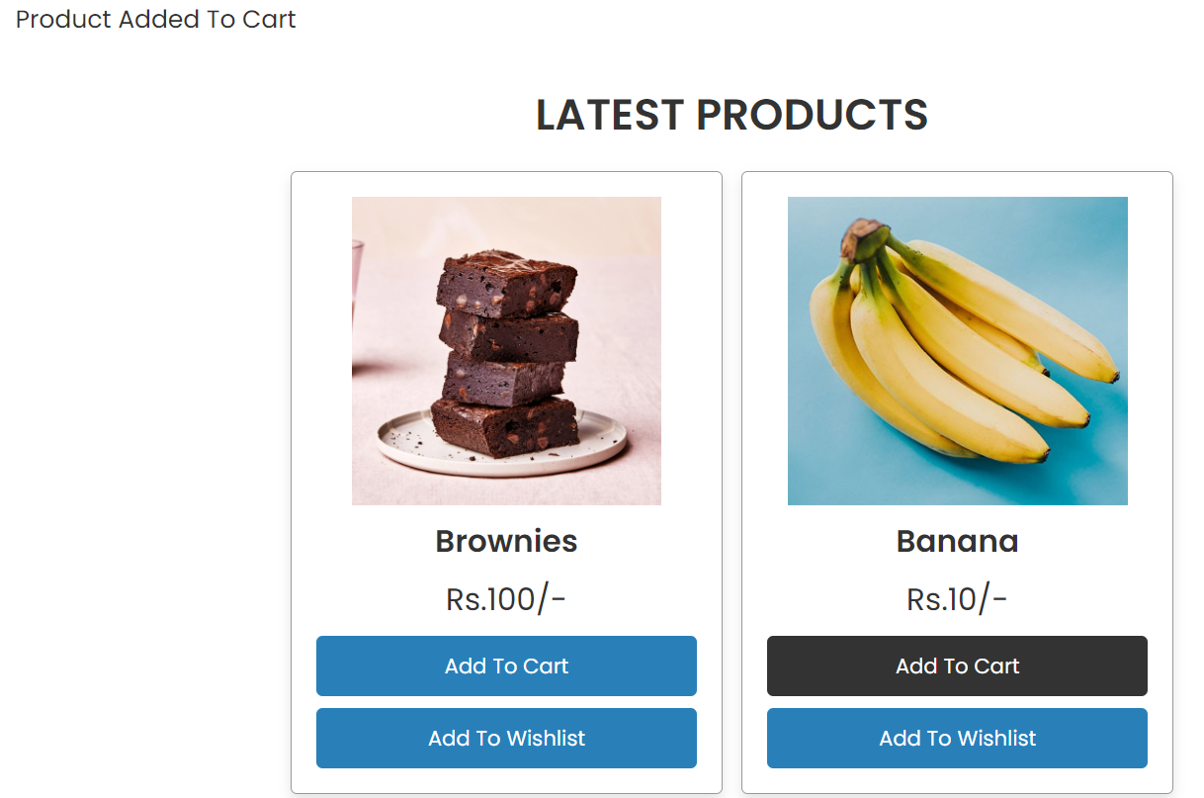

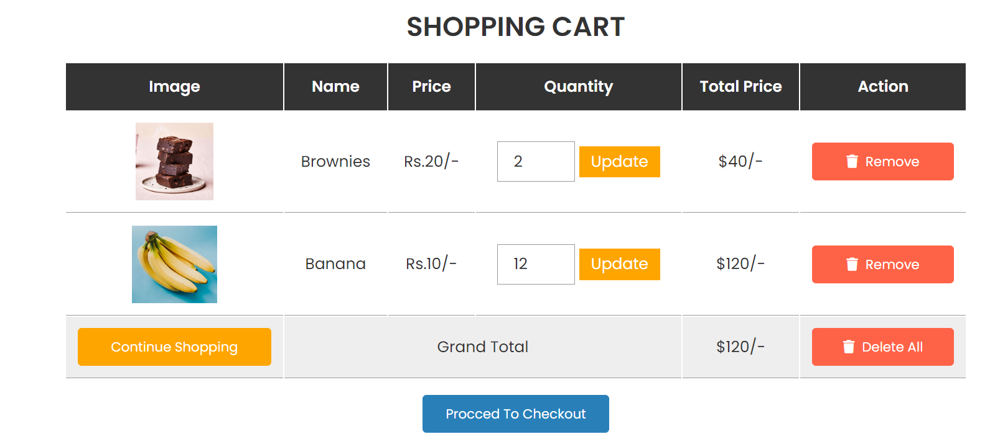

**LAB 04: A script to maintain Wish list.**

**Source Code:**

<?php

@include 'config.php';

if (isset($_POST['add_to_cart'])) {

$product_name = $_POST['product_name'];

$product_price = $_POST['product_price'];

$product_image = $_POST['product_image'];

$product_quantity = 1;

$select_cart = mysqli_query($conn, "SELECT * FROM `cart` WHERE name = '$product_name'");

if (mysqli_num_rows($select_cart) > 0) {

$message[] = 'Product already added to cart';

} else {

$insert_product = mysqli_query($conn, "INSERT INTO `cart`(name,price,image,quantity) VALUES('$product_name','$product_price','$product_image','$product_quantity')");

$message[] = 'Product added to cart successfully';

}

}

if(isset($_GET['remove'])){

$remove_id = $_GET['remove'];

mysqli_query($conn, "DELETE FROM wishlist WHERE id ='$remove_id'");

header('location:wishlist.php');

}

?>

<!DOCTYPE html>

<html lang="en">

<head>

<meta charset="UTF-8">

<meta http-equiv="X-UA-Compatible" content="IE=edge">

<meta name="viewport" content="width=device-width, initial-scale=1.0">

<title>Wishlist</title>

<!-- font awesome cdn link -->

<link rel="stylesheet" href="https://cdnjs.cloudflare.com/ajax/libs/font-awesome/6.0.0/css/all.min.css">

<!-- custom css file link -->

<link rel="stylesheet" href="style.css">

</head>

<body>

<?php

if (isset($message)) {

foreach ($message as $message) {

echo '<div class="message"><span>' . $message . '</span> <i class="fas fa-times" onclick="this.parentElement.style.display = `none`;"></i> </div>';

}

;

}

;

?>

<div class="container">

<section class="products">

<h1 class="heading">wishlist</h1>

<div class="box-container">

<?php

$select_products = mysqli_query($conn, "SELECT * FROM wishlist");

if (mysqli_num_rows($select_products) > 0) {

while ($fetch_product = mysqli_fetch_assoc($select_products)) {

?>

<form action="" method="post">

<div class="box">

<img src="<?php echo UPLOAD_DIR, $fetch_product['image']; ?>" alt="">

<h3>

<?php echo $fetch_product['name']; ?>

</h3>

<div class="price">Rs.

<?php echo $fetch_product['price']; ?>

</div>

<input type="hidden" name="product_name" value="<?php echo $fetch_product['name']; ?>">

<input type="hidden" name="product_price" value="<?php echo $fetch_product['price']; ?>">

<input type="hidden" name="product_image" value="<?php echo $fetch_product['image']; ?>">

<input type="submit" class="btn" value="add to cart" name="add_to_cart">

<td><a href="wishlist.php?remove=<?php echo $fetch_product['id']; ?>"

onclick="return confirm('remove item from cart?')" class="delete-btn"><i

class="fas fa-trash"></i> remove</a></td>

</div>

</form>

<?php

}

;

}

;

?>

</div>

</section>

</div>

**Output:**

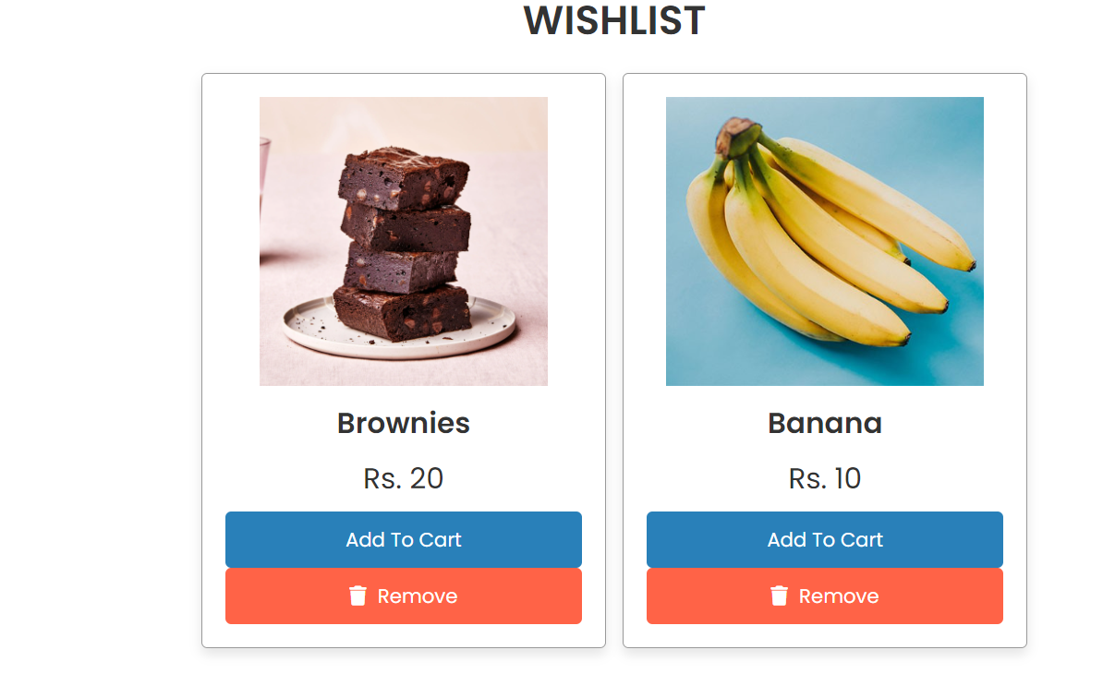

**LAB 05: A script to check out the cart.**

**Source Code:**

<?php

@include 'config.php';

if(isset($_POST['order_btn'])){

$name = $_POST['name'];

$number = $_POST['number'];

$email = $_POST['email'];

$method = $_POST['method'];

$house_no = $_POST['house_no'];

$city = $_POST['city'];

$street = $_POST['street'];

$state = $_POST['state'];

$country = $_POST['country'];

$pin_code = $_POST['pin_code'];

$cart_query = mysqli_query($conn, "SELECT * FROM `cart`");

$price_total = 0;

if(mysqli_num_rows($cart_query) > 0){

while($product_item = mysqli_fetch_assoc($cart_query)){

$product_name[] = $product_item['name'] .' ('. $product_item['quantity'] .') ';

$product_price = $product_item['price'] * $product_item['quantity'];

echo $product_price;

$price_total += $product_price;

};

};

$total_product = implode(', ',$product_name);

$detail_query = mysqli_query($conn, "INSERT INTO `order`(name, number, email, method, house_no, city, street,state,country, pin_code, total_products, total_price) VALUES('$name','$number','$email','$method','$house_no','$city','$street','$state','$country','$pin_code','$total_product','$price_total')") or die('query failed');

if($cart_query && $detail_query){

echo "

<div class='order-message-container'>

<div class='message-container'>

<h3>thank you for shopping!</h3>

<div class='order-detail'>

<span>".$total_product."</span>

<span class='total'> total : $".$price_total."/- </span>

</div>

<div class='customer-details'>

<p> your name : <span>".$name."</span> </p>

<p> your number : <span>".$number."</span> </p>

<p> your email : <span>".$email."</span> </p>

<p> your address : <span>".$house_no.", ".$city.", ".$country." - ".$pin_code."</span> </p>

<p> your payment mode : <span>".$method."</span> </p>

</div>

<a href='pay.php' class='btn'>Pay</a>

<a href='products.php' class='btn'>continue shopping</a>

</div>

</div>

";

}

}

?>

?>

<!DOCTYPE html>

<html lang="en">

<head>

<meta charset="UTF-8">

<meta http-equiv="X-UA-Compatible" content="IE=edge">

<meta name="viewport" content="width=device-width, initial-scale=1.0">

<title>checkout</title>

<!-- font awesome cdn link -->

<link rel="stylesheet" href="https://cdnjs.cloudflare.com/ajax/libs/font-awesome/6.0.0/css/all.min.css">

<!-- custom css file link -->

<link rel="stylesheet" href="style.css">

</head>

<body>

<div class="container">

<section class="checkout-form">

<h1 class="heading">complete your order</h1>

<form action="" method="post">

<div class="display-order">

<?php

$select_cart = mysqli_query($conn, "SELECT * FROM `cart`");

$total = 0;

$grand_total = 0;

if(mysqli_num_rows($select_cart) > 0){

while($fetch_cart = mysqli_fetch_assoc($select_cart)){

$total_price = $fetch_cart['price'] * $fetch_cart['quantity'];

$grand_total += $total_price;

?>

<span><?= $fetch_cart['name']; ?>(<?= $fetch_cart['quantity']; ?>)</span>

<?php

}

}else{

echo "<div class='display-order'><span>your cart is empty!</span></div>";

}

?>

<span class="grand-total"> grand total : $<?php echo number_format($grand_total, 2); ?>/- </span>

</div>

<div class="flex">

<div class="inputBox">

<span>your name</span>

<input type="text" placeholder="Name" name="name" required>

</div>

<div class="inputBox">

<span>your number</span>

<input type="number" placeholder="Phone Number" name="number" required>

</div>

<div class="inputBox">

<span>your email</span>

<input type="email" placeholder="Email" name="email" required>

</div>

<div class="inputBox">

<span>payment method</span>

<select name="method">

<option value="cash on delivery" selected>cash on devlivery</option>

<option value="esewa">esewa</option>

</select>

</div>

<div class="inputBox">

<span>House Number</span>

<input type="text" placeholder="" name="house_no" required>

</div>

<div class="inputBox">

<span>City</span>

<input type="text" placeholder="" name="city" required>

</div>

<div class="inputBox">

<span>Street</span>

<input type="text" placeholder="" name="street" required>

</div> <div class="inputBox">

<span>State</span>

<input type="text" placeholder="" name="state" required>

</div>

<div class="inputBox">

<span>country</span>

<input type="text" placeholder="" name="country" required>

</div>

<div class="inputBox">

<span>pin code</span>

<input type="text" placeholder="" name="pin_code" required>

</div>

</div>

<input type="submit" value="order now" name="order_btn" class="btn">

</form>

</section>

</div>

<!-- custom js file link -->

<script src="./script.js"></script>

</body>

</html>

**Output:**

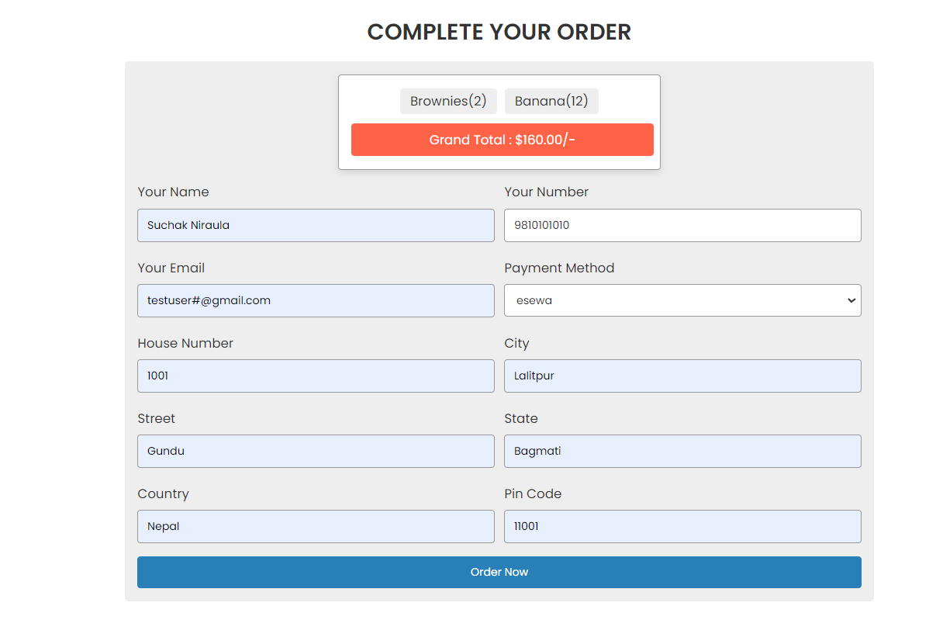

**LAB 06: A script to integrate the payment API (Esewa).**

**Source Code:**

**Esewa.php**

<!DOCTYPE html>

<html lang="en">

<head>

<meta charset="UTF-8">

<meta http-equiv="X-UA-Compatible" content="IE=edge">

<meta name="viewport" content="width=device-width, initial-scale=1.0">

<title>Checkout</title>

<link rel="stylesheet" href="https://cdnjs.cloudflare.com/ajax/libs/font-awesome/6.0.0/css/all.min.css">

<link rel="stylesheet" href="style.css">

<script src="https://stackpath.bootstrapcdn.com/bootstrap/4.5.2/js/bootstrap.min.js" integrity="sha384-B4gt1jrGC7Jh4AgTPSdUtOBvfO8shuf57BaghqFfPlYxofvL8/KUEfYiJOMMV+rV" crossorigin="anonymous"></script>

<link rel="stylesheet" href="https://stackpath.bootstrapcdn.com/bootstrap/4.5.2/css/bootstrap.min.css" integrity="sha384-JcKb8q3iqJ61gNV9KGb8thSsNjpSL0n8PARn9HuZOnIxN0hoP+VmmDGMN5t9UJ0Z" crossorigin="anonymous">

</head>

<body>

<?php

@include 'config.php';?>

<?php

@include 'setting.php';

$grand_total = 0;

$select_cart = mysqli_query($conn, "SELECT * FROM cart");

if(mysqli_num_rows($select_cart) > 0){

while($fetch_cart = mysqli_fetch_assoc($select_cart)){

$grand_total += ($fetch_cart['price'] * $fetch_cart['quantity']);

}

}?>

<body>

<div class="container">

<section class="checkout-form">

<h1 class="heading">Complete Your Payment</h1>

<div class="display-order">

<span class="grand-total">Grand Total: Rs.<?= number_format($grand_total, 2); ?>/-</span>

</div>

<div class="col-md-3">

<h3 class="text-center">Pay With</h3>

<ul class="list-group">

<li class="list-group-item">

<form action="<?php echo $epay_url?>" method="POST">

<input value="<?php echo $grand_total; ?>" name="tAmt" type="hidden">

<input value="<?php echo $grand_total; ?>" name="amt" type="hidden">

<input value="0" name="txAmt" type="hidden">

<input value="0" name="psc" type="hidden">

<input value="0" name="pdc" type="hidden">

<input value="<?php echo $merchant_code?>" name="scd" type="hidden">

<input value="<?php echo $pid?>" name="pid" type="hidden">

<input value="<?php echo $successurl?>" type="hidden" name="su">

<input value="<?php echo $failedurl?>" type="hidden" name="fu">

<input type="image" src="uploaded_img/esewa.jpg" alt="Pay with eSewa" width="150px">

</form>

</li>

</ul>

</div>

</section>

</div>

<script src="https://stackpath.bootstrapcdn.com/bootstrap/4.5.2/js/bootstrap.min.js"></script>

<script src="script.js"></script>

</body>

</html>

**Setting.php**

<?php

$epay_url="https://uat.esewa.com.np/epay/main";

$pid="jerseystore1000009";

$failedurl="http://localhost:8080/esewa_failed.php?q=fu";

$successurl="http://localhost:8080/esewa_success.php?q=su";

$merchant_code="epay_payment";

$fraudcheck_url="https://uat.esewa.com.np/epay/transrec";

?>

**Esewa_success.php**

<?php

@include 'setting.php';

echo "<h1> Payment Success. Thank you for choosing us.";

$oid=$_GET['oid'];

$amt=$_GET['amt'];

$ref=$_GET['refId'];

echo "<br>";

echo "Order ID: ".$oid."<br>";

echo "Amount:".$amt."<br>";

echo "Reference:".$ref."<br>";

?>

**Esewa_failed.php**

<?php

echo "<h1> Payment failed";

?>

<a href="index.php"> <br>Back to Homepage</a>

**Output:**

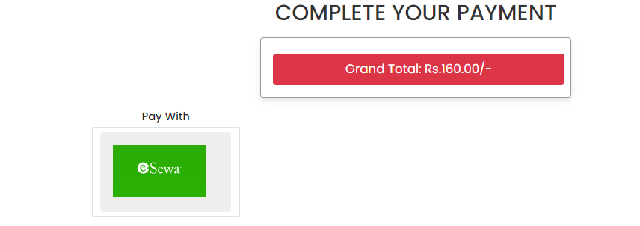

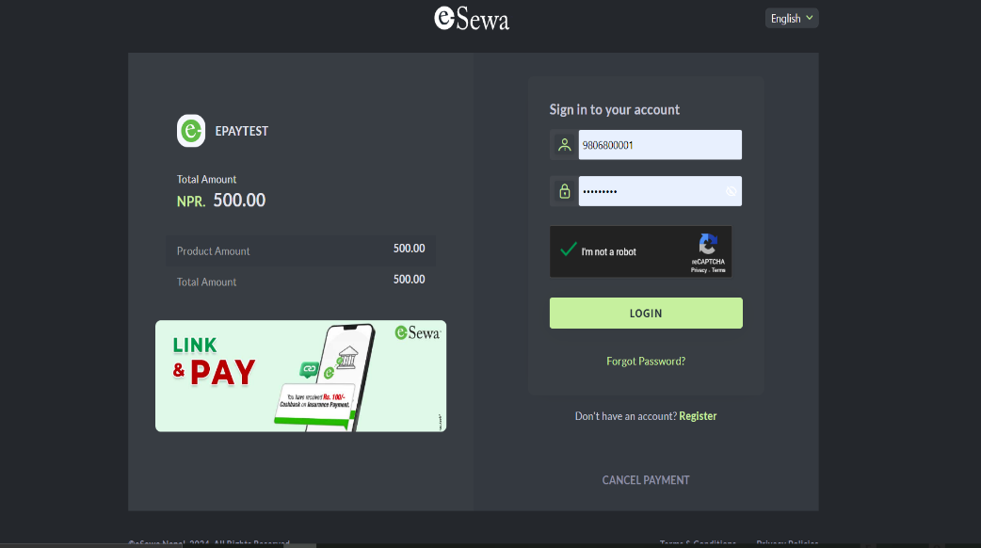

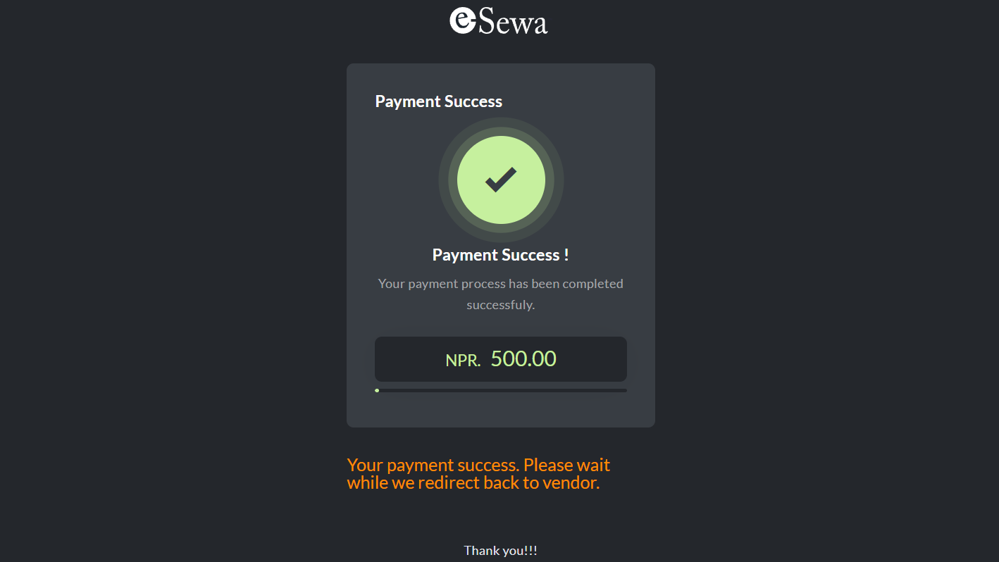

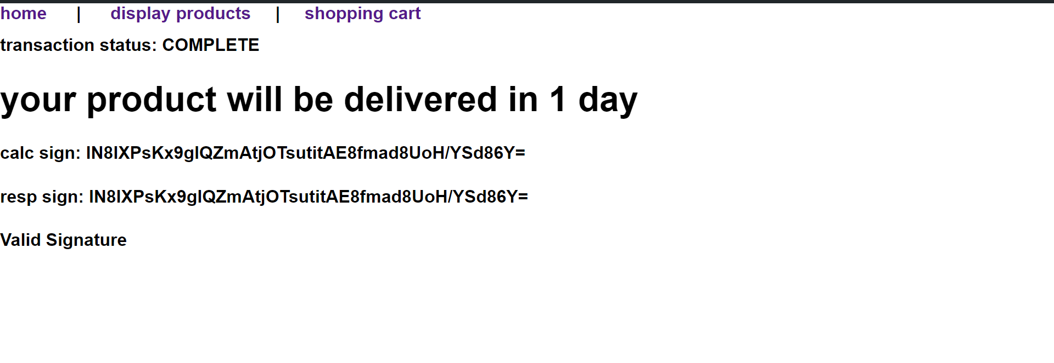



**Lab report of E-Commerce**

**Submitted by**: **Submitted to:**

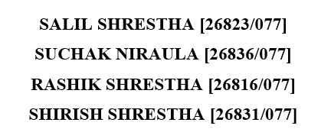 Samriddhi College Lokanthali, Bhaktapur

……………………….

Sudip Raj Khadka

Date of Submission: 2081/04/06