**Entity Framework Database First:**

**Create New Project Console Application core (As Shown in figure)**

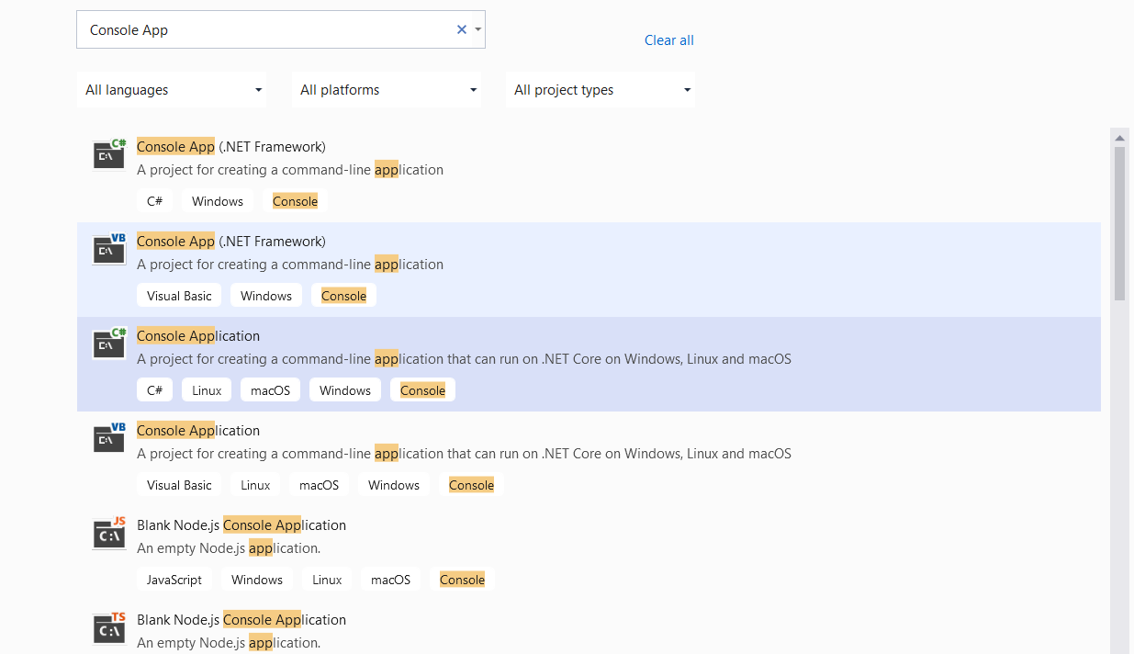

**After Created it will show like below screenshot.**

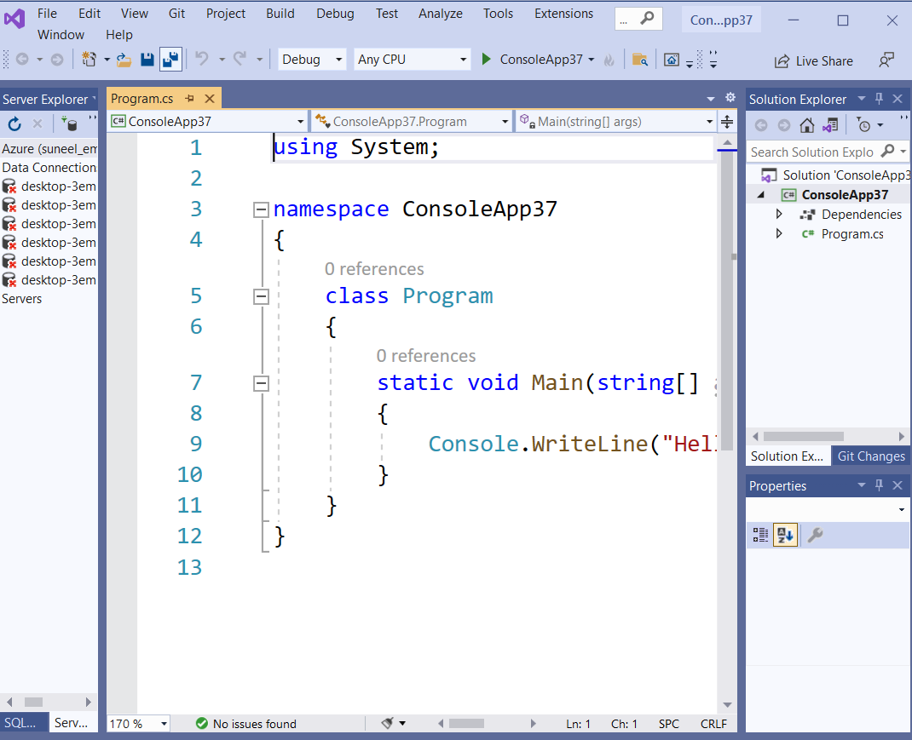

**Now Go to Menu as shown in picture: Tools>Nuget Package Manager>Package Manager Console**

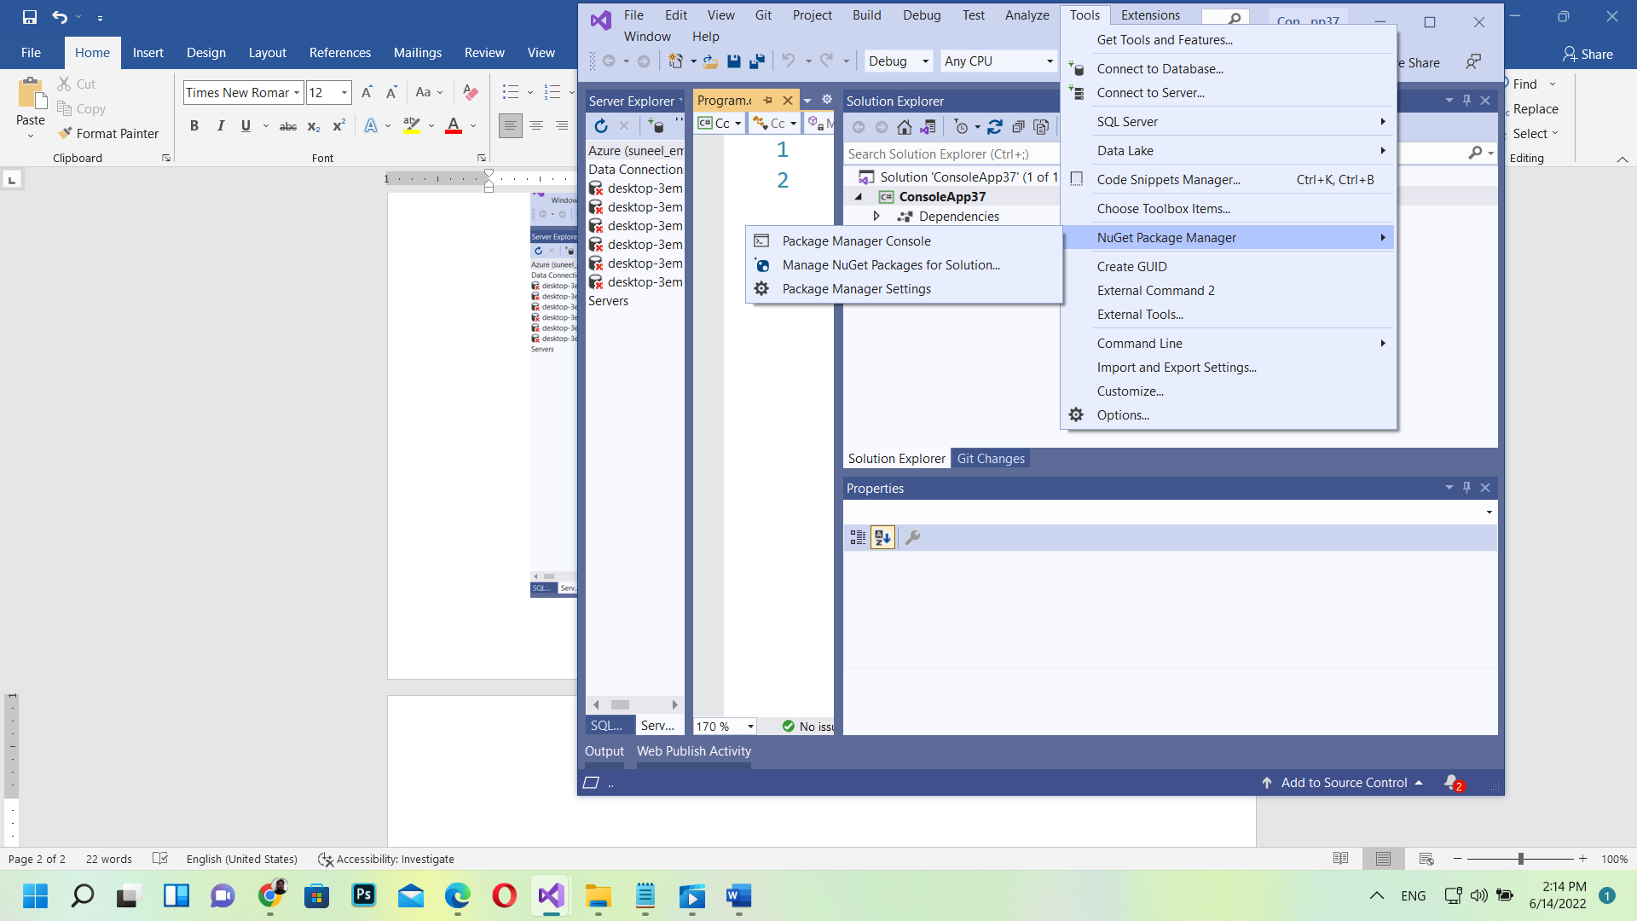

**Now in Console Manager Appear below**

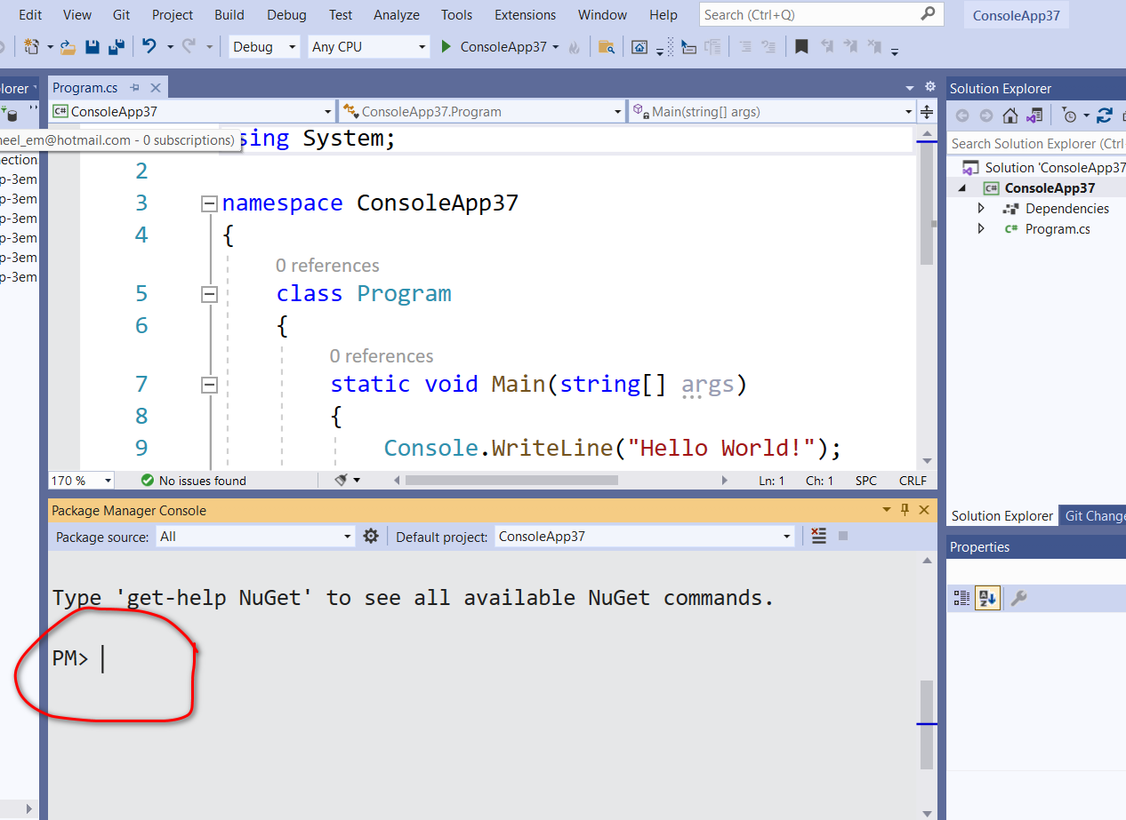

**Install Microsoft.EntityFrameworkCore.Tool**

**PM> Install-Package Microsoft.EntityFrameworkCore.Tools -version 5.0.0**

**PM>Install-Package Microsoft.EntityFrameworkCore.SqlServer -version 5.0.0**

**After Installing Generate DataContext(Scaffold):**

**PM>Scaffold-DbContext "Server=(LocalDB)\MSSQLLocalDB;Database=CollegeDB;Integrated Security =True;" Microsoft.EntityFrameworkCore.SqlServer -OutputDir Models**

**If any Changes in database we can use**

**PM> Scaffold-DbContext "Server=(LocalDB)\MSSQLLocalDB;Database=CollegeDB;Integrated Security=True;" Microsoft.EntityFrameworkCore.SqlServer -OutputDir Models -f**

**After Generated Scaffold it will generate two class as shown in Picture**

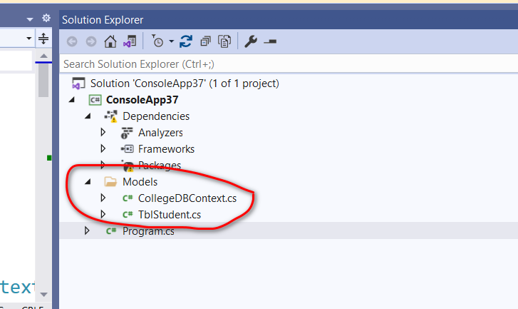

**CRUD using Entity Framework Core**

namespace ConsoleApp37

{

class Program

{

static void Main(string[] args)

{

Console.WriteLine("Hello World!");

}

}

public class StudentDB

{

public void DeleteStudent()

{

CollegeDBContext db = new CollegeDBContext();

TblStudent stu = db.TblStudents.Where(a => a.Id == 2).FirstOrDefault();

db.TblStudents.Remove(stu);

db.SaveChanges();

}

public void UpdateStudent()

{

CollegeDBContext db = new CollegeDBContext();

TblStudent stu = db.TblStudents.Where(a => a.Id == 2).FirstOrDefault();

stu.Firstname = "hari";

stu.Lastname = "Adhikari";

stu.Email = "hari@gmail.com";

db.SaveChanges();

}

public void LoadStudent()

{

CollegeDBContext db = new CollegeDBContext();

List<TblStudent> students = db.TblStudents.ToList();

foreach (TblStudent stu in students)

{

Console.WriteLine(stu.Firstname + " " + stu.Lastname);

}

}

public void SaveStudent()

{

CollegeDBContext db = new CollegeDBContext();

TblStudent st = new TblStudent();

st.Firstname = "Suneel";

st.Lastname = "Chaudhary";

st.Email = "suneel@gmail.com";

db.TblStudents.Add(st);

db.SaveChanges();

}

}

}

**Code First Approach in EntityFramework Core:**

**Create New Project similarly done in above Database first.**

**Now Go to Menu as shown in picture: Tools>Nuget Package Manager>Package Manager Console**



**Now in Console Manager Appear below**



**Install Microsoft.EntityFrameworkCore.Tool**

**PM> Install-Package Microsoft.EntityFrameworkCore.Tools -version 5.0.0**

**PM>Install-Package Microsoft.EntityFrameworkCore.SqlServer -version 5.0.0**

**PM> Install-Package Microsoft.EntityFrameworkCore.Design -version 5.0.0**

**Create Student.cs class**

public class Student

{

public int Id { get; set; }

public string Firstname { get; set; }

public string Lastname { get; set; }

public string Email { get; set; }

}

**Create StudentContext Class**

public class StudentContext:DbContext

{

public DbSet<Student> Students { get; set; }

protected override void OnConfiguring(DbContextOptionsBuilder optionsBuilder)

{

optionsBuilder.UseSqlServer(@"Server=(LocalDB)\MSSqlLocalDB;Database=CollegeDBCode;Integrated Security=True;");

}

}

**Now go to Console Manager**

PM> add-migration Initial

**Now It Will Generate Migration Files inside Migration Folder as shown in Picture.**

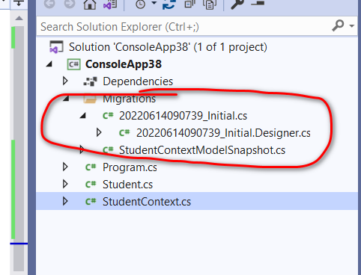 **Now use this command to create database and tables**

PM> update-database –verbose

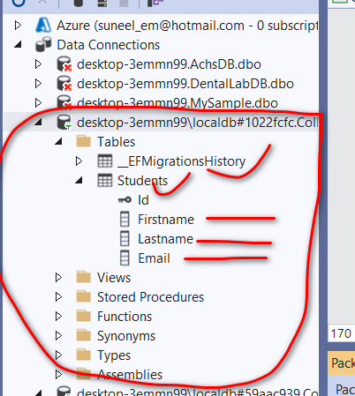

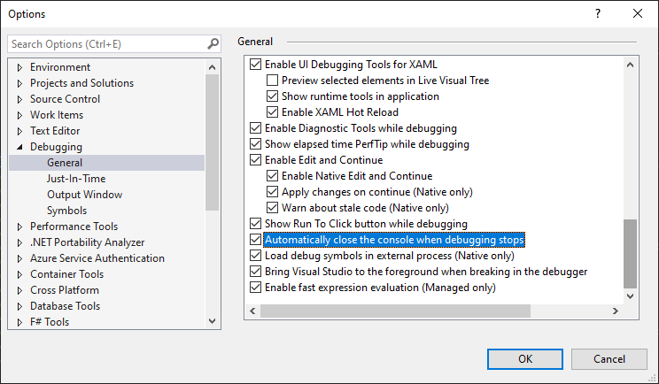

**Tools>Option Menu**

**Code in Program.cs**

namespace ConsoleApp38

{

class Program

{

static void Main(string[] args)

{

Console.WriteLine("Hello World!");

}

}

public class StudentDB

{

private static void DeleteStudent()

{

StudentContext db = new StudentContext();

Student stu = db.Students.Where(a => a.Id == 2).FirstOrDefault();

db.Students.Remove(stu);

db.SaveChanges();

}

private static void UpdateStudent()

{

StudentContext db = new StudentContext();

Student stu = db.Students.Where(a => a.Id == 2).FirstOrDefault();

stu.Firstname = "hari";

stu.Lastname = "Adhikari";

stu.Email = "hari@gmail.com";

db.SaveChanges();

}

private static void LoadStudent()

{

StudentContext db = new StudentContext();

List<Student> students = db.Students.ToList();

foreach (Student stu in students)

{

Console.WriteLine(stu.Firstname + " " + stu.Lastname);

}

}

private static void SaveStudent()

{

StudentContext db = new StudentContext();

Student st = new Student();

st.Firstname = "Suneel";

st.Lastname = "Chaudhary";

st.Email = "suneel@gmail.com";

db.Students.Add(st);

db.SaveChanges();

}

}

}