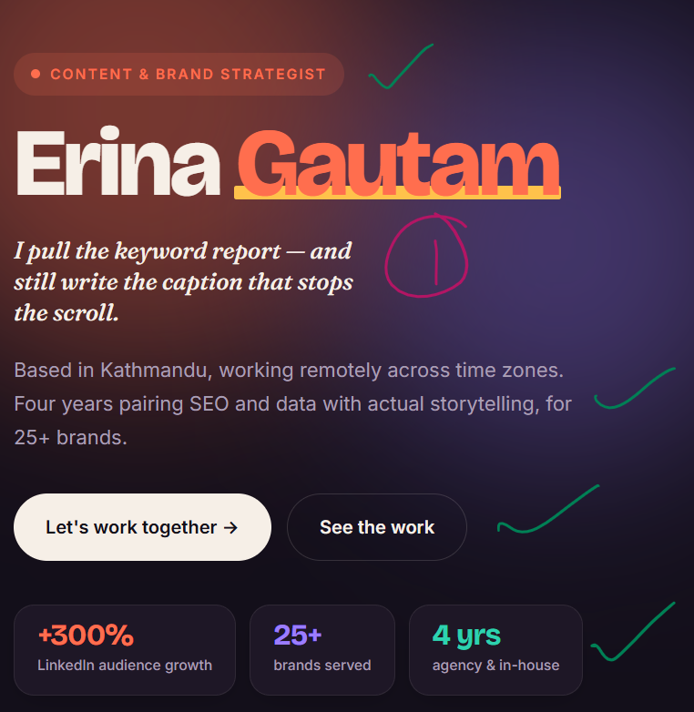
Replace “I pull ….”
- Strategy that's actually followed by content people click on.

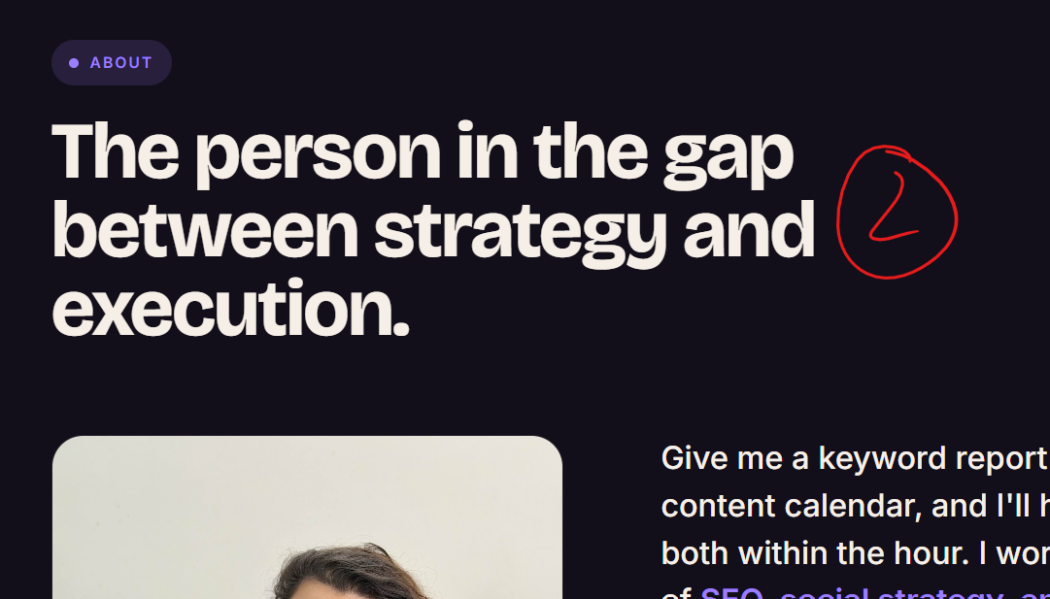

Replace : “The person in ….. “

Goal-driven strategy, not good-looking strategy.
Planning to execution, end to end. That's how I know what actually moves the needle.
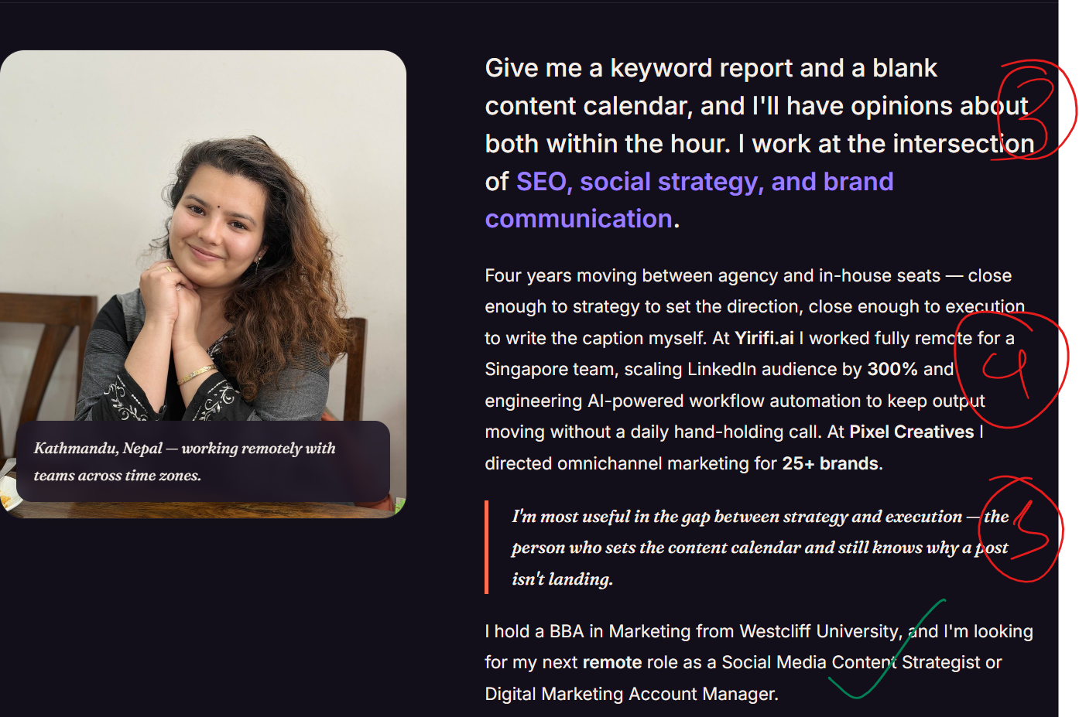
- Replace “ Give me a keyword…….”
Give me a crowded market, and I'll find what makes your brand the obvious pick.

- Replace “Four years moving …..”

Four years between agency and in-house work, enough to know both playbooks: close enough to strategy to set the direction, close enough to execution to write the caption myself. At Yirifi.ai, I worked fully remote for a Singapore-based team, scaling LinkedIn audience by 300% and engineering AI-powered workflow automation that kept output moving on its own. At Pixel Creatives, I directed positioning and content across 25+ brands at once, each one needing to sound like itself, not like the competitor next to it.

Completely remove no. 5

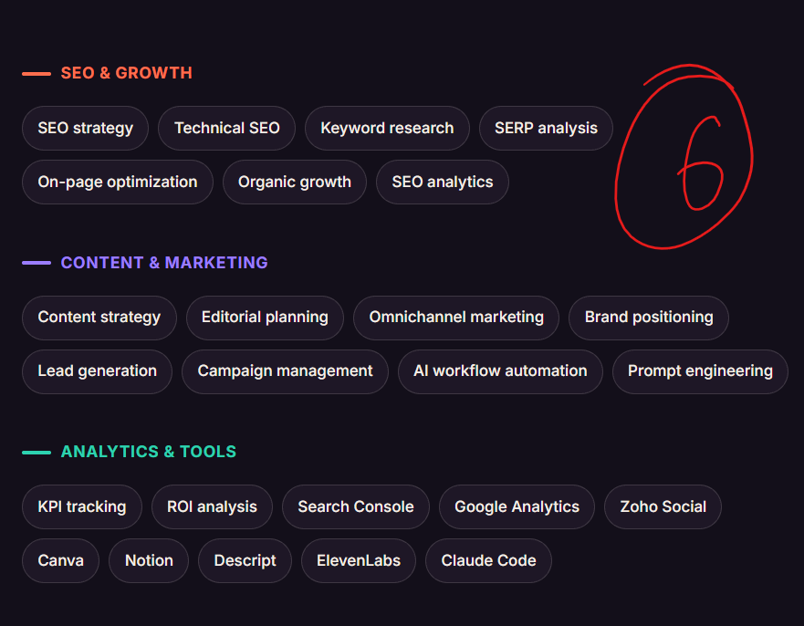

Needs to be in the following hierarchy:

1. Brand & Content
Featured: Social media strategy & management · Brand positioning · Content strategy · Editorial planning
Also: Omnichannel marketing · Campaign management
2. SEO & Growth
Featured: SEO strategy · Keyword research
Also: Technical SEO · SERP analysis · On-page optimization · Organic growth · SEO analytics
3. Analytics & Tools
KPI tracking · ROI analysis · Search Console · Google Analytics · Zoho Social · Canva · Notion · Descript · ElevenLabs · Claude Code · AI workflow automation · Prompt engineering

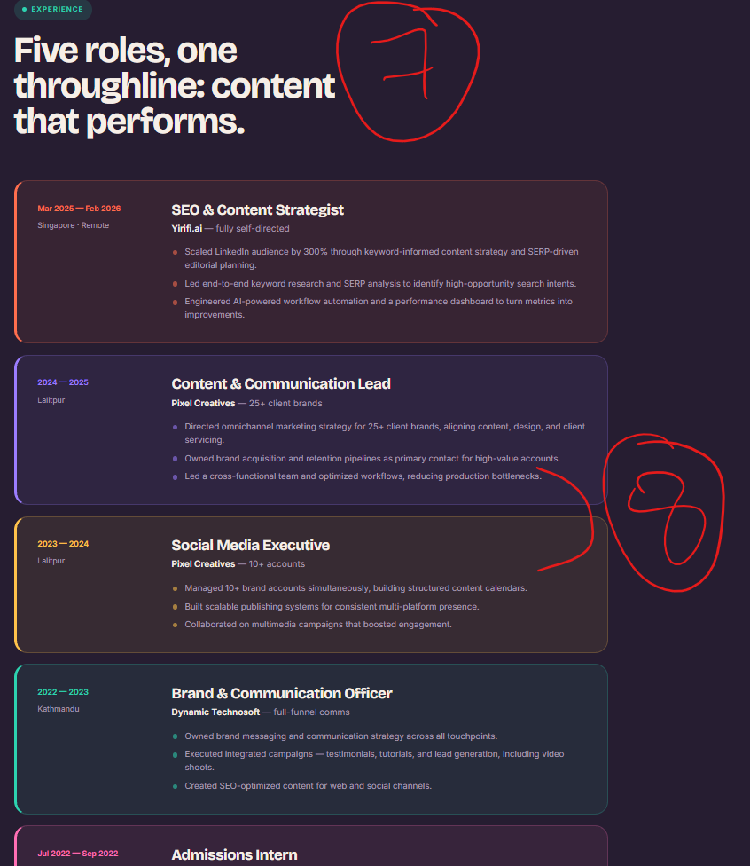

Replace “Five roles….” with
7.
I'd rather show you than tell you

Number 8. Content & Communication lead and Social Media executive is from the same company, can we keep it in a single box, same format but a single box

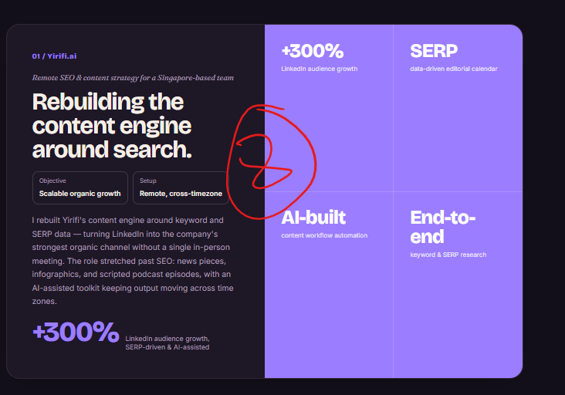

8. Replace from “ Rebuilding …..”

The noise was missing a value angle. We found it.
Objective: Authority & audience trust
Setup: Remote, cross-timezone
Web3 content is loud with hype: price predictions, trading calls, the same noise everywhere. We went the other way: a daily roundup covering regulation, policy, and governance, the institutional side nobody else in the niche was covering. All of it organic!! Other authority figures in the space started engaging back, which is how we knew it was working. Once the format proved out, I automated the research, selection, and publishing — then did the same for the infographics that followed.
Stat tiles:
- +300% → LinkedIn growth, fully organic
- Daily → Regulation & policy roundup
- Keyword-led → Research feeding a niche no one else targeted
- Automated → Research to publishing, end-to-end
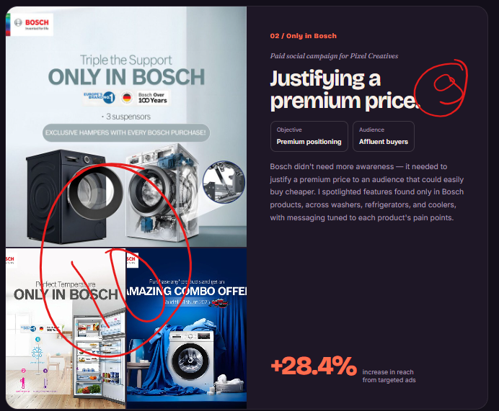

Replace “Justifying,,,”
9.

Showing the value.
Objective: Brand awareness → preference
Audience: Affluent buyers
Bosch's price wasn't the problem, people just didn't know what it was paying for. I built the campaign around what only Bosch had, like anti-wrinkle and anti-vibration tech, under one simple line: "It's a Bosch."
+28.4% increase in reach from targeted ads
10. The image is crammed up there is alot of empty spaces need the image to be fully visible and not restricted to the boxes, it can flow around if that looks good too.

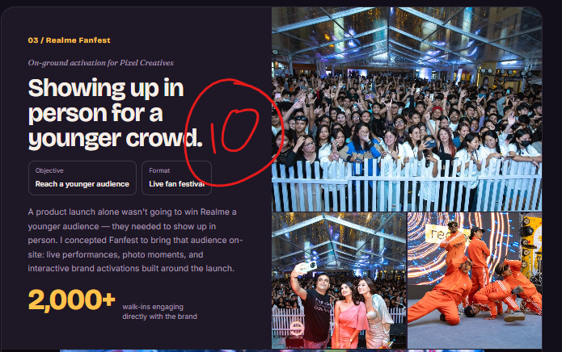

10.

Nobody leaves the house for an ad.
Objective: Reach Nepal's gaming youth
Format: Live fan festival
Realme was one of my main accounts at Pixel Creatives — event strategy, social, and paid ads, the whole time I was there. Fanfest was the biggest piece of it: Realme was moving from budget phones to gaming, and I conceptualized and planned the event to get that younger crowd in the room. I also worked directly with their Nepal brand ambassador on shoots and video.
And obviously, turned it into content too.
2,000+ walk-ins engaging directly with the brand
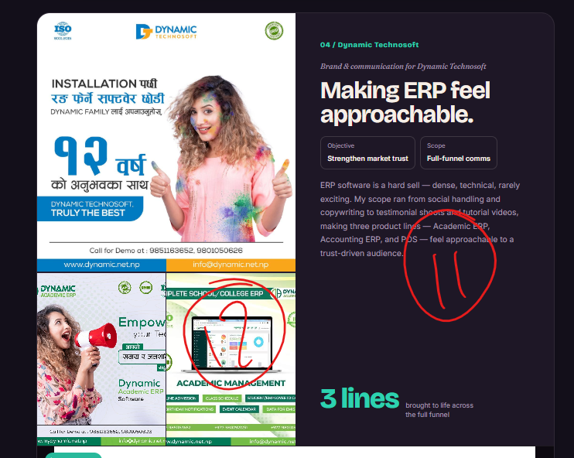

11.

Features were the problem.
Objective: Win decision-makers in a crowded market
Audience: School principals & institutional buyers
Listing features wasn't landing, it didn't match how principals actually thought about the problem. So I wrote around what the software fixed for them instead, across Academic ERP and their Accounting Solution. I also handled testimonials and tutorial videos for both.
12. Remove this photo not good
13. The images are crammed up need to flow and give view of the entire creative

Need to include the following videos:

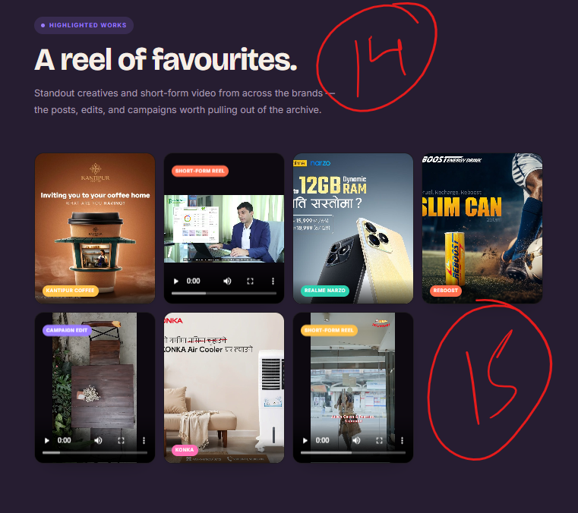
Replace the “ a reel of fa…” and the text below with
14. A few favourites.
A handful of pieces, across a few different brands.
15. Some of the works has a tag to it “Kantipur Cofee” “Realme” I don’t think it looks consistent and don’t love the view. Maybe we can go with panoramic curved view with this one?
Simply keeping all the creative in this style makes it look like very few work and no style at all. Need to add more work too.

